1. Materials and methods
1.1 Appendix E1: IORT and adjuvant therapy
A multidisciplinary team, which included surgeons, radiation oncologists, and radiologists, determined the appropriate treatment strategy of IORT and the following adjuvant therapy in LAPC patients. During surgery, a cytological diagnosis and a gross examination were routinely performed to confirm the diagnosis of pancreatic cancer without peritoneal or liver metastases. Before IORT, palliative surgery, including gastrojejunostomy or biliary bypass as appropriate, was regularly carried out depending on the tumor's location and clinical symptoms. After palliative surgery, the extent of lesion at operation was accessed by the surgeon and radiation oncologist, then a field including the pancreatic mass with a 0.5-1.0cm margin around and regional lymph nodes was covered by a cone^{[7]}. The electron energy of electron beam employed in IORT was 9-12 Mev depending on the maximum diameter of tumor, with an average dose of 14.8 Gy (range 13.5-15.0 Gy). In order to protect adjacent normal tissue, the IORT field excluded the liver, gastric wall and small bowels.
Sequential adjuvant therapy was composed of radiotherapy and chemotherapy. Radiotherapy: external beam radiotherapy (EBRT) or stereotactic body radiotherapy (SBRT) (ERBT:45-1.8-2.5Gy/fraction, total dose of 45-50Gy, SBRT no restriction required). Chemotherapy regimens include: gemcitabine-based regimens (Gemcitabine, Gemcitabine plus albumin-bound paclitaxel, or Gemcitabine plus S-1).

2. Supplementary tables
 | Revolution CT | Discovery CT 750 HD | Lightspeed VCT | Optima CT 660
No. of channels | 256 | 64 | 64 | 64
Section collimation* | 128 × 0.625 | 64 × 0.625 | 64 × 0.625 | 64 × 0.625
Thickness(mm) | 5 | 5 | 5 | 5
Interval(nm) | 5 | 5 | 5 | 5
Helical pitch | 0.992 | 0.984 | 0.984 | 1.375
Gantry rotation time(s) | 0.5 | 0.7 | 0.5 | 0.5
Tube voltage (kVp) | 120 | 120 | 120 | 120
Matrix | 512 × 512 | 512 × 512 | 512 × 512 | 512 × 512
2.1 Table S1. Multiphase contrast-enhanced CT scan parameter
Tube current was adjusted using automatic tube current modulation
*Number of detector rows times section thickness (mm)

2.2 Table S2. Definition of each CT imaging feature in this study
CT radiological feature | Definitions
Necrosis | Tumoral tissue that did not enhance on multiphasic CT examinations after contrast medium injection | 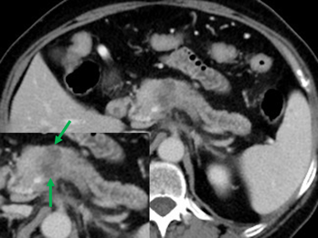
Rim-enhancement | irregular ringlike enhancement with a relatively hypo-vascular central area on dynamic-enhanced images | 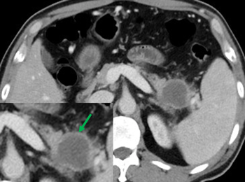
Peripancreatic fat infiltration | Tumor directly attached to the peri-pancreatic adipose tissues or extending directly from the intra-pancreatic tumor to the extra-pancreatic adipose tissues resulting in blurring or hyperdense shadowing at the interface between the tumor and the adipose tissues | 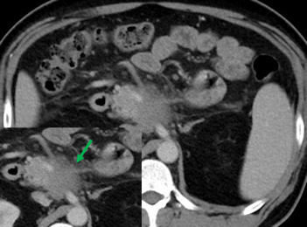
Suspicious lymph nodes | Including any of the following: short axis > 1 cm, abnormal round morphology, heterogeneity, or central necrosis. | 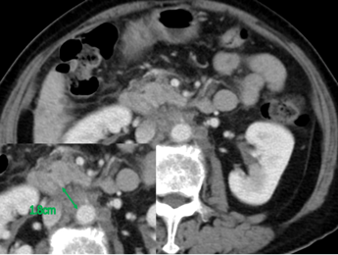
Pancreatic duct dilatation | Interrupted main pancreatic duct was defined as an abrupt luminal disruption of the main pancreatic duct. | 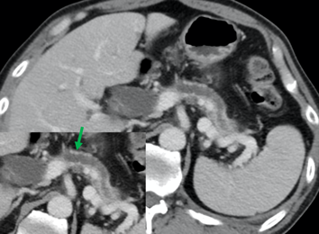
Atrophic upstream pancreatic parenchyma | A main pancreatic duct calibre to total pancreatic parenchymal width ratio of less than 0.50. | 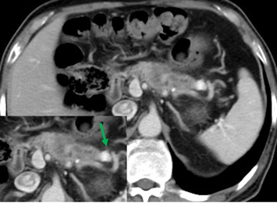

References:^{[1-4]}
1.Lee S, Kim SH, Park HK, et al. Pancreatic Ductal Adenocarcinoma: Rim Enhancement at MR Imaging Predicts Prognosis after Curative Resection. Radiology 2018;288(2):456-66. doi: 10.1148/radiol.2018172331.
2.Tamada T, Ito K, Kanomata N, et al. Pancreatic adenocarcinomas without secondary signs on multiphasic multidetector CT: association with clinical and histopathologic features. Eur Radiol 2016;26(3):646-55. doi: 10.1007/s00330-015-3880-3.
3.AlHawary MM FI, Chari ST, Fishman EK, Hough DM, Lu DS, Macari M, Megibow AJ, Miller FH, Mortele KJ, Merchant NB, Minter RM, Tamm EP, Sahani DV, Simeone DM. . Pancreatic ductal adenocarcinoma radiology reporting template: consensus statement of the society of abdominal radiology and the american pancreatic association. Gastroenterology 2014;146(1):291-304. doi: 10.1053/j.gastro.2013.11.0042.
4. Yoon SH LJ, Cho JY, Lee KB, Kim JE, Moon SK, Kim SJ, Baek JH, Kim SH, Kim SH, Lee JY, Han JK, Choi BI. Small (≤ 20 mm) pancreatic adenocarcinomas: analysis of enhancement patterns and secondary signs with multiphasic multidetector CT. Radiology 2011;259:442–52. doi: 10.1148/radiol.11101133

2.4 Table S3. Interobserver agreement of CECT Semantic features and CT quantitative value between radiologists with 5 and 9 years of experience

Variables | kappa coefficient or ICC (95% CI)
CT quantitative parameters
Pre-long-axis (cm) | 0.87 (0.82, 0.91)
Post-long-axis (cm) | 0.80 (0.77, 0.85)
Δlong-axis (cm) | 0.83 (0.78, 0.86)
Pre-REV (HU) | 0.86 (0.81, 0.89)
Post-REV (HU) | 0.85 (0.79, 0.90)
ΔREV (HU) | 0.85 (0.81, 0.89)
Pre-RER | 0.86 (0.81, 0.89)
Post-RER | 0.85 (0.79, 0.90)
ΔRER% | 0.85 (0.81-0.89)
CT radiological features
Tumor location | 1.00 (1.00,1.00)
Tumor attenuating in PVP | 0.71 (0.64, 0.81)
Necrosis | 0.82 (0.79, 0.89)
Rim-enhancement | 0.79 (0.69, 0.86)
Peripancreatic fat infiltration | 0.74 (0.67, 0.86)
Suspicious lymph nodes | 0.70 (0.68, 0.78)
Pancreatic duct dilatation | 0.78 (0.73, 0.81)
Atrophic up stream pancreatic parenchyma | 0.72 (0.67, 0.78)
Data are Cohens κ values and ICC values; numbers in parentheses are 95% CI; ICC, intraclass correlation coefficient; REV, relative enhanced value; RER, relative enhanced ratio; RER, relative enhanced ratio; ΔREV, the change of REV; ΔRER%, the percentage change of RER.

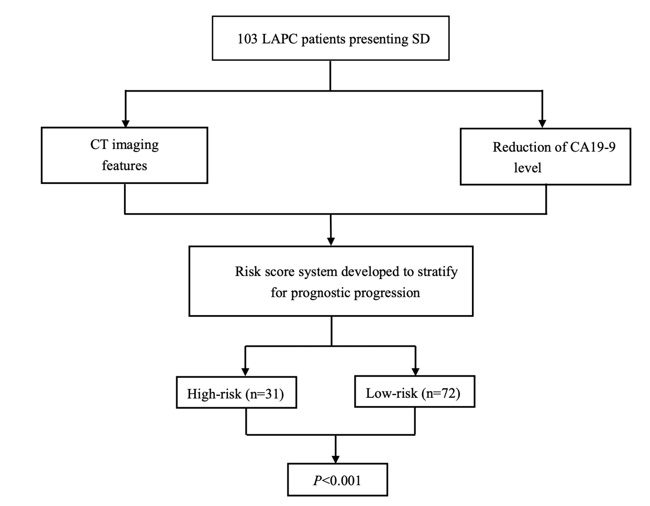
Figure S1. Illustration of this study. LAPC, locally advanced pancreatic cancer; IORT, Intraoperative radiotherapy; SD, stable disease.

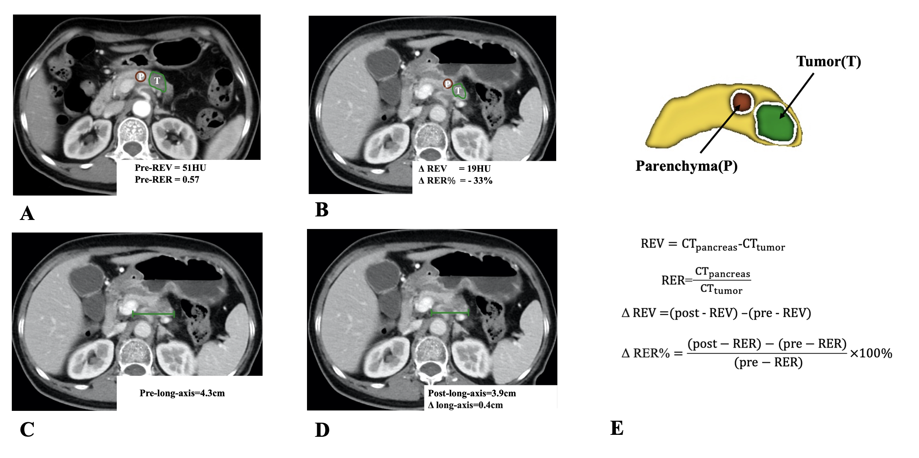

Figure S2. Representative examples of ductal adenocarcinoma detection by the contrast-enhanced CT in the portal venous phase and the lesion delineation. (A-D) CT images in PVP of a 64-year-old man diagnosed as LAPC with a 4.3cm lesion before IORT. After treatment, lesions shrunk and was assessed as SD according to RECISTv1.1 criteria. The quantitative CT parameters are showed on the images. (E) Schematic diagram shows delineation of tumor (green), the surrounding normal pancreatic parenchyma (red), and delination of normal pancreatic parenchyma (yellow). The formulars of CT quantitative parameters are also displayed. Green and red lines show the delineation of tumor lesion and the normal peripancreatic parenchyma, respectively. T indicated the tumor and P represented surrounding normal peripancreatic parenchyma. REV, relative enhanced value; RER, relative enhanced ratio; ΔREV, the change of REV; ΔRER%, the percentage change of RER.

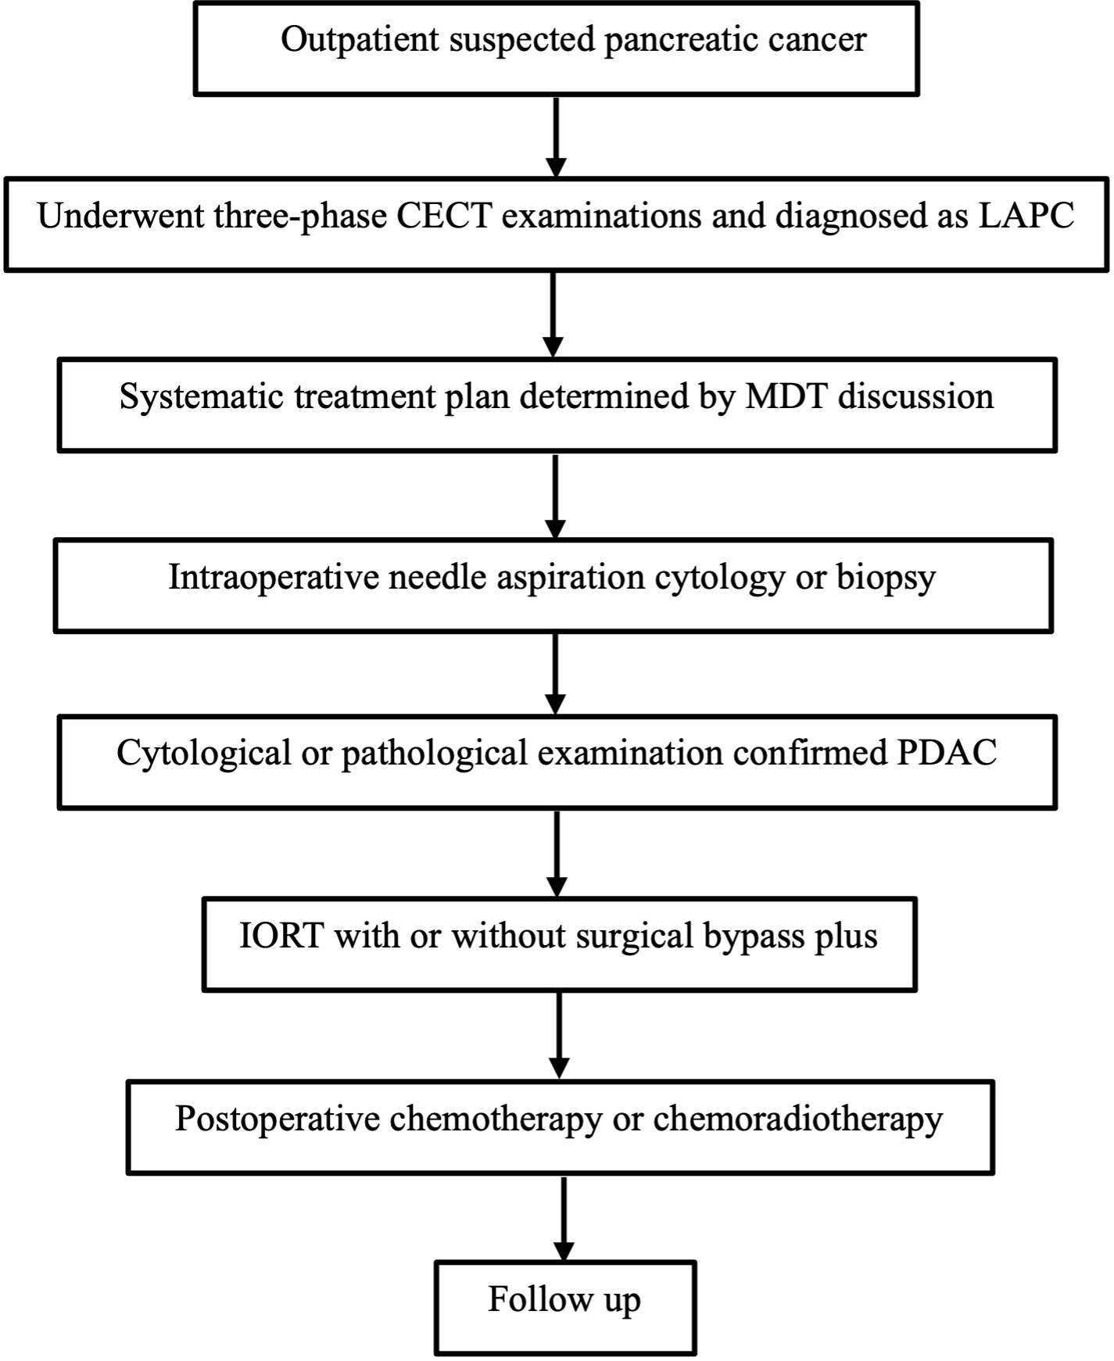

Figure S3. The illustration of IORT procedure in LAPC. IORT, intraoperative radiotherapy; LAPC, locally advanced pancreatic cancer; CECT, contrast-enhanced CT; MDT, multi-disciplinary team; PDAC, pancreatic ductal adenocarcinoma.

Figure S4. Schematic diagram shows treatment schedule and time plan of CT in this study. The median intervals from pre-IORT CT to IORT and was 10.0 days (range, 8.0-14.0 days).
LAPC=locally advanced pancreatic cancer, IORT= Intraoperative radiotherapy, PVP= portal venous phase.

