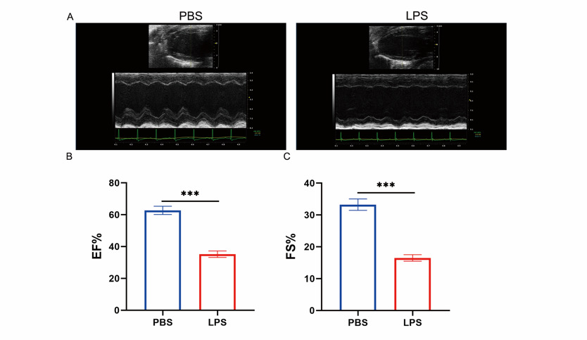
Figure S1:
(A) Representative images showing the echocardiography of mice after intraperitoneal injection LPS; (B-C) Left ventricular ejection fraction (LVEF) and left ventricular shortening fraction (FS) after LPS injection (n=6, ***p<0.001.)
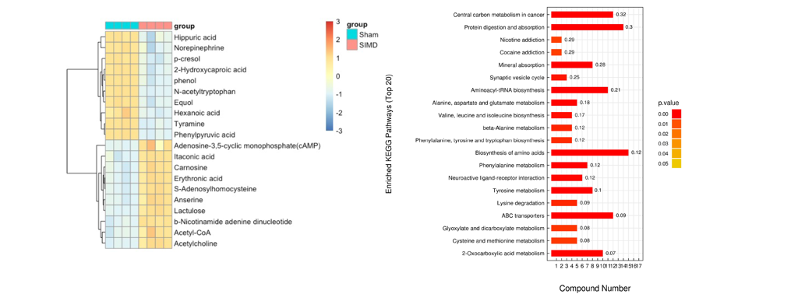
Figure S2:
Heatmap and KEGG analysis of metabolites with the most significant differences in cardiometabolic sequencing 24h after intraperitoneal injection of LPS in mice. (SIMD v.s. Sham; n=4)

Figure S3:
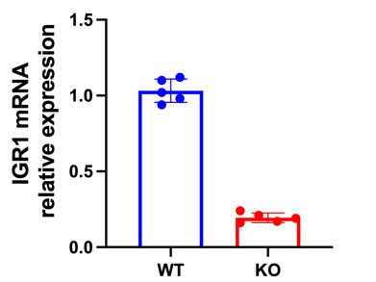
Figure S3:
Q-PCR analysis of Irg1 mRNA expression from myocardial tissues of IRG1 KO and littermate control WT mice. (WT v.s. KO; n=5)

