Supporting Information for the article:

Far-reaching Effects of Tyrosine64 Phosphorylation on Ras Revealed with BeF₃– Complexes
Patrick Baumann^{[1,2]} and Yi Jin*^{[1,2]}
^{[1]} Manchester Institute of Biotechnology, University of Manchester, 131 Princess Street, Manchester, M1 7DN, United Kingdom
^{[2]} School of Chemistry, Cardiff University, Park Place, Cardiff, CF10 3AT, United Kingdom

* E-mail: yi.jin@manchester.ac.uk

Table of Contents
Supplementary Figure 1. Mass spectroscopy (MS) analysis of Src-mediated phosphorylation of Ras. 2
Supplementary Figure 2. Separation of phosphorylated Ras species by anion exchange chromatography. 3
Supplementary Figure 3. Trypsin digest of monophosphorylated Ras. 4
5
Supplementary Figure 4. ¹⁹F NMR Src related TSA complex. 6
Supplementary Figure 5. RMSD comparison of structures of Ras_{WT}-GTP (PDB: 1QRA) with Ras_{WT}-GDP-BeF₃– (PDB: 8CNJ) on the backbone. 7
7
Supplementary Figure 6. Solvent-induced isotope shifts (SIIS) analysis of Ras_{WT}-GDP-BeF₃– using ¹⁹F-NMR 7
Supplementary Figure 7. ¹⁹F NMR Ras_{Y32F}-GDP-BeF₃– spectrum. Free fluoride presaturated on –120 ppm to suppress the protein-unbound BeF_{x} species (bottom) compared to unpresaturated spectrum (top). 8
8
Supplementary Figure 8. ¹⁹F NMR spectra for Ras-BeF₃– complexes. 8
Supplementary Figure 9. ¹⁹F NMR spectrum of RasGAP₃₃₄/HRas_{WT}-GDP-AlF₄– TSA complex. 9
Supplementary Figure 10. Stability of monophosphorylated HRas. 9
Supplementary Figure 11: RMSD comparison of the structures of Ras_{pY64}-GDP (PDB: 8BWG) with Ras_{pY64}-GDP-BeF₃– (PDB: 8CNN) on the backbone. 10
Supplementary Figure 12: RMSD comparison of structures of Ras_{WT}-GDP-BeF₃– (PDB: 8CNJ) was aligned on Ras_{pY64}-GDP-BeF₃– (PDB: 8CNN). 10
10
Supplementary Figure 13: Protein mass spectrometry for Ras_{WT}, Ras_{Y32F}, Ras_{Y64F}, mono-phosphorylated Ras_{WT} and double-phosphorylated Ras_{WT}. 13
Supplementary Table 1: X-ray data collection, processing, and refinement statistics. 14

Supplementary Figure 1. Mass spectroscopy (MS) analysis of Src-mediated phosphorylation of Ras.
HRas (1.0 mM) was incubated with cSrc (20 µM) for 15 h at 4 ˚C in phosphorylation buffer (Tris-HCl 25 mM, pH = 7.6, NaCl 200 mM, 2-ME 2 mM, MgCl₂ 5 mM, ATP 5 mM). The deconvoluted spectrum detected unphosphorylated, mono- and double-phosphorylated species after the Src phosphorylation assay.

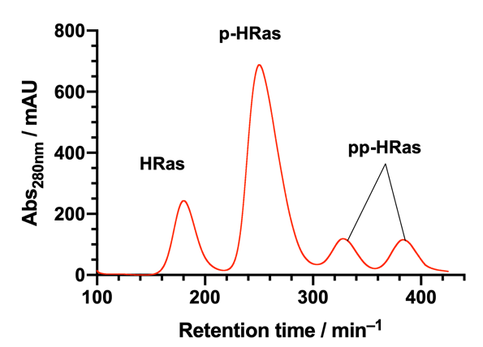

Supplementary Figure 2. Separation of phosphorylated Ras species by anion exchange chromatography.
Separation of Src-phosphorylated HRas into un-, mono- and double-phosphorylated species using anion exchange chromatography. After overnight incubation of 1.0 mM HRas with Src (1:250 Src:HRas molar ratio) in phosphorylation buffer (Tris-HCl 25 mM, pH 7.6, NaCl 200 mM, 2-ME 2 mM, MgCl₂ 5 mM, ATP 3 mM) at 4 ˚C, the unmodified, singly phosphorylated and doubly phosphorylated forms were separated using anion exchange chromatography. A Mono Q 5/50 GL column was run with 20 mM HEPES pH = 7.0, 5 mM MgCl₂, and 1 mM DTT (Buffer A), and 20 mM HEPES pH = 7.0, 5 mM MgCl₂, 1mM DTT, and 1M NaCl (Buffer B) using a gradient of 0 to 40% B over 80 column volumes.

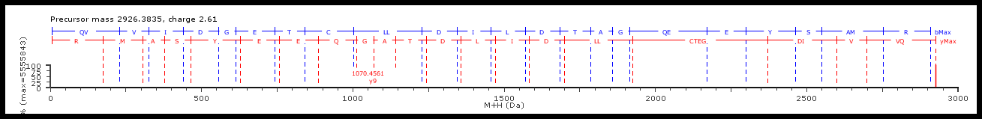
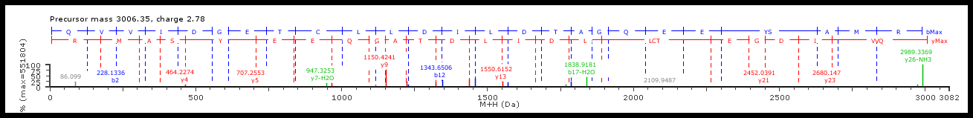

Supplementary Figure 3. Trypsin digest of monophosphorylated Ras.
Data was acquired using an Agilent 6520 Ion Mobility LC/Q-TOF system in positive mode (reference mass 922.00979800) equipped with a LC Agilent 1290 Infinity system and Waters ACQUITY UPLC glycoprotein BEH Amide (300 Å, 1.7 μm) column. Column flow was set at 0.2 mL/min. MS/MS spectrum of native and phosphorylated- peptides (light chain peptide 1-18). Top (native peptide): 2926.38. Bottom (Y64-phosphorylated fragment): 3006.35. Fragment sequence: RMASY*EEQGATDLIDLLCTRGDIVVQ.

Supplementary Figure 4. ¹⁹F NMR Src related TSA complex.

¹⁹F NMR spectra (500 MHz, 1024 scans) showed free MgF⁺/AlF_{x} signal, but no formation of a magnesium fluoride or aluminium fluoride TSA complex between Ras (0.5 mM) or Boc-l-Tyr-OH (3 mM) and Src (0.5 mM). Measured samples:

(a) Src/Mg²⁺: Src 0.5 mM, Tris-HCl 25 mM pH = 7.5, NaCl 200 mM, MgCl₂ 30 mM, NH₄F 30 mM, ADP 10 mM, DTT 1 mM, 10% D₂O.
(b) Src/Mg²⁺/Tyr: Src 0.5 mM, Boc-l-Tyr-OH 3 mM, Tris-HCl 25 mM pH = 7.5, NaCl 200 mM, MgCl₂ 30 mM, NH₄F 30 mM, ADP 10 mM, DTT 1 mM, 10% D₂O.
(c) Src/Mg²⁺/Ras: Src 0.5 mM, Ras 0.5 mM, Tris-HCl 25 mM pH = 7.5, NaCl 200 mM, MgCl₂ 30 mM, NH₄F 30 mM, ADP 10 mM, DTT 1 mM, 10% D₂O.
(d) Src/Al³⁺: Src 0.5 mM, Tris-HCl 25 mM pH = 7.5, NaCl 200 mM, MgCl₂ 30 mM, NH₄F 30 mM, ADP 10 mM, DTT 1 mM, AlCl₃ 2 mM, 10% D₂O.
(e) Src/Al³⁺/Tyr: Src 0.5 mM, Boc-l-Tyr-OH 3 mM, Tris-HCl 25 mM pH = 7.5, NaCl 200 mM, MgCl₂ 30 mM, NH₄F 30 mM, ADP 10 mM, DTT 1 mM, AlCl₃ 3 mM, 10% D₂O.
(f) Src/Al³⁺/Ras: Src 0.5 mM, Ras 0.5 mM, Tris-HCl 25 mM pH = 7.5, NaCl 200 mM, MgCl₂ 30 mM, NH₄F 30 mM, ADP 10 mM, DTT 1 mM, AlCl₃ 3 mM, 10% D₂O.

Supplementary Figure 5. RMSD comparison of structures of Ras_{WT}-GTP (PDB: 1QRA) with Ras_{WT}-GDP-BeF₃– (PDB: 8CNJ) on the backbone.

Supplementary Figure 6. Solvent-induced isotope shifts (SIIS) analysis of Ras_{WT}-GDP-BeF₃– using ¹⁹F-NMR
¹⁹F NMR, 500 MHz, 2048 scans: Ras 1.1 mM, Tris-HCl 25 mM, pH/pD = 7.5, NaCl 150 mM, MgCl₂ 5 mM, NH₄F 30 mM, DTT 1 mM, BeCl₃ 3 mM. NMR samples contain 10–95% D₂O content.
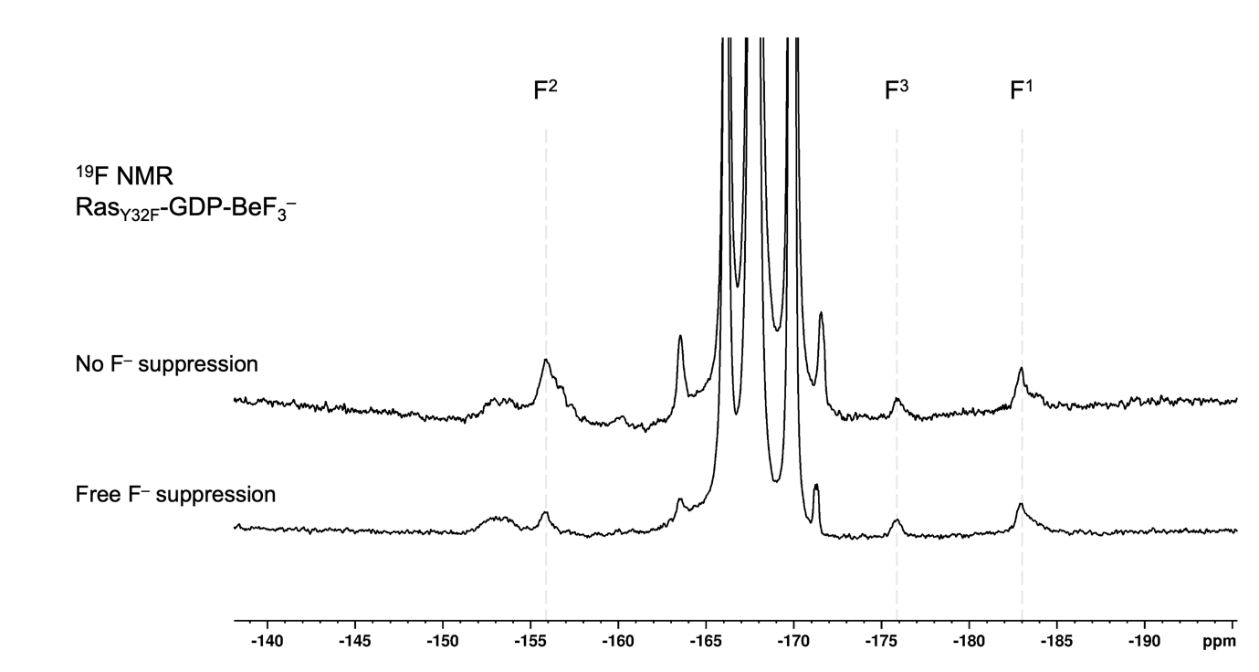

Supplementary Figure 7. ¹⁹F NMR Ras_{Y32F}-GDP-BeF₃– spectrum. Free fluoride presaturated on –120 ppm to suppress the protein-unbound BeF_{x} species (bottom) compared to unpresaturated spectrum (top).

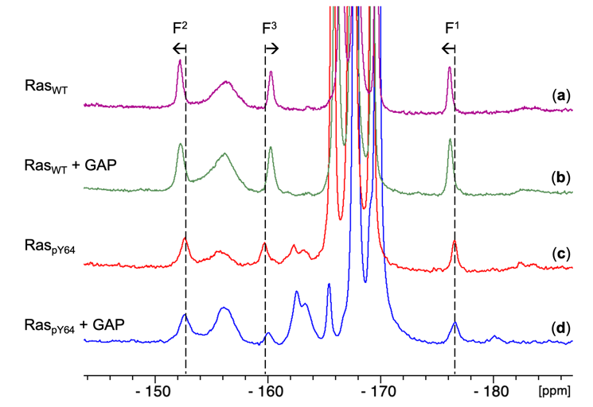
Supplementary Figure 8. ¹⁹F NMR spectra for Ras-BeF₃– complexes. ¹⁹F NMR spectra with 1024 scans were recorded for (a) Ras_{WT}-GDP-BeF₃– GSA complex; (b) NMR sample of (a) supplemented with 1.1 eq of RasGAP₃₃₄; (c) HRas_{pY64}-GDP-BeF₃– GSA complex; (d) NMR sample of (c) supplemented with 1.1 eq of RasGAP₃₃₄. All samples consisted of 0.8–1.0 mM Ras_{WT,} Ras_{Y32F} or HRas_{pY64}, in the buffer of 25 mM Tris-HCl pH = 7.0 and 10% D₂O with 3 mM BeCl₂, 30 mM NH₄F, and 5 mM MgCl₂.
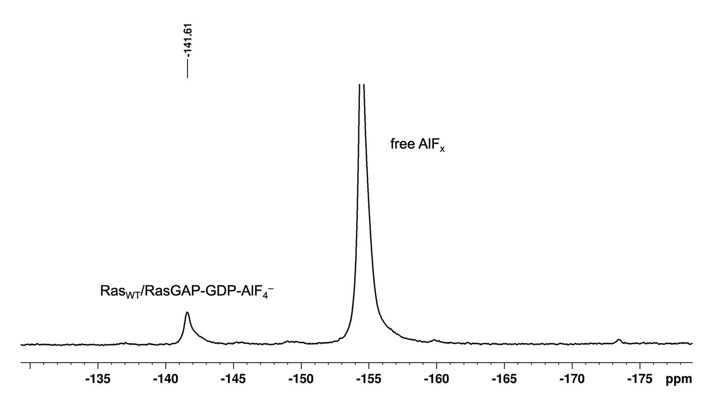

Supplementary Figure 9. ¹⁹F NMR spectrum of RasGAP₃₃₄/HRas_{WT}-GDP-AlF₄– TSA complex.
¹⁹F NMR, 500 MHz, 1024 scans: Ras 1.0 mM, Tris-HCl 25 mM, pH = 7.5, NaCl 200 mM, MgCl₂ 5 mM, NH₄F 30 mM, DTT 1 mM, AlCl₃ 3 mM, D₂O 10%.

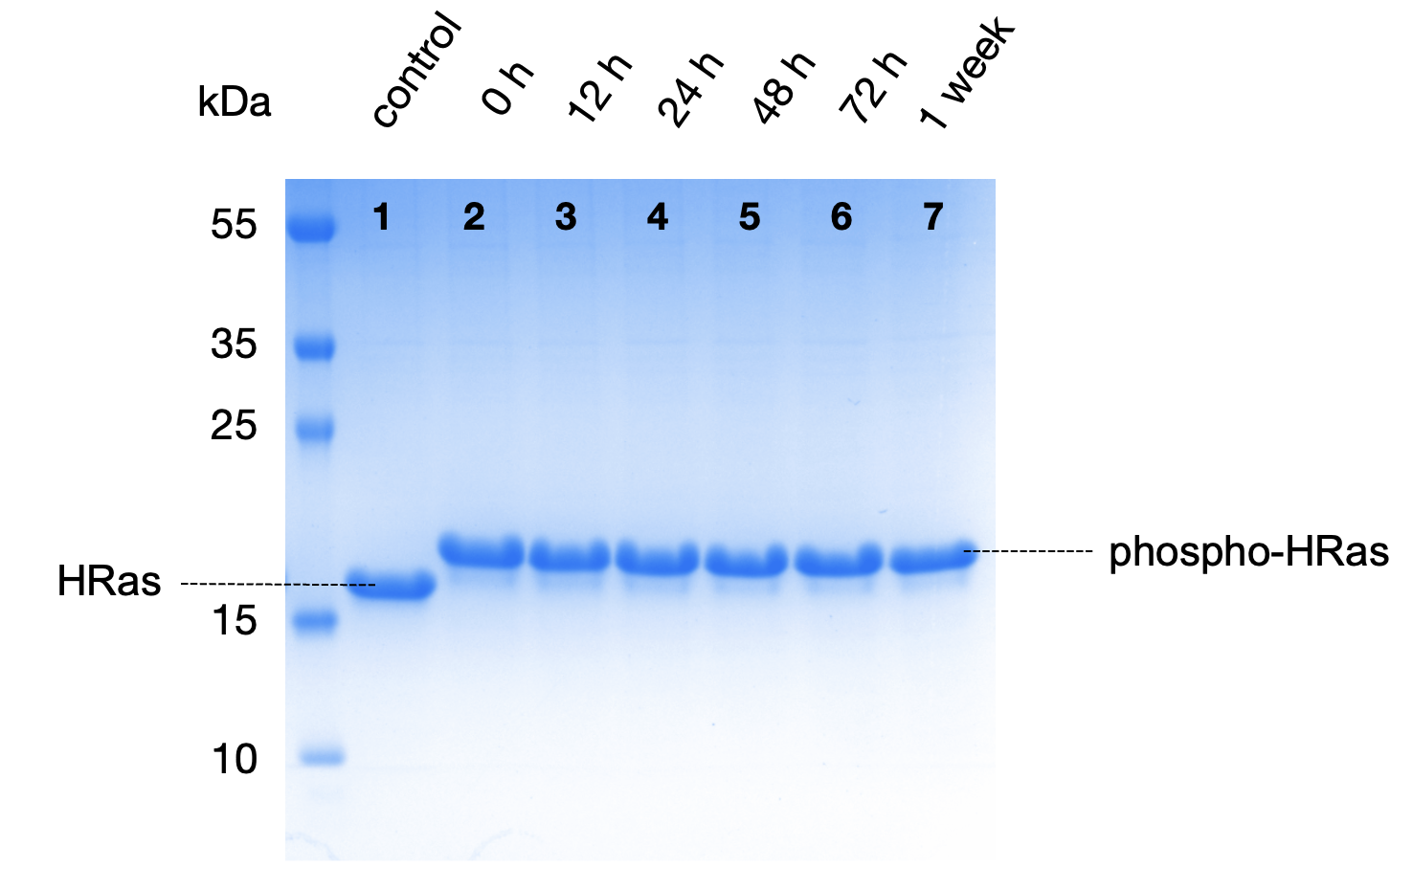

Supplementary Figure 10. Stability of monophosphorylated HRas.
The stability of monophosphorylated Ras was determined by incubating 100 μM monophosphorylated HRas in crystallisation buffer (HEPES-Na 20 mM pH = 8.0, MgCl₂ 10 mM, NaF 20 mM) at 4 ˚C. In regular intervals aliquots were taken, mixed with SDS-PAGE loading buffer, heated to 100 ˚C for 3 min and stored at –80 ˚C until all timepoints could be analysed by SDS-PAGE.

Supplementary Figure 11: RMSD comparison of the structures of Ras_{pY64}-GDP (PDB: 8BWG) with Ras_{pY64}-GDP-BeF₃– (PDB: 8CNN) on the backbone.

Supplementary Figure 12: RMSD comparison of structures of Ras_{WT}-GDP-BeF₃– (PDB: 8CNJ) was aligned on Ras_{pY64}-GDP-BeF₃– (PDB: 8CNN).

Mass spectrum for HRas_{WT}

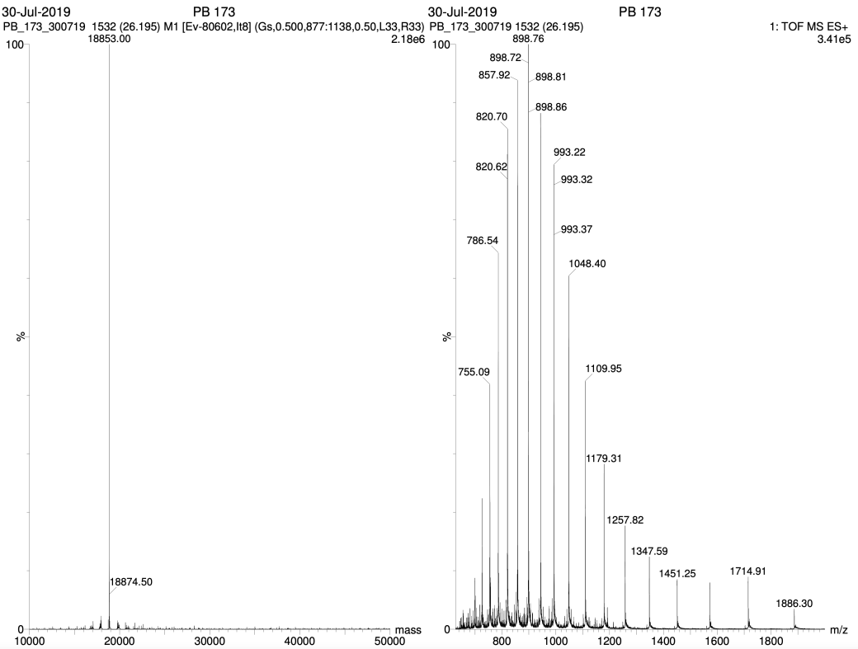

Mass spectrum for monophosphorylated Ras_{WT}.
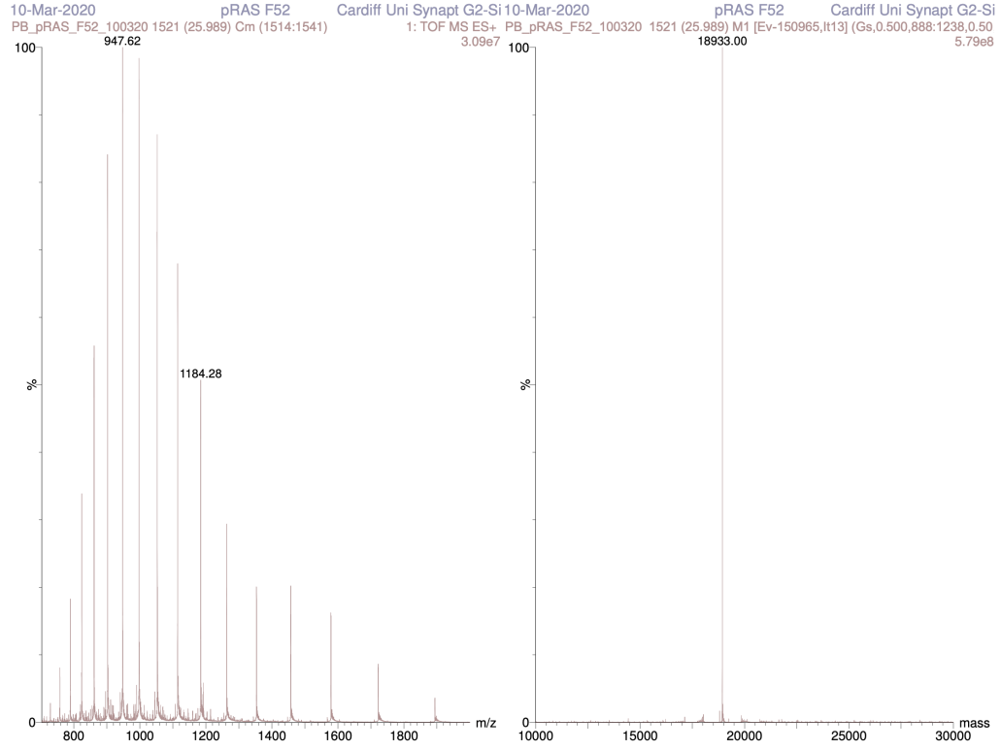

Mass spectrum for double-phosphorylated Ras_{WT}
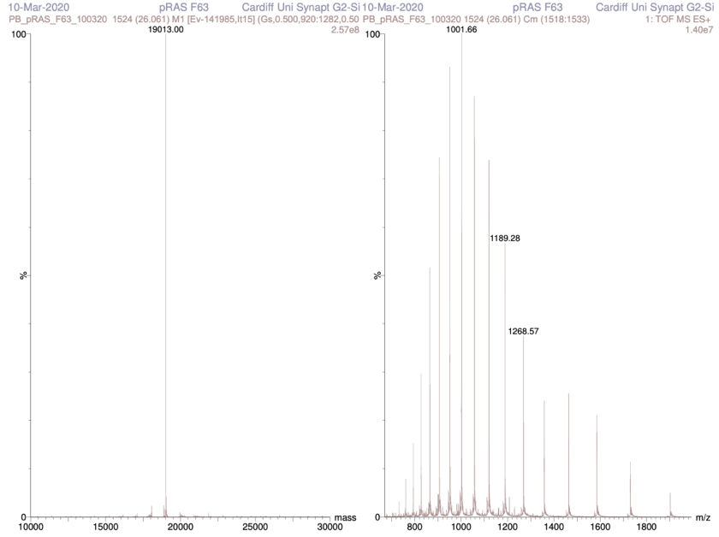

Mass spectrum for Ras_{Y32F}
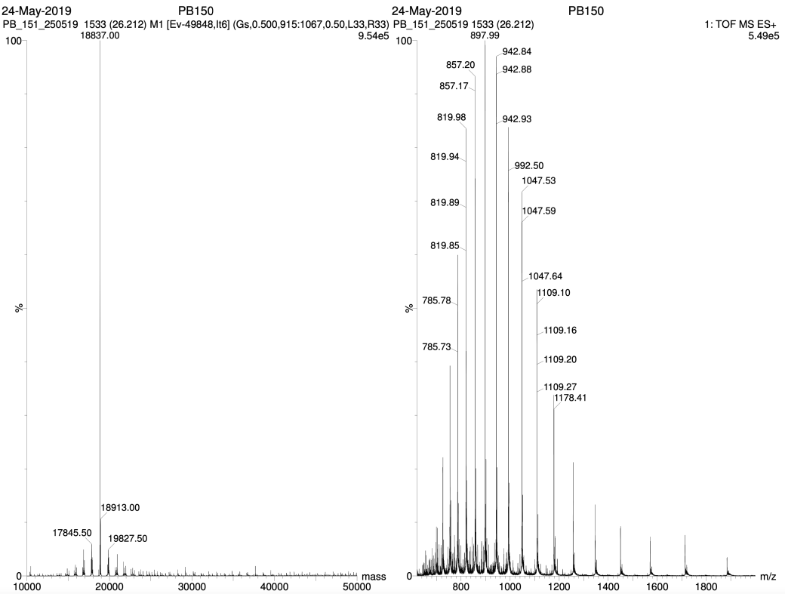

Mass spectrum for Ras_{Y64F}
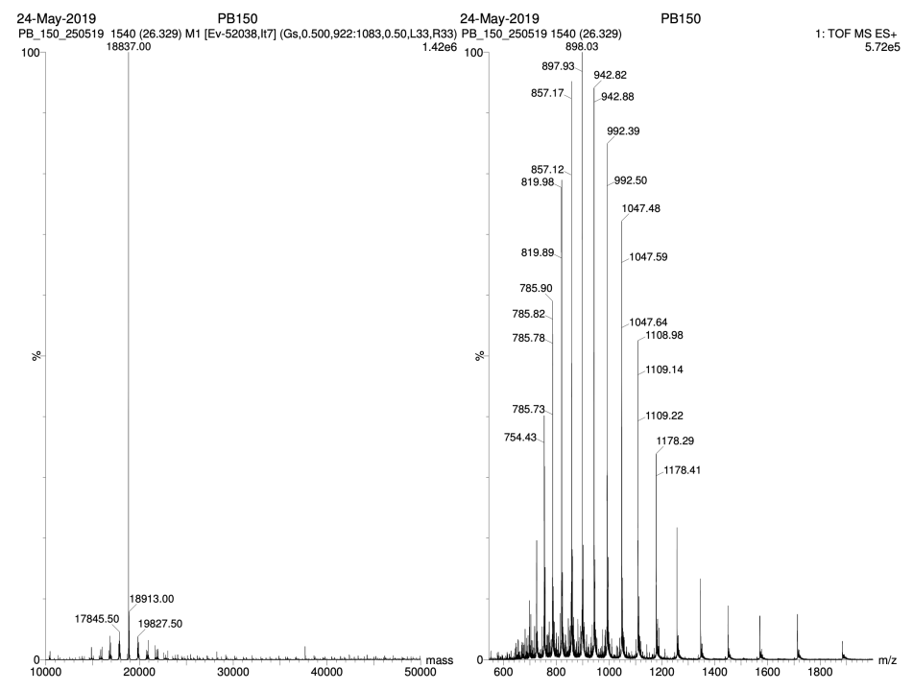

Supplementary Figure 13: Protein mass spectrometry for Ras_{WT}, Ras_{Y32F}, Ras_{Y64F}, mono-phosphorylated Ras_{WT} and double-phosphorylated Ras_{WT}.

Supplementary Table 1: X-ray data collection, processing, and refinement statistics.

 | HRas_{pY64}-GDP apo | HRas-GDP-BeF₃– | HRas_{pY64}-GDP-BeF₃–
PDB | 8BWG | 8CNJ | 8CNN
Crystal Data  Wavelength | 0.976 Å | 0.976 Å | 0.976 Å
Space group | H 3 2 | P 21 21 21 | H 3 2
a, b, c (Å) | 92.66, 92.66, 119.32 | 45.43, 51.96, 136.15 | 87.77 87.77 132.38
α, β, γ (°) | 90.00, 90.00, 120.00 | 90.00, 90.00, 90.00 | 90.00, 90.00, 120.00
Resolution (Å) | 47.92–1.32 | 48.59–1.35 | 49.92–1.48
R_{merge} | 0.041 | 0.056 | 0.033
I / sig(I) | 28.6 (1.1) | 13.7 (1.4) | 15.8 (1.2)
CC(1/2) | 1.000 (0.577) | 0.999 (0.598) | 1.000 (0.559)
Completeness (%) | 99.2 (91.0) | 96.2 (68.4) | 100.0 (100.0)
Refinement
Unique reflections | 45988 (2073) | 69077 (2387) | 32936 (1622)
R_{work} / R_{free} | 0.135 / 0.174 | 0.144 / 0.183 | 0.138 / 0.176
No. atoms
Protein | 1335 | 2707 | 2669
Ligand/ion | 33 / 1 | 64 / 2 | 140 / 1
Water | 131 | 260 | 123
B-factors
Protein | 25.65 | 20.99 | 24.07
Ligand/ion | 24.28 / 20.97 | 14.16 / 14.95 | 39.8 / 16.43
Water | 37.45 | 34.49 | 36.09
RMS deviations
Bond lengths (Å) | 0.0097 | 0.0137 | 0.0118
Bond angles (°) | 1.607 | 1.750 | 1.637

Values in parentheses are for the highest-resolution shell.

