Supplementary Material

Suppl. Table 1: Localization of lymphedema in 81 melanoma patients

Localisation Lymphedema | N° of patients
Upper extremity | 21(26,0%)
Lower extremity | 57 (70.4%)
Upper + Lower extremities | 1 (1.2%)
Neck | 2 (2.5%)

Suppl. Table 2: Lymphedema development and number of lymph nodes removed in melanoma patients undergoing sentinel lymph node biopsy (SLNB)

LE after SLNB | N° of patients
Total number | 13
Anatomic localization of LE:  Upper extremity  Lower extremity | 1  12
N° of lymph nodes (LN) removed:  1 LN  2 LN  3 LN  4 LN | 8  2  2  1

Suppl. Table 3: Patient characteristics of melanoma patients undergoing lymphadenectomy (LAD). Differences in continuous variables (age, Breslow, etc.) were tested with a t-test, while differences in categorical variables (sex, localisation, etc) were tested with Fisher’s Exact Test.

 | NO Lymphedema | Lymphedema | p
n | 411 | 68
Age (mean (SD)) | 63.30 ± 14.58 | 62.63 ± 14.20 | 0.727
Sex = M (%) | 252 (61.3 %) | 33 (48.5 %) | 0.063
Breslow (mean (SD)) | 3.61 ± 3.26 | 2.96 ± 2.78 | 0.156
Clark.Level (mean (SD)) | 3.85 ± 0.69 | 3.84 ± 0.69 | 0.924
Diagnosis (%) |  |  | 0.033
Cerebral metastatic melanoma | 41 (10.0 %) | 3 (4.4 %)
Lymphoid metastasic melanoma | 0 (0.0 %) | 1 (1.5 %)
Metastatic melanoma | 315 (76.6 %) | 52 (76.5 %)
Primary cutaneous melanoma | 55 (13.4 %) | 12 (17.6 %)
Localisation (%) |  |  | <0.001
 | 21 (5.1 %) | 4 (5.9 %)
arm | 77 (18.7 %) | 10 (14.7 %)
foot left | 1 (0.2 %) | 0 (0.0 %)
head | 38 (9.2 %) | 2 (2.9 %)
leg | 123 (29.9 %) | 43 (63.2 %)
trunk | 151 (36.7 %) | 9 (13.2 %)
Ulceration (%) | 104 (28.8 %) | 12 (20.3 %) | 0.233

Suppl. Table 4: Lymphedema patient characteristics from the patients that have been used for histological and molecular characterization

 | Control | Lymphedema
Number of cases | 9 | 9
Gender
Female | 7 | 8
Male | 2 | 1
Average BMI | 27.86 ± 4.478 | 26.94 ± 4.93
Average Age | 48.45 ± 9.501 | 61.11 ± 11.74
Lymphedema Stage
Stage 1
Stage 2 |  | 8
Stage 3 |  | 1
Harvesting location  Lower extremity | 8 | 7
Upper extremity | 1 | 2

Suppl. Table 5: Human primer list used for qPCRs

Primer | Sequence (5’ to 3’)
B2M forward | TGT GCT CGC GCT ACT CTC TCT
B2M reverse | CGG ATG GAT GAA ACC CAG ACA
CD4 forward | CCT CCT GCT TTT CAT TGG GCT AGG
CD4 reverse | TGA GGA CAC TGG CAG GTC TTC T
CTLA4 forward | ACG GGA CTC TAC ATC TGC AAG G
CTLA4 reverse | GGA GGA AGT CAG AAT CTG GGC AC
CD25 forward | GAG ACT TCC TGC CTC GTC ACA AC
CD25 reverse | GAT CAG CAG GAA AAC ACA GCC G
FOXP3 forward | CAC TGG TTC ACA CGC ATG TTT
FOXP3 reverse | CAC CCG CAC AAA GCA CTT G

Suppl. Table 6: Murine primer list used for qPCRs

Primer | Sequence (5’ to 3’)
Rplp0 forward | AGA TTC GGG ATA TGC TGT TGG C
Rplp0 reverse | TCG GGT CCT AGA CCA GTG TTC
Il2 forward | GCG GCA TGT TCT GGA TTT GAC TC
Il2 reverse | CCA CCA CAG TTG CTG ACT CAT C
Infg forward | CAG CAA CAG CAA GGC GAA AAA GG
Infg reverse | TTT CCG CTT CCT GAG GCT GGA T
Tnfa forward | AGC ACA GAA AGC ATG ATC CG
Tnfa reverse | GTT TGC TAC GAC GTG GGC TA
Il10 forward | ACA GCC GGG AAG ACA ATA ACT
Il10 reverse | GCA GCT CTA GGA GCA TGT GG
Il13 forward | CAC ACA AGA CCA GAC TCC CC
Il13 reverse | CCA GGG ATG GTC TCT CCT CA
Ccr4 forward | TCC TGA CGG ACG TGT ACC T
Ccr4 reverse | CAG ACC TAG TCC AAA AAC CCA C
Ccr8 forward | TTC CTC TAC TTA GGG AGA CAA ATG C
Ccr8 reverse | CAT CCA GGG TGG AAG AAT GG
Ctla4 forward | GTA CCT CTG CAA GGT GGA ACT C
Ctla4 reverse | CCA AAG GAG GAA GTC AGA ATC CG
Foxp3 forward | ACT GGG GTC TTC TCC CTC AA
Foxp3 reverse | CGT GGG AAG GTG CAG AGT AG
CD25 forward | AAG ATG AAG TGT GGG AAA ACG G
CD25 reverse | GGG AAG TCT GTG GTG GTT ATG G

Suppl. Table 7: List of mouse flow cytometry antibodies

Antibody | Clone | Dilution | Cat | Company
Surface Markers
CD73-APC-Fire | TY/11.8 | 1:200 | 127221 | Biolegend
CD45-BUV395 | 30-F11 | 1:500 | 564279 | BD
CD11b-BUV661 | M1/70 | 1:500 | 612977 | BD
CD8-BUV805 | 53-6.7 | 1:100 | 612898 | BD
LAG3-BV421 | C9B7W | 1:100 | 125221 | Biolegend
CD44-BV570 | IM7 | 1:200 | 103037 | Biolegend
PD1-BV605 | 29F.1A12 | 1:100 | 135219 | Biolegend
CD25-BV650 | PC61 | 1:100 | 102037 | Biolegend
TIM3-BV785 | RMT3-23 | 1:200 | 119725 | Biolegend
NKp46-FITC | 29A1.4 | 1:200 | 137605 | Biolegend
TCRb-PE-Cy5 | H57-597 | 1:300 | 109209 | Biolegend
CD127-PE-Cy7 | SB/199 | 1:200 | 560733 | BD
CD39-PerCP-eFluor 710 | 24DMS1 | 1:500 | 46-0391-80 | Thermo
CD19-Spark Blue550 | 6D5 | 1:100 | 115565 | Biolegend
CD27-V450 | LG.3A10 | 1:200 | 561245 | BD
Intracellular Markers
CD4-BUV496 | GK1.5 | 1:100 | 612952 | BD
TCF-Alexa Fluor 647 | C63D9 | 1:200 | 6709S | CellSignaling
CTLA4-APC-R700 | UC10-4F10-11 | 1:1600 | 565778 | BD
FOXP3-PE-eFlour610 | FJK-16s | 1:100 | 61-5773-80 | Thermo
TNF-BV711 | MP6-XT22 | 1:100 | 506349 | Biolegend
IFNg-BUV737 | XMG1.2 | 1:100 | 612769 | BD
Ki67-BV480 | B56 | 1:200 | 566172 | BD
TOX-PE | REA473 | 1:200 | 130-120-785 | Milteny

Suppl. Table 8: List of mouse flow cytometry antibodies

Antibody | Clone | Dilution | Cat | Company
CD45-APC-Cy7 | 30-F11 | 1:200 | 103116 | Biolegend
CD4-APC | GK1.5 | 1:200 | 100412 | Biolegend
CD8a-eFluor 450 | 53-6.7 | 1:200 | 48-0081-82 | eBioscience
Foxp3- PE | FJK-16s | 1:100 | 12-5773-82 | eBioscience
CD11b -BV650 | M1/70 | 1:200 | 101239 | Biolegend

Suppl. Table 9: List of human flow cytometry antibodies

Antibody | Clone | Dilution | Cat | Company
CD45-BV650 | HI30 | 1:200 | 127221 | BD
CD4-APC | SK3 | 1:200 | 564279 | Biolegend
CD8a-PerCP/Cy5.5 | RPA-T8 | 1:200 | 612977 | Biolegend
CD25-FITC | M-A251 | 1:50 | 612898 | BD
Foxp3- PE/Cy 7 | 236A/E7 | 1:100 | 125221 | BD
CD152 - BV421 | BNI3 | 1:400 | 103037 | BD
CD11b -BV510 | ICRF44 | 1:200 | 135219 | Biolegend

Suppl. Table 10: Treatment details of melanoma patients

 | Sex | Previous Therapies | No. of Infusions | Duration between Therapy start and PBMC isolation in days
Pre-treatement
Pat1 | M |  |  | -3
Pat2 | M |  |  | 0
Pat3 | M | radio |  | 0
Pat4 | M |  |  | 0
Pat5 | M |  |  | 0
Pat6 | F |  |  | 0
Pat7 | M |  |  | 0
Pat8 | F |  |  | 0
Pat9 | M |  |  | 0
Pat10 | M |  |  | 0
Post-Treatment
Pat1 | M |  | 2 | 42
Pat2 | M |  | 3 | 43
Pat3 | M | radio | 2 | 41
Pat4 | M |  | 2 | 49
Pat5 | M |  | 1 | 22
Pat11 | F |  | 3 | 51

Suppl. Figure 1:

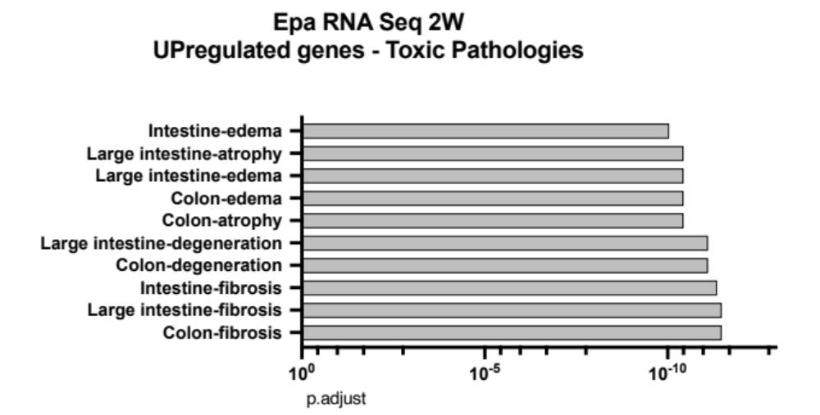

Suppl. Figure 1: Upregulated “Toxic Pathologies” in mice two weeks after lymphedema induction. Re-analysis of the RNA sequencing in C57BL/6 mice two weeks after lymphedema induction, using the data obtained by Gousopoulos et al. (15) and the MetaCore “Toxic Pathologies” revealed the key pathways involved in lymphedema development, namely fibrosis, tissue degeneration and edema. These pathways are the major pathways downregulated by anti-CTLA4 treatment in Figure 5G.
These key hallmarks are all related to intestine and colon tissue, because fibrosis and edema in mouse skin and soft tissue are understudied, thus lacking the appropriate number of reference genes. According to MetaCore, colon edema is represented with 1259 reference genes, while skin edema counts 110 references. Similarly, colon fibrosis has 913 gene references, while skin fibrosis 84.

Suppl. Figure 2:

Suppl. Figure 2: Flow cytometry gating example for (A) single cells isolated lymphedematous tissue and PBMCs from mice (B) and humans (C)

