Supplementary information for:

Ser/Leu-swapped cell-free translation system constructed with natural/in vitro transcribed-hybrid tRNA set

Tomoshige Fujino¹, Ryogo Sonoda¹, and Hiroshi Murakami^{1,2 *}

¹ Department of Biomolecular Engineering, Graduate School of Engineering, Nagoya University
² Institute of Nano-Life-Systems, Institutes of Innovation for Future Society, Nagoya University

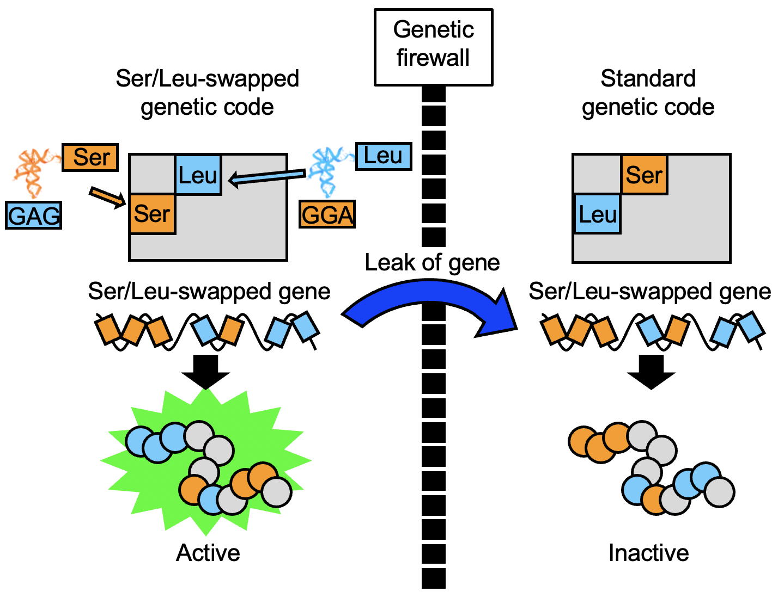

Supplementary Figure 1. Concept for preventing the expression of the functional proteins from leaked genes using the Ser/Leu-swapped genetic code. In the translation system employing the Ser/Leu-swapped genetic code, Ser is assigned to Leu codons and vice versa, by utilizing anticodon-swapped chimeric tRNAs. A gene encoded by this Ser/Leu-swapped code is translated into a functional protein only within this specific translation system. If this gene were to leak into the environment and be assimilated by natural organisms, it would translate into a non-functional protein due to the Ser/Leu-swap. Thus, the Ser/Leu-swapped genetic code acts as a genetic firewall, reducing potential biohazards.

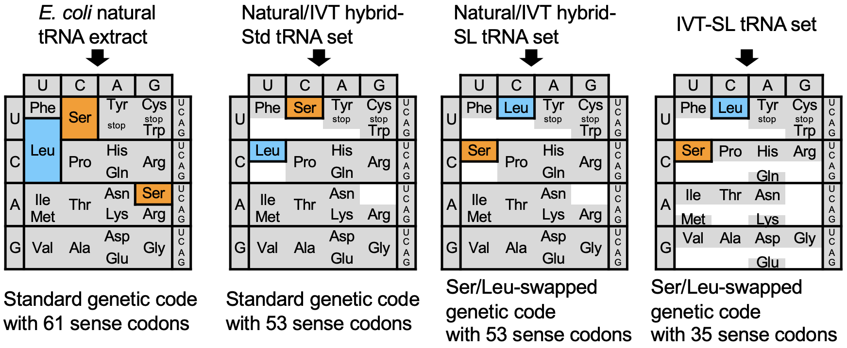

Supplementary Figure 2. The four genetic codes produced by respective tRNA sets in this study. Abbreviations: E. coli, Escherichia coli; IVT, in vitro transcribed; Std, standard; SL, Ser/Leu-swapped.

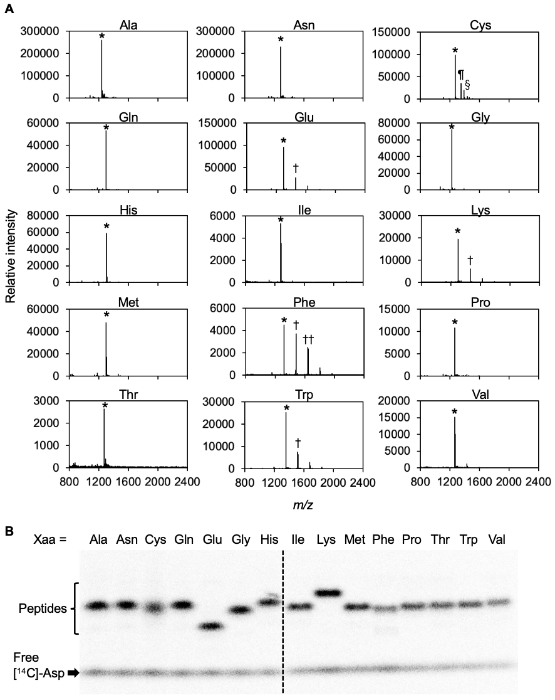

Supplementary Figure 3. Translation of model peptides using the cell-free translation system with the hybrid-Std tRNA set. The sequences of the model peptides and the corresponding mRNAs are shown in Figure 3A. Within the sequence, Xaa denotes 15 of the 20 natural amino acids, excluding Tyr, Asp, Arg, Ser, and Leu. (A) MALDI-TOF-MS analysis of the model peptides. The translation reaction was performed in the presence of 50 μM Asp. Peak labels are as follows: full-length model peptide with the intended amino acid at the position Xaa (*), full-length model peptide with adducts of either β-mercaptoethanol (¶) or Cys monomer (§), and +163 by-product corresponding to an added Tyr (†), and +326 by-product corresponding to two additional Tyr residues (††). The calculated and observed masses of the peptides are provided in Table S2. (B) Tricine SDS-PAGE analysis of the model peptides. 50 µM [¹⁴C]-Asp was added to the cell-free translation system to radiolabel the products. The model peptides were detected by the autoradiography.

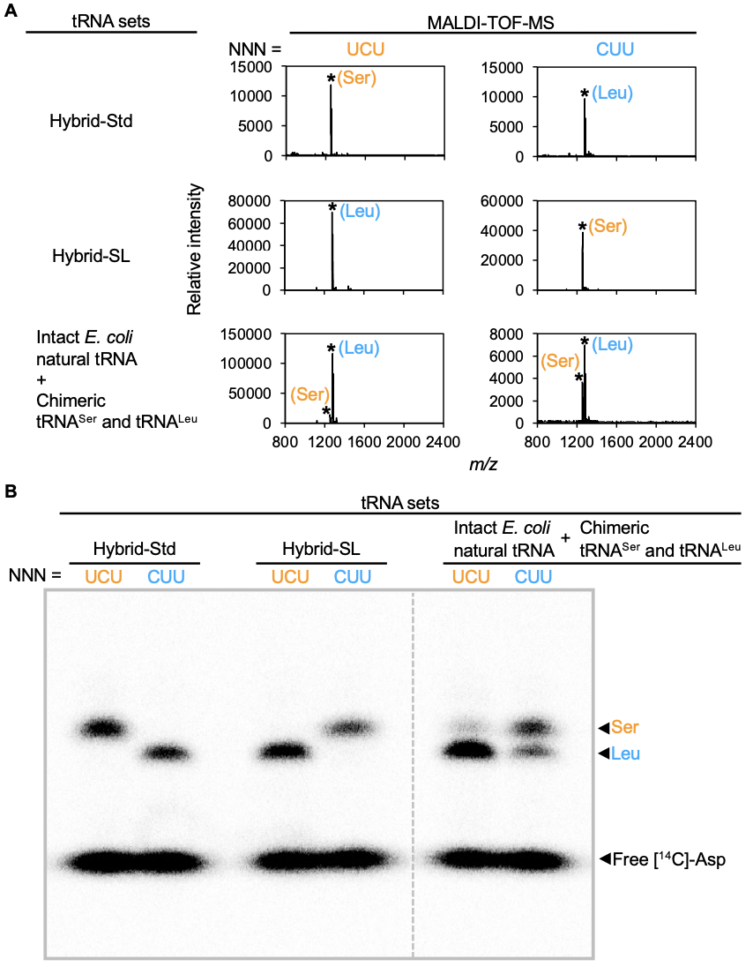

Supplementary Figure 4. Full spectra of the MALDI-TOF-MS analysis (A) and full image of the SDS-PAGE analysis (B) of the model peptides shown in Figure 3.

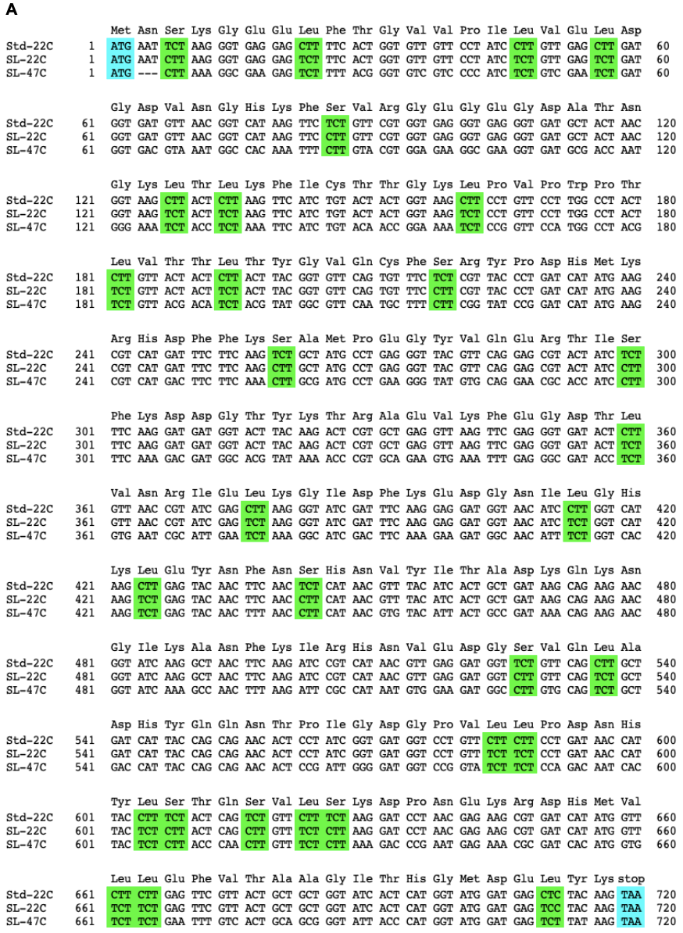
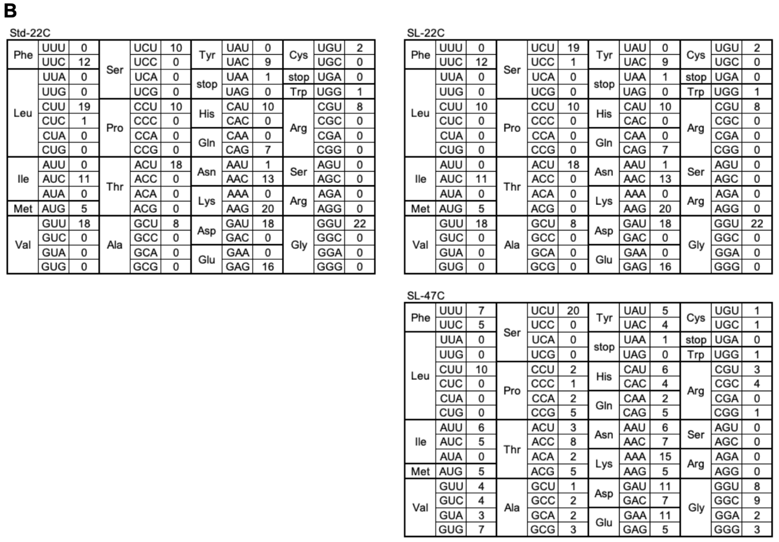

Supplementary Figure 5. Detailed information on the genes coding model protein sfGFP (Std-22C, SL-22C, and SL-47C genes). (A) Amino acid and nucleotide sequences of the sfGFP genes. Start and stop codons are highlighted in blue. Ser and Leu codons are highlighted in green. (B) Codon usages of the three genes.

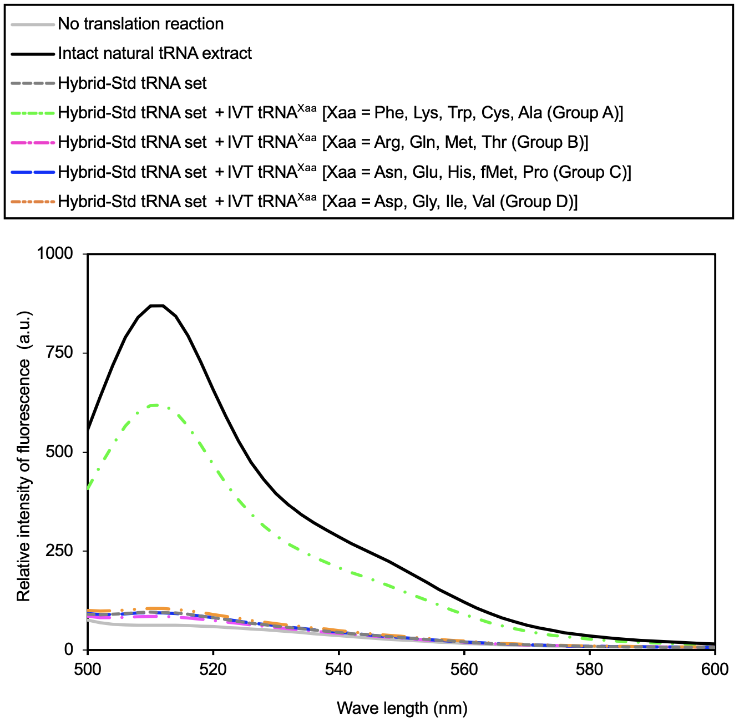

Supplementary Figure 6. Exploration of the additional IVT tRNA groups required for the efficient production of the model protein sfGFP. The IVT initiator tRNA and 17 IVT tRNAs corresponding to 17 out of the 20 natural amino acids (excluding Ser, Leu, and Tyr) were divided into four groups A–D. Each group of tRNAs was added to the cell-free the translation system containing the hybrid-Std tRNA set. sfGFP was translated from the Std-22C_sfGFP gene in the presence of 500 μM Asp. After the reaction, the fluorescent intensity of sfGFP in the translation systems was measured by using a spectrofluorometer (ex = 488 nm, em = 500–600 nm). Abbreviation: IVT, in vitro transcribed; Std, standard.

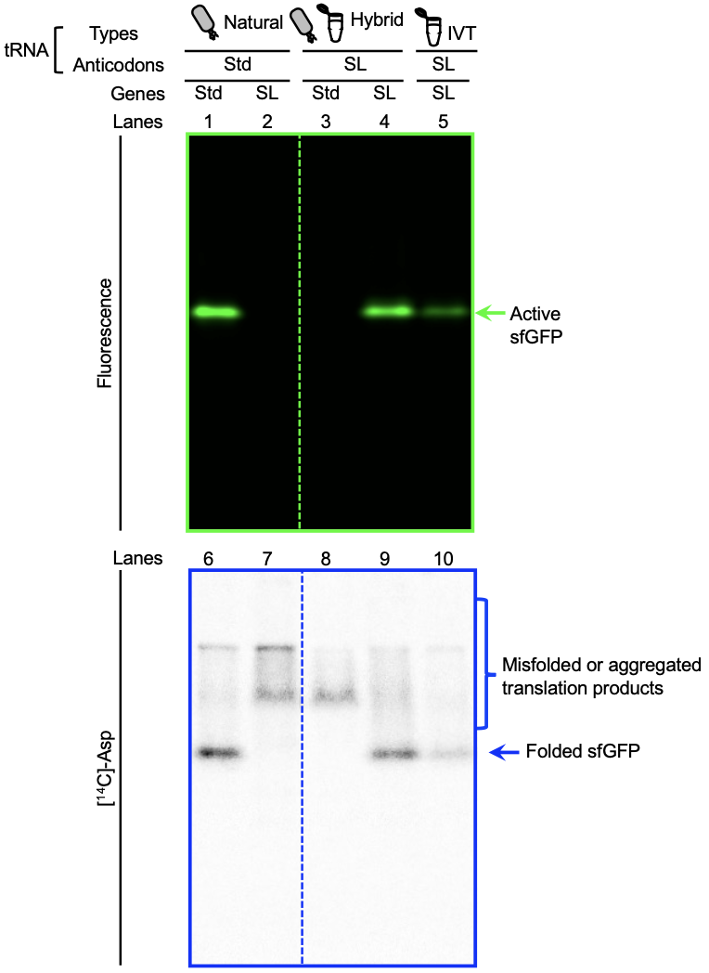

Supplementary Figure 7. Full images of the native PAGE gels shown in Figure 5. Abbreviations: IVT, in vitro transcribed; Std, standard; SL, Ser/Leu-swapped.

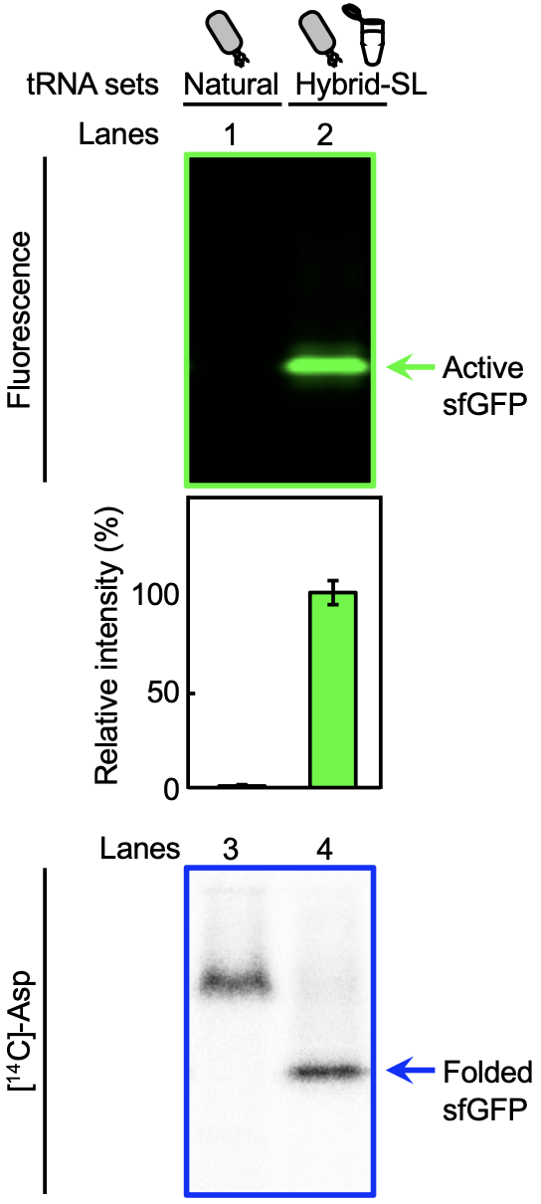

Supplementary Figure 8. Translation of the SL-47C_sfGFP gene using the natural tRNA extract or the hybrid-SL tRNA set. The translation reaction was performed in the presence of 200 μM [¹⁴C]-Asp. The upper panel shows the result of native PAGE followed by the fluorescence imaging of the sfGFP. Relative band intensities were normalized against the intensity of the band observed with the combination of the natural tRNA extract and the Std-22C gene (Figure. 5, lane 1). The bottom panel displays the autoradiography result of the same gel. Error bars represent the standard deviation from the triplicated experiments. Abbreviations: SL, Ser/Leu-swapped.

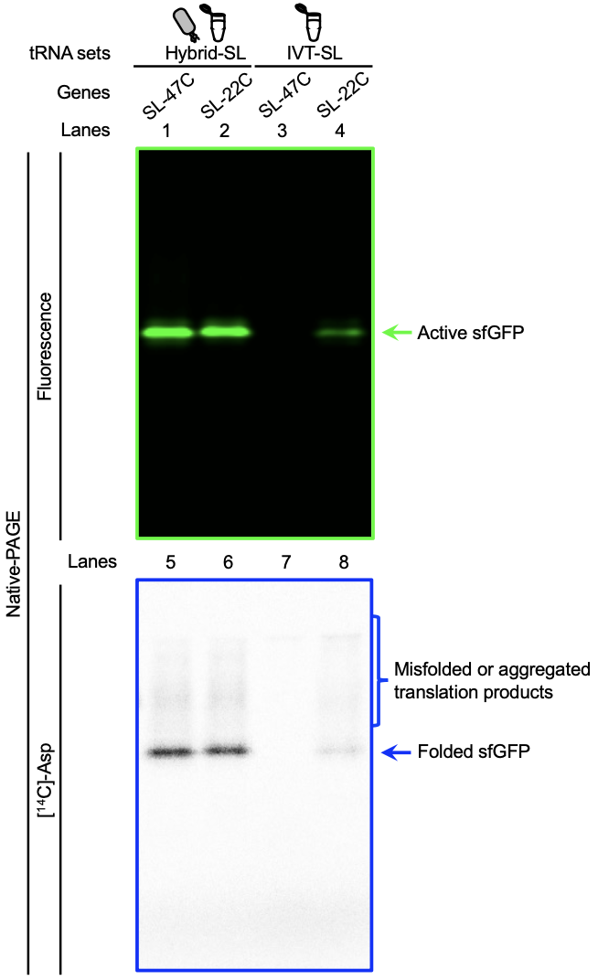

Supplementary Figure 9. Full images of the native PAGE gels shown in Figure 6. Abbreviations: IVT, in vitro transcribed; SL, Ser/Leu-swapped.

Supplementary Table 1. Calculated and observed mass of the model peptides. Abbreviations: Std, standard; SL, Ser/Leu-swapped.

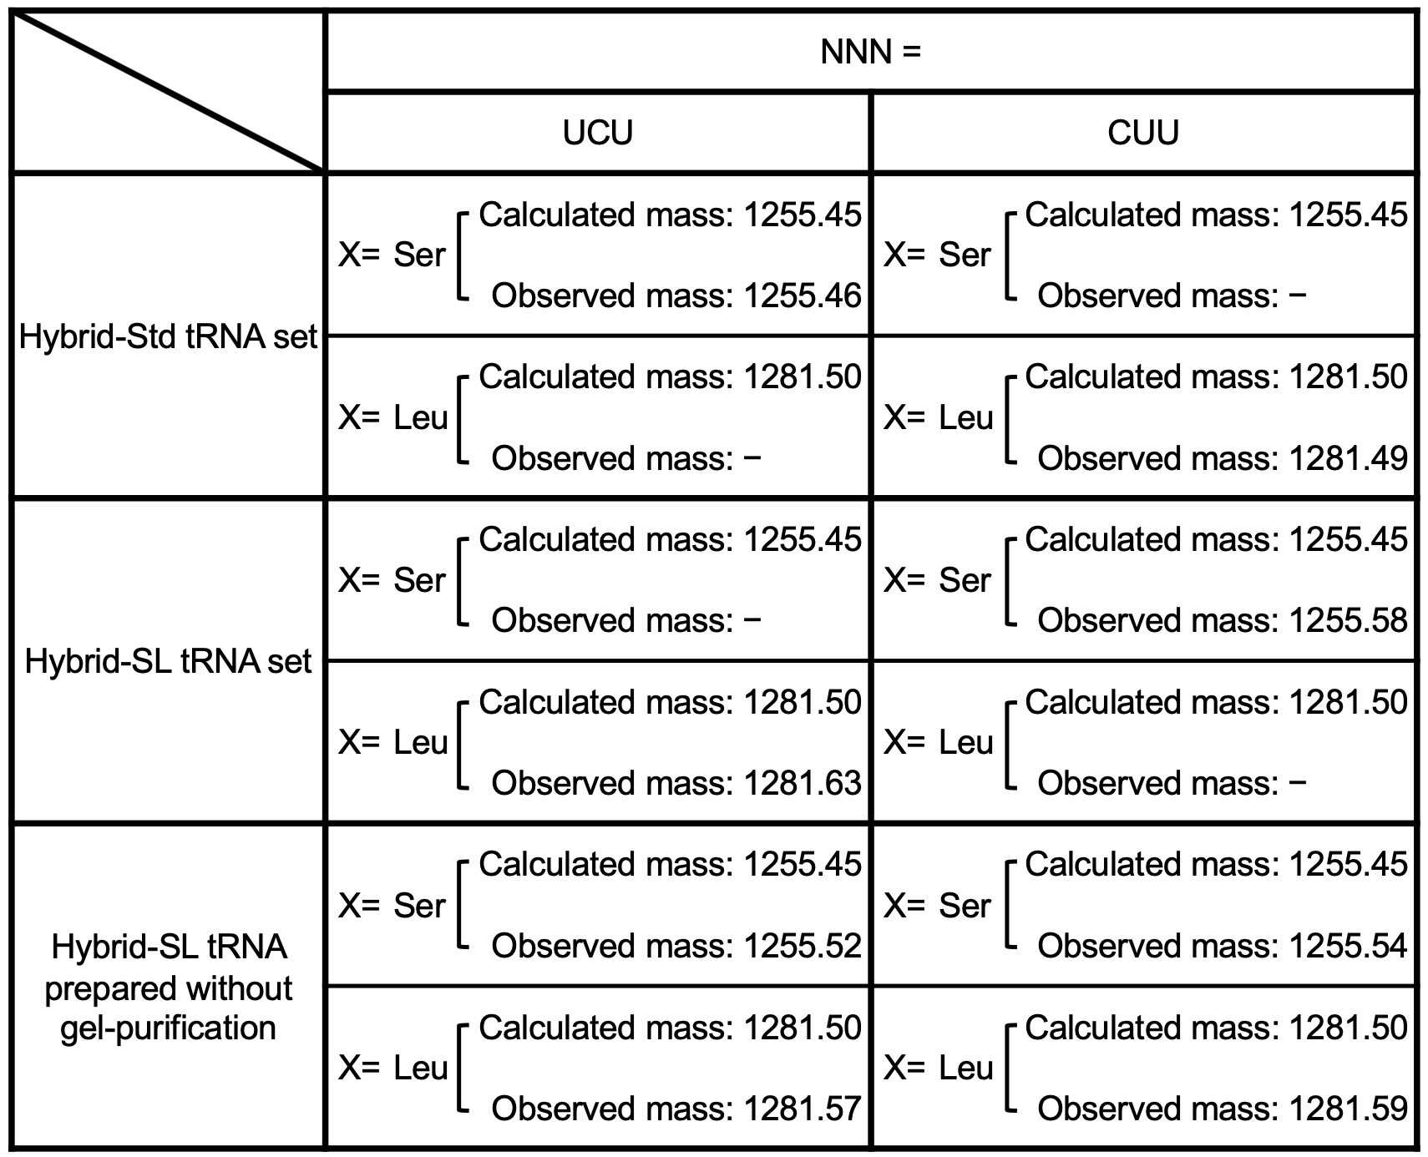

Supplementary Table 2. Calculated and observed masses of the model peptides and the subproducts. Symbols (*, ¶, §, †, ††) in the table correspond to the peak labels in Figures 3, and S3.

