Extended Data
Extended Data Fig. 1. Fire carbon emissions from three fire-vegetation models.

Annual fire total carbon emissions from three fire-vegetation models—(a) CLASSIC, (b) SSiB4/TRIFFID, and (c) JULES-INFERNO—and (d) observation-based reference data GFED4.1s (Global Fire Emissions Database version 4.1) for 1997–2019 and (e) GFAS (CAMS Global Fire Assimilation System) for 2003–2019. Y-axis is annual fire total carbon emissions; Peta (10¹⁵) gram C per year; decadal mean for (a), (b), and (c), and yearly for (d) and (e). Columns in (a)–(c) show two simulation results for the three fire-vegetation models—(1) factual simulation and (2) counterfactual simulation—and (3) the difference between the factual and counterfactual simulations. GFED4.1s data are described in van der Werf et al.⁷⁴; GFAS data were generated using Copernicus Atmosphere Monitoring Service Information [2023]⁷⁵

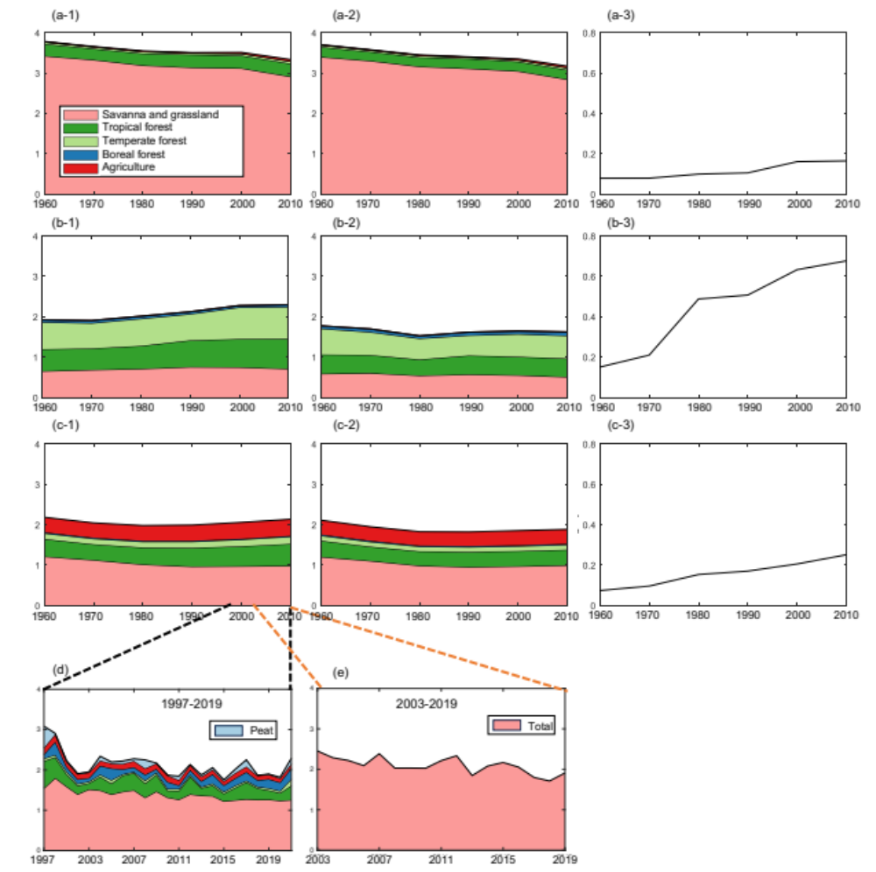

Extended Data Fig. 2. The difference between factual and counterfactual simulations in the 2010s from each model.
The difference is obtained by subtracting the values of the counterfactual simulation from those of the factual simulation by three fire-vegetation models—(a) CLASSIC, (b) SSiB4/TRIFFID, and (c) JULES-INFERNO—. Difference in (1) fire carbon emissions, (2) fire PM_{2.5} concentration, and (3) fire mortality. Positive values (pink) indicate a larger value in factual simulation, while negative values (green) indicate a larger value in counterfactual simulation. Differences exceeding the threshold (0.5 times the standard deviation of differences) are removed (white).

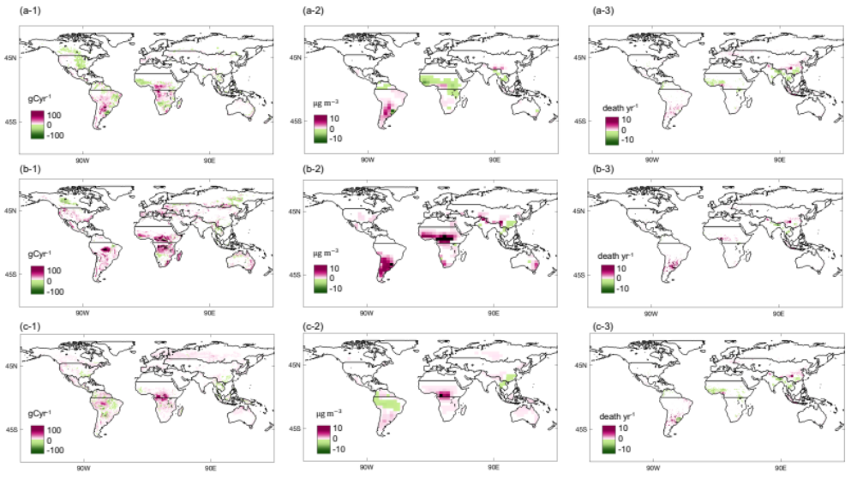
Extended Data Fig. 3. Regional climate change impact on fire mortality.

Difference between fire mortality under counterfactual and factual simulations (Factual – Counterfactual). The bar charts show the mean value of the three fire-model results, and asterisks show each model result (green: LASSIC, orange: SSiB4/TRIFFID, and blue: JULES-INFERNO). BONA, Boreal North America; TENA, Temperate North America; CEAM, Central America; NHSA, Northern Hemisphere South America; SHSA, Southern Hemisphere South America; EURO, Europe; MIDE, Middle East; NHAF, Northern Hemisphere Africa; SHAF, Southern Hemisphere Africa; BOAS, Boreal Asia; CEAS, Central Asia; SEAS, Southeast Asia; EQAS, Equatorial Asia; AUST, Australia and New Zealand.

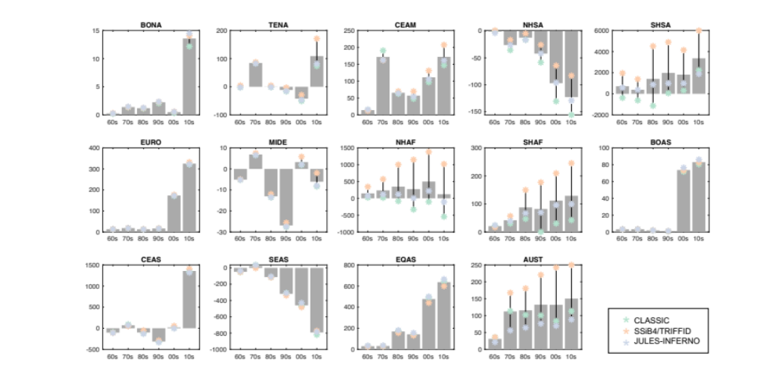

Extended Data Fig. 4. Spatial fire PM_{2.5} and its mortality in 2010s in the factual simulations.

(1) Fire PM_{2.5} and (2) fire mortality simulated by three fire-vegetation models—(a) CLASSIC, (b) SSiB4/TRIFFID, and (c) JULES-INFERNO—.
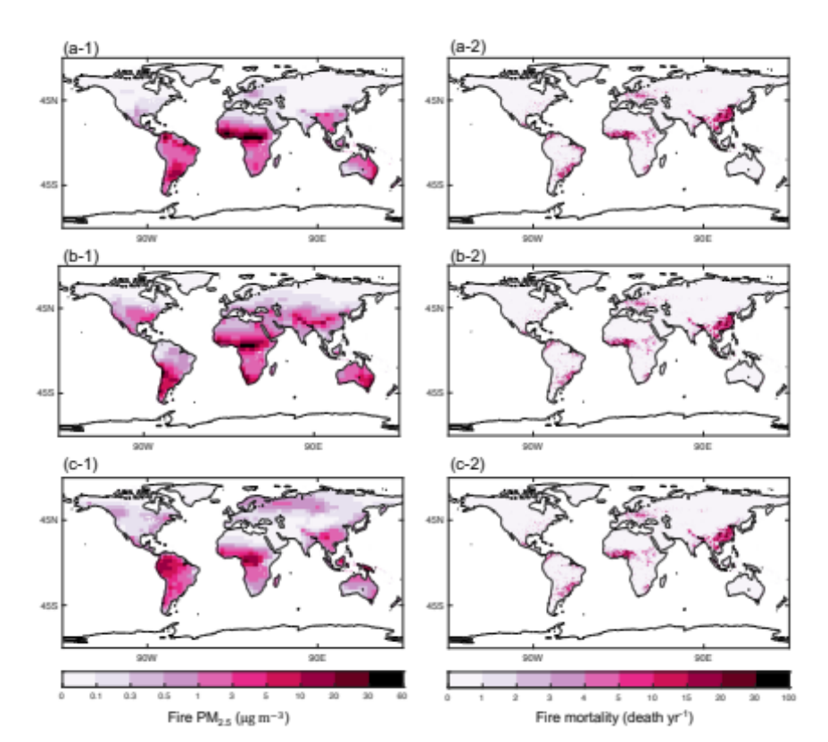
Extended Data Fig. 5. Difference of historical relative humidity between simulations.

We subtracted the relative humidity of the counterfactual simulations from that of the factual simulations (F$-$C). The units for the color bar and y-axes of regional bar plots are percentages. We used monthly relative humidity when the fire activity is highest. We selected one maximum fire month for each of the 14 regions, which represents the majority month in the grid cells within each region. Map in the middle shows the results for the 2010s. The bar plots show temporal changes (x-axis is time, six decades). “Std” is the standard deviation of differences between two simulations. Std/2 becomes a threshold for identifying differences. The data were derived from ISIMIP3a. BONA, Boreal North America; TENA, Temperate North America; CEAM, Central America; NHSA, Northern Hemisphere South America; SHSA, Southern Hemisphere South America; EURO, Europe; MIDE, Middle East; NHAF, Northern Hemisphere Africa; SHAF, Southern Hemisphere Africa; BOAS, Boreal Asia; CEAS, Central Asia; SEAS, Southeast Asia; EQAS, Equatorial Asia; AUST, Australia and New Zealand.

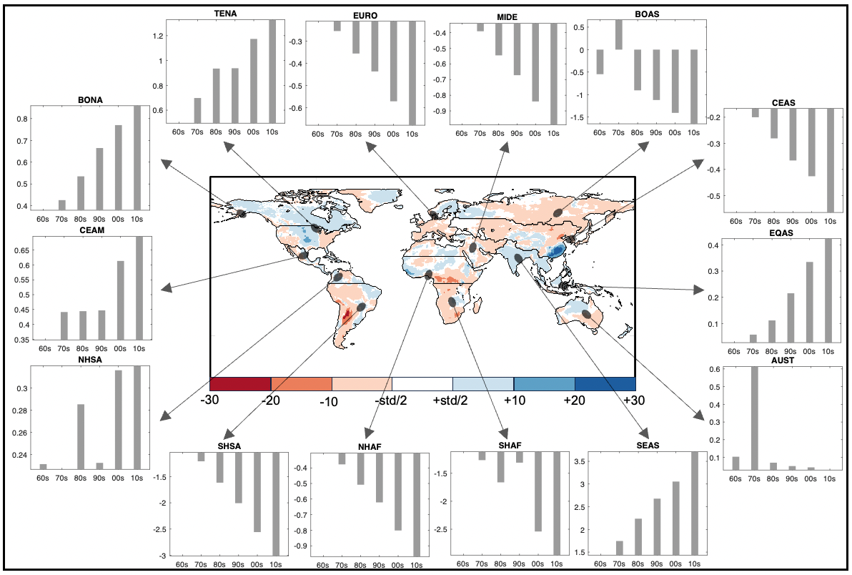

Extended Data Fig. 6. Historical air-temperature difference between simulations.

We subtracted the air temperature of the counterfactual simulations from that of the factual simulations (F$-$C). The units for the color bar and y-axes of regional bar plots are degrees Celsius. We used monthly air temperature when the fire activity is highest. We selected one maximum fire month for each of the 14 regions, which represents the majority month in the grid cells within each region. Map in the middle shows the results for the 2010s. The bar plots show temporal changes (x-axis is time, six decades). “Std” is the standard deviation of differences between two simulations. Std/2 becomes a threshold for identifying differences. The data were derived from ISIMIP3a. BONA, Boreal North America; TENA, Temperate North America; CEAM, Central America; NHSA, Northern Hemisphere South America; SHSA, Southern Hemisphere South America; EURO, Europe; MIDE, Middle East; NHAF, Northern Hemisphere Africa; SHAF, Southern Hemisphere Africa; BOAS, Boreal Asia; CEAS, Central Asia; SEAS, Southeast Asia; EQAS, Equatorial Asia; AUST, Australia and New Zealand.

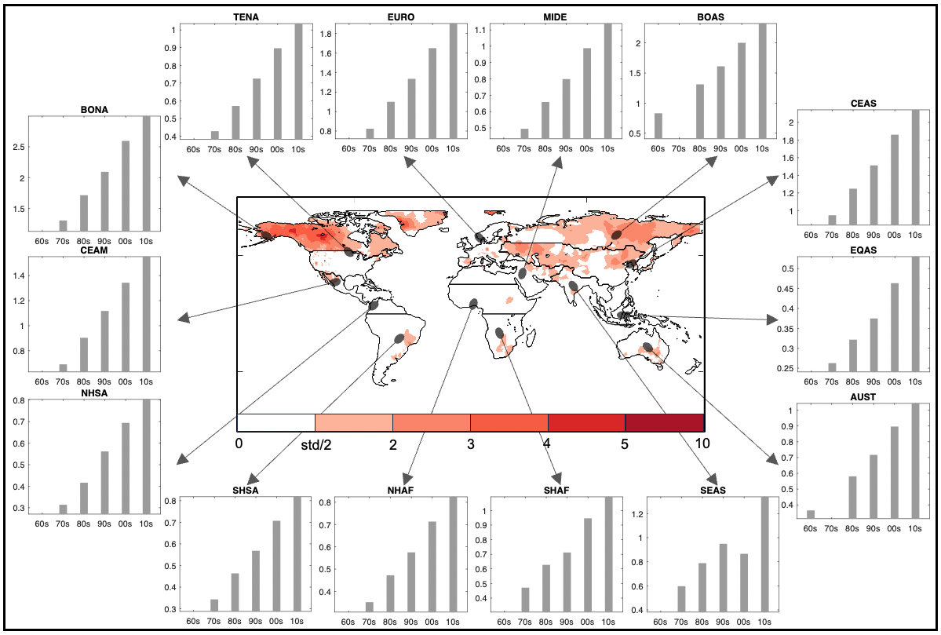

Extended Data Fig. 7. Relationship between fire emissions and relative humidity.

(a) The relation between annual fire carbon emissions and relative humidity of the peak fire month. (b) The relation between annual fire carbon emissions by land type and relative humidity of the peak fire month. We used six decadal means during 1960s–2010s (n=6 time $×$ 259,000 grid points). We partition relative humidity into 100 bins (with over same values), and average values in each bin and plotted. Black circles indicate the average in bin with sample size>15. Fire emissions from areas where the relative humidity is above 55% show a decreasing trend. However, JULES-INFERNO showed a steep increase fire occurrence over 80% of relative humidity. This fire occurred in equatorial Asian tropical forests where have high relative humidity. This is because the model assumes that fuel combustibility gradually decreases until the humidity reaches 90%.

