Supplementary information

Table of contents
Supplementary Notes 1-3
Supplementary Figs. 1-8
Supplementary Table 1-2

Supplementary Note 1. Conversion of ISIMIP3a into GEOS-Chem input

We followed GFED GEOS-Chem input format, that is dry matter emissions by five land types: SAVA (grassland and shrubland), AGRI (agricultural areas), TEMF (temperate forests), DEFO (tropical forests), and BORF (boreal forests). For JULES-INFERNO and SSiB4-TRIFFID, we converted burned area (BA) into fire carbon emissions ($ffire$) first, and then we divided them into five land types. As the CLASSIC outcome includes fire carbon emissions by plant functional type (PFT) ($ffire_{PFT}$), we converted $ffire_{PFT}$ into $DM_{type}$ by designating PFT into five land types. The outcome formats of SSiB4/TRIFFID and JULES-INFERNO were burned area by PFT (${BA}_{PFT}$), and we converted ${BA}_{PFT}$ into $ffire_{PFT}$ and designating PFT as the five land types.
To convert $BA$ into $ffire$, we used the biomass and soil moisture of each model (ISIMIP3a) to calculate fuel consumption and combustion completeness (CC). The CC was scaled linearly by using a soil moisture index. The 15th and 85th percentiles of the soil moisture index corresponded with the minimum and maximum CC values. The minimum values of CC for leaf, stem, fine litter, and woody litter were 0.8, 0.2, 0.9, and 0.5, respectively, and maximum values were 1, 0.3, 1, and 0.6¹. The soil moisture index was calculated by soil moisture and soil type with MARS compute script (https://www.ecmwf.int/en/forecasts/documentation-and-support/evolution-ifs/cycles/change-soil-hydrology-scheme-ifs-cycle#implications). Biomass and soil moisture, the inputs of $ffire$ calculation, were taken from each model (e.g., TRIFFID, INFERNO) in ISIMIP3a and calculated with two simulations (i.e., observation and counterfactual).
We redistributed $ffire$ by plant functional type (PFT) into five land types. Each forest PFT was divided into tropical forests, temperate forest, and boreal forest based on the temperature of the coldest month ($T_{c}$) and growing-degree days above 5$℃$ (GDD)². For broadleaf PFT, areas with $T_{c}$ lower than 15.5°C became DEFO, areas with $T_{c}$ less than –15°C and GDD less than 1200 days became BORF, and others become TEMF. For needleleaf PFT, areas with $T_{c}$ less than –19°C and GDD less than 1200 days became BORF, and others became TEMF. $T_{c}$ and GDD were calculated with observed and counterfactual daily air temperature from ISIMIP3a. Grasslands and shrubland PFTs became SAVA. For JULES-INFERNO, cropland and pastureland become AGRI, whereas SSiB4/TRIFFID do not consider agricultural fire. Three models do not include peat fires.

Supplementary Note 2. Validation of fire-vegetation models and GEOS-Chem results.

We used three global fire-vegetation models (CLASSIC, SSiB4/TRIFFID, and JULES-INFERNO) to calculate the gas and aerosol emissions from fires between 1960 and 2019. We presented carbon emissions as a representative component, as other emissions are calculated using emission factors derived from carbon emissions³². The decadal average yearly carbon emissions from the three fire-vegetation models in the 2010s were 3.3, 2.1, and 2.3 peta-gram per year for CLASSIC, SSiB4/TRIFFID, and JULES-INFERNO, respectively which is slightly higher than the 2.0 peta-gram per year from a benchmark dataset (Extended Data Fig. 1). The normalized mean error (NME) in annual average scored 1.03 for CLASSIC, 0.88 for SSiB4/TRIFFID, and 0.81 for JULES-INFERNO indicating that all three models are at the better end of previous benchmarking studies where the NME of similar fire-vegetation models ranged from 0.9–1.6³³ and from 0.6–1.1³⁴.
We compared GEOS-Chem results (surface yearly mean PM_{2.5} concentration) with Global Burden Disease (GBD) datasets. GBD 2019 provides PM2.5 exposure gridded annual mean estimates from 1990 to 2019. We chose 1995, 2005, and 2015 as reference years that were matched with our study period. Supplementary Fig. 1 shows that linear regression models from our estimation had R-squared values of 0.68–0.74 and 0.44–9.53 % normalized mean bias (NMB, ${\sum{(B_{i}-A_{i})}}/{\sum{A_{i}}}×100)$. The implication is that the GEOS-Chem results could generate reasonable global PM_{2.5} concentration.
We compared our PM2.5 estimation and GBD 2019 data only for regions with greater fire proportion (over 30%) to identify whether GEOS-Chem generated reasonable fire attributed PM2.5. When we simulated PM2.5 without fire emissions, NMB was 62%, 54%, and 57% for 1995, 2005, and 2015, respectively (Supplementary Fig. 2). When we simulated PM2.5 with fire emissions from CLASSIC, SSiB4/TRIFFID, and JULES-INFERNO, NMB decreased to 33–36%, 19–23%, and 24–26% for 1995, 2005, and 2015, respectively. Areas where the ratio of fire to total PM_{2.5} concentration is greater than 30% are mainly found in South America, central and southern Africa, and eastern Australia. The PM_{2.5} concentration of those areas could not be calculated with high accuracy without fire consideration. This implies that our model setup captures well the events with strongly-fire induced PM_{2.5} concentrations.
The total PM_{2.5} exposure led to a model-averaged of 1.22 (1.21, 1.23, 1.20, model respectively) million annual deaths in 1960s and 3.33 (3.12, 3.36, 3.32, model respectively) million annual deaths in 2010s, which amount was similar to the previous Global Burden Disease (GBD) 2019 results (3.62 million annual deaths in 2010s) (Supplementary Table 1).

Supplementary Note 3. Historical fire impacts.
When we extracted the impact of fire, the population-weighted concentration (PWC) of annual fire PM_{2.5} was 1.4 (1,4, 1,8, 0.9, model respectively) $μ$g m-3 for the last 60 years with a slightly increasing trend (Fig. 1a). Compared with the global PWC of total PM_{2.5}, fire accounted for 3.8–5.2% of PM_{2.5} concentration. The historical fire PM_{2.5} exposure led to 31,934 (36,824, 30,222, 28,757, model respectively) deaths in 1960s and 75,870 (80,806, 75,967, 70,836, model respectively) annual deaths in 2010s (Fig. 1b). The fire mortality varied with region and followed different temporal trends. A large proportion (65%) of the annual deaths from fire PM_{2.5} in the 2010s occurred in Central Asia (CEAS, 17,650 [17,560, 17,724, 17,665, model respectively] deaths), Northern Hemisphere Africa (NHAF, 15,013 [16,101, 15,274, 13,663] deaths), and Southern Hemisphere South America (SHSA, 15,990 [19,336, 15,654, 12,979] deaths) (Fig. 2b). Southeast Asia (SEAS) and Equatorial Asia (EQAS) had the next highest fire mortality; 7,721 (7,782, 7,655, 7,727) and 3,779 (3,787, 3,679, 3,872), respectively, in the 2010s (Fig. 2b). Although NHAF had the highest PWC of fire PM_{2.5} (e.g., 6.6 [9.6, 7.3, 2.9] $μ$g m-3 in 2010s), the fire mortality in CEAS was the highest because of the regions’ high population density.
Northern hemisphere of Africa (NHAF) fires occur in savanna-dominated regions³, and many are ignited by humans to manage land for cultivation and grazing. The number of human-induced fires in the savanna has increased along with the increase in human population despite more intensively managed landscapes reducing fuel connectivity and fire spread⁴. Therefore, fire PM_{2.5} in NHAF has remained high for the past 60 years (6.6–8.1 $μ$g m⁻³), and fire mortality has increased with population growth (from 8,371 to 15,013 deaths).
Central Asia (CEAS) fire emissions result primarily from agricultural fires, also known as crop residue burning^{5,6}. Fire impacts in CEAS increased until the 1980s (1.0 $μ$g m⁻³, 17,650 annual deaths) and subsequently decreased alongside changes in land management. The natural vegetation has been decreasing along with increasing while agricultural land has been increasing, which decreased total fires. Given these complex interactions, timeseries of the different fire-vegetation model shows a high inter-model variance. SSiB4/TRIFFID, which does not simulate agricultural fires, simulated decreasing fire emissions in China due to increasing population and decreasing natural vegetation areas. On the other hand, JULES-INFERNO, which includes agricultural fires, simulated increasing fire emissions especially in Southwest China (Supplementary Fig. 3).
Southern hemisphere of South American (SHSA) fires include forest, savanna, and agricultural fires. Tropical forest fires are primarily driven by deforestation, and savannas and evergreen forests fires are sensitive to drought⁷. The SHSA fire PM_{2.5} shows a slight decreasing trend (Supplementary Fig. 4) through an overall decrease in fire activity following an increase in population density. However, the fire-vegetation models showed high agreement for increasing fire activity in the Brazilian Cerrado and the southern edges of Amazon (Supplementary Fig. 3), which is consistent with previous analyses of long-term trends of fires in South America⁷. Especially, Amazonian deforestation fires from slash-and-burn practices increased in the 1990s^{8,9}, but decreased in the 2000s to gain traction again in the 2010s⁷. These fires resulted in a large increase in SHSA fire mortality during the 1990s and 2010s (12,656 and 15,990 annual deaths, respectively) and slight decrease in the 2000s (10,486 annual deaths).
Southeast Asia (SEAS) maintained a high PWC of fire PM_{2.5} at 1 $μ$g m⁻³ in the past six decades (Extended Data Fig. 3). Previous studies detected varied temporal trends by country in SEAS during 2003–2016; India, Cambodia, and Vietnam showed an increasing trend, whereas Timor Leste showed a decreasing trend¹⁰. Furthermore, our results showed varied trends with regions, increasing only in India and under JULES-INFERNO model (Extended Data Fig. 2). In Equatorial Asia (EQAS), peatland drainage and deforestation caused large-scale fires¹¹. Some studies have highlighted the impact of El Niño on EQAS fires because it contributes to severe droughts, particularly in Indonesia^{3,11–13}. There were frequent El Niño events in the 2000s (i.e., 2002, 2004, and 2009)¹⁰ and the 2010s (i.e., 2015)¹², which might have resulted in high fire PM_{2.5} and health impacts.
Supplementary Fig. 1. Validation of PM_{2.5} concentration.
(a) Global Burden Disease (GBD) annual PM_{2.5} concentration in 2015. (b) Estimated PM_{2.5} concentration in 2015 (with CLASSIC 2010s fire emissions). (c–e) Correlation between the estimation (with CLASSIC, SSiB4/TRIFFID, JULES-INFERNO fire-vegetation models) and GBD data at a resolution of 4° × 5° in 1995, 2005, and 2015.
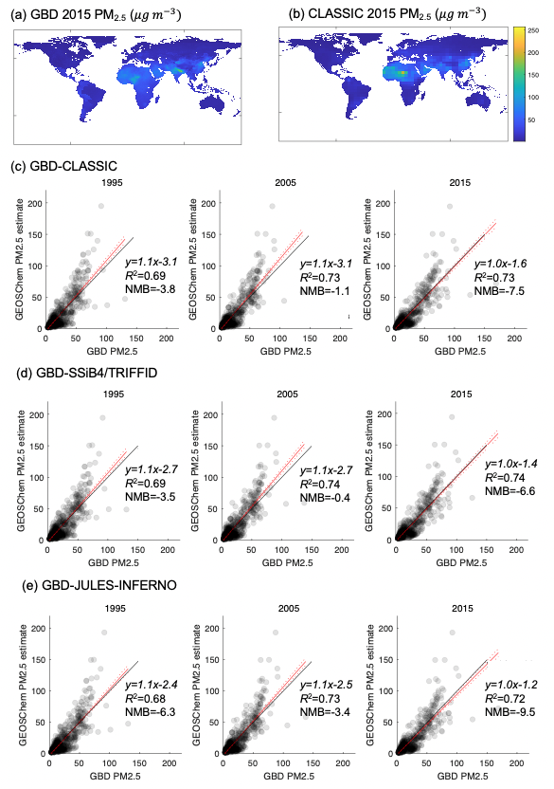

Supplementary Fig. 2. Validation of PM_{2.5} concentration for areas with >30% fire proportion.
(a) Areas with >30% fire proportion based on the mean PM_{2.5} without fire and PM2.5 with fire of three models. (c–e) Correlation between the estimation ((b) without fire, (c) with fire from CLASSIC, (d) SSiB4/TRIFFID, and (e) JULES-INFERNO) and GBD data at a resolution of 4° × 5° in 1995, 2005, and 2015.
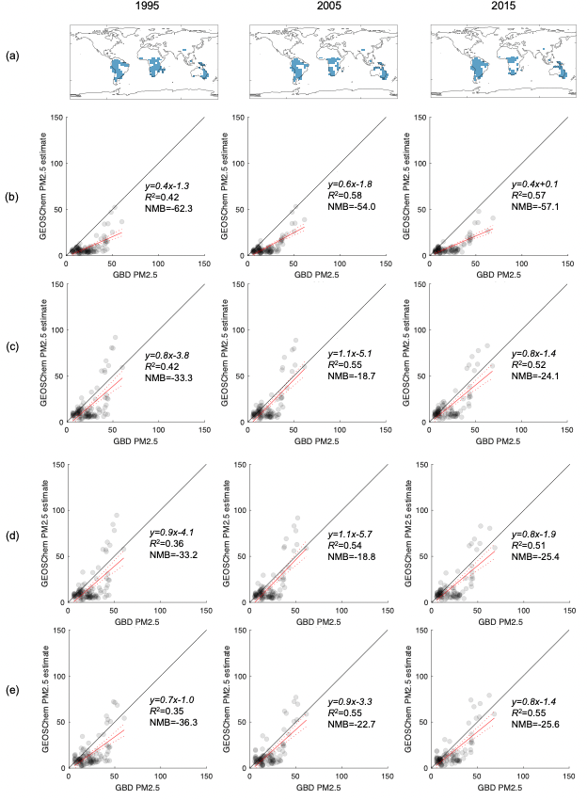

Supplementary Fig. 3. Spatial distribution of temporal changes in fire carbon emissions in the factual simulation.

We chose carbon as a representative emission gas. Colors indicate the slope of the linear regression of fire carbon emissions over time from the historical period (n = 6) with grids masked out where the Mann-Kendell test returned a p-value >0.05. Darker pink indicates that fire C emissions in the grid increased steeply. Darker green indicates that fire C emissions in the grid decreased steeply.

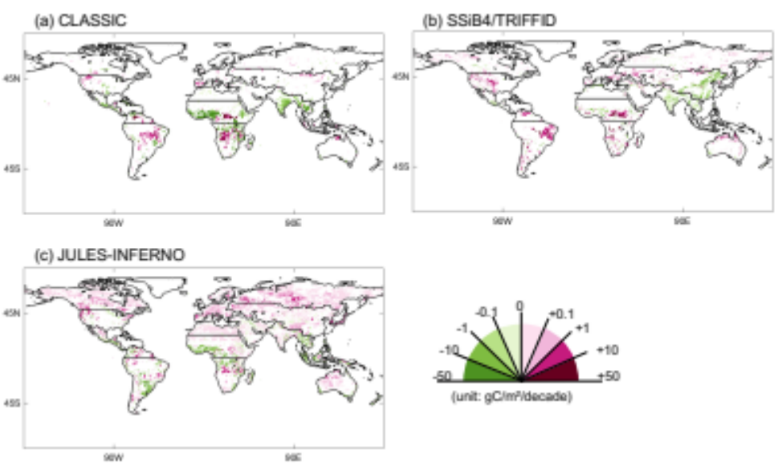
Supplementary Fig. 4. Regional population weighted concentration of fire PM_{2.5}.

Regional population weighted concentration of fire PM_{2.5} ($μ{ m}^{-3}$) under two simulations. Darker color indicates factual simulation, and lighter color indicates counterfactual simulation; bar chart shows the mean value of three fire-vegetation models, and asterisks show each model result (green: CLASSIC, orange: SSiB4/TRIFFID, and blue: JULES-INFERNO). BONA, Boreal North America; TENA, Temperate North America; CEAM, Central America; NHSA, Northern Hemisphere South America; SHSA, Southern Hemisphere South America; EURO, Europe; MIDE, Middle East; NHAF, Northern Hemisphere Africa; SHAF, Southern Hemisphere Africa; BOAS, Boreal Asia; CEAS, Central Asia; SEAS, Southeast Asia; EQAS, Equatorial Asia; AUST, Australia and New Zealand.

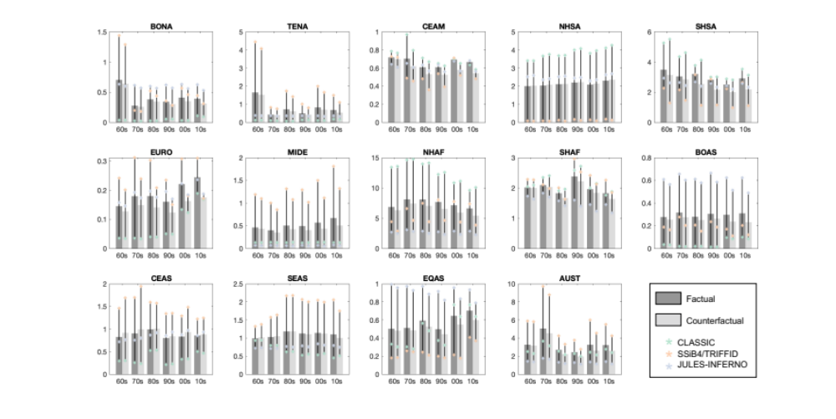

Supplementary Fig. 5. Fire mechanism of fire-vegetation model: CLASSIC.
We generated the fire mechanism diagram in the model based on Arora and Boer¹⁴.
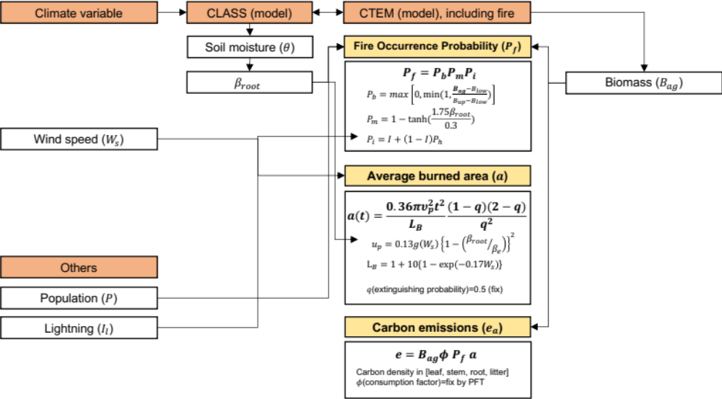

Supplementary Fig. 6. Fire mechanism of fire-vegetation model: SSiB4/TRIFFID.
We generated the fire mechanism diagram in the model based on Huang et al.¹⁵
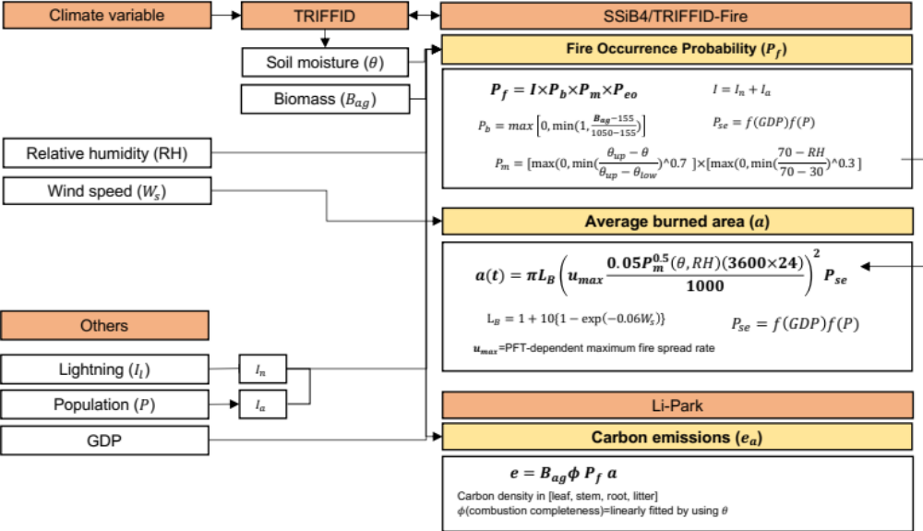
Supplementary Fig. 7. Fire mechanism of fire-vegetation model: JULES-INFERNO.
We generated the fire mechanism diagram in the model based on Mangeon et al.¹⁶
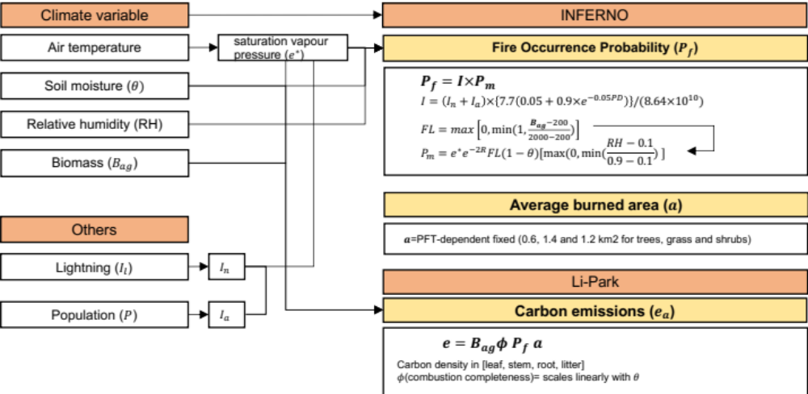

Supplementary Fig. 8. Terrestrial land biome map

Biome map from Olson et al.¹⁷ to show the global vegetation type.
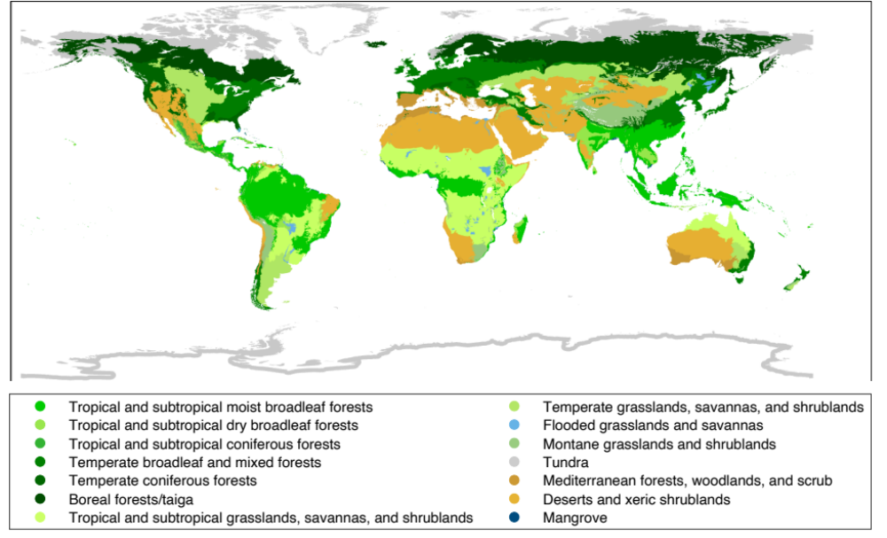

Supplementary Table 1. Global PM_{2.5} mortality benchmarking with GBD2019 results

We evaluated the health impact model by comparing global total mortality with GBD 2019 results (from six diseases; chronic obstructive pulmonary disease, lung cancer, ischemic heart disease, type II diabetes, stroke, and lower respiratory infection¹⁸. We calculated decadal mean values. GBD 2019 results are available from 1990-year. Unit is million annual deaths. The model results used fixed baseline mortality rate for 1960s–1980s. Lower” and “Upper” refer to the lower and upper bounds of the 95% uncertainty interval.
 | Model |  |  | GBD 2019
 | Value | lower | upper | value | lower | upper
1960s  (1960-1969) | 1.22 | 0.93 | 1.49 | - | - | -
1970s  (1970-1979) | 1.72 | 1.33 | 2.07 | - | - | -
1980s  (1980-1989) | 2.31 | 1.81 | 2.76 | - | - | -
1990s  (1990-1999) | 2.89 | 2.27 | 3.47 | 2.16 | 1.51 | 2.90
2000s  (2000-2009) | 3.18 | 2.52 | 3.80 | 2.77 | 2.08 | 3.50
2010s  (2010-2019) | 3.33 | 2.64 | 3.97 | 3.62 | 2.86 | 4.39

Supplementary Table 2. Global fire mortality sensitivity test from two types of baseline mortality rate (BM) data.

“BM fix” assumes that background disease rates remain constant at 1990s levels. “BM int” (integrated) assumes that the BM between the 1960s and 1980s follows the same trend of 1990s–2000s. “Lower” and “Upper” refer to the lower and upper bounds of the 95% uncertainty interval from the meta-regression-Bayesian regularized trimmed splines derived from the 2019 GBD study.
Factual simulation
 |  | BM fix |  |  | BM int
 |  | Mean | Lower | Upper | Mean | Lower | Upper
CLASSIC | 1960s | 36823 | 27990 | 45482 | 88238 | 64754 | 112665
CLASSIC | 1970s | 43789 | 33460 | 53865 | 71924 | 54224 | 89669
CLASSIC | 1980s | 57469 | 44160 | 70465 | 71343 | 54508 | 87999
CLASSIC | 1990s | 58651 | 44708 | 72440 | 58651 | 44708 | 72440
CLASSIC | 2000s | 68176 | 52042 | 83991 | 68176 | 52042 | 83991
CLASSIC | 2010s | 80806 | 61513 | 99539 | 80806 | 61513 | 99539
SSiB4/ TRIFFID | 1960s | 30222 | 22730 | 37816 | 74531 | 53827 | 96748
SSiB4/ TRIFFID | 1970s | 35630 | 26947 | 44433 | 59097 | 43992 | 74852
SSiB4/ TRIFFID | 1980s | 51484 | 39466 | 63418 | 63953 | 48720 | 79288
SSiB4/ TRIFFID | 1990s | 53673 | 40817 | 66551 | 53673 | 40817 | 66551
SSiB4/ TRIFFID | 2000s | 62706 | 47833 | 77462 | 62706 | 47833 | 77462
SSiB4/ TRIFFID | 2010s | 75967 | 57723 | 93922 | 75967 | 57723 | 93922
JULES-INFERNO | 1960s | 28757 | 21614 | 36059 | 70880 | 51077 | 92373
JULES-INFERNO | 1970s | 33743 | 25447 | 42218 | 55530 | 41159 | 70689
JULES-INFERNO | 1980s | 47588 | 36413 | 58798 | 58930 | 44795 | 73324
JULES-INFERNO | 1990s | 48454 | 36799 | 60258 | 48454 | 36799 | 60258
JULES-INFERNO | 2000s | 58491 | 44616 | 72315 | 58491 | 44616 | 72315
JULES-INFERNO | 2010s | 70837 | 53837 | 87650 | 70837 | 53837 | 87650
Model mean | 1960s | 31934 | 24111 | 39786 | 77883 | 56553 | 100595
Model mean | 1970s | 37721 | 28618 | 46839 | 62184 | 46458 | 78403
Model mean | 1980s | 52180 | 40013 | 64227 | 64742 | 49341 | 80204
Model mean | 1990s | 53593 | 40775 | 66416 | 53593 | 40775 | 66416
Model mean | 2000s | 63124 | 48164 | 77923 | 63124 | 48164 | 77923
Model mean | 2010s | 75870 | 57691 | 93704 | 75870 | 57691 | 93704
Counterfactual simulation
 |  | BM fix |  |  | BM int
 |  | Mean | Lower | Upper | Mean | Lower | Upper
CLASSIC | 1960s | 37222 | 28385 | 45842 | 89468 | 65902 | 113870
CLASSIC | 1970s | 43827 | 33618 | 53729 | 72118 | 54598 | 89570
CLASSIC | 1980s | 58557 | 45168 | 71522 | 72791 | 55851 | 89394
CLASSIC | 1990s | 59355 | 45434 | 73031 | 59355 | 45434 | 73031
CLASSIC | 2000s | 67661 | 51843 | 83089 | 67661 | 51843 | 83089
CLASSIC | 2010s | 77326 | 59103 | 95006 | 77326 | 59103 | 95006
SSiB4/ TRIFFID | 1960s | 27969 | 21094 | 34994 | 69740 | 50379 | 90701
SSiB4/ TRIFFID | 1970s | 33102 | 25114 | 41238 | 55042 | 41073 | 69685
SSiB4/ TRIFFID | 1980s | 45573 | 35088 | 56102 | 56468 | 43202 | 69980
SSiB4/ TRIFFID | 1990s | 47688 | 36459 | 59059 | 47688 | 36459 | 59059
SSiB4/ TRIFFID | 2000s | 56417 | 43293 | 69473 | 56417 | 43293 | 69473
SSiB4/ TRIFFID | 2010s | 66507 | 50802 | 82050 | 66507 | 50802 | 82050
JULES | 1960s | 28154 | 21192 | 35285 | 69790 | 50323 | 90957
JULES | 1970s | 32767 | 24782 | 40921 | 54040 | 40162 | 68669
JULES | 1980s | 46472 | 35643 | 57341 | 57548 | 43852 | 71501
JULES | 1990s | 47804 | 36445 | 59289 | 47804 | 36445 | 59289
JULES | 2000s | 56834 | 43504 | 70091 | 56834 | 43504 | 70091
JULES | 2010s | 67153 | 51240 | 82863 | 67153 | 51240 | 82863
Model mean | 1960s | 31115 | 23557 | 38707 | 76333 | 55535 | 98509
Model mean | 1970s | 36565 | 27838 | 45296 | 60400 | 45278 | 75975
Model mean | 1980s | 50201 | 38633 | 61655 | 62269 | 47635 | 76958
Model mean | 1990s | 51616 | 39446 | 63793 | 51616 | 39446 | 63793
Model mean | 2000s | 60304 | 46213 | 74218 | 60304 | 46213 | 74218
Model mean | 2010s | 70329 | 53715 | 86640 | 70329 | 53715 | 86640
References
1. Park, C. Y. et al. Impact of climate and socioeconomic changes on fire carbon emissions in the future: Sustainable economic development might decrease future emissions. Global Environmental Change 80, 102667 (2023).
2. Bonan, G. B., Levis, S., Kergoat, L. & Oleson, K. W. Landscapes as patches of plant functional types: An integrating concept for climate and ecosystem models. Global Biogeochem Cycles 16, 5-1-5–23 (2002).
3. van der Werf, G. R. et al. Global fire emissions and the contribution of deforestation, savanna, forest, agricultural, and peat fires (1997-2009). Atmos Chem Phys 10, 11707–11735 (2010).
4. Archibald, S. Managing the human component of fire regimes: Lessons from Africa. Philosophical Transactions of the Royal Society B: Biological Sciences 371, (2016).
5. Yin, H. et al. Monitoring fire regimes and assessing their driving factors in Central Asia. J Arid Land 13, 500–515 (2021).
6. Zha, S. et al. Agricultural fires and their potential impacts on regional air quality over China. Aerosol Air Qual Res 13, 992–1001 (2013).
7. Chen, Y. et al. Long-term trends and interannual variability of forest, savanna and agricultural fires in South America. Carbon Manag 4, 617–638 (2013).
8. van Marle, M. J. E. et al. Fire and deforestation dynamics in Amazonia (1973-2014). Global Biogeochem Cycles 31, 24–38 (2017).
9. Nawaz, M. O. & Henze, D. K. Premature Deaths in Brazil Associated With Long-Term Exposure to PM2.5 From Amazon Fires Between 2016 and 2019. Geohealth 4, (2020).
10. Vadrevu, K. P. et al. Trends in Vegetation fires in South and Southeast Asian Countries. Sci Rep 9, 1–13 (2019).
11. van der Werf, G. R. et al. Climate regulation of fire emissions and deforestation in equatorial Asia. Proc Natl Acad Sci U S A 105, 20350–20355 (2008).
12. Shiogama, H. et al. Historical and future anthropogenic warming effects on droughts, fires and fire emissions of CO2 and PM2.5 in equatorial Asia when 2015-like El Niño events occur. Earth System Dynamics 11, 435–445 (2020).
13. Crippa, P. et al. Population exposure to hazardous air quality due to the 2015 fires in Equatorial Asia. Sci Rep 6, 1–9 (2016).
14. Arora, V. K. & Boer, G. J. Fire as an interactive component of dynamic vegetation models. J Geophys Res Biogeosci 110, (2005).
15. Huang, H., Xue, Y., Li, F. & Liu, Y. Modeling long-term fire impact on ecosystem characteristics and surface energy using a process-based vegetation-fire model SSiB4/TRIFFID-Fire v1.0. Geosci Model Dev 13, 6029–6050 (2020).
16. Mangeon, S. et al. INFERNO: A fire and emissions scheme for the UK Met Office’s Unified Model. Geosci Model Dev 9, 2685–2700 (2016).
17. Olson, D. M. et al. Terrestrial ecoregions of the world: a new map of life on Earth. Bioscience 51, 933–938 (2001).
18. Global Burden of Disease Collaborative Network. Global Burden of Disease Study 2019 (GBD 2019) Results. Seattle, United States of America: Institute for Health Metrics and Evaluation (IHME). http://ghdx.healthdata.org/gbd-results-tool (2020).

