Vibration-enabled mobility of liquid metal
Stephan Handschuh-Wang,^{1,*,#} Tiansheng Gan,^{2, #} Tao Wang,³ Bin He,¹ Peigang Han,¹ Florian J. Stadler,⁴ Xuechang Zhou²
¹ College of New Materials and New Energies, Shenzhen Technology University, Shenzhen 518118, China
² College of Chemistry and Environmental Engineering, Shenzhen University, Shenzhen 518060, China
³ Advanced Energy Storage Technology Center, Shenzhen Institutes of Advanced Technology, Chinese Academy of Sciences, Shenzhen 518055, China
⁴ College of Materials Science and Engineering, Shenzhen University, Shenzhen 518055, People’s Republic of China

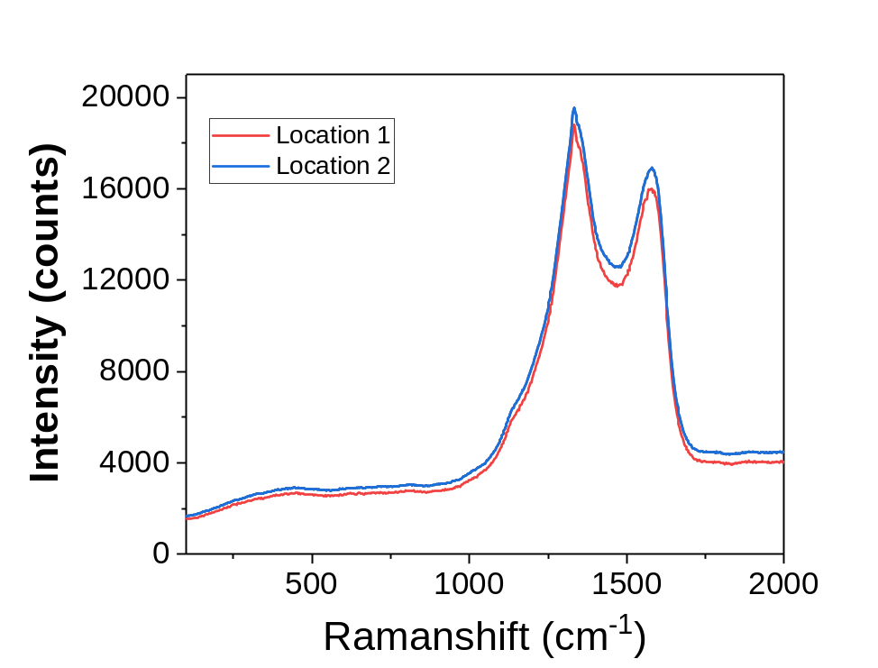
Figure S1 Raman spectra of the diamond coating on Si.

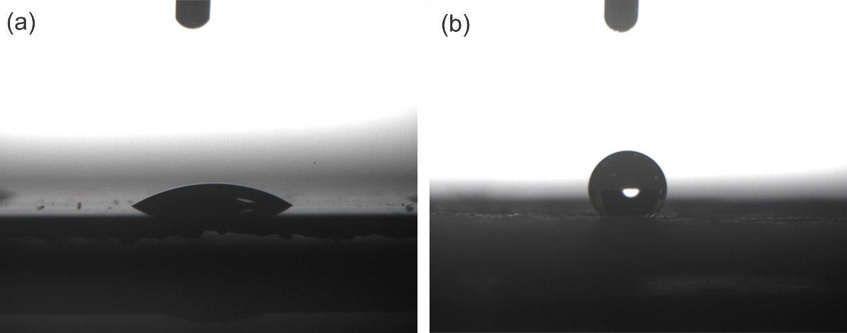
Figure S2 Representative contact angles for the water on (a) the structured (and aged) diamond coating and (b) the Neverwet coating on polystyrene (after use in the experiment).
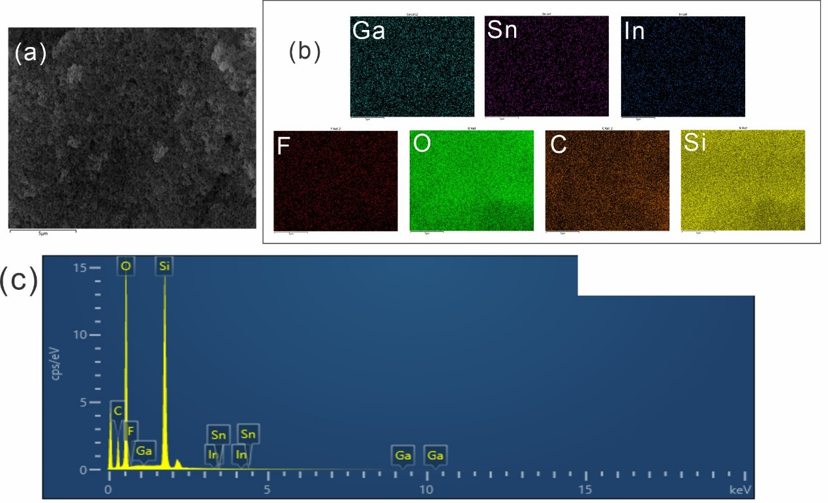
Figure S3 (a) SEM micrograph of the Neverwet coating on PS and the corresponding EDS maps (b) showing the elements Ga, In, Sn, F, O, C, and Si. (c) EDS spectrum of the Neverwet coating. Images a and b as well as the spectrum were taken after use of the coated sample for all experiments in the main manuscript and without a cleaning step.

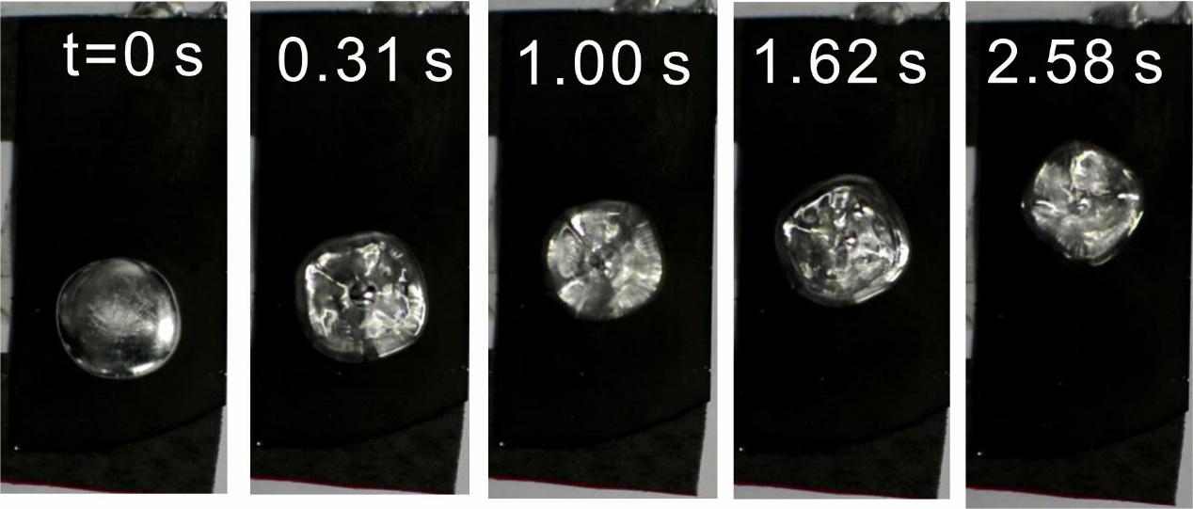
Figure S4 Linear translational movement of 600 µL Galinstan droplet on the diamond coated Si sample induced by an inclination angle of 0.5° and a specific vibration (27.5 Hz, 3 V (1.65 mm)). The elapsed time since vibrations were started is given in each sequential image.

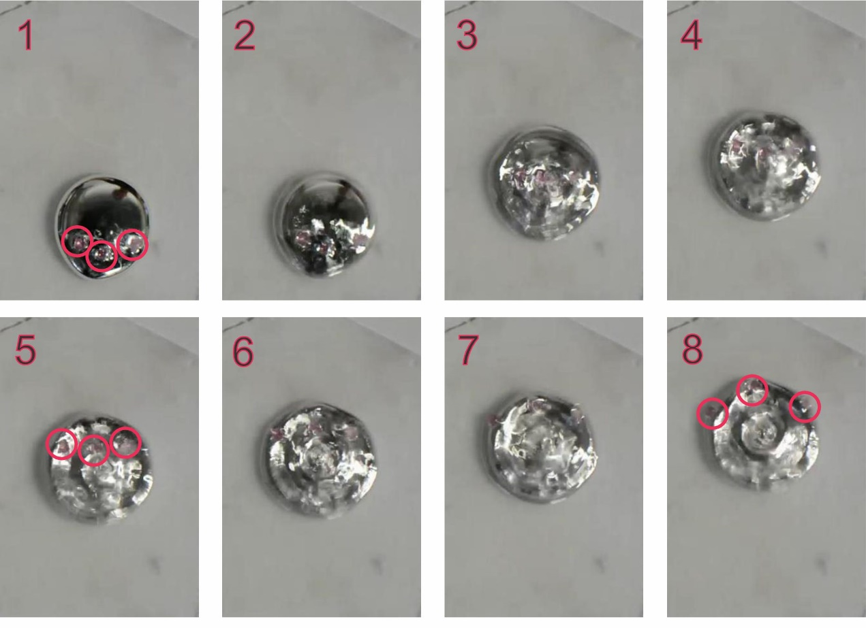
Figure S5 Movement of a Galinstan droplet marked with silica bead. The volume of droplet was 1000 µL, the tilting angle was 3°, and the vibration was 27.5 Hz at 2 V (1.1 mm). The images are stills from a video captured with a standard camera. A standard camera was chosen as the contrast and visibility of the beads is better than when the high speed camera is used.
Error of the liquid metal droplet volume
The dispensing unit is a self-built system and thus we cannot directly assume the precision of the whole system is equal to the precision of the syringe pump. Further, dispensing liquid metals in a precise manner is difficult due to several factors. First, the liquid metal has a high density, resulting in dieseling (slow flow of liquid metal after dispensing is concluded). This process is exacerbated by long tube lengths (especially, for the downpipe near the nozzle. This process typically results in an increase of dispensed volume (and with time). Therefore, this effect can be minimized by quick dispensing of the liquid metal. One should keep this effect in mind, in order to minimize contamination by spillage of liquid metal. This process is somewhat balanced by the second issue, namely, some liquid metal does not detach from the nozzle (needle tip). The non-detaching droplet volume is in general lower than 20 µL, as droplets of 20 µL detach from the needle tip freely. This makes the dispensed droplet volume smaller. The latter effect is especially important for small droplet volumes. Therefore, we estimate the error of the droplet volume to approx. 15 µL.
Weber and Ohnesorge numbers
The Weber and Ohnesorge numbers were calculated as follows. The Ohnesorge number was calculated by Equation S1.
$Oh=\frac{μ_{l}}{\sqrt{2Rρ_{l}γ_{l}}}$ S1
Here, μ_{l} denotes the viscosity of the liquid, R is the radius of the droplet, ρ_{l} is the density of the liquid, and γ_{l} is the surface tension of the liquid. The Radius was approximated by the Volume of the droplet. For the viscosity of the liquid, the viscosity of the liquid metal without an oxide skin was used, as the oxide skin is very thin and the viscosity of the oxide skin is not known. For the surface tension of the liquid metal, the surface tension of the oxide skin was used, as this value is known to be ca. 365 mN/m. The Ohnesorge number dependent on droplet volume is listed in Table S1. Similarly, the Weber number (We) was calculated by Equation S2.
$We=\frac{2Rρu_{0}^{2}}{γ}$ S2
In this equation, the only new variable is $u_{0}^{2}$ and it denotes the velocity of the droplet. The location of a vibrating plate considering a sinusoidal can be described by the following equation S3.
$f\left(t\right)=A∙sin⁡(ωt)$ S3
Here, A denotes the amplitude of the vibration and ω is the angular velocity. The angular velocity can be expressed by using the frequency (f) of the vibrating plate. ω = 2 π f, resulting in Equation S4.
$f\left(t\right)=A∙sin⁡(2πft)$ S4
The velocity at any given time (t) can be determined by the first derivative of Equation S4, resulting in equation S5.
$f'\left(t\right)=A2πf∙cos⁡(2πft)$ S5
The cosine of 2πft at the highest velocity (u_{max}) is 1, and thus the velocity can be approximated with known vibration frequency and amplitude.
$u_{max}=2∙A∙π∙f$ S6
Table S1 Ohnesorge and Weber numbers dependent on the droplet volume. The Weber numbers were calculated for a drive frequency of 27.5 Hz and either 3.3 or 1.1 mm amplitude.
Droplet volume in µL | Ohnesorge number | Weber number 3.3 mm | Weber number 1.1 mm
30 | 0.000939 | 22.11 | 2.45
100 | 0.000768 | 33.03 | 3.67
250 | 0.000659 | 44.83 | 4.98
500 | 0.000587 | 56.48 | 6.27
1000 | 0.000523 | 71.17 | 7.90
2000 | 0.000466 | 89.67 | 9.96

Reynolds and Bond numbers
The Reynolds number is given by the following Equation S7.
$Re=\frac{2ρu_{0}R}{μ}$ S7
Table S2 Reynolds number dependent on droplet volume
Droplet volume in µL | Reynolds number 3.3 mm | Reynolds number 1.1 mm
30 | 7078.20 | 2359.40
100 | 10573.43 | 3524.47
250 | 14350.36 | 4783.45
500 | 18080.32 | 6026.77
1000 | 22779.77 | 7593.25
2000 | 28700.72 | 9566.90
Such high Reynolds numbers signify turbulent flow.
The Bond number was calculated by the following Equation S8.
$Bo=\frac{4R^{2}ρ_{l}g}{γ}$ S8
Table S3 Bond number dependent on droplet volume
Droplet volume in µL | Bond number
30 | 1334.54
100 | 1993.54
250 | 2705.65
500 | 3408.91
1000 | 4294.96
2000 | 5411.31
The high bond numbers imply that gravitational forces dominate over interfacial forces.

