Targeted Chemoimmunotherapy for Hepatocellular Carcinoma: Dual-Stimulus Nanocarrier for Enhanced Antitumor Responses

Jinxiao Song†¹, Zhenghui Jing†¹, You Wu², Jingyi Zhou¹, Deteng Zhang²* Xinlong Zang^{1*}
- School of basic medicine, Qingdao medical college, Qingdao University, Qingdao, PR China
- Institute of Neuroregeneration and Neurorehabilitation, Qingdao University, Qingdao 266071, China.
*Corresponding author:
Xinlong Zang, E-mail: zangxinlong@126.com; Deteng Zhang, E-mail: zhangbio137@qdu.edu.cn
†These authors contributed equally to this work.
Supporting information
Figure S1. Schematic illustration of PGla-PEG-PPBP (A) and PEG-PBA (B) synthesis.
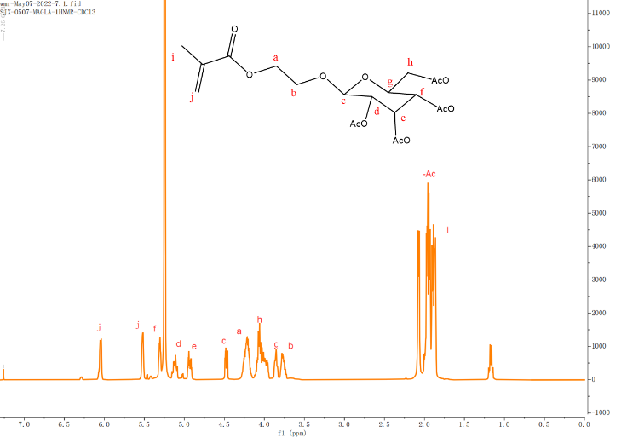
Figure S2. ¹H NMR of MAGlaAc.
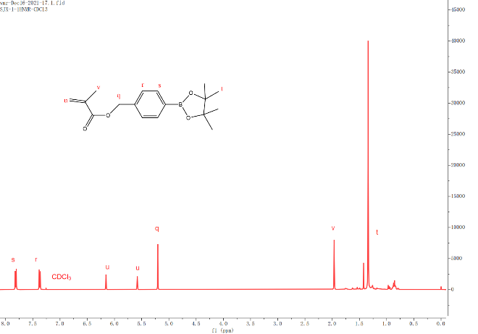
Figure S3. ¹H NMR of MAPBP.
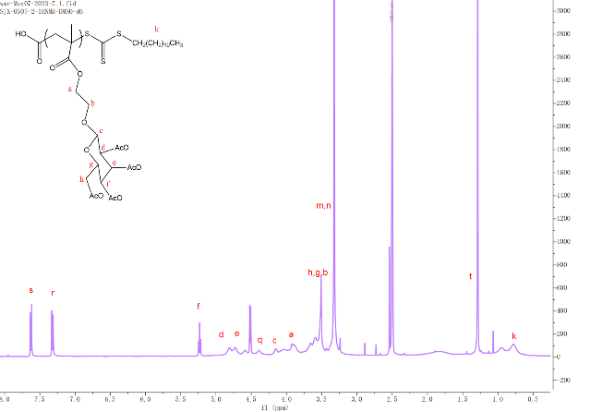
Figure S4. ¹H NMR of PGlaAc.
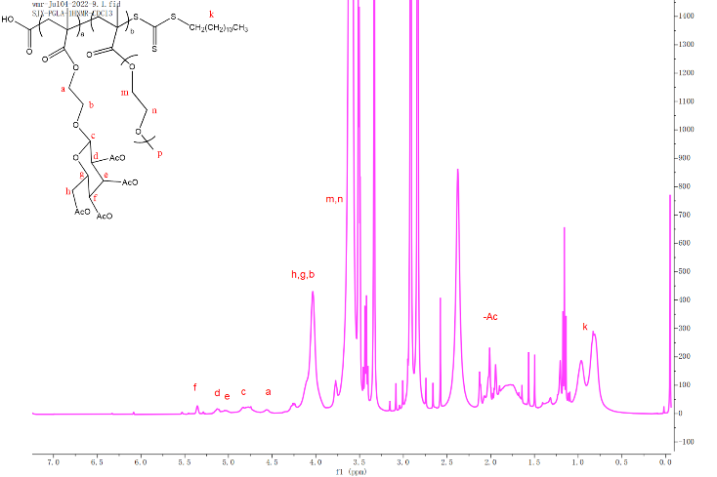
Figure S5. ¹H NMR of PGlaAc-PEG.

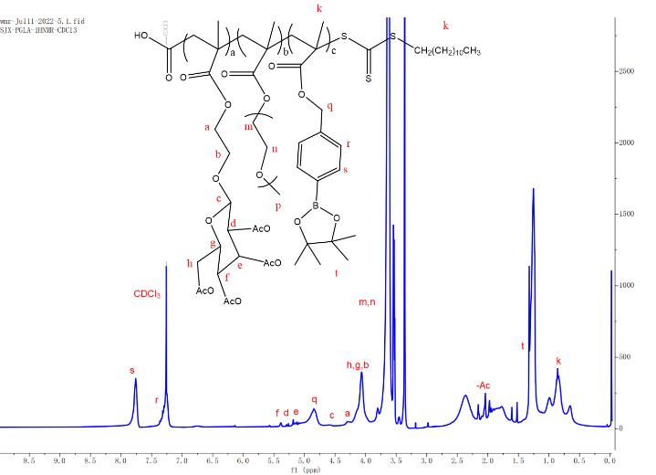
Figure S6. ¹H NMR of PGlaAc-PEG-PPBP.
Table S1. Particle sizes of nanoparticles at different pHs and redox conditions (n=3).
Formulations | Particle sizes (nm) |  | Zeta potential (mV)
Formulations | Without H₂O₂ | With H₂O₂ | Zeta potential (mV)
PN@GPB NPs | 103.36 ± 2.31 | 873.3 ± 50.3 | -14.7 ± 0.67
PN@GPB-PEG NPs at pH6.5 | 99.44 ± 3.46 | 906.9 ± 51.32 | -11.7 ± 1.06
PN@GPB-PEG NPs at pH7.4 | 87.83 ± 5.61 | 735 ± 100.1 | -3.73 ± 0.24

Table S2. The encapsulation and drug loading efficiency of different formulations.
Formulations | PTX |  | NLG919
Formulations | EE (%) | DLE (%) | EE (%) | DLE (%)
PN@GPB NPs | 75 | 2.9 | 48.77 | 0.94
PN@GPB-PEG NPs at pH6.5 | 77.5 | 2.98 | 41.04 | 0.79
PN@GPB-PEG NPs at pH7.4 | 69.5 | 2.67 | 55.6 | 1.07

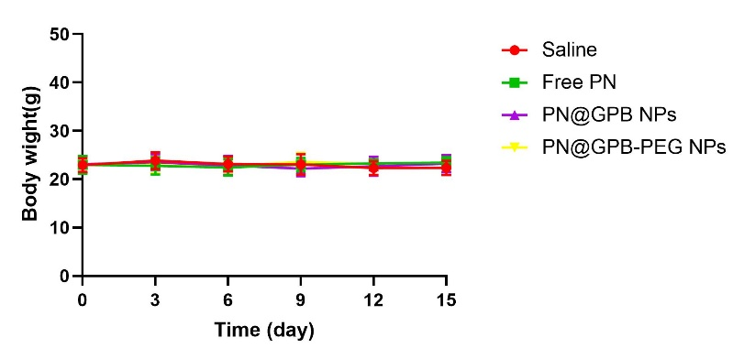
Figure S7. Body weight of mice received different treatments.
Figure S8. HE staining of main organs (heart, liver, spleen, lung and kidney) obtained from mice in different treatment groups.

