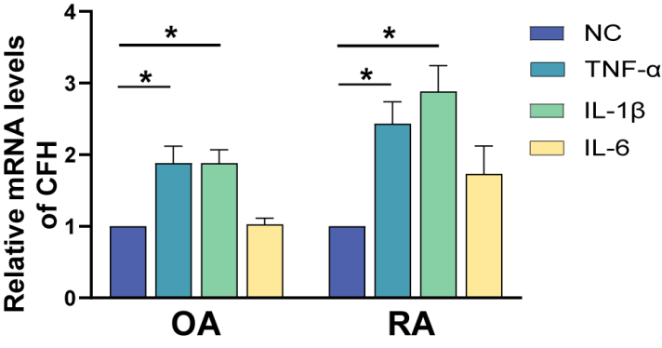

Supplementary Figure 1: Purified CD14+ monocytes (n=8) were treated with TNF-α, IL-1β, and IL-6 (50 ng/ml) for 24h. The expression of CFH in RA-FLS and OA-FLS stimulated with TNF-α, IL-1β, and IL-6 detected by qPCR. Data are expressed as mean ± SEM (n=6). *p < 0.05.

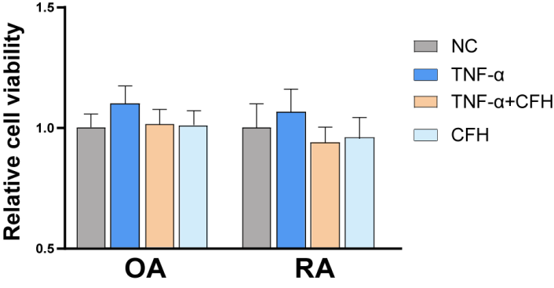

Supplementary Figure 2: Cells were treated with TNF-α（50ng/ml）or TNF-α（50ng/ml）+CFH (5μg/ml) or CFH (5μg/ml) for 24 h. The CCK-8 assay was used to detect cell viability. Data are expressed as mean ± SEM (n=6).

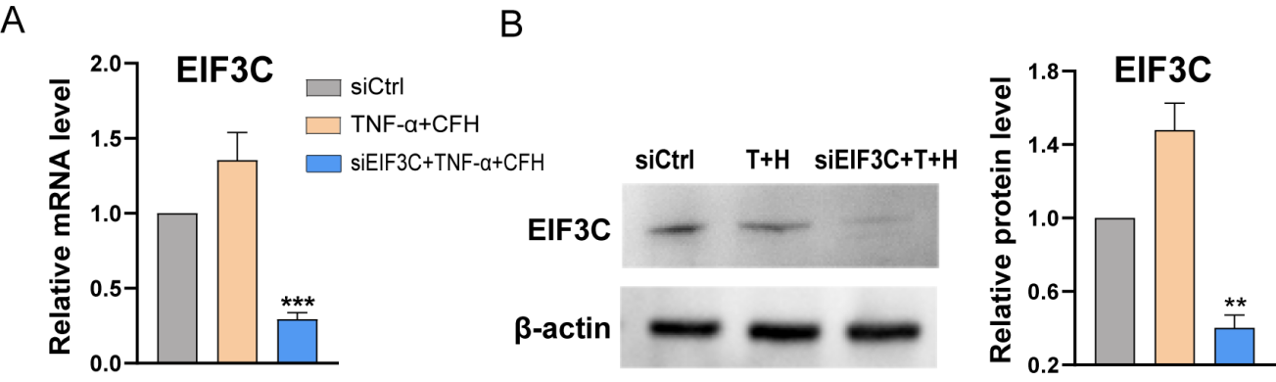

Supplementary Figure 3: The efficiency of EIF3C knockdown was detected by RT-qPCR analysis (A) and Western blotting (B). Data are expressed as mean ± SEM (n=6). **p < 0 .01; ***p < 0 .001.

Table S1. Demographic and clinical features of included RA patients
Age, yrs (mean ± SD) | 57.77±12.4
Female: Male | 50:7
Disease duration, yrs (mean±SD) | 16.90±6.92
Rheumatoid factor-positive (%) | 81
Anti-CCP-positive (%) | 67
ESR | 35±12.68
DAS28 (mean±SD) | 4.8±0.8
Previous medications (%)
Prednisone | 47
Methotrexate | 58
Leflunomide | 41
Hydroxychloroquine | 18
NSAIDs | 29

Table S2. Demographic and clinical features of patients with OA
Age, yrs (mean ± SD) | 71±8.5
Female: Male | 6:8
Disease duration, yrs (mean±SD) | 14.90±6.62
VAS | 6.20±1.42

Table S3: Sequences of primers for RT-qPCR and siRNA oligonucleotides

gene |  | sequences
CFH | Forward | GTGAAGTGTTTACCAGTGACAGC
 | Reverse | AACCGTACTGCTTGTCCAAAA
EIF3C | Forward | CAAGTTCAATATCATCGCCTCT
 | Reverse | CATCCATTCGTTCCACCA
β-actin | Forward | CATGTACGTTGCTATCCAGGC
 | Reverse | CTCCTTAATGTCACGCACGAT
EIF3C | siRNA | GCACACCTACTACAAGTTT

