Supporting information

 | Authors | Q1 | Q2 | Q3 | Q4 | Q5 | Q6 | Q7 | Q8 | Q9 | Q10 | Q11 | Q12 | Q13 | Q14 | Q15 | Q16 | Conclusion
CBZ | M. Biswas et al. 2022 | Y | Y | Y | Y | Y | Y | Y | Partial Y | Y | N | Y | Y | Y | Y | Y | Y | High
CBZ | M. Rashid et al. 2022 | Y | Y | Y | Y | Y | Y | Y | Y | Y | N | Y | Y | Y | Y | Y | Y | High
CBZ | C. Sukasem et al. 2021 | Y | N | Y | N | N | N | N | N | N | N | N | N | N | N | N | Y | Critically low
CBZ | Y. Moutaouakkil et al. 2019 | Y | Partial Y | N | Partial Y | N | N | N | N | N | N | Y | Y | Y | N | N | Y | Critically low
CBZ | M. Chouchi et al. 2018 | Y | Y | Y | Y | Y | Y | Y | Partial Y | N | N | Y | N | N | Y | Y | Y | Critically low
CBZ | W. Tangamornsuksan et al. 2013 | Y | N | N | Partial Y | Y | Y | Y | Y | Y | N | Y | Y | Y | Y | Y | Y | Low
CBZ | Yip et al. 2012 | Y | Y | Y | Y | Y | N | Y | Y | N | N | Y | N | N | Y | N | N | Critically low
LTG | Deng et al. 2018 | Y | Partial Y | N | Partial Y | Y | Y | Y | Y | N | Y | Y | Y | Y | Y | Y | Y | Moderate
LTG | Zeng et al. 2015 | Y | N | N | Partial Y | N | Y | Partial Y | Partial Y | Y | N | Y | Y | Y | Y | Y | Y | Low
LTG | Li et al. 2015 | Y | N | Y | Y | Y | Y | N | Partial Y | Partial Y | N | Y | N | Y | Y | Y | Y | Low
OXC | Liu et al. 2018 | Y | N | N | Partial Y | Y | Y | Y | Y | N | N | Y | N | N | Y | Y | Y | Critically low
OXC | Tangamornsuksan et al. 2018 | Y | N | Y | Partial Y | Y | Y | Y | Y | Y | N | Y | N | N | Y | N | N | Critically low
PHT | Li et al. 2015 | Y | Y | Y | Y | Y | Y | Y | Y | N | N | Y | N | N | Y | Y | Y | Critically low
PHT | Phung et al. 2021 | Y | Y | Y | Y | Y | Y | Y | Y | Y | N | Y | Y | Y | Y | Y | Y | High
PHT | Rashid et al. 2022 | Y | Y | Y | Y | Y | Y | Y | Y | Y | N | Y | Y | Y | Y | Y | Y | High
PB | Rashid et al. 2022 | Y | Y | Y | Y | Y | Y | Y | Y | Y | N | Y | Y | Y | Y | Y | Y | High

Table 1 AMSTAR-2 of meta-analyses included in the study

 | Authors | Selection |  |  |  | Comparability | Exposure |  |  | Score | Quality
 | Authors | Q1 | Q2 | Q3 | Q4 | Q1 | Q1 | Q2 | Q3 | Score | Quality
OXC | Hung et al. 2010 | 1 | 1 | 0 | 1 | 1 | 1 | 1 | 1 | 7 | Good
OXC | Sun et al. 2014 | 1 | 1 | 1 | 1 | 1 | 1 | 1 | 1 | 8 | Good
OXC | Chen et al. 2017 | 1 | 1 | 0 | 1 | 1 | 1 | 1 | 1 | 7 | Good
PHT | Locharernkul et al. 2008 | 1 | 1 | 0 | 1 | 1 | 1 | 1 | 1 | 7 | Good
PHT | Devi et al. 2018 | 1 | 1 | 1 | 1 | 1 | 0 | 1 | 1 | 7 | Good
PHT | Hung et al. 2010 | 1 | 1 | 1 | 1 | 1 | 0 | 1 | 1 | 7 | Good
PHT | Wang et al. 2014 | 1 | 1 | 1 | 1 | 1 | 0 | 1 | 1 | 7 | Good
PHT | Manuyakorn et al. 2020 | 1 | 1 | 1 | 1 | 1 | 0 | 1 | 1 | 7 | Good
PHT | Sukasem et al. 2020 | 1 | 1 | 1 | 1 | 1 | 0 | 1 | 1 | 7 | Good
PHT | Yampayon et al. 2017 | 1 | 1 | 1 | 1 | 1 | 0 | 1 | 1 | 7 | Good
PHT | Kwan PKL et al. 2014 | 1 | 1 | 1 | 1 | 1 | 0 | 1 | 1 | 7 | Good
PHT | Su et al. 2019 | 1 | 1 | 1 | 1 | 1 | 0 | 1 | 1 | 7 | Good
PB | Sun et al. 2014 | 1 | 1 | 1 | 1 | 1 | 1 | 1 | 1 | 8 | Good
PB | Wang et al. 2014 | 0 | 1 | 0 | 1 | 1 | 1 | 1 | 1 | 6 | Fair
PB | Manuyakorn et al. 2016 | 1 | 1 | 0 | 1 | 1 | 1 | 1 | 1 | 7 | Good
PB | Cheung et al. 2013 | 0 | 1 | 0 | 1 | 2 | 1 | 1 | 1 | 7 | Good

Table 2 NOS of case-control studies for Oxcarbazepine, Phenytoin and Phenobarbital included in the study

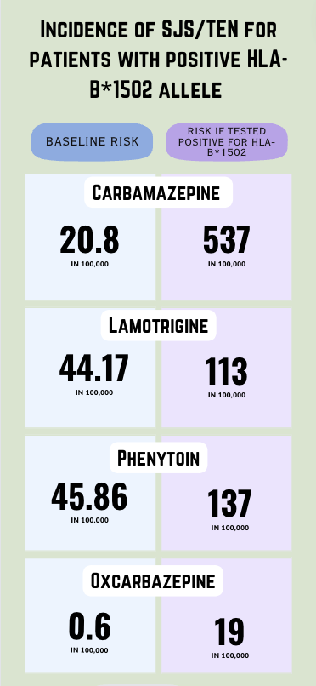
Fig. 7 Incidence of SJS/TEN for patients with positive HLA-B*1502 allele

Search strategy

Document full search strategies as run in each database adhering to PRISMA-S checklist.
Database: Medline (PubMed)
Date of Search: 21/05/23
No. of Results: 108
Limits applied (refer to PRISMA-S item 9): Inception – May 2023
Filters applied (refer to PRISMA-S item 10): Article type (Clinical trial, Meta-Analysis, Randomized Controlled Trial, Review, Systematic Review)

Search Strategy (copy and paste as run)

[Title/Abstract]
((adverse drug reaction)OR(stevens-johnson syndrome)OR(SJS)OR(TEN)OR(toxic epidermal necrolysis))AND(HLA)AND((antiepileptic)OR(AED)OR(antiseizure)OR (anticonvulsant)OR(phenytoin)OR(valpro*)OR(carbamazepine)OR(oxcarbazapine)OR(lamotrigine)OR(phenobar*))

Database: Embase.com
Date of Search: 21/05/23
No. of Results: 375
Limits applied (refer to PRISMA-S item 9): Inception – May 2023
Filters applied (refer to PRISMA-S item 10): none

Search Strategy (copy and paste as run)
[Title/Abstract/Author keywords]

(‘antiepileptic’/exp OR 'phenytoin'/exp OR 'valproic acid'/exp OR 'lamotrigine'/exp OR 'oxcarbamazepine'/exp) AND 'HLA’ AND ('stevens-johnson’ OR 'adverse drug reaction' OR 'toxic epidermal necrolysis')

Database: Scopus
Date of Search: 21/05/23
No. of Results: 616
Limits applied (refer to PRISMA-S item 9): Inception – May 2023
Filters applied (refer to PRISMA-S item 10): Source type: Journal; Document type: Article, Review
Search Strategy (copy and paste as run)

[Article title, Abstract, Keywords]

"adverse drug reaction" OR "stevens-johnson syndrome" OR "sjs" OR "ten" OR "toxic epidermal necrolysis" OR "cutaneous" AND "hla" AND "antiepileptic" OR "aed" OR "antiseizure" OR "anticonvulsant" OR "phenytoin" OR "valpro*" OR "carbamazepine" OR "oxcarbazapine" OR "lamotrigine" OR "phenobar*"

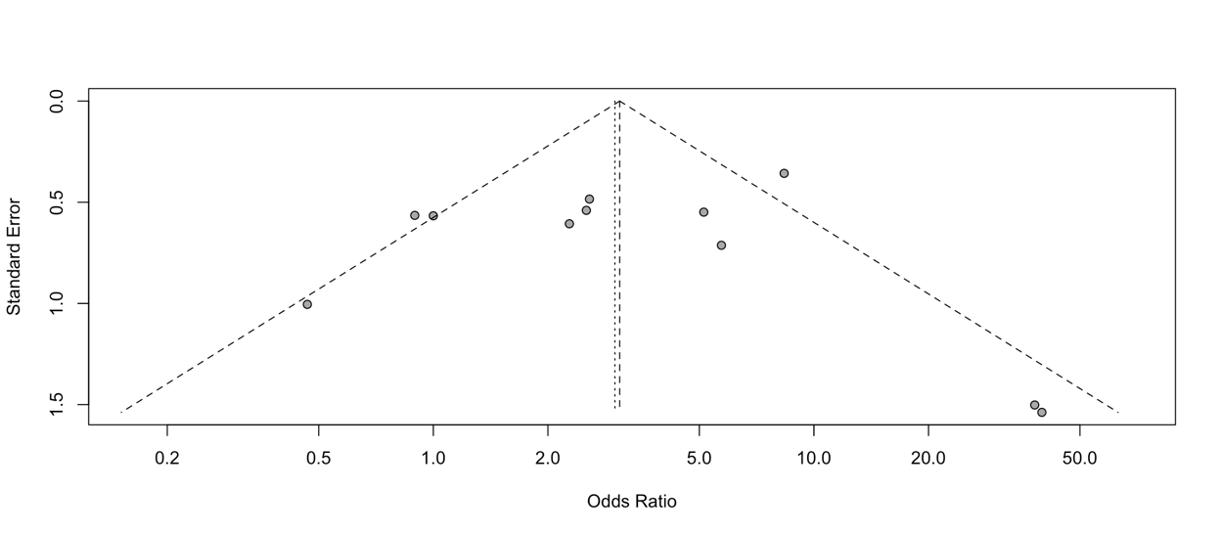
Fig.8 Funnel plot for meta-analysis of phenytoin

Eggers test for meta-analysis of phenytoin showed an intercept of 1.22 with a p-value of 0.948, indicating that there is no evidence of publication bias.

