Supplementary Appendix

Supplementary table 1 – Study sites page 2
Supplementary table 2 – Exclusion criteria page 3
Supplementary table 3 – Primary COVID-19 case definitions page 5
Supplementary figure 1 – Days on which solicited local and systemic AEs occurred page 7
Supplementary table 4 – All reported COVID-19 cases page 8
Supplementary table 5 – VE endpoints against Delta variant in phase 3b page 9
Supplementary table 6 – VE endpoints in phases 1, 2 and 3a combined page 9

Supplementary table 1 – study sites
Site no. | Institute | Location
1 | Clinical Pharmacology Center – Hanoi Medical University | Hanoi
2 | Yên Phong District Medical Center | Bắc Ninh
3 | Vĩnh Long District Medical Center | Tỉnh Vĩnh Long
4 | Long Hồ District Medical Center – Tỉnh Vĩnh Long | Tỉnh Vĩnh Long
5 | Cái Bè District Medical Center | Tỉnh Tiền Giang
6 | Chợ Gạo District Medical Center | Tỉnh Tiền Giang
7 | Cao Lãnh District Medical Center | Tỉnh Đồng Tháp
8 | Lấp Vò District Medical Center | Tỉnh Đồng Tháp
9 | Văn Lâm District Medical Center | Hưng Yên Province
10 | Văn Giang District Medical Center | Hưng Yên Province
11 | Phù Cừ District Medical Center | Hưng Yên Province
12 | Tiên Lữ District Medical Center | Hưng Yên Province
13 | Kim Động District Medical Center | Hưng Yên Province
14 | Ân Thi District Medical Center | Hưng Yên Province
15 | Khoái Châu District Medical Center | Hưng Yên Province
16 | Hưng Yên District Medical Center | Hưng Yên Province

Supplementary table 2: Exclusion Criteria
Individuals meeting any of the following criteria were excluded from the study:
Medical Conditions
1. Significant infection or other acute illness, including body temperature >100.4°F (>38.0°C) on the day prior to or Day 1. Participants meeting this criterion could be rescheduled within the relevant window periods (Section 5.2.1). Afebrile participants with minor illnesses could be enrolled at the discretion of the investigator.
2. Pregnant or breastfeeding.
3. Known history of COVID-19 (nucleocapsid positive test is not exclusionary) or positive nasal swab SARS-CoV-2 by RT-PCR test. Note: if obtained within 5 days prior to Screening period, there was no need to repeat RT-PCR at Screening.
4. Close contact with a person known to be SARS-CoV-2 positive or with a clinical diagnosis of COVID-19 within 7 days prior to enrolment. Participants meeting this criterion who remained asymptomatic for 7 days could be rescheduled for enrolment within the relevant window periods (Section 5.2.1).
5. Known history of anaphylaxis, urticaria, or other significant adverse reaction to the vaccine or its excipients as listed in the Investigator’s Brochure.
6. Known history of anaphylaxis to other vaccines.
7. Bleeding disorder considered a contraindication to intramuscular (IM) injection or phlebotomy.
8. Immunosuppressive or immunodeficient state, asplenia, recurrent severe infections, or known to be HIV positive.
9. An underlying clinically significant acute or chronic medical condition or physical examination findings for which, in the opinion of the investigator, participation would not be in the best interest of the participant (e.g., compromise the well-being) or that could prevent, limit, or confound the protocol-specified assessments.
Prior/Concomitant Therapy
10. Had previously received investigational or approved MERS-CoV, SARS-CoV, SARS-CoV-2 vaccines or who had plans to receive off-study COVID-19 vaccines.
11. Had received a live replicating vaccine within 28 days prior to each study vaccination or a licensed inactivated or non-replicating vaccine within 14 days prior to first study vaccination.
12. Had received treatment with immunosuppressive therapy, including cytotoxic agents or systemic corticosteroids, e.g., for cancer or an autoimmune disease, within 6 months prior to Screening, or planned receipt throughout the study. If systemic corticosteroids had been administered short term (<14 days) for treatment of an acute illness, participants should not be enrolled into the study until corticosteroid therapy had been discontinued for at least 28 days prior to first study vaccine administration. Inhaled/nebulised, intra-articular, intrabursal, or topical (skin or eyes) corticosteroids are permitted.
13. Had received systemic immunoglobulins or blood products within 3 months prior to first study vaccine administration or planned to receive such products during the study.

Other Exclusions
14. Demonstrated inability to comply with the study procedures.
15. Investigator site staff members, employees of the Sponsor or the CRO directly involved in the conduct of the study, or site staff members otherwise supervised by the investigator, or immediate family members of any of the previously mentioned individuals.

Additional Exclusion Criteria for Phase 1 Participants Only
16. Individuals ≥ 60 years of age.
17. Individuals with clinically significant abnormalities in medical history or physical examination, including but not limited to, the following:
a) Respiratory disease (e.g., chronic obstructive pulmonary disease [COPD], asthma) requiring daily medications or oxygen currently or any treatment of respiratory disease exacerbations (e.g., COPD or asthma exacerbation) warranting hospitalization or an emergency room visit or supplemental oxygen in the last 5 years.
b) Significant cardiovascular disease (e.g., congestive heart failure, cardiomyopathy, ischemic heart disease) or history of myocarditis or pericarditis as an adult.
c) Neurological or neurodevelopmental conditions (e.g., migraines, epilepsy, stroke, seizures in the last 3 years, encephalopathy, focal neurologic deficits, Guillain-Barré syndrome, encephalomyelitis or transverse myelitis).
d) Significant hematologic abnormalities (e.g., sickle cell disease, beta thalassemia, coagulation disorders).
e) Major surgery within the past 6 months.
f) Individuals with a history of chronic liver disease.
18. Individuals with the following abnormal Screening laboratory results:
a) Positive nasal swab SARS-CoV-2 by RT-PCR test. Note: if obtained within 5 days prior to Screening period, do not need to repeat RT-PCR at Screening.
b) Alanine aminotransferase (ALT), aspartate aminotransferase (AST), gamma-glutamyl transferase (GGT), total bilirubin, or alkaline phosphatase >1.5 upper limit of normal.
c) Haemoglobin <9.5 g/dL for females and <10.5 g/dL for males.
d) Platelet count <100 × 109/L.
e) Other clinically significant abnormal (according to the judgment of the Investigator) Screening laboratory values.
f) Individuals with Type 2 diabetes and Screening haemoglobin A1c >8.0%.
g) Hepatitis B core antigen (HbsAg), Hepatitis C virus (HCV) antibody or HIV positive.

Supplementary table 3: Primary COVID-19 case definitions based on FDA recommendation *
Case definition | Laboratory finding | Clinical status
Case definition | Laboratory finding | Symptoms | Other clinical parameters
Uninfected | No +ve SARS-CoV-2 test | None | None relevant
Asymptomatic SARS-CoV-2 infection | +ve SARS-CoV-2 test | None | None relevant
Protocol-defined COVID-19 | +ve SARS-CoV-2 test | At least one of the following that is a NEW or WORSENING finding:  - Fever or chills  - Cough  - Shortness of breath or difficulty breathing  - Fatigue  - Muscle or body aches  - Headache  - New loss of taste or smell  - Sore throat  - Congestion or runny nose  - Nausea or vomiting  - Diarrhea | None relevant
Atypical COVID-19 | +ve SARS-CoV-2 test | Clinical findings suggestive of COVID-19 but not included above | None relevant
Severe COVID-19 | +ve SARS-CoV-2 test | As above for protocol-defined COVID-19 | Any of the following  - Clinical signs at rest indicative of severe systemic illness  - Respiratory rate ≥ 30 per min  - Heart rate ≥ 125 per min  - SpO₂ ≤ 93% on room air at sea level or PO₂/FiO₂ < 300 mm Hg  - Respiratory failure (needing high flow oxygen, noninvasive ventilation, mechanical ventilation or ECMO)  - Evidence of shock  - SBP < 90 mm Hg, or  - DBP < 60 mm Hg, or  - requiring vasopressors  - Significant acute renal, hepatic, or neurologic dysfunction  - Admission to an ICU  - Death
* Department of Health and Human Services (DHHS), Food and Drug Administration, Center for Biologics Evaluation and Research (US). Guidance Document. Development and Licensure of Vaccines to Prevent COVID-19. 2020. https://www.fda.gov/regulatory-information/search-fda-guidance-documents/development-and-licensure-vaccines-prevent-covid-19. Accessed 10 Mar 2021.

Supplementary figure 1:
Days post-vaccination on which local reactions and systemic adverse events were reported.

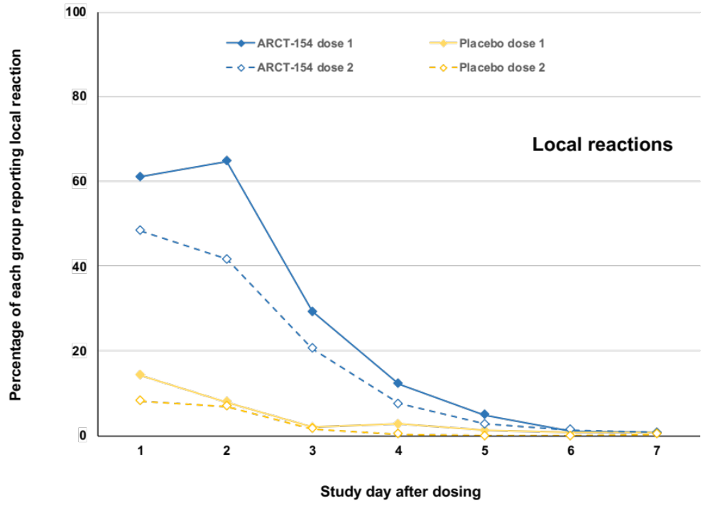

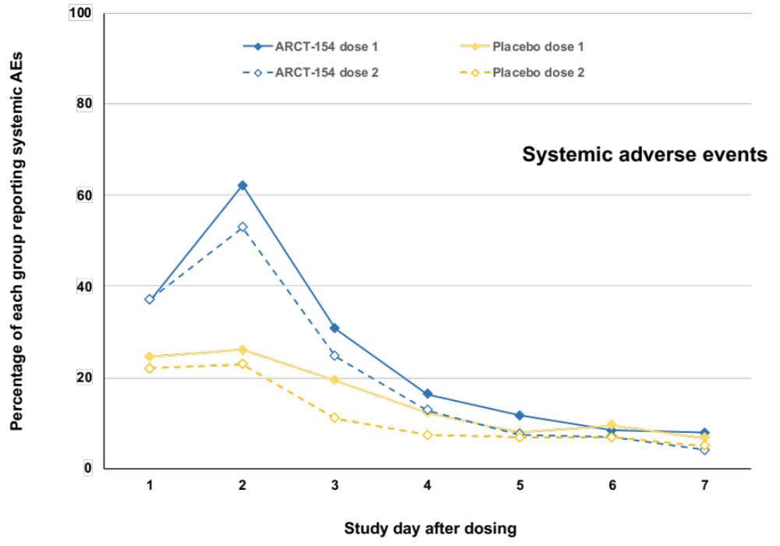

Supplementary table 4: All reported COVID-19 cases
Analysis Period | Number of Events | Phase 1/2/3a | Phase 3b | Total
Day 1  to Day 35 | Any protocol-confirmed COVID-19 | 1 | 44 | 45
Day 1  to Day 35 | Severe COVID-19 | 0 | 2 | 2
Day 1  to Day 35 | Death attributed to COVID-19 | 0 | 0 | 0
Day 36  to Day 92 | Any protocol-confirmed COVID-19 | 40 | 651 | 691
Day 36  to Day 92 | Severe COVID-19 | 2 | 44 | 46
Day 36  to Day 92 | Death attributed to COVID-19 | 0 | 10 | 10
Any | Any protocol-confirmed COVID-19 | 50 | 734 | 784
Any | Severe COVID-19 | 2 | 48 | 50
Any | Death attributed to COVID-19 | 0 | 10 | 10
Any | Asymptomatic SARS-CoV-2 infection | 30 | 102 | 132
Any | Total | 80 | 836 | 916

Supplementary table 5: Key secondary vaccine efficacy (VE) endpoints in phase 3b against the Delta SARS-CoV-2 variant
 | No. of persons censored | Cumulative follow-up in person-yrs | No. with event | No. of persons censored | Cumulative follow-up in person-yrs | No. with event | Vaccine efficacy (95% confidence intervals)
 | ARCT-154 (N = 7297) |  |  | Placebo (N = 244)
Primary VE endpoints in the mITT population against Delta variant SARS-CoV-2
Any severity protocol-confirmed COVID-19 (Days 36–92) | 7623 | 1131.7 | 164 | 7412 | 1100.6 | 311 | 49.8% (39.3–58.4)
Severe protocol-confirmed COVID-19 (Days 36–92) | 7786 | 1148.2 | 1 | 7706 | 1134.8 | 17 | 94.3% (57.4–99.2)

Supplementary table 6: Key secondary vaccine efficacy (VE) endpoints in the cumulative phase 1, 2 and 3a study population
 | No. of persons censored | Cumulative follow-up in person-yrs | No. with event | No. of persons censored | Cumulative follow-up in person-yrs | No. with event | Vaccine efficacy (95% confidence intervals)
 | ARCT-154 (N = 7297) |  |  | Placebo (N = 244)
VE endpoints in the phase 1, 2 and 3a mITT population
Any severity protocol-confirmed COVID-19 (Days 36–92) | 706 | 120.8 | 23 | 227 | 39.6 | 17 | 56.3% (18.2–76.7)
VE endpoints in the phase 1, 2 and 3a ITT population
Any severity protocol-confirmed COVID-19 (Days 1–92) | 726 | 195.5 | 23 | 234 | 64.6 | 18 | 58.9% (23.8–77.8)

