Supplementary Figures

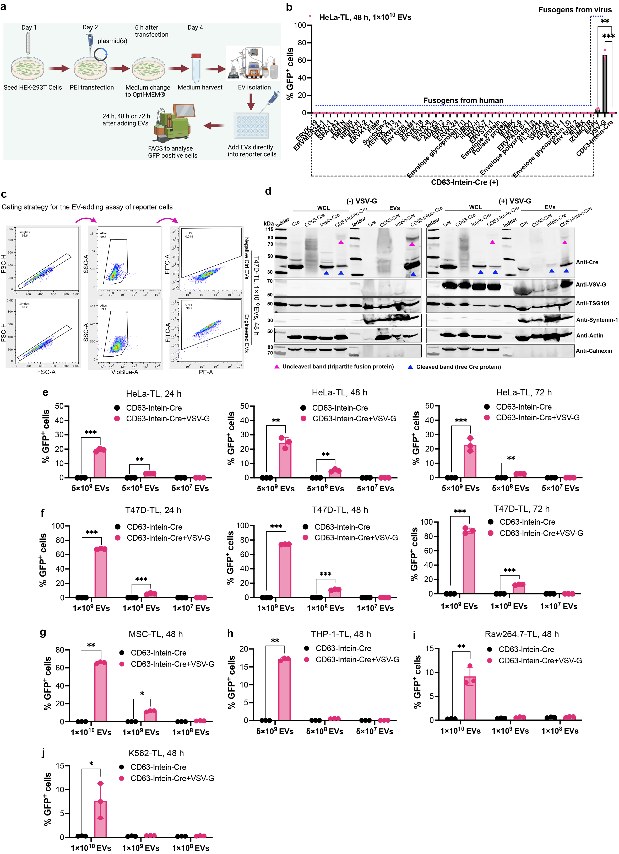
Supplementary Fig. 1. Development of VEDIC system for efficient intracellular protein delivery. a, A workflow schematic for the evaluation of EV-mediated Cre delivery to Cre recombinase fluorescent Traffic Light (TL) reporter cells and the subsequent analysis of GFP positive cells in recipient cells after adding isolated EVs. b, Fusogen screen in HeLa-TL cells after a two-day incubation with EVs. c, Example of the applied flow cytometry gating strategy for the analysis of GFP positive cells to evaluate Cre recombination after adding isolated EVs to fluorescent TL reporter cells. d, Protein expression of various engineered Cre fusion constructs in whole cell lysates (WCL) and isolated EVs derived from HEK293T cells evaluated by western blot (WB) analysis. Lysates from 5×10⁵ EV-producing cells and 1×10¹⁰ engineered vesicles were used for the assay. TSG101, syntenin-1 and β-actin were used as EV markers and Calnexin was used as a cellular organelle marker (endoplasmic reticulum) and should be absent for EV samples. e,f, Percentage of GFP positive cells in HeLa-TL and T47D-TL reporter cells respectively after adding different doses of isolated engineered EVs for 1 to 3 days. (g-j) Percentage of recombined GFP positive cells mediated by intracellular Cre delivery through different doses of engineered EVs for 48 hours (h) in hard-to-transfect cells (g: MSC-TL; h: THP-1-TL; i: Raw264.7-TL; j: K562-TL). One-way ANOVA multiple comparisons test was used for analysis of (b); Two-way ANOVA multiple comparisons test was used for analysis of (e-j). Data are shown as mean+SD, * p < 0.05; ** p < 0.01; *** p < 0.001.

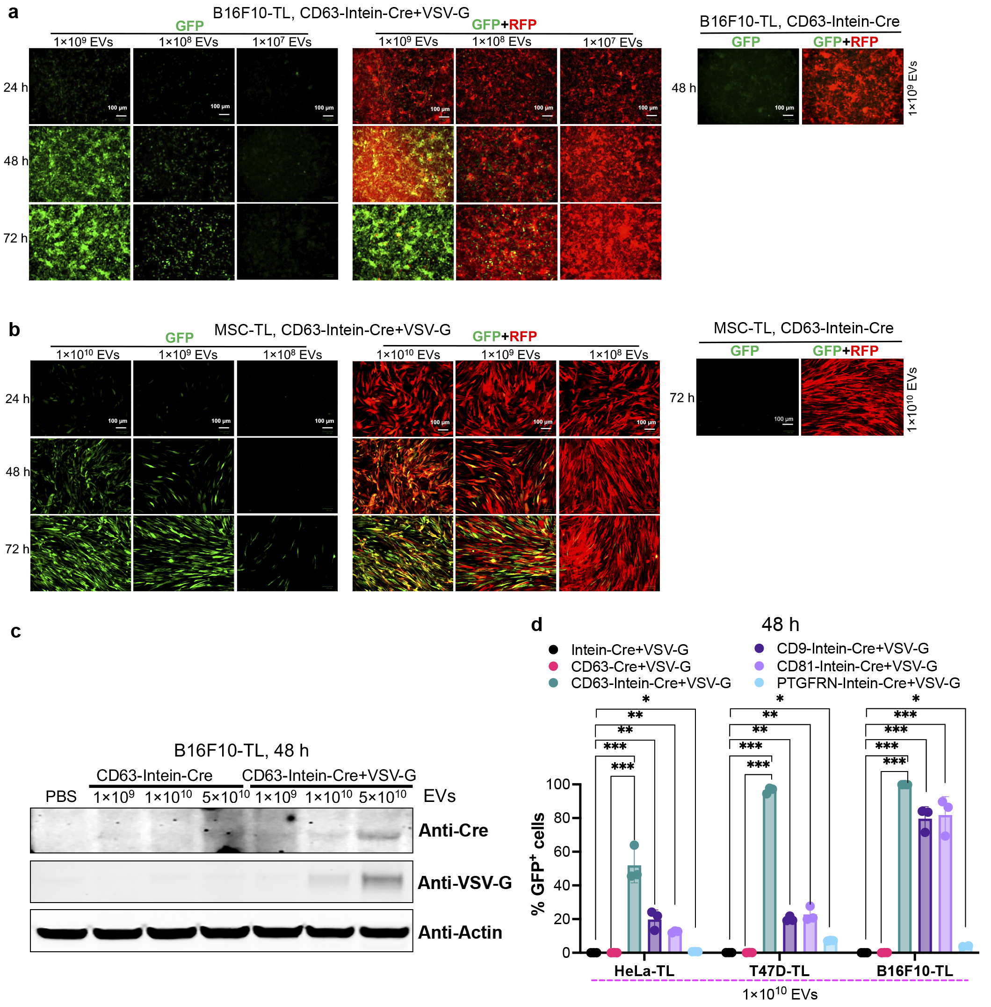 Supplementary Fig. 2. Fluorescent microscopy Analysis of EV-mediated Cre delivery and test of different EV-sorting domains for VEDIC system. a,b, Fluorescent microscopy analysis of Cre-mediated B16F10-TL and MSC-TL reporter cell activation after adding indicated doses of EVs for indicated time of incubation. Scale bar, 100 μm, representative images. c, Cre and VSV-G proteins measured by WB in B16F10-TL cells after adding the indicated doses of engineered EVs in 24-well plates. d, Recombination in reporter cells mediated by EVs derived from engineered cells using different EV-sorting domains. Two-way ANOVA multiple comparisons test was used for analysis of (d). Data are shown as mean+SD, * p < 0.05; ** p < 0.01; *** p < 0.001.
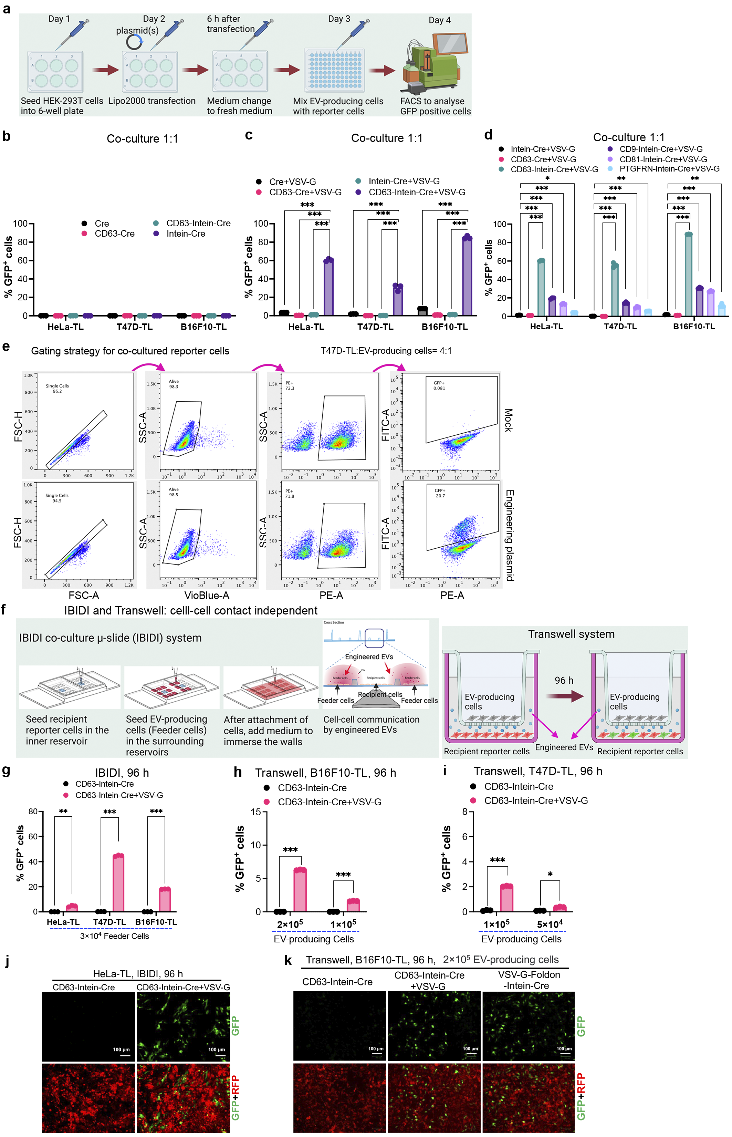
Supplementary Fig. 3. Co-culture assays for validation of the VEDIC system for efficient intracellular protein delivery. a, Brief workflow for the direct co-culture assay of EV-producing cells and reporter cells to show EV-mediated Cre delivery. b, Co-culture assay for evaluation of Cre transfer without expression of VSV-G. c, Analysis of Cre-mediated recombination in cells after a co-culture assay with expression of VSV-G. d, Comparison of Cre transfer efficiency using different EV loading domains in a direct co-culture assay. e, Gating strategy utilized for the analysis of Cre recombination, as indicated by the percentage of GFP positive cells, in co-culture assay. f, Schematic graph to show the principle and workflow of IBIDI co-culture µ-slide (IBIDI) and Transwell co-culture assays demonstrating cell-cell contact independent Cre delivery from donor cells to recipient cells. The pore size for Transwell assay was 0.4 μm. g, Flow cytometry analysis of Cre delivery mediated by engineered EVs in a contact-independent co-culture assay using IBIDI assay. 3×10⁴ EV-producing cells and 4×10⁴ reporter cells were seeded into the surrounding reservoirs and central reservoir respectively and the analysis was performed after 4 days. h,i, Flow cytometry analysis of Engineered EV-mediated Cre delivery from donor cells to B16F10-TL and T47D-TL reporter cells respectively in a co-culture Transwell assay in 24-well plates. Indicated numbers of EV-producing cells were seeded into the upper chamber and the numbers of B16F10-TL and T47D-TL reporter cells in the lower chamber were 5×10⁴ and 8×10⁴ respectively in 24-well plate. Flow cytometry analysis was performed after 96 h. j, Representative fluorescence microscopy images showing Cre recombinase-induced GFP expression in HeLa-TL cells by IBIDI assay. Scale bar, 100 μm. k, Fluorescence microscopy images demonstrating GFP positive cells in B16F10-TL after a Transwell assay in 24-well plates. Scale bar, 100 μm, representative images. Two-way ANOVA multiple comparisons test was used for analysis of (b-d) and (g-i). Data were shown as means+SD, * p < 0.05; ** p < 0.01; *** p < 0.001.
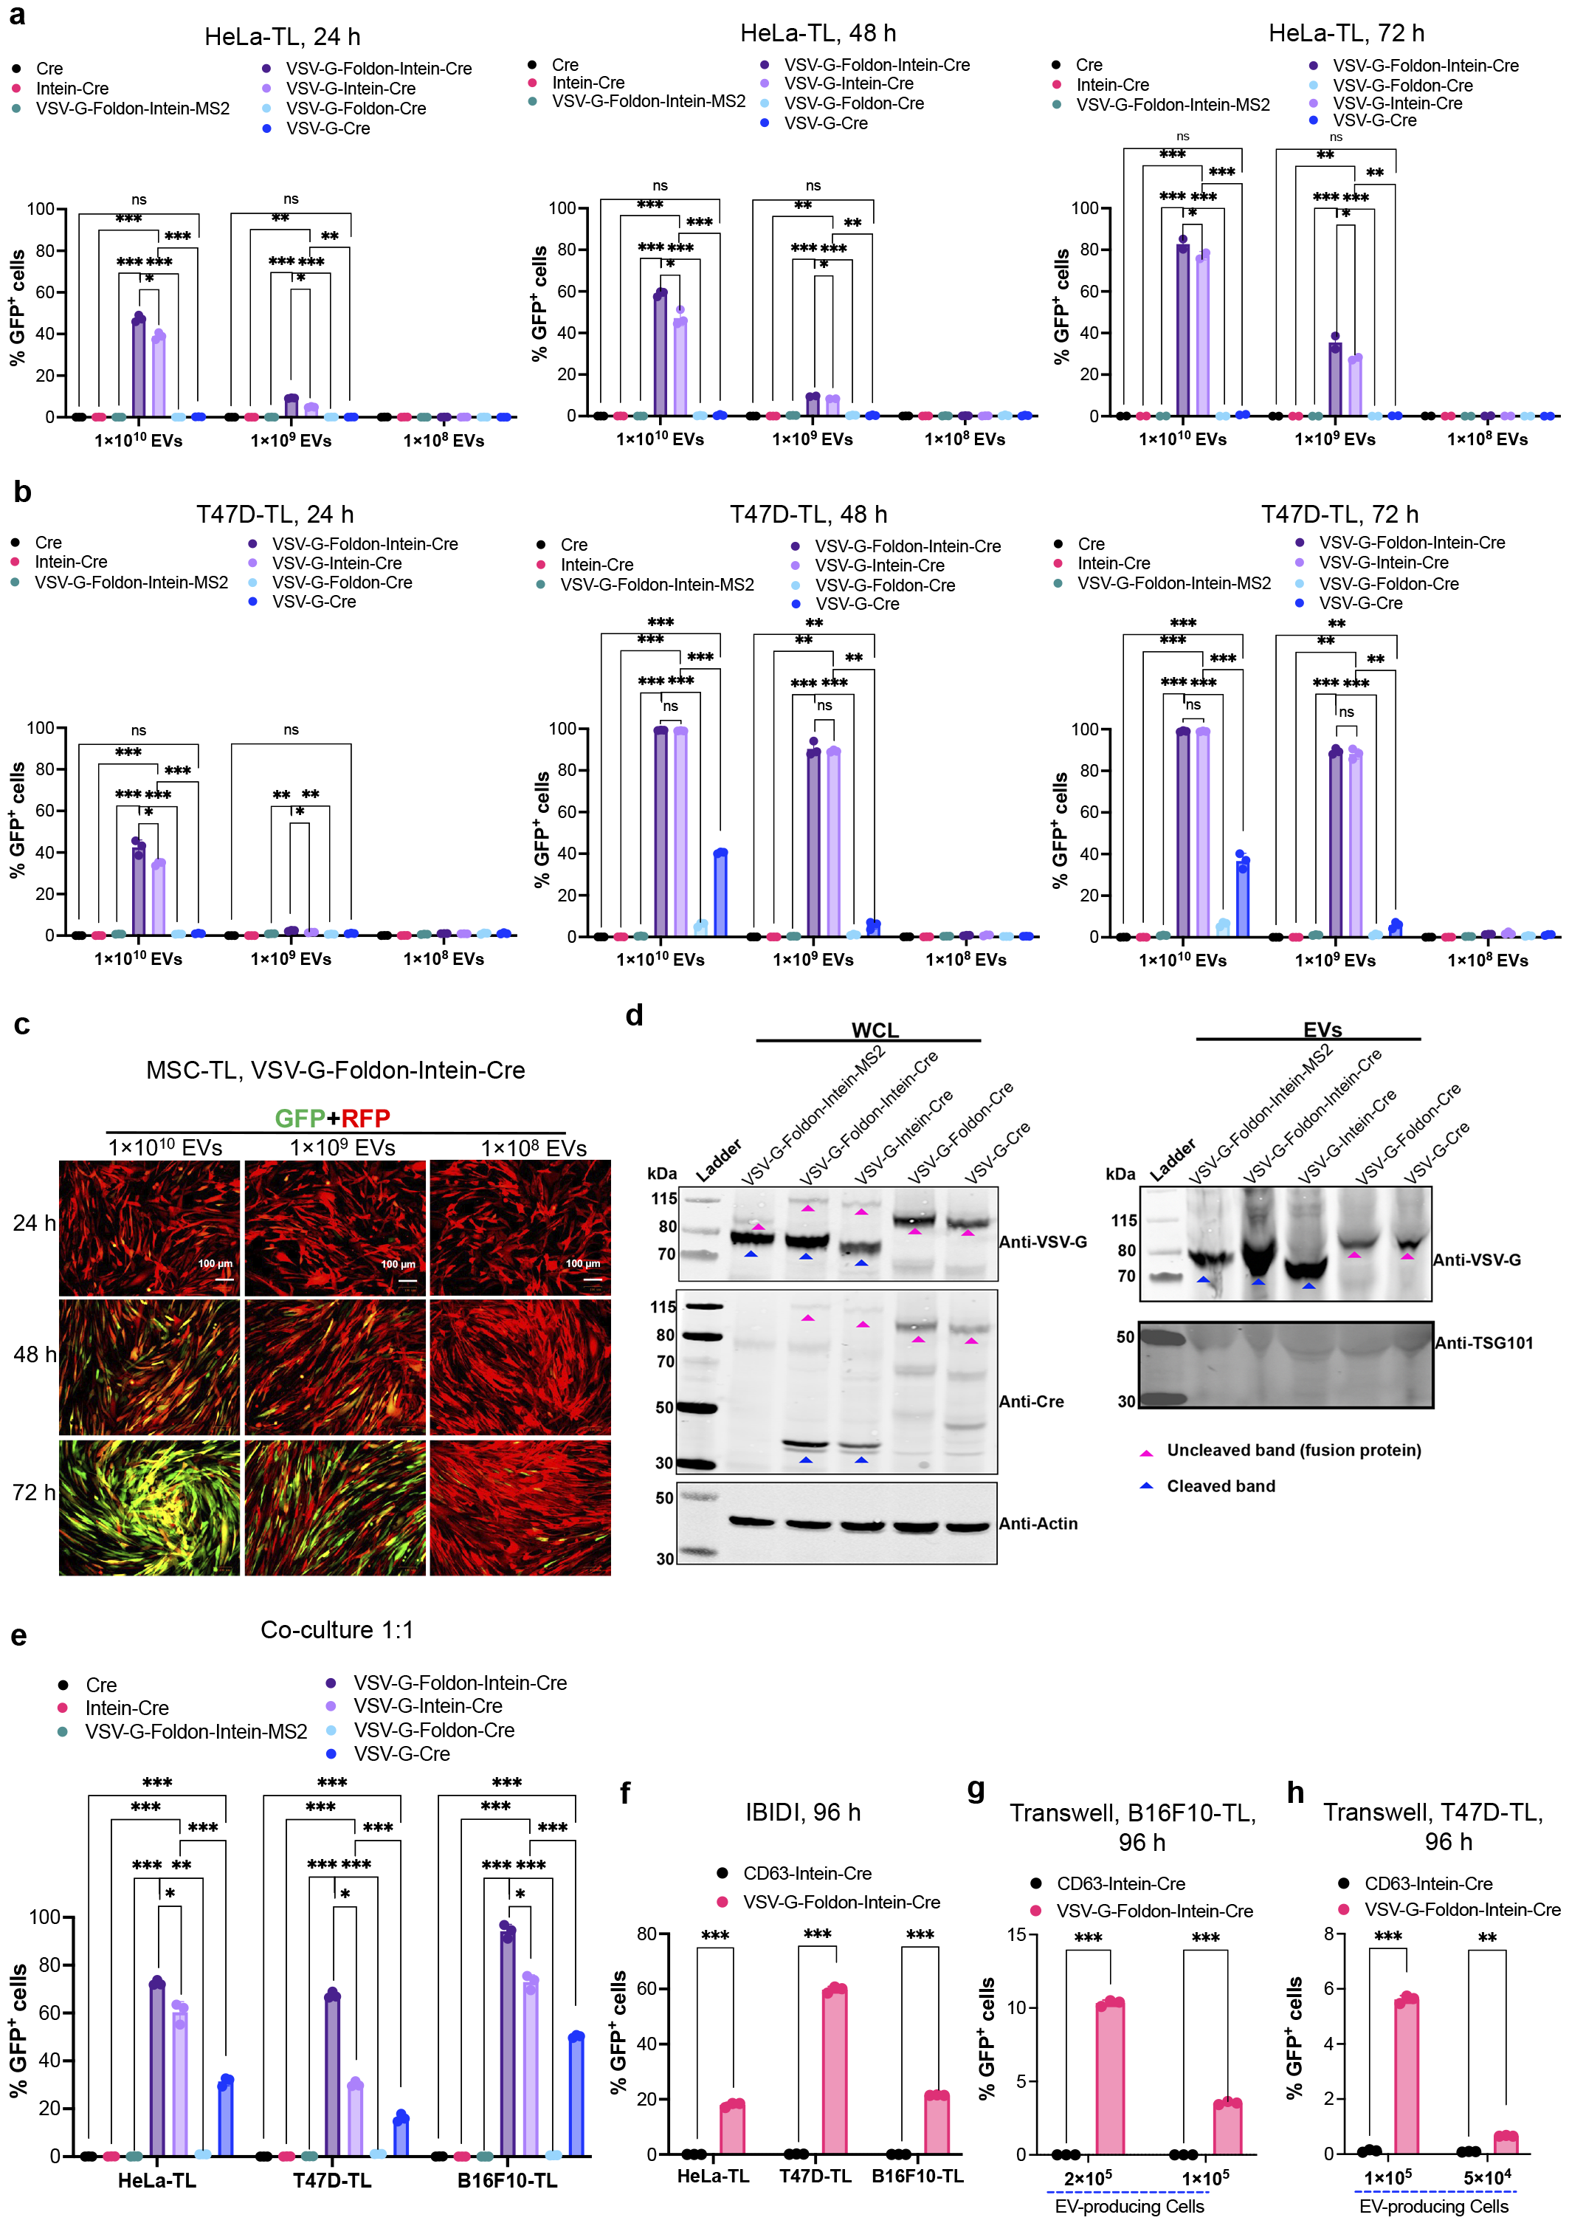
Supplementary Fig. 4. Development of VFIC system for efficient intracellular protein delivery. a, Percentage of GFP positive cells in HeLa-TL cells after adding engineered EVs for 1-3 days. Indicated doses of EVs were added. b, Percentage of recombined cells mediated by Cre from adding engineered EVs in T47D-TL cells for 1-3 days. c, Representative fluorescence microscopy images showed the GFP expression in MSC-TL cells after EV-mediated Cre delivery. Indicated doses of isolated EVs were incubated for the indicated time. Isolated EVs from VFIC system demonstrated dose- and time-dependent Cre delivery into recipient cells. Scale bar, 100 μm. d, The expression of constructs related to VFIC system as measured by WB analysis. Proteins from 5×10⁵ EV-producing cells and 1×10¹⁰ engineered vesicles were analyzed. TSG101 was included as EV marker. e, Flow cytometry analysis of a direct co-culture assay using various EV engineering strategies to assay Cre transfer after 24 h. f, Percentage of GFP positive cells evaluated by IBIDI assay for 96 h. 4×10⁴ EV producing cells and 4×10⁴ reporter cells were seeded into the surrounding reservoirs and central reservoir respectively and flow cytometry was performed after 4 days. g,h, Percentage of GFP positive cells in B16F10-TL and T47D-TL cells respectively evaluated by Transwell assay for 96 h. Indicated numbers of EV-producing cells were added into the up chamber of the Transwell system and co-cultured with 5×10⁴ B16F10-TL or 8×10⁴ T47D-TL reporter cells in the lower chamber in 24-well plates. Two-way ANOVA multiple comparisons test was used for analysis of (a and b) and (e-h). Data are shown as means+SD, * p < 0.05; ** p < 0.01; *** p < 0.001, ns: non-significant.
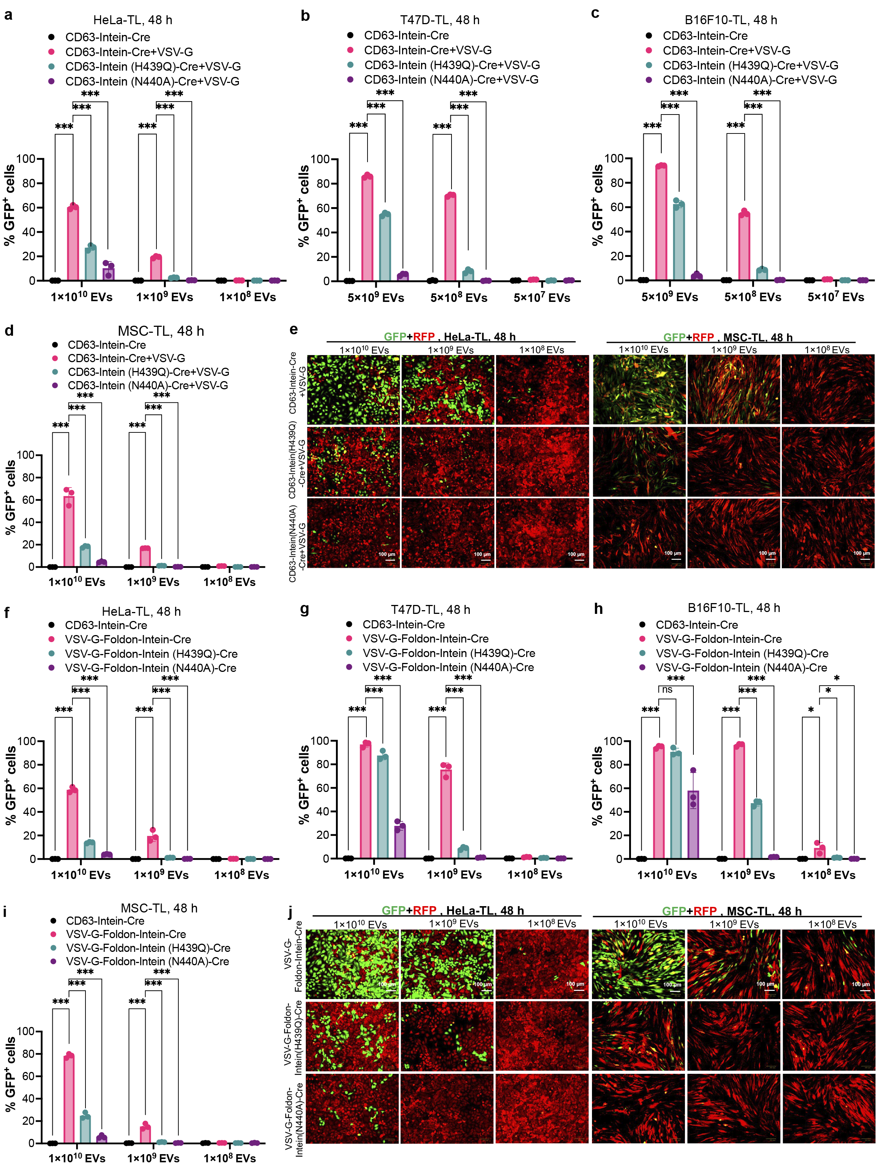
Supplementary Fig. 5. The pH-sensitive intein performs C-terminal cleavage during EV-biogenesis. a-d, Recombination in reporter cells (a: HeLa-TL; b: T47D-TL; c: B16F10-TL; d: MSC-TL) mediated by EVs derived from engineered cells using mutant inteins (H439Q and N440A) in VEDIC system. e, Fluorescent images showing the GFP positive cells in Hela-TL and MSC-TL cells. Scale bar, 100 μm, representative images. f-i, Recombination in reporter cells (f: HeLa-TL; g: T47D-TL; h: B16F10-TL; i: MSC-TL) mediated by EVs derived from engineered cells using mutant inteins (H439Q and N440A) in VFIC system detected by flow cytometry. j, Representative fluorescent images for the GFP positive cells after 48 hours’ adding various mutant intein variants engineered EVs at different doses for VFIC system. Scale bar, 100 μm. Two-way ANOVA multiple comparisons test was used for analysis of (a-d) and (f-i). Data are shown as means+SD, * p <0.05; *** p < 0.001; ns: non-significant.

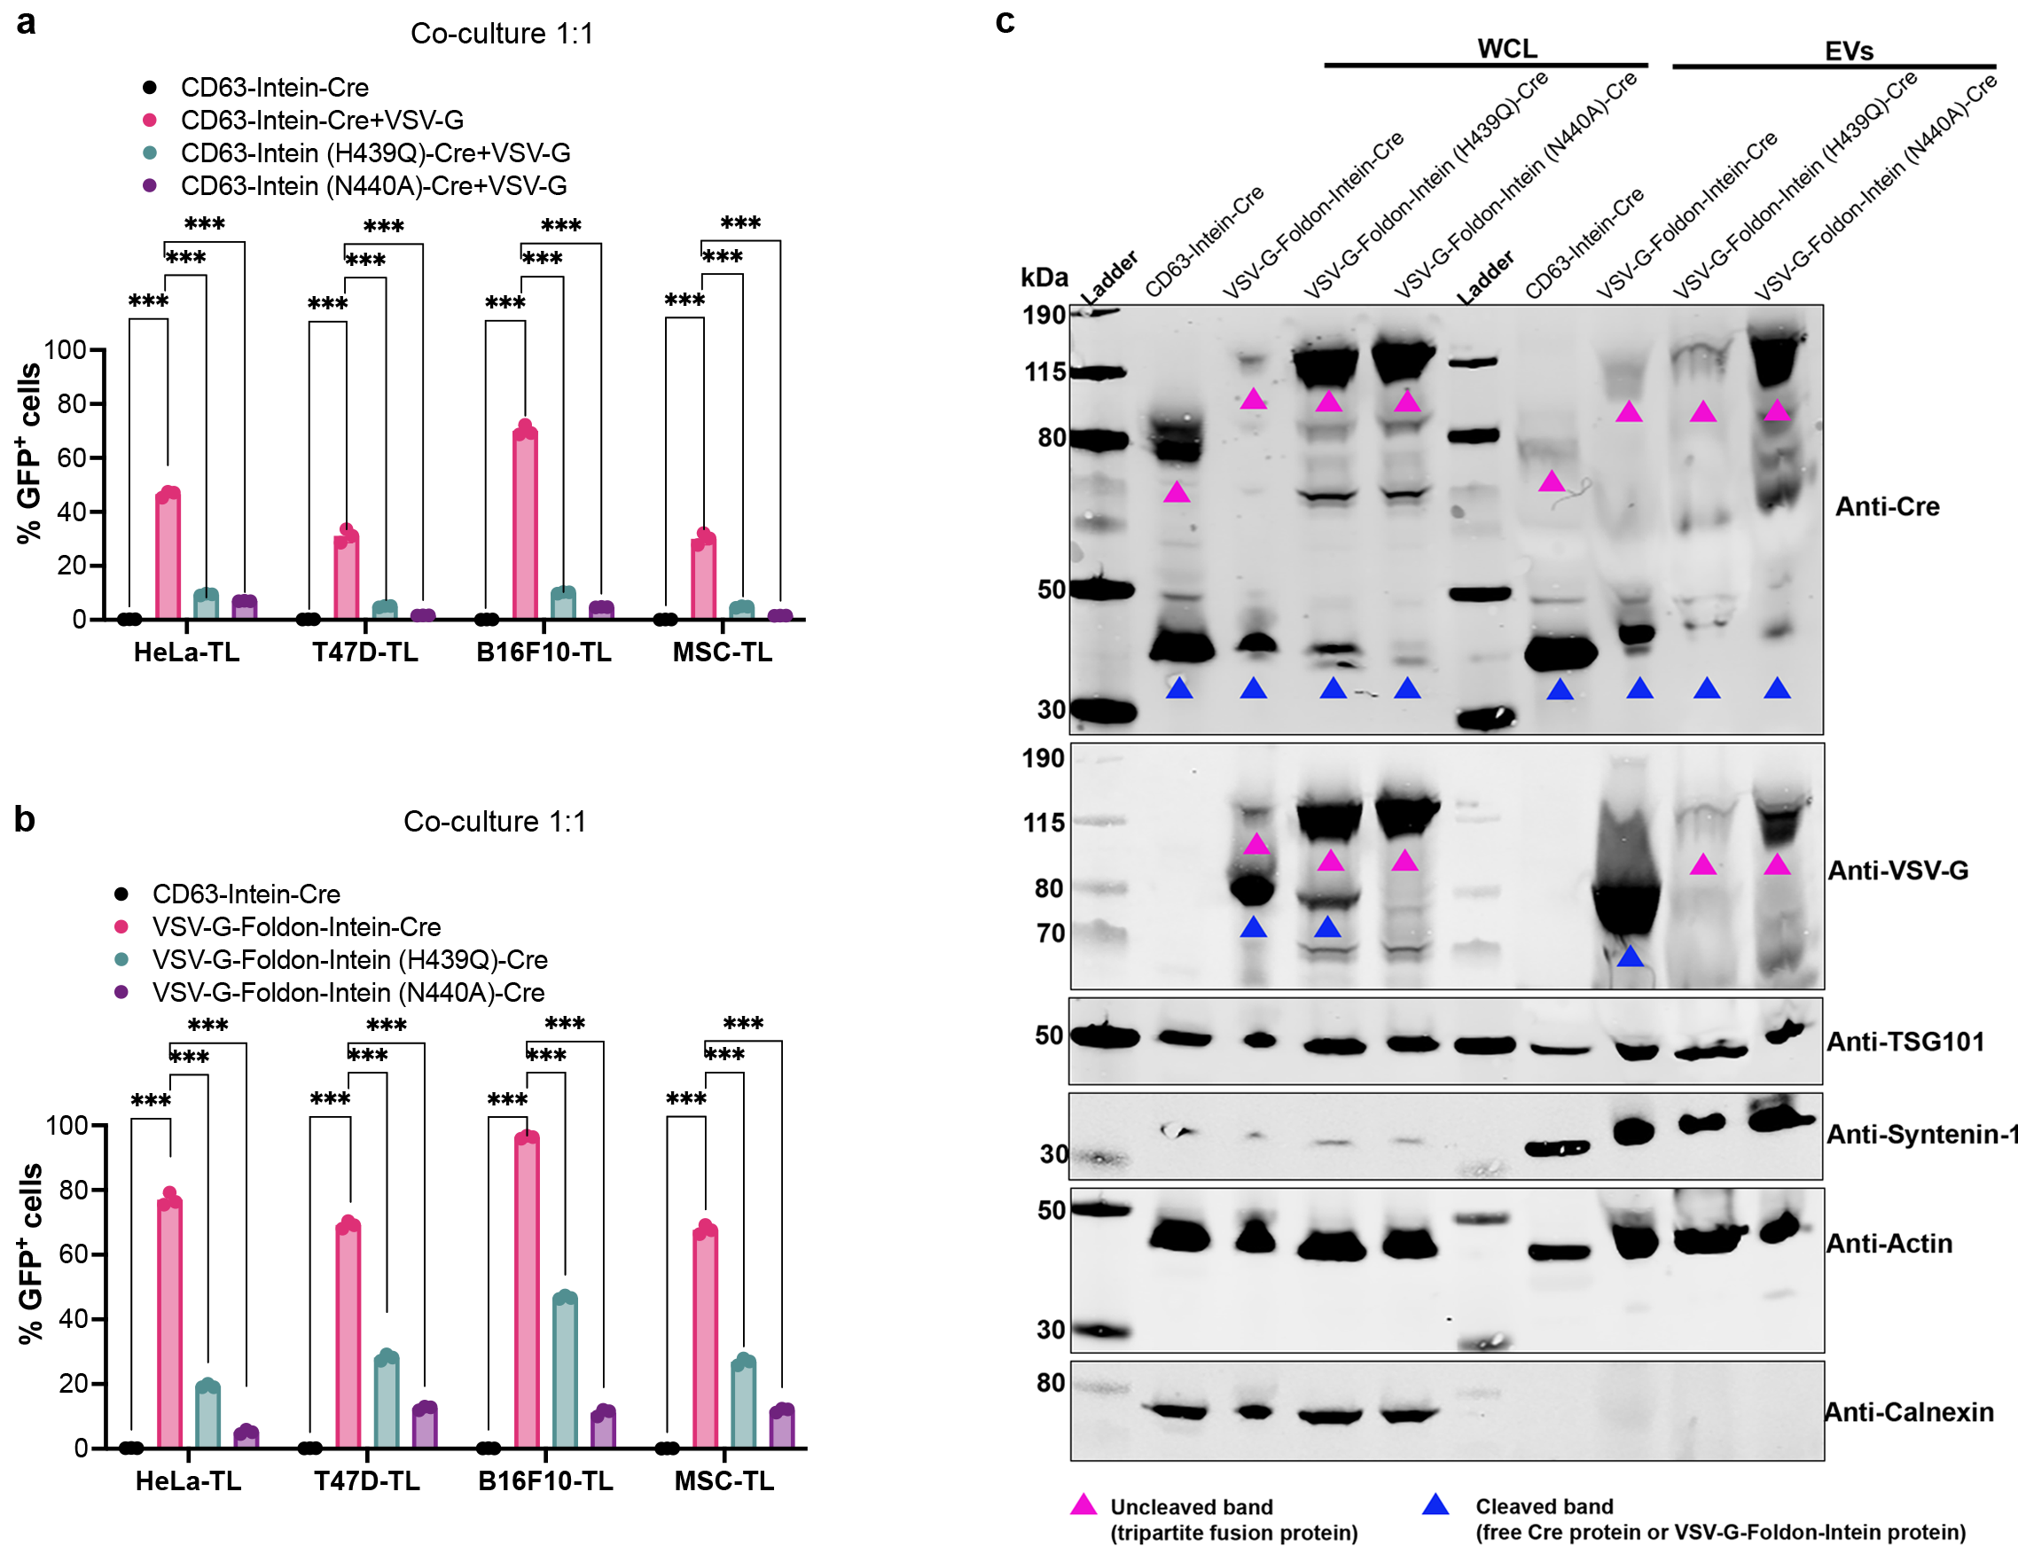 Supplementary Fig. 6. The pH-sensitive intein performs C-terminal cleavage during EV-biogenesis. a, Comparison of Cre transfer efficiency using different intein variants in a direct co-culture assay for VEDIC system. b, Flow cytometry analysis of a direct co-culture assay using intein variants to decrease Cre transfer for VFIC system. Co-culture was analyzed after 24 h incubation of the EV-producing cells and reporter cells. c, Protein expression of various engineered mutant intein constructs in WCL and isolated EVs derived from HEK-293T cells evaluated by WB analysis. Lysates from 5×10⁵ EV-producing cells and 1×10¹⁰ engineered vesicles were used for the assay. TSG101, syntenin-1 and β-actin were used as EV markers and Calnexin was used as a cellular organelle marker (endoplasmic reticulum) and should be absent for EV samples. Two-way ANOVA multiple comparisons test was used for analysis of (a and b). Data are shown as means+SD, *** p < 0.001.

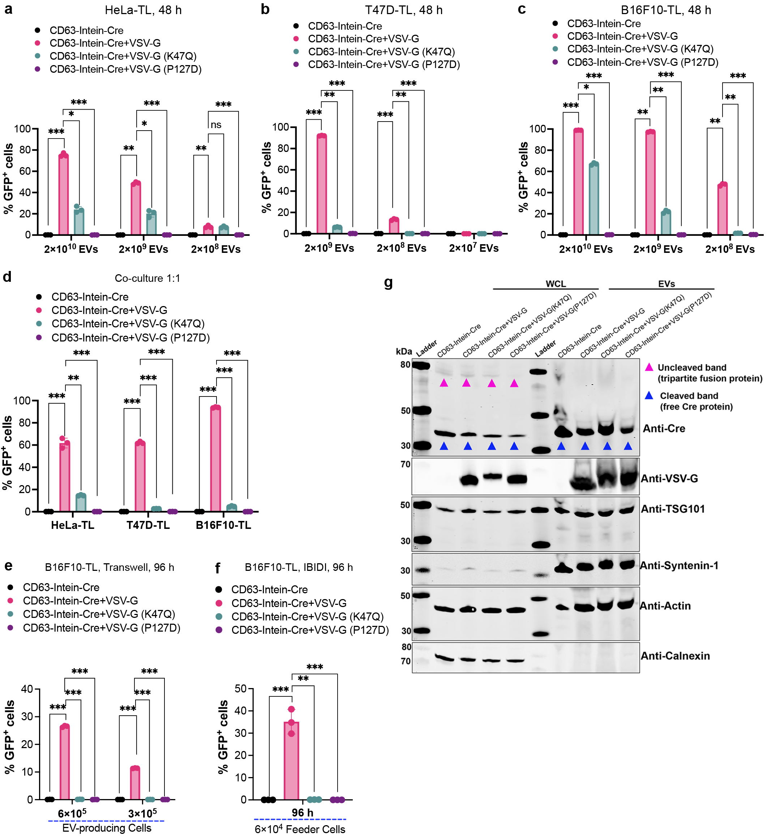
Supplementary Fig. 7. VSV-G boosts endosomal escape following receptor-mediated endocytosis of engineered EVs into recipient cells. a-c, Percentage of GFP positive HeLa-TL, T47D-TL and B16F10-TL cells after adding CD63-Intein-Cre EVs or wild type, P127D or K47Q VSV-G plus CD63-Intein-Cre EVs, as evaluated by flow cytometry. d, Direct co-culture assay to show the recombination efficiency of different engineered EVs. VSV-G (K47Q) and VSV-G (P127D) mutants were expressed in the EV-producing cells and resulting in abolished Cre delivery. e, Percentage of recombined GFP positive cells after a Transwell assay with B16F10-TL cells. VSV-G (K47Q) and VSV-G (P127D) mutants were expressed in the EV producing cells. Indicated numbers of EV-producing cells and 5×10⁴ B16F10-TL cells were used for the assay in 24-well plates. f, Percentage of GFP positive cells evaluated by IBIDI assay in B16F10-TL cells. Indicated number of EV-producing cells and 4×10⁴ reporter cells were used for this assay. g, Protein expression of mutated VSV-G-related constructs both in WCL of and isolated EVs evaluated by WB analysis. Proteins from 5×10⁵ EV producing cells and 1×10¹⁰ engineered vesicles were used for the assay. TSG101, syntenin-1 and β-actin were used as EV markers and Calnexin was used as cellular organelle marker (endoplasmic reticulum). Two-way ANOVA multiple comparisons test was used for analysis of (a-f). Data are shown as means+SD, * p < 0.05; ** p < 0.01; *** p < 0.001, ns: non-significant.

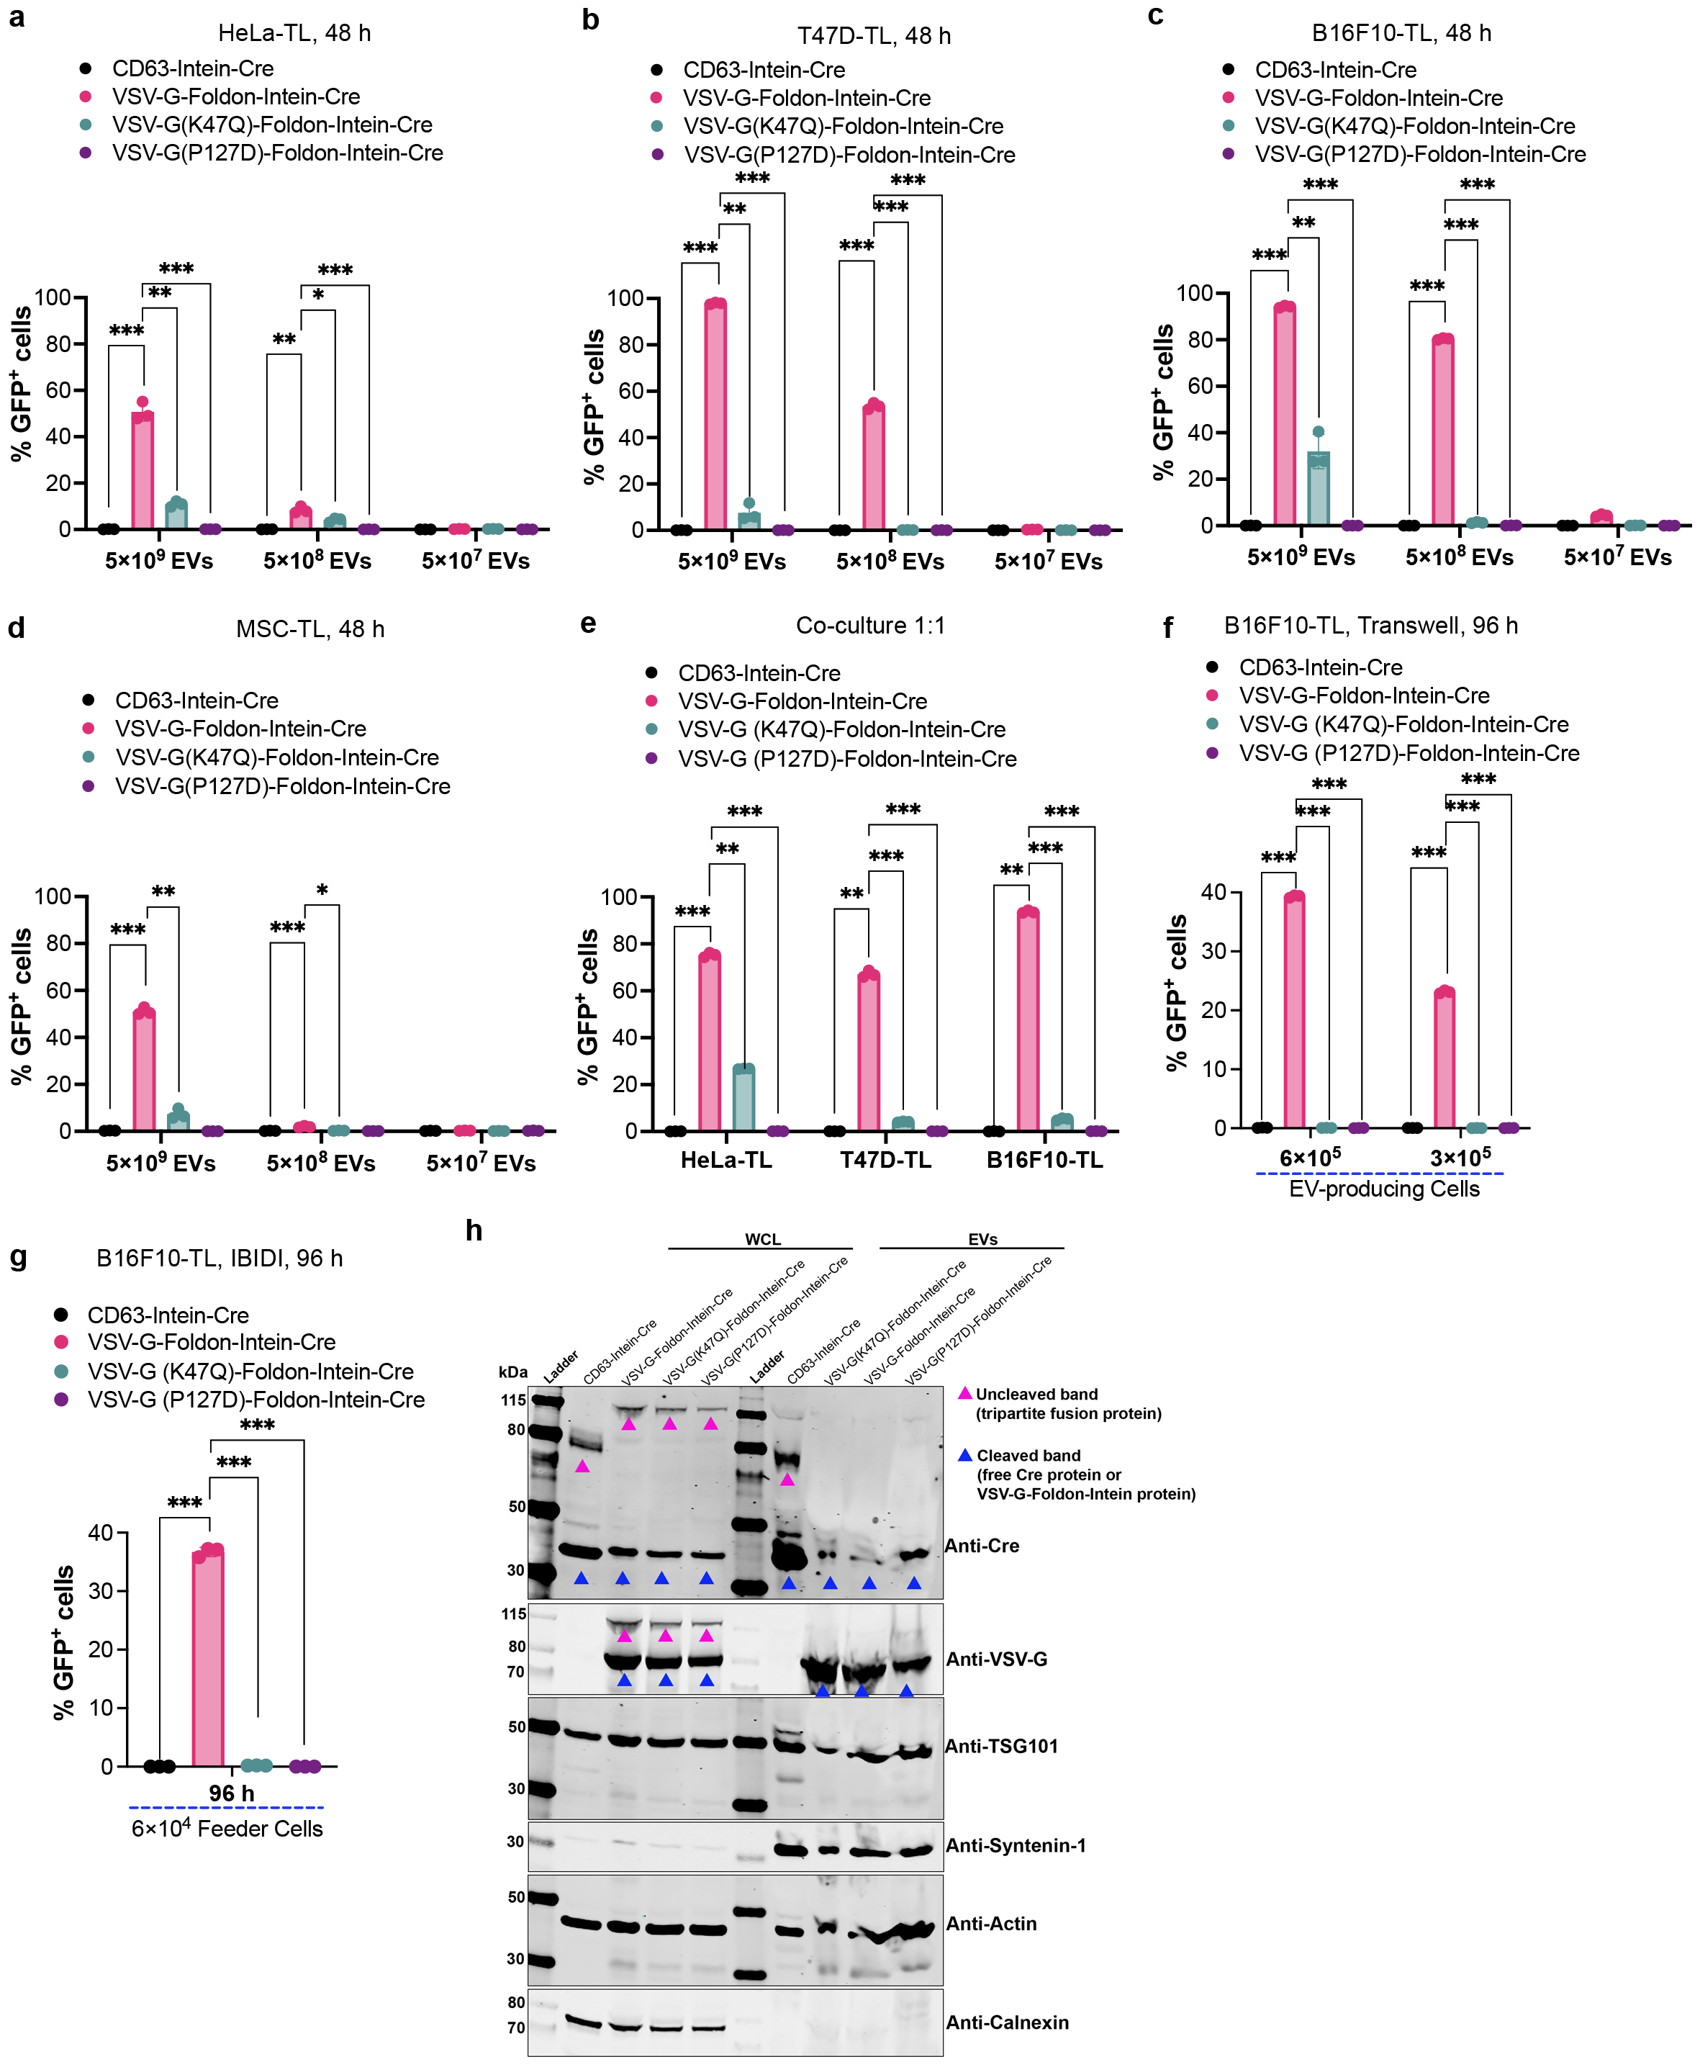
Supplementary Fig. 8. VSV-G boosts endosomal escape following receptor-mediated endocytosis of engineered EVs into recipient cells. a-d, Percentage of GFP positive HeLa-TL, T47D-TL, B16F10-TL and MSC-TL cells after adding wild type, P127D or K47Q VSV-G directly fused with Foldon-Intein-Cre EVs, as evaluated by flow cytometry. e, Direct co-culture assay to show the recombination efficiency of different engineered EVs. VSV-G (K47Q) and VSV-G (P127D) mutants were expressed in the EV-producing cells and resulting in abolished Cre delivery. f, Percentage of recombined GFP positive cells after a Transwell assay with B16F10-TL cells. VSV-G (K47Q) and VSV-G (P127D) mutants were expressed in the EV producing cells. Indicated numbers of EV-producing cells and 5×10⁴ B16F10-TL cells were used for the assay in 24-well plates. g, Percentage of GFP positive cells evaluated by IBIDI assay in B16F10-TL cells. Indicated number of EV-producing cells and 4×10⁴ reporter cells were used for this assay. h, Protein expression of directly fused mutated VSV-G-related constructs both in WCL of and isolated EVs evaluated by WB analysis. Proteins from 5×10⁵ EV producing cells and 1×10¹⁰ engineered vesicles were used for the assay. TSG101, syntenin-1 and β-actin were used as EV markers and Calnexin was used as cellular organelle marker (endoplasmic reticulum). Two-way ANOVA multiple comparisons test was used for analysis of (a-g). Data are shown as means+SD, * p < 0.05; ** p < 0.01; *** p < 0.001.

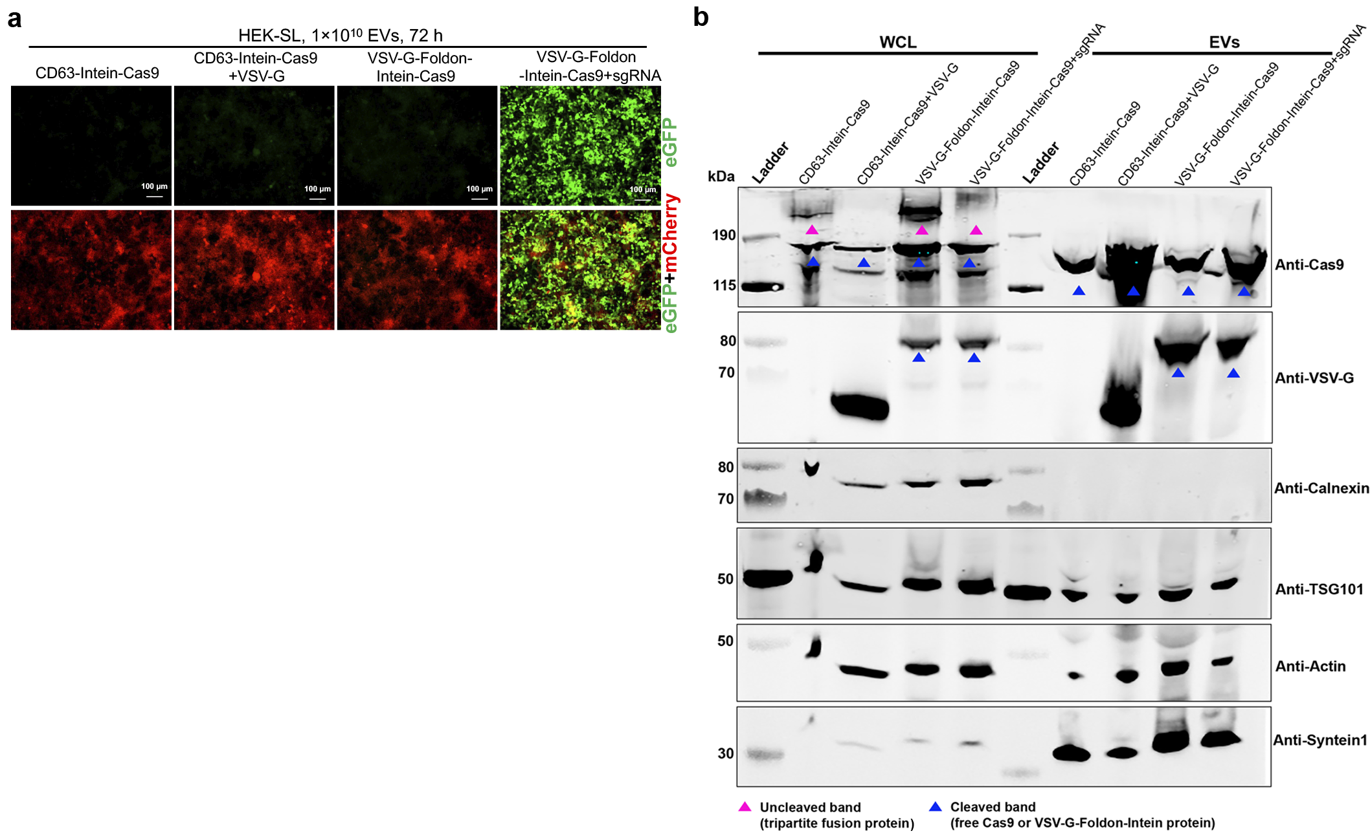 Supplementary Fig. 9. Characterization of Cas9-mediated genome editing in reporter cells by engineered EVs. a, Fluorescence microscopy images demonstrating functional Cas9/sgRNA RNPs delivery, as indicated by GFP positive signals, in HEK293T stoplight (HEK-SL) reporter cells after addition of indicated doses of EVs for 72 h. Scale bar, 100 μm, representative images. b, Protein expression of Cas9 related constructs in both whole cell lysate (WCL) and EVs evaluated by western blot analysis. Proteins from 5×10⁵ EV-producing cells and 1×10¹⁰ engineered vesicles were used for the assay. TSG101, syntenin-1 and β-actin were used as EV markers while Calnexin was used as cellular organelle marker (endoplasmic reticulum).
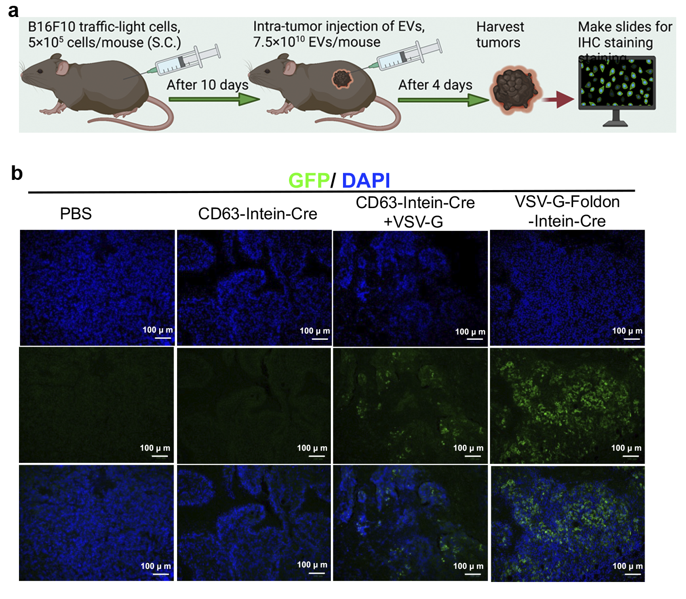
Supplementary Fig. 10. Cre recombination in melanoma-xenograft. a, Workflow for the intratumoral injection model. b, Representative immunofluorescence images from tumor tissues after intratumoral injection of engineered EVs to induce GFP expression. Scale bar, 100 µm. n=3 mice per group.
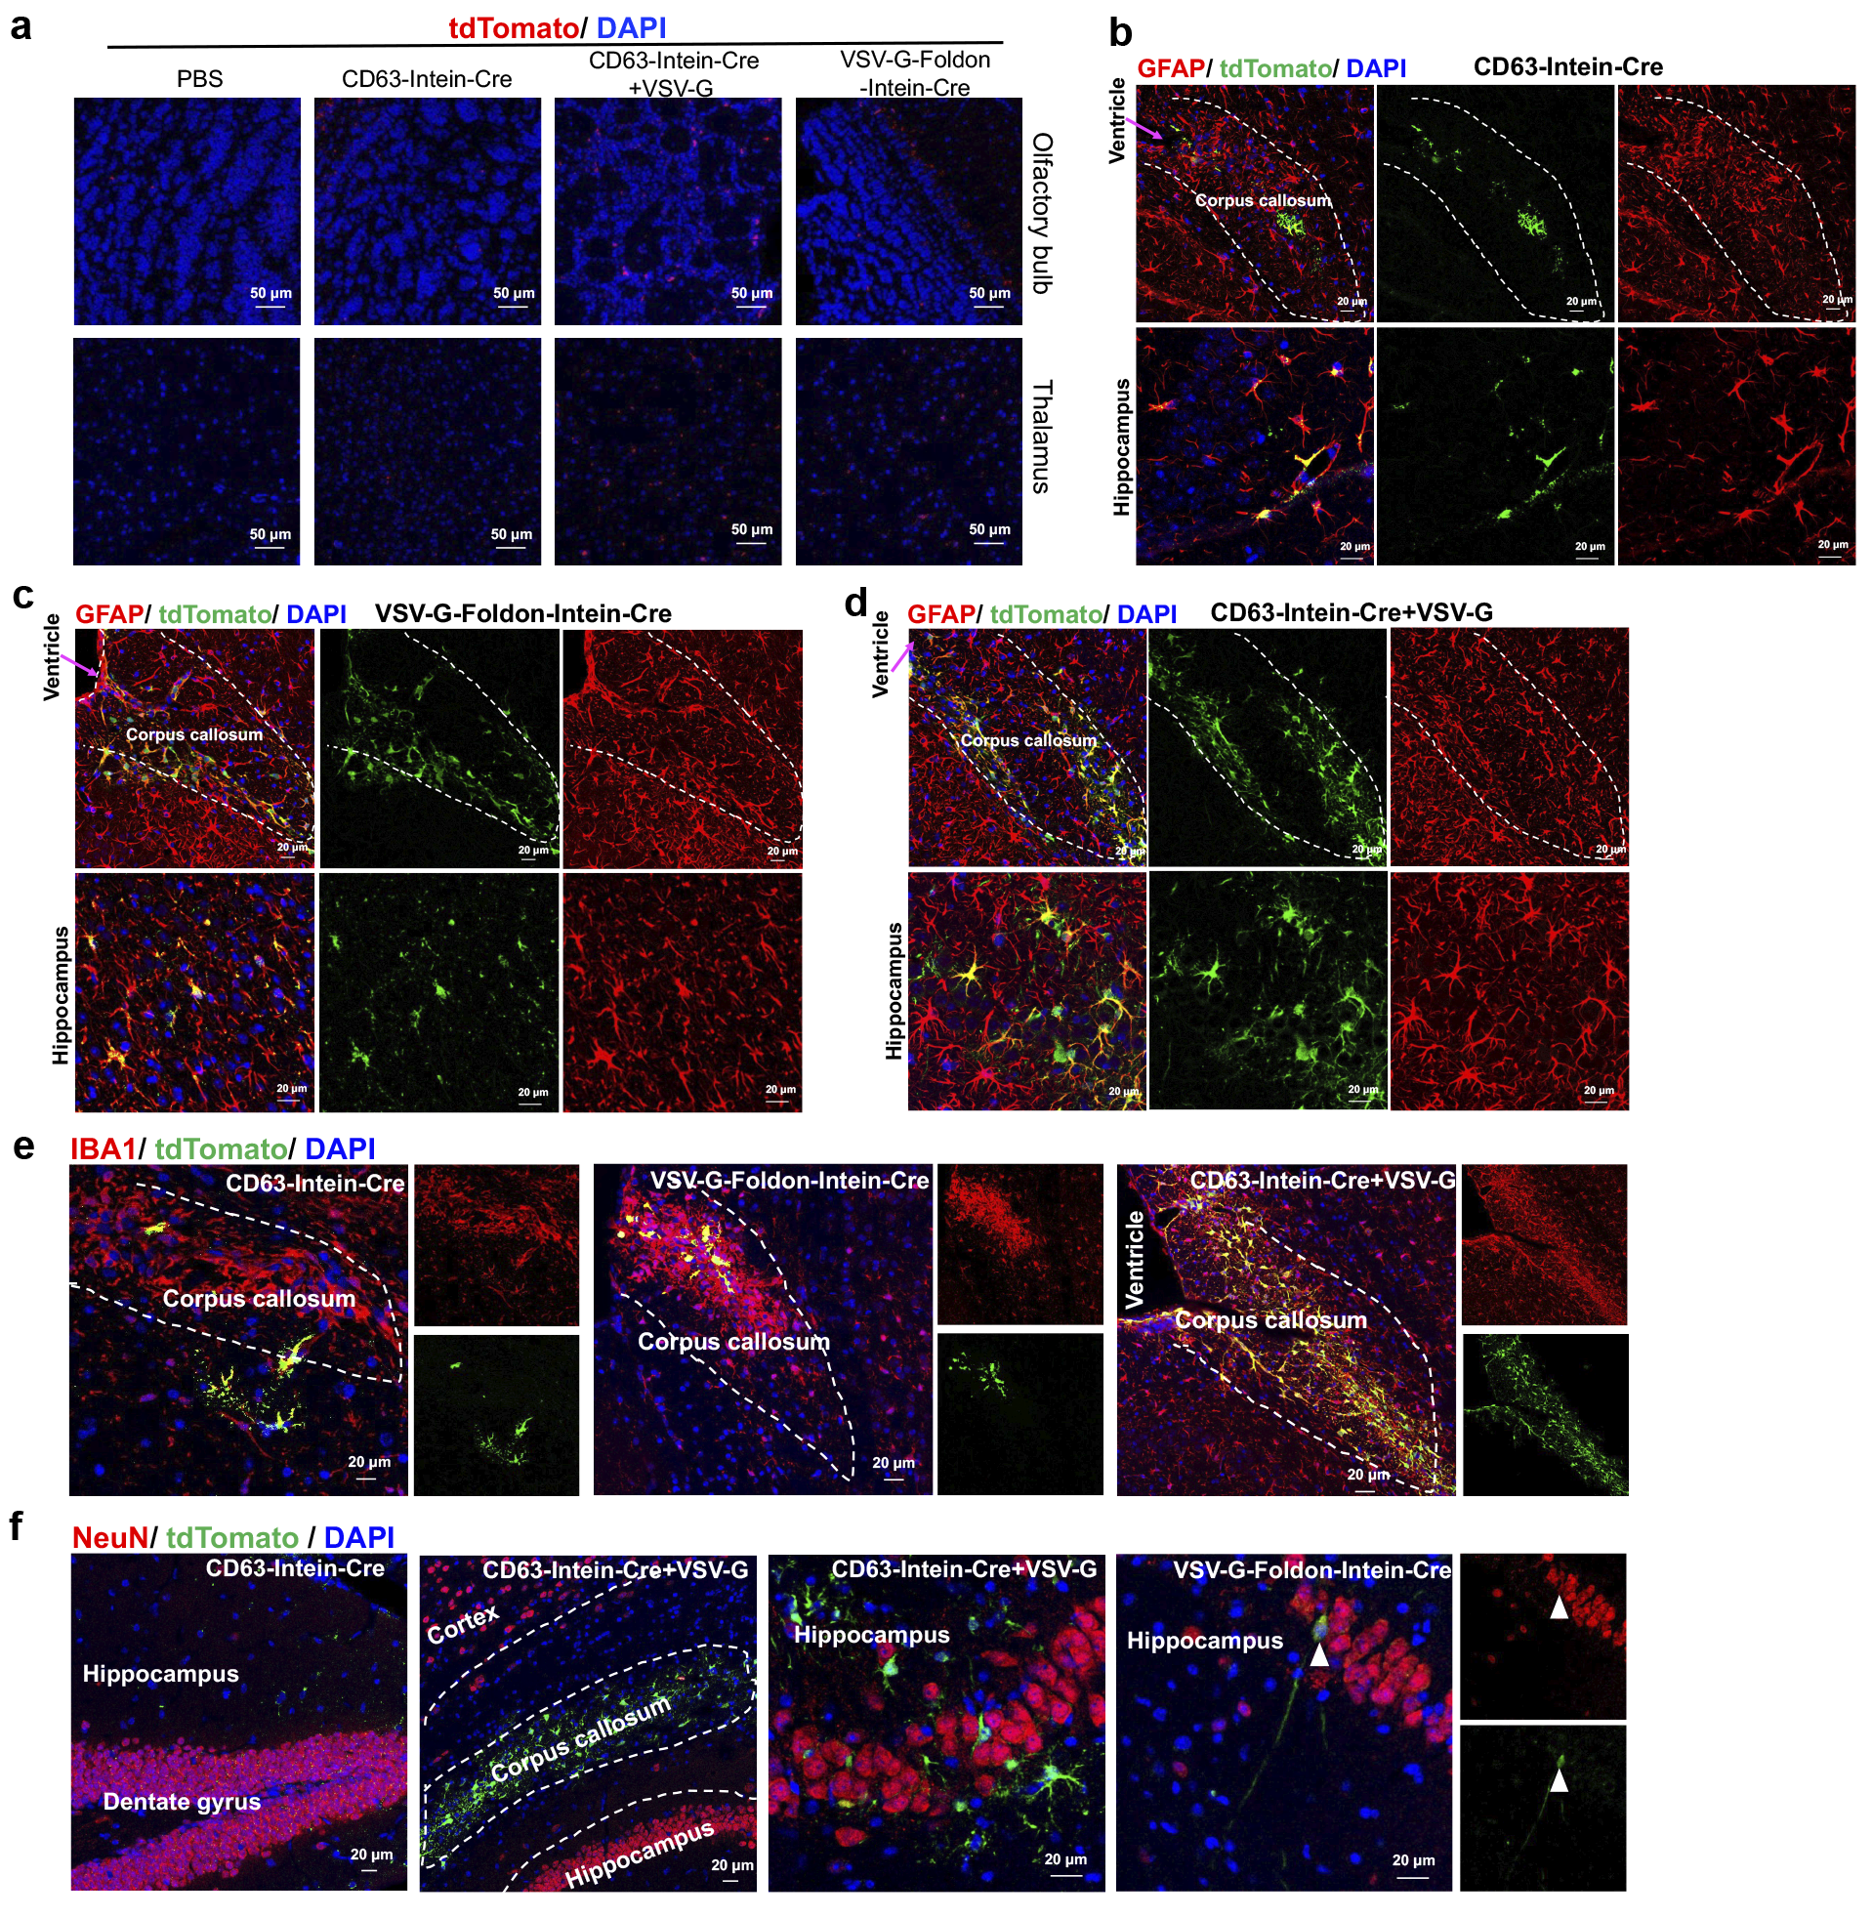 Supplementary Fig. 11. Cre-mediated recombination in R26-LSL-tdTomato reporter mice by VEDIC and VFIC systems after local injection. a, IHC staining of the olfactory bulb and thalamus one week after ICV injection of the engineered EVs. Scale bar, 50μm. b-d, Co-staining of tdTomato with the astrocyte marker GFAP in corpus callosum (outlined by dashed lines) and hippocampus one week after ICV injection of engineered EVs. Scale bar, 20 µm. e, Co-staining of microglia marker IBA1 with tdTomato in corpus callosum (highlighted by dashed lines) after ICV injection of engineered EVs. Scale bar, 20 μm. f, Co-staining of neuron cell marker NeuN with tdTomato in different regions of brain after ICV injection of different engineered EVs. Scale bar, 20 μm. White arrow indicates sporadic cells with co-localization of NeuN and RFP. n=3 mice per group, representative images for (a-f).
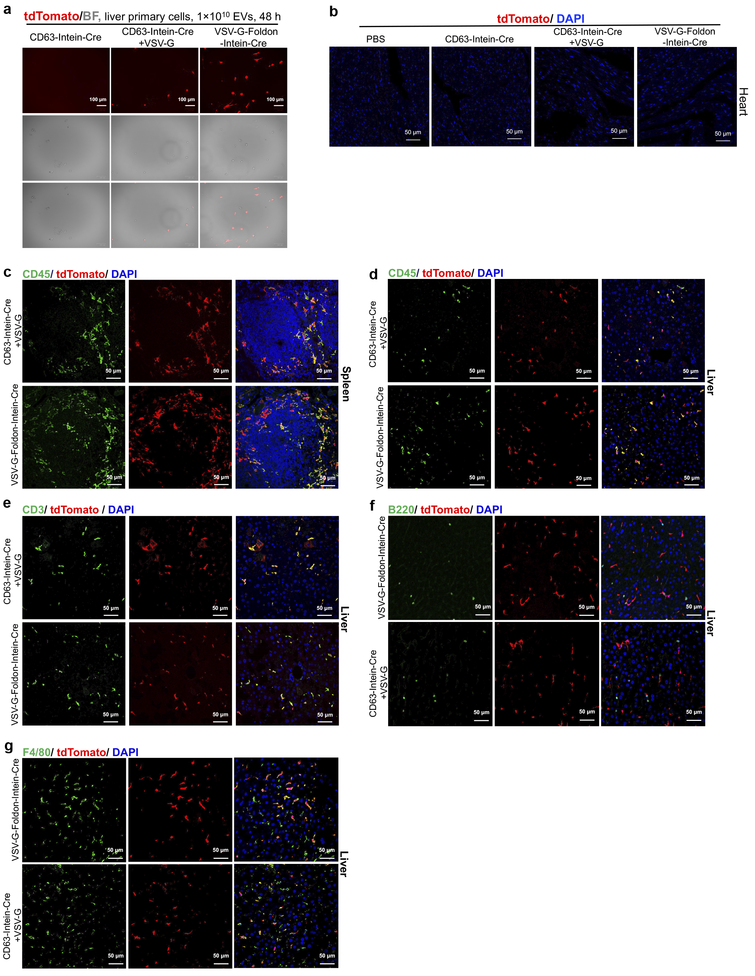
Supplementary Fig. 12. Cre recombination in R26-LSL-tdTomato reporter mice following systemic VEDIC and VFIC EV-mediated Cre delivery. a, Representative fluorescent microscopic images demonstrated tdTomato positive liver primary cells from R26-LSL-tdTomato reporter mice after adding VEDIC and VFIC EVs for 2 days. Scale bar, 100 μm.
b, IHC staining of the heart, one week after IP injection of the engineered EVs. Scale bar, 50 μm. c, Co-staining of tdTomato with the general leukocyte marker CD45 in spleen as detected by immunofluorescence one week after IP injection of engineered EVs. Scale bar, 50 µm. d, Co-staining of general leukocyte marker CD45 with tdTomato expression in liver after IP injection of engineered EVs. Scale bar, 50 μm. e, C-localization of T cell marker CD3 with tdTomato in liver one week after IP injection of engineered EVs as detected by IHC co-staining. Scale bar, 50 μm. f, Co-localization of B cell marker B220 with tdTomato in liver one week after IP injection of different engineered EVs. Scale bar, 50 μm. g, Co-expression of macrophage marker F4/80 with tdTomato in liver evaluated by IHC co-staining one week after injecting engineered EVs. Scale bar, 50 μm. n=3 mice per group, representative images for (b-g).

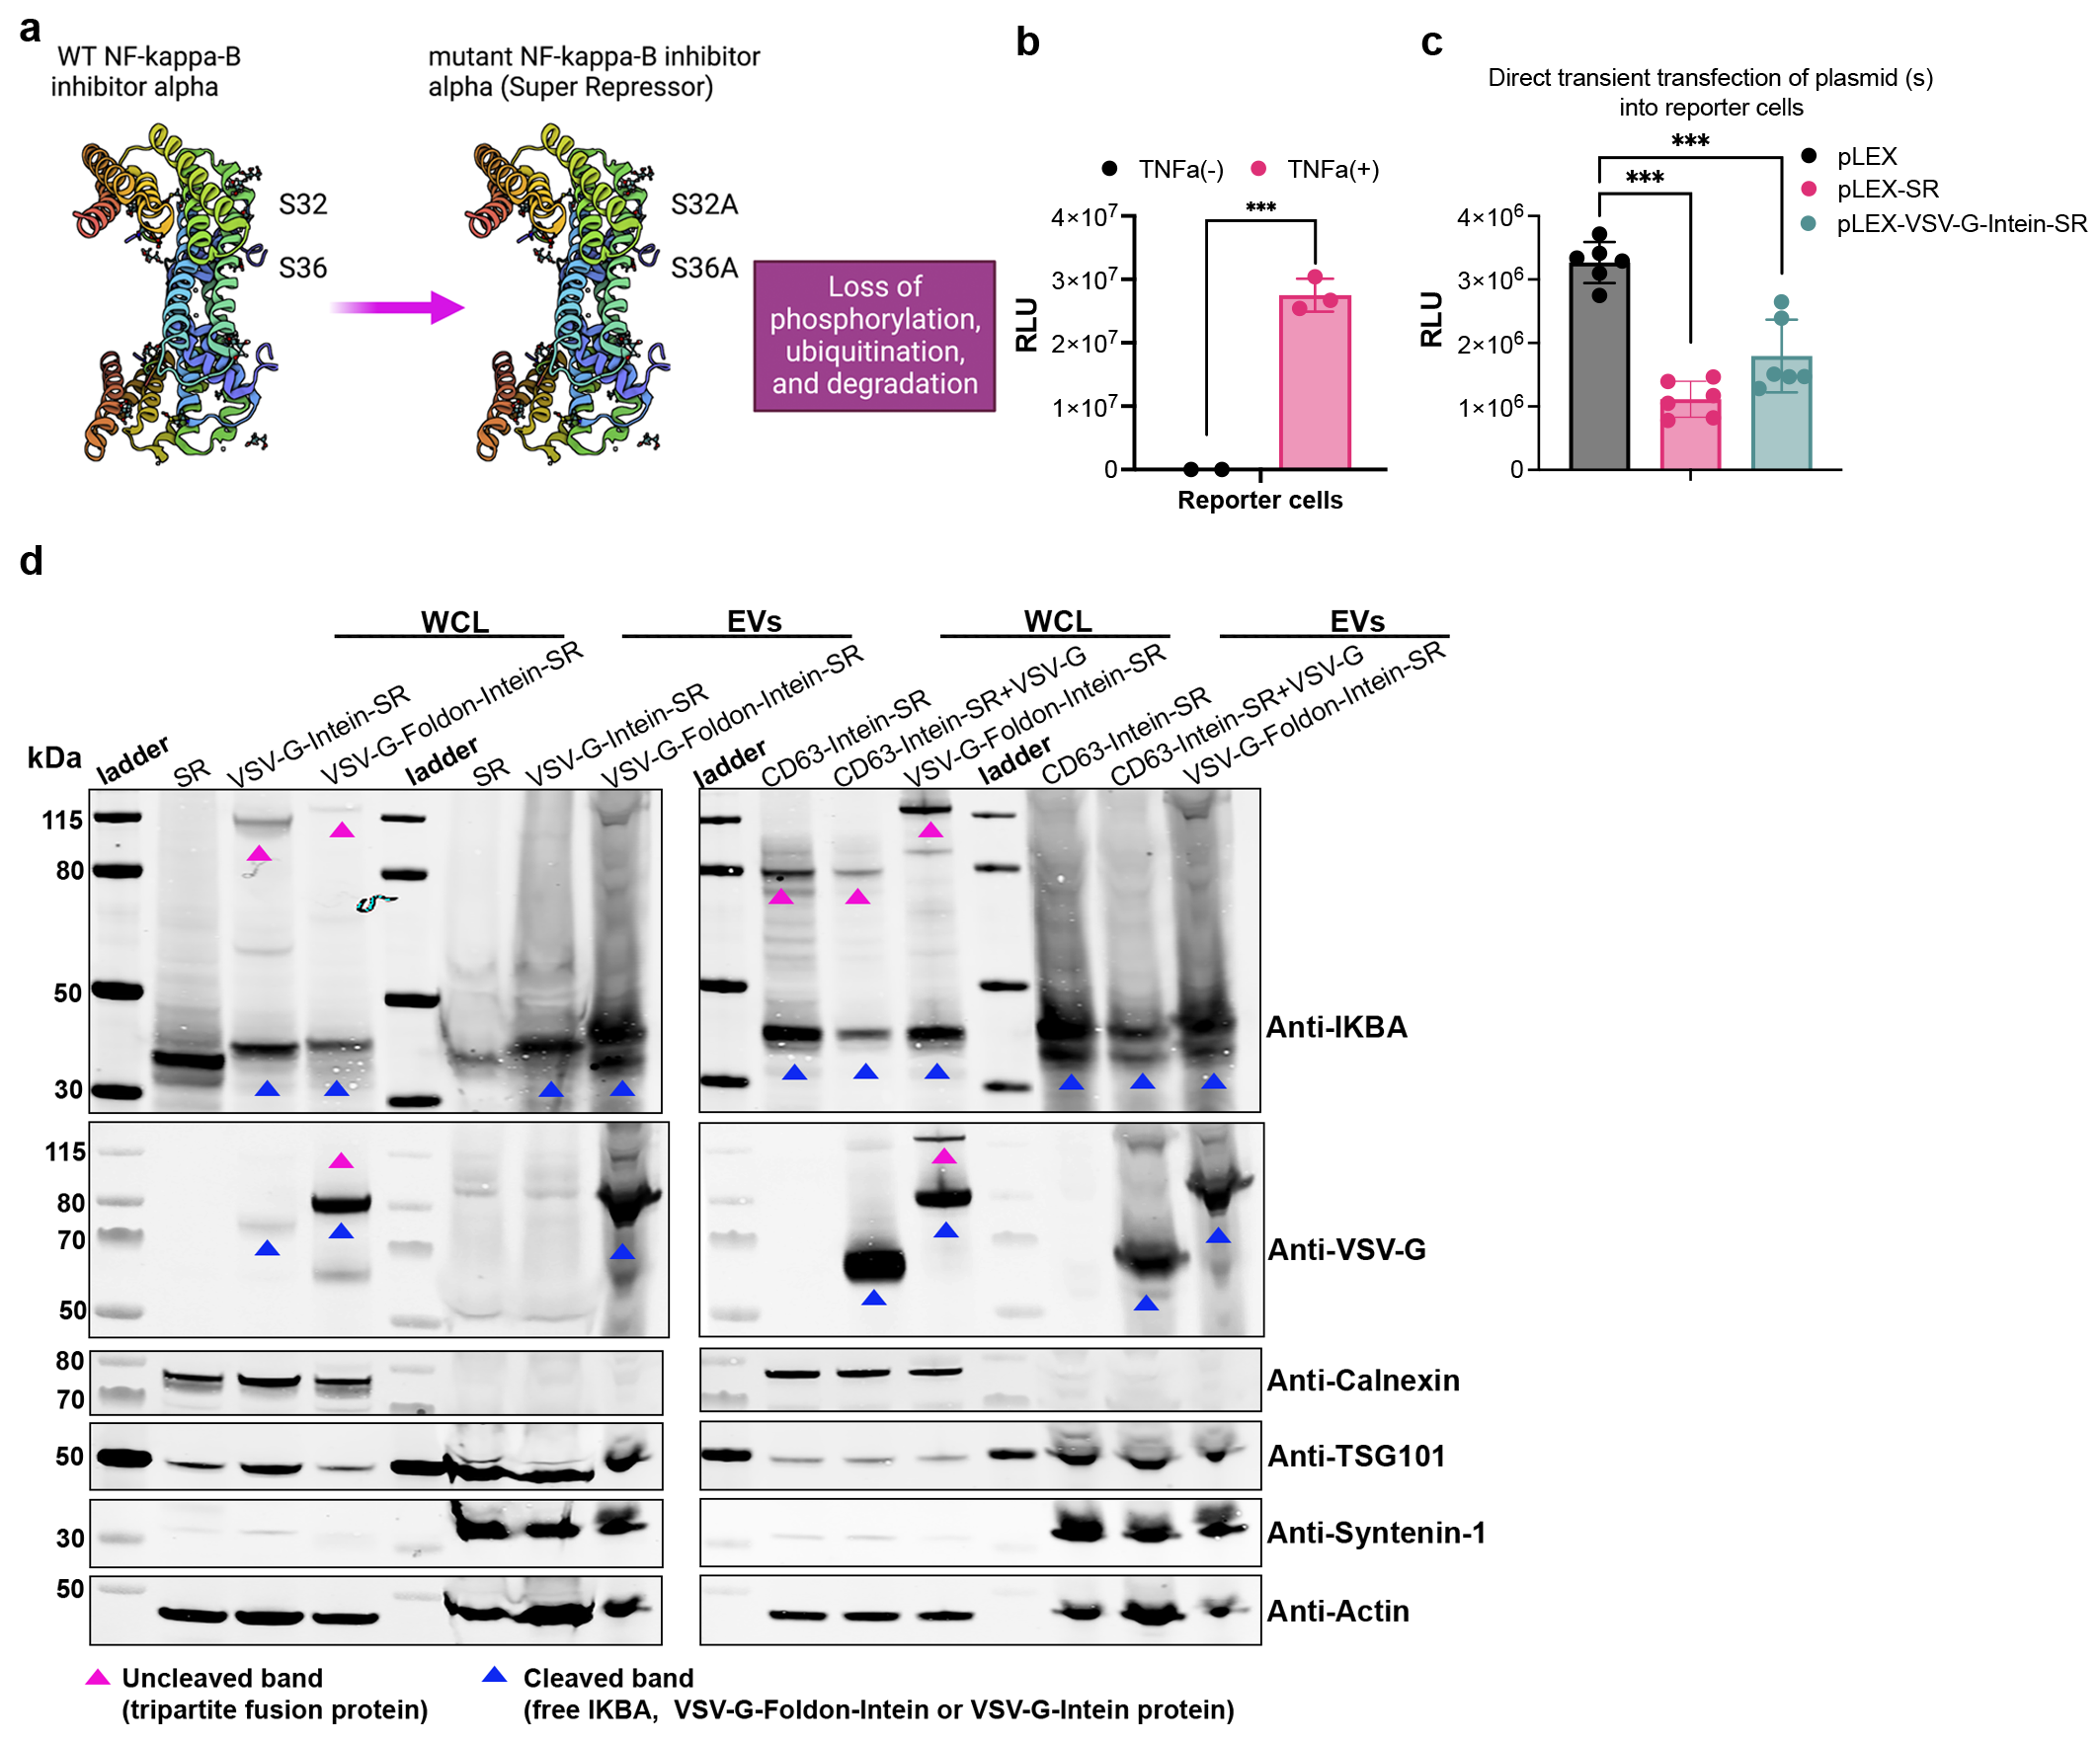 Supplementary Fig. 13. The design of super repressor (SR) inhibitor of NF-ĸB constructs and their expression and function in vitro. a, The mutations and properties of the super repressor inhibitor of NF-ĸB. b, Activation of luciferase expression 6 h after TNF-α stimulation (10 ng/ml) in HEK-Blue-NF-ĸB reporter cells. c, Significant decrease of the luciferase signals from lysate of HEK-Blue-NF-ĸB reporter cells after transient transfection of SR-related constructs. 48 h after transfection cells were stimulated with TNF-α for 6 h prior to luciferase detection. d, Protein expression of SR-related constructs in both WCL and isolated EVs evaluated by WB analysis. Proteins from 5×10⁵ EV-producing cells and 1×10¹⁰ engineered vesicles were used for the assay. TSG101, syntenin-1 and β-actin were used as EV markers while Calnexin was used as cellular organelle marker (endoplasmic reticulum). Two-tailed T-test was used for the analysis of (b); One-way ANOVA multiple comparisons test was used for analysis of (c). Data are shown as means+SD, *** p < 0.001.

Supplementary Table 1: key reagents and resources

Reagent or resource | Source | Identifier | Dilution
Primary antibodies for IHC
Rabbit anti-IBA1 | Wako | Cat#: 019-1941 | 1:500
Rabbit anti-GFAP | Abcam | Cat#: ab53554 | 1:500
Rabbit anti-RFP | Thermo Fisher Scientific | Cat#: 600-401-379-RTU | 1:400
Biotin anti-RFP | Abcam | Cat#: ab34771 | 1:400
Rabbit anti-CD45 | Abcam | Cat#: ab10558 | 1:200
Rat anti-F4/80 | Bio-Rad | Cat#: MCA497G | 1:100
Rat anti-B220 | Thermo Fisher Scientific | Cat#: 14-0452-82 | 1:100
Rat anti-NeuN | Millipore | Cat#: MAB377 | 1:100
Rat anti-CD3 | Dako | Cat#: A0452 | 1:100
Rat anti-Mouse CD8a | BD Pharmingen | Cat#: 553027 | 1:500
Rabbit anti-GFP | Abcam | Cat#: ab290 | 1:200
Secondary antibodies for IHC
Alexa Flour 488 goat anti-mouse | Thermo Fisher Scientific | Cat#: A11001 | 1:400
Alexa Fluor 633 goat anti-rabbit | Thermo Fisher Scientific | Cat#: A21070 | 1:400
Alexa Fluor 568 goat anti-rat | Thermo Fisher Scientific | Cat#: A11077 | 1:400
Alexa Fluor 568-conjugated streptavidin | Thermo Fisher Scientific | Cat#: S11226 | 1:400
Alexa Fluor 488 goat anti-rat | Abcam | Cat#: ab150077 | 1:800

Reagent or resource | Source | Identifier | Dilution
Primary antibodies for WB
Rabbit anti-TSG101 | Thermo Fisher Scientific | Cat#: PA5-82236 | 1:1000
Rabbit anti-Cre | Abcam | Cat#: ab188568 | 1:1000
Rabbit anti-Syntenin-1 | Thermo Fisher Scientific | Cat#: 600-401-379-RTU | 1:1000
Goat anti-VSV-G | Thermo Fisher Scientific | Cat#: PA1-30278 | 1:1000
Mouse anti-Cas9 | Thermo Fisher Scientific | Cat#: MA5-23519 | 1:1000
Goat anti-Calnexin | Thermo Fisher Scientific | Cat#: MCA497G | 1:1000
Mouse anti-β-Actin | Sigma | Cat#: A5441 | 1:20000
Mouse anti- IkB-alpha | Thermo Fisher Scientific | Cat#: MA5-15132 | 1:1000
Rabbit anti-PCSK9 | Thermo Fisher Scientific | Cat#: PA5-78663 | 1:1000
Secondary antibodies for WB
IRDye® 800CW Donkey anti-Goat IgG | LI-COR Biosciences | Cat#: 926-32214 | 1:10000
IRDye® 800CW Goat anti-Mouse IgG | LI-COR Biosciences | Cat#: 926-32210 | 1:10000
IRDye® 800CW Goat anti-Rabbit IgG | LI-COR Biosciences | Cat#: 926-32211 | 1:10000
IRDye® 680RD Goat anti-Mouse IgG | LI-COR Biosciences | Cat#: 926-68070 | 1:10000
IRDye® 800CW Donkey anti-Goat IgG | LI-COR Biosciences | Cat#: 926-32214 | 1:10000

Reagent or resource (plasmids) | Source | Identifier
pCMV-VSV-G | Addgene | 8454
pLV-CMV-LoxP-DsRed-LoxP-eGFP | Addgene | 65726
pCMV-VSV-G-(P127D)-Myc | Addgene | 80055
pLEX | This study
pLEX-Cre | This study
pLEX-Intein-Cre | This study
pLEX-CD63-Cre | This study
pLEX-CD63-Intein-Cre | This study
pLEX-VSV-G-Intein-Cre | This study
pLEX-VSV-G-Cre | This study
pLEX-VSV-G-Foldon-Intein-Cre | This study
pLEX-VSV-G-Foldon-Intein-MS2 | This study
pLEX-VSV-G-Foldon-Cre | This study
pLEX-CD63-mnGFP | This study
pLEX-CD63-Intein-mnGFP | This study
pLEX-VSV-G (K47Q)-Foldon-Intein-Cre | This study
pLEX-VSV-G (P127D)-Fodon-Intein-Cre | This study
pLEX-VSV-G (K47Q) | This study
pLEX-VSV-G-Foldon-Intein-Cas9 | This study
pLEX-CD63-Intein-Cas9 | This study
pLEX-VSV-G-Intein-SR | This study
pLEX-VSV-G-Foldon-Intein-SR | This study
pLEX-super repressor (SR) | This study
pLEX-CD9-Intein-Cre | This study
pLEX-C81-Intein-Cre | This study
pLEX-PTGFRN-Intein-Cre | This study
pBB-U6-GFPsgRNA | This study
pLEX-CV-G-Intein-Cre | This study
pLEX-EPFV-Intein-Cre | This study
pLEX-CV-G | This study
pTwist CMV-ERVK-19 | This study
pTwist CMV-ERVMER34-1 | This study
pTwist CMV-ERVI-1 | This study
pTwist CMV-SPACA3 | This study
pTwist CMV-EQTN | This study
pTwist CMV-TMEM95 | This study
pTwist CMV-HERV-H | This study
pTwist CMV-ERVV-2 | This study
pTwist CMV-ERVK13-1 | This study
pTwist CMV-FIMP | This study
pTwist CMV-Syncytin-2 | This study
pTwist CMV-HERVK_113 | This study
pTwist CMV-ERVK-21 | This study
pTwist CMV-Env type 1 | This study
pTwist CMV-SPAM1 | This study
pTwist CMV-ERVK-18 | This study
pTwist CMV-ERVK-8 | This study
pTwist CMV-ERVK-25 | This study
pTwist CMV-ADAM12 | This study
pTwist CMV-ERVK-9 | This study
pTwist CMV-ERVK-24 | This study
pTwist CMV-Envelope glycoprotein (1) | This study
pTwist CMV-IZUMO1 | This study
pTwist CMV-HERV-H | This study
pTwist CMV-ERVK-7 | This study
pTwist CMV-ERVS71-1 | This study
pTwist CMV-Envelope protein | This study
pTwist CMV-Pol/env protein | This study
pTwist CMV-MYMK | This study
pTwist CMV-ERVK-6 | This study
pTwist CMV-ERVPABLB-1 | This study
pTwist CMV-Envelope polyprotein (2) | This study
pTwist CMV-FLJ32214 | This study
pTwist CMV-SPACA6 | This study
pTwist CMV-ERVFC1 | This study
pTwist CMV-ERVV-1 | This study
pTwist CMV-Envelope glycoprotein (3) | This study
pTwist CMV-Env type 2 | This study
pTwist CMV-MYMX | This study
pTwist CMV-IZUMO1R | This study
pcoPE01(EPFV) | This study
pCD/NL-BH | This study
pLEX-M1 PCSK9 | This study
pLEX-CD63-Intein-M1 | This study
pLEX-VSV-G-Foldon-Intein-M1 This study
pLEX-CD63-Intein (H439Q)-Cre | This study
pLEX-CD63-Intein (N440A)-Cre | This study
pLEX-VSV-G-Foldon-Intein (H439Q)-Cre | This study
pLEX-VSV-G-Foldon-Intein (N440A)-Cre This study
pLEX-CD63-Intein-SR | This study

Reagent or resource (sequences) | Source | Sequence
sgRNA | This study | GGACAGTACTCCGCTCGAGT

Reagent or resource | Source | Identifier
Plasmid Plus Midi Kit | QIAGEN | Cat#: 12943
Plasmid Plus Maxi Kit | QIAGEN | Cat#: 12963
Phusion High-Fidelity DNA Polymerase | Thermo Fisher Scientific | Cat#: 15331732
NucleoSpin Gel and PCR Clean-up XS | Techtum Lab | Cat#: 32-740611.250
HotStarTaq Plus Master Mix Kit | QIAGEN | Cat#: 203645
Maxwell RSC Cell DNA Purification Kit | Promega | Cat#: AS1370
T4 DNA Ligase | Thermo Fisher Scientific | Cat#: EL0011
One Shot TOP10 Chemically Competent E. coli | Thermo Fisher Scientific | Cat#: C404006
Ibidi USA U SLIDE | IBIDI | Cat#: 81806
Millicell Cell Culture Insert | Merck Millipore | Cat#: PICM01250
polyethylenimine (PEI) MAX | Polysciences | Cat#: 24765-1
InterceptTM blocking buffer | LI-COR Biosciences | Cat#: 927-60003
TNF-α | Thermo Fisher Scientific | Cat#: PHC3013

Reagent or resource | Source | Identifier
Experimental cell lines
HEK-293T | ATCC | Cat#: CRL-3216
Hela-TL | This study
Huh7 | Elabscience | Cat#: EP-CL-0120
B16F10-TL | This study
MSC-TL | This study
Raw264.7-TL | This study
THP-1-TL | This study
K562-TL | This study
HEK-SL | Pieter Vader’s lab
MSC-TL | This study
T47D-TL | This study
HEK-Blue-NF-ĸB | InvivoGen

Reagent or resource | Source | Identifier
Experimental animals
C57BL/6J mice | Charles River Laboratories | Cat#: 027
Cre-LoxP R26-LSL-tdTomato reporter mice | Jackson Laboratory | Cat#: 007914

