Supplementary Material for

Electricity Experiment Regarding Magnetic Fields with Gravity

Jong-hoon Lee

Science & Research Center, Seoul National University College of Medicine, Seoul, South Korea

*Corresponding Author
Jong-hoon Lee
Science and Research Center, Seoul National University College of Medicine
103 Daehak-ro, Jongno-gu, Seoul, 03080, Republic of Korea
Tel: 82-2-762-3062 Fax: 82-2-762-3061
Email: science@research.re.kr
내용
Supplemental Section 1. Magnetic sea generator Design 4
Supplemental Section 2. Keysight B2901A Manual 9
Supplemental Section 3. 2019-10-10 Experiments 11
(A, B, C – Supplementary Table 1) 11
Experiments (D, E, F – Supplementary Table 3) 13
Experiments (Only Voltage while Rotating) 15
Experiments (Voltage Only while Stationary) 16
Supplemental Section 4. 2020-06-18 Experiments in the Vacuum Chamber 17
Keysight B2901A Equipment preparation for vacuum experiments in the air 19
Voltage and Current of Keysight B2901A Equipment 19
Current of Keysight B2901A Equipment 20
Voltage of Keysight B2901A Equipment 21
The magnetic sea generator’s voltage and current in the air measured by Keysight B2901A Equipment 22
The magnetic sea generator’s current in the air measured by Keysight B2901A Equipment 23
The magnetic sea generator’s voltage in the air measured by Keysight B2901A Equipment 24
The magnetic sea generator in the vacuum 25
The magnetic sea generator’s voltage and current in the vacuum measured by Keysight B2901A Equipment 25
The magnetic sea generator’s current in the vacuum measured by Keysight B2901A Equipment 28
The magnetic sea generator’s voltage in the vacuum measured by Keysight B2901A Equipment 31
Statistics 34
Supplemental Section 8. DATA 36

Figure
Supplementary Fig. 1. Gravity and magnetic field. 4
Supplementary Fig. 2. A schematic diagram of gravity that navigates in magnetic sea. 4
Supplementary Fig. 3. Magnetic sea generator blueprint. 5
Supplementary Fig. 4. Magnetic sea generator parts. 7
Supplementary Fig. 5. B2900A series manual. 10
Supplementary Fig. 6. Magnetic sea generator in the Vacuum Chamber. 18

Table
Supplementary Table 1. Electricity measured while the generator rotating. 11
Supplementary Table 2. Electricity data rearranged while the generator rotating. 11
Supplementary Table 3. Electricity measured while the generator stationary. 13
Supplementary Table 4. Electricity data rearranged while the generator stationary. 13
Supplementary Table 5. Voltage measurement data while Rotating. 15
Supplementary Table 6. Voltage measurement data while Stationary. 16
Supplementary Table 7. Voltage measurement in the vacuum chamber. 34
Supplementary Table 8. Time and voltage measurement in the vacuum chamber. 36

Movie
Supplementary Movie 1. 2019.10.04 Discovery of Gravity to Electricity on Magnetic sea generator. 8
Supplementary Movie 2. 2019.10.10 Voltage measurement data while Rotating on Magnetic sea generator. 15
Supplementary Movie 3. 2019.10.10 Voltage measurement data while stationary on Magnetic sea generator. 16

Data-set
Supplementary Data 1. 2019.10.10. Experiments with the magnetic sea generator in the air. 16
Supplementary Data 2. 2020.06.18. Vacuum chamber & the magnetic sea generator in the air. 16
Supplementary Data 3. 2020.06.18. Experiments with the magnetic sea generator in the vacuum chamber. 35

Supplemental Section 1. Magnetic sea generator Design

If gravity is a particle¹, it was assumed that gravity could interact with magnetic fields and collide to induce changes in the fields. Michael Faraday wrote a paper in 1851 titled "On the possible relation of gravity to electricity"². Faraday's experiments could not prove the relationship between gravity and electromagnetic fields.
This study demonstrated that gravity influences magnetic fields by introducing magnetic fields in the direction of the Earth's rotation.

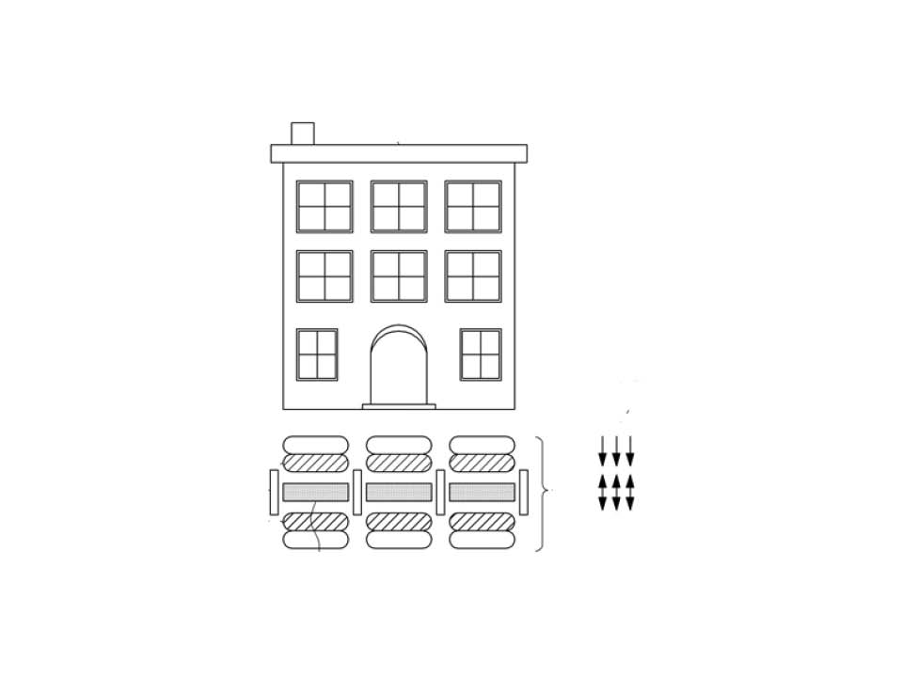 | 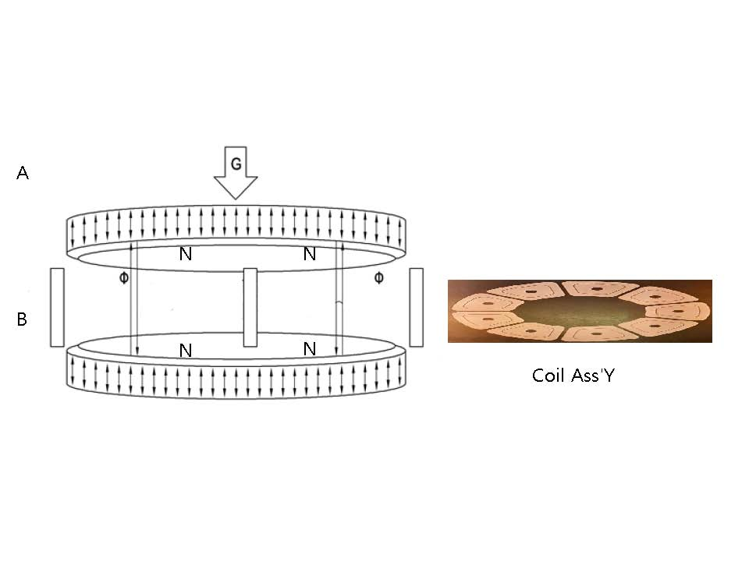
Supplementary Fig. 1. Gravity and magnetic field.

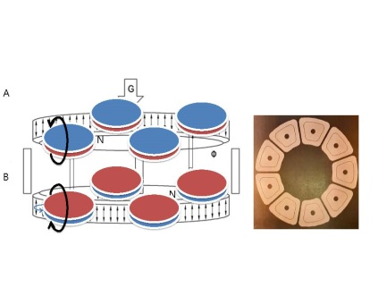 | 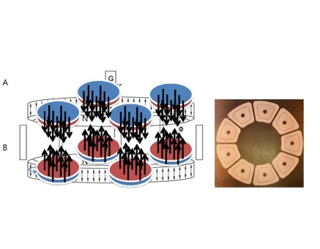 | 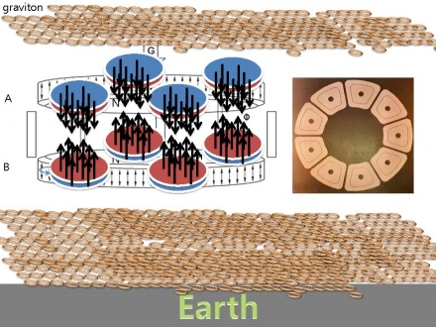
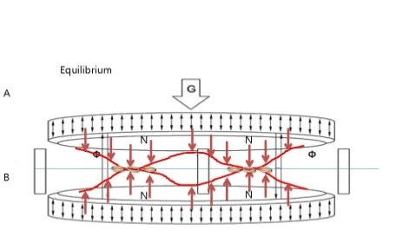 | 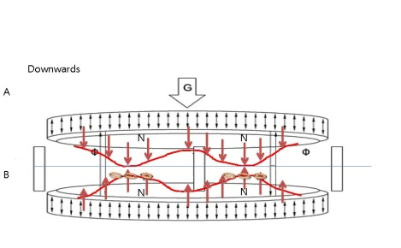 | 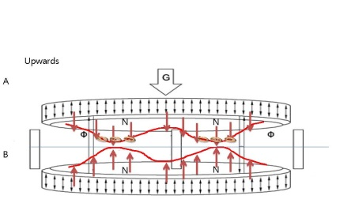
Supplementary Fig. 2. A schematic diagram of gravity that navigates in magnetic sea.
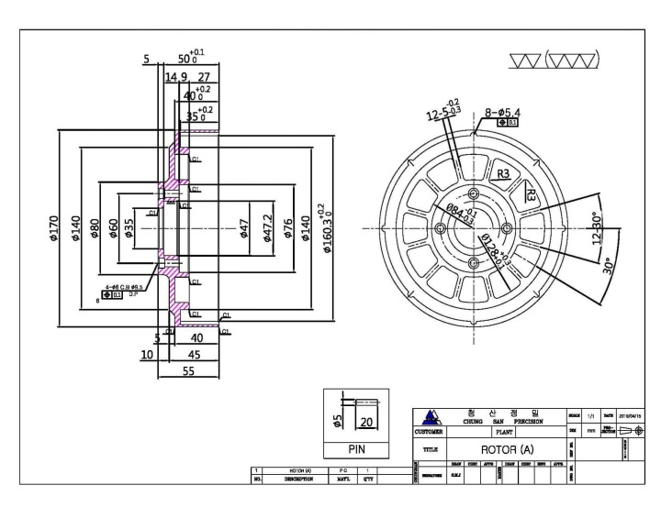
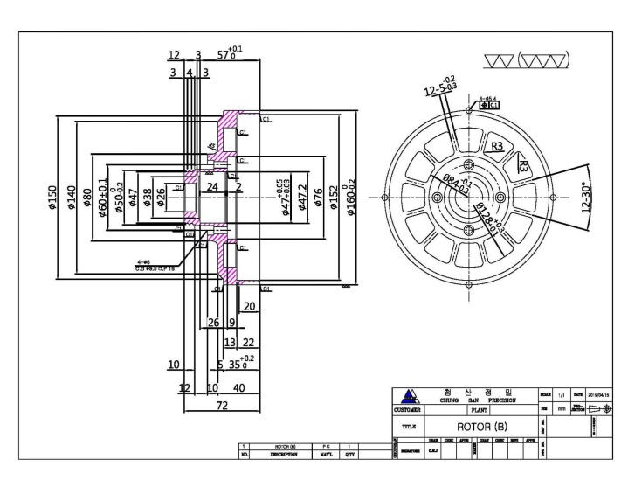
Supplementary Fig. 3. Magnetic sea generator blueprint.

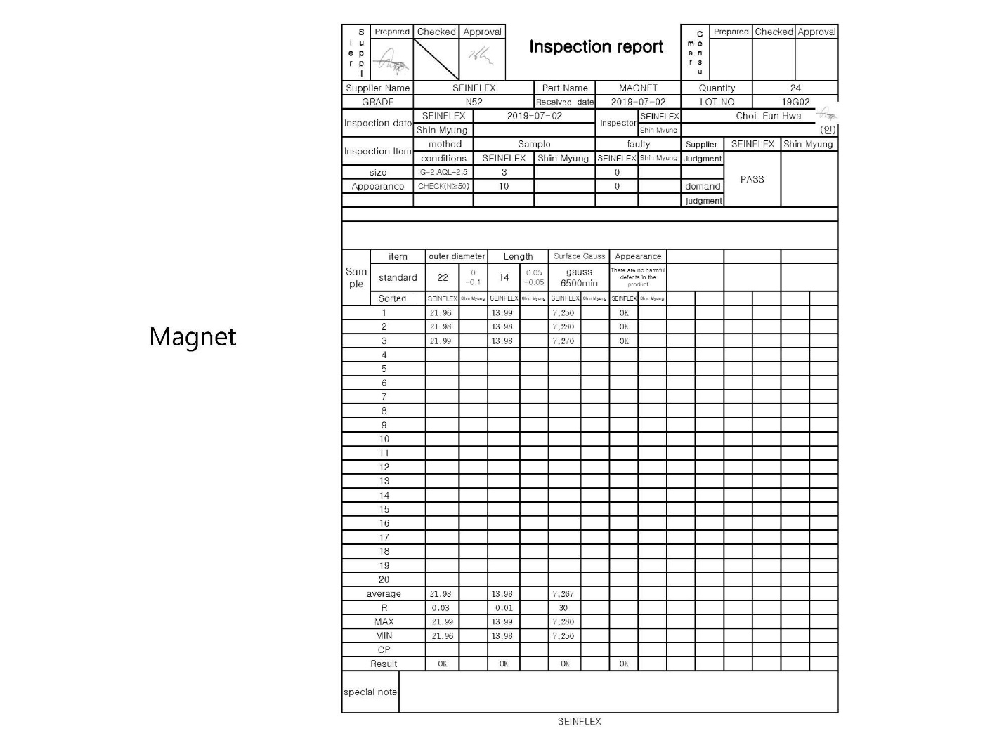
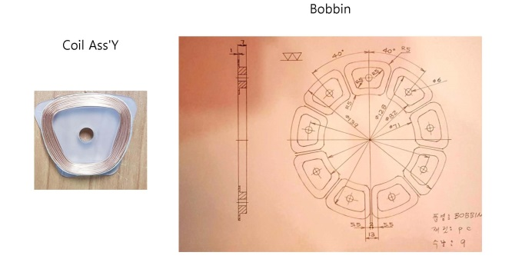
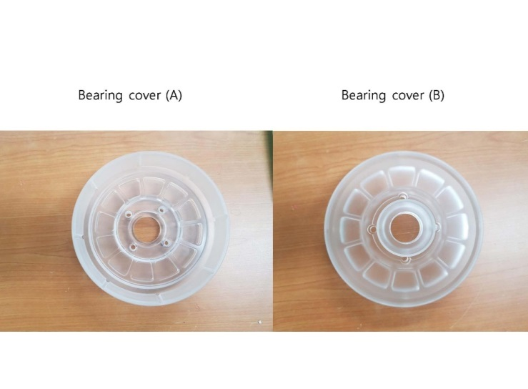
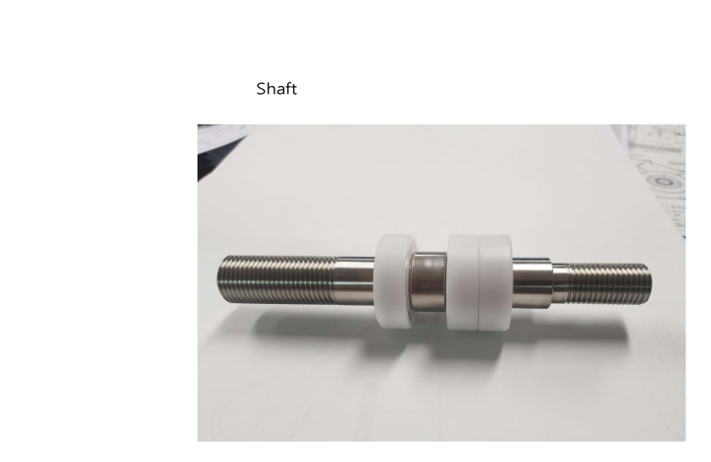

Supplementary Fig. 4. Magnetic sea generator parts.

https://www.youtube.com/embed/IlvOZ9bpPYw 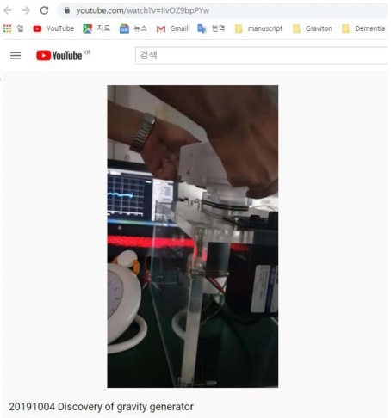
<iframe width="560" height="315" src="https://www.youtube.com/embed/IlvOZ9bpPYw" frameborder="0" allow="accelerometer; autoplay; clipboard-write; encrypted-media; gyroscope; picture-in-picture" allowfullscreen></iframe>

Supplementary Movie 1. 2019.10.04 Discovery of Gravity to Electricity on Magnetic sea generator.

Supplemental Section 2. Keysight B2901A Manual

The magnetic sea generator (MG) itself is a device that measures the current and voltage generated by passing a small current in proportion to the resistance of the connected device. Therefore, it was necessary to discriminate whether we were measuring the amount of current generated by the MG or the amount of current generated by gravity. The most effective method is to measure the amount of current generated by the MG with or without air. If there is a difference in the amount of current generated with and without air, the difference in the generated amount is due to gravity.
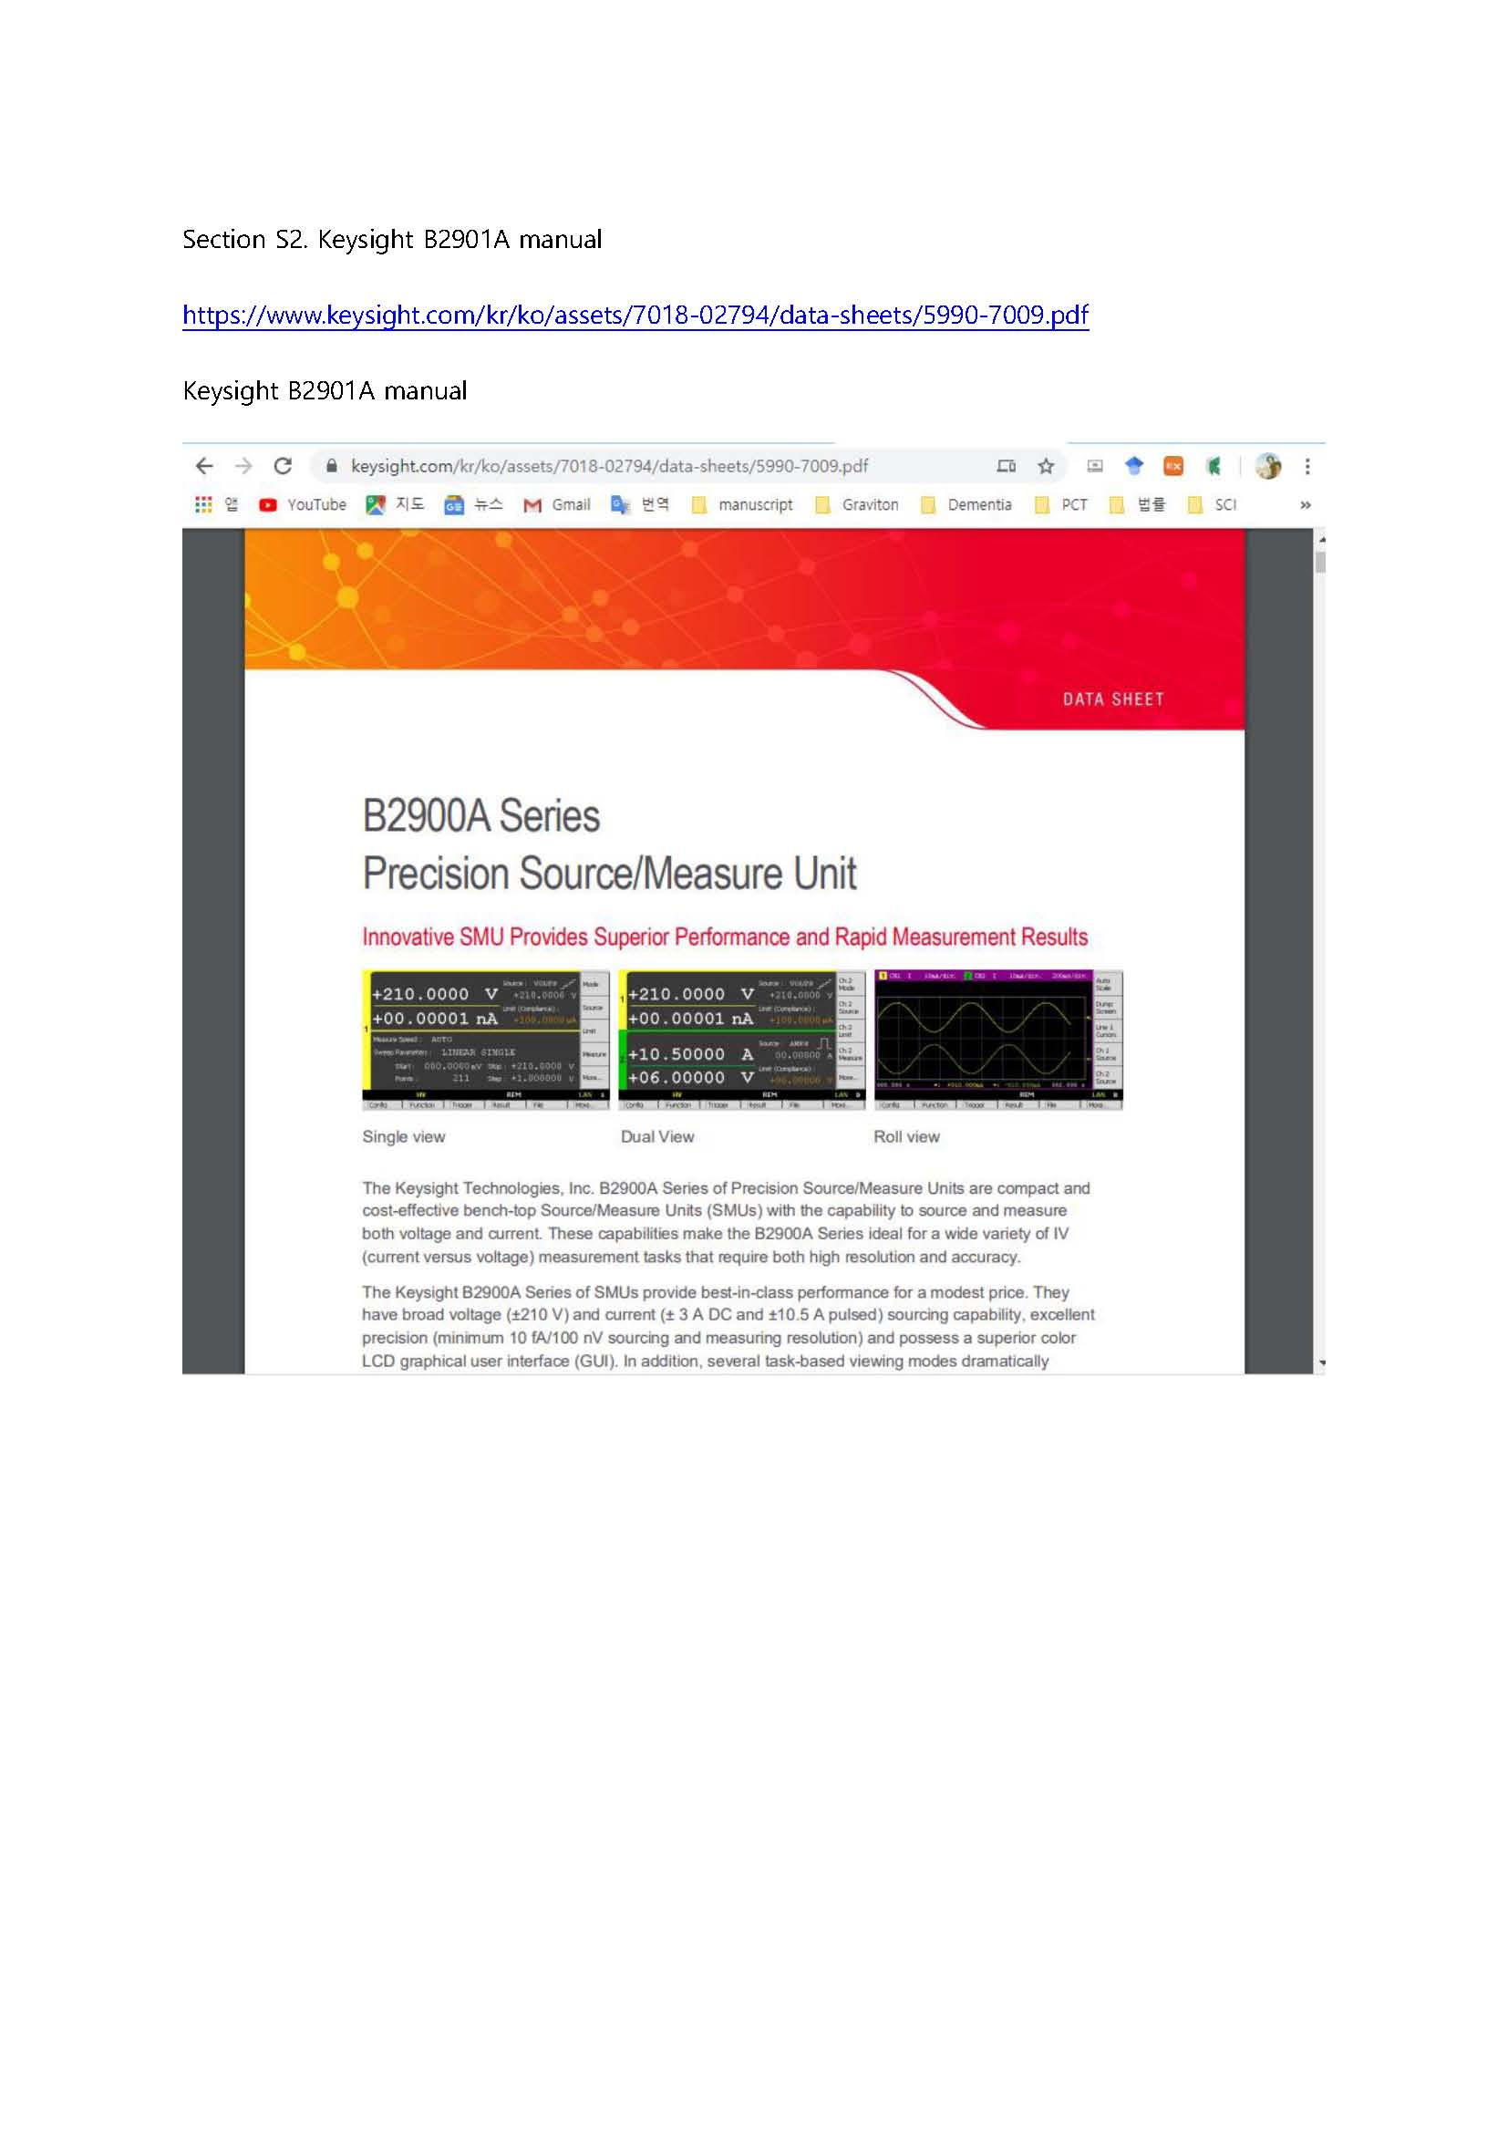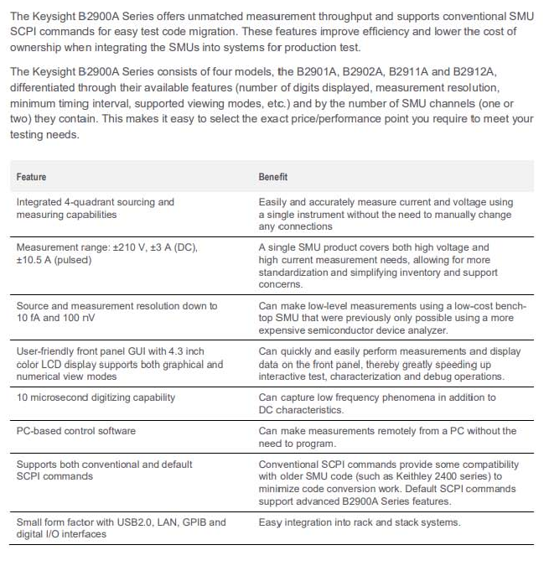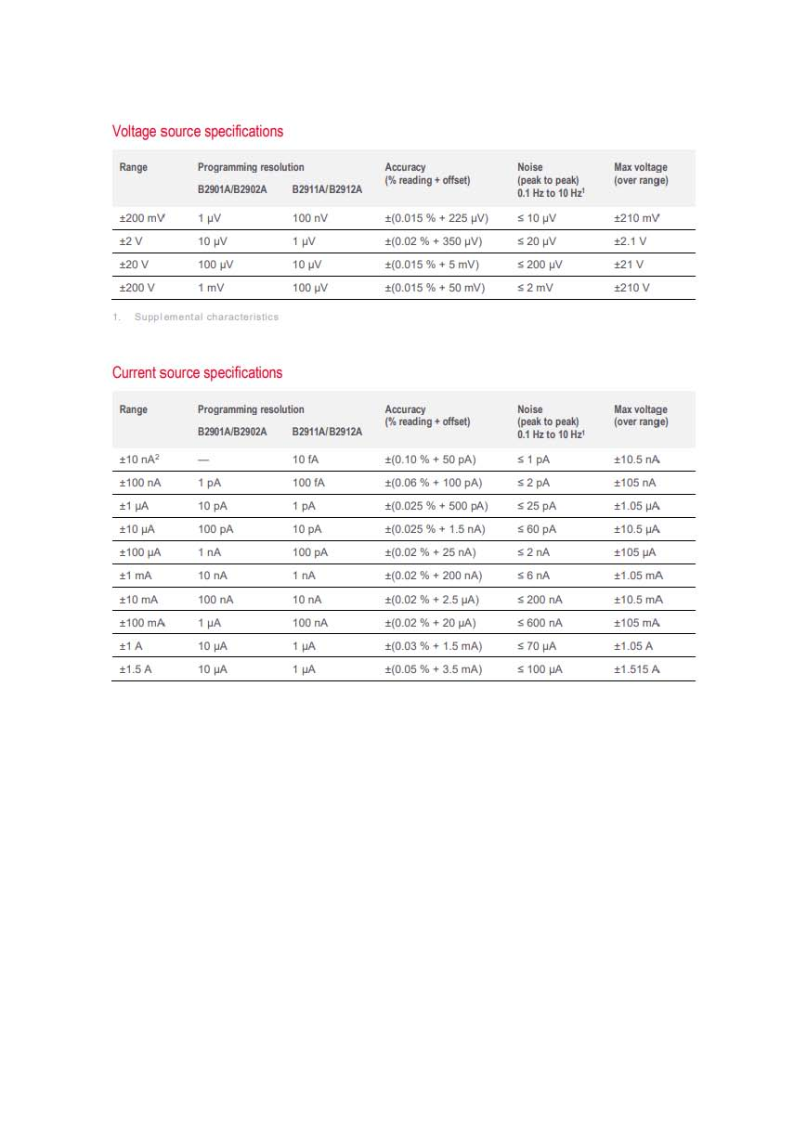
Supplementary Fig. 5. B2900A series manual.

Supplemental Section 3. 2019-10-10 Experiments

(A, B, C – Supplementary Table 1)

To apply the weight in the three-dimensional system, dumbbells 1 and 2 were raised in order, and the generator's electricity was measured. Additionally, dumbbell one and dumbbell two were put down in order, and the electricity generated was measured on October 10, 2019. Electricity was measured three times (A, B, C) while the generator rotated and three times (D, E, F) when the generator was stationary. Supplementary Tables 1 and 3 were rearranged from Supplementary Tables 2 and 4 to compare the maximum values. When dumbbell one was placed on the generator while rotating, it generated 745.8 µA (Supplementary Table 1A2), 883.7 µA (Supplementary Table 1B2) and 471.4 µA (Supplementary Table 1C2). When dumbbell two was placed on dumbbell one while the generator was rotating, it generated 1,068.3 µA (Supplementary Table 1A3), 895.9 µA (Supplementary Table 1B3) and 2,666.2 µA (Supplementary Table 1C3).

Supplementary Table 1. Electricity measured while the generator rotating.
 | CH1 Current (A) |  |  | CH1 Voltage (V) |  |  | (0.001 s)
 | Maximum | Minimum | Sum | Maximum | Minimum | Sum | (0.001 s)
A1  B1  C1 | 0.0004433 | -0.0003803 | -0.0009149 | 0.0000204 | -0.0000172 | -0.0019751 | 10000
A1  B1  C1 | 0.0005052 | -0.0003646 | 0.0056757 | 0.0000209 | -0.0000189 | 0.0005494 | 10000
A1  B1  C1 | 0.0004593 | -0.0003969 | 0.033351 | 0.0000198 | -0.0000202 | -0.0034343 | 10000
A2  B2  C2 | 0.0007458 | -0.0016802 | -0.1374131 | 0.0000179 | -0.0000208 | -0.0002372 | 10000
A2  B2  C2 | 0.0008837 | -0.0021383 | -0.1239456 | 0.0000237 | -0.0000212 | 0.0019692 | 10000
A2  B2  C2 | 0.0004714 | -0.0012035 | -0.0831234 | 0.0000191 | -0.0000231 | -0.0006971 | 10000
A3  B3  C3 | 0.0010683 | -0.0017568 | -0.1140228 | 0.0000251 | -0.000031 | 0.0017442 | 10000
A3  B3  C3 | 0.0008959 | -0.0032941 | -0.1080884 | 0.0000406 | -0.0000417 | -0.0024536 | 10000
A3  B3  C3 | 0.0026662 | -0.0019067 | -0.0950192 | 0.0000236 | -0.0000218 | 0.0001664 | 10000
A4  B4  C4 | 0.0026882 | -0.0011917 | 0.1360524 | 0.0000189 | -0.0000229 | -0.0002788 | 10000
A4  B4  C4 | 0.0024636 | -0.0011921 | 0.0723971 | 0.000019 | -0.0000214 | -0.0013109 | 10000
A4  B4  C4 | 0.0029132 | -0.0016932 | 0.118348 | 0.0000194 | -0.0000221 | -0.0022711 | 10000
A5  B5  C5 | 0.0056106 | -0.0047926 | 0.1460264 | 0.0000815 | -0.0000623 | -0.0017428 | 10000
A5  B5  C5 | The test recorder overwrote the measurement data in the notebook. |  |  |  |  |  | 10000
A5  B5  C5 | 0.0052364 | -0.0065765 | 0.1328696 | 0.0000721 | -0.0000538 | 0.000513 | 10000
A6  B6  C6 | 0.0004334 | -0.0003605 | 0.0101899 | 0.0000194 | -0.0000186 | -0.0022982 | 10000
A6  B6  C6 | 0.0004619 | -0.0003687 | -0.0004063 | 0.0000211 | -0.0000182 | 0.0013422 | 10000
A6  B6  C6 | 0.0004454 | -0.000404 | 0.0400267 | 0.0000224 | -0.0000205 | 0.0011928 | 10000

Supplementary Table 2. Electricity data rearranged while the generator rotating.
 | CH1 Current (A) |  |  | CH1 Voltage (V) |  |  | (0.001 s)
 | Maximum | Minimum | Sum | Maximum | Minimum | Sum | (0.001 s)
A1  A2  A3  A4  A5  A6 | 0.0004433 | -0.0003803 | -0.0009149 | 0.0000204 | -0.0000172 | -0.0019751 | 10000
A1  A2  A3  A4  A5  A6 | 0.0007458 | -0.0016802 | -0.1374131 | 0.0000179 | -0.0000208 | -0.0002372 | 10000
A1  A2  A3  A4  A5  A6 | 0.0010683 | -0.0017568 | -0.1140228 | 0.0000251 | -0.000031 | 0.0017442 | 10000
A1  A2  A3  A4  A5  A6 | 0.0026882 | -0.0011917 | 0.1360524 | 0.0000189 | -0.0000229 | -0.0002788 | 10000
A1  A2  A3  A4  A5  A6 | 0.0056106 | -0.0047926 | 0.1460264 | 0.0000815 | -0.0000623 | -0.0017428 | 10000
A1  A2  A3  A4  A5  A6 | 0.0004334 | -0.0003605 | 0.0101899 | 0.0000194 | -0.0000186 | -0.0022982 | 10000
B1  B2  B3  B4  B5  B6 | 0.0005052 | -0.0003646 | 0.0056757 | 0.0000209 | -0.0000189 | 0.0005494 | 10000
B1  B2  B3  B4  B5  B6 | 0.0008837 | -0.0021383 | -0.1239456 | 0.0000237 | -0.0000212 | 0.0019692 | 10000
B1  B2  B3  B4  B5  B6 | 0.0008959 | -0.0032941 | -0.1080884 | 0.0000406 | -0.0000417 | -0.0024536 | 10000
B1  B2  B3  B4  B5  B6 | 0.0024636 | -0.0011921 | 0.0723971 | 0.000019 | -0.0000214 | -0.0013109 | 10000
B1  B2  B3  B4  B5  B6 | The test recorder overwrote the measurement data in the notebook. |  |  |  |  |  | 10000
B1  B2  B3  B4  B5  B6 | 0.0004619 | -0.0003687 | -0.0004063 | 0.0000211 | -0.0000182 | 0.0013422 | 10000
C1  C2  C3  C4  C5  C6 | 0.0004593 | -0.0003969 | 0.033351 | 0.0000198 | -0.0000202 | -0.0034343 | 10000
C1  C2  C3  C4  C5  C6 | 0.0004714 | -0.0012035 | -0.0831234 | 0.0000191 | -0.0000231 | -0.0006971 | 10000
C1  C2  C3  C4  C5  C6 | 0.0026662 | -0.0019067 | -0.0950192 | 0.0000236 | -0.0000218 | 0.0001664 | 10000
C1  C2  C3  C4  C5  C6 | 0.0029132 | -0.0016932 | 0.118348 | 0.0000194 | -0.0000221 | -0.0022711 | 10000
C1  C2  C3  C4  C5  C6 | 0.0052364 | -0.0065765 | 0.1328696 | 0.0000721 | -0.0000538 | 0.000513 | 10000
C1  C2  C3  C4  C5  C6 | 0.0004454 | -0.000404 | 0.0400267 | 0.0000224 | -0.0000205 | 0.0011928 | 10000

Experiments (D, E, F – Supplementary Table 3)

To apply the weight in the three-dimensional system, dumbbells 1 and 2 were raised in order, and the generator's electricity was measured. Additionally, dumbbell one and dumbbell two were put down in order, and the electricity generated was measured on October 10, 2019. When dumbbell one was placed on while the generator was stationary, it caused 1,041.9 µA (Supplementary Table 3D2), 1,324.2 µA (Supplementary Table 3E2), and 482.2 µA (Supplementary Table 3F2). When dumbbell two was placed on dumbbell one while the generator was stationary, it generated 1,050.6 µA (Supplementary Table 3D3), 1,018.8 µA (Supplementary Table 3E3), and 851.7 µA (Supplementary Table 3F3).

Supplementary Table 3. Electricity measured while the generator stationary.
 | CH1 Current (A) |  |  | CH1 Voltage (V) |  |  | (0.001 s)
 | Maximum | Minimum | Sum | Maximum | Minimum | Sum | (0.001 s)
D1  E1  F1 | 0.0000047 | -0.000004 | 0.0025892 | 0.0000186 | -0.0000187 | -0.0014627 | 10000
D1  E1  F1 | 0.0000084 | -0.0000079 | 0.0012128 | 0.0000195 | -0.0000191 | -0.0003436 | 10000
D1  E1  F1 | 0.0000042 | -0.0000044 | 0.0002018 | 0.0000176 | -0.0000189 | -0.0001177 | 10000
D2  E2  F2 | 0.0010419 | -0.0015249 | -0.1176412 | 0.0000171 | -0.0000197 | -0.003063 | 10000
D2  E2  F2 | 0.0013242 | -0.002625 | -0.1247941 | 0.0000429 | -0.0000418 | -0.0008347 | 10000
D2  E2  F2 | 0.0004822 | -0.0015375 | -0.1268739 | 0.0000174 | -0.0000233 | -0.0024814 | 10000
D3  E3  F3 | 0.0010506 | -0.0007511 | -0.0177963 | 0.0000178 | -0.0000204 | -0.001477 | 10000
D3  E3  F3 | 0.0010188 | -0.0005505 | -0.013439 | 0.0000193 | -0.0000207 | 0.0005212 | 10000
D3  E3  F3 | 0.0008517 | -0.0004604 | -0.0165925 | 0.0000196 | -0.0000191 | -0.0001067 | 10000
D4  E4  F4 | 0.0004691 | -0.0004882 | 0.0123762 | 0.000017 | -0.0000158 | -0.0009084 | 10000
D4  E4  F4 | 0.0004207 | -0.0003099 | 0.0131795 | 0.0000188 | -0.0000196 | -0.0018299 | 10000
D4  E4  F4 | 0.0006965 | -0.0002703 | 0.0236493 | 0.0000186 | -0.0000201 | 0.0014059 | 10000
D5  E5  F5 | 0.0072367 | -0.0075738 | 0.1321999 | 0.0001089 | -0.0000709 | -0.001653 | 10000
D5  E5  F5 | 0.0049669 | -0.0050688 | 0.1273632 | 0.0000908 | -0.0000666 | 0.0001761 | 10000
D5  E5  F5 | 0.004052 | -0.0040384 | 0.1180847 | 0.0000597 | -0.0000483 | -0.0016282 | 10000
D6  E6  F6 | 0.0000038 | -0.0000042 | 0.0020211 | 0.000019 | -0.0000218 | 0.0019935 | 10000
D6  E6  F6 | 0.0000043 | -0.0000044 | 0.0010742 | 0.0000184 | -0.0000191 | 0.0015754 | 10000
D6  E6  F6 | 0.0000041 | -0.0000042 | 0.0002543 | 0.0000187 | -0.0000202 | 0.0015011 | 10000

Supplementary Table 4. Electricity data rearranged while the generator stationary.
 | CH1 Current (A) |  |  | CH1 Voltage (V) |  |  | (0.001 s)
 | Maximum | Minimum | Sum | Maximum | Minimum | Sum | (0.001 s)
D1  D2  D3  D4  D5  D6 | 0.0000047 | -0.000004 | 0.0025892 | 0.0000186 | -0.0000187 | -0.0014627 | 10000
D1  D2  D3  D4  D5  D6 | 0.0010419 | -0.0015249 | -0.1176412 | 0.0000171 | -0.0000197 | -0.003063 | 10000
D1  D2  D3  D4  D5  D6 | 0.0010506 | -0.0007511 | -0.0177963 | 0.0000178 | -0.0000204 | -0.001477 | 10000
D1  D2  D3  D4  D5  D6 | 0.0004691 | -0.0004882 | 0.0123762 | 0.000017 | -0.0000158 | -0.0009084 | 10000
D1  D2  D3  D4  D5  D6 | 0.0072367 | -0.0075738 | 0.1321999 | 0.0001089 | -0.0000709 | -0.001653 | 10000
D1  D2  D3  D4  D5  D6 | 0.0000038 | -0.0000042 | 0.0020211 | 0.000019 | -0.0000218 | 0.0019935 | 10000
E1  E2  E3  E4  E5  E6 | 0.0000084 | -0.0000079 | 0.0012128 | 0.0000195 | -0.0000191 | -0.0003436 | 10000
E1  E2  E3  E4  E5  E6 | 0.0013242 | -0.002625 | -0.1247941 | 0.0000429 | -0.0000418 | -0.0008347 | 10000
E1  E2  E3  E4  E5  E6 | 0.0010188 | -0.0005505 | -0.013439 | 0.0000193 | -0.0000207 | 0.0005212 | 10000
E1  E2  E3  E4  E5  E6 | 0.0004207 | -0.0003099 | 0.0131795 | 0.0000188 | -0.0000196 | -0.0018299 | 10000
E1  E2  E3  E4  E5  E6 | 0.0049669 | -0.0050688 | 0.1273632 | 0.0000908 | -0.0000666 | 0.0001761 | 10000
E1  E2  E3  E4  E5  E6 | 0.0000043 | -0.0000044 | 0.0010742 | 0.0000184 | -0.0000191 | 0.0015754 | 10000
F1  F2  F3  F4  F5  F6 | 0.0000042 | -0.0000044 | 0.0002018 | 0.0000176 | -0.0000189 | -0.0001177 | 10000
F1  F2  F3  F4  F5  F6 | 0.0004822 | -0.0015375 | -0.1268739 | 0.0000174 | -0.0000233 | -0.0024814 | 10000
F1  F2  F3  F4  F5  F6 | 0.0008517 | -0.0004604 | -0.0165925 | 0.0000196 | -0.0000191 | -0.0001067 | 10000
F1  F2  F3  F4  F5  F6 | 0.0006965 | -0.0002703 | 0.0236493 | 0.0000186 | -0.0000201 | 0.0014059 | 10000
F1  F2  F3  F4  F5  F6 | 0.004052 | -0.0040384 | 0.1180847 | 0.0000597 | -0.0000483 | -0.0016282 | 10000
F1  F2  F3  F4  F5  F6 | 0.0000041 | -0.0000042 | 0.0002543 | 0.0000187 | -0.0000202 | 0.0015011 | 10000

Experiments (Only Voltage while Rotating)

Experiments were performed to compare the voltages while the generator was rotating and stationary. We used a TDS 2014 four-channel digital storage oscilloscope voltage metre (100 MHz, 1 GS/s). A video was taken because the voltage metre could not save and output the data. We connected the magnetic sea generator to the TDS 2014 in experiments A1 to C6 and measured the voltage in order.

Supplementary Table 5. Voltage measurement data while Rotating.
6.204.8011.010.610.611.09.0011.05.006.6010.48.4011.610.210.68.606.8011.28.609.209.0011.210.48.407.609.0010.67.006.8010.212.610.89.4010.29.2010.07.0011.211.08.408.608.807.8011.49.207.209.007.806.808.809.605.608.8012.09.407.605.6011.08.6011.612.211.611.29.0010.28.209.407.4011.49.6011.46.607.409.409.8010.69.208.2011.89.206.8010.09.008.408.009.009.6010.88.408.809.2012.09.8012.68.409.208.2012.89.208.2010.69.608.206.408.409.4010.814.810.412.011.49.0012.25.8011.211.012.613.09.207.8011.611.08.0013.85.206.6010.29.4011.09.8010.69.6011.010.811.28.008.4010.210.06.207.609.607.609.208.209.209.607.609.608.009.6010.06.6012.010.88.6012.49.805.208.609.8011.810.05.006.606.204.003.003.203.803.203.403.804.003.404.403.204.007.607.6011.610.614.610.412.211.49.8014.413.612.68.8010.27.4013.611.811.013.410.08.408.609.2010.49.607.807.2010.612.48.809.006.805.4010.45.608.009.008.8010.27.0010.29.6010.88.806.0010.28.8010.48.808.2011.67.808.208.8010.47.608.609.0010.89.60 (V) while the generator was rotating.

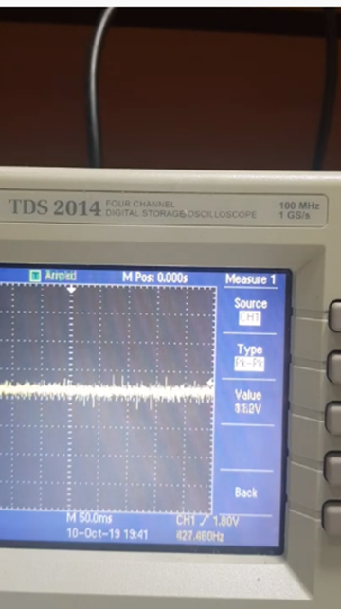 https://www.youtube.com/embed/HS6Qbp6i-SU
<iframe width="560" height="315" src="https://www.youtube.com/embed/HS6Qbp6i-SU" frameborder="0" allow="accelerometer; autoplay; clipboard-write; encrypted-media; gyroscope; picture-in-picture" allowfullscreen></iframe>

Supplementary Movie 2. 2019.10.10 Voltage measurement data while Rotating on Magnetic sea generator.

Experiments (Voltage Only while Stationary)

Experiments were performed to compare the voltages output while the generator was rotating and stationary. We used a TDS 2014 four-channel digital storage oscilloscope voltage metre (100 MHz, 1 GS/s). A video was taken because the voltage metre could not save and output the data. We connected the magnetic sea generator to the TDS 2014 four-channel digital storage oscilloscope (100 MHz, 1 GS/s), and the voltage was measured for experiments D1 to F6.

Supplementary Table 6. Voltage measurement data while Stationary.
3.603.203.403.204.003.603.403.804.005.003.402.803.804.003.404.003.603.404.003.803.404.203.403.803.403.203.404.003.204.203.403.603.003.203.804.203.403.603.404.003.404.003.803.003.804.003.003.203.803.203.403.804.003.404.403.204.007.604.603.604.003.80 (V) while the generator was stationary through the monitor.

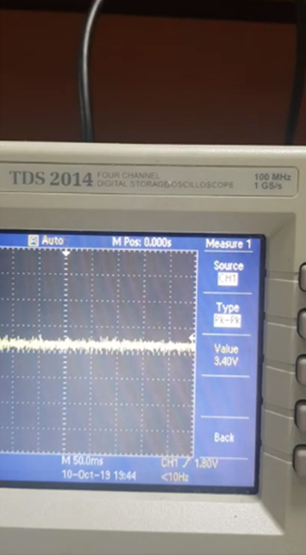 https://www.youtube.com/embed/vLRvoBs5924
<iframe width="560" height="315" src="https://www.youtube.com/embed/vLRvoBs5924" frameborder="0" allow="accelerometer; autoplay; clipboard-write; encrypted-media; gyroscope; picture-in-picture" allowfullscreen></iframe>

Supplementary Movie 3. 2019.10.10 Voltage measurement data while stationary on Magnetic sea generator.

Supplementary Data 1. 2019.10.10. Experiments with the magnetic sea generator in the air.
Supplemental Section 2. 20191004_preparation_experiment.zip, Section 2 20191010MG.zip
https://osf.io/ntuda/files/

Supplementary Data 2. 2020.06.18. Vacuum chamber & the magnetic sea generator in the air.
Supplemental Section 2. 20200618_preparation_before_experiment.zip
https://osf.io/ntuda/files/

Supplemental Section 4. 2020-06-18 Experiments in the Vacuum Chamber
(Current, Voltage and Time while Stationary)
The amounts of electricity generated in the vacuum chamber were measured. The Korea Institute of Civil Engineering and Building Technology (KICT) has operated at the centre of extreme environmental construction technology. The world's largest dusty thermal vacuum chamber (DTVC), a facility simulating the Moon's surface environment, was publicly operated. Nevertheless, other existing vacuum chambers can only be utilised in a complete vacuum state without any impurities. Therefore, this magnetic sea generator (MG) experiment was performed in an absolute vacuum state chamber.
1) Chamber information
Size: 1.0m in diameter, 1.3m in length ﻿
Material: Stainless Steel 304
2) pump
- Low vacuum (1000~1E-2 mbar): Dry Vauum pump (Model: EV-S20, Manufacturer: EBARA, Pumping performance: 1670 L/min )
- High vacuum (1E-2 mbar or less): Turbo pump (Model: HIPACE2300, Manufacturer: PFEIFFER VACUUM, Pumping performance: 1900L/s (Nitrogen basis))
3) Gauge
- 1100~11﻿ mbar: Ceramic Capacitance Gauge (Model: CMR 361, Manufacturer: PFEIFFER VACUUM, Accuracy: 0.20%)
- 11~0.11 mbar: Ceramic Capacitance Gauge (Model: CMR 363, Manufacturer: PFEIFFER VACUUM, Accuracy: 0.20%)﻿
- 0.11~0.0011 mbar : Ceramic Capacitance Gauge (Model: CMR 365, Manufacturer: PFEIFFER VACUUM, Accuracy: 0.20%)
- 0.0011 mbar or less: Cold Cathod Gauge (Model: PKR251, Manufacturer: PFEIFFER VACUUM, Accuracy: +/-30%)

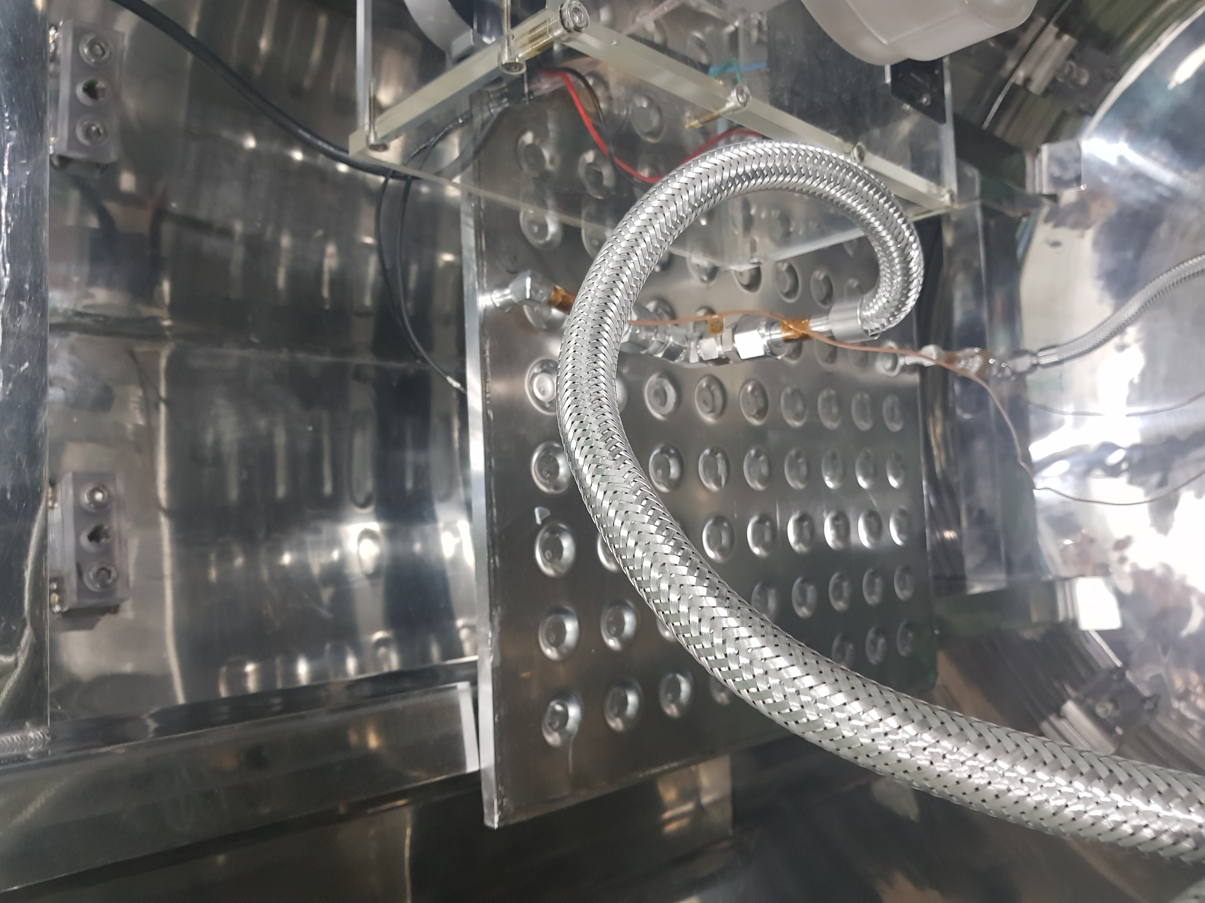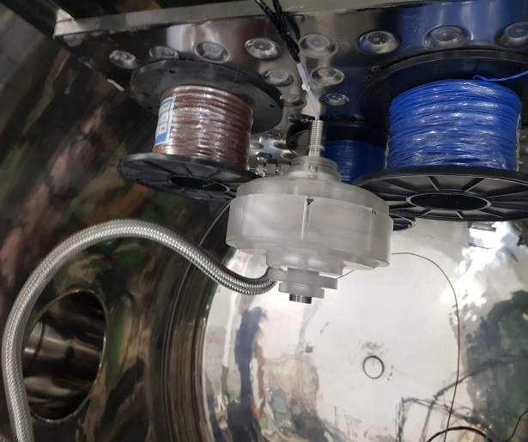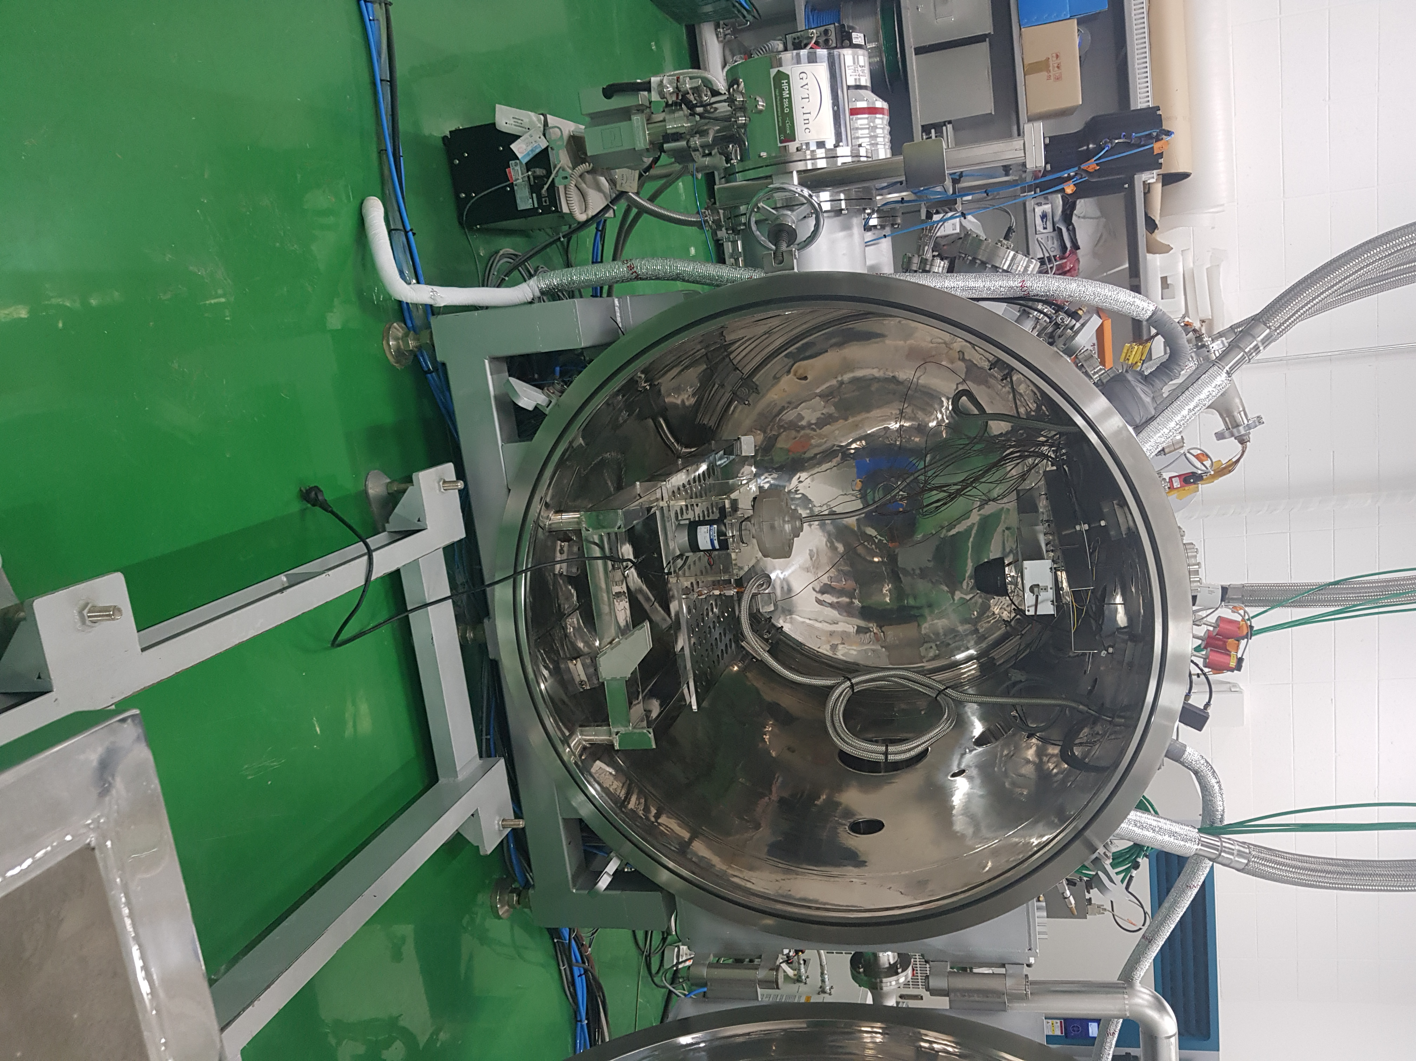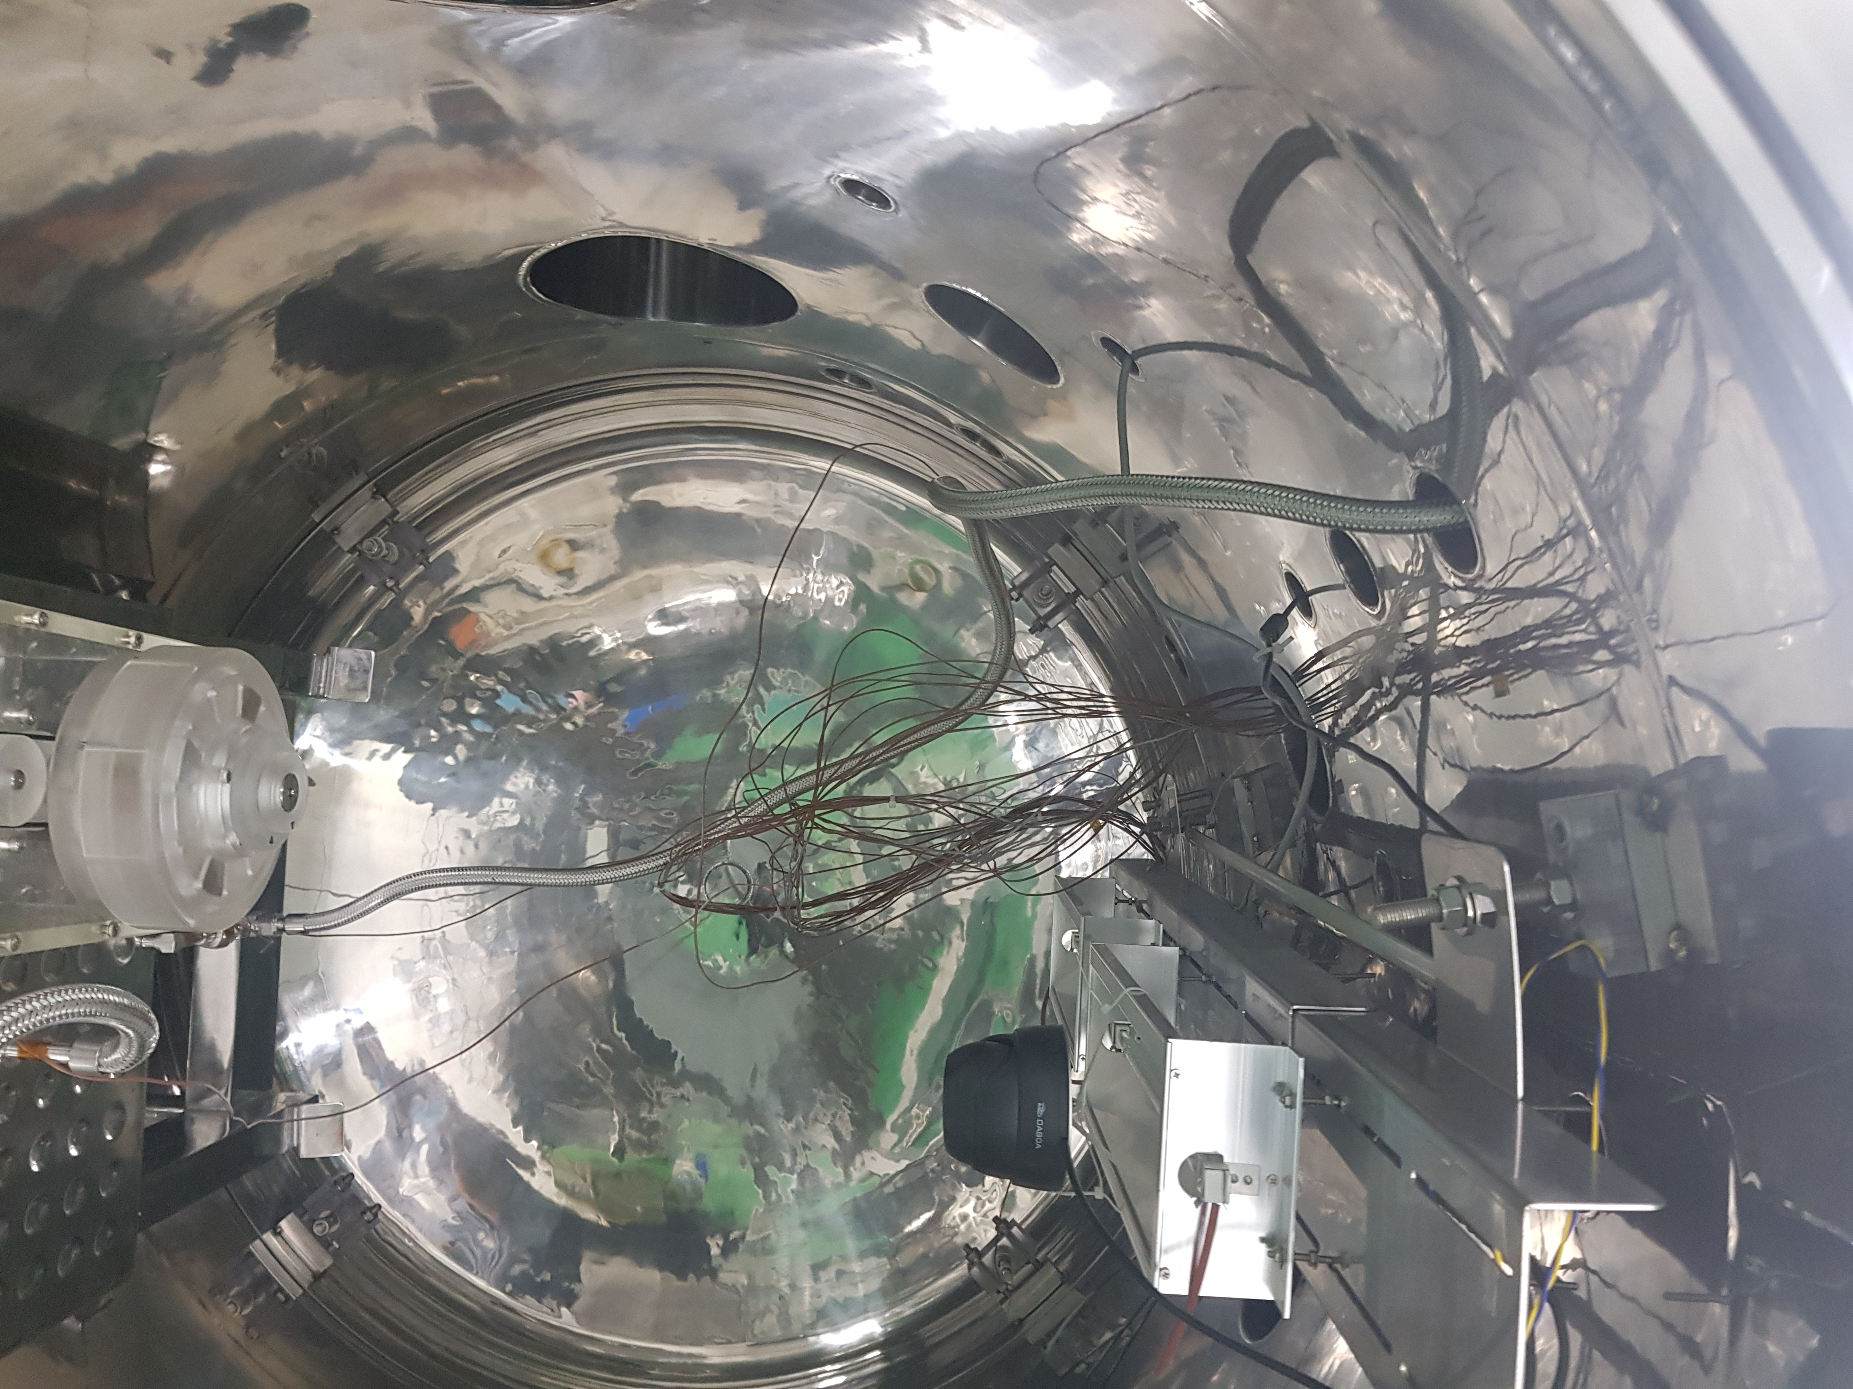

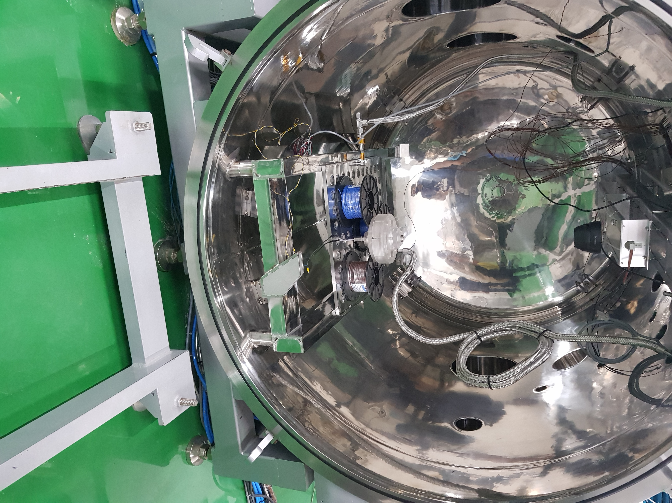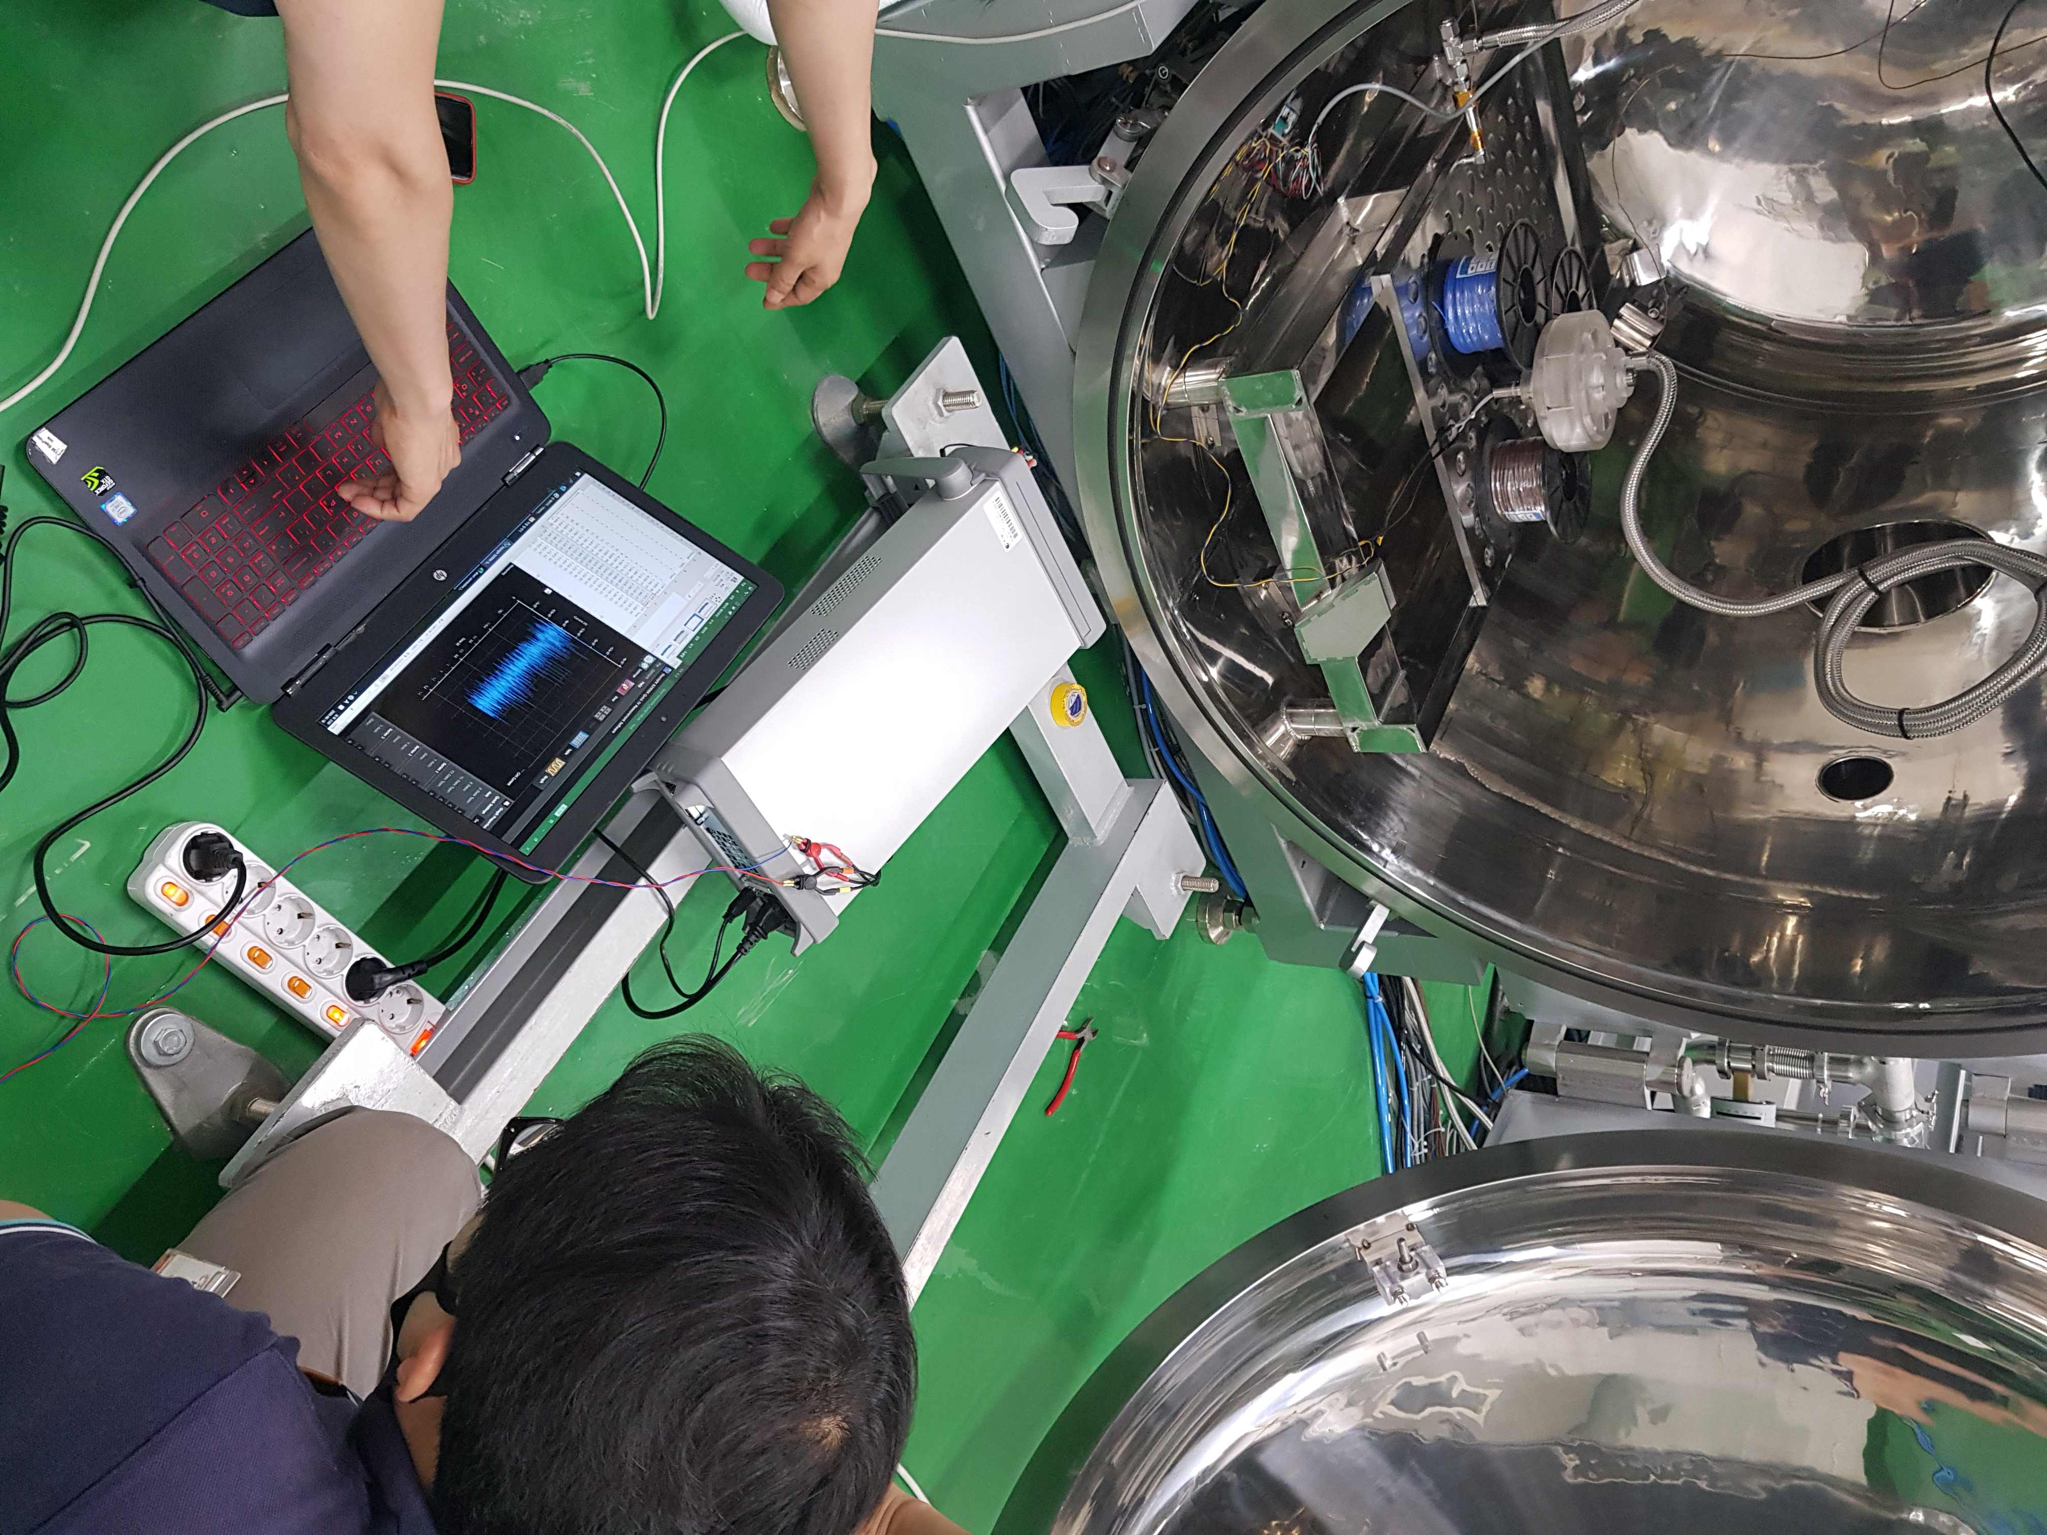

Supplementary Fig. 6. Magnetic sea generator in the Vacuum Chamber.

Keysight B2901A Equipment preparation for vacuum experiments in the air

Voltage and Current of Keysight B2901A Equipment
1st

2nd

3rd

Current of Keysight B2901A Equipment

1st

2nd

3rd

Voltage of Keysight B2901A Equipment

1st

2nd

3rd

The magnetic sea generator’s voltage and current in the air measured by Keysight B2901A Equipment

1st
2nd
3rd

The magnetic sea generator’s current in the air measured by Keysight B2901A Equipment

Current in the air
1st
2nd
3rd

The magnetic sea generator’s voltage in the air measured by Keysight B2901A Equipment

Voltage in the air
1st
2nd
3rd

The magnetic sea generator in the vacuum

The magnetic sea generator’s voltage and current in the vacuum measured by Keysight B2901A Equipment
The magnetic sea generator in the vacuum
1st
2nd
3rd
4th
5th
6th
7th
8th
9th
10th

The magnetic sea generator’s current in the vacuum measured by Keysight B2901A Equipment

Current in the vacuum
1st
2nd
3rd
4th
5th
6th
7th
8th
9th
10th

The magnetic sea generator’s voltage in the vacuum measured by Keysight B2901A Equipment

Voltage in the vacuum
1st
2nd
3rd
4th
5th
6th
7th
8th
9th
10th

Statistics

In each measurement, the measured currents from 1 to 100000 were all summed. The change in the amount of current generated as the barometric pressure decreased was observed.

Supplementary Table 7. Voltage measurement in the vacuum chamber.
Barometric pressure (mbar) | 1000 | 100 | 10 | 1 | 0.1 | 0.01 | 0.0001
1¹measurement | -5.69E-03 | -5.70E-03 | -5.68E-03 | -5.69E-03 | -5.73E-03 | -5.70E-03 | -5.68E-03
2¹measurement | -5.77E-03 | -5.69E-03 | -6.00E-03 | -5.67E-03 | -5.70E-03 | -5.70E-03 | -5.33E-03
3¹measurement |  | -5.72E-03 | -5.78E-03 | -5.31E-03 | -5.31E-03 | -5.38E-03 | -5.69E-03
4¹Measurement |  |  |  |  |  | -5.74E-03 | -5.66E-03
5¹measurement |  |  |  |  |  | -5.74E-03 | -5.69E-03
6¹measurement |  |  |  |  |  |  | -5.27E-03
7¹measurement |  |  |  |  |  |  | -5.76E-03
8¹measurement |  |  |  |  |  |  | -5.76E-03
9¹measurement |  |  |  |  |  |  | -5.68E-03
10¹  measurement |  |  |  |  |  |  | -5.69E-03
average | -5.73E-03 | -5.70E-03 | -5.82E-03 | -5.56E-03 | -5.58E-03 | -5.65E-03 | -5.62E-03

Supplementary Data 3. 2020.06.18. Experiments with the magnetic sea generator in the vacuum chamber.
Vacuum chamber & MG.zip
https://osf.io/ntuda/files/

Supplemental Section 8. DATA
The data were analysed from point 4000 to point 4999, with this interval corresponding to 1 second from the 4th measurement measured in the vacuum chamber. It is a case where the voltage is the same, and the time is different.

Supplementary Table 8. Time and voltage measurement in the vacuum chamber.
 | CH1 Voltage | CH1 Time | 2 times | 3 times | 4 times
37 | 0.0002638 | 4.4845 | 0.0002638
38 | 0.0002638 | 4.8365 | 0.0002638
58 | 0.0002843 | 4.1685 | 0.0002843
59 | 0.0002843 | 4.4335 | 0.0002843
64 | 0.0002862 | 4.1005 | 0.0002862
65 | 0.0002862 | 4.3345 | 0.0002862
74 | 0.0002906 | 4.0455 | 0.0002906
75 | 0.0002906 | 4.9945 | 0.0002906
77 | 0.0002912 | 4.4305 | 0.0002912
78 | 0.0002912 | 4.6465 | 0.0002912
83 | 0.0002932 | 4.1775 | 0.0002932
84 | 0.0002932 | 4.7385 | 0.0002932
92 | 0.0002981 | 4.2075 | 0.0002981
93 | 0.0002981 | 4.9665 | 0.0002981
129 | 0.0003200 | 4.0335 | 0.0003200
130 | 0.0003200 | 4.4695 | 0.0003200
138 | 0.0003239 | 4.6695 | 0.0003239
139 | 0.0003239 | 4.8645 | 0.0003239
151 | 0.0003275 | 4.2505 | 0.0003275
152 | 0.0003275 | 4.8275 | 0.0003275
161 | 0.0003318 | 4.3465 | 0.0003318
162 | 0.0003318 | 4.4865 | 0.0003318
163 | 0.0003319 | 4.4645 | 0.0003319
164 | 0.0003319 | 4.5605 | 0.0003319
167 | 0.0003329 | 4.0435 |  | 0.0003329
168 | 0.0003329 | 4.1325 |  | 0.0003329
169 | 0.0003329 | 4.7625 |  | 0.0003329
184 | 0.0003368 | 4.4015 | 0.0003368
185 | 0.0003368 | 4.6845 | 0.0003368
187 | 0.0003373 | 4.7095 | 0.0003373
188 | 0.0003373 | 4.7185 | 0.0003373
189 | 0.0003377 | 4.8815 | 0.0003377
190 | 0.0003377 | 4.8955 | 0.0003377
193 | 0.000339 | 4.5225 | 0.000339
194 | 0.000339 | 4.5585 | 0.000339
207 | 0.0003445 | 4.4725 | 0.0003445
208 | 0.0003445 | 4.8335 | 0.0003445
213 | 0.0003462 | 4.3365 | 0.0003462
214 | 0.0003462 | 4.7335 | 0.0003462
221 | 0.0003476 | 4.1125 | 0.0003476
222 | 0.0003476 | 4.9065 | 0.0003476
227 | 0.0003488 | 4.6025 | 0.0003488
228 | 0.0003488 | 4.7265 | 0.0003488
231 | 0.0003492 | 4.2015 | 0.0003492
232 | 0.0003492 | 4.8115 | 0.0003492
234 | 0.0003496 | 4.1385 |  | 0.0003496
235 | 0.0003496 | 4.4265 |  | 0.0003496
236 | 0.0003496 | 4.5405 |  | 0.0003496
242 | 0.0003514 | 4.0535 | 0.0003514
243 | 0.0003514 | 4.3915 | 0.0003514
245 | 0.0003523 | 4.2645 | 0.0003523
246 | 0.0003523 | 4.7745 | 0.0003523
251 | 0.0003539 | 4.2285 | 0.0003539
252 | 0.0003539 | 4.4615 | 0.0003539
263 | 0.0003578 | 4.3535 | 0.0003578
264 | 0.0003578 | 4.8065 | 0.0003578
267 | 0.0003584 | 4.6915 | 0.0003584
268 | 0.0003584 | 4.9115 | 0.0003584
272 | 0.0003593 | 4.4095 | 0.0003593
273 | 0.0003593 | 4.5985 | 0.0003593
278 | 0.0003605 | 4.6355 | 0.0003605
279 | 0.0003605 | 4.8835 | 0.0003605
291 | 0.0003636 | 4.2545 |  | 0.0003636
292 | 0.0003636 | 4.4055 |  | 0.0003636
293 | 0.0003636 | 4.8665 |  | 0.0003636
298 | 0.0003646 | 4.1195 | 0.0003646
299 | 0.0003646 | 4.6225 | 0.0003646
301 | 0.0003648 | 4.5215 | 0.0003648
302 | 0.0003648 | 4.5785 | 0.0003648
306 | 0.000366 | 4.5285 | 0.000366
307 | 0.000366 | 4.6985 | 0.000366
312 | 0.0003669 | 4.6565 | 0.0003669
313 | 0.0003669 | 4.7045 | 0.0003669
314 | 0.0003675 | 4.2985 | 0.0003675
315 | 0.0003675 | 4.5625 | 0.0003675
319 | 0.0003683 | 4.3955 | 0.0003683
320 | 0.0003683 | 4.8265 | 0.0003683
321 | 0.0003684 | 4.1615 | 0.0003684
322 | 0.0003684 | 4.3705 | 0.0003684
325 | 0.0003691 | 4.3235 | 0.0003691
326 | 0.0003691 | 4.8375 | 0.0003691
328 | 0.0003696 | 4.1135 | 0.0003696
329 | 0.0003696 | 4.2395 | 0.0003696
332 | 0.0003715 | 4.1975 | 0.0003715
333 | 0.0003715 | 4.9395 | 0.0003715
335 | 0.0003719 | 4.8395 | 0.0003719
336 | 0.0003719 | 4.8975 | 0.0003719
337 | 0.0003721 | 4.1945 | 0.0003721
338 | 0.0003721 | 4.8515 | 0.0003721
346 | 0.0003741 | 4.2125 | 0.0003741
347 | 0.0003741 | 4.9505 | 0.0003741
349 | 0.0003745 | 4.1635 | 0.0003745
350 | 0.0003745 | 4.3185 | 0.0003745
354 | 0.0003752 | 4.8385 | 0.0003752
355 | 0.0003752 | 4.9235 | 0.0003752
356 | 0.0003753 | 4.5135 |  | 0.0003753
357 | 0.0003753 | 4.6165 |  | 0.0003753
358 | 0.0003753 | 4.8555 |  | 0.0003753
361 | 0.0003761 | 4.3555 |  | 0.0003761
362 | 0.0003761 | 4.6005 |  | 0.0003761
363 | 0.0003761 | 4.8735 |  | 0.0003761
364 | 0.0003764 | 4.0705 | 0.0003764
365 | 0.0003764 | 4.7895 | 0.0003764
367 | 0.0003771 | 4.1205 | 0.0003771
368 | 0.0003771 | 4.1455 | 0.0003771
380 | 0.0003797 | 4.3795 | 0.0003797
381 | 0.0003797 | 4.5565 | 0.0003797
386 | 0.0003807 | 4.5945 | 0.0003807
387 | 0.0003807 | 4.9525 | 0.0003807
391 | 0.0003819 | 4.4165 | 0.0003819
392 | 0.0003819 | 4.5885 | 0.0003819
397 | 0.0003843 | 4.1305 | 0.0003843
398 | 0.0003843 | 4.8085 | 0.0003843
406 | 0.0003862 | 4.0395 |  |  | 0.0003862
407 | 0.0003862 | 4.1545 |  |  | 0.0003862
408 | 0.0003862 | 4.2615 |  |  | 0.0003862
409 | 0.0003862 | 4.8855 |  |  | 0.0003862
413 | 0.0003874 | 4.1375 | 0.0003874
414 | 0.0003874 | 4.9415 | 0.0003874
419 | 0.0003883 | 4.1085 |  | 0.0003883
420 | 0.0003883 | 4.2725 |  | 0.0003883
421 | 0.0003883 | 4.3945 |  | 0.0003883
424 | 0.0003891 | 4.0045 | 0.0003891
425 | 0.0003891 | 4.4135 | 0.0003891
428 | 0.0003896 | 4.1065 | 0.0003896
429 | 0.0003896 | 4.9625 | 0.0003896
431 | 0.0003903 | 4.4475 | 0.0003903
432 | 0.0003903 | 4.9135 | 0.0003903
434 | 0.0003905 | 4.2375 | 0.0003905
435 | 0.0003905 | 4.9085 | 0.0003905
439 | 0.0003917 | 4.2185 | 0.0003917
440 | 0.0003917 | 4.2585 | 0.0003917
441 | 0.0003922 | 4.2055 | 0.0003922
442 | 0.0003922 | 4.3835 | 0.0003922
448 | 0.0003938 | 4.9755 | 0.0003938
449 | 0.0003938 | 4.9935 | 0.0003938
455 | 0.0003961 | 4.0265 | 0.0003961
456 | 0.0003961 | 4.6365 | 0.0003961
459 | 0.0003972 | 4.5085 |  | 0.0003972
460 | 0.0003972 | 4.5095 |  | 0.0003972
461 | 0.0003972 | 4.9315 |  | 0.0003972
464 | 0.000398 | 4.7555 | 0.000398
465 | 0.000398 | 4.7635 | 0.000398
473 | 0.0003997 | 4.7005 | 0.0003997
474 | 0.0003997 | 4.7115 | 0.0003997
477 | 0.0004004 | 4.2025 | 0.0004004
478 | 0.0004004 | 4.2535 | 0.0004004
479 | 0.0004007 | 4.0195 | 0.0004007
480 | 0.0004007 | 4.1935 | 0.0004007
482 | 0.0004009 | 4.1645 | 0.0004009
483 | 0.0004009 | 4.5205 | 0.0004009
486 | 0.0004015 | 4.5295 | 0.0004015
487 | 0.0004015 | 4.6275 | 0.0004015
488 | 0.0004016 | 4.0425 | 0.0004016
489 | 0.0004016 | 4.6865 | 0.0004016
497 | 0.0004041 | 4.2355 | 0.0004041
498 | 0.0004041 | 4.6035 | 0.0004041
507 | 0.0004063 | 4.0285 |  | 0.0004063
508 | 0.0004063 | 4.2165 |  | 0.0004063
509 | 0.0004063 | 4.3395 |  | 0.0004063
512 | 0.0004078 | 4.7175 | 0.0004078
513 | 0.0004078 | 4.9565 | 0.0004078
523 | 0.0004105 | 4.0235 |  | 0.0004105
524 | 0.0004105 | 4.1875 |  | 0.0004105
525 | 0.0004105 | 4.9485 |  | 0.0004105
528 | 0.0004112 | 4.3515 | 0.0004112
529 | 0.0004112 | 4.4115 | 0.0004112
531 | 0.000412 | 4.0215 | 0.000412
532 | 0.000412 | 4.9375 | 0.000412
537 | 0.0004131 | 4.0625 | 0.0004131
538 | 0.0004131 | 4.4225 | 0.0004131
542 | 0.0004137 | 4.0035 | 0.0004137
543 | 0.0004137 | 4.7595 | 0.0004137
548 | 0.0004147 | 4.2845 | 0.0004147
549 | 0.0004147 | 4.6385 | 0.0004147
553 | 0.000416 | 4.8345 | 0.000416
554 | 0.000416 | 4.8485 | 0.000416
555 | 0.0004162 | 4.2275 | 0.0004162
556 | 0.0004162 | 4.7675 | 0.0004162
565 | 0.0004197 | 4.5305 | 0.0004197
566 | 0.0004197 | 4.5575 | 0.0004197
567 | 0.0004205 | 4.3255 | 0.0004205
568 | 0.0004205 | 4.6055 | 0.0004205
575 | 0.0004228 | 4.2145 | 0.0004228
576 | 0.0004228 | 4.5115 | 0.0004228
586 | 0.0004254 | 4.3775 | 0.0004254
587 | 0.0004254 | 4.3885 | 0.0004254
588 | 0.0004255 | 4.2885 | 0.0004255
589 | 0.0004255 | 4.9035 | 0.0004255
591 | 0.0004258 | 4.2825 |  | 0.0004258
592 | 0.0004258 | 4.3985 |  | 0.0004258
593 | 0.0004258 | 4.8015 |  | 0.0004258
598 | 0.000427 | 4.3135 | 0.000427
599 | 0.000427 | 4.7445 | 0.000427
607 | 0.0004303 | 4.1175 | 0.0004303
608 | 0.0004303 | 4.8685 | 0.0004303
610 | 0.0004307 | 4.0545 | 0.0004307
611 | 0.0004307 | 4.5055 | 0.0004307
613 | 0.0004317 | 4.1585 | 0.0004317
614 | 0.0004317 | 4.6335 | 0.0004317
623 | 0.0004344 | 4.2365 |  | 0.0004344
624 | 0.0004344 | 4.3815 |  | 0.0004344
625 | 0.0004344 | 4.7885 |  | 0.0004344
627 | 0.000435 | 4.0385 | 0.000435
628 | 0.000435 | 4.7255 | 0.000435
634 | 0.0004365 | 4.7235 | 0.0004365
635 | 0.0004365 | 4.7355 | 0.0004365
636 | 0.0004366 | 4.5545 | 0.0004366
637 | 0.0004366 | 4.9175 | 0.0004366
638 | 0.0004368 | 4.5865 | 0.0004368
639 | 0.0004368 | 4.9145 | 0.0004368
642 | 0.0004379 | 4.2705 | 0.0004379
643 | 0.0004379 | 4.7415 | 0.0004379
645 | 0.0004385 | 4.8135 |  | 0.0004385
646 | 0.0004385 | 4.8185 |  | 0.0004385
647 | 0.0004385 | 4.9605 |  | 0.0004385
653 | 0.0004406 | 4.1095 | 0.0004406
654 | 0.0004406 | 4.7765 | 0.0004406
656 | 0.0004412 | 4.2605 | 0.0004412
657 | 0.0004412 | 4.8875 | 0.0004412
669 | 0.0004444 | 4.0635 |  | 0.0004444
670 | 0.0004444 | 4.1075 |  | 0.0004444
671 | 0.0004444 | 4.5435 |  | 0.0004444
677 | 0.000446 | 4.7855 | 0.000446
678 | 0.000446 | 4.9025 | 0.000446
684 | 0.000447 | 4.3745 |  | 0.000447
685 | 0.000447 | 4.4575 |  | 0.000447
686 | 0.000447 | 4.5535 |  | 0.000447
705 | 0.0004512 | 4.3485 | 0.0004512
706 | 0.0004512 | 4.4155 | 0.0004512
721 | 0.0004549 | 4.0965 | 0.0004549
722 | 0.0004549 | 4.7695 | 0.0004549
726 | 0.0004563 | 4.1955 | 0.0004563
727 | 0.0004563 | 4.2435 | 0.0004563
732 | 0.0004581 | 4.5925 | 0.0004581
733 | 0.0004581 | 4.9265 | 0.0004581
743 | 0.0004603 | 4.0795 | 0.0004603
744 | 0.0004603 | 4.4285 | 0.0004603
750 | 0.0004626 | 4.0075 | 0.0004626
751 | 0.0004626 | 4.2405 | 0.0004626
761 | 0.0004656 | 4.3075 | 0.0004656
762 | 0.0004656 | 4.9615 | 0.0004656
767 | 0.0004669 | 4.5075 | 0.0004669
768 | 0.0004669 | 4.6045 | 0.0004669
786 | 0.0004722 | 4.1515 | 0.0004722
787 | 0.0004722 | 4.5275 | 0.0004722
825 | 0.0004833 | 4.7565 | 0.0004833
826 | 0.0004833 | 4.9595 | 0.0004833
828 | 0.0004843 | 4.3685 | 0.0004843
829 | 0.0004843 | 4.5875 | 0.0004843
837 | 0.0004877 | 4.6505 |  | 0.0004877
838 | 0.0004877 | 4.7075 |  | 0.0004877
839 | 0.0004877 | 4.7715 |  | 0.0004877
848 | 0.0004924 | 4.2595 | 0.0004924
849 | 0.0004924 | 4.2685 | 0.0004924
853 | 0.0004946 | 4.4825 | 0.0004946
854 | 0.0004946 | 4.6575 | 0.0004946
893 | 0.0005166 | 4.4795 |  | 0.0005166
894 | 0.0005166 | 4.6475 |  | 0.0005166
895 | 0.0005166 | 4.8745 |  | 0.0005166
897 | 0.0005178 | 4.1595 | 0.0005178
898 | 0.0005178 | 4.9885 | 0.0005178
917 | 0.0005305 | 4.6405 | 0.0005305
918 | 0.0005305 | 4.6715 | 0.0005305
929 | 0.0005375 | 4.2655 | 0.0005375
930 | 0.0005375 | 4.3575 | 0.0005375

References
1. Goldhaber, A. S. & Nieto, M. M. Mass of the graviton. Phys. Rev. D 9, 1119 (1974).
2. Faraday, M. Experimental researches in electricity. Twenty-fourth series. On the possible relation of gravity to electricity. In Abstracts of the Papers Communicated to the Royal Society of London 994 (The Royal Society, London, 1851).

