Supplementary Data

Table S1: Ovarian cancer patients used in this study
Manuscript ID | Age at Collection | Tumor Site | Tx Status* | Pt Sensitivity** | Diagnosis | Stage
Patient 1 | 70-74 | Pleural Fluid | Recurrent | Resistant | HGSOC | 3C
Patient 2 | 45-49 | Pleural Fluid | Recurrent | Resistant | HGSOC | 3C
Patient 3 | 75-79 | Ascites | Recurrent | Resistant | HGSOC | 3C
Patient 4 | 60-64 | Pleural Fluid | Recurrent | Resistant | HGSOC | 4A
Patient 5 | 60-64 | Ascites | Recurrent | Sensitive | HGSOC | 2A
Patient 6 | 75-79 | Ascites | Chemonaive | Sensitive | HGSOC | 3C
Patient 7 | 55-59 | Ascites | Chemonaive | Unknown | HGSOC | 3C
Patient 8 | 55-59 | Ovary | Chemonaive | Sensitive | HGSOC | 2A
Patient 9 | 60-64 | Omentum | Chemonaive | Sensitive | HGSOC | 3C
Patient 9 | 60-64 | Blood | Post-NACT | Sensitive | HGSOC | 3C
Patient 10 | 75-79 | Omentum | Post-NACT | Resistant | HGSOC | 4A
Patient 11 | 75-79 | Ovary | Post-NACT | Sensitive | HGSOC | 3C
Patient 11 | 75-79 | Ascites | Chemonaive | Sensitive | HGSOC | 3C

Figure Legends
Figure S1: Decreased number immune cell subsets in the peripheral blood of cancer patients.
PBMCs from healthy individuals and cancer patients were isolated from 1 mL of peripheral blood, and the number of cells counted using microscopy. PBMCs (2 x 10⁵ cells) were used to determine the percentages of CD16+CD56+, CD19+, CD14+, CD3+, CD3+CD4+, and CD3+CD8+ subsets within CD45+ immune cells using flow cytometric analysis (n=5). Number of NK cells, B cells, monocytes, and T cells were determined in 1 mL of peripheral blood using the percentages obtained by flow cytometric analysis (n=5). ***(p value <0.001), **(p value 0.001-0.01), *(p value 0.01-0.05).
Figure S2: sNK cell-mediated higher cytotoxicity in comparison to primary IL-2 treated NK cells against both OVCAR4 and OVCAR8.
NK cell-mediated cytotoxicity against OVCAR4 and OVCAR8 was determined using primary IL-2 treated NK cells and day 15 sNK cells as effectors using a standard 4-hour ⁵¹Cr release assay.

Figure S3: Unlike primary activated NK cells, sNK cells greatly lyse CSCs/poorly differentiated tumors and well differentiated tumors when assessed in a long-term killing assay using esight.
OSCSCs and OSCCs were cultured on esight plates for 20-24 hours before the sNKs, primary NK cells activated with IL-2 or IL-2+anti-CD16mAb were added at various E:T ratio, and co-cultures were continued to 55-65 hours. The graphs for normalized cell index and %cytolysis was assessed by the esight software (A). OVCAR4 and OVCAR8 were cultured on esight plates for 20-24 hours before the sNKs, primary NK cells activated with IL-2 (1000 U/ml) or with a combination of IL-2 (1000 U/ml) and anti-CD16 mAbs (3 µg/ml) were added at various E:T ratio, and co-cultures were continued to 55-65 hours. The graphs for normalized cell index and %cytolysis was assessed by the esight software (B).
Figure S4: NK cell-mediated cytotoxicity against patient-derived ovarian cancer cells.
Freshly isolated NK cells (pNK) from healthy individuals were treated with IL-2 (1000 U/ml) and anti-CD16 mAbs (3 µg/ml) for 18 hours before they were used as effectors in standard 4-hour ⁵¹Cr release assay against patient-derived ovarian cancer. To generate supercharged NK cells (sNK), osteoclasts (OCs) were generated from healthy individuals as described in Materials and Methods section. NK cells (1x10⁶ cells/ml) from healthy individuals were treated with a combination of IL-2 (1000 U/ml) and anti-CD16 mAbs (3 µg/ml) for 18 hours before they were cultured with OCs and sAJ2 at a ratio of 1:2:4 (OCs:NK:sAJ2). On day 15 of co-culture, cells (sNK) were used as effectors in standard 4-hour ⁵¹Cr release assay against patient-derived ovarian cancer. The lytic units 30/10⁶ cells were determined using the inverse number of pNK or sNK required to lyse 30% of tumors X 100. ***(p value <0.001).

Figure S1
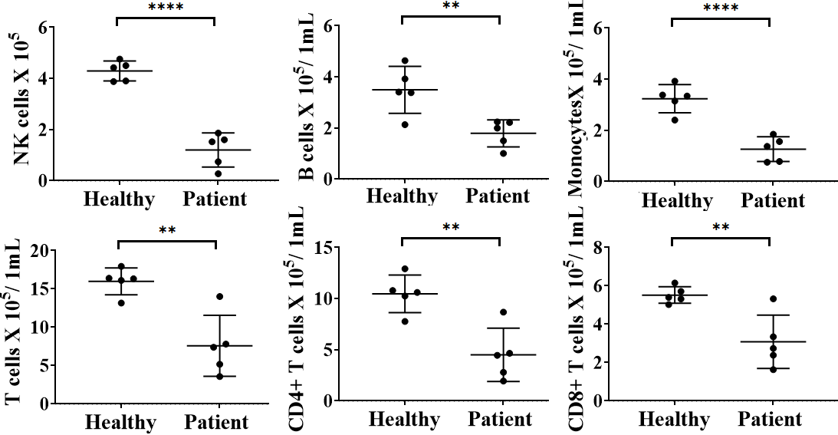

Figure S2

Figure S3
A
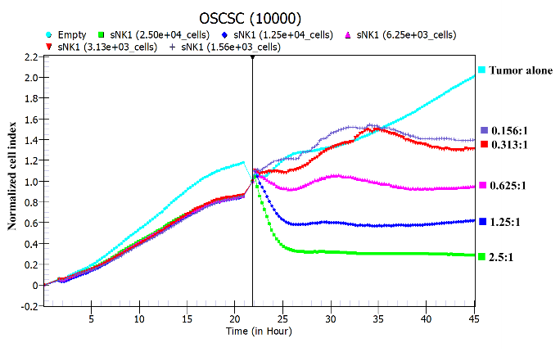
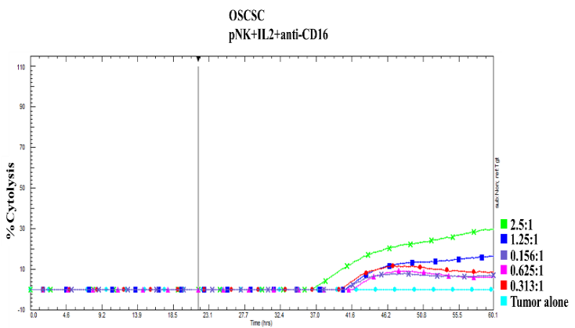
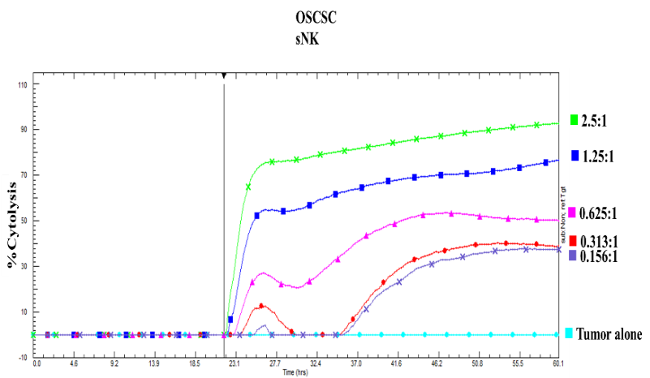
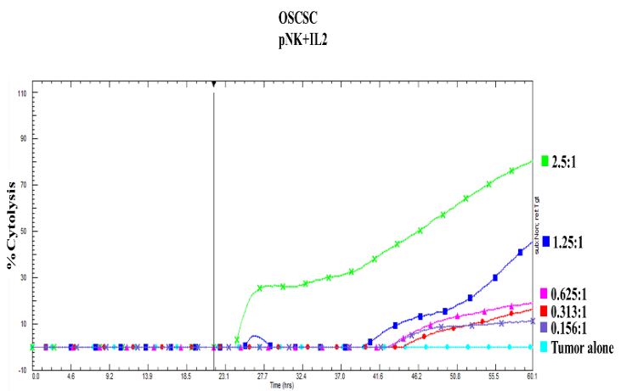
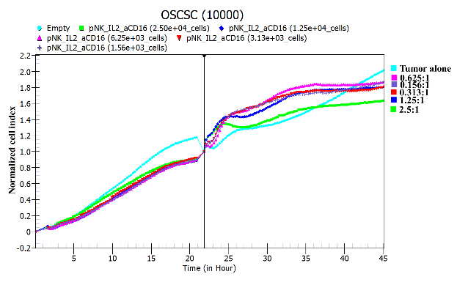
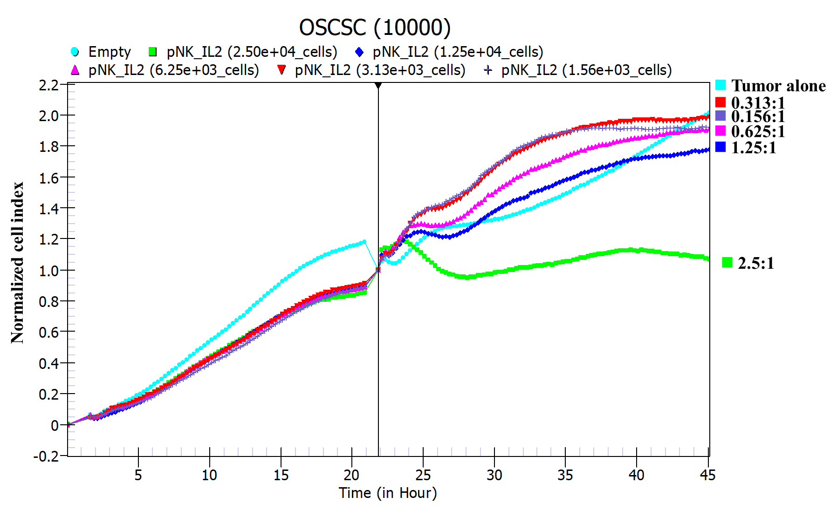

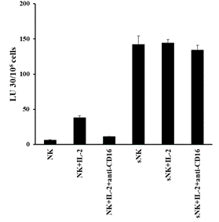
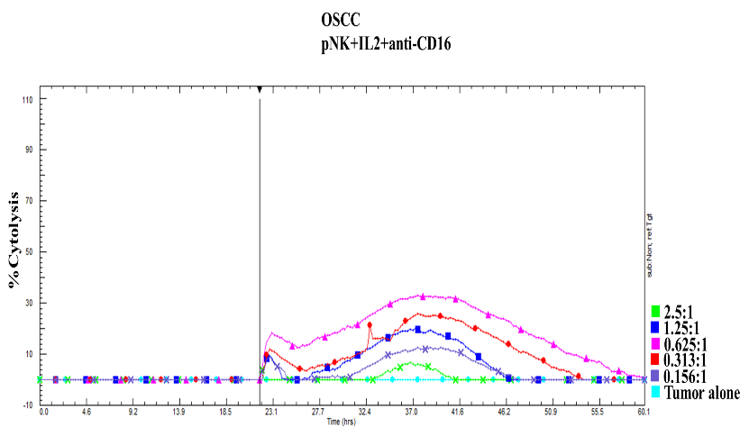
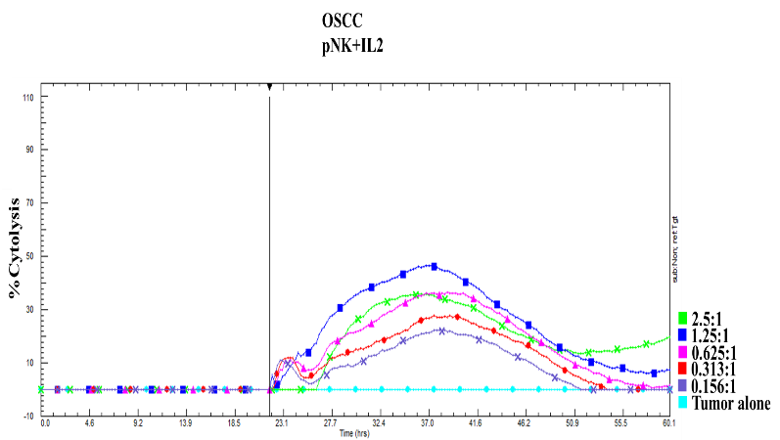
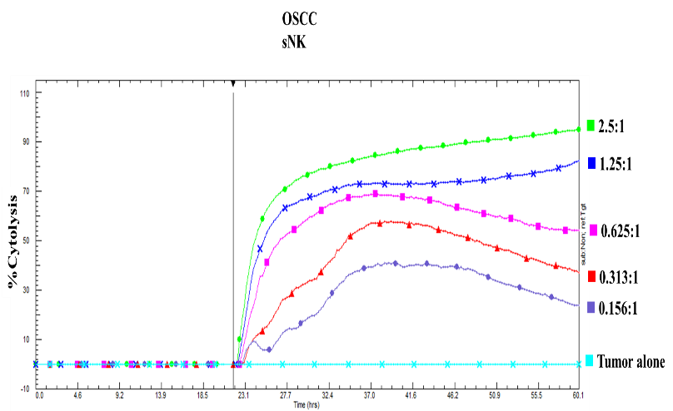
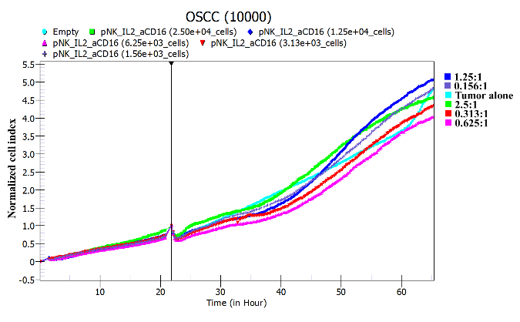
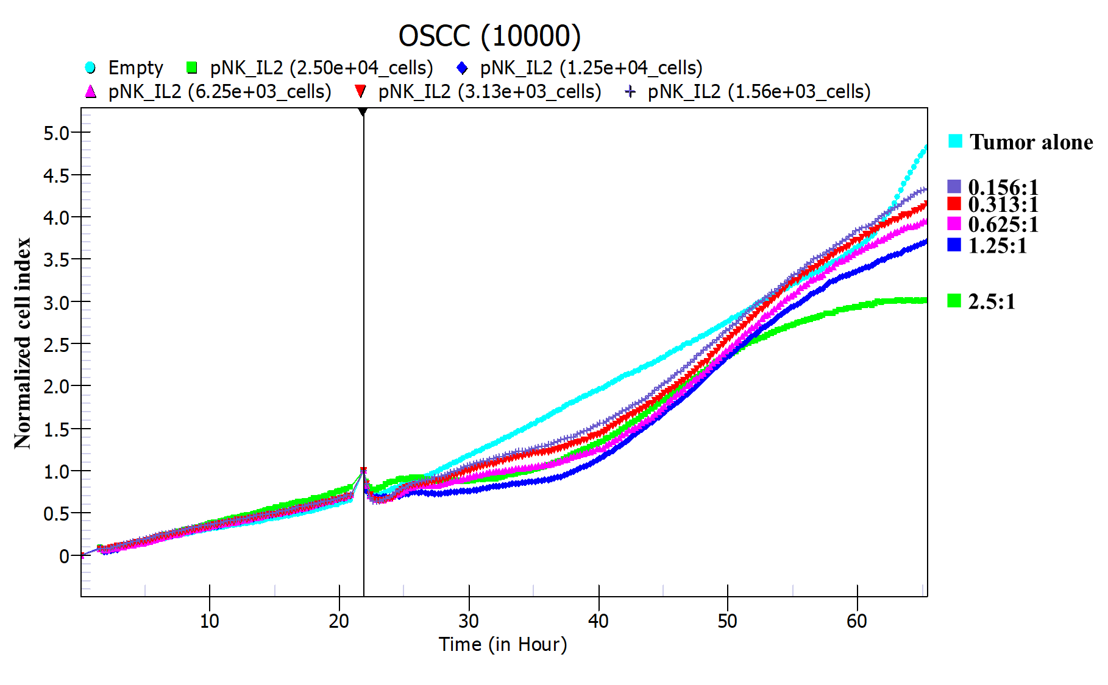
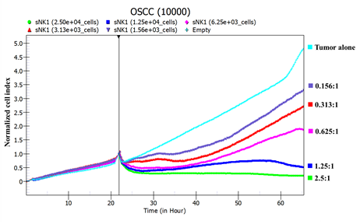
B

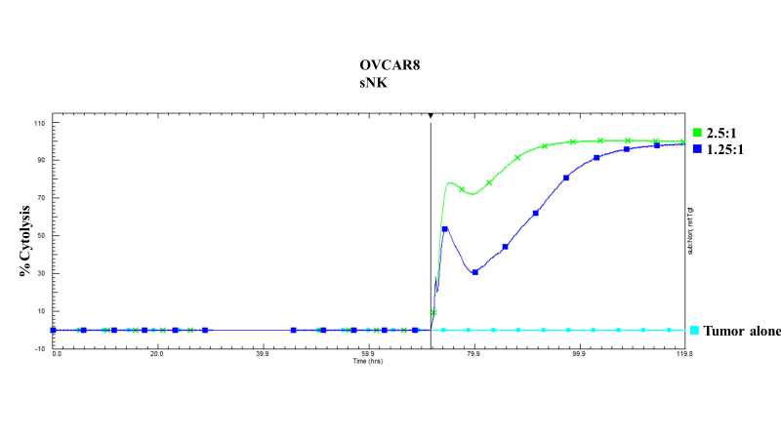
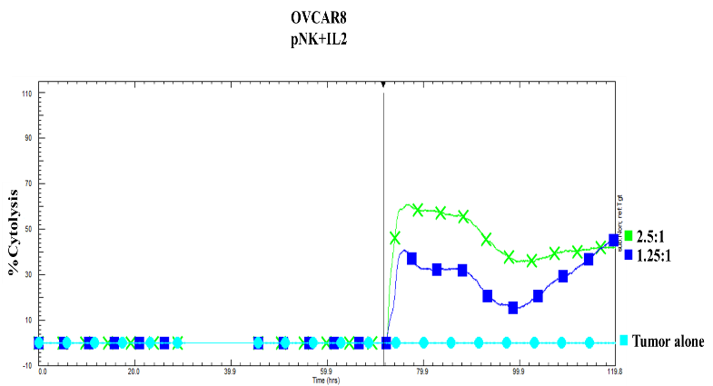
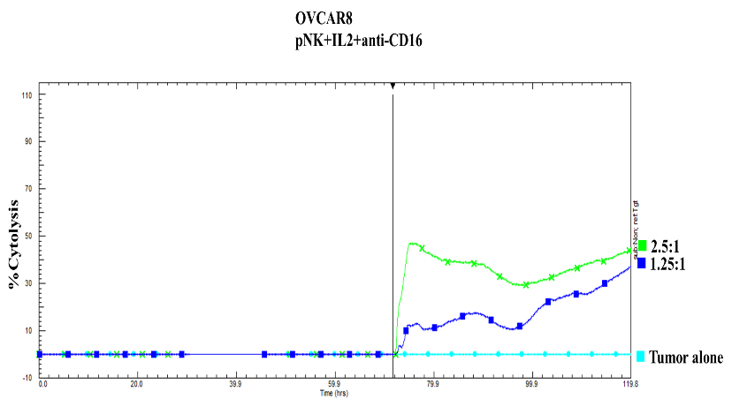
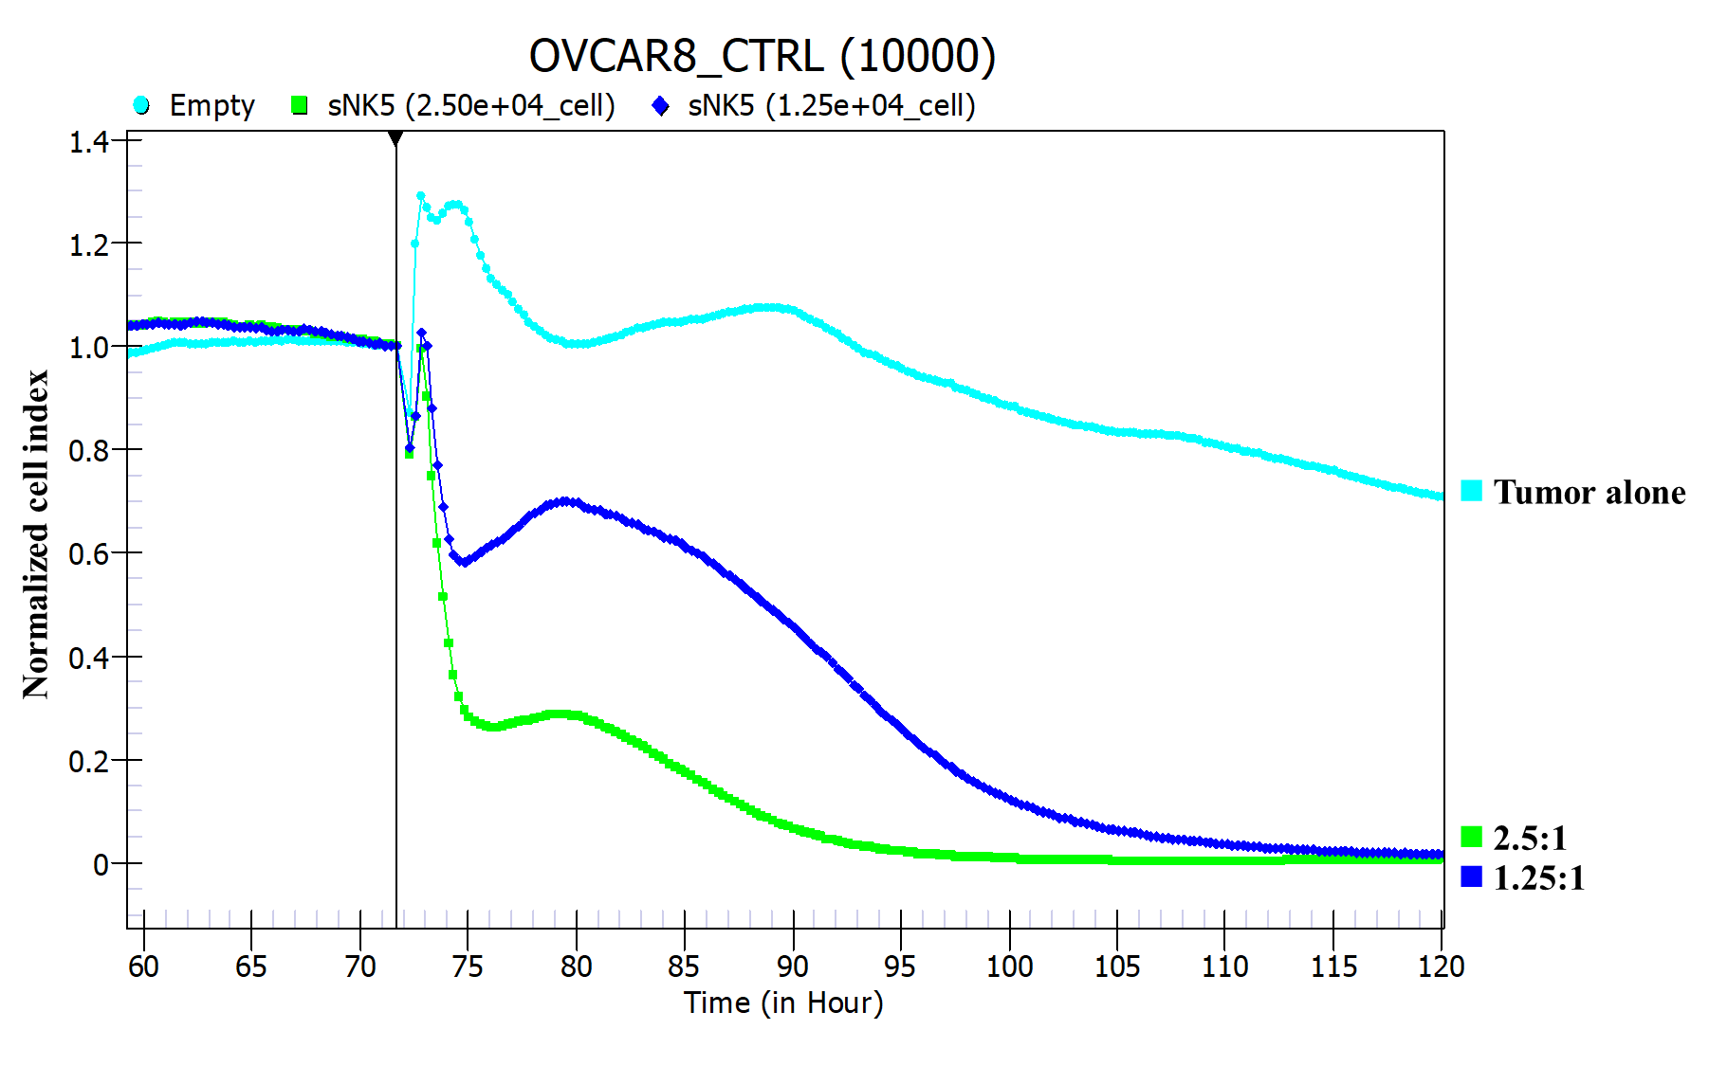
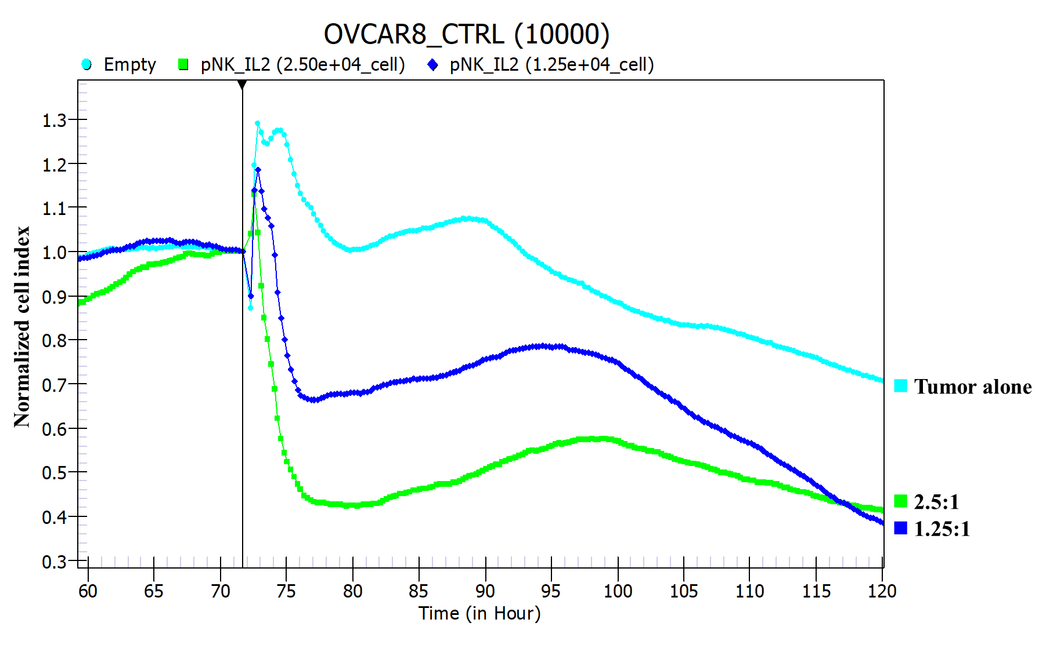
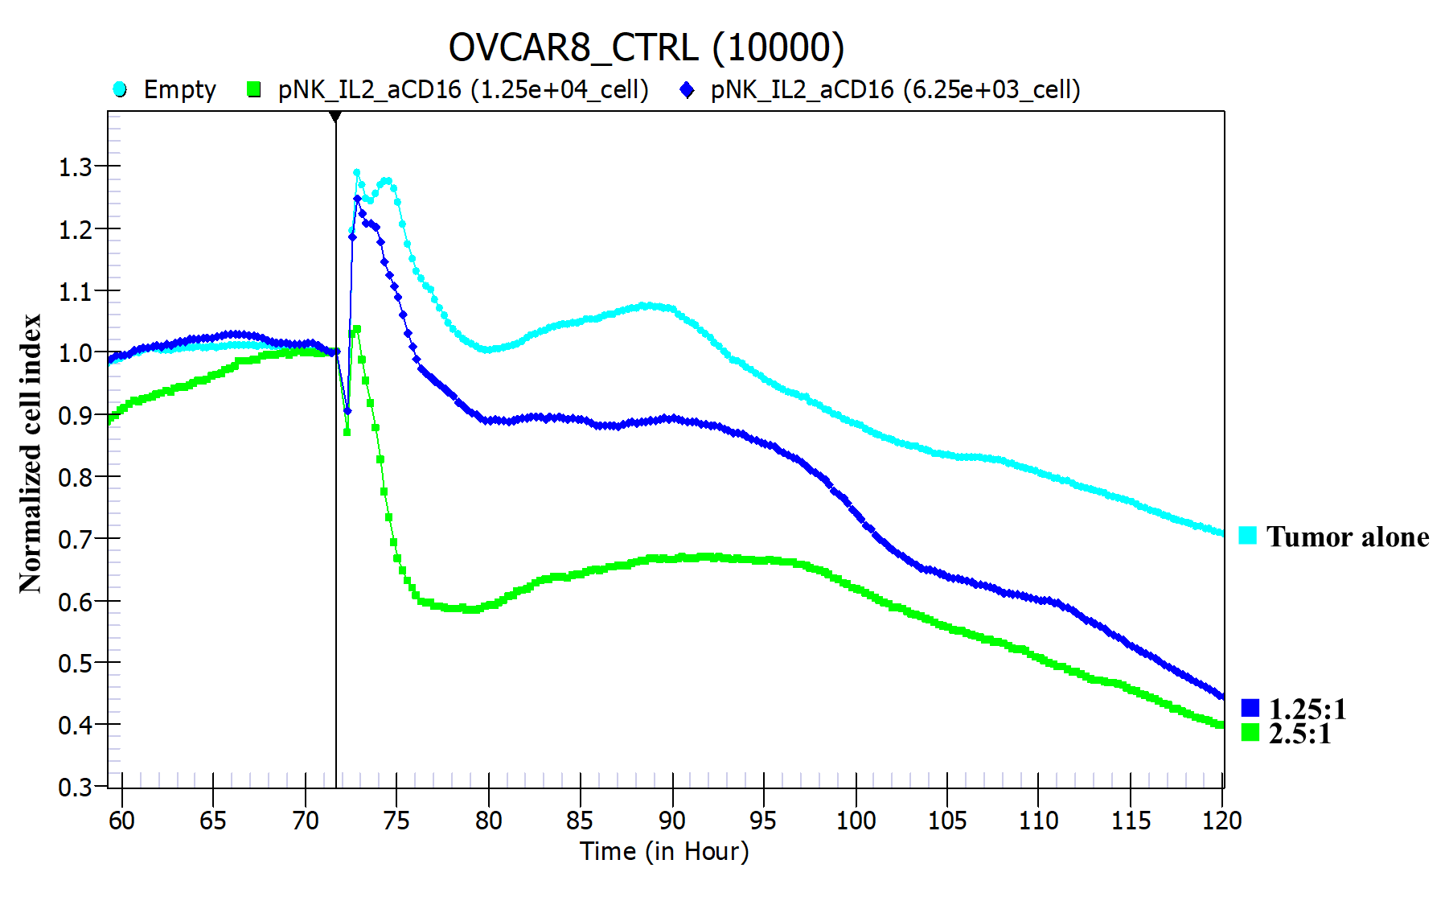

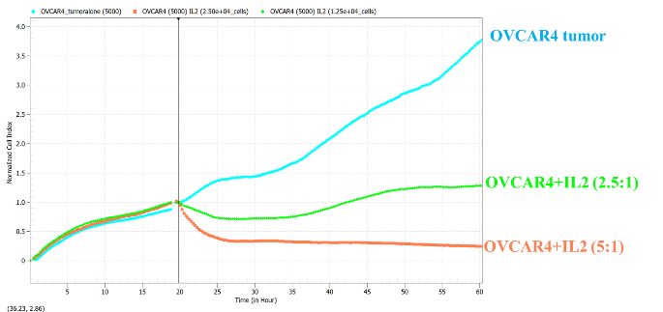
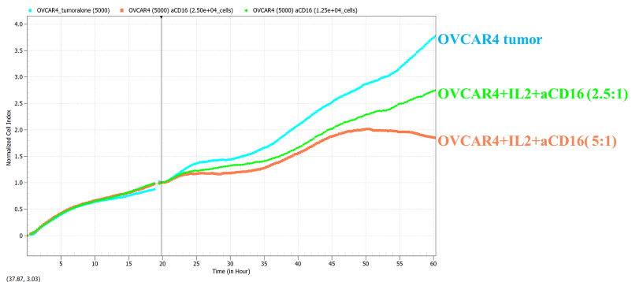
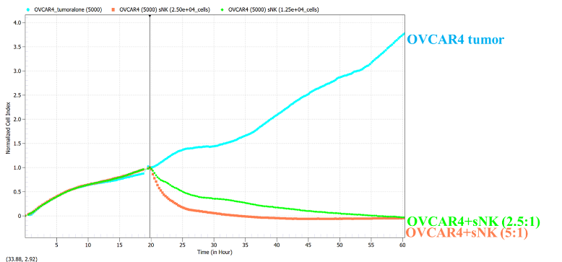
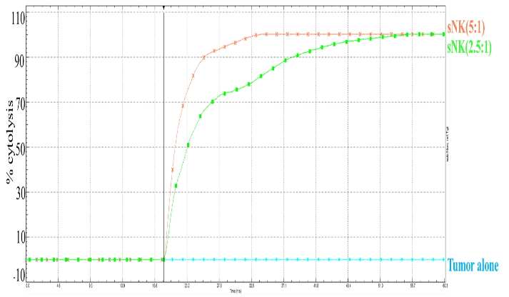
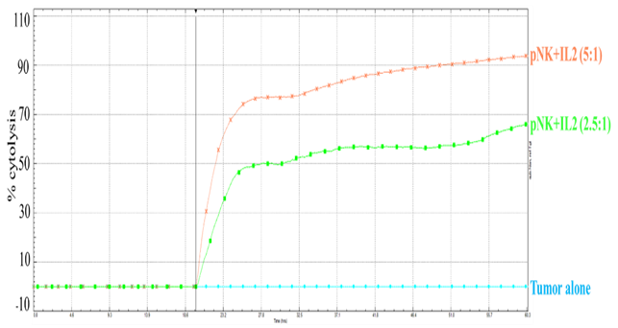
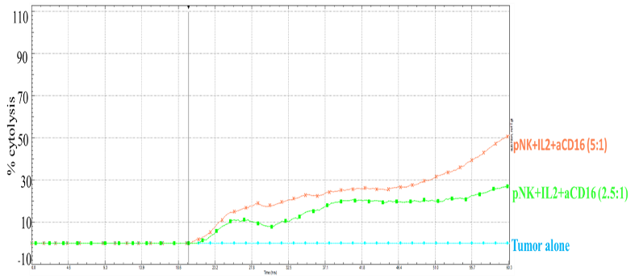

Figure S4

