Supporting Information

Improving the antibacterial activity of tryptophan-containing peptide nanostructures by self-assembly

Lei Zhao, Zhaoyang Liu and Mingyang Ji*

Research School of Polymeric Materials, School of Materials Science & Engineering, Jiangsu University, Zhenjiang 212013, China

*Corresponding Author
Mingyang Ji
E-mail: jimy@ujs.edu.cn

Experimental Section

Synthesis of Aromatic Peptide Amphiphiles and Corresponding Fmoc-Removed Peptide Analogs
Fmoc-protected, aromatic peptide amphiphiles and corresponding Fmoc-removed peptide analogs in this study were prepared using Fmoc/t-Bu solid-phase peptide synthesis on rink amide resin (loading 0.65 mmol/g). Amide-coupling steps were accomplished with standard techniques for all peptide sequences. Deprotected rink amide resin was sequentially treated with Fmoc-amino acids in DMF in the presence of 1,3-diisopropylcarbodiimide (DIC) and 1-hydroxybenzotriazole (HOBt) (500 mol% each relative to resin) to achieve specific peptide regions for this study. For peptides without aromatic C-terminus, Fmoc deprotection was carried out in a solution of 20% piperidine in DMF for 20 min. Thus, prepared peptides, as well as aromatic peptide amphiphiles, were cleaved from resin beads by treatment with TFA/water/triethylsilane (94/1/5) for 2 h. The crude products were precipitated in cold diethyl ether, purified by reversed-phase HPLC, and lyophilized to yield pure products as powder, which were stored at 4 °C for subsequent study.

Self-Assembly of Aromatic Peptide Amphiphiles
Freeze-dried aromatic peptide amphiphiles were added to HPLC-grade water and sonicated to dissolve. The pH of the prepared solutions was adjusted with 1 M NaOH/HCl, and aqueous solutions of aromatic peptide amphiphiles (5-9 mM) with the desired pH were incubated at 25 °C for 24 h to achieve complete self-assembly, yielding self-supporting hydrogels or viscous solutions of aromatic peptide amphiphiles.

Preparation of Polydopamine/Fmoc-KWK (PDA/Fmoc-KWK) Composites
Lyophilized Fmoc-KWK powder and monomeric dopamine hydrochloride were dissolved in water at various molar ratios (1:5 or 1:10), and the pH of the resulting mixture was adjusted to ~7.4. After aging at 25 °C for 24 h away from ambient light, the former transparent aqueous mixture turned into a self-supporting, dark brown hydrogel, forming a PDA/Fmoc-KWK composite.

Preparation of Phospholipid/Polydiacetylene Colorimetric Vesicles
Phospholipid/polydiacetylene vesicles capable of biological association-induced colorimetric transitions were prepared from aqueous mixtures of dimyristoylphosphatidylcholine (DMPC) and 10,12-tricosandiynoic acid (TDA) following a previously reported procedure (Kolusheva et al. 2000a, 2000b). Specifically, DMPC and TDA were dissolved in chloroform at a molar ratio of 2:3, followed by solvent vaporization and hydration (2 mM with respect to DMPC). The resulting aqueous mixture was probe sonicated at 80 °C for 10 min. The aqueous dispersions prepared were cooled down at 8 °C overnight and subsequently exposed to 120-s irradiation at 245 nm (2 W) to achieve the polymerization of TDA (PTDA). The resulting vesicles comprising DMPC and PTDA formed a homogeneous aqueous dispersion exhibiting an intense blue color. Finally, the DMPC-PTDA vesicle passed through a membrane filter (pore size 0.45 µm), and its hydrodynamic diameter was determined by DLS to be 322.4 ± 39.6 nm.
The color transition of DMPC-PTDA vesicles from blue to red upon interaction with peptides or Fmoc-capped aromatic peptides is quantified by the colorimetric response (%CR) (Kolusheva et al. 2000b), which is defined as follows:
$\%CR = \frac{\left({blue}/{red} ratio of background\right)-({blue}/{red} ratio of sample)}{({blue}/{red} ratio of background)} ×100$,
where ${blue}/{red}ratio=\frac{(absorbance at 640 nm)}{\left(absorbance at 640 nm\right) + (absorbance at 500 nm)}$ , the blue/red ratio of the background is taken from DMPC-PTDA vesicle dispersion prior to amphiphile addition, and the blue/red ratio of the sample is obtained after treating DMPC-PTDA vesicle with Fmoc-capped aromatic peptides or their peptide analogs.

Transmission Electron Microscopy (TEM)
Freshly diluted solutions of aromatic peptide amphiphiles and their peptide analogs were applied on carbon-coated copper grids (Ted Pella, Inc.) for 10 min. After excessive solutions were removed, copper grids deposited with sample were negatively stained with 2% (w/w) uranyl acetate and dried at room temperature. Stained sample grids were then subjected to TEM imaging on an FEI Tecnai 12 transmission electron microscope with an accelerating voltage of 100.0 kV.

Circular Dichroism (CD) Measurements
After self-assembly was complete, the aromatic peptide amphiphiles were diluted to 0.25 mM and loaded into 0.5-mm quartz cells. Under continuous purging of compressed air, CD spectra were collected on a JASCO J-815 CD spectrometer at 25 °C. Each spectrum was averaged from three scans ranging from 190-650 nm at a step width of 1.0 nm and a step speed of 0.5 s. The solvent spectra measured under identical conditions were subtracted from all sample spectra.

Dynamic Light Scattering (DLS) Measurements
The hydrodynamic diameter and ζ-potential were determined by DLS measurement on a Malvern Zetasizer NanoZS system using folded capillary zeta cells (DTS1070). The folded capillary cell loaded with freshly prepared sample was inserted into the equipment chamber with preset temperatures (25 °C) and equilibrated for 10 min prior to measurement. After equilibration, the samples were taken for 3-5 measurements at each condition, and each measurement was automatically averaged from 10-15 test results of a 10-s test run.

Steady-State Fluorescence Study
Freshly diluted aqueous samples were bubbled with nitrogen for 10 min before the fluorescence emission was measured. Fluorescence spectra were collected on a PerkinElmer FL8500 fluorescence spectrometer with a 5-mm cuvette at 25 °C using excitation at 290 nm and emission at 300-550 nm. The excitation and emission slits were set at 5 nm, and the emission scan speed was 60 nm/min.

Antimicrobial Assays
The antimicrobial activities of Fmoc-capped peptides against a panel of laboratory bacterial strains, including E. coli ATCC 8739, E. coli ATCC 25922, S. aureus ATCC 27217, and E. faecalis ATCC 29212, were evaluated by a broth microdilution method (EUCAST and ESCMID 2003). Bacteria in the mid-logarithmic phase were diluted in Luria–Bertani (LB) broth medium to reach a concentration of ~1 × 10⁶ colony forming units (CFU)/mL, and a 100 µL aliquot of bacterial suspension in LB broth medium was added to each well of sterile 96-well polystyrene plates. Fmoc-KWK (which achieved complete self-assembly and nonassembled control as monomeric form) and Fmoc-KWWK were diluted in LB broth medium to 0.5 and 0.9 mM, respectively. Then, LB solutions of Fmoc-capped peptides were added to each well of multiwell plates containing bacterial medium in twofold serial dilutions, resulting in concentrations of Fmoc-KWK and Fmoc-KWWK ranging from 500 to 0.5 µM and from 900 to 1 µM, respectively. LB broth media with or without bacteria served as the positive and negative controls, and all plates were incubated at 37 °C for 24 h. The minimum inhibitory concentration (MIC) was determined as the minimal peptide concentration that prevented turbidity of bacterial culture after incubation from visual inspection, and all MIC measurements were the average of 3 independent experiments.

Toxicity Assessment via Hemolysis
The initial toxicity assessment of the examined peptides was conducted via human red blood cell (hRBC) hemolysis. In polycarbonate tubes containing anticoagulant ethylenediaminetetraacetic acid, hRBCs were collected through centrifugation at 1000 rpm for 10 min and were washed two times prior to resuspension in 10 mM PBS solution (pH 7.4). A 20 µL aliquot of hRBC suspension was added to 1 mL of the solution of the examined compounds (working concentration: 100 µM), and the resulting mixture was incubated with gentle agitation at 37 °C for 60 min. After incubation, the mixture was centrifuged at 3000 rpm for 10 min to collect the supernatant, and the absorbance of the supernatant at a wavelength proportional to the amount of hemoglobin released from hRBCs was recorded at 415 nm. PBS and 0.3% Triton X-100 were employed as the negative and positive controls, which gave absorbance at 415 nm for zero and 100% hemolysis, respectively. Percent hemolysis was calculated according to the following equation:
$\% Hemolysis=\frac{Abs of examined compound-Abs of PBS}{Abs of Triton -Abs of PBS} ×100$,
Each measurement was conducted in triplicate.

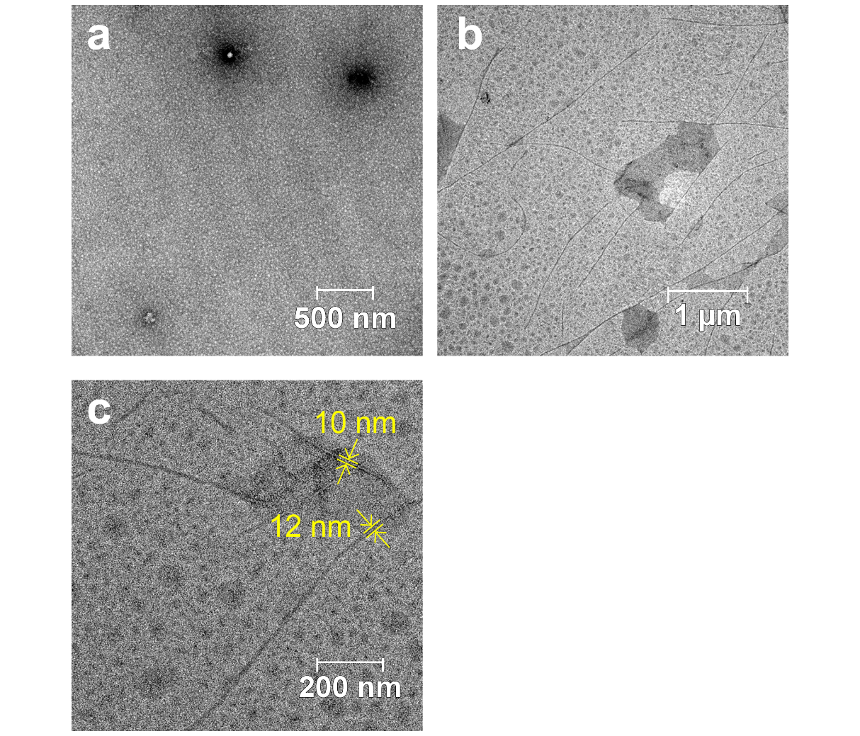
Fig. S1 TEM images of Fmoc-KWWK (9 mM) assembled at (a) pH 5.8 and (b, c) pH 8.1 for 24 h. All samples were freshly diluted to 0.25 mM for TEM imaging

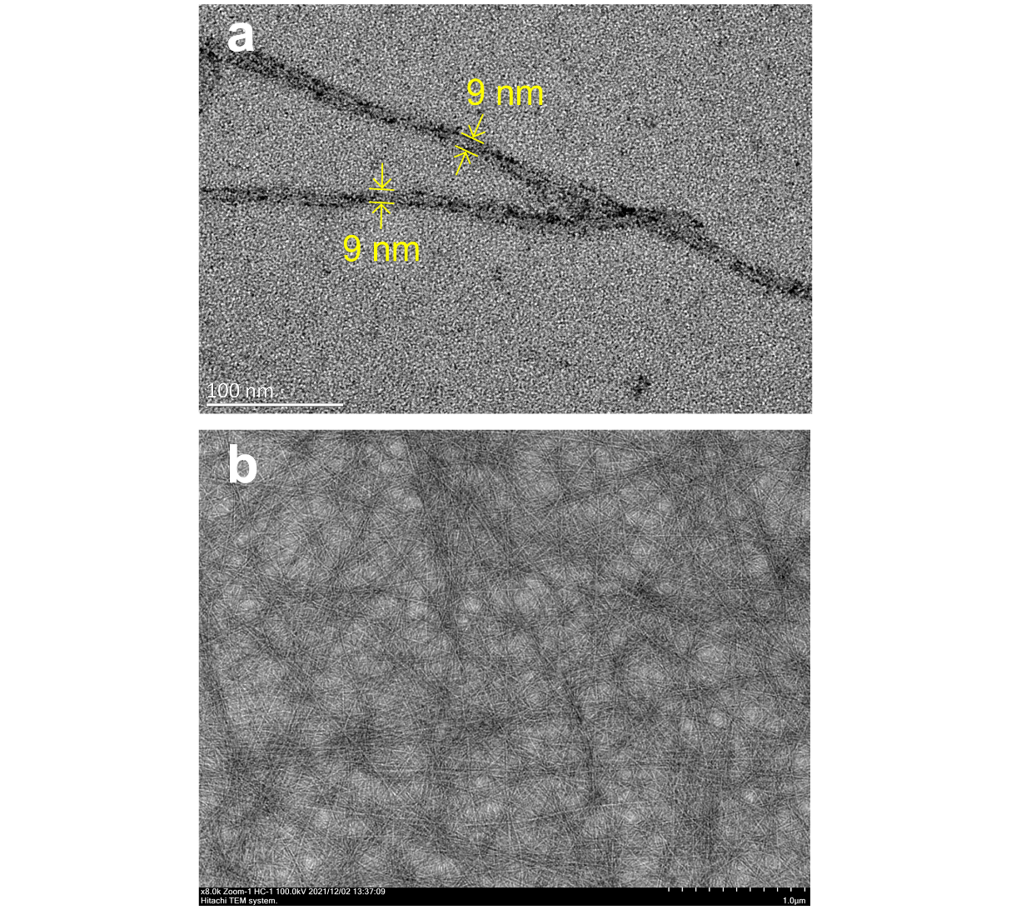
Fig. S2 TEM images of Fmoc-KWK (5 mM) assembled at pH 7.4 and diluted to (a) 0.25 mM and (b) 2 mM for TEM imaging

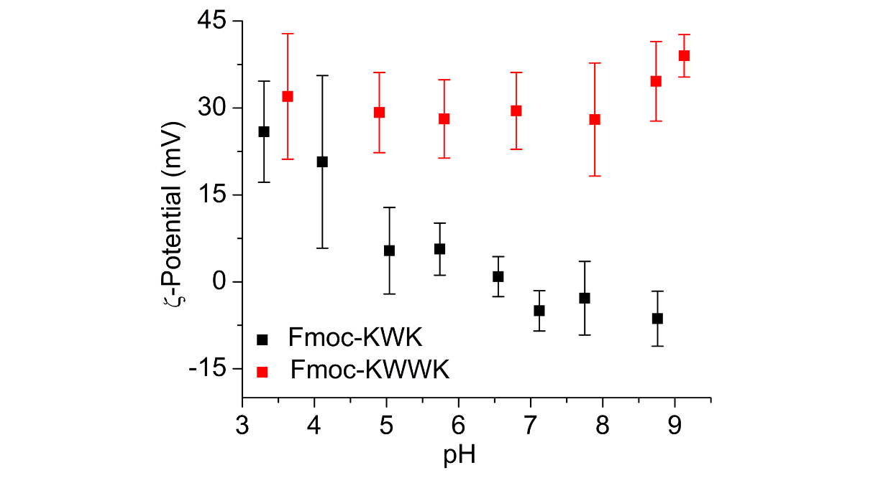
Fig. S3 ζ-Potentials of Fmoc-KWWK (0.25 mM) and Fmoc-KWK (0.25 mM) at various pH conditions at 25 °C

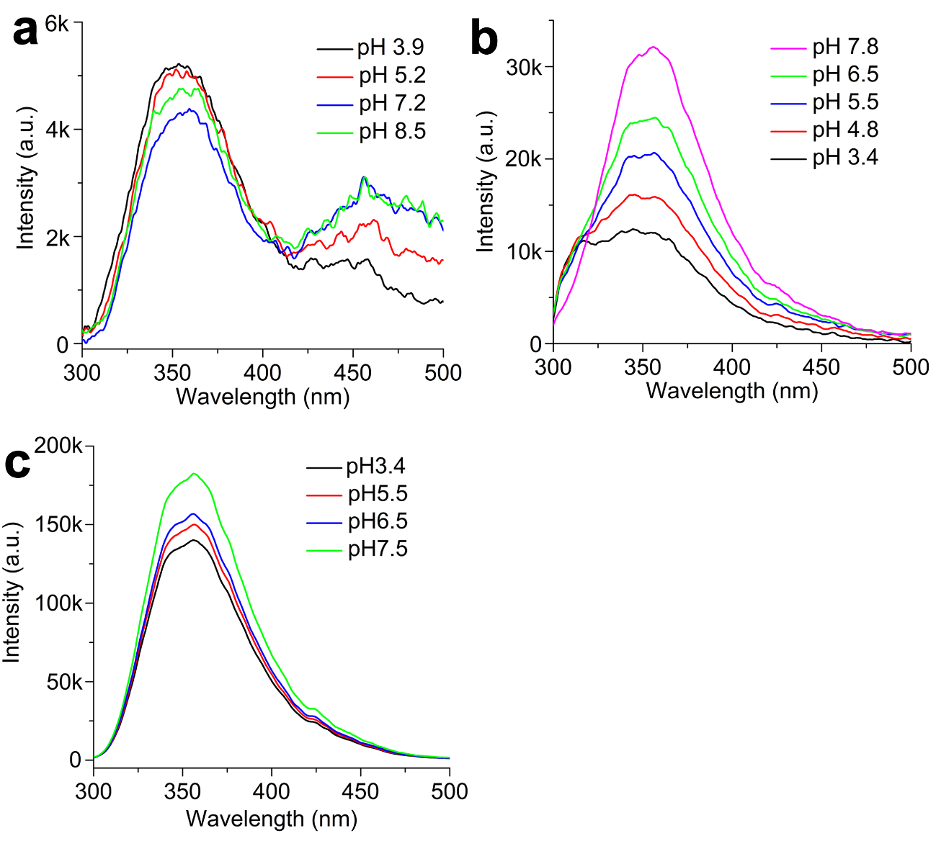
Fig. S4 Fluorescence spectra of (a) Fmoc-KWWK (1 mM) and (b) Fmoc-KWK (1 mM) at various pH conditions. Fmoc-KWWK (9 mM) and Fmoc-KWK (5 mM) were dissolved in water and adjusted to the desired pH with 1 M NaOH/HCl. After incubation at 25 °C for 24 h, samples were diluted to 1 mM to collect emission spectra, Ex 290 nm. (c) Emission spectra of KWK (1 mM) at various pH conditions, Ex 290 nm

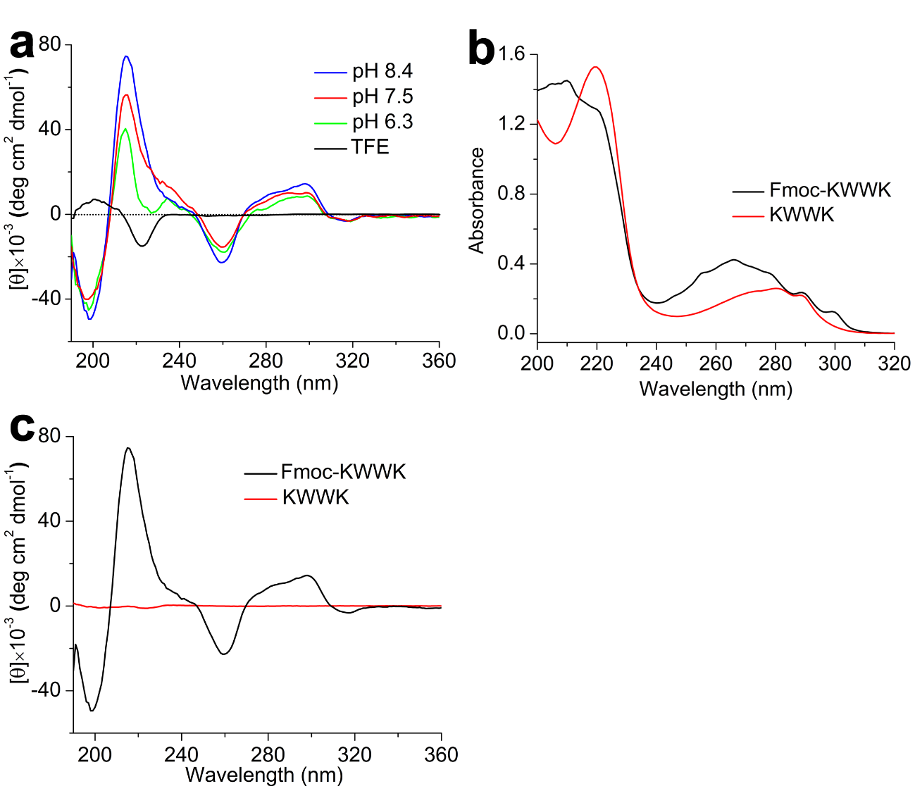
Fig. S5 (a) CD spectra of Fmoc-KWWK (0.25 mM) in TFE and water. Fmoc-KWWK dissolved in water was freshly diluted from 9 mM after incubation at different pH conditions. (b) UV‒vis and (c) CD spectra of Fmoc-KWWK (pH 8.4) and KWWK (pH 8.1) collected in water. Fmoc-KWWK and KWWK, dissolved at a concentration of 9 mM, were adjusted to the desired pH, incubated at 25 °C for 24 h, and then diluted to 0.5 and 0.25 mM for UV‒vis and CD studies, respectively

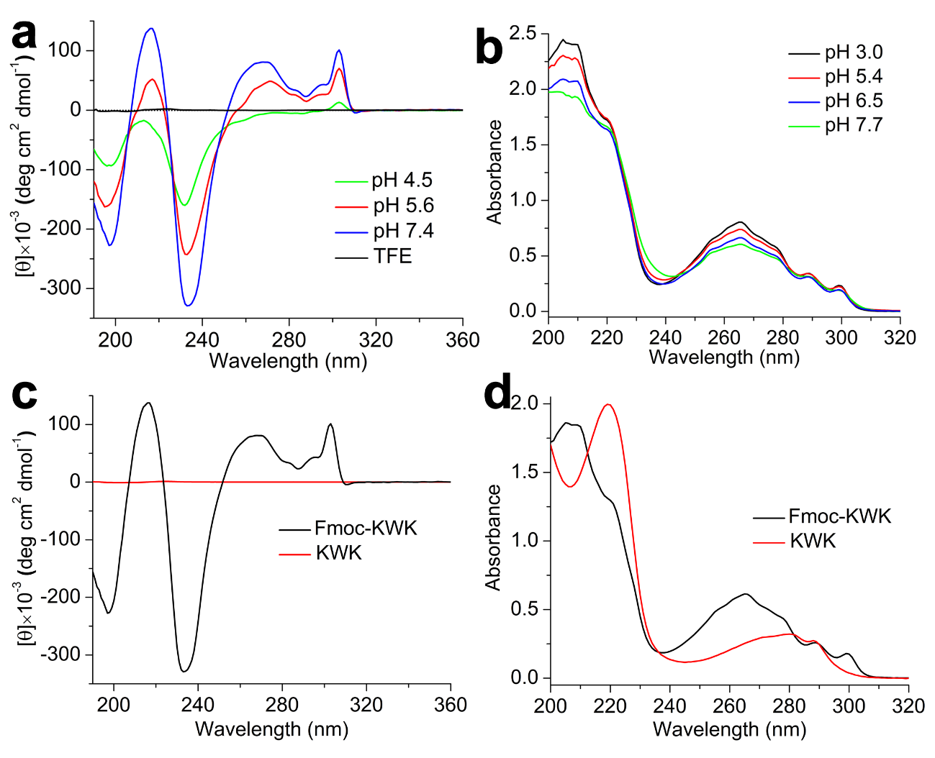
Fig. S6 (a) CD and (b) UV‒vis spectra of preassembled Fmoc-KWK fibrils collected at various pH values in water. (c) CD and (d) UV‒vis spectra of Fmoc-KWK and KWK collected at pH 7.4 in water. Both Fmoc-KWK and KWK, dissolved at a concentration of 5 mM, were incubated in water at the desired pH for 24 h. Then, the resulting hydrogels of assembled Fmoc-KWK and the aqueous solution of KWK were diluted to 0.25 and 0.5 mM immediately before spectra were collected for CD and UV studies, respectively

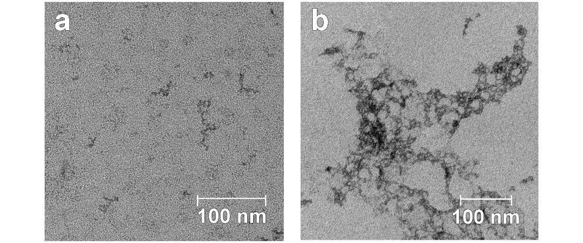
Fig. S7 TEM images of (a) KWWK and (b) KWK after incubation at a concentration of 10 mM and solvent pH 9-11 for 24 h, and both samples were diluted to 1 mM prior to TEM imaging

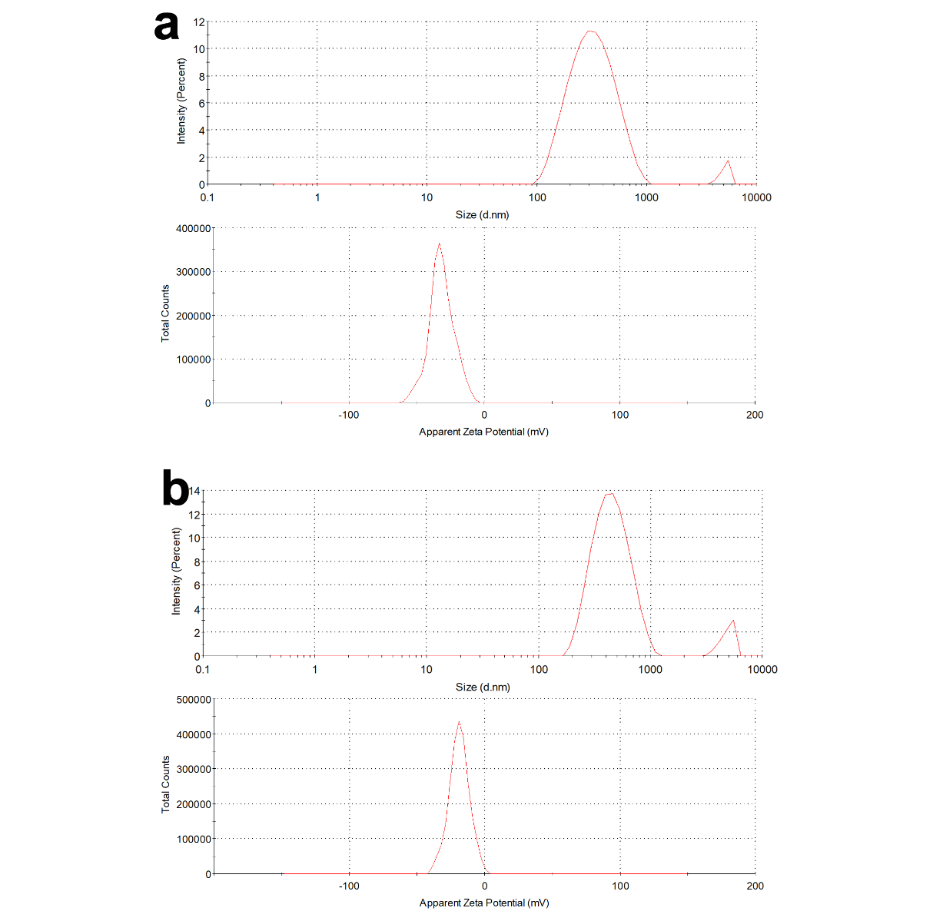
Fig. S8 Hydrodynamic diameter and ζ-potential intensity distributions of (a) DMPC-PTDA (2:3, DMPC/PTDA n/n) and (b) PTDA at pH ~7.4 and 25 °C shortly after 245 nm irradiation-triggered TDA polymerization. The diameters of DMPC-PTDA (2:3) and PTDA were determined to be 322.4 ± 39.6 and 419.0 ± 51.1 nm, and their ζ-potentials were measured to be -32.0 ± 0.7 and -18.9 ± 0.3 mV, respectively

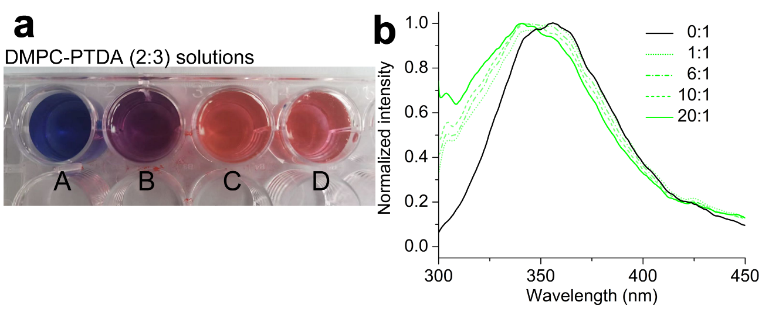
Fig. S9 (a) Photograph of DMPC-PTDA solutions upon treatment with peptide amphiphiles: A, pure DMPC-PTDA vesicles; B, C, and D, DMPC-PTDA vesicles after addition of peptide amphiphiles in molar ratios of 0.5, 1.0, and 2.0, respectively. The concentration of DMPC-PTDA (with respect to DMPC) was 0.5 mM in all wells. (b) Fluorescence emission of Fmoc-KWK (0.1 mM) upon titration by DMPC-PTDA vesicles from 0:1 (pure Fmoc-KWK) to 20:1 (DMPC-PTDA/Fmoc-KWK, n/n), Ex 290 nm

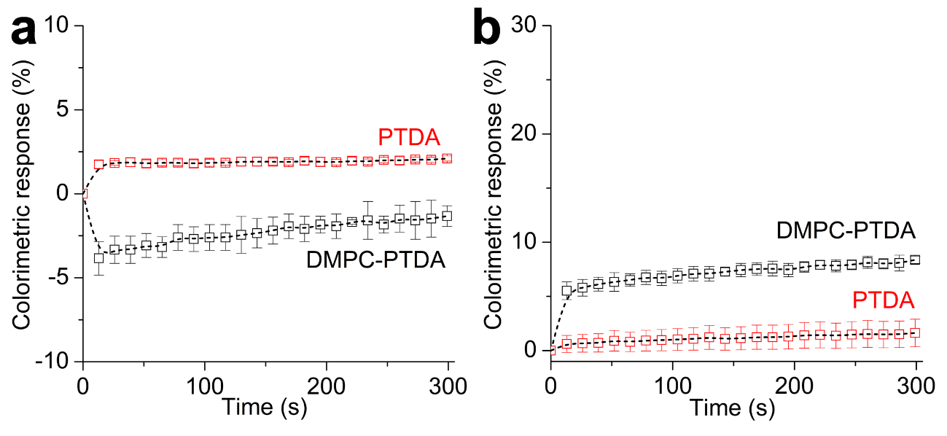
Fig. S10 Colorimetric responses of DMPC-PTDA (2:3, DMPC/PTDA) and pure PTDA vesicles upon mixing with (a) KWK and (b) Fmoc-lysine. DMPC-PTDA and pure PTDA vesicle dispersions were freshly diluted with PBS prior to spectra collection, and the concentration of PTDA in both vesicle dilutions was 0.75 mM. Due to its poor solubility in water, Fmoc-lysine was dissolved in MeOH before it was mixed with aqueous dispersions of colorimetric vesicles, and the final concentration of MeOH was no more than 2.5% (v/v). The applied concentration of KWK and Fmoc-lysine at measurement was 0.1 mM

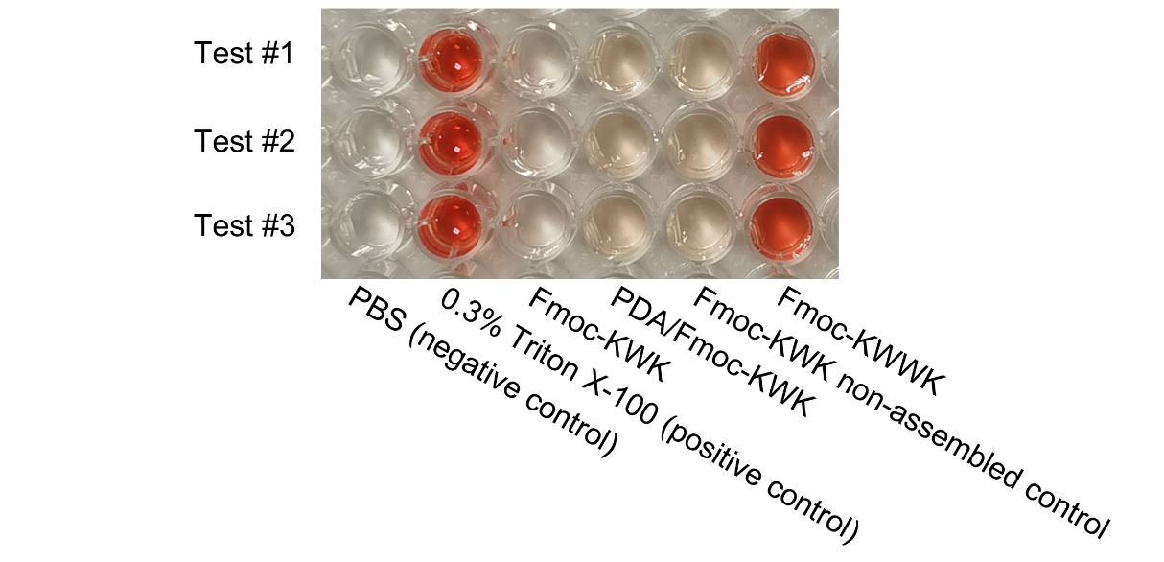
Fig. S11 Multicell plates exhibiting the hemolytic activities of the examined compounds. The working concentrations of the studied peptides and peptide composites were 100 µM

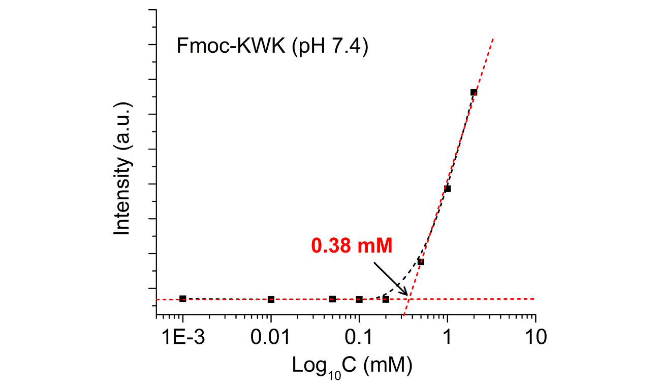
Fig. S12 Plot of the fluorescence intensity of Nile red at 635 nm (λ_{Ex} = 530 nm) versus the concentration of Fmoc-KWK at pH 7.4, showing a critical micelle concentration (CMC) of 0.38 mM

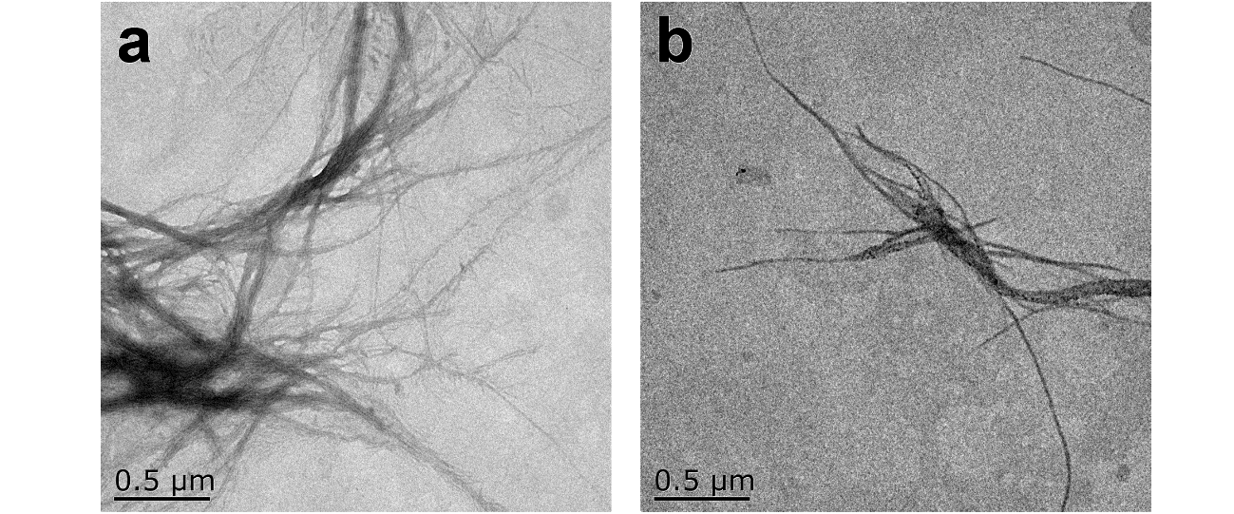
Fig. S13 (a) Assembled Fmoc-KWK (5 mM) nanofibers were diluted with PBS (pH 7.4) to (a) 100 μM and (b) 10 μM, and the resulting dilutions were aged for 24 h prior to TEM imaging

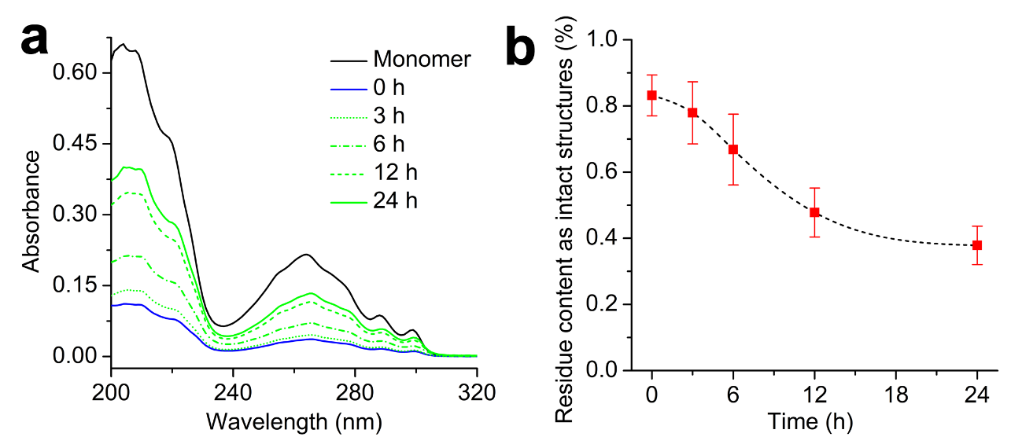
Fig. S14 (a) UV‒vis spectra of monomeric Fmoc-KWK (black, treated with TFE, 0.1 mM in PBS) and supernatants of preassembled Fmoc-KWK nanostructures after dilution with PBS to 0.1 mM for 0, 3, 6, 12, and 24 h. Fmoc-KWK (5 mM) was adjusted to ~pH 7 and stored at 25 °C for 24 h to complete self-assembly. After 24 h of incubation, assembled Fmoc-KWK was diluted with PBS to 0.1 mM, and equal aliquots of Fmoc-KWK solution (0.1 mM in PBS) were centrifuged (60k rpm for 30 min) at the desired time intervals. After centrifugation, supernatants were separated from precipitates for UV‒vis measurements. (b) Time profile of the content of Fmoc-KWK remaining intact nanostructures (collected as precipitates) after PBS dilution, estimated from absorbance at 265 nm. Each value was averaged from three independent measurements, and the dashed curve is given for visual guidance

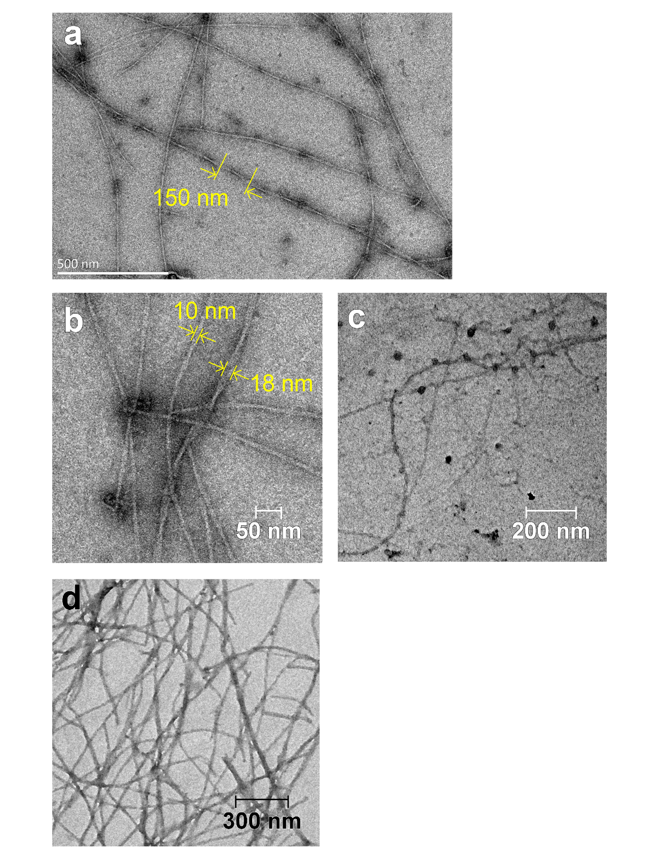
Fig. S15 TEM images of PDA/Fmoc-KWK composites prepared from different feeding molar ratios of dopamine hydrochloride to Fmoc-KWK: (a, b) 5:1 and (c) 10:1. Dopamine hydrochloride was added to the aqueous solution of monomeric Fmoc-KWK (5 mM), and then the resulting mixture was aged at pH 7.4 at 25 °C for 24 h to produce dark brown, self-supporting hydrogels. All samples were freshly diluted to 0.25 mM for TEM imaging. (d) PDA/Fmoc-KWK (5:1) was redispersed in PBS and aged for 24 h

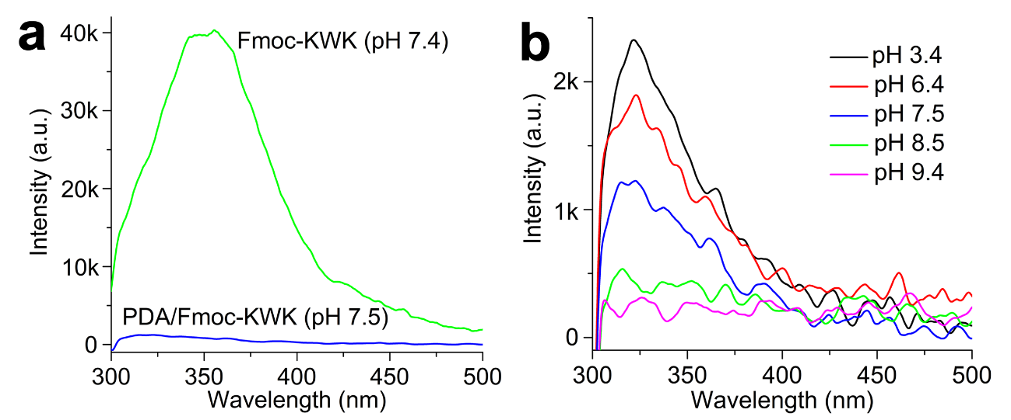
Fig. S16 (a) Fluorescence spectra of Fmoc-KWK (1 mM, pH 7.4) and PDA/Fmoc-KWK (1 mM with respect to Fmoc-KWK, pH 7.5), Ex 290 nm. (b) Emission spectra of preformed PDA/Fmoc-KWK at different pH conditions. The PDA/Fmoc-KWK composite was prepared from a feeding molar ratio of dopamine hydrochloride to Fmoc-KWK of 5:1 at pH 7.4 and then incubated at 25 °C for 24 h prior to the spectral study

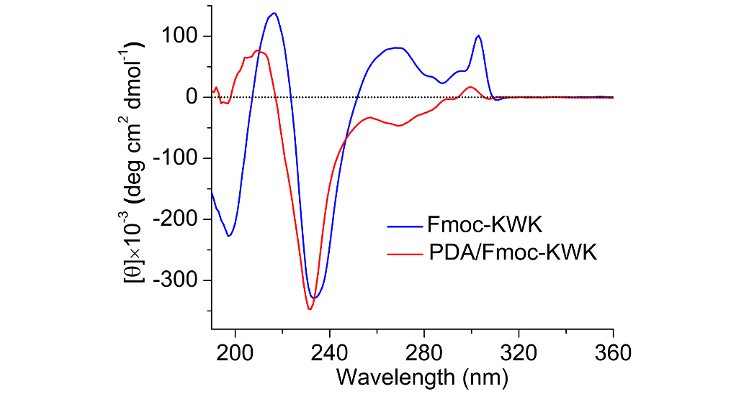
Fig. S17 CD spectra of Fmoc-KWK and PDA/Fmoc-KWK collected at pH 7.4. Both samples were freshly diluted from the incubation concentration prior to measurements, and the concentration with respect to Fmoc-KWK after dilution was 0.25 mM

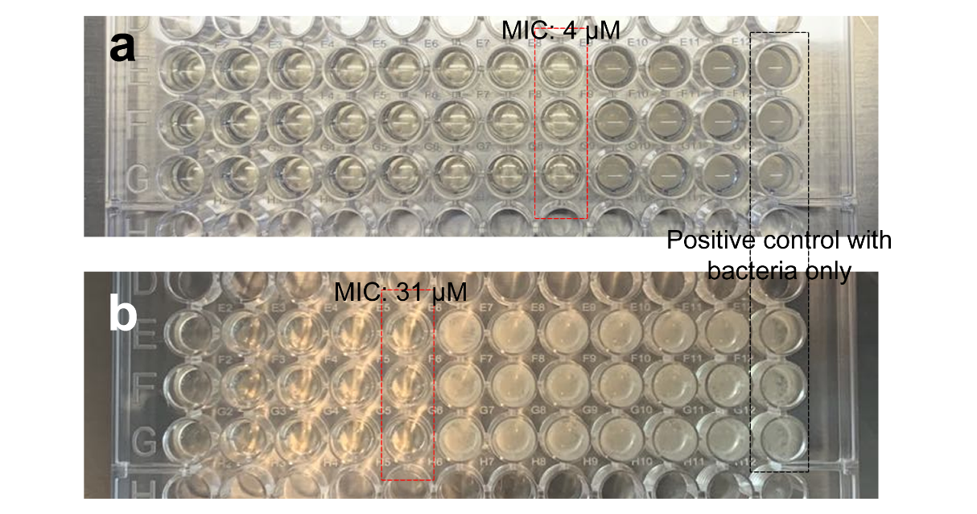
Fig. S18 Multicell plates containing (a) Fmoc-KWK achieved complete self-assembly and (b) nonassembled Fmoc-KWK in monomeric form after incubation, showing significantly different antibacterial activities against E. faecalis ATCC 29212

Table S1. Antimicrobial and hemolytic activities of Fmoc-capped peptides.
Compounds | MICª (µM) |  |  |  |  |  | Hemolysis^{b} (%)
Compounds | Gram-negative bacteria |  |  | Gram-positive bacteria |  |  | Hemolysis^{b} (%)
Compounds | E. coli  ATCC 8739 | E. coli  ATCC 25922 |  | S. aureus  ATCC 27217 | E. faecalis  ATCC 29212 |  | Hemolysis^{b} (%)
Fmoc-KWK | 16 | 8 |  | 16 | 4 |  | 2.7 ± 0.2
Fmoc-KWWK | 28 | 7 |  | 56 | 28 |  | 55.1 ± 1.3
Nonassembled control | 62 | 62 |  | 62 | 31 |  | 8.7 ± 1.2
PDA/Fmoc-KWK | 31 | 16 |  | 31 | 31 |  | 9.2 ± 0.9
ª Minimum inhibitory concentration (MIC) was determined as the lowest concentration of examined compounds that inhibited bacterial growth. ^{b} Percent hemolysis was measured in PBS in the presence of 100 µM of the examined compounds, and PBS and 0.3% Triton X-100 were employed as the negative and positive controls, respectively.

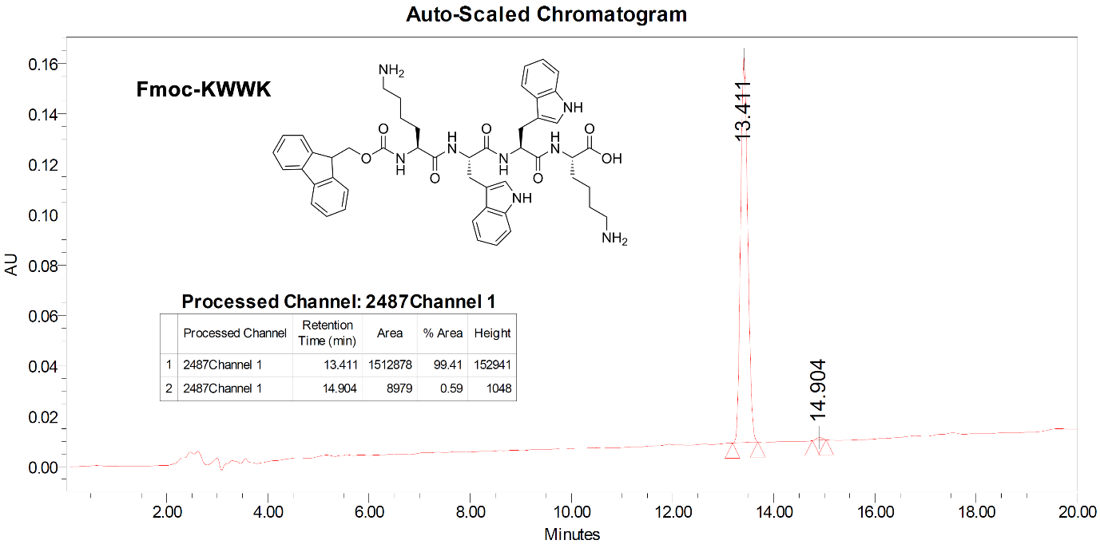
HPLC traces of purified Fmoc-KWWK (CH₃CN/water 0.1% TFA: 32/68 to 57/43 over 20 min).

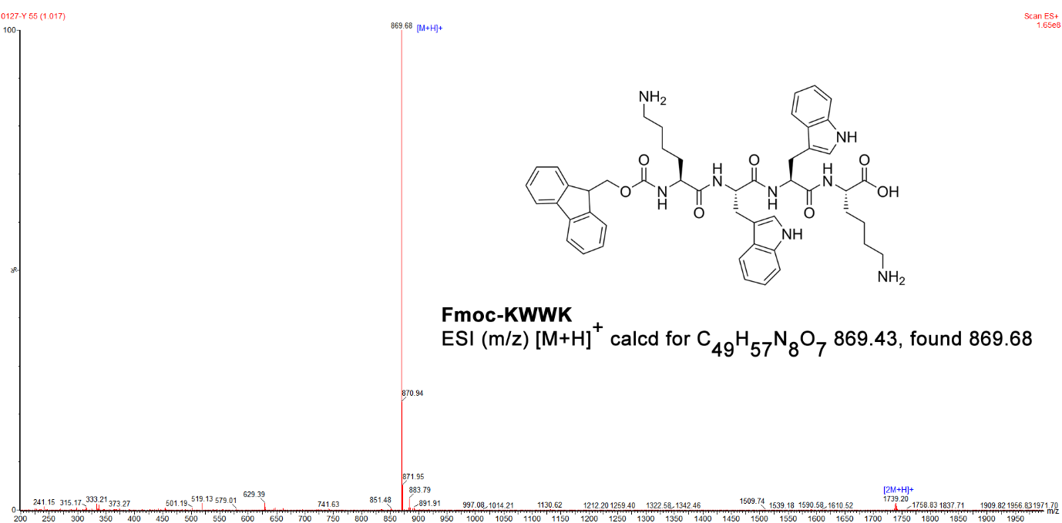
ESI-MS for C₄₉H₅₇N₈O₇ [M + H]+ calculated 869.43; found 869.68.

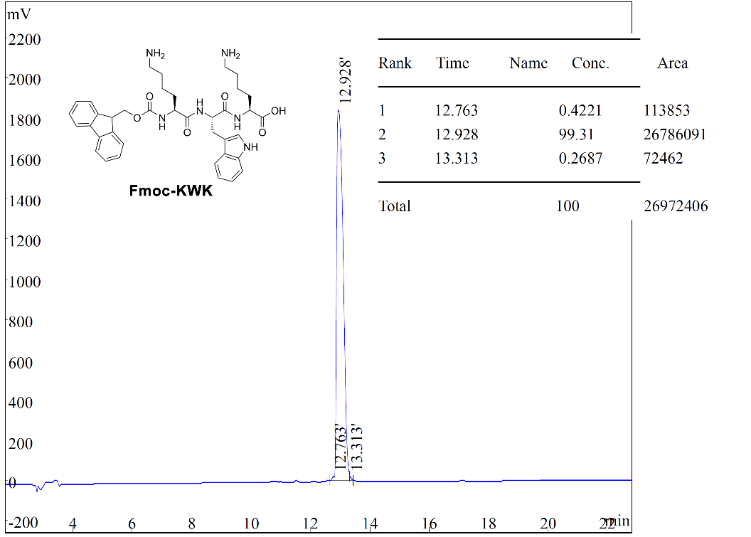
HPLC traces of purified Fmoc-KWK (CH₃CN/water 0.1% TFA: 26/74 to 51/49 over 20 min).
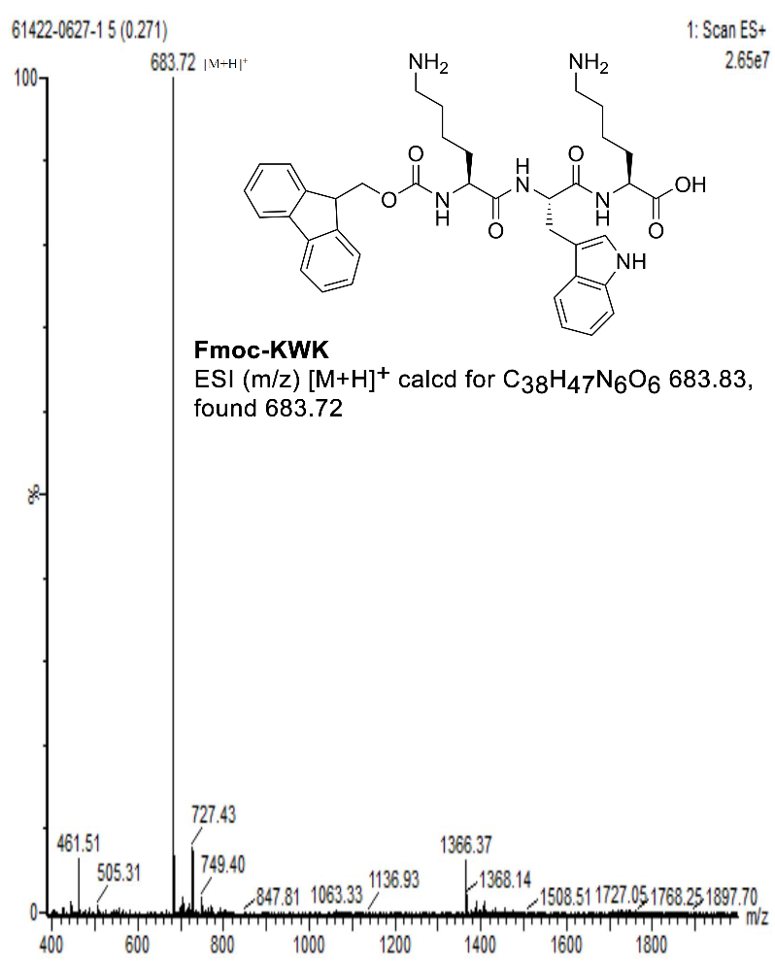
ESI-MS for C₃₈H₄₇N₆O₆ [M + H]+ calculated 683.83; found 683.72.

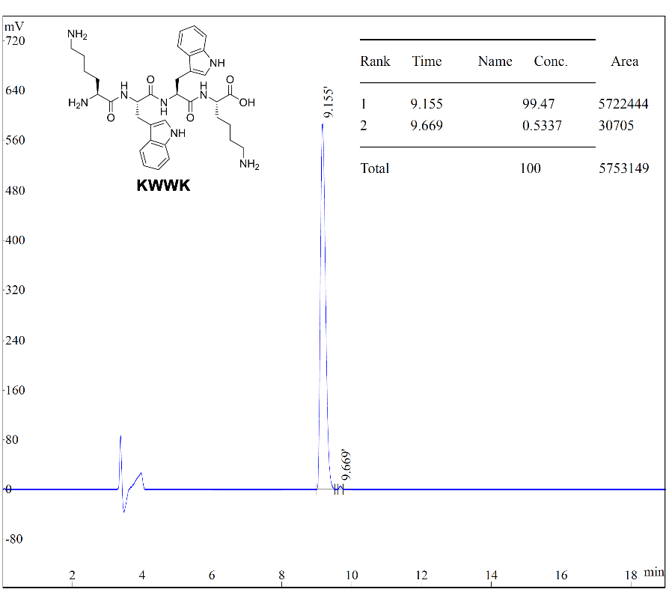
HPLC traces of purified KWWK (CH₃CN/Water 0.1% TFA: 15/50 to 50/50 over 20 min).
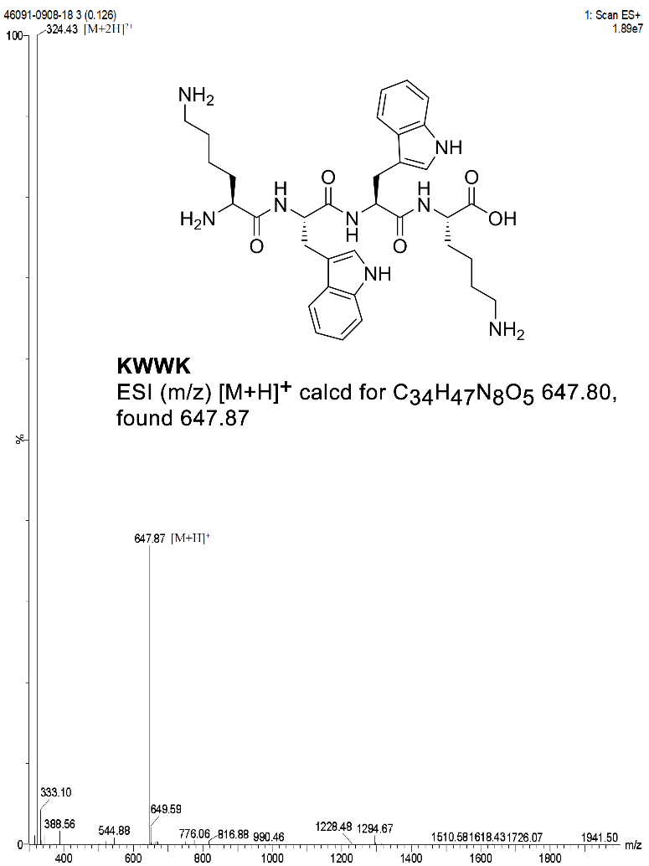
ESI-MS for C₃₄H₄₇N₈O₅ [M + H]+ calculated 647.80; found 647.87.

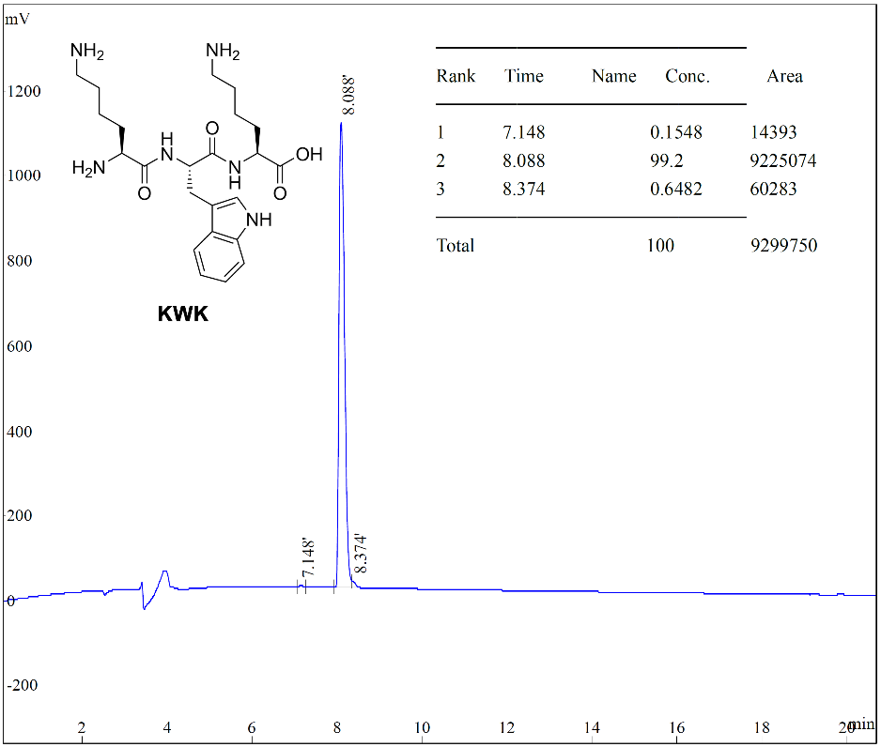
HPLC traces of purified KWK (CH₃CN/water 0.1% TFA: 10/90 to 35/65 over 20 min).
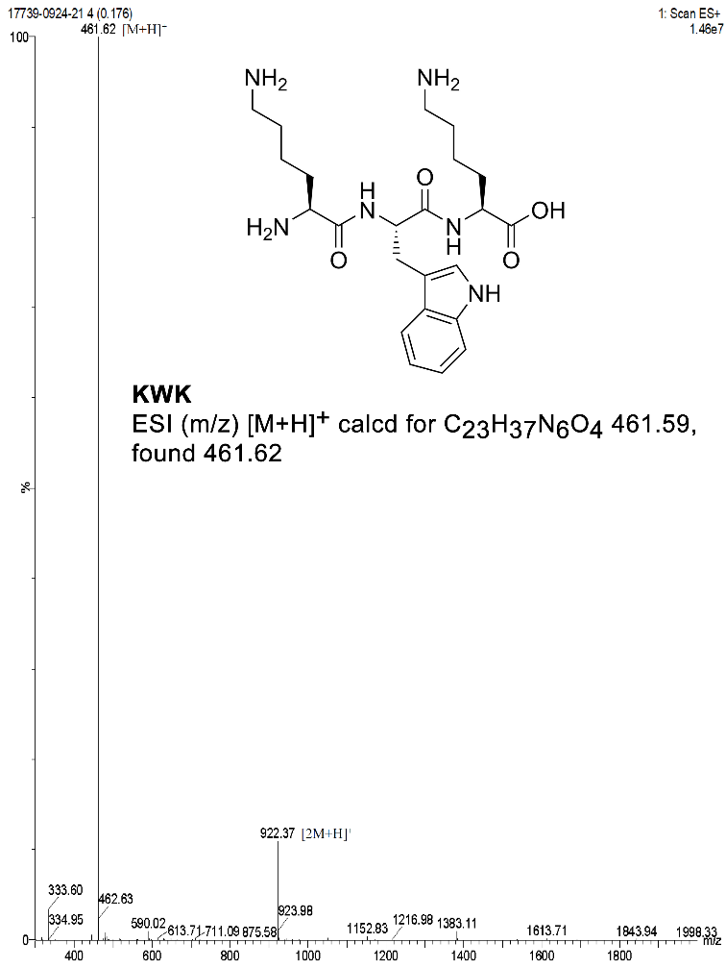
ESI-MS for C₂₃H37N₆O₄ [M + H]+ calculated 461.59; found 461.62.

References
EUCAST, ESCMID (2003) Determination of minimum inhibitory concentrations (MICs) of antibacterial agents by broth dilution. Clin Microbiol Infect 9:ix–xv. https://doi.org/10.1046/j.1469-0691.2003.00790.x
Kolusheva S, Boyer L, Jelinek R (2000a) A colorimetric assay for rapid screening of antimicrobial peptides. Nat Biotechnol 18:225–227. https://doi.org/10.1038/72697
Kolusheva S, Shahal T, Jelinek R (2000b) Peptide− membrane interactions studied by a new phospholipid/polydiacetylene colorimetric vesicle assay. Biochemistry 39:15851–15859. https://doi.org/10.1021/bi000570b

