Supporting information
For

Synthesis and Characterization of Material Derived from Chitosan, Malic acid and Urea

Richa Sharma and R. Dhamodharan*
Department of Chemistry
Indian Institute of Technology Madras, Chennai 600 036, India
*Author for Correspondence
E-mail for Correspondence: damo@iitm.ac.in

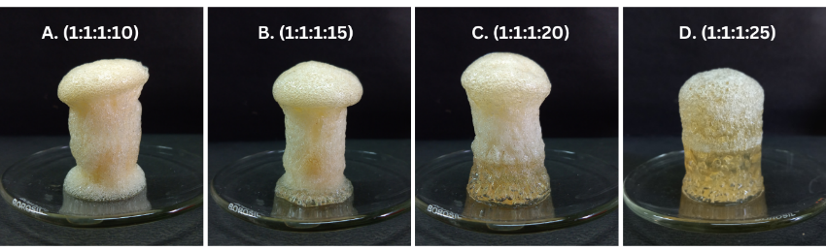
Fig. S1. Photographs of CHMAUR prepared from a 1:1:1 weight mixture of CH:MA:UR with varying ratios of chitosan and water (the last two digits indicate the quantity of water used per gram of chitosan.
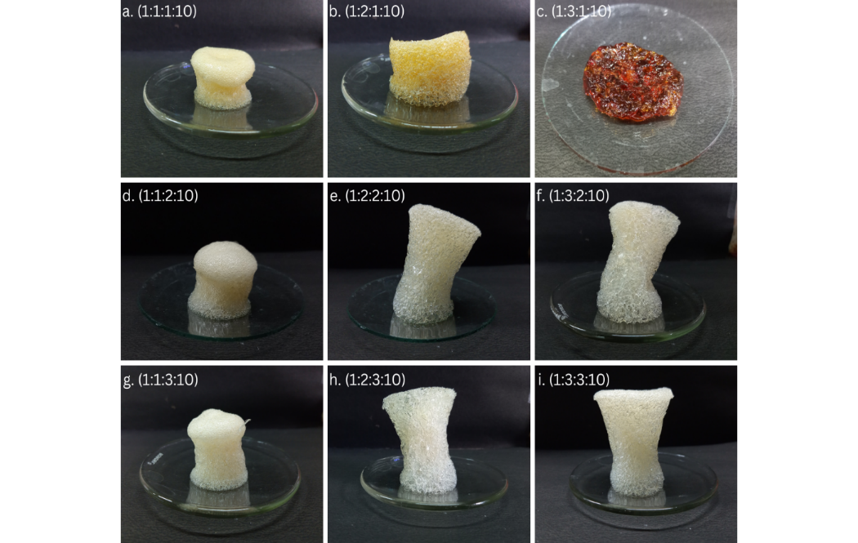

Fig. S2. Photographs of the CHMAUR.H₂O foams with different CH:MA:UR:H₂O ratios (indicated at the top left corner of the respective photos).

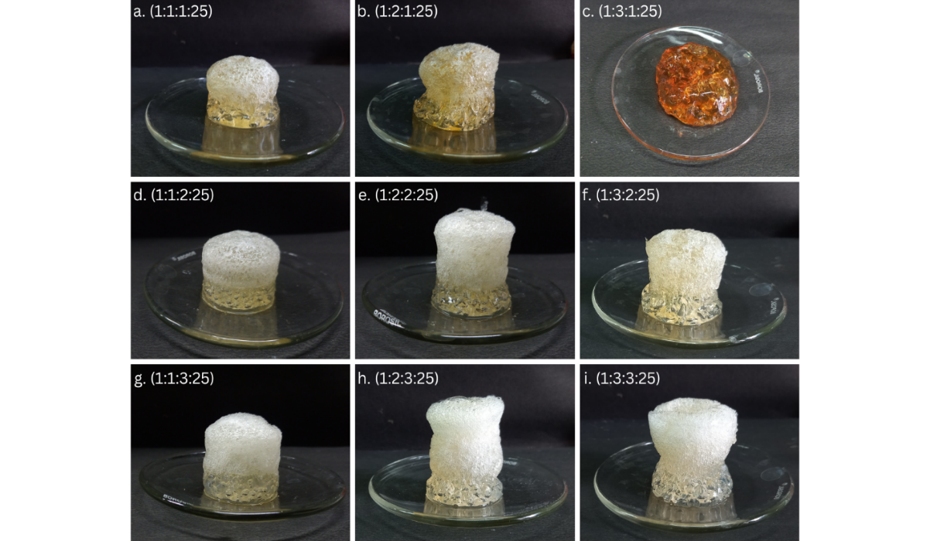
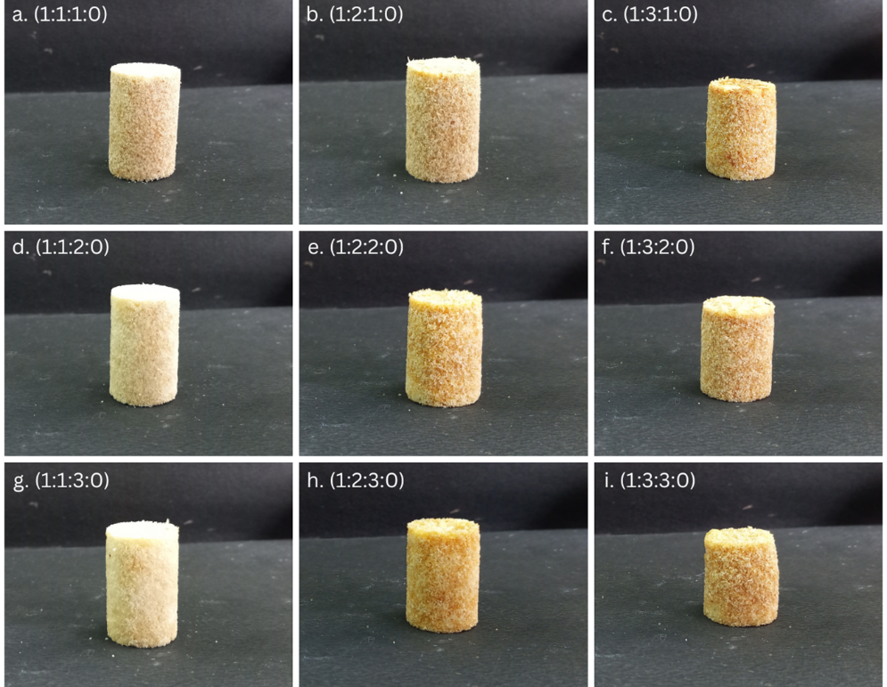
Fig. S3. Photographs of the CHMAUR.H₂O NPTGs with different MA:UR ratio.

Fig. S4. Photographs of the CHMAUR PDPs with different CH:MA:UR weight ratios (indicated at the top left corner of each photo) with no externally added water.
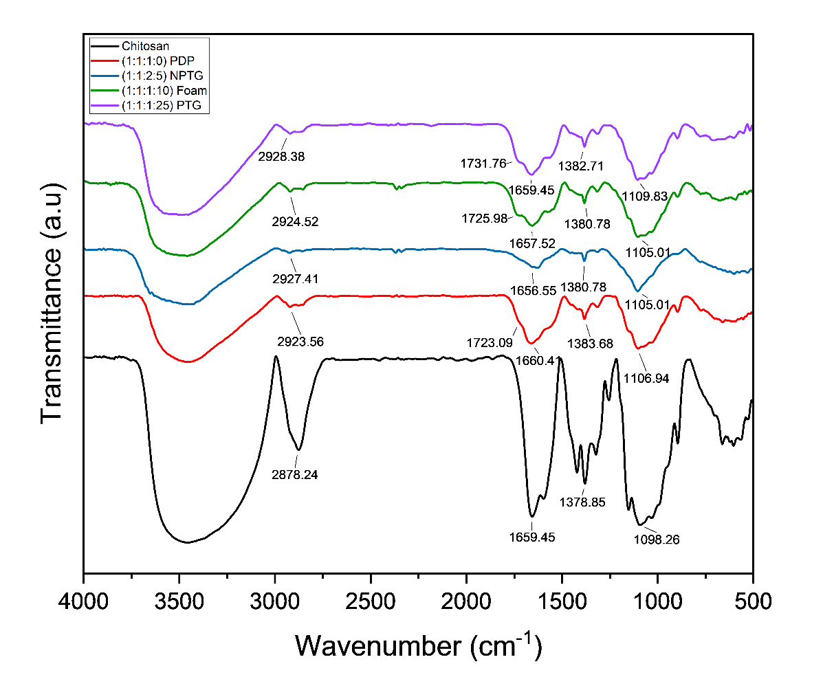
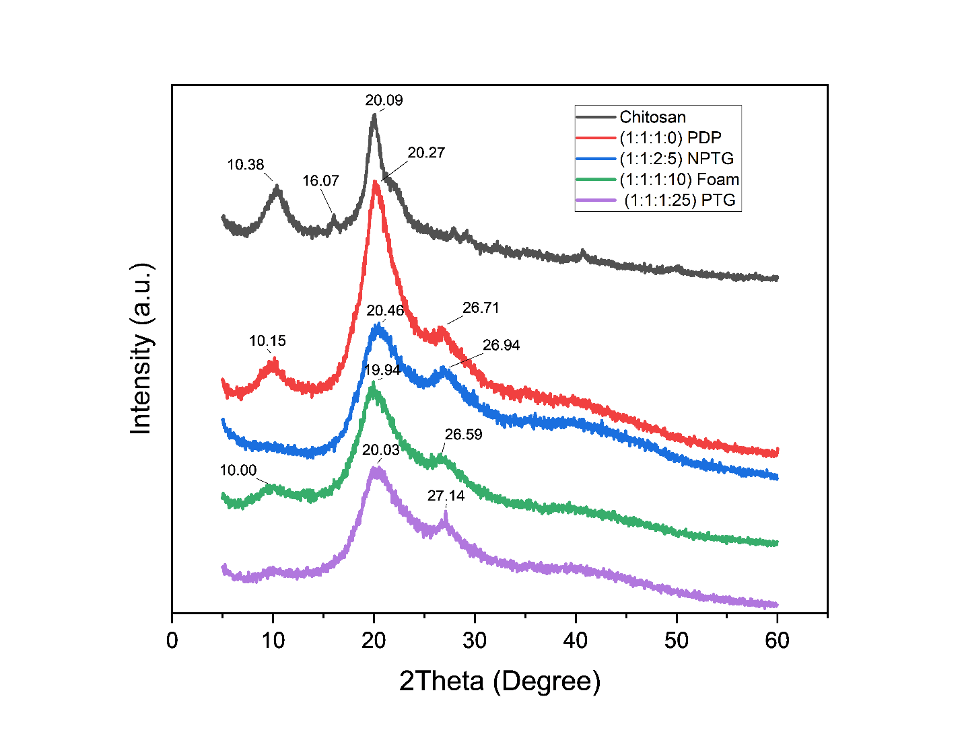
Fig. S5. FTIR of Chitosan, CHMAUR foam (1:1:1:10), PTG (1:1:1:25), NPTG (1:1:2:5) and PDP (1:1:1:0).
Fig. S6. PXRD of chitosan and CHMAUR [foam (1:1:1:10), PTG (1:1:1:25), NPTG (1:1:2:5) and PDP (1:1:1:0)].
Table S1. Pore volume and percentage porosity of CHMAUR foams
S. no. | Foam  CH:MA:UR:H₂O | Pore volume (cc/g)  Helium Pycnometry | Percentage porosity  Helium Pycnometry | Percentage porosity  Liquid displacement
1 | (1:1:1:10) | 2.12 ± 0.01 | 69.81 ± 0.45 | 17.47 ± 4.43
2 | (1:1:2:10) | 2.15 ± 0.06 | 71.10 ± 1.82 | 34.28 ± 1.32
3 | (1:1:3:10) | 2.17 ± 0.13 | 71.49 ± 4.11 | 39.29 ± 3.43
4 | (1:2:1:10) | 2.10 ± 0.01 | 69.14 ± 0.45 | 26.05 ± 7.48
5 | (1:2:2:10) | 1.90 ± 0.01 | 62.79 ± 0.23 | 27.32 ± 2.61
6 | (1:2:3:10) | 2.01 ± 0.07 | 66.39 ± 2.17 | 39.58 ± 17.9
7 | (1:3:2:10) | 2.00 ± 0.04 | 66.13 ± 1.14 | 36.75 ± 1.34
8 | (1:3:3:10) | 1.85 ± 0.08 | 61.06 ± 2.53 | 19.96 ± 1.83

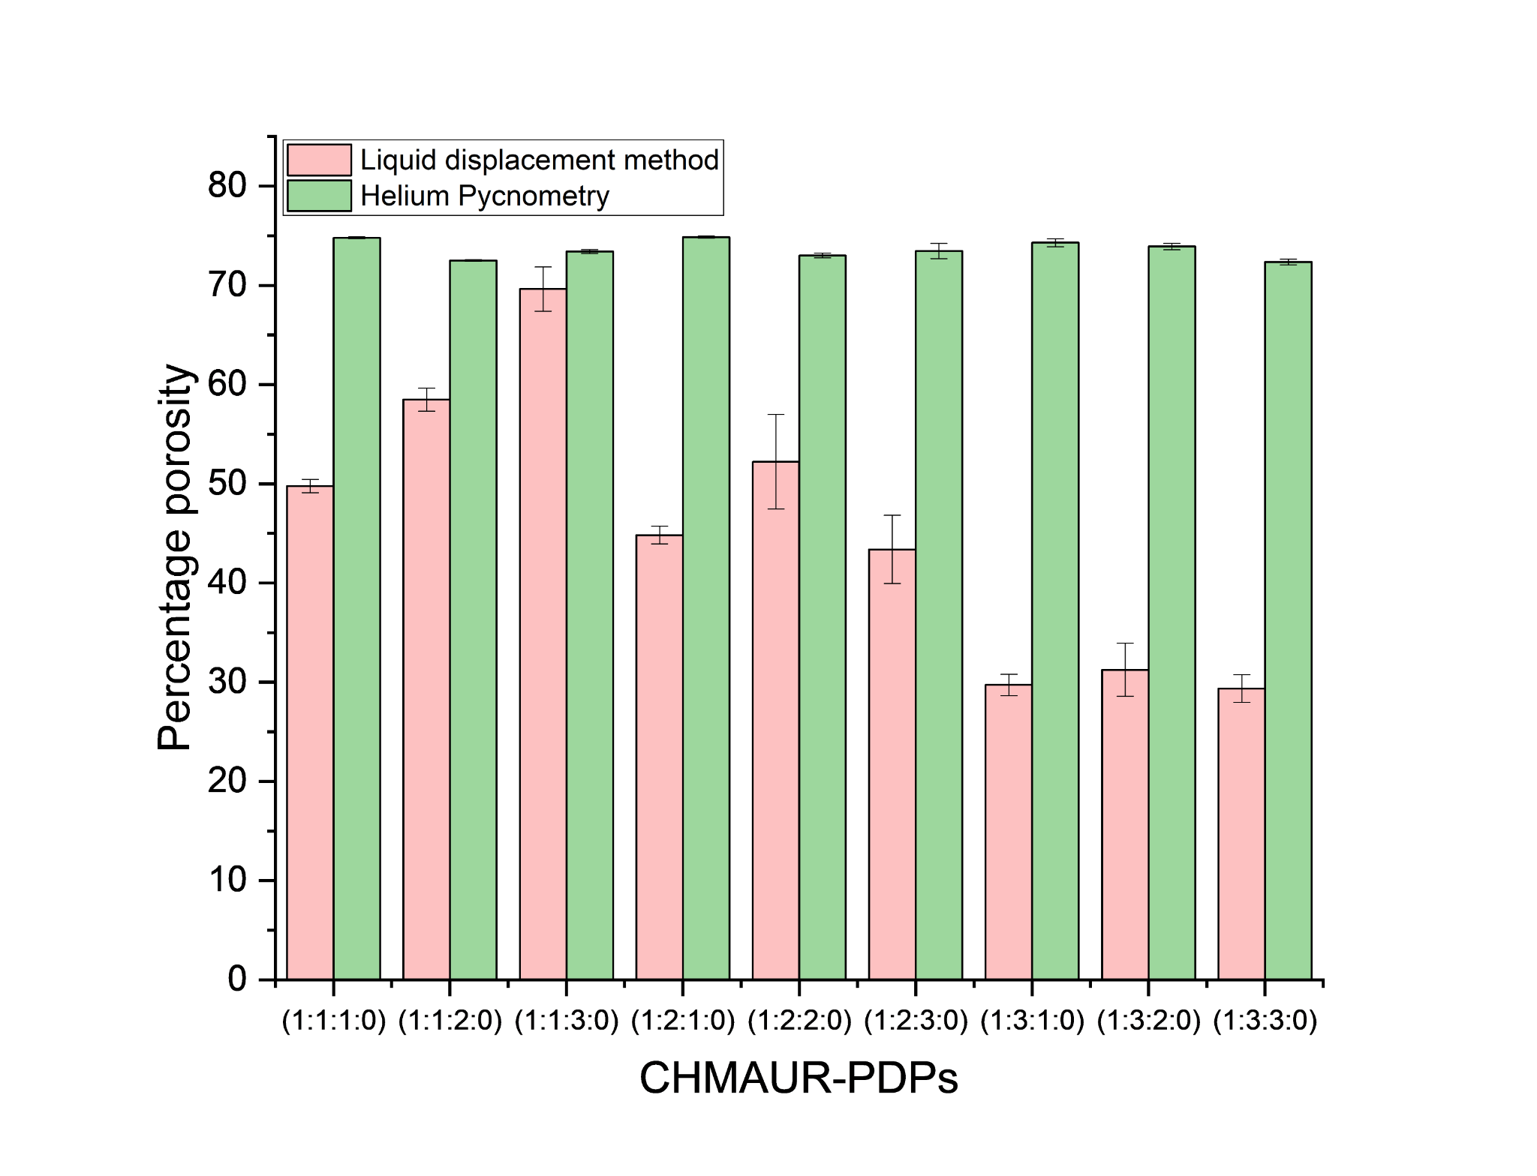
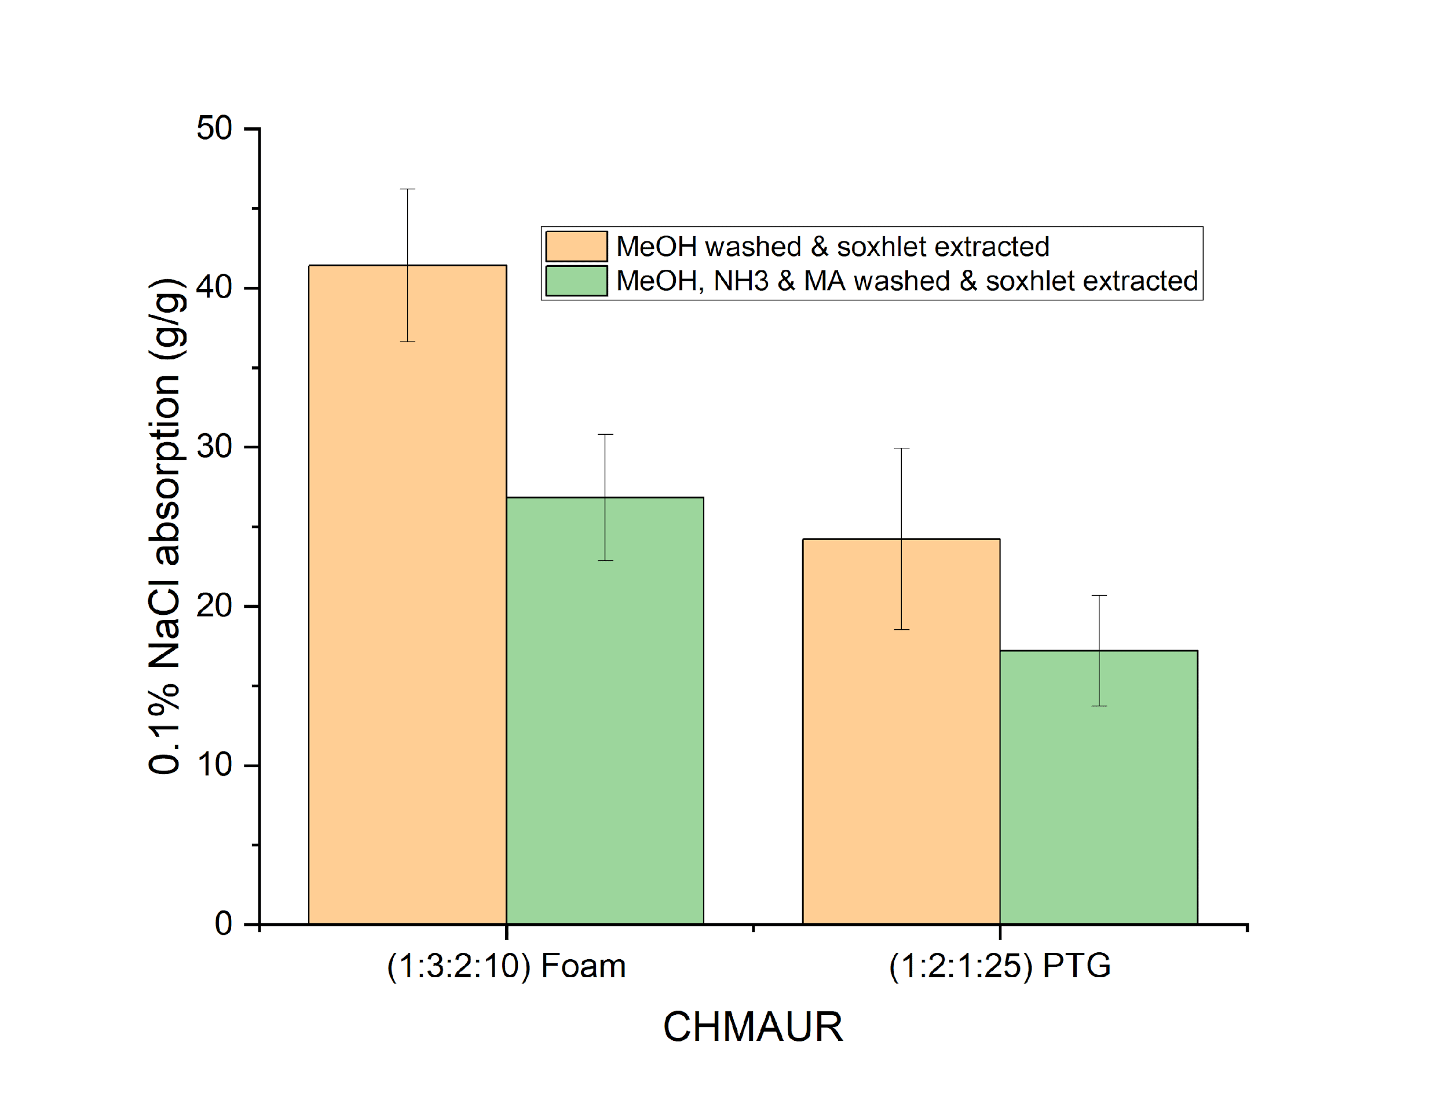
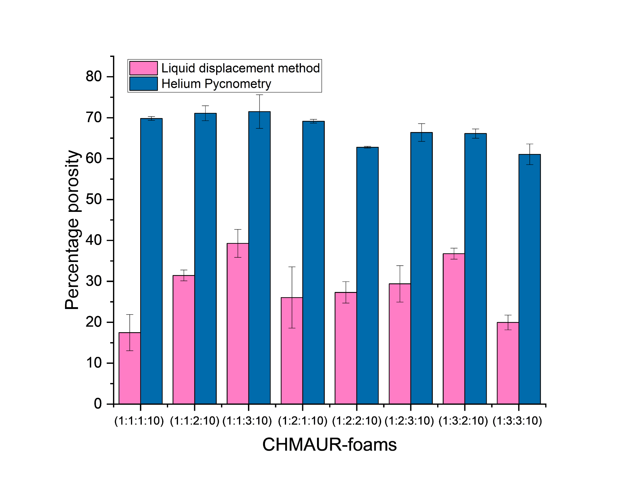
Fig. S7. Results from the percentage porosity analysis of CHMAUR.H₂O foams (left) and PDP (right); helium pyconometry vs. ethanol displacement method.

Fig. S8. Absorption of 0.1% (w/v) aqueous NaCl of CHMAUR [foam and PTG]. t = 1 h.

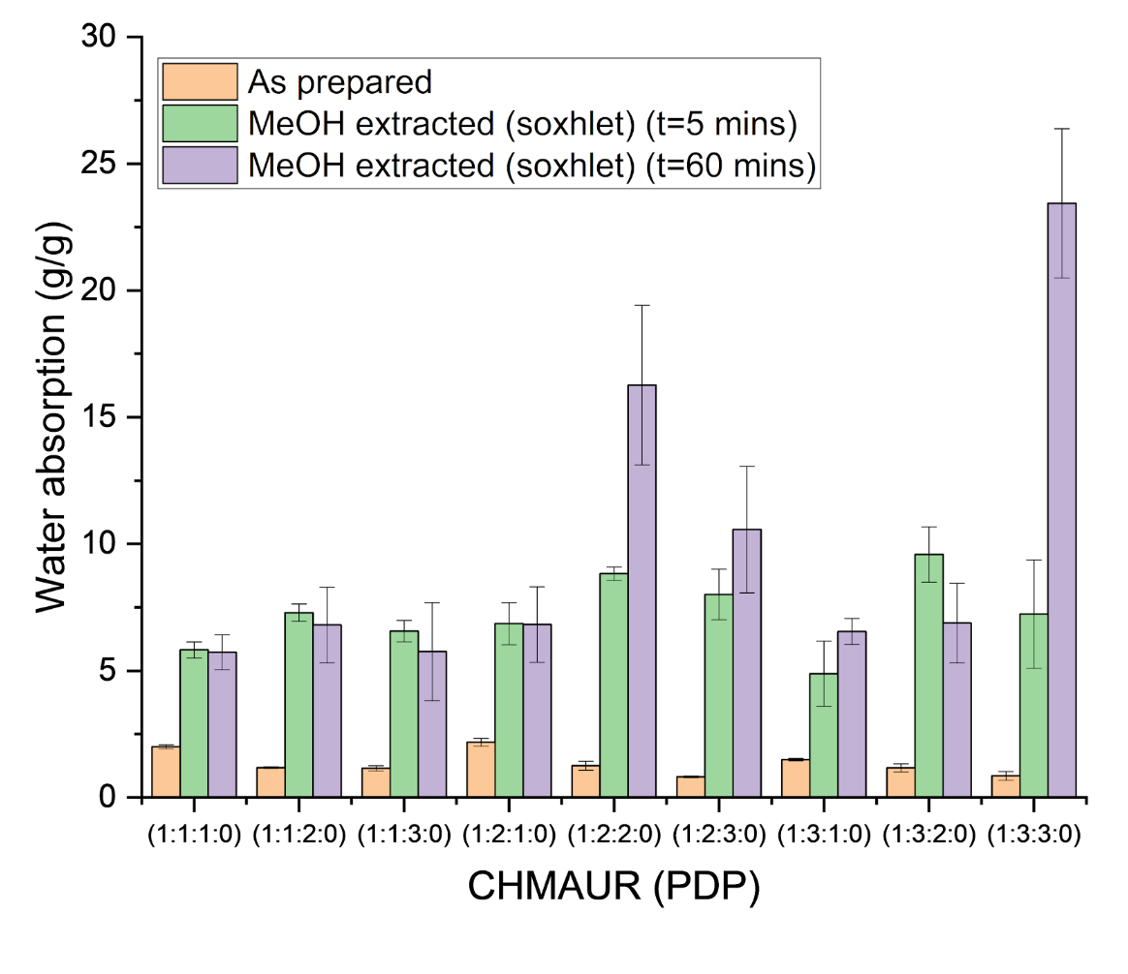
Fig. S9. Absorption of water PDPs (as prepared; t = 5 min and methanol extracted; t = 5 min and 60 min).

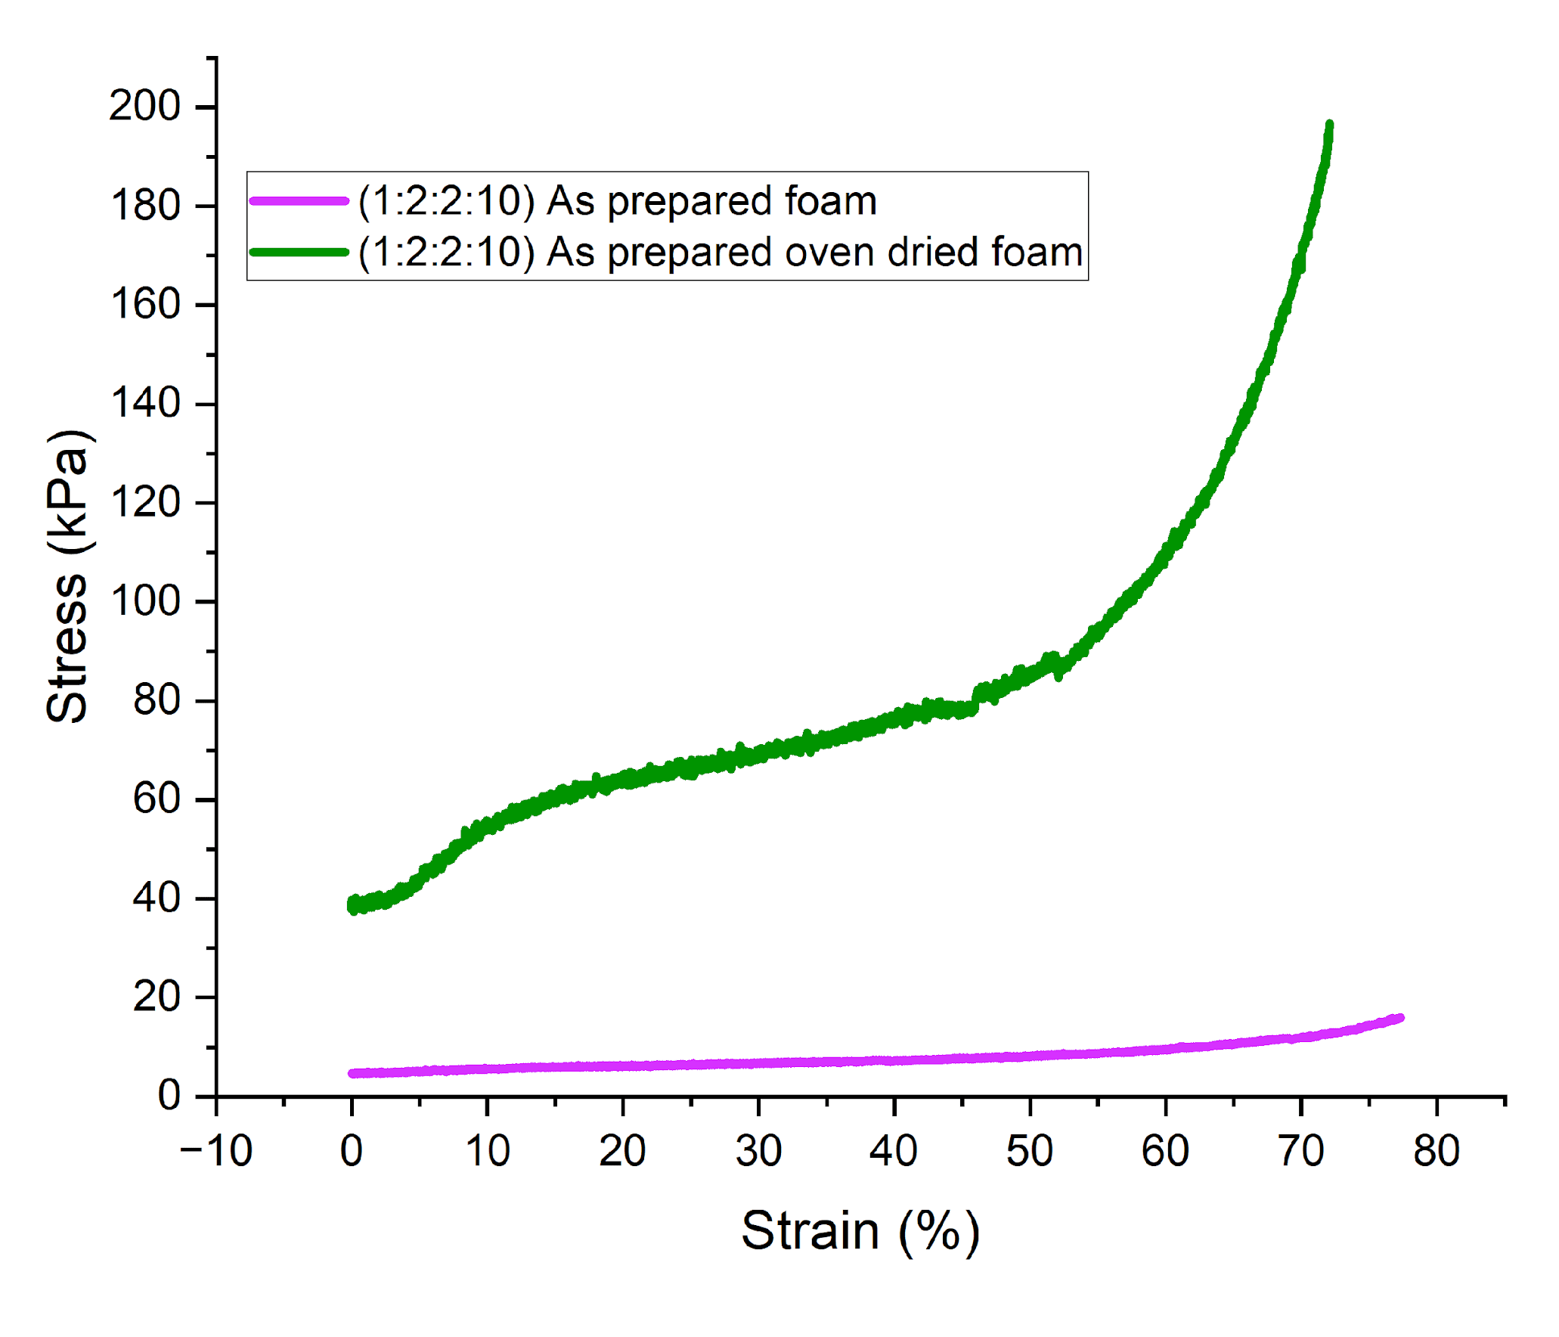
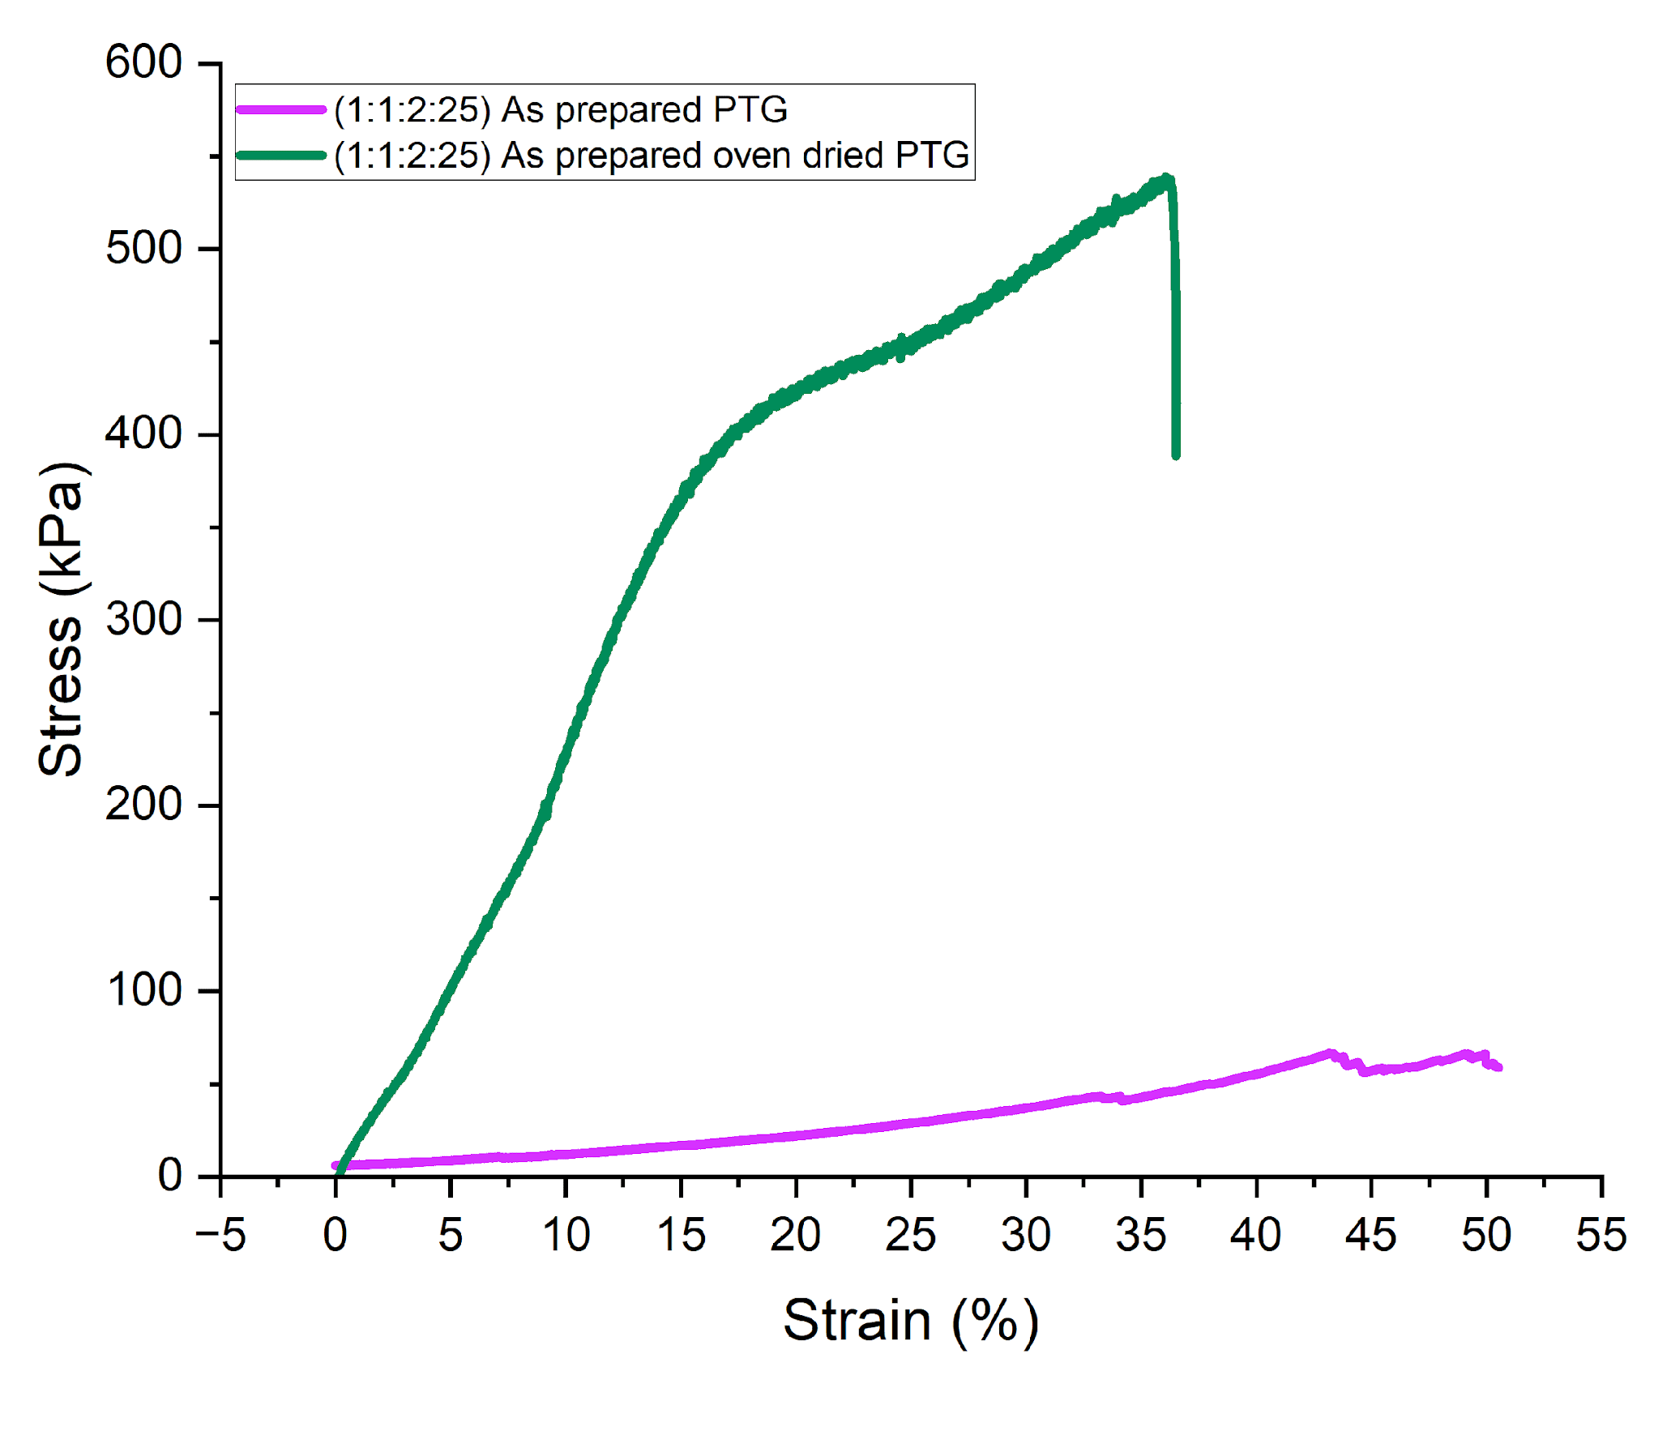
Fig. S10. Compressive stress versus percentage strain for foam and PTG CHMAUR samples.
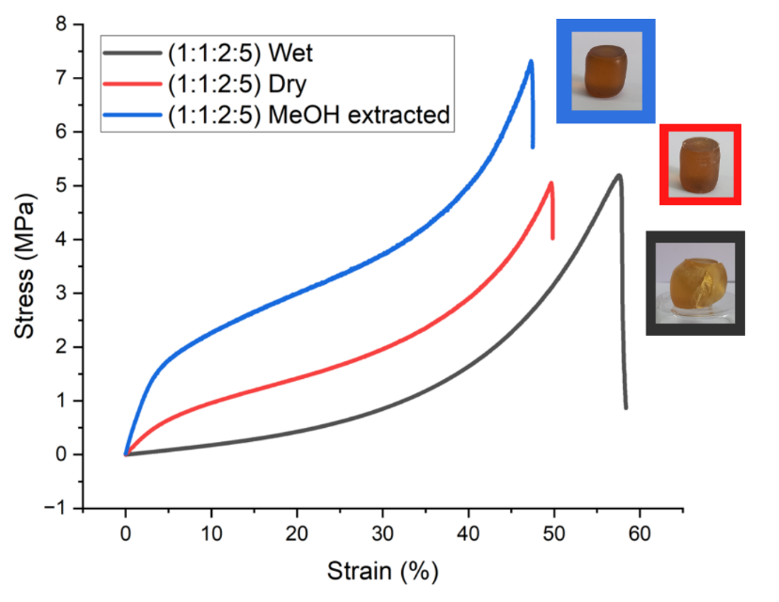
Fig. S11. Compressive stress versus percentage strain plot for CHMAUR in the NPTG.

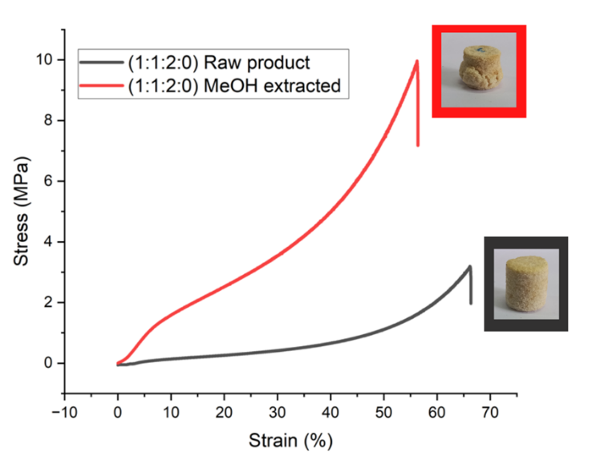
Fig. S12. Compressive stress versus percentage strain for CHMAUR in the PDP.
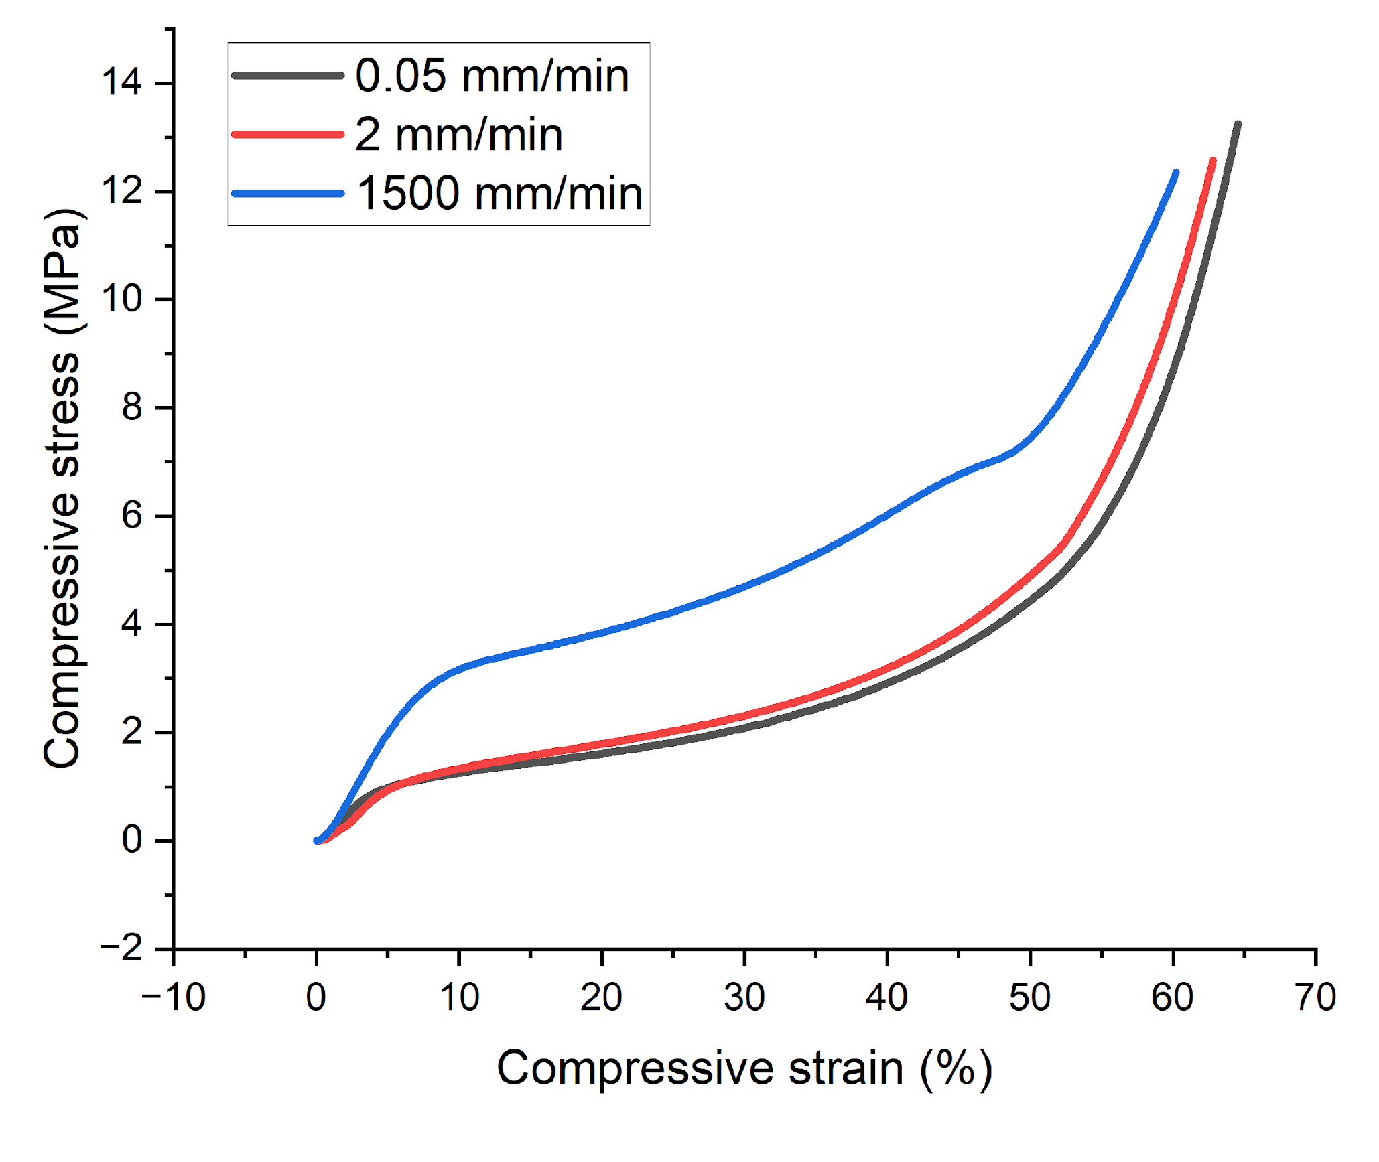
Fig. S13. Compressive stress versus percentage strain. Weight ratio of CH:MA:UR 1:1:2:5. CHMAUR purified through Soxhlet extraction with methanol.

