Supplementary Information
for
Gut microbial interactions based on network construction and bacterial pairwise cultivation
Min-Zhi Jiang^{1#}, Chang Liu¹，Chang Xu¹, He Jiang¹, Yulin Wang^{1*}, Shuang-Jiang Liu^{1,2,3*}

Min-Zhi Jiang: State Key Laboratory of Microbial Technology, Shandong University, Qingdao 266000, P. R. China. jiangminzhi2006@126.com
Chang Liu: State Key Laboratory of Microbial Technology, Shandong University, Qingdao 266000, P. R. China. liu.c@sdu.edu.cn
Chang Xu: State Key Laboratory of Microbial Technology, Shandong University, Qingdao 266000, P. R. China. changx_t@163.com
He Jiang: State Key Laboratory of Microbial Technology, Shandong University, Qingdao 266000, P. R. China. jianghe@sdu.edu.cn
Yulin Wang: State Key Laboratory of Microbial Technology, Shandong University, Qingdao 266000, P. R. China. wangyulin@sdu.edu.cn
Shuang-Jiang Liu: State Key Laboratory of Microbial Technology, Shandong University, Qingdao 266000, China; State Key Laboratory of Microbial Resources, and Environmental Microbiology Research Center (EMRC), Institute of Microbiology, Chinese Academy of Sciences, Beijing 100101, China; University of Chinese Academy of Sciences, Beijing 100049, China. liusj@sdu.edu.cn

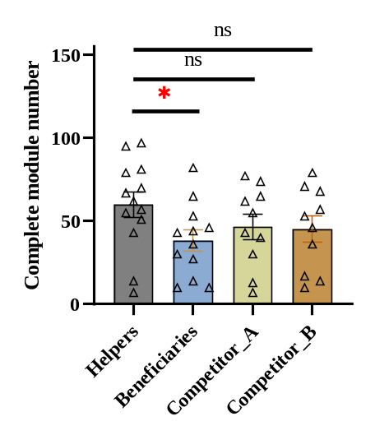
Figure S1 The complete module number of profitable and competitive groups. Helpers and beneficiaries in the profitable group represented the interaction of cultivated bacterial isolate combinations were promotion, and the Competitor_A and Competitor_B in the competition group represented the interaction of cultivated bacterial isolate combinations were competition. The module number of helpers was significantly higher than beneficiaries. The P-value was calculated by two-sided paired t-test (p<0.05 *, p< 0.01 **, p< 0.001 ***).
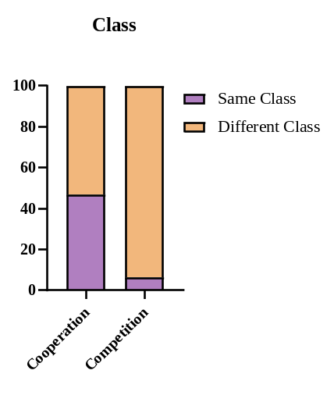
Figure S2 Phylogenetic relationship in profitable and competitive groups. The purple block in profitable and competitive group represented the cultivated bacterial isolate combinations came from the same Class, while the orange block represented bacterial isolate combinations came from different Class.

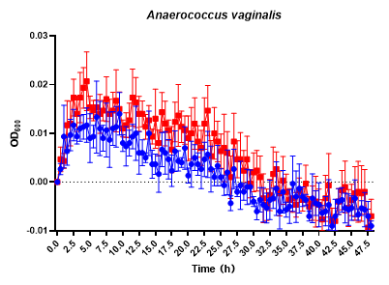
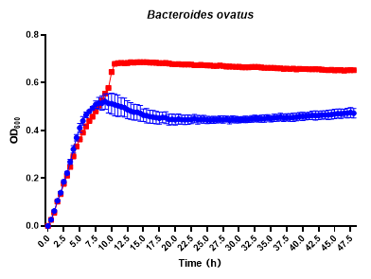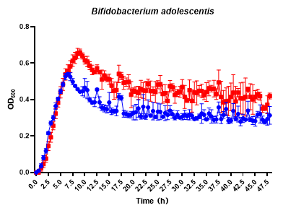
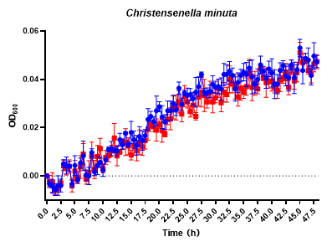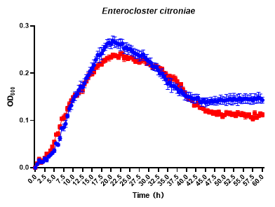
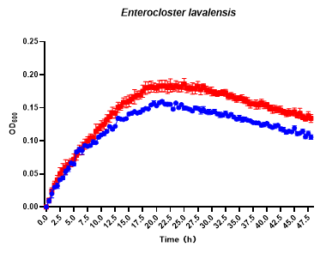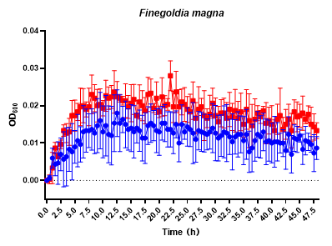
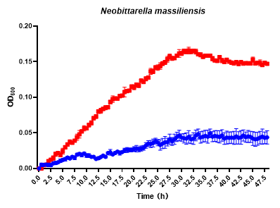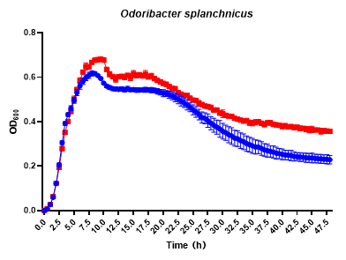
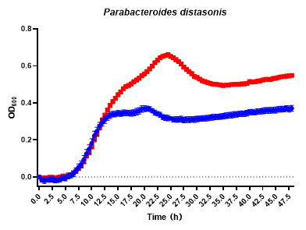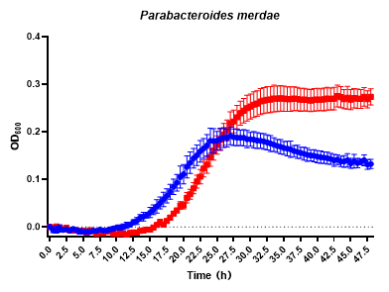
Figure S3 Evaluating the growth curve of each beneficiary under different culture conditions. The blue line represented the control groups, the red line represented the experimental group.

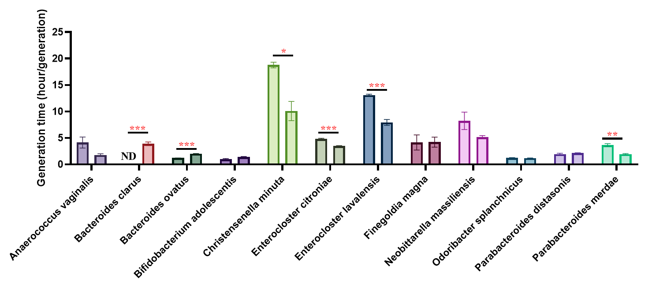
Figure S4 Evaluating the generation time of each beneficiary under different culture conditions. In the bar chart, the left column of each beneficiary represented the microbe cultured into YCFA base medium, and the right column of each beneficiary represented the microbe cultured into YCFA supplementation medium. The P-value was calculated by two-sided paired t-test (p<0.05 *, p< 0.01 **, p< 0.001 ***).

