Supporting Information
Chirality-governed Clusteroluminescence in Polypeptides
Wangtao Zhao¹, Yali Liu¹, Mei Gao¹, Liufen Kong¹, Shunfeng Yu¹, Chuanzhuang Zhao¹ and Chongyi Chen¹*
¹ School of Materials Science and Chemical Engineering, Ningbo University, Ningbo 315211, China. E-mail: chenchongyi@nbu.edu.cn

Experimental Section
Characterization. ¹H NMR spectra were recorded on a Bruker 400 MHz instrument with CDCl₃ by using tetramethylsilane (TMS) as an internal reference. Gel permeation chromatography was performed on a system equipped with an Agilent 1260 Infinity series degasser and pump, an Agilent PL-gel guard column, a multi-angle laser scattering (MALLS) detector (Agilent Technologies, Santa Clara, CA, USA), and a refractive index (RI) detector (Agilent Technologies, Santa Clara, CA, USA). Samples were filtered through a PTFE membrane (pore size of 0.22 μm) and were run at 1 mL/min at 60 °C using DMF containing 0.05 M LiBr as the mobile phase. The molecular weights (MWs) of polymers were determined based on the dn/dc value of each polymer sample calculated offline by using the internal calibration system processed by the Agilent GPC/SEC software. Photoluminescence spectra were collected from a F-7100 transient fluorescence spectrometer with an excitation source of a xenon lamp. Fourier transform infrared spectrometry (FT-IR) analyses were performed on a PerkinElmer FT-IR 1500 spectrometer. The polymer was solubilized in hexafluoroisopropanol (HFIP), and subsequent circular dichroism (CD) spectra were acquired at a concentration of 0.2 mg·mL⁻¹ using a 1 mm quartz cell on a JASCO J-1700 CD spectrometer. L₂₀₀ and L₁₀₀D₁₀₀ were dissolved in CDCl₃ (50 g·L⁻¹) and subsequently sealed within NMR tubes to mitigate volatilization. 2D NOESY experiments were conducted using a Bruker 500MHz NMR spectrometer.
Materials. γ-benzyl-L-glutamate, γ-benzyl-D-glutamate, ε-carbobenzyloxy-L-lysine and ε-carbobenzyloxy-D-lysine were purchased from GL Biochem (Shanghai) Ltd. Triphosgene, tetrahydrofuran (THF), n-hexane and propylene oxide were obtained from Aladdin (Shanghai). Hexylamine was purchased from Tokyo Chemical Industry CO., Ltd. Hexafluoroisopropanol (HFIP) and dimethylformamide (DMF) were obtained from Macklin.
General procedure for the synthesis of γ-benzyl-L glutamate N-carboxyanhydride (BLG NCA). γ-benzyl-L-glutamate (5.0 g, 1.0 equiv), triphosgene (3.2 g, 0.5 equiv) and anhydrous THF (75 mL) were added to a 300 mL round-bottom flask. Propylene oxide (4.0 equiv) was then added to the mixture. The resulting solution was stirred until complete conversion was achieved in 1.5 h without external heating. The solvent was then removed under vacuum to yield the crude product, which was further purified by recrystallization from THF/hexane three times. The final product obtained was a white crystalline solid with a yield of 80%. The D-isomer (BDG NCA), Lys NCA and corresponding D-isomer were prepared using a similar procedure.
General process for ring opening polymerization of NCA. polyglutamates were obtained through the controlled ring opening polymerization with different the feed ratios of NCAs. For example, the synthesis of L₅₀D₅₀ was carried out as follows: BLG NCA (1.0 g, 3.8 mmol), BDG NCA (1.0 g, 3.8 mmol), and hexylamine (10 µL, 0.038 mmol) were added to a 100 mL round-bottom flask and dissolved in 20 mL of THF. The solution was stirred at RT for 48 hours. The resulting product was precipitated with excess deionized water and centrifuged to obtain a white solid. The product was collected after lyophilized for 36 hours.
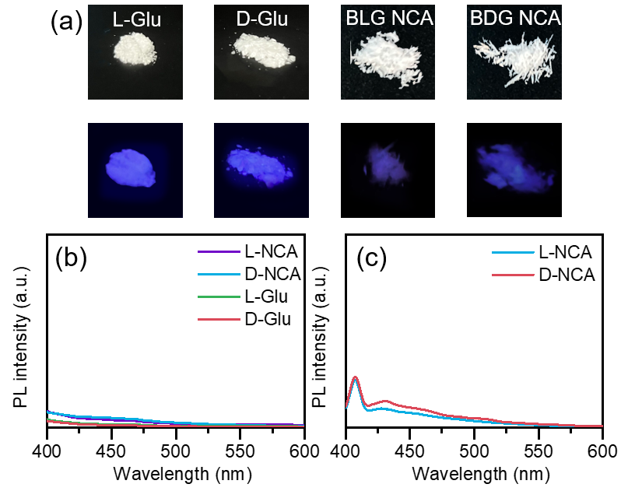
Supplementary Fig. 1. Fluorescence of amino acids and corresponding NCAs with different chirality. (a) Digital photographs of amino acids and NCAs under sunlight and 365 nm UV lamp. PL spectra of amino acids and NCAs in (b) bulk state and (c) NCA in solution state (50 g·L⁻¹ in THF).

Supplementary Table 1. The chemical shift of protons on polypeptides (H_{a}, H_{b}, H_{c} and H_{d}) with different optical rotations.
Entry | a | b | c | d
L₁₀₀ | 3.929 | 2.257 | 2.594 | 5.034
L₇₅D₂₅ | 3.898 | 2.283 | 2.576 | 5.029
L₅₀D₅₀ | 3.885 | 2.299 | 2.570 | 5.022
L₂₅D₇₅ | 3.899 | 2.282 | 2.576 | 5.031
D₁₀₀ | 3.926 | 2.257 | 2.595 | 5.036
Entry | a | b | c | d
L₂₀ | 3.925 | 2.263 | 2.591 | 5.036
L₁₀₀ | 3.929 | 2.257 | 2.594 | 5.034
L₂₀₀ | 3.926 | 2.253 | 2.598 | 5.037
L₁₀D₁₀ | 3.888 | 2.285 | 2.563 | 5.024
L₅₀D₅₀ | 3.885 | 2.299 | 2.570 | 5.022
L₁₀₀D₁₀₀ | 3.879 | 2.312 | 2.584 | 5.021

Supplementary Table 2. The properties of PZLs with different chirality.
Entry | Initiator | [M]/[I] | [M_{L}]/[M_{D}] | M_{n} (kDa)^{[a]} | DP | Đ^{[a]}
PZL-L | n-hexylamine | 50/1 | 50/0 | 8.6 | 33 | 1.11
PZL-DL | n-hexylamine | 50/1 | 25/25 | 9.2 | 36 | 1.25
PZL-D | n-hexylamine | 50/1 | 0/50 | 9.0 | 35 | 1.09
^{[a]} M_{n} and Đ are calculated from the GPC traces.

