Cellulose/biochar cryogel from poultry little waste for adsorption of dyes in an aqueous medium
Lídia K. Lazzari^{a,b,*} Ademir J. Zattera^{b}, Ruth M. C. Santanaª

ªPostgraduate Program in Mining, Metallurgical and Materials Engineering, Federal University of Rio Grande do Sul (UFRGS), Porto Alegre, Brazil;
^{b}Postgraduate Program in Process Engineering and Technologies, University of Caxias do Sul (UCS), Caxias do Sul, Brazil.

*Corresponding author: E-mail address: lidia_lazzzari@yahoo.com.br

SUPPORTING INFORMATION

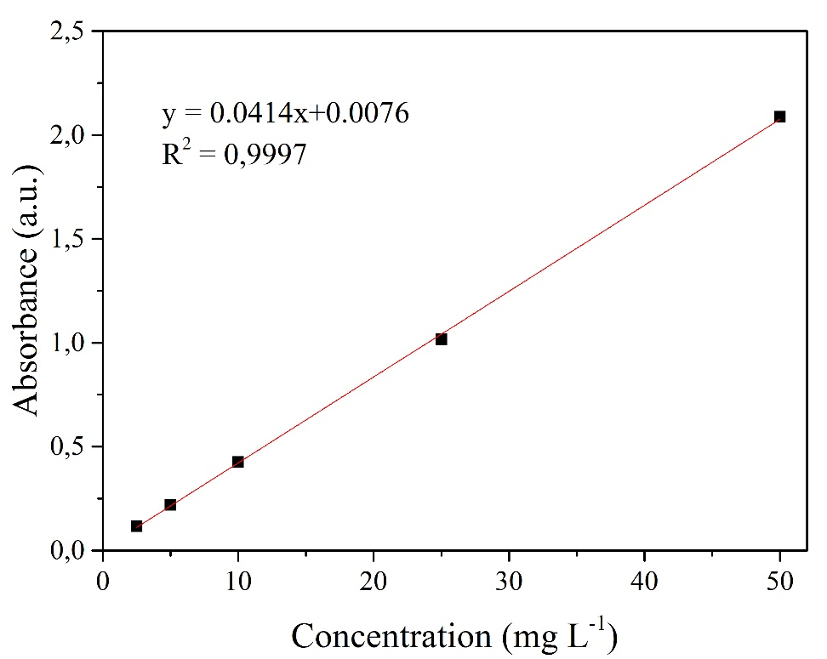
Figure S.1 - Calibration curve for Congo Red dye.

