Search Strategy
PubMed: ("GSTT1"[Title/Abstract] OR "GST"[Title/Abstract] OR "GSTP1"[Title/Abstract] OR "Glutathione S-transferase"[Title/Abstract]) AND (“mouth”[Title/Abstract] OR “OSCC”[Title/Abstract] OR “oral”[Title/Abstract] OR “tongue”[Title/Abstract] OR “head and neck”[Title/Abstract] OR “HNSCC“[Title/Abstract] OR “nasopharyngeal”[Title/Abstract] OR “nasopharynx” [Title/Abstract] OR “oropharyngeal”[Title/Abstract] OR “salivary gland”[Title/Abstract] OR “laryngeal”[Title/Abstract] OR “larynx” [Title/Abstract] OR “hypopharyngeal”[Title/Abstract] OR “pharyngeal”[Title/Abstract] OR “pharynx”[Title/Abstract] OR “oral cavity”[Title/Abstract] OR “hypopharynx” [Title/Abstract]) AND (tumor*[Title/Abstract] OR carcinoma*[Title/Abstract] OR cancer*[Title/Abstract] OR neoplasm*[Title/Abstract]) AND (“polymorphism*”[Title/Abstract] OR “variant*”[Title/Abstract] OR “gene*” [Title/Abstract] OR “genotype*” [Title/Abstract] OR “allele*” [Title/Abstract])
Scopus: (TITLE-ABS-KEY (“GSTT1”) OR TITLE-ABS-KEY (“GSTP1”) OR TITLE-ABS-KEY (“GST”) OR TITLE-ABS-KEY(“Glutathione S-transferase”)) AND (TITLE-ABS-KEY (“mouth”) OR TITLE-ABS-KEY (“OSCC”) OR TITLE-ABS-KEY (“oral”) OR TITLE-ABS-KEY (“tongue”) OR TITLE-ABS-KEY (“head and neck”) OR TITLE-ABS-KEY (“HNSCC“) OR TITLE-ABS-KEY (“nasopharyngeal”) OR TITLE-ABS-KEY (“nasopharynx”) OR TITLE-ABS-KEY (“oropharyngeal”) OR TITLE-ABS-KEY (“Salivary gland”) OR TITLE-ABS-KEY (“laryngeal”) OR TITLE-ABS-KEY (“larynx”) OR TITLE-ABS-KEY (“hypopharyngeal”) OR TITLE-ABS-KEY (“pharyngeal”) OR TITLE-ABS-KEY (“pharynx”) OR TITLE-ABS-KEY (“oral cavity”) OR TITLE-ABS-KEY (“hypopharynx”)) AND (TITLE-ABS-KEY (tumor*) OR TITLE-ABS-KEY (carcinoma*) OR TITLE-ABS-KEY (cancer*) OR TITLE-ABS-KEY (neoplasm*)) AND (TITLE-ABS-KEY (“polymorphism*”) OR TITLE-ABS-KEY (“variant*”) OR TITLE-ABS-KEY (“gene*”) OR TITLE-ABS-KEY (“genotype*”) OR TITLE-ABS-KEY (“allele*”))
Web of Science: TS=(“GSTT1” OR “GSTP1” OR “GST” OR “Glutathione S-transferase”) AND TS=(“mouth” OR “OSCC” OR “oral” OR “tongue” OR “head and neck” OR “HNSCC“ OR “nasopharyngeal” OR “nasopharynx” OR “oropharyngeal” OR “salivary gland” OR “laryngeal” OR “larynx” OR “hypopharyngeal” OR “pharyngeal” OR “pharynx” OR “oral cavity” OR “hypopharynx”) AND TS=(tumor* OR carcinoma* OR cancer* OR neoplasm*) AND TS=(“polymorphism*” OR “variant*” OR “gene*” OR “genotype*” OR “allele*”)
Cochrane Library: (“GSTT1”:ti,ab,kw OR “GSTP1”:ti,ab,kw OR “GST”:ti,ab,kw OR “Glutathione S-transferase”:ti,ab,kw) AND (“mouth”:ti,ab,kw OR “OSCC”:ti,ab,kw OR “oral”:ti,ab,kw OR “tongue”:ti,ab,kw OR “head and neck”:ti,ab,kw OR “HNSCC“:ti,ab,kw OR “nasopharyngeal”:ti,ab,kw OR “nasopharynx”:ti,ab,kw OR “oropharyngeal”:ti,ab,kw OR “salivary gland”:ti,ab,kw OR “laryngeal”:ti,ab,kw OR “larynx”:ti,ab,kw OR “hypopharyngeal”:ti,ab,kw OR “pharyngeal”:ti,ab,kw OR “pharynx”:ti,ab,kw OR “oral cavity”:ti,ab,kw OR “hypopharynx”:ti,ab,kw) AND (tumor*:ti,ab,kw OR carcinoma*:ti,ab,kw OR cancer*:ti,ab,kw OR neoplasm*:ti,ab,kw) AND (“polymorphism*”:ti,ab,kw OR “variant*”:ti,ab,kw OR “gene*”:ti,ab,kw OR “genotype*”:ti,ab,kw OR “allele*”:ti,ab,kw)

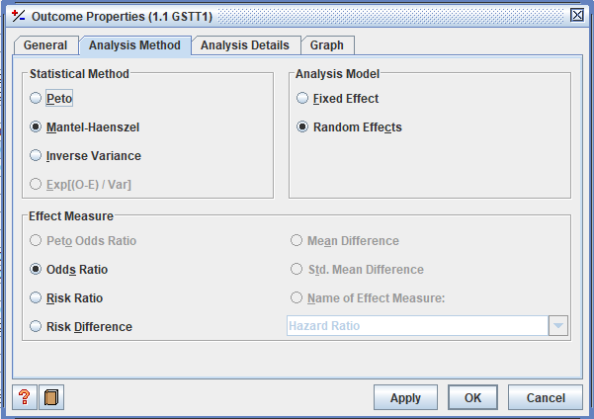
Supplement Figure 1. Options selected in Review Manager.

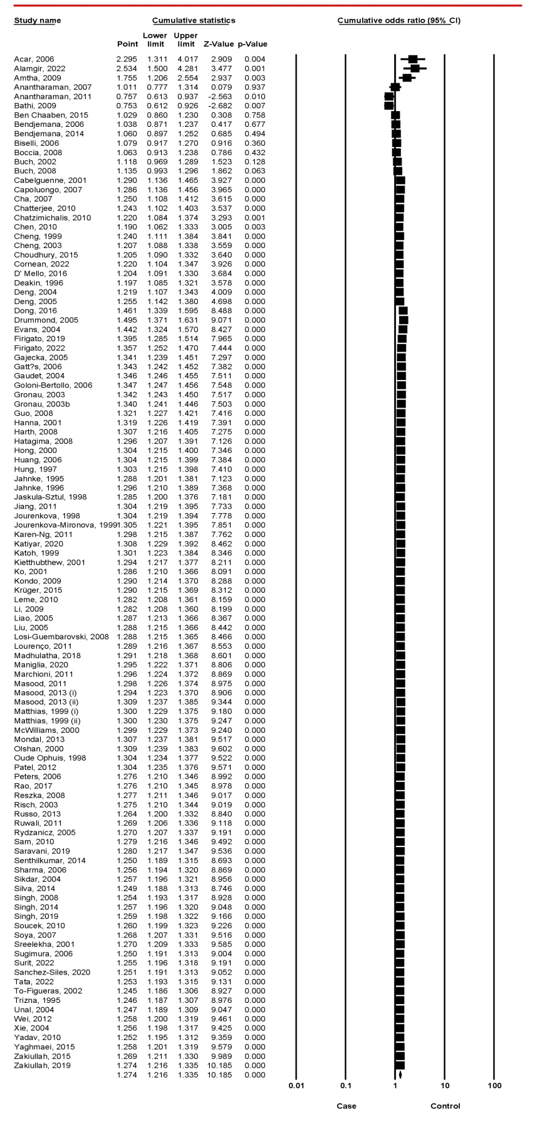
Supplement Figure 2. Cumulative analysis

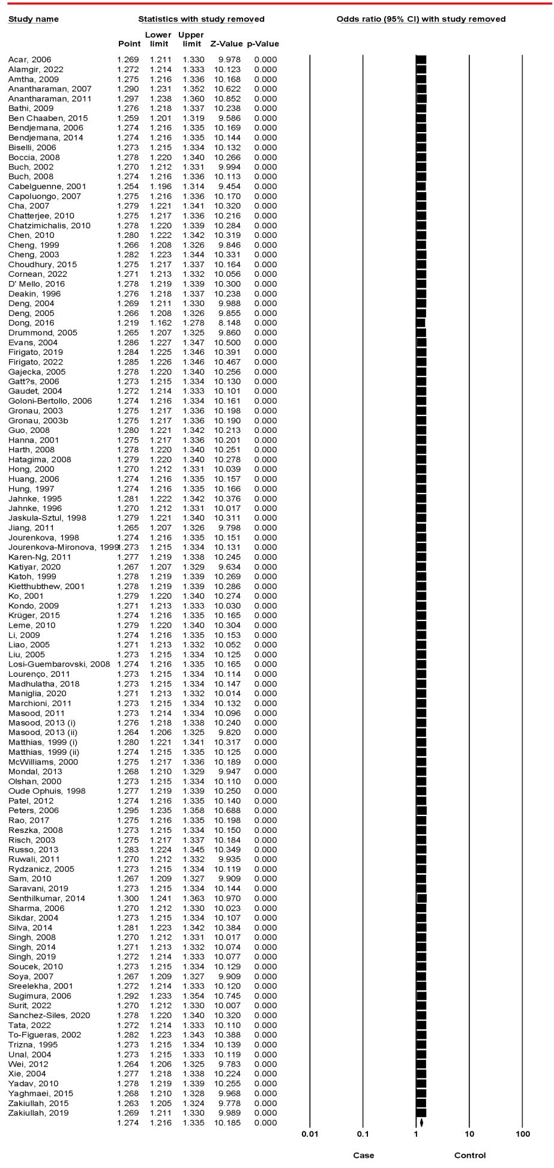
Supplement Figure 3. One-study-removed analysis
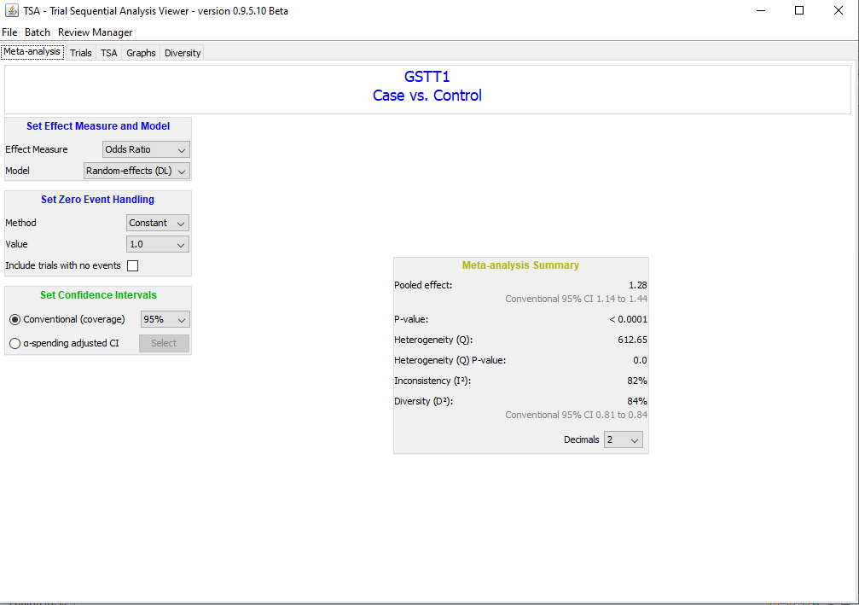
Supplement Figure 4. Selected options and summary data from trial sequential analysis

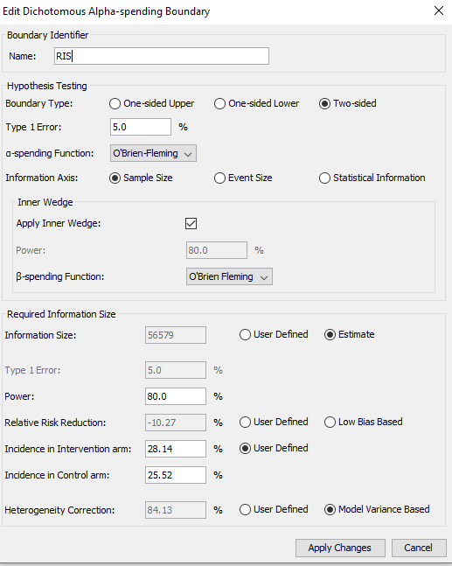
Supplement Figure 5. Alpha-spending Boundary in trial sequential analysis

