Rationalizing the efficiency of Cu-based MOF for the Capture and biomimetic Sequestration of Carbon dioxide
Dana Susan Abrahamª, Athul K.Vª, Shamna Iª, MargandanBhagiyalakshmi^{a*} and Soon Kwan Jeong^{b*}
ªDepartment of Chemistry, Central University of Kerala, India
^{b}Fine Dust Research Center, Korea Institute of Energy Research, Daejeon 34129, Republic of Korea
Corresponding author: mbhagiya@gmail.com; bhagiyalakshmi@cukerala.ac.in; jeongsk@kier.re.kr

Table S1 : Kinetic analysis of p-NPA hydrolysis on spectrophotometer with CA/Cu-MOF
Concentration of p-NPA (mM) | Absorbance at 403 nm
Concentration of p-NPA (mM) | Trail 1 | Trail 2 | Trail 3 | mean | Standard Deviation
5 | 0.171 | 0.190 | 0.205 | 0.189 | 0.017039171
10 | 0.279 | 0.314 | 0.302 | 0.298 | 0.017785762
20 | 0.382 | 0.376 | 0.370 | 0.376 | 0.006
40 | 0.689 | 0.750 | 0.732 | 0.724 | 0.031342197
60 | 1.052 | 1.049 | 1.052 | 1.051 | 0.001732051
80 | 1.372 | 1.387 | 1.371 | 1.377 | 0.008962886
100 | 1.729 | 1.724 | 1.751 | 1.735 | 0.014364308
 |  |  | Average | 0.821 | 0.013889482
Uncertainty associated with precession from one-way Anova Test

Anova: Single Factor
SUMMARY
Groups | Count | Sum | Average | Variance
Column 1 | 7 | 5.674 | 0.810571 | 0.351179
Column 2 | 7 | 5.79 | 0.827143 | 0.34096
Column 3 | 7 | 5.783 | 0.826143 | 0.346786
ANOVA
Source of Variation | SS | df | MS | F | P-value | F crit
Between Groups | 0.00120886 | 2 | 0.000604 | 0.001745 | 0.998256 | 3.554557
Within Groups | 6.23354943 | 18 | 0.346308
Total | 6.23475829 | 20
Since F<F criteria Uncertainty associated with precession = $\frac{s}{\overline{x}√n}$
Where S= Average standard deviation; $\overline{x}$ is average mean and n is no of measurement of analysts
For our results S =0.01 ; $\overline{x}$ = 0.82 and n =7
Therefore Uncertainty associated with precession = $\frac{0.01}{\overline{0.82}√7}$
= 0.0046= 0.005

Table S2a: Experimental data for the adsorption isotherms for CO₂.
CO₂ isotherm at 298 K |  |  |  | CO₂ isotherm at 308 K |  |  |  | CO₂ isotherm at 318 K
Adsorption Pressure (bar) | Amount of CO₂ adsorbed (mmol/g) | Desorption Pressure (bar) | Amount of CO₂ desorbed (mmol/g) | Adsorption Pressure (bar) | Amount of CO₂ adsorbed (mmol/g) | Desorption Pressure (bar) | Amount of CO₂ desorbed (mmol/g) | Adsorption Pressure (bar) | Amount of CO₂ adsorbed (mmol/g) | Desorption Pressure (bar) | Amount of CO₂ desorbed (mmol/g)
0.00 | 0.00 | 29.80 | 8.25 | 0.00 | 0.00 | 29.83 | 8.02 | 0.00 | 0.00 | 29.84 | 7.79
0.10 | 0.19 | 28.97 | 8.25 | 0.12 | 0.24 | 29.02 | 8.04 | 0.10 | 0.21 | 29.00 | 7.78
0.21 | 0.58 | 27.52 | 8.22 | 0.20 | 0.59 | 27.50 | 8.02 | 0.20 | 0.45 | 27.53 | 7.75
0.40 | 1.20 | 25.05 | 8.19 | 0.41 | 1.15 | 25.06 | 7.97 | 0.40 | 0.92 | 25.05 | 7.68
0.52 | 1.64 | 22.54 | 8.16 | 0.50 | 1.41 | 22.52 | 7.89 | 0.50 | 0.99 | 22.54 | 7.58
0.60 | 1.98 | 20.04 | 8.10 | 0.61 | 1.57 | 20.04 | 7.86 | 0.60 | 1.31 | 20.03 | 7.48
0.80 | 2.44 | 17.53 | 8.02 | 0.81 | 1.98 | 17.53 | 7.67 | 0.81 | 1.59 | 17.53 | 7.33
1.00 | 2.85 | 15.00 | 7.90 | 1.01 | 2.45 | 14.99 | 7.53 | 1.00 | 1.86 | 15.00 | 7.16
2.50 | 4.79 | 12.50 | 7.74 | 2.50 | 4.38 | 12.50 | 7.37 | 2.50 | 3.67 | 12.50 | 6.93
5.00 | 6.33 | 10.00 | 7.50 | 5.00 | 5.94 | 10.00 | 7.14 | 4.99 | 5.36 | 10.00 | 6.58
7.50 | 7.10 | 7.50 | 7.14 | 7.50 | 6.66 | 7.50 | 6.73 | 7.50 | 6.17 | 7.50 | 6.08
10.00 | 7.46 | 5.02 | 6.49 | 10.00 | 7.06 | 5.00 | 5.98 | 10.00 | 6.49 | 5.00 | 5.26
12.50 | 7.74 | 2.50 | 5.02 | 12.50 | 7.32 | 2.50 | 4.40 | 12.49 | 6.82 | 2.50 | 3.57
15.00 | 7.90 | 1.00 | 2.95 | 15.00 | 7.49 | 1.01 | 2.45 | 15.00 | 7.16 | 1.01 | 1.90
17.50 | 8.00 | 0.80 | 2.55 | 17.49 | 7.64 | 0.80 | 2.06 | 17.48 | 7.42 | 0.80 | 1.55
19.99 | 8.10 | 0.60 | 2.04 | 19.99 | 7.76 | 0.60 | 1.68 | 20.00 | 7.44 | 0.60 | 1.19
22.38 | 8.16 | 0.50 | 1.77 | 22.38 | 7.89 | 0.50 | 1.32 | 22.39 | 7.61 | 0.50 | 1.15
24.85 | 8.21 | 0.40 | 1.48 | 24.89 | 7.95 | 0.40 | 1.16 | 24.86 | 7.69 | 0.40 | 0.85
27.33 | 8.24 | 0.20 | 0.83 | 27.35 | 8.02 | 0.20 | 0.67 | 27.34 | 7.74 | 0.20 | 0.46
29.80 | 8.25 | 0.10 | 0.46 | 29.83 | 8.02 | 0.10 | 0.35 | 29.84 | 7.79 | 0.10 | 0.29

Table S2b: Experimental data for the adsorption isotherms forCH₄
CH₄ isotherm at 298 K |  |  |  | CH₄ isotherm at 308 K |  |  |  | CH₄ isotherm at 318 K
Adsorption Pressure (bar) | Amount of CH₄ adsorbed (mmol/g) | Desorption Pressure (bar) | Amount of CH₄ desorbed (mmol/g) | Adsorption Pressure (bar) | Amount of CH₄ adsorbed (mmol/g) | Desorption Pressure (bar) | Amount of CH₄ desorbed (mmol/g) | Adsorption Pressure (bar) | Amount of CH₄ adsorbed (mmol/g) | Desorption Pressure (bar) | Amount of CH₄ desorbed (mmol/g)
0.00 | 0.00 | 49.75 | 5.64 | 0.00 | 0.00 | 49.74 | 5.39 | 0.00 | 0.00 | 49.75 | 5.13
0.10 | 0.05 | 48.87 | 5.63 | 0.10 | 0.05 | 48.83 | 5.37 | 0.10 | 0.05 | 48.85 | 5.12
0.20 | 0.12 | 44.97 | 5.57 | 0.20 | 0.13 | 44.96 | 5.30 | 0.20 | 0.12 | 44.95 | 5.02
0.40 | 0.27 | 39.96 | 5.50 | 0.40 | 0.27 | 39.95 | 5.18 | 0.40 | 0.21 | 40.01 | 4.88
0.50 | 0.36 | 34.97 | 5.37 | 0.50 | 0.32 | 34.95 | 5.03 | 0.50 | 0.26 | 34.95 | 4.69
0.60 | 0.45 | 29.98 | 5.18 | 0.60 | 0.38 | 29.98 | 4.83 | 0.60 | 0.32 | 29.97 | 4.47
0.80 | 0.58 | 27.48 | 5.10 | 0.80 | 0.48 | 27.48 | 4.71 | 0.80 | 0.39 | 27.47 | 4.34
1.00 | 0.69 | 24.99 | 4.96 | 1.00 | 0.58 | 24.99 | 4.56 | 1.00 | 0.48 | 24.98 | 4.18
2.50 | 1.35 | 22.49 | 4.77 | 2.50 | 1.14 | 22.49 | 4.39 | 2.50 | 0.98 | 22.52 | 4.01
5.00 | 2.17 | 19.99 | 4.61 | 5.00 | 1.90 | 19.99 | 4.19 | 5.00 | 1.66 | 19.99 | 3.81
7.50 | 2.81 | 17.50 | 4.41 | 7.50 | 2.49 | 17.50 | 3.97 | 7.50 | 2.16 | 17.50 | 3.58
10.00 | 3.33 | 15.00 | 4.14 | 10.00 | 2.92 | 15.00 | 3.69 | 10.00 | 2.63 | 15.00 | 3.31
12.50 | 3.75 | 12.50 | 3.81 | 12.50 | 3.37 | 12.50 | 3.37 | 12.50 | 2.98 | 12.50 | 3.00
15.00 | 4.09 | 10.00 | 3.39 | 15.00 | 3.66 | 10.00 | 2.97 | 15.00 | 3.31 | 10.00 | 2.63
17.50 | 4.38 | 7.50 | 2.87 | 17.50 | 3.94 | 7.50 | 2.50 | 17.50 | 3.58 | 7.50 | 2.18
20.00 | 4.61 | 5.00 | 2.23 | 20.00 | 4.20 | 5.00 | 1.91 | 20.00 | 3.80 | 5.00 | 1.66
22.43 | 4.77 | 2.50 | 1.39 | 22.42 | 4.35 | 2.50 | 1.18 | 22.44 | 4.00 | 2.50 | 1.00
24.91 | 4.91 | 1.00 | 0.72 | 24.91 | 4.55 | 1.00 | 0.60 | 24.92 | 4.18 | 1.00 | 0.50
27.40 | 5.07 | 0.80 | 0.61 | 27.39 | 4.68 | 0.80 | 0.51 | 27.41 | 4.33 | 0.80 | 0.41
29.89 | 5.20 | 0.60 | 0.48 | 29.90 | 4.82 | 0.60 | 0.40 | 29.90 | 4.47 | 0.60 | 0.33

Table S2c: Experimental data for the adsorption isotherms for N₂.

N₂ isotherm at 298 K |  |  |  | N₂ isotherm at 308 K |  |  |  | N₂ isotherm at 318 K
Adsorption Pressure (bar) | Amount of N₂ adsorbed (mmol/g) | Desorption Pressure (bar) | Amount of N₂ desorbed (mmol/g) | Adsorption Pressure (bar) | Amount of N₂ adsorbed (mmol/g) | Desorption Pressure (bar) | Amount of N₂ desorbed (mmol/g) | Adsorption Pressure (bar) | Amount of N₂ adsorbed (mmol/g) | Desorption Pressure (bar) | Amount of N₂ desorbed (mmol/g)
0.07 | 0.02 | 49.79 | 3.63 | 0.00 | 0.00 | 49.81 | 3.25 | 0.00 | 0.00 | 49.80 | 3.02
0.10 | 0.06 | 48.90 | 3.63 | 0.10 | 0.02 | 48.87 | 3.24 | 0.10 | 0.02 | 48.89 | 2.99
0.20 | 0.11 | 44.97 | 3.53 | 0.20 | 0.04 | 44.97 | 3.11 | 0.20 | 0.03 | 44.98 | 2.89
0.40 | 0.21 | 39.99 | 3.39 | 0.40 | 0.08 | 39.98 | 2.99 | 0.40 | 0.06 | 40.02 | 2.75
0.50 | 0.28 | 35.00 | 3.22 | 0.50 | 0.09 | 34.99 | 2.80 | 0.50 | 0.08 | 35.00 | 2.57
0.60 | 0.32 | 30.01 | 3.02 | 0.60 | 0.12 | 30.01 | 2.61 | 0.60 | 0.10 | 29.99 | 2.39
0.80 | 0.41 | 27.51 | 2.90 | 0.80 | 0.15 | 27.46 | 2.51 | 0.80 | 0.13 | 27.49 | 2.27
1.00 | 0.49 | 25.01 | 2.77 | 1.00 | 0.20 | 25.03 | 2.38 | 1.00 | 0.16 | 25.00 | 2.16
2.50 | 0.94 | 22.51 | 2.63 | 2.50 | 0.46 | 22.51 | 2.25 | 2.50 | 0.39 | 22.51 | 2.02
5.00 | 1.37 | 20.02 | 2.47 | 5.00 | 0.81 | 20.02 | 2.08 | 5.00 | 0.69 | 20.01 | 1.89
7.49 | 1.64 | 17.52 | 2.29 | 7.49 | 1.10 | 17.50 | 1.94 | 7.49 | 0.94 | 17.45 | 1.73
9.99 | 1.87 | 15.01 | 2.09 | 9.99 | 1.35 | 15.01 | 1.76 | 9.98 | 1.21 | 15.01 | 1.57
12.48 | 2.09 | 12.50 | 1.87 | 12.48 | 1.59 | 12.50 | 1.53 | 12.49 | 1.38 | 12.50 | 1.38
14.97 | 2.29 | 10.00 | 1.62 | 14.97 | 1.81 | 10.00 | 1.32 | 14.96 | 1.57 | 10.00 | 1.17
17.46 | 2.47 | 7.50 | 1.33 | 17.47 | 1.95 | 7.50 | 1.09 | 17.47 | 1.77 | 7.50 | 0.93
19.95 | 2.63 | 5.00 | 0.99 | 19.95 | 2.09 | 5.00 | 0.79 | 19.96 | 1.88 | 5.00 | 0.67
22.43 | 2.76 | 2.50 | 0.58 | 22.44 | 2.27 | 2.50 | 0.43 | 22.44 | 2.06 | 2.50 | 0.37
24.92 | 2.88 | 1.00 | 0.28 | 24.94 | 2.37 | 1.00 | 0.20 | 24.93 | 2.15 | 0.99 | 0.16
27.42 | 2.98 | 0.80 | 0.23 | 27.41 | 2.51 | 0.80 | 0.18 | 27.43 | 2.30 | 0.80 | 0.13
29.91 | 3.07 | 0.60 | 0.19 | 29.92 | 2.63 | 0.60 | 0.13 | 29.90 | 2.38 | 0.60 | 0.10

Table S3: Selectivity data for CO₂/CH₄ and CO₂/N₂
CO₂ isotherm at 298 K |  | CH₄ isotherm at 298 K |  | N₂ isotherm at 298 K |  | Selectivity
Adsorption Pressure (bar) | Amount of CO₂ adsorbed (mmol/g) | Adsorption Pressure (bar) | Amount of CH₄ adsorbed (mmol/g) | Adsorption Pressure (bar) | Amount of N₂ adsorbed (mmol/g) | Adsorption Pressure (bar) | CO₂/CH₄ | CO₂/N₂
0.00 | 0.00 | 0.00 | 0.00 | 0.07 | 0.02
0.10 | 0.19 | 0.10 | 0.05 | 0.10 | 0.06 | 0.10 | 4.04 | 3.39
0.21 | 0.58 | 0.20 | 0.12 | 0.20 | 0.11 | 0.20 | 4.79 | 5.52
0.40 | 1.20 | 0.40 | 0.27 | 0.40 | 0.21 | 0.40 | 4.49 | 5.83
0.52 | 1.64 | 0.50 | 0.36 | 0.50 | 0.28 | 0.50 | 4.57 | 5.96
0.60 | 1.98 | 0.60 | 0.45 | 0.60 | 0.32 | 0.60 | 4.43 | 6.11
0.80 | 2.44 | 0.80 | 0.58 | 0.80 | 0.41 | 0.80 | 4.18 | 5.98
1.00 | 2.85 | 1.00 | 0.69 | 1.00 | 0.49 | 1.00 | 4.12 | 5.82
2.50 | 4.79 | 2.50 | 1.35 | 2.50 | 0.94 | 3.00 | 3.56 | 5.10
5.00 | 6.33 | 5.00 | 2.17 | 5.00 | 1.37 | 5.00 | 2.92 | 4.62
7.50 | 7.10 | 7.50 | 2.81 | 7.49 | 1.64 | 8.00 | 2.52 | 4.34
10.00 | 7.46 | 10.00 | 3.33 | 9.99 | 1.87 | 10.00 | 2.24 | 3.99
12.50 | 7.74 | 12.50 | 3.75 | 12.48 | 2.09 | 13.00 | 2.07 | 3.71
15.00 | 7.90 | 15.00 | 4.09 | 14.97 | 2.29 | 15.00 | 1.93 | 3.46
17.50 | 8.00 | 17.50 | 4.38 | 17.46 | 2.47 | 18.00 | 1.83 | 3.24
19.99 | 8.10 | 20.00 | 4.61 | 19.95 | 2.63 | 20.00 | 1.76 | 3.08
22.38 | 8.16 | 22.43 | 4.77 | 22.43 | 2.76 | 22.00 | 1.71 | 2.96
24.85 | 8.21 | 24.91 | 4.91 | 24.92 | 2.88 | 25.00 | 1.67 | 2.85
27.33 | 8.24 | 27.40 | 5.07 | 27.42 | 2.98 | 27.00 | 1.62 | 2.77
29.80 | 8.25 | 29.89 | 5.20 | 29.91 | 3.07 | 29.00 | 1.59 | 2.68
 |  | 34.85 | 5.34 | 34.87 | 3.25
 |  | 39.82 | 5.49 | 39.84 | 3.40
 |  | 44.77 | 5.59 | 44.81 | 3.52
 |  | 49.75 | 5.64 | 49.79 | 3.63

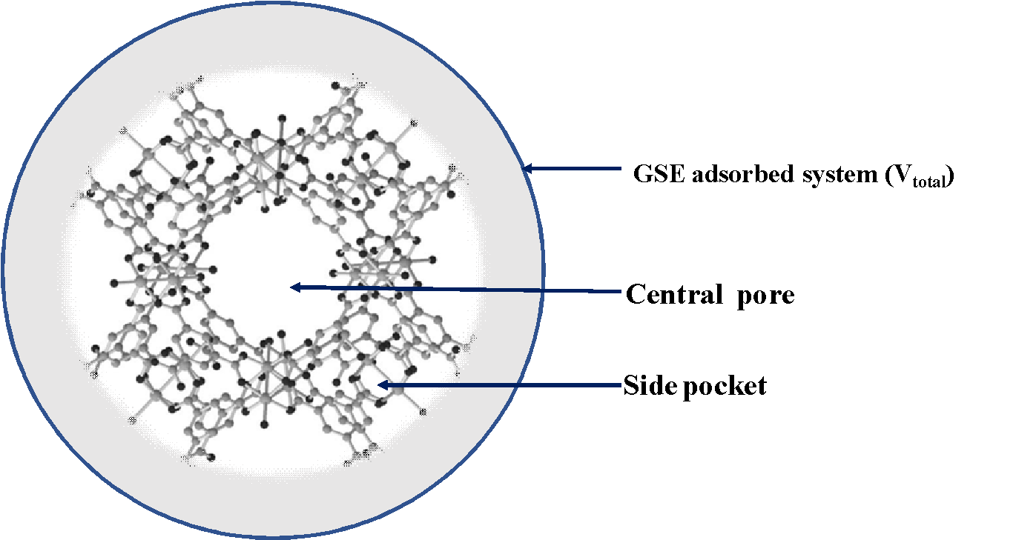
Figure S1 : Schematic of Cu-MOF framework for surface excess adsorption of CO₂

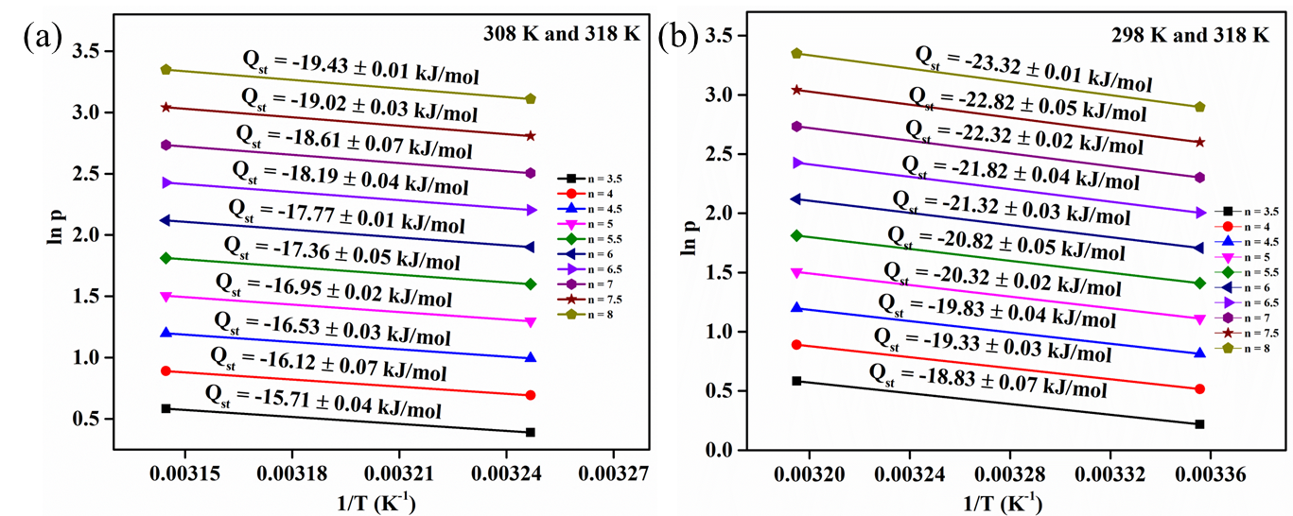
Figure S2 : Isosteric enthalpy Q_{st,n} for CO₂ adsorption on Cu-MOF at surface excess values of 3.5,4.5,5.5,6.5,7.5 and 8 mmol g⁻¹ from Clausius−Clapeyron graphs for different temperatures studied.

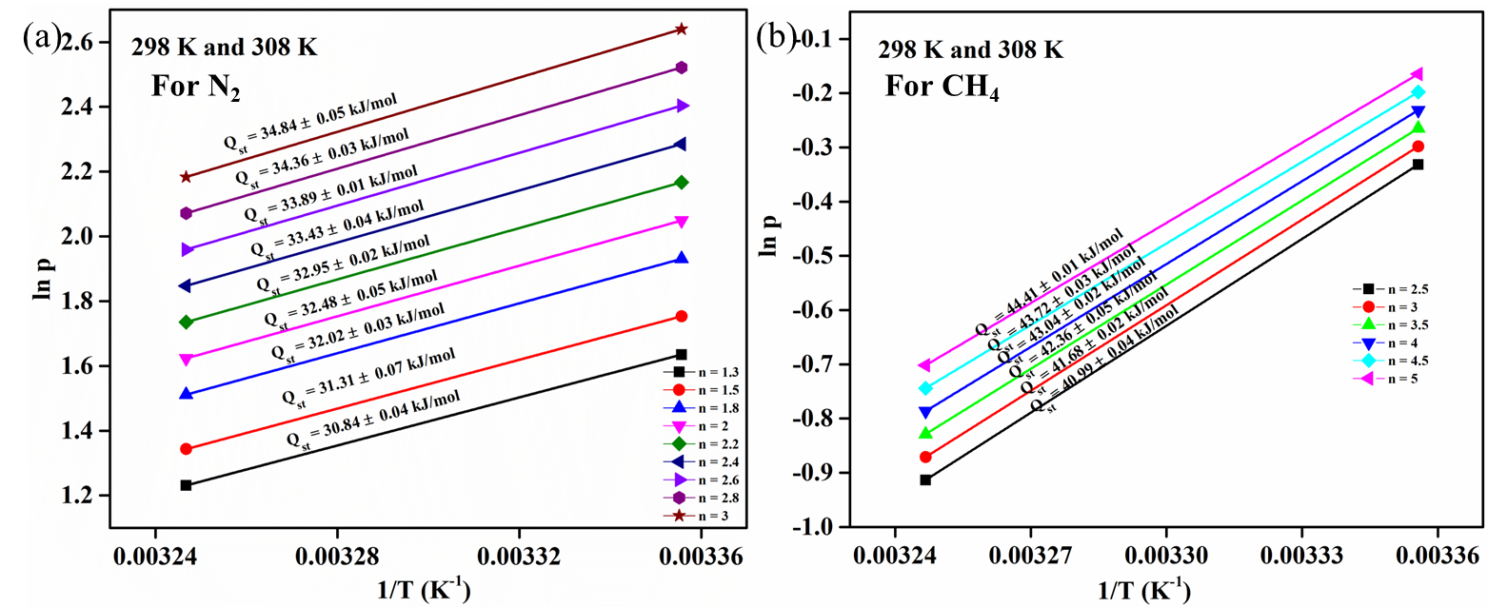
Figure S3 : Isosteric enthalpy Q_{st,n} for N₂ and CH₄ adsorption on Cu-MOF from Clausius−Clapeyron graphs.

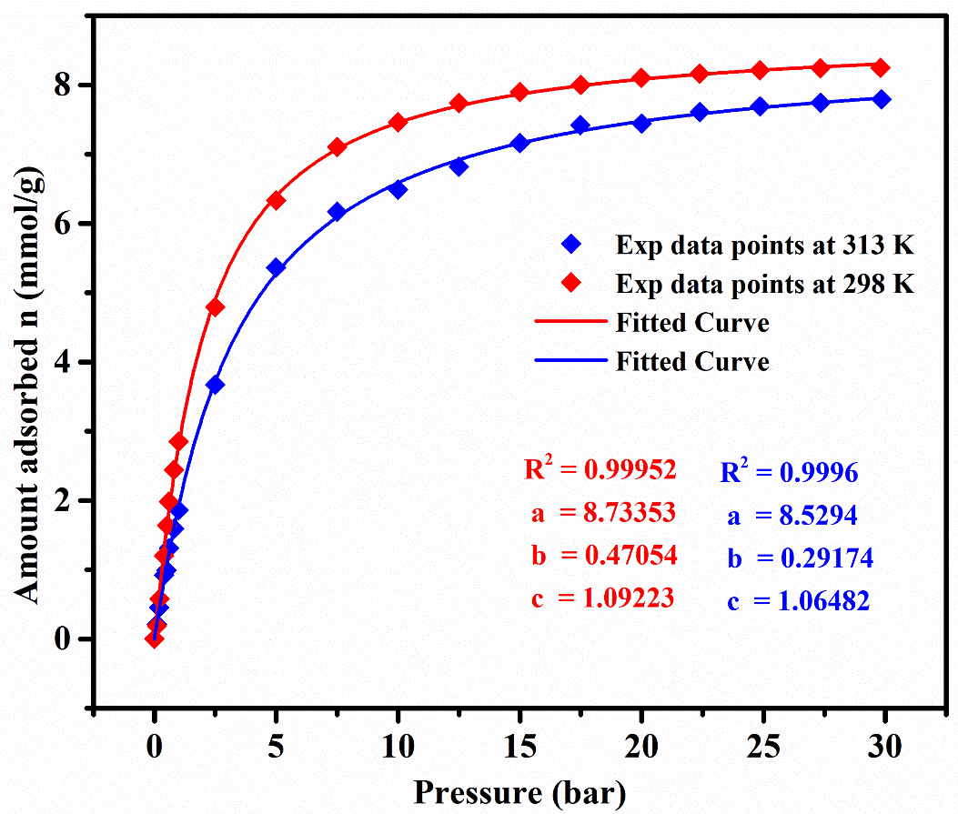
Figure S4 : Freundlich-Langmuir isotherm fit for CO₂ adsorption on Cu-MOF at 298 K and 313 K.
CO₂ adsorption/desorption isotherms on Cu-MOF represents an isotherm of the Freundlich-Langmuir model; the two isotherms recorded at two different temperatures (298 and 318K) are considered and fitted with the Freundlich-Langmuir equation to obtain at derived pressure through the following equation (1):
$n=\frac{a.b.p^{c}}{1+b. p^{c}}$ (1)
Where n is the amount of CO₂ adsorbed by Cu-MOF in mmol/g, p is pressure in bar, a is the maximum amount adsorbed, b is the affinity constant, and c is the heterogeneity exponent. Equation (1) can be rearranged to obtain derived p values
$p\left(n\right)= \sqrt[c]{\frac{n}{a.b-n.b}}$ (2)
From the derived pressure, $∆H_{ads}$ is evaluated using the equation (3).
$∆H_{ads}= -R. ln\left(\frac{p_{2}}{p_{1}}\right). \frac{T_{1}.T_{2}}{(T_{2}- T_{1})}$ (3)

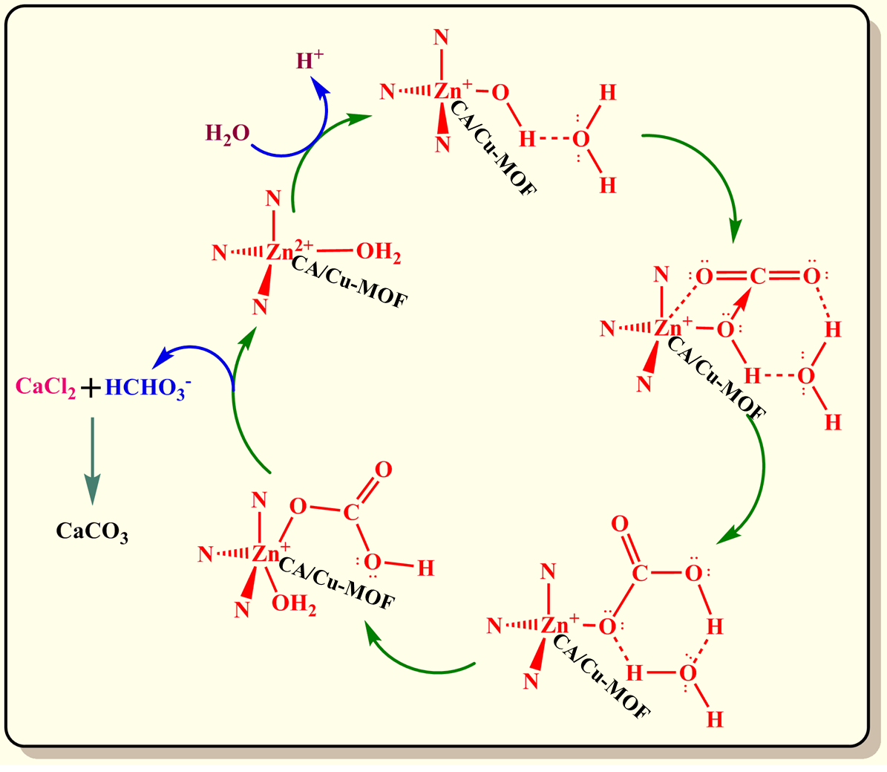
Figure S5: Reaction scheme for CO₂ sequestration as CaCO₃ using CA/Cu-MOF.

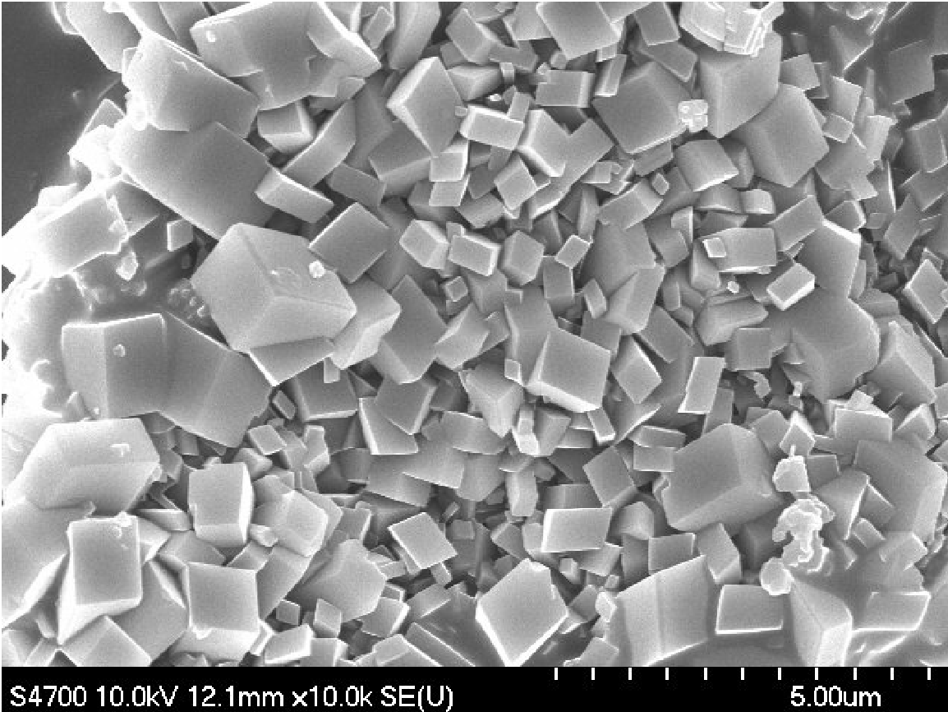

Figure S6 : FE-SEM image of precipitated CaCO₃.

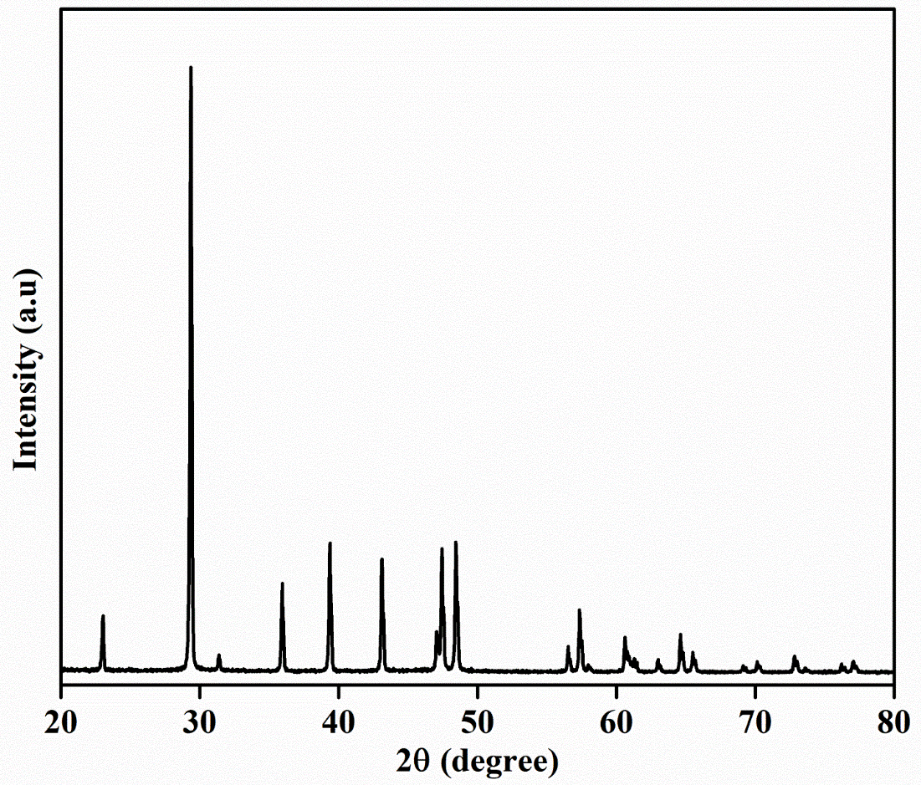
Figure S7 : XRD pattern of precipitated CaCO₃.

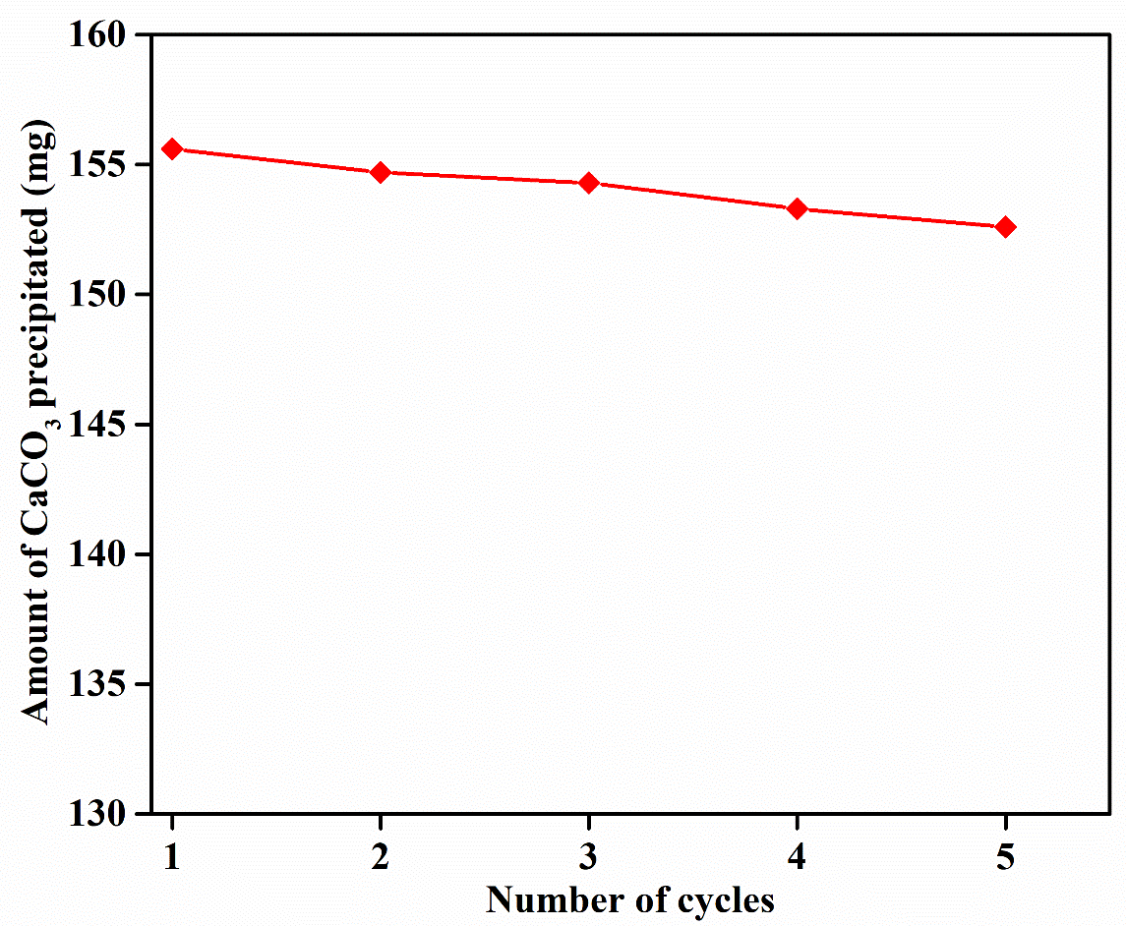
Figure S8 : Reusability of CA/Cu-MOF for CaCO₃ precipitation

Calculations:
Estimation of immobilization yield from Bradford Assay

1mg/ml of CA contains 946.13 µg of protein.

Amount of protein present in 4ml of CA solution | = 946.13 $×$ 4  = 3784.52 µg of protein
Amount of protein left in the buffer after immobilization  in 4ml | = 784.52 µg of protein
Amount of protein-bound on 100mg of Cu-MOF | = 3784.52-784.52  = 3000 µg of protein
Immobilization Yield (%) | = $\left(\frac{3000}{3784.52}\right)×$ 100  = 79%
Amount of CA loaded per mg of CA/Cu-MOF | = 3000 µg/100mg CA/Cu-MOF  = 30µg/mg CA/Cu-MOF

Reference:
- Jcgm, J. C. G. M. Evaluation of measurement data—Guide to the expression of uncertainty in measurement. Int. Organ. Stand. Geneva ISBN, 50, 134. (2008). http://dx.doi.org/10.1088/0026-1394/43/4/S01.

