Supplementary Figure 1. Fallback planning beam angle design.

Supplementary Figure 2. CBCT and sCT of the 1st, 5th, 10th, 15th and 20th RT session. The brown line delineates the overridden area.
Supplementary Figure 3. Regression analysis of the D_{mean} difference and the volume change rate of GTV, CTV, PTV and the right lung, respectively.

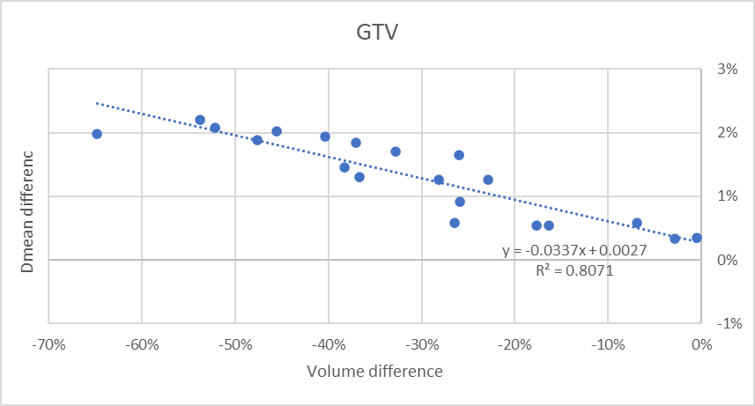

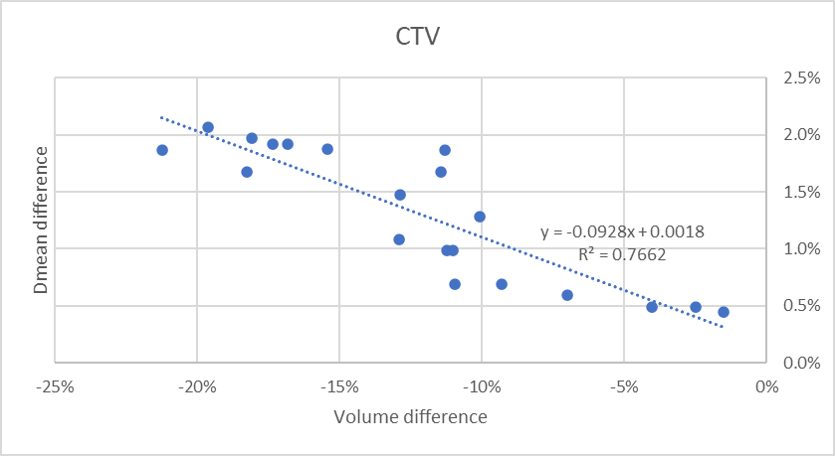

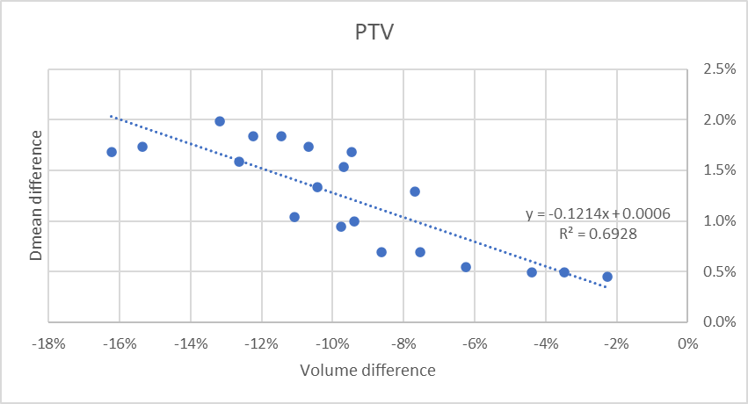

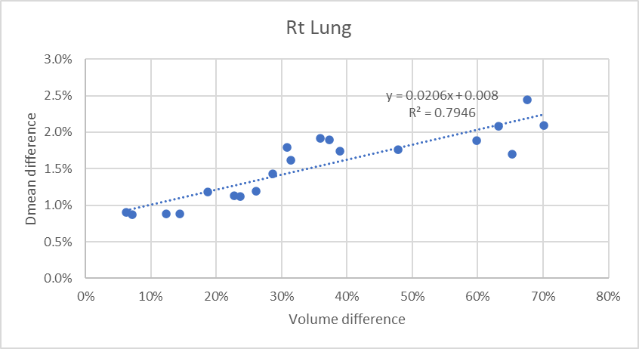

Supplementary Figure 4. Regression analysis of the D_{max} difference and the volume change rate of GTV and the right lung, respectively.
