Supplemental information
Figures
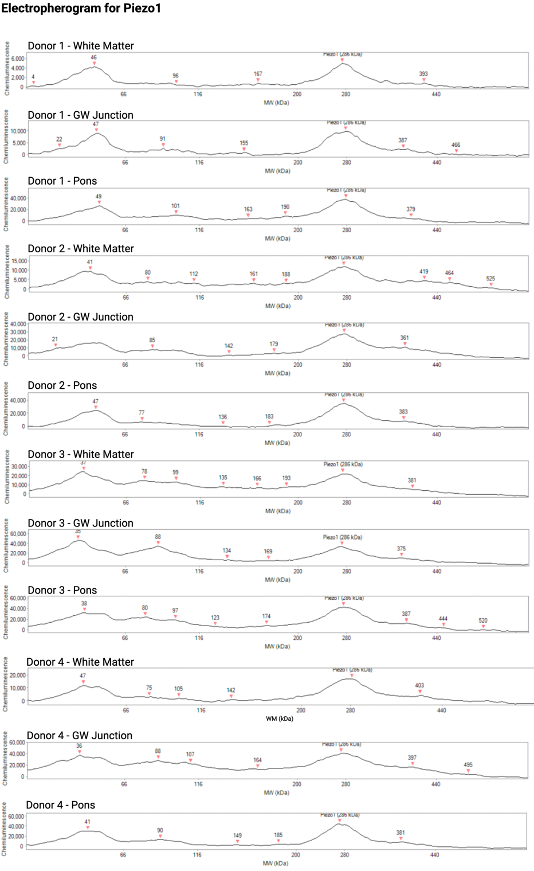
Fig. S1 Electropherogram of capillary electrophoresis for Piezo1 protein across brain regions (WM, GW Junction, and Pons) from different donors. Electropherograms correspond to Fig. 2A showing chemiluminescence versus molecular weight (MW) indicating a signal of bound proteins to the capillaries in the form of peaks on the graphs. Piezo1 has a molecular weight of 286kDa and is captured as such as its respective antibody on the electropherogram. Each donor and the respective brain regions have a signal peak for Piezo1 at 286kDa.
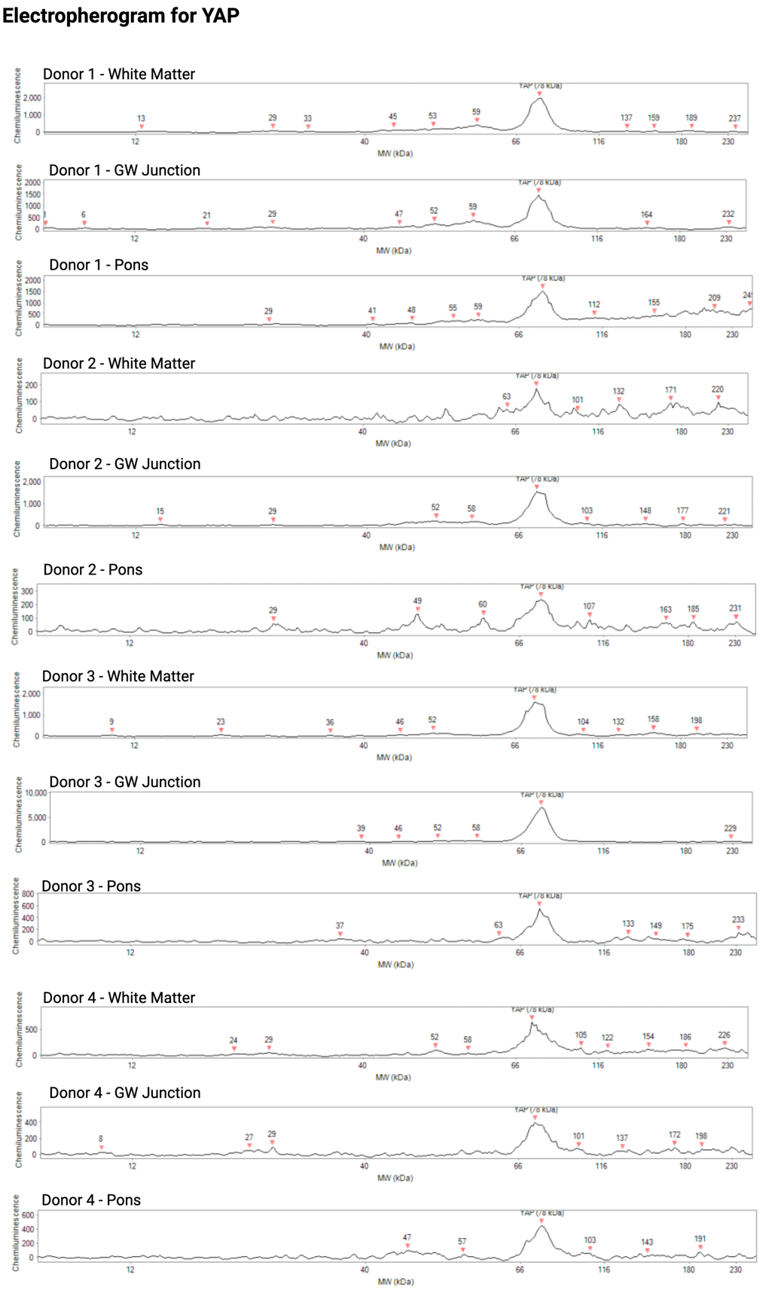
Fig. S2 Electropherogram of capillary electrophoresis for YAP across brain regions (WM, GW Junction, and Pons) from different donors. Electropherograms corresponding to Fig. 2B showing chemiluminescence versus molecular weight (MW) indicating signal of bound proteins to the capillaries in the form of peaks on the graphs. YAP has a molecular weight of ~78kDa and is captured as such as its respective antibody on the electropherogram. Each donor and the respective brain regions have a signal peak for YAP at 78kDa.
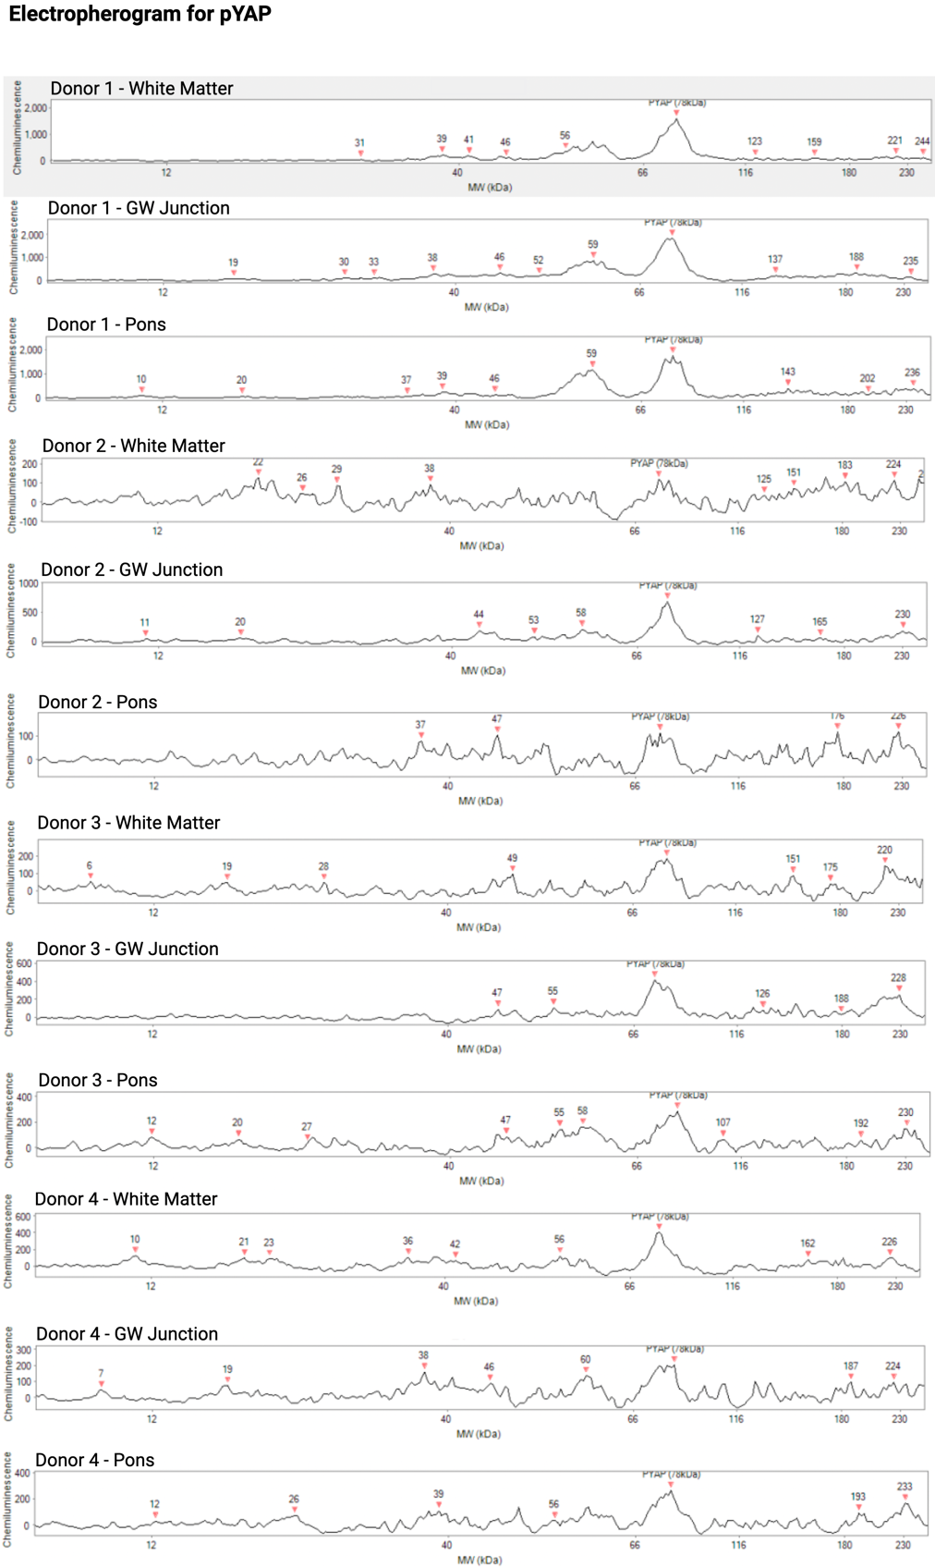
Fig. S3 Electropherogram of capillary electrophoresis for pYAP across brain regions (WM, GW Junction, and Pons) from different donors. Electropherograms corresponding to Fig. 2C showing chemiluminescence versus molecular weight (MW) indicating signal of bound proteins to the capillaries in the form of peaks on the graphs. pYAP has a molecular weight of ~78kDa and is captured as such by its respective antibody on the electropherogram. Each donor and the respective brain regions have a signal peak for YAP at 78kDa.
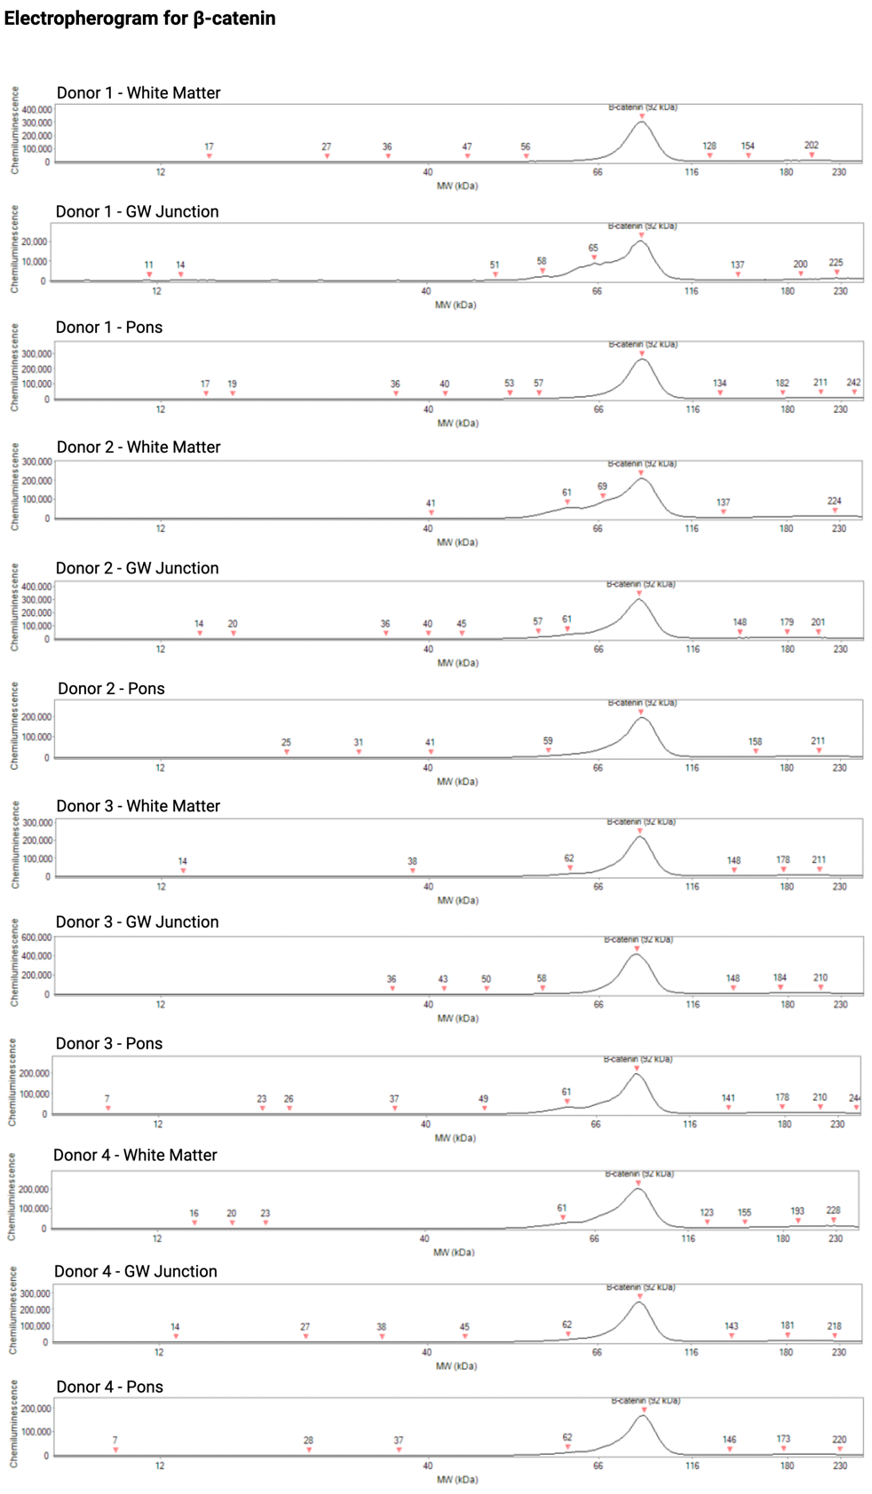
Fig. S4 Electropherogram of capillary electrophoresis for $β$-catenin protein across brain regions (WM, GW Junction, and Pons) from different donors. Electropherograms corresponding to Fig. 2D showing chemiluminescence versus molecular weight (MW) indicating signal of bound proteins to the capillaries in the form of peaks on the graphs. $β$-catenin has a molecular weight of ~92kDa and is captured as such by its respective antibody on the electropherogram. Each donor and the respective brain regions have a signal peak for $β$-catenin at 92kDa.

