Supplementary Material
Supplementary Text
Supplementary Methods
Study area & data collection
The icddr,b Kamalapur urban surveillance site comprises seven communities in four municipal wards with 350,000 residents, divided into 734 geographical clusters, each consisting of ∼100 households in a 4.2 km² area with a median household income <US $80.00/month, a mean education of 6.6 years for men and 5.1 for women. In brief, the pneumonia surveillance system follows 5,500 children <5 years longitudinally. All children <5 years old residing in selected clusters were kept under active morbidity surveillance, after parents provided informed written consent. All study staff were trained (both clinic and field staff) to achieve standardization of case assessments, making clinical diagnosis, case management and specimen collection. Each week, trained research field assistants visited each household within the surveillance area and, using standardized calendar questionnaires, inquired about signs of pneumonia.
Signs of illness (home visit)
Clinical signs were divided into major and minor signs. Major signs included fever (axillary temperature ≥ 38°C), age-specific tachypnea using WHO criteria, danger signs (chest indrawing, lethargy, cyanosis, inability to drink, convulsions), difficult breathing, noisy breathing, and ear pain/discharge. Minor signs included cough, rhinorrhea, sore throat, myalgia/arthralgia, chills, headache, irritability/ decreased activity, and vomiting. Children needed one major or, if absent, two minor signs for clinic referral. Thus, the basis of referrals was identification of standardized key signs and not a pneumonia diagnosis.
Definition of CAP (onsite study clinic)
All pneumonia definitions for children < 5 years are based on the World Health Organisation’s (WHO) program, Integrated Management of Childhood Illness (IMCI) guidelines [s1] Table 5 (p33). We have modified these by adding the definition of pneumonia, severe pneumonia and very severe pneumonia. The IMCI definition does not include auscultation findings. By incorporating auscultation findings, we will clinically detect fluid in the lungs and improve specificity. All other definitions of pneumonia are modifications of the WHO guidelines adapted for patient age.
CAP
Two criteria: 1) Age-specific tachypnoea (≥ 60/min if < 2 months; ≥ 50/min if 2 – 11 months; ≥ 40/min if 12 – 59 months; >24/min if 5 – 9 years; > 22/min if 10 – 14 years; >20/min if ≥ 15 years); 2) Crepitations on auscultation. Patients with concomitant wheezing would fit the definition, however based on our previous studies, would probably not have bacterial pneumonia, seem to respond differently to zinc than do non-wheezing children, and therefore will not be be recorded as pneumonia. Wheezing without crepitations would be defined as reactive airways disease or bronchiolitis (afebrile or febrile presentation, respectively).
Severe CAP
Pneumonia plus chest indrawing [s1].
Very severe CAP
Pneumonia plus 2) at least one of the danger signs. Danger signs include: central cyanosis, severe respiratory distress, convulsions, altered mental status, and in children < 5 years, head nodding, nasal flaring, grunting, inability to drink, and lethargy, and vomiting [s1].

Definition of Outcome of Illness
Recovered: If child meets illness resolution criteria without any persisting or ongoing problem. Illness resolution criteria: seven disease free days (temperature <38⁰C and respiratory rate <40/min) and no danger sign.
Recovered with Disability: If child meets illness resolution criteria with any persisting or ongoing problem
Example for recovered with disability: temperature <38⁰C and respiratory rate <40/min and no danger sign. Lungs clear but has persisting cough/night time cough.
Continues to be ill: If illness continue up to the date of convalescent clinic visit/exit interview.
Deceased: If child died during the specific illness episode.
Lost to follow up: If child left the Kamalapur surveillance area after reporting the illness and the field research assistant could not communicate with the family for follow up visit of the child throughout the illness period. And the exit interview for the particular illness could not be conducted.
Serotype-specific pneumococcal antibody measurement by multiplex immune assay
Two consecutive serum samples were obtained from 1530 cases. In 28/1530 cases the late serum sample was registered under a duplicate date. Thus, two unique serum samples were available from 1502 cases, from day 1 and 9-442 days after CAP was diagnosed [median 25, IQR 19-41].
Multiplex immunoassay
The standard used for performing the MIA was calibrated against the 007sp reference serum. Three assay controls 007sp (NIBSC) in 3 dilutions were taken along in duplicate with the test samples in each assay as internal control.
The paired samples were diluted 100x in sample buffer composed of phosphate-buffered saline (PBS), pH 7.3, 5% antibody depleted human serum (ADHS) pneumococcal cell wall polysaccharide (CWPS multi), to inhibit nonspecific binding of anti-cell wall polysaccharides I and II. Diluted sera were incubated with a mixture of 25 differently color-coded microspheres r, with each region being coated with an unique polysaccharide representing the serotype. Following incubation, non-bound antibodies were washed away and incubated with phycoerythrin (PE)-conjugated goat anti-human IgG. Bead suspensions were analyzed on a Bio-Plex 100 (IS 2.3)(for details, see ref [s2]).
Cross-reactivity and specificity. To assess analytical specificity, a procedure described by Lal et al. [s3] was applied as described before, with modifications. Briefly, WHO reference serum 007sp [s4] was diluted 3200x in sample buffer containing either one of the 25 polysaccharides (2 µg/ml)(inhibitor polysaccharides). One replicate served as control. The samples were preadsorbed at RT for 1,5 hour, and subsequently processed according to the general protocol described above. Specificity results for each sample and serotype–microsphere using homologous and heterologous inhibition were determined by calculating the percent inhibition in median fluorescent intensity (MFI) signal according to the method described by Schlottmann et al. [s5]:
Percent inhibition = (MFI of serum in preadsorbent –MFI in serum in preadsorbent + inhibitor serotype /MFI of serum in preadsorbent) × 100.
The experiment was repeated 3x.
To provide insight into the MIA method, we performed intra-assay correlations of early and late serotype-specific antibody concentrations.

Supplementary Results
Pneumococcal antibody measurement
Serotype-specific pneumococcal antibody response
Within the 41 children excluded for having a delta <14 days between the early and late sample date, three (7%) showed an antibody response against one single serotype (serotype 2, 19F and 22F), whereas 53 of the 81 children with a delta >100 days did have a positive immune response (65%). Within the latter group, either one of the top 10 most prevalent serotypes was identified in 32 cases (57%) (maximum ratio of 11% for serotype 15B and 19F).
Of cases the 406 cases with pneumococcal CAP, 27 children were enrolled as a case 2 times, two children 3 times and one child 4 times. None of these 30 children were diagnosed with the same serotype more than once. The minimum and maximum time between diagnosing two pneumococcal CAP episode in these cases was 32 and 636 days, respectively.
Intra-assay correlations of early and late serotype-specific antibody concentrations
Comparing serotype antibody concentrations from the first and second serum samples, serotypes from the same serogroup generally showed a better correlation compared to unrelated serotypes. Scatterplots are shown in Supplementary Figure 2 and the full correlation matrix is shown in Supplementary Table 1. As mentioned in the results section of the main manuscript, especially serotype 12A and 12F (PCC=0.70) and 6A and 6B (PCC=0.66) correlated well. The correlation between 19A and 19F was low (PCC=0.54). Noteworthy was the correlation of the biologically unrelated serotype 8 vs. serotype 12A and 12F (PCC=0.63).
Cross-reactivity and specificity
Considering the good correlation between concentration of antibodies against serotype 8 and serotype 12 family polysaccharides, validation data of the 25-plex were retrieved. In this validation experiment, the dilution chosen of the reference serum 007sp had a signal >500 MFI for most serotypes. Inhibition >95% and <15% are considered good and no inhibition. A background level of heterologous cross-inhibition of ~15% was generally observed between experiments. This was not related to any specific polysaccharide, but rather dependent on order of acquisition. Heterologous inhibition >15% proved reproducible. Homologues inhibition >95% was observed for all serotypes, and good cross-inhibition was found for serotype family members 6A/6B (yet A>B then B>A), and 12A/F (yet F>A then A>F). Modest cross-inhibition of ~30% was observed for both members of serotype 19. Several unexpected cross-inhibitions were observed: 1➔19F, 4➔14, 8➔9V/11A, 9N➔6A/B and 20➔1. No cross-inhibition was found between serotypes 8 and 12A/F (see Supplementary Table 2 and Supplementary Figure 3).

Supplementary Discussion
Cross-reactivity and specificity
We found serologic support for antibody cross-reactivity within serotype families, e.g. serogroup 6, by correlating serotype-specific antibody concentrations. Noteworthy was the good correlation between serotype 8 and serogroup 12 members, despite their distinct composition [s6]. After having ruled out cross-contamination of polysaccharide batches (see Supplementary Figure 3), the most likely explanation for this remarkable correlation is a high degree of exposure and probably combined nasopharyngeal carriage of these serotypes [s7]. Even though, these results could be indicative for cross protection, the functionality of cross-reactive antibodies has not been established.
Currently, experiments are ongoing to determine what factors are contributing to the “so-called” unexpected cross-inhibitions. It may be related to the polysaccharide batches used, modifications introduced by the conjugation of polysaccharides to the bead allowing binding of moderately cross-reactive antibodies, or related to the artificial experimental conditions involving an excess of polysaccharide molecules during the pre-absorption phase.
Supplementary Reference list
[s1] World Health Organization (WHO). Management of the child with a serious infection or severe malnutrition: Guidelines for care at the first-referral level in developing countries. 2000. Available at: https://apps.who.int/iris/bitstream/handle/10665/42335/WHO_FCH_CAH_00.1.pdf
[s2] Vestjens SMT, Wagenvoort GHJ, Grutters JC, et al. Changes in pathogens and pneumococcal serotypes causing community-acquired pneumonia in The Netherlands. Vaccine 2017; 35:4112–4118.
[s3] Goldblatt D, Plikaytis BD, Akkoyunlu M, Antonello J, Ashton L, Blake M, et al. Establishment of a new human pneumococcal standard reference serum, 007sp. Clin Vaccine Immunol 2011; Oct;18(10):1728-1736.
[s4] Pickering JW, Martins TB, Greer RW, Schroder MC, Astill ME, Litwin CM, et al. A multiplexed fluorescent microsphere immunoassay for antibodies to pneumococcal capsular polysaccharides. Am J Clin Pathol 2002; Apr;117(4):589-596.
[s5] Schlottmann SA, Jain N, Chirmule N, Esser MT. A novel chemistry for conjugating pneumococcal polysaccharides to Luminex microspheres. J Immunol Methods 2006; Feb 20;309(1-2):75-85.
[s6] Geno KA, Gilbert GL, Song JY, et al. Pneumococcal Capsules and Their Types: Past, Present, and Future. Clin Microbiol Rev 2015; 28:871–899.
[s7] O’Brien KL, Baggett HC, Brooks WA, et al. Causes of severe pneumonia requiring hospital admission in children without HIV infection from Africa and Asia: the PERCH multi-country case-control study. Lancet 2019; 394:757–779.

Supplementary Tables
Supplementary Table 1. Correlation matrix showing Pearson correlation coefficients of correlations between serotype-specific antibody concentrations.
 | 1 | 2 | 3 | 4 | 5 | 6A | 6B | 7F | 8 | 9N | 9V | 10A | 11A | 12A | 12F | 14 | 15B | 18C | 19A | 19F | 20 | 22F | 23F | 33F | 45
1 | 1,00 | 0,24 | 0,22 | 0,19 | 0,14 | 0,17 | 0,17 | 0,28 | 0,26 | 0,24 | 0,24 | 0,22 | 0,16 | 0,25 | 0,21 | 0,20 | 0,19 | 0,27 | 0,23 | 0,18 | 0,19 | 0,14 | 0,24 | 0,22 | 0,22 | 1
2 |  | 1,00 | 0,16 | 0,19 | 0,26 | 0,17 | 0,22 | 0,29 | 0,50 | 0,46 | 0,31 | 0,27 | 0,24 | 0,49 | 0,51 | 0,07 | 0,13 | 0,22 | 0,21 | 0,20 | 0,30 | 0,22 | 0,20 | 0,22 | 0,39 | 2
3 |  |  | 1,00 | 0,14 | 0,18 | 0,11 | 0,14 | 0,22 | 0,24 | 0,22 | 0,20 | 0,13 | 0,13 | 0,17 | 0,21 | 0,05 | 0,05 | 0,20 | 0,21 | 0,11 | 0,19 | 0,14 | 0,21 | 0,13 | 0,17 | 3
4 |  |  |  | 1,00 | 0,20 | 0,14 | 0,17 | 0,19 | 0,18 | 0,19 | 0,18 | 0,15 | 0,09 | 0,19 | 0,17 | 0,08 | 0,16 | 0,20 | 0,16 | 0,15 | 0,18 | 0,17 | 0,10 | 0,16 | 0,17 | 4
5 |  |  |  |  | 1,00 | 0,15 | 0,14 | 0,25 | 0,32 | 0,28 | 0,23 | 0,27 | 0,19 | 0,25 | 0,30 | 0,08 | 0,20 | 0,21 | 0,16 | 0,10 | 0,27 | 0,17 | 0,10 | 0,23 | 0,24 | 5
6A |  |  |  |  |  | 1,00 | 0,66 | 0,15 | 0,16 | 0,28 | 0,27 | 0,27 | 0,25 | 0,17 | 0,15 | 0,28 | 0,32 | 0,24 | 0,28 | 0,27 | 0,30 | 0,23 | 0,22 | 0,32 | 0,19 | 6A
6B |  |  |  |  |  |  | 1,00 | 0,18 | 0,16 | 0,29 | 0,30 | 0,20 | 0,21 | 0,20 | 0,16 | 0,26 | 0,27 | 0,29 | 0,27 | 0,24 | 0,24 | 0,22 | 0,25 | 0,26 | 0,18 | 6B
7F |  |  |  |  |  |  |  | 1,00 | 0,31 | 0,32 | 0,28 | 0,34 | 0,20 | 0,26 | 0,25 | 0,12 | 0,22 | 0,17 | 0,24 | 0,20 | 0,28 | 0,16 | 0,22 | 0,28 | 0,24 | 7F
8 |  |  |  |  |  |  |  |  | 1,00 | 0,54 | 0,30 | 0,31 | 0,24 | 0,63 | 0,63 | 0,02 | 0,14 | 0,20 | 0,18 | 0,21 | 0,34 | 0,22 | 0,19 | 0,23 | 0,48 | 8
9N |  |  |  |  |  |  |  |  |  | 1,00 | 0,48 | 0,39 | 0,22 | 0,52 | 0,50 | 0,10 | 0,22 | 0,22 | 0,27 | 0,25 | 0,36 | 0,27 | 0,28 | 0,30 | 0,47 | 9N
9V |  |  |  |  |  |  |  |  |  |  | 1,00 | 0,28 | 0,27 | 0,27 | 0,28 | 0,19 | 0,24 | 0,30 | 0,33 | 0,23 | 0,31 | 0,22 | 0,22 | 0,28 | 0,24 | 9V
10A |  |  |  |  |  |  |  |  |  |  |  | 1,00 | 0,25 | 0,29 | 0,27 | 0,15 | 0,38 | 0,14 | 0,24 | 0,22 | 0,38 | 0,28 | 0,16 | 0,42 | 0,32 | 10A
11A |  |  |  |  |  |  |  |  |  |  |  |  | 1,00 | 0,16 | 0,22 | 0,16 | 0,23 | 0,16 | 0,15 | 0,17 | 0,24 | 0,23 | 0,21 | 0,30 | 0,17 | 11A
12A |  |  |  |  |  |  |  |  |  |  |  |  |  | 1,00 | 0,70 | 0,11 | 0,21 | 0,22 | 0,19 | 0,21 | 0,31 | 0,25 | 0,22 | 0,22 | 0,52 | 12A
12F |  |  |  |  |  |  |  |  |  |  |  |  |  |  | 1,00 | 0,05 | 0,14 | 0,23 | 0,18 | 0,18 | 0,33 | 0,21 | 0,15 | 0,25 | 0,56 | 12F
14 |  |  |  |  |  |  |  |  |  |  |  |  |  |  |  | 1,00 | 0,36 | 0,19 | 0,19 | 0,16 | 0,18 | 0,18 | 0,22 | 0,22 | 0,04 | 14
15B |  |  |  |  |  |  |  |  |  |  |  |  |  |  |  |  | 1,00 | 0,19 | 0,23 | 0,21 | 0,32 | 0,19 | 0,20 | 0,38 | 0,22 | 15B
18C |  |  |  |  |  |  |  |  |  |  |  |  |  |  |  |  |  | 1,00 | 0,28 | 0,17 | 0,25 | 0,21 | 0,22 | 0,16 | 0,20 | 18C
19A |  |  |  |  |  |  |  |  |  |  |  |  |  |  |  |  |  |  | 1,00 | 0,54 | 0,25 | 0,12 | 0,17 | 0,21 | 0,19 | 19A
19F |  |  |  |  |  |  |  |  |  |  |  |  |  |  |  |  |  |  |  | 1,00 | 0,19 | 0,10 | 0,21 | 0,20 | 0,20 | 19F
20 |  |  |  |  |  |  |  |  |  |  |  |  |  |  |  |  |  |  |  |  | 1,00 | 0,28 | 0,22 | 0,36 | 0,33 | 20
22F |  |  |  |  |  |  |  |  |  |  |  |  |  |  |  |  |  |  |  |  |  | 1,00 | 0,16 | 0,26 | 0,19 | 22F
23F |  |  |  |  |  |  |  |  |  |  |  |  |  |  |  |  |  |  |  |  |  |  | 1,00 | 0,14 | 0,19 | 23F
33F |  |  |  |  |  |  |  |  |  |  |  |  |  |  |  |  |  |  |  |  |  |  |  | 1,00 | 0,26 | 33F
45 |  |  |  |  |  |  |  |  |  |  |  |  |  |  |  |  |  |  |  |  |  |  |  |  | 1,00 | 45
 | 1 | 2 | 3 | 4 | 5 | 6A | 6B | 7F | 8 | 9N | 9V | 10A | 11A | 12A | 12F | 14 | 15B | 18C | 19A | 19F | 20 | 22F | 23F | 33F | 45

Supplementary Table 2. Cross-reactivity and specificity.

Interrogated bead
 | % | 1 | 2 | 3 | 4 | 5 | 6A | 6B | 7F | 8 | 9N | 9V | 10A | 11A | 12A | 12F | 14 | 15B | 18C | 19A | 19F | 20 | 22F | 23F | 33F | 45
Inhibitor | 1 | 99 | 10 | 10 | 9 | 13 | 5 | 12 | 11 | 11 | 11 | 13 | 10 | 13 | 4 | 16 | 10 | 10 | 11 | 14 | 32 | 15 | 9 | 15 | 8 | 10
PPS | 2 | 14 | 99 | 16 | 8 | 17 | 14 | 16 | 13 | 14 | 10 | 13 | 10 | 12 | 17 | 24 | 13 | 11 | 14 | 13 | 14 | 18 | 12 | 15 | 8 | 15
 | 3 | 16 | 12 | 97 | 13 | 17 | 13 | 14 | 14 | 11 | 11 | 12 | 11 | 11 | 8 | 22 | 14 | 12 | 13 | 22 | 14 | 17 | 12 | 15 | 10 | 17
 | 4 | 14 | 13 | 13 | 98 | 14 | 7 | 12 | 12 | 12 | 11 | 13 | 11 | 15 | 3 | 16 | 53 | 13 | 10 | 11 | 11 | 16 | 9 | 13 | 10 | 13
 | 5 | 7 | 6 | 6 | 5 | 96 | 6 | 7 | 6 | 8 | 8 | 6 | 6 | 7 | 7 | 8 | 7 | 7 | 7 | 8 | 5 | 11 | 6 | 12 | 5 | 6
 | 6A | 9 | 6 | 7 | 6 | 9 | 96 | 34 | 6 | 6 | 7 | 7 | 7 | 8 | 9 | 9 | 7 | 6 | 6 | 8 | 3 | 10 | 6 | 10 | 3 | 7
 | 6B | 10 | 11 | 14 | 6 | 13 | 83 | 96 | 13 | 9 | 14 | 12 | 9 | 12 | 10 | 12 | 9 | 11 | 12 | 11 | 9 | 14 | 13 | 18 | 9 | 9
 | 7F | 7 | 6 | 5 | 1 | 6 | 2 | 7 | 96 | 2 | 3 | 7 | 7 | 7 | 11 | 11 | 6 | 7 | 7 | 7 | 5 | 9 | 6 | 8 | 3 | 7
 | 8 | 2 | 5 | 11 | -3 | 21 | 0 | 3 | 3 | 98 | 8 | 43 | 6 | 38 | 14 | 9 | 1 | 3 | 2 | 4 | 4 | 6 | 4 | 7 | 0 | 3
 | 9N | 9 | 8 | 15 | 10 | 13 | 35 | 45 | 10 | 7 | 99 | 18 | 10 | 10 | 18 | 14 | 10 | 6 | 9 | 11 | 10 | 14 | 8 | 12 | 9 | 10
 | 9V | 9 | 11 | 24 | 7 | 16 | 9 | 15 | 11 | 8 | 33 | 96 | 11 | 10 | 1 | 14 | 9 | 10 | 8 | 22 | 9 | 13 | 7 | 15 | 6 | 9
 | 10A | 8 | 6 | 6 | 5 | 13 | 9 | 13 | 10 | 7 | 11 | 10 | 96 | 12 | 11 | 14 | 10 | 11 | 10 | 10 | 11 | 13 | 10 | 13 | 6 | 11
 | 11A | 6 | 7 | 11 | 6 | 8 | 7 | 9 | 7 | 8 | 5 | 9 | 10 | 100 | 5 | 10 | 7 | 4 | 5 | 13 | 5 | 9 | 7 | 8 | 5 | 8
 | 12A | 0 | -3 | -2 | -4 | -1 | 20 | 4 | -3 | -2 | -4 | 0 | -5 | -1 | 99 | 24 | -2 | -1 | -5 | -3 | -2 | 1 | 19 | -1 | -5 | -7
 | 12F | 2 | 6 | 11 | 3 | 8 | 3 | 6 | 4 | 5 | 2 | 6 | 2 | 11 | 83 | 95 | 6 | 6 | 5 | 3 | 1 | 10 | 4 | 8 | -1 | 0
 | 14 | -5 | -4 | -5 | -6 | 0 | -2 | -4 | -3 | -4 | -5 | 4 | -3 | -1 | -11 | -1 | 98 | 6 | -4 | -1 | -5 | -2 | -3 | -1 | -6 | -1
 | 15B | 5 | 3 | 5 | 0 | 5 | 3 | 6 | 4 | 1 | 2 | 3 | 4 | 3 | 1 | 5 | 9 | 98 | 4 | 4 | 2 | 7 | 4 | 7 | 0 | 7
 | 18C | 2 | 3 | 16 | 0 | 5 | 4 | 3 | 6 | 1 | 2 | 4 | 5 | 2 | 3 | 0 | 4 | 2 | 99 | 9 | 4 | 6 | -1 | 5 | 2 | 8
 | 19A | 7 | 6 | 11 | 1 | 7 | 3 | 9 | 4 | 3 | 5 | 14 | 5 | 7 | 4 | 7 | 4 | 3 | 8 | 98 | 32 | 10 | 5 | 9 | 2 | 7
 | 19F | 5 | 2 | 14 | 0 | 9 | 2 | 6 | 1 | 2 | 1 | 4 | 1 | 3 | 4 | 3 | 4 | 3 | 3 | 23 | 97 | 6 | 1 | 6 | -3 | 5
 | 20 | 42 | 1 | -5 | -3 | 3 | 0 | 1 | -2 | -6 | 0 | 2 | -2 | 0 | -8 | 2 | -1 | -1 | -2 | 0 | -1 | 98 | -1 | 4 | -3 | -3
 | 22F | -5 | -5 | -15 | -9 | -2 | -3 | -1 | -6 | -6 | -6 | -3 | -7 | -7 | -13 | -5 | -5 | -5 | -7 | -7 | -5 | -1 | 100 | 1 | -8 | -6
 | 23F | -4 | -7 | -8 | -9 | -2 | -7 | -4 | -5 | -10 | -9 | -3 | -7 | -4 | -13 | -3 | -4 | -5 | -4 | -6 | -7 | 1 | -4 | 97 | -8 | -5
 | 33F | 10 | -5 | 0 | -5 | -1 | -3 | -4 | -4 | -1 | 6 | -2 | -2 | -2 | -10 | -1 | -3 | -2 | -2 | 1 | -1 | 0 | -6 | 2 | 98 | -3
 | 45 | -4 | -6 | 5 | -7 | -3 | -7 | -3 | -4 | -7 | -6 | -3 | -5 | -4 | -14 | -1 | -5 | -7 | -6 | -4 | -4 | 1 | -5 | -4 | -6 | 97

Supplementary Figures
Supplementary Figure 1. Serotype-specific antibody concentration (µg/ml) dynamics - examples of response patterns in individual patients.
Pattern A. Single serotype-specific immune response (19A pneumococcal CAP).
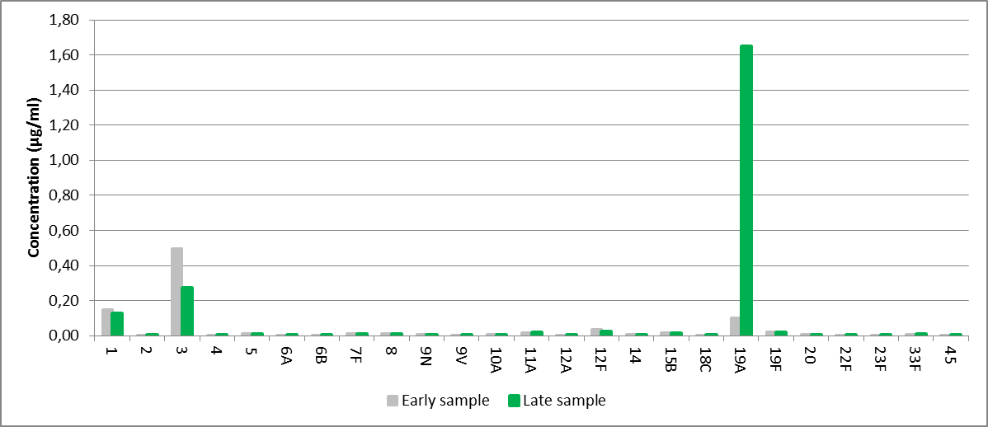
Pattern B. No positive immune response against any serotype (fold-increases all below two).
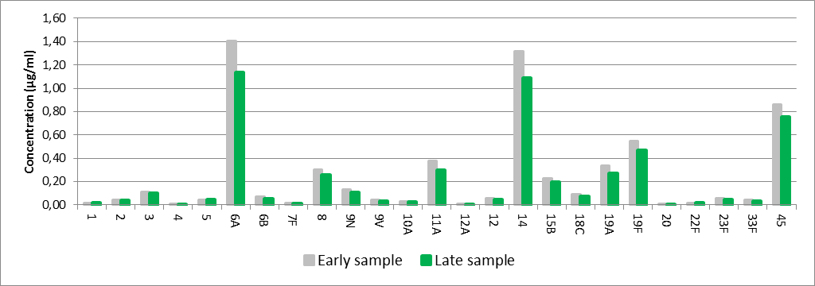
Pattern C. No single serotype-specific immune response (antibody concentration has increased for 3 serotypes: 2, 9N and 9V).
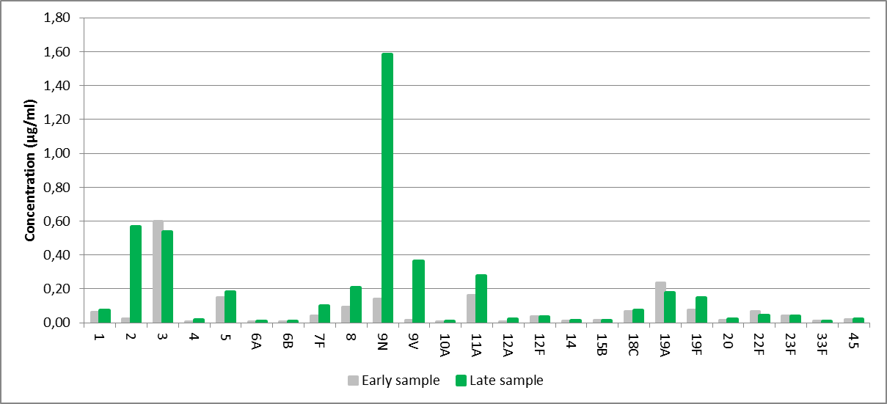
Pattern D: Indistinct antibody dynamics (increase in concentration of antibodies specific for 11A, decrease in antibodies specific for 3 and 18C).

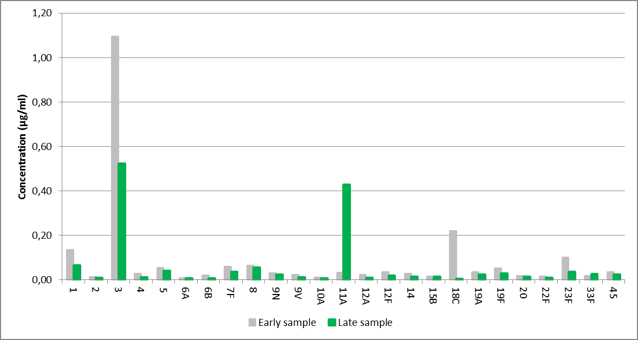

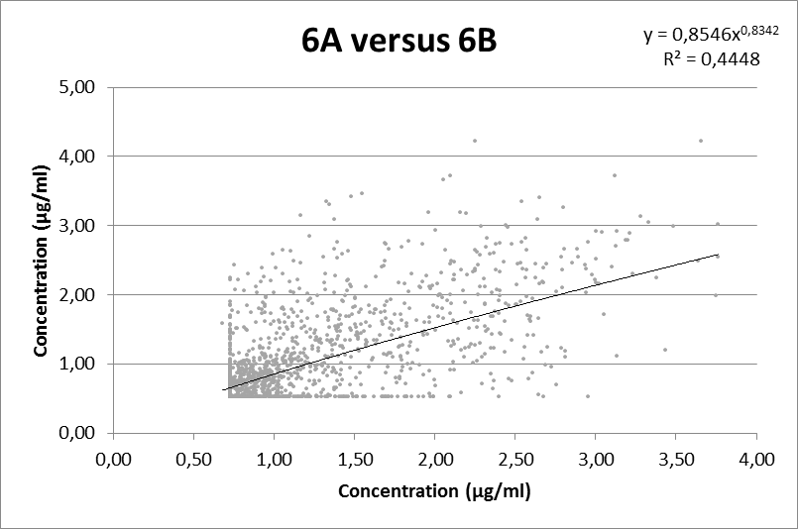
Supplementary Figure 2. Scatterplots of log-transformed serotype-specific antibody concentrations (ng/ml).
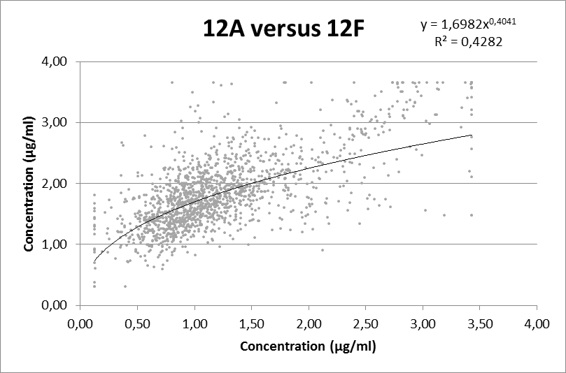

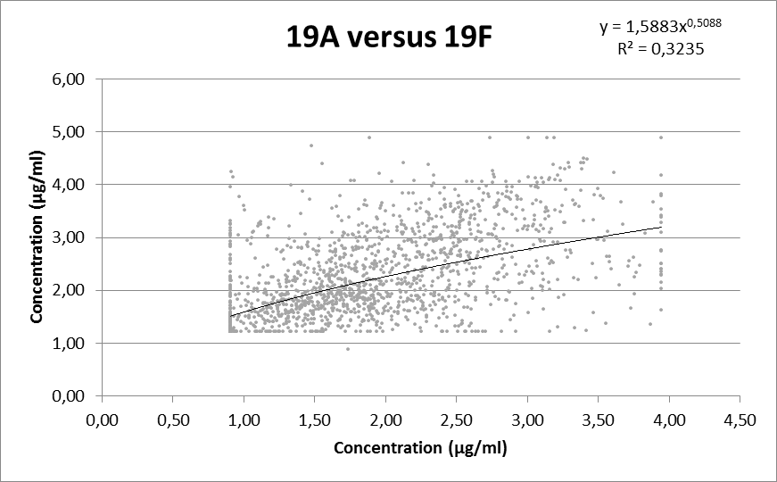

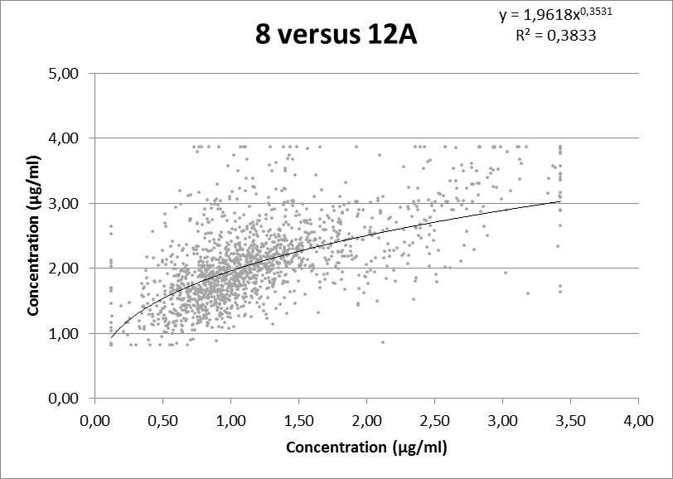
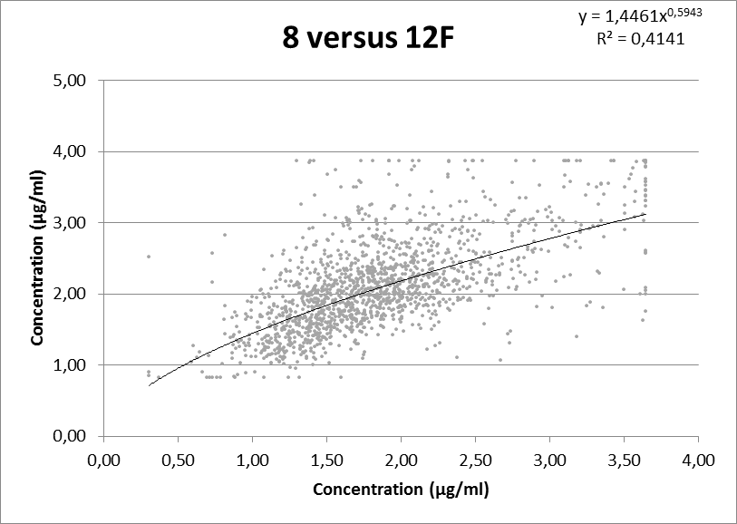

Supplementary Figure 3. Cross-reactivity and specificity.
