Supplement Table 1. Carbon footprint assignment
 | - Category | - Specification | - Carbon footprint | - Weight(kg)
Transportation  (kg CO₂-eq/ (person*km)) | - Diesel bus | - - | - 0.015 | - -
Transportation  (kg CO₂-eq/ (person*km)) | - Electric bus | - - | - 0.009 | - -
Transportation  (kg CO₂-eq/ (person*km)) | - Metro | - - | - 0.015 | - -
Transportation  (kg CO₂-eq/ (person*km)) | - Gasoline Taxi | - - | - 0.041 | - -
Transportation  (kg CO₂-eq/ (person*km)) | - Electric Taxi | - - | - 0.017 | - -
Transportation  (kg CO₂-eq/ (person*km)) | - Gasoline private car | - - | - 0.041 | - -
Transportation  (kg CO₂-eq/ (person*km)) | - Electric private car | - - | - 0.017 | - -
Discharge medication  (kg CO2-eq/specification) | - Ferrous Succinate | 0.1g*24# | - 0.63 | -
Discharge medication  (kg CO2-eq/specification) | - Folic Acid | 5mg*100# | - 0.46 | -
Discharge medication  (kg CO2-eq/specification) | - Calcium Carbonate | 0.75g*48# | - 0.28 | -
Discharge medication  (kg CO2-eq/specification) | - Compound Aluminium Hydroxide Tablets | 48# | - 0.07 | -
Discharge medication  (kg CO2-eq/specification) | - Lanthanum Carbonate | 0.5g*20# | - 4.97 | -
Discharge medication  (kg CO2-eq/specification) | - Calcitriol (Rocaltrol) | 0.25ug*20# | - 1.80 | -
Discharge medication  (kg CO2-eq/specification) | - Compound α-keto Acid Tablets | 630mg*100# | - 3.23 | -
Discharge medication  (kg CO2-eq/specification) | - Roxadustat | 20mg*3# | - 1.08 | -
Discharge medication  (kg CO2-eq/specification) | - Nifedipine Controlled-Release Tablets | 30mg*7# | - 0.63 | -
Discharge medication  (kg CO2-eq/specification) | - Amlodipine (Norvasc) | 5mg*7# | - 0.60 | -
Discharge medication  (kg CO2-eq/specification) | - Metoprolo | 47.5*7# | - 0.37 | -
Discharge medication  (kg CO2-eq/specification) | - Terazosin | 2mg*48# | - 0.33 | -
Discharge medication  (kg CO2-eq/specification) | - Atorvastatin | 20mg*7# | - 1.06 | -
Discharge medication  (kg CO2-eq/specification) | - Sodium Polystrene Sulfonate | 5g*9^{bag} | - 3.71 | -
Discharge medication  (kg CO2-eq/specification) | - Isosorbide Mononitrate Injection | 20mg*48# | - 0.92 | -
Discharge medication  (kg CO2-eq/specification) | - Sevelamer | 0.8*30# | - 4.72 | -
Discharge medication  (kg CO2-eq/specification) | - Sodium Bicarbonate | 0.5*100# | - 0.24 | -
Dialysis medication  (kg CO2-eq/specification) | - L-Carnitine | 5ml: 1g | - 0.98 | -
Dialysis medication  (kg CO2-eq/specification) | - Recombinant Human Erythropoietin Injection | 1ml | - 0.71 | -
Dialysis medication  (kg CO2-eq/specification) | - Heparin Sodium Injection | 4100IU*2 | - 3.73 | -
Dialysis medication  (kg CO2-eq/specification) | - Enoxaparin Sodium | 0.6ml: 6000AXa | - 1.44 | -
Dialysis medication  (kg CO2-eq/specification) | - Paricalcitol | 1ml: 5ug | - 4.13 | -
Dialysis medication  (kg CO2-eq/specification) | - Thermotherapy | 1 time | - 0.25 | -
Dialysis medication  (kg CO2-eq/specification) | - Heparin | 2ml: 12500 units | - 0.24 | -
Dialysis medication  (kg CO2-eq/specification) | - Dalteparin Sodium Injection | 5000 IU *10 | - 0.95 | -
Dialysis medication  (kg CO2-eq/specification) | - Citric Acid | 1.45*20 | - 0.62 | -
Dialysis medication  (kg CO2-eq/specification) | - Iron Sucrose Injection | 5ml: 0.1g | - 0.73 | -
Medical Supplies  (kg CO2-eq/kg) | - Blood duct (blood filter tube) | PP | 5.98 | 0.33
Medical Supplies  (kg CO2-eq/kg) | Internal fistula needle Kit | PVP(polyvivnyl), PVC | 1.77 | 0.01
Medical Supplies  (kg CO2-eq/kg) | disposable sterilized syringe | PP | 5.98 | 0.01
Medical Supplies  (kg CO2-eq/kg) | Dialyzer (semipermeable membrane) | polyacrylonitrile | 7.88 | 0.19
Medical Supplies  (kg CO2-eq/kg) | Normal Saline | Sodium chloride | 0.62 | 1.04
Medical Supplies  (kg CO2-eq/kg) | Care Kit | PE, PVC, cotton fiber, fabric | 0.60 | 0.12
Medical Supplies  (kg CO2-eq/kg) | Iodine volts cap | Polyurethane foam (PUR) | 0.57 | 0.02
Medical Supplies  (kg CO2-eq/kg) | Drainage pack | PVC | 1.77 | 0.08
Equipment power consumption  (kg CO2-eq/h) | Pentair Water Purifier | - | 14.88 | -
Equipment power consumption  (kg CO2-eq/h) | Fresenius Dialysis Equipment (Type1) | - | 2.25 | -
Equipment power consumption  (kg CO2-eq/h) | Fresenius Dialysis Equipment (Type 2) | - | 1.84 | -
Equipment power consumption  (kg CO2-eq/h) | Gambro Dialysis Equipment (Type1) | - | 1.88 | -
Equipment power consumption  (kg CO2-eq/h) | Gambro Dialysis Equipment (Type2) | - | 2.09 | -
Equipment power consumption  (kg CO2-eq/h) | Wego Dialysis Equipment | - | 2.05 | -

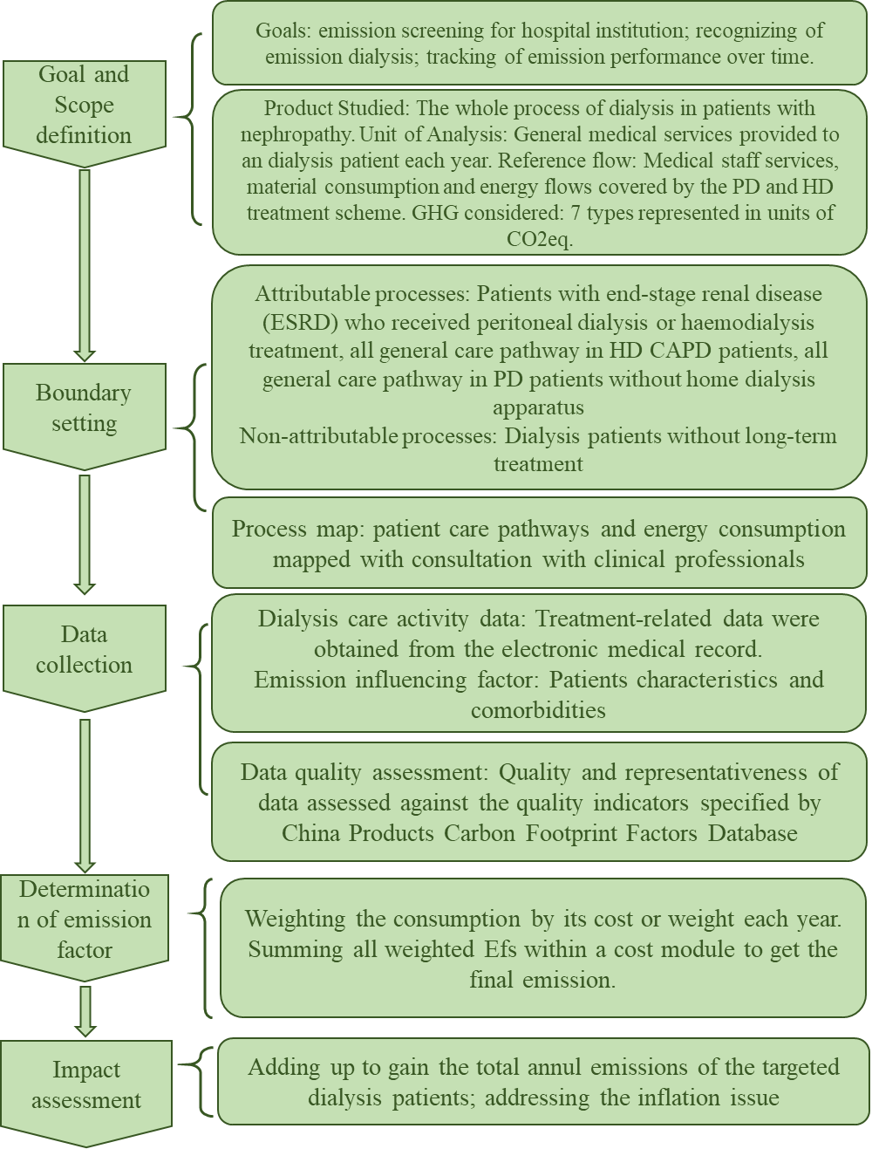
Supplement figure1 LCA general steps

Supplement figure1 LCA general steps

