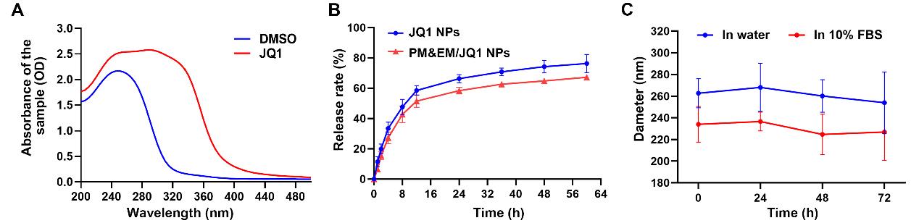
S1. A) The full spectrums of JQ1 and DMSO. B) JQ1 release profiles from JQ1 NPs and PM&EM/JQ1 NPs over 64 h in 20% FBS at room temperature measured by a spectrophotometer at the wavelength of 320 nm (mean ± SD, n = 3 independent experiments). C) The size change tendency of PM&EM/JQ1 NPs in water and medium containing 10% FBS at room temperature (mean ± SD, n = 3 independent experiments).

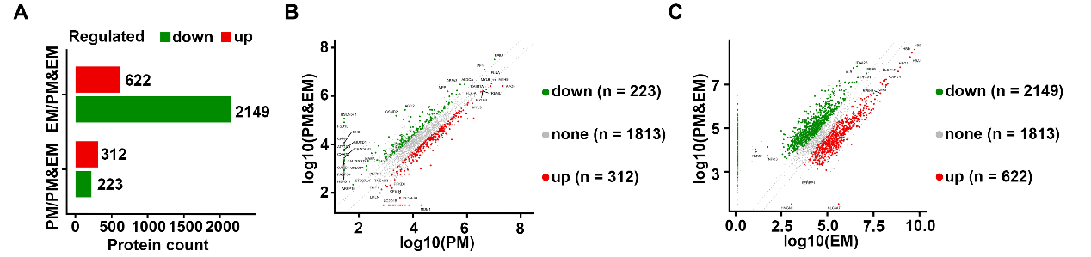
S2. A) Up and down regulated protein counts in PM vesicles vs. PM&EM vesicles and EM vesicles vs. PM&EM vesicles. B) Dot plot Up and down regulated protein counts in PM vesicles vs. PM&EM vesicles. C) Dot plot Up and down regulated protein counts in EM vesicles vs. PM&EM vesicles.

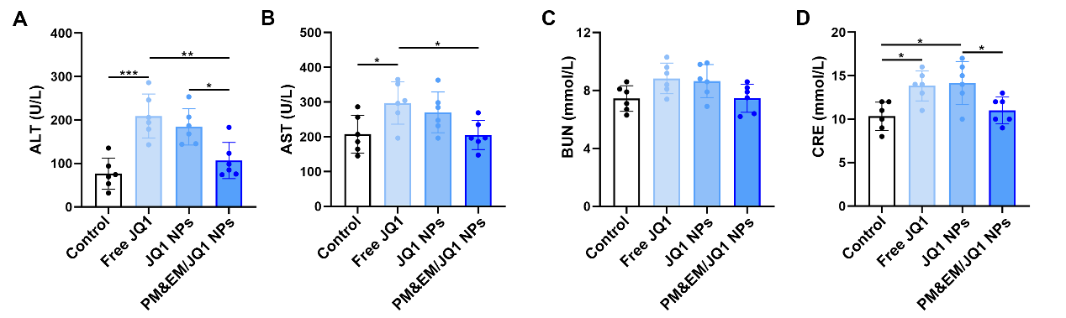
S3. Biochemical markers relevant to hepatic and kidney function (mean ± SD, n = 6 independent experiments). *p < 0.05, **p < 0.01, and ***p < 0.001, one-way ANOVA, Tukey’s multiple comparison test.

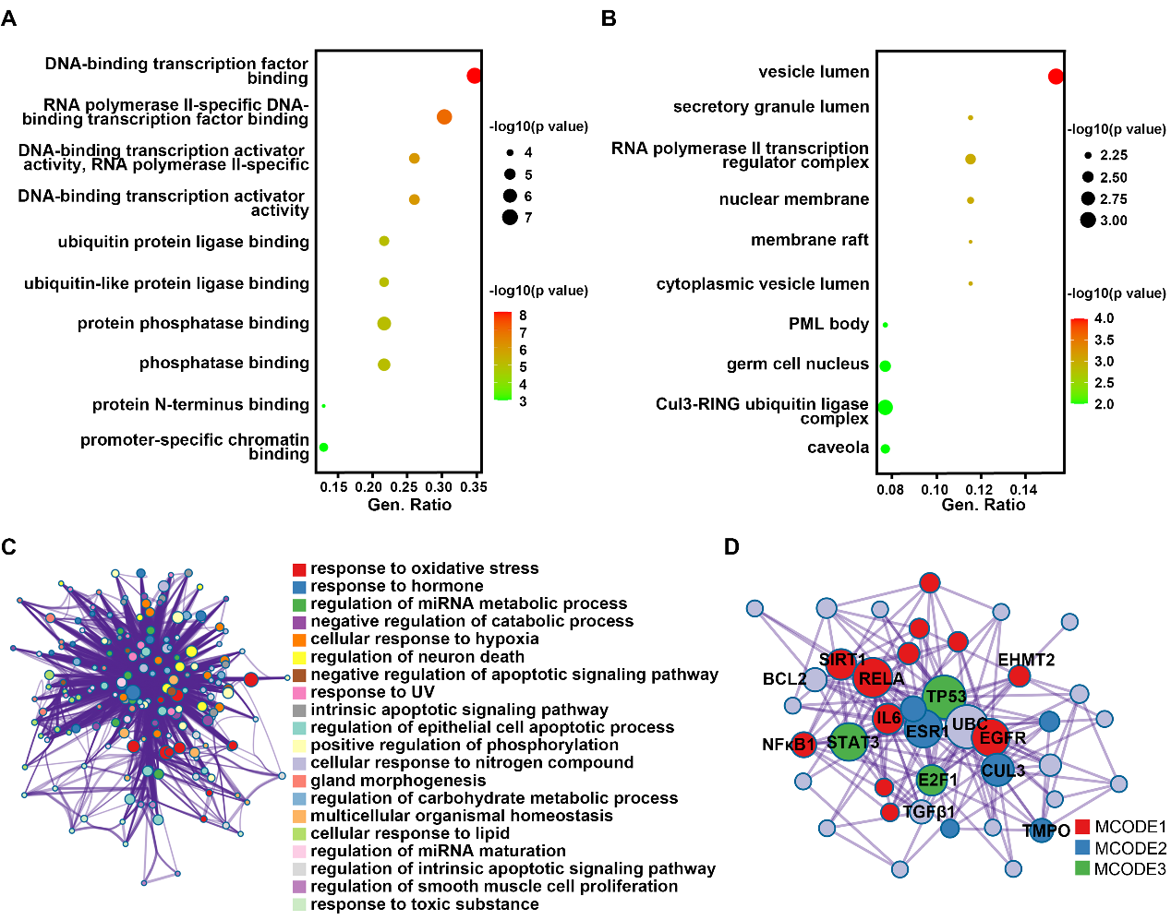
S4. A) and B) GO pathway enrichment analysis (Molecular Function, MF and Cellular Component, CC) of the common gene from different groups by R. C) GO pathway enrichment analysis of the common gene from different groups by Metascape. D) The key regulatory molecules of the significant enrichment pathways.

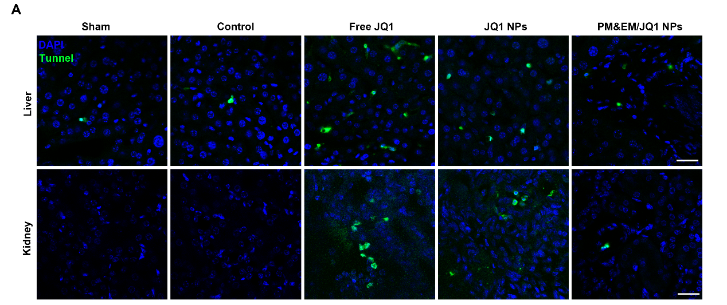
S5. Representative cross sections from liver and kidney stained with Tunnel staining, scale bar = 20 μm.

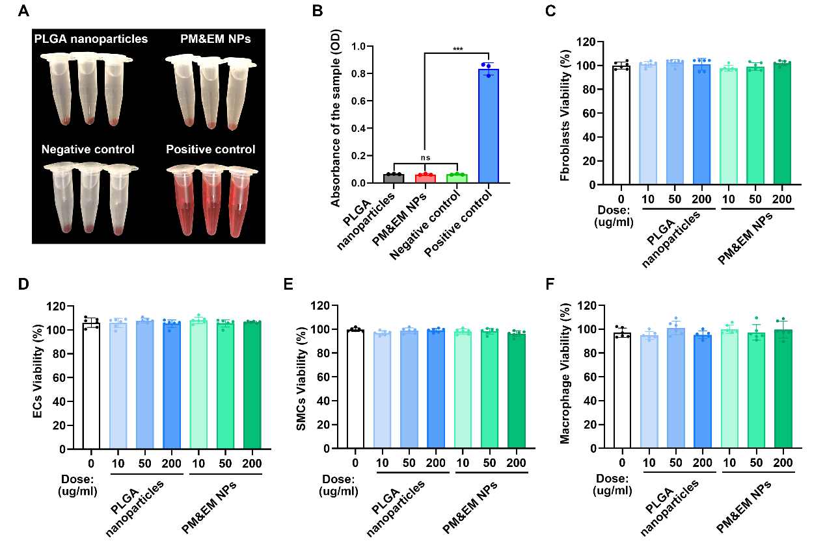
S6. Centrifuged red blood cells after incubation with PLGA NPs and PM&EM NPs. (C) The absorbance of the blood sample incubated with PLGA NPs and PM&EM NPs. measured at 540 nm (n = 3, mean ± SD). ***p < 0.001, n.s. = not significant, one-way ANOVA, Tukey’s multiple comparison test.

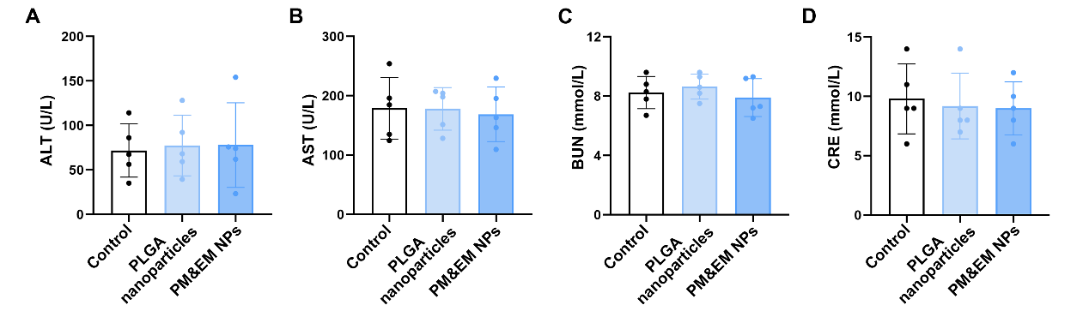
S7. Biochemical markers relevant to hepatic and kidney function (mean ± SD, n = 5 independent experiments). one-way ANOVA, Tukey’s multiple comparison test.

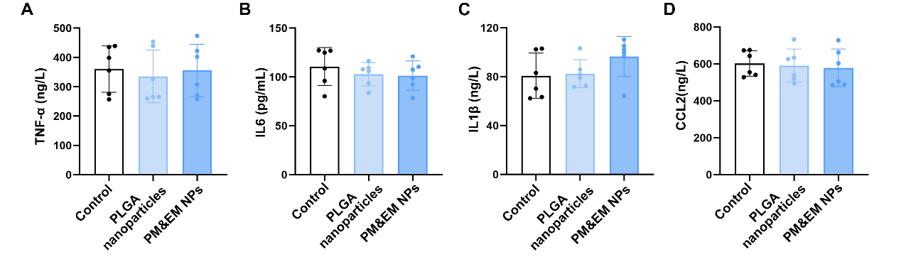
S8. Mouse serum cytokines relevant to inflammation. (mean ± SD, n = 5 independent experiments). one-way ANOVA, Tukey’s multiple comparison test.

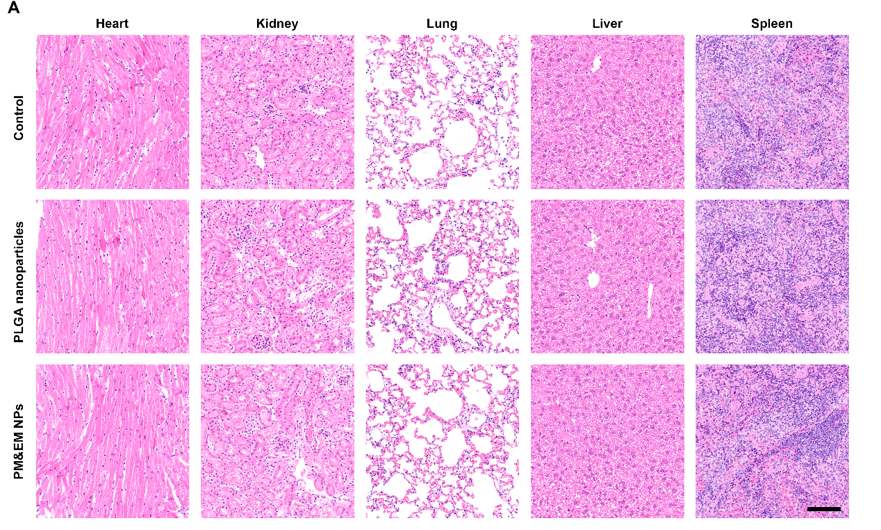
S9. H&E staining of the main organs collected from the mice treated with PLGA nanoparticles and PM&EM NPs (scale bar = 100 μm).

