Supplementary figures

Figure S1. Gating strategies to define SARS-CoV-2 RBD-specific B cells. (a) Lymphocytes were gated based on forward- and side-scatter and single cells were gated based on SSC-A andSSC-H. Total B cells were identified as CD19⁺cells. Memory B cells were identified as CD38⁻CD27⁺cells. spike specific B cells were identified based on binding to corresponding spike probes. (b)Particular samples of BTI group and non-BTI group at T1 timepoint.
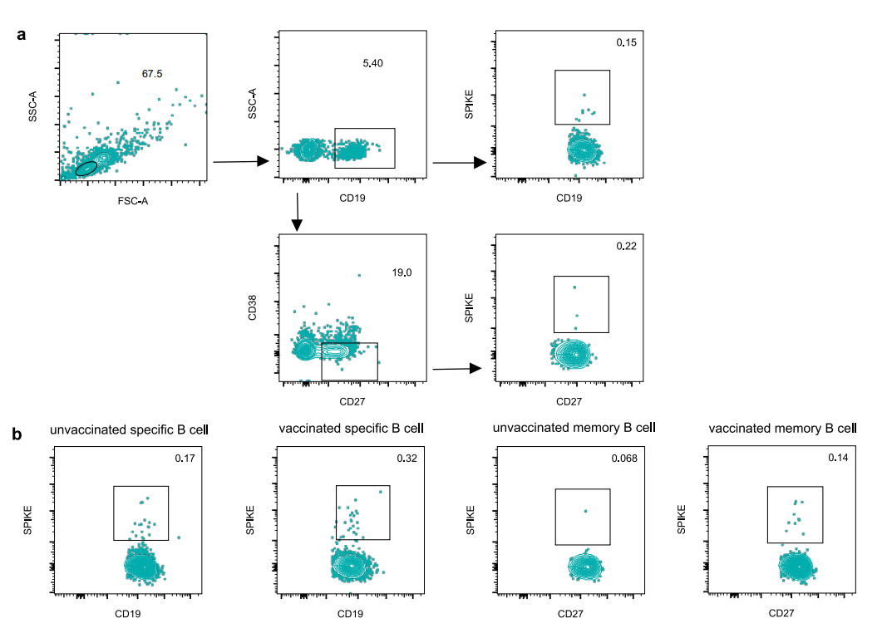
Figure S2 The Flow cytometry gating strategy to mark spike activated cTfh and specific memory cTfh. (a)Representative flow cytometry gating strategy of spike activated cTfh and specific memory cTfh. (b)Representative flow cytometry gating for activated cTfh and memory cTfh in BTI and non-BTI groups.
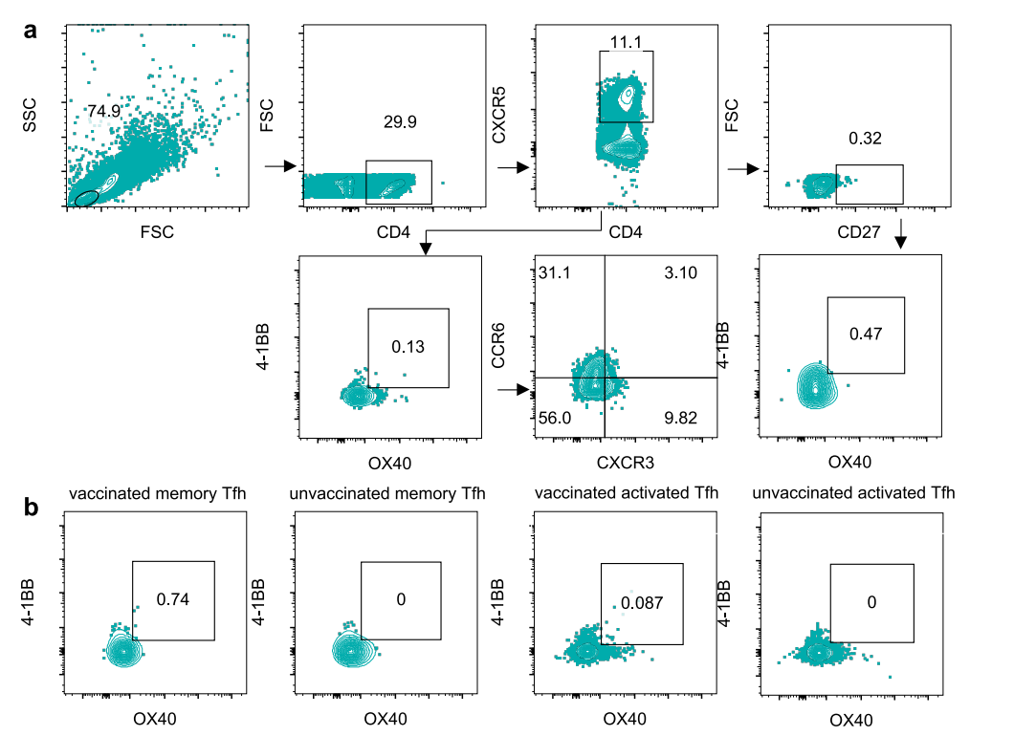

Figure S3. The Flow cytometry gating strategy to mark spike activated CD4+ T and specific memory CD4+ T cell. (a) Representative flow cytometry gating strategy of spike activated CD4+ T cell and specific memory CD4+ T cell. (b) Representative flow cytometry gating for activated CD4+ T cell and memory CD4+ T cell in BTI and non-BTI groups.
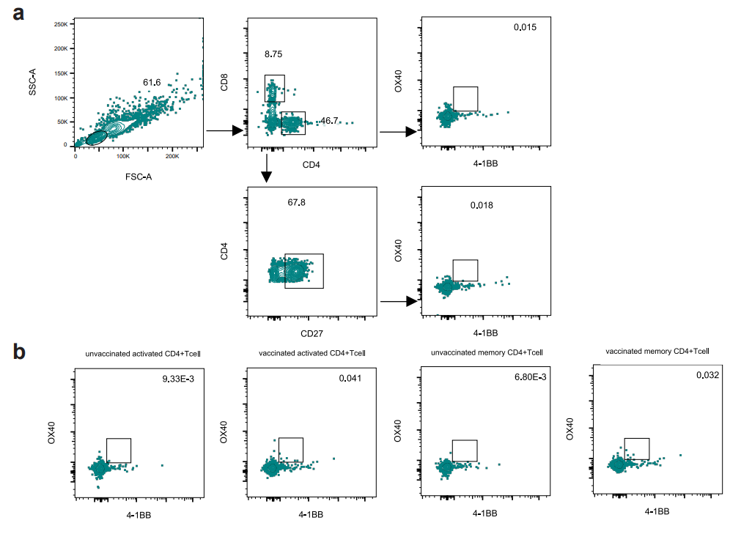
Figure S4. The Flow cytometry gating strategy to mark spike activated CD4+ T and specific memory CD8+ T cell. (a) Representative flow cytometry gating strategy of spike activated CD8+ T cell and specific memory CD8+ T cell. (b) Representative flow cytometry gating for activated CD8+ T cell and memory CD8+ T cell in BTI and non-BTI groups.
