Supplementary Material for
Chloride Electrode Composed of Ubiquitous Elements for High-Energy-Density All-Solid-State Sodium-Ion Batteries

Naoto Tanibata,* Naoki Nonaka, Keisuke Makino, Hayami Takeda, and Masanobu Nakayama
Department of Advanced Ceramics, Nagoya Institute of Technology, Gokiso, Showa, Nagoya, Aichi 466-8555, Japan

*Correspondence should be addressed to tanibata.naoto@nitech.ac.jp

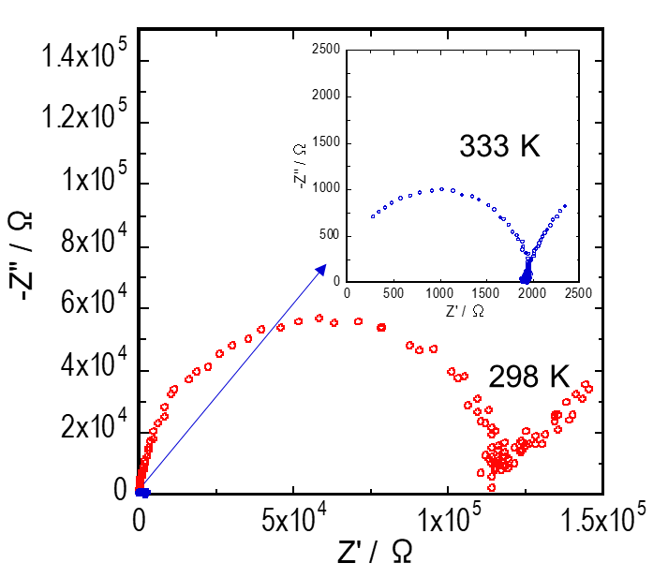
Supplementary Material 1 Investigation of Solid Electrolyte Materials for Separator Layer
Figure S1. AC impedance plots of NaFeCl₄ compressed pellet at 298 K and 333 K.
Figure S2 shows the characterization results of the NaFeCl₄ electrode using the Na₃PS₄ sulfide electrolyte, which is the most commonly used solid electrolyte in all-solid-state batteries (ASSBs). The charge–discharge curve (Figure S2a) reveals a low capacity of approximately 30% of the theoretical capacity (121.5 mAh g⁻¹), although it operated at a high average working potential of approximately 3.45 V (vs. Na/Na⁺). The impedance plot after charging and discharging (Figure S2b) shows two semicircles. The resistance R1 on the high-frequency side is the resistance of Na₁₀Sn₄/Na₃PS₄ obtained from the results of the Na₁₀Sn₄/Na₃PS₄ symmetric cell. R2 on the low-frequency side is the resistance of the Na₃PS₄/NaFeCl₄ interface because the capacitance is 8.3 × 10⁻⁶ F after discharge and 1.6 × 10⁻⁶ F after charge. The resistance is larger than that of Na₁₀Sn₄/Na₃PS₄, particularly after charging, showing a significant increase. This may be attributed to the poor oxidation resistance of Na₃PS₄ sulfide. Therefore, we fabricated and evaluated an ASSB using Na_{2.25}Y_{0.25}Zr_{0.75}Cl₆ as a separator, which reportedly exhibits the highest ionic conductivity in an oxidation-resistant chloride electrolyte.

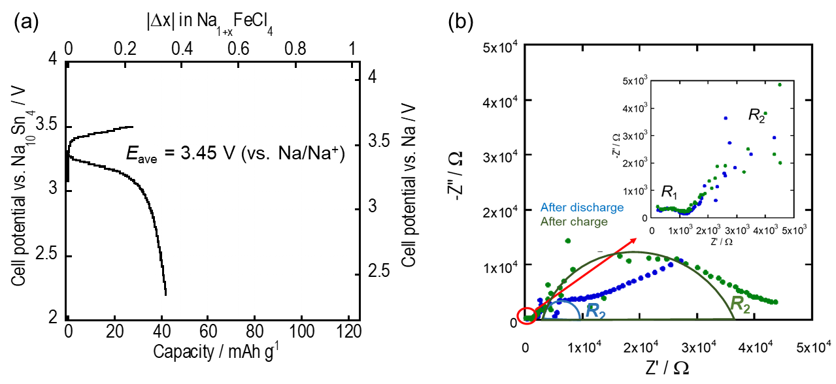Figure S2. Characteristics of all-solid-state sodium-ion batteries (Na₁₀Sn₄+AB | Na₃PS₄ | NaFeCl₄+KB) using a NaFeCl₄ electrode without an electrolyte (NaFeCl₄:KB = 90:10 wt.%) and with Na₃PS₄ sulfide solid electrolyte. (a) Constant current charge–discharge curves. (b) Impedance plots before and after the charge–discharge process.

In the charge–discharge curve (Figure S3), the average working potential was approximately 0.3 V lower, 3.2 V (vs. Na/Na⁺) when only Na_{2.25}Y_{0.25}Zr_{0.75}Cl₆ was used as the separator. The Na_{2.25}Y_{0.25}Zr_{0.75}Cl₆ electrolyte is known to increase the resistance with each cycle, even when Na–Sn alloys are used. These results suggest that the Na_{2.25}Y_{0.25}Zr_{0.75}Cl₆ electrolyte is less resistant to reduction than Na₃PS₄ and reacts with Na₁₀Sn₄. Therefore, in this study, we used an electrolyte bilayer all-solid-state cell with Na₃PS₄ electrolyte on the Na₁₀Sn₄ negative electrode side and Na_{2.25}Y_{0.25}Zr_{0.75}Cl₆ electrolyte on the NaFeCl₄ positive electrode side.
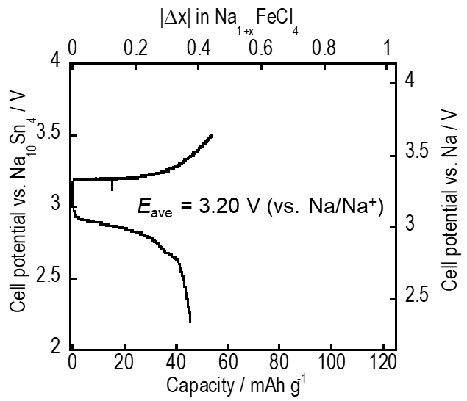
Figure S3. Constant current charge–discharge curves of the all-solid-state sodium-ion battery (Na₁₀Sn₄+AB | Na_{2.25}Y_{0.25}Zr_{0.75}Cl₆ | NaFeCl₄+KB) with NaFeCl₄ electrode without electrolyte (NaFeCl₄:KB = 90:10 wt.%) and chloride electrolyte Na_{2.25}Y_{0.25}Zr_{0.75}Cl₆.

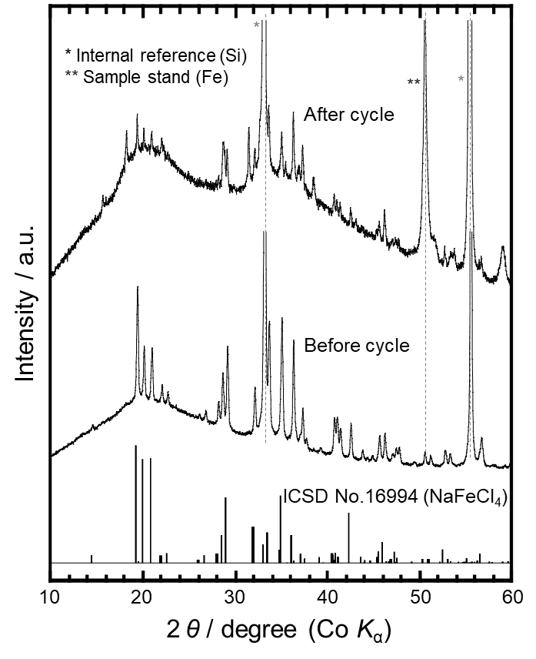
Figure S4. XRD patterns of the NaFeCl₄ electrode before and after charging.

