Supplementary Information

Method - LCA model
Data were collected for this analysis based on the system boundary defined in SI Fig. 7. All information obtained was readily available in the public domain. This was then coupled with existing datasets contained within the SSSD [76].
The SSSD has a variety of datasets on the production of different launchers, including Falcon-9, Ariane, and Soyuz-FG, carefully formed based on freely available industry data and interviews with a variety of relevant industrial stakeholders. Reusability of launchers was considered for Starlink, assuming that one launcher is capable of ten launches. As result, the production of just six launchers was considered, with refurbishment to bring each launcher back to launch grade considered as part of the Assembly, Integration and Testing (AIT) for each launch.
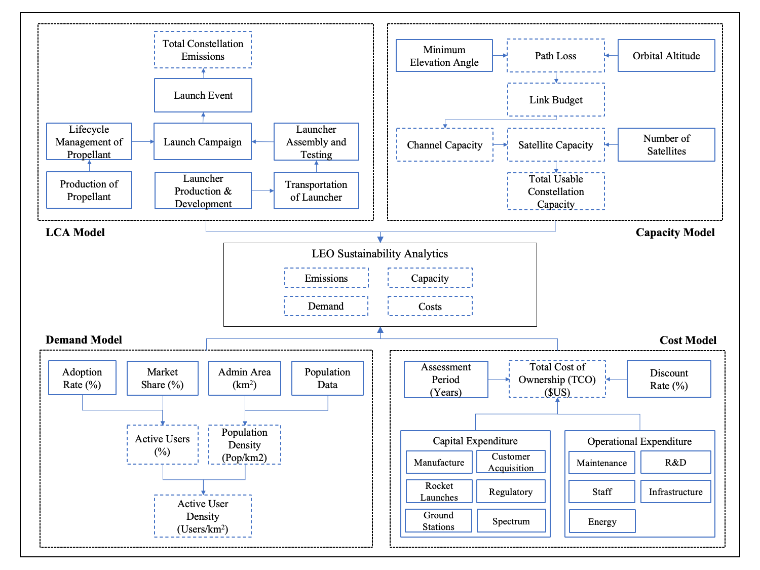
Fig. 7 | Method box diagram. Outlines environmental, capacity, demand and financial cost modules.
For the production of propellant, 480,000 kg of ammonium ice/ammonium perchlorate/hydroxyl terminated polybutadiene (solid), 184,900 kg of liquid oxygen/liquid hydrogen (cryogenic) and 10,000 kg of nitrogen tetraoxide (N₂O₄)/monomethylhydrazine (hypergolic) were considered per Ariane launch. In comparison, 488,370 kg of liquid oxygen/Rocket Propellant (RP-1) (kerosene) was considered per Falcon-9 launch, whilst 218,150 kg liquid oxygen/RP-1 (kerosene) and 7,360 kg of N₂O₄/Unsymmetrical dimethylhydrazine (hypergolic) were considered per Soyuz-FG launch. The SSSD contained datasets on the production of all of these propellant formulations, based on averaged industry data.
Transportation was calculated based on the distance to bring the launcher to the launch pad. In the case of Ariane, this was the distance covered by transoceanic ship from Europe to Kourou, French Guiana and then from the port to Kiruna, Sweden. For the Falcon-9, transportation via truck was considered from the SpaceX headquarters in California to Kennedy Space Centre in Florida. The transportation of the Soyuz-FG was modeled from Samara, Russia to the launch site in Baikonur, Kazakhstan via train.
Data for the AIT of each specific launcher, along with the management of the Storage, Containment, Handling and Decontamination (SCHD) of propellant (considered for the mass/volume of all launcher propellants for a launch campaign period of 21 days), were based on SSSD datasets, stemming from mean industry data [37]. The launch campaign was applied using an SSSD dataset consisting of generic data on energy consumption, water consumption and chemicals use for a 21-day launch campaign period, including test firings, directly applied for each launch event.
The baseline accounting data for the launch event were constructed on the mass and characterization factors of different exhaust products per launcher, as listed by [37]. However, these values do not include NIEs such as the influence of aluminium oxide, black carbon or water vapor, due to the high uncertainties concerning their characterization and the potential significance of their influence on LCIA results. Quantities and characterization factors for each of these particles were also included in the SSSD, based on recent research concerning emission quantities and their radiative forcings and ozone depletion potential [4], [42], [43], which was defined for a worst-case scenario (based on the black carbon radiative forcing potential of the aviation industry and expert opinion for ozone depletion) as shown in Table 2.
Launch Exhaust Product | Applied Characterization Factor
Launch Exhaust Product | Global Warming Potential (kg CO₂eq) | Ozone Depletion Potential (kg CFC-11eq)
Aluminium Oxide (kg) | 464 | 0.7
Black Carbon (kg) | 1160 | 0.7
Water Vapor (kg) | 33 | -
Table 2 | Launch exhaust products and their characterization factors not included in the launch event process due to their high uncertainty and sensitivity with respect to the LCIA results. All values are representative of a worst-case scenario.

Method - Capacity model
We estimate the downlink channel capacity of a satellite using the standard Friss Transmission equation (1), following [24].
$${\frac{C}{N}}_{\left(dB\right)}=EIRPD+\frac{G}{T}-P_{L}-L_{All}-10∙\log_{10}\left(k∙T\right)$$ | (1)
Where ${\frac{C}{N}}_{\left(dB\right)}$ is the Carrier-to-Noise Ratio, $EIRPD$ the effective isotropic radiated power density, $\frac{G}{T}$ the receiver antenna gain, $P_{L}$ the path loss, $L_{All}$ for all other losses, $k$ the Boltzmann constant, and $T$ the system temperature. The channel capacity ($C_{channel\left(Mbps\right)}$) is then estimated, as specified in equation (2), using modulation techniques, bandwidth per channel (${BW}_{ch\left(MHz\right)}$) and the corresponding spectral efficiency ($n_{eff}$).
$$C_{channel\left(Mbps\right)}={{BW}_{ch\left(MHz\right)} × n}_{{eff}_{\frac{C}{N}\left(dB\right)}}$$ | (2)
Where $n_{eff}$ is based on the $\frac{C}{N}$ estimated from equation (1) using a $\frac{C}{N}$ lookup table from the European Telecommunications Standards Institute (2020-08, page 53) documentation [77].
Furthermore, based on the number of beams ($b$), and number of channels ($ch$) used throughout each constellation, it is possible to estimate the satellite capacity ($C_{Sat\left(Mbps\right)}$), as per equation (3).
$$C_{Sat\left(Mbps\right)}=C_{channel\left(Mbps\right)}∙b∙ch$$ | (3)
Only approximately two thirds of the capacity of each constellation is capable of being used at any one time, as many satellites are underutilized when over oceans, or other uninhabited areas. Therefore, in accordance with the literature, the total usable constellation capacity ($C_{usable\left(Mbps\right)}$) is only approximately 50% of the total capacity [78], as stated in equation (4) (quantified elsewhere in the literature as the ‘useful capacity’ [79] or ‘sellable capacity’ [80]).
$$C_{usable\left(Mbps\right)}=C_{Sat\left(Mbps\right)}×N_{sat}×\frac{50}{100}$$ | (4)
Where $N_{sat}$ is the total number of satellites in each constellation.

Method - Demand model
Firstly, the number of subscribers that operational LEO operators have acquired by the final quarter of 2022 forms the low adoption scenario [49], [81]. In contrast, the higher scenario represents twice this existing number of adopted users, predicated on nearly half of the satellites of the planned constellations having been launched thus far [50]. For instance, in the United States alone, Starlink has already deployed 1 million user terminals in anticipation of having 5 million subscribers [82]. Finally, the baseline adoption scenario is set at the midpoint of the lower and upper scenarios. Next, the mean capacity per user ($C_{{Mbps}^{-user}}$) is then estimated by dividing the total usable constellation capacity ($C_{usable\left(Mbps\right)}$) by the number of subscribers for each low, baseline or high scenario, ${Sub}_{\left(low,baseline, high\right)}$ (equation 5).
$$C_{{Mbps}^{-user}}=\frac{C_{usable\left(Mbps\right)}}{{Sub}_{\left(low,baseline, high\right)}}$$ | (5)

The monthly traffic ($T_{mon\left(GB\right)}$) is estimated per user (in Gigabytes) for each of the constellations via equation (6).
$$T_{mon\left(GB\right)}=\frac{C_{{Mbps}^{-user}}×3600×30}{8000×\frac{bh}{100}}$$ | (6)

In which the mean capacity per user ($C_{{Mbps}^{-user}}$) is converted from seconds into the capacity per hour, by multiplying by 3600 (the number of seconds in an hour). Next, the resulting capacity per hour is then converted to a monthly value by taking into account the number of days (30 days in a month for this model). The result is then divided by 8,000 (accounting for the product of 1,000 and 8, for converting from Megabits Per Second to Gigabytes, and then divided by the percentage traffic taking place at the busiest hour of the day ($bh$), treated here as 20% based on Google empirical network data [83].
Finally, the mean subscribers per area, ${Sub}_{Area}$ (${Subscribers}^{{-km}^{2}}$) can be obtained by considering the satellite coverage area ($S_{cov\left({km}^{2}\right)}$) as defined in equation (7).
$${Sub}_{Area} ({Subscribers}^{{-km}^{2}})=\frac{{Sub}_{\left(low,baseline,high\right)}}{S_{cov\left({km}^{2}\right)}}$$ | (7)
$S_{cov\left({km}^{2}\right)}$ is given by equation (8).
$$S_{cov\left({km}^{2}\right)}=\frac{S_{n}}{E_{A\left({km}^{2}\right)}}$$ | (8)
Where $S_{n}$, is the number of satellites in the constellation and $E_{A\left({km}^{2}\right)}$, the area of the earth that the satellites cover.

Method - Cost model
The costs associated with launching and operating LEO satellite constellations are quantified by aggregating the initial capital expenditure ($Capex$) and annually recurring operational expenditure ($Opex$) for a period ($n$) of five years (representing the lifetime of each asset). The resulting total cost of ownership ($TCO$) forms the basis of estimating the discounted cost over this time period at a discount rate ($r$) of 5% [75], as per equation (9).
$$TCO=Capex+\sum_{t=0}^{n}{\frac{Opex}{{\left(1+r\right)}^{n}}}$$ | (9)
Next, both the capex and opex components are estimated using equations (10) and (11) respectively.
$$Capex=C_{Man.}+C_{Acq.}+C_{Lch}+C_{Gst}+C_{Spm}+C_{Reg.}$$ | (10)
$$Opex=C_{Fib}+C_{E}+C_{Staff}+C_{R\&D}+C_{Maint}$$ | (11)
Where $C_{Man.}$ is the satellite manufacturing, $C_{Acq.}$ subscriber acquisition, $C_{Lch}$ satellite launch, $C_{Gst}$ ground station, $C_{Spm}$ spectrum, $C_{Reg}$ regulation fees, $C_{Fib}$ fiber infrastructure, $C_{E}$ ground station energy, $C_{Staff}$ staff, $C_{R\&D}$ research and development and $C_{Maint}$ maintenance costs.
The resulting per user cost for capex (${Cap}_{user}$), opex (${Op}_{user}$), and TCO (${TCO}_{user}$), are obtained as follows in equations (12), (13) and (14).
$${Cap}_{user}=\frac{Capex}{{Sub}_{\left(low,baseline, high\right)}}$$ | (12)
$${Op}_{user}=\frac{Opex}{{Sub}_{\left(low,baseline, high\right)}}$$ | (13)
$${TCO}_{user}=\frac{TCO}{{Sub}_{\left(low,baseline, high\right)}}$$ | (14)

Finally, the SCC (${SC}_{carbon}$) is calculated by multiplying the total emissions due to climate change ${Total Emissions}_{cc\left(t\right)}$, by US$ 185 per tonne as established in [64], and specified in equation (15).
$${SC}_{carbon}={Total Emissions}_{cc\left(t\right)}×{185}_{US\$}$$ | (15)

Method - Uncertainty
A proportion of inputs that affect the demand, capacity, and cost estimations are treated as uncertain parameters, when a lack of evidence is available to correctly parameterize these values. For example, the capacity calculation has various uncertain parameters including the satellite altitude, receiver gain, atmospheric and other losses. Future demand adoption of satellite broadband services is unknown. Moreover, investment uncertainty is captured for various financial cost parameters where no openly provided data are available, including the cost of satellite launches, ground stations, maintenance, satellite manufacturing and staff expenses. All parameter values utilized in the uncertainty analysis are provided in Table 3, with the data sources provided in Table 4.
Type | Parameter | Kuiper |  |  | OneWeb |  |  | Starlink |  |  | Unit | UQ
Type | Parameter | Low | Baseline | High | Low | Baseline | High | Low | Baseline | High | Unit | UQ
Capacity | Altitude | 600 | 605 | 610 | 1190 | 1195 | 1220 | 540 | 545 | 550 | km | Y
Capacity | Atmospheric Losses | 7 | 10 | 13 | 7 | 10 | 13 | 13 | 10 | 7 | dB | Y
Capacity | Receiver Gain | 26 | 31 | 36 | 25 | 30 | 35 | 25 | 30 | 35 | dB | Y
Demand | Subscribers | 1.5 | 2.5 | 3.5 | 0.5 | 0.8 | 1 | 2.5 | 3.5 | 4.5 | M | Y
Cost | Satellite Launch | 116 | 180 | 244 | 86 | 150 | 214 | 186 | 250 | 314 | US$M | Y
Cost | Ground Station | 26 | 33 | 40 | 16 | 20 | 24 | 39 | 49 | 59 | US$M | Y
Cost | Satellite Manufacturing | 0.4 | 0.4 | 0.4 | 0.4 | 0.4 | 0.4 | 0.25 | 0.25 | 0.25 | US$M | Y
Cost | Spectrum | 125 | 125 | 125 | 125 | 125 | 125 | 125 | 125 | 125 | US$M | N
Cost | Regulation Fees | 7.2 | 7.2 | 7.2 | 7.2 | 7.2 | 7.2 | 7.2 | 7.2 | 7.2 | US$M | N
Cost | Fiber Infrastructure | 2.5 | 2.5 | 2.5 | 3.6 | 3.6 | 3.6 | 3.6 | 3.6 | 3.6 | US$M | N
Cost | Ground Station Energy | 15 | 15 | 15 | 3.3 | 3.3 | 3.3 | 3.3 | 3.3 | 3.3 | US$M | N
Cost | Subscriber Acquisition | 50 | 50 | 50 | 50 | 50 | 50 | 50 | 50 | 50 | US$M | N
Cost | Staff Costs | 243 | 253 | 263 | 197 | 207 | 217 | 290 | 300 | 310 | US$M | Y
Cost | Research Development | 60 | 60 | 60 | 60 | 60 | 60 | 60 | 60 | 60 | US$M | N
 | Maintenance | 19 | 22 | 25 | 15 | 18 | 21 | 23 | 26 | 29 | US$M | Y
Table 3 | Uncertainty inputs. Capacity, demand and cost parameters for the three constellations (US$M is Millions of US dollars) (UQ refers to an Uncertain Quantity).

Method - Data availability
All the data used in the model are specified in Table 4.
Model Part | Data Description | Reference
Capacity | Starlink Federal Communications Commission (FCC) Filing | [25]
Capacity | Kuiper FCC Filing | [27]
Capacity | OneWeb Filing | [26]
Capacity | Channel Encoding Documentation | [77]
Emissions | Falcon-9 Technical Details | [84]
Emissions | Soyuz-FG Technical Details | [39]
Emissions | Ariane Technical Details | [40]
Emissions | Life-Cycle Assessment Dataset | [76]
Demand | Number of subscribers | [82]
Cost | Cost Estimates | [74], [85]
Table 4 | Data sources for the model.

Additional Results
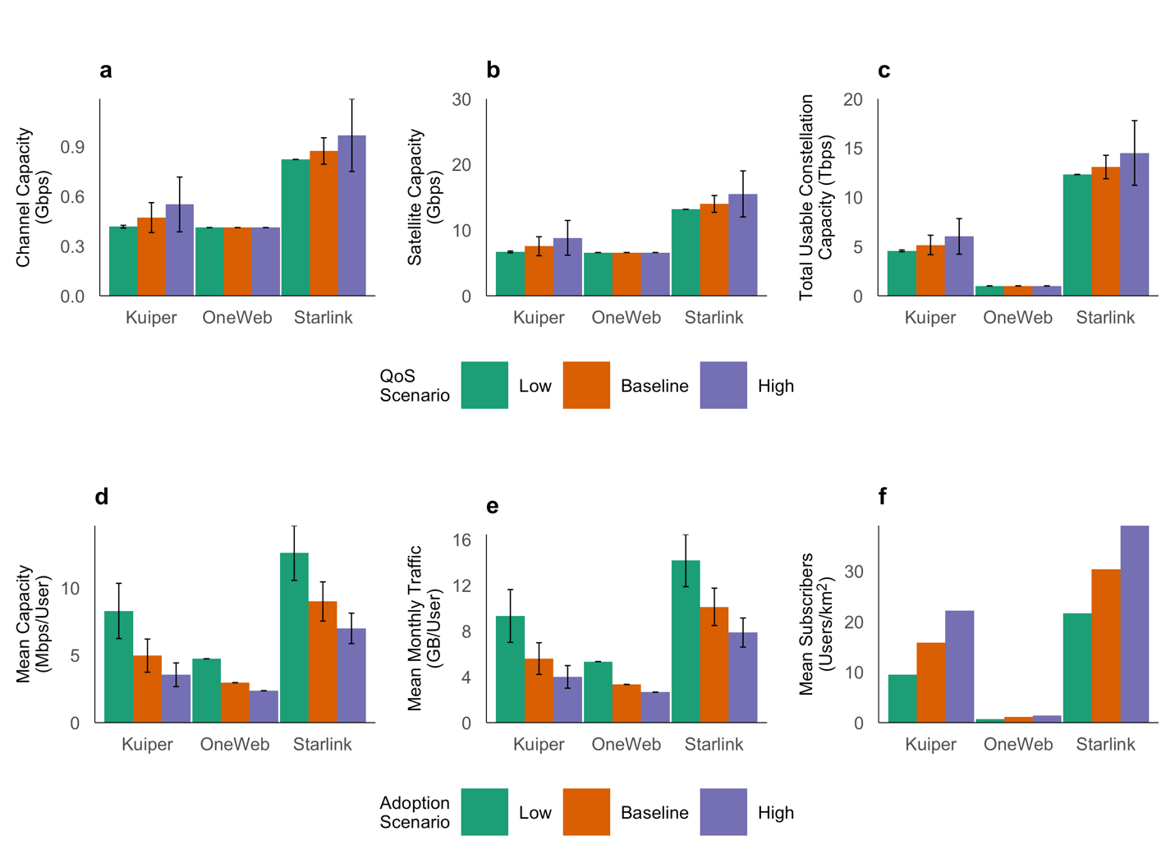
Fig. 8 | Capacity results for different QoS scenarios in a, b, c, d and e (CIs represent uncertainty in QoS due to variation in design parameters including satellite altitude, receiver gain and atmospheric losses at 1 SD. level). a, estimated channel capacity, b, estimated single satellite capacity, c, estimated total usable constellation capacity. Per user results for different user/subscriber scenario in d, e and f. d, mean capacity per user, e, mean monthly traffic spread over the projected 5-year lifespan of the constellations, f, mean subscribers per area.

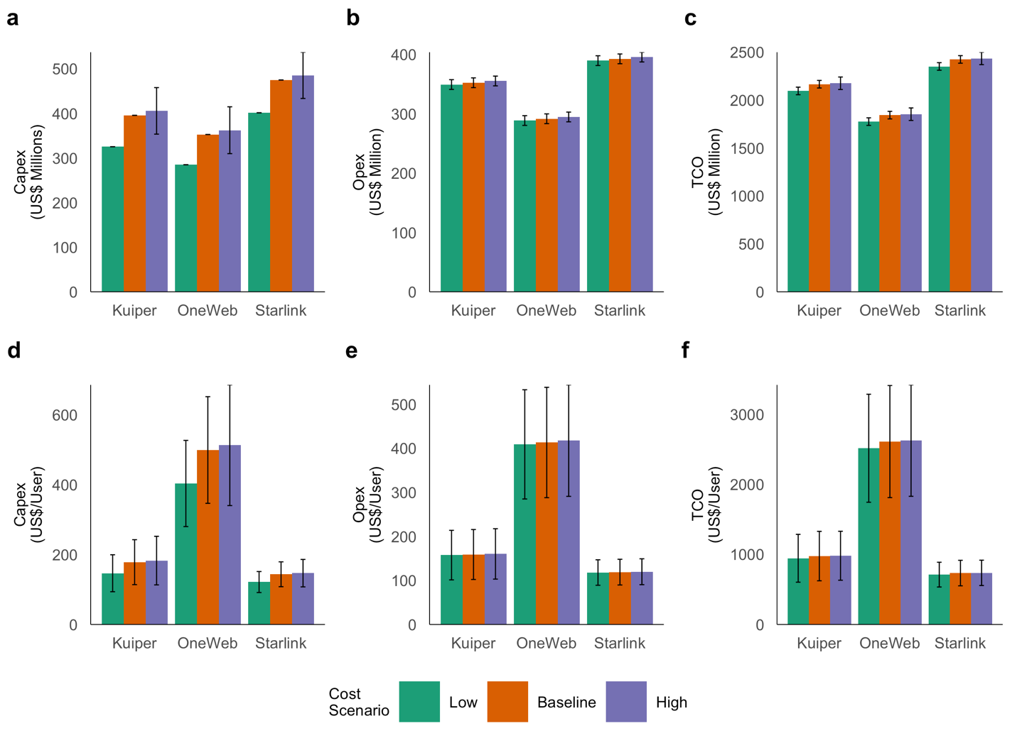
Fig. 9 | Constellation financial costs. a, total capital expenditure (Capex) (CIs 1 SD.), b, total operating expenditure (opex) (CIs 1 SD.), c, total cost of ownership (CIs 1 SD.), d, capex per user (CIs 1 SD.), e, opex per user (CIs 1 SD.), f, total cost of ownership per user (CIs 1 SD.).

