Supplementary Information

AZD2014, a dual mTOR inhibitor, attenuates cardiac hypertrophy in vitro and in vivo

Byung-Hyun Cha ª, Minjin Jung ª, Angela S. Kim ª, Victoria C. Lepak ^{b}, Brett A. Colson ^{b}, David A. Bull ª, Youngwook Won ª*

ª Division of Cardio-Thoracic Surgery, Department of Surgery, University of Arizona College of Medicine, Tucson, AZ, 85724, USA.

^{b} Department of Cellular & Molecular Medicine, University of Arizona College of Medicine, Tucson, AZ, 85724, USA

*Correspondence and requests for materials should be addressed to Dr. Y.Won. (email: youngwookwon@email.arizona.edu)

This Supplemental file includes:
Figure S1, Figure S2, and Figure S3

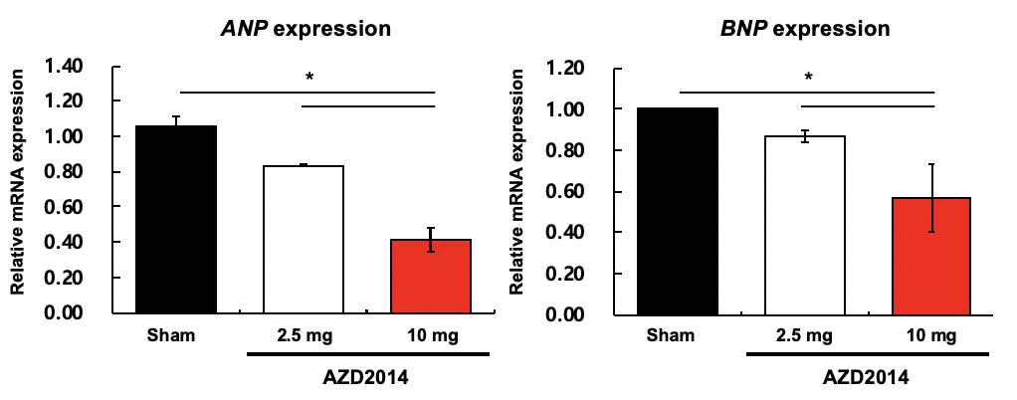
Fig. S1. mRNA expression of atrial natriuretic peptide (ANP) and B-type natriuretic peptide (BNP) from Mybpc3-KO mouse model following AZD2014 intraperitoneal (i.p.) administration. The mRNA expression levels of cardiac hypertrophy markers ANP and BNP in hearts were determined by qRT-PCR. #, p > 0.05; *, p < 0.05. n = 3.

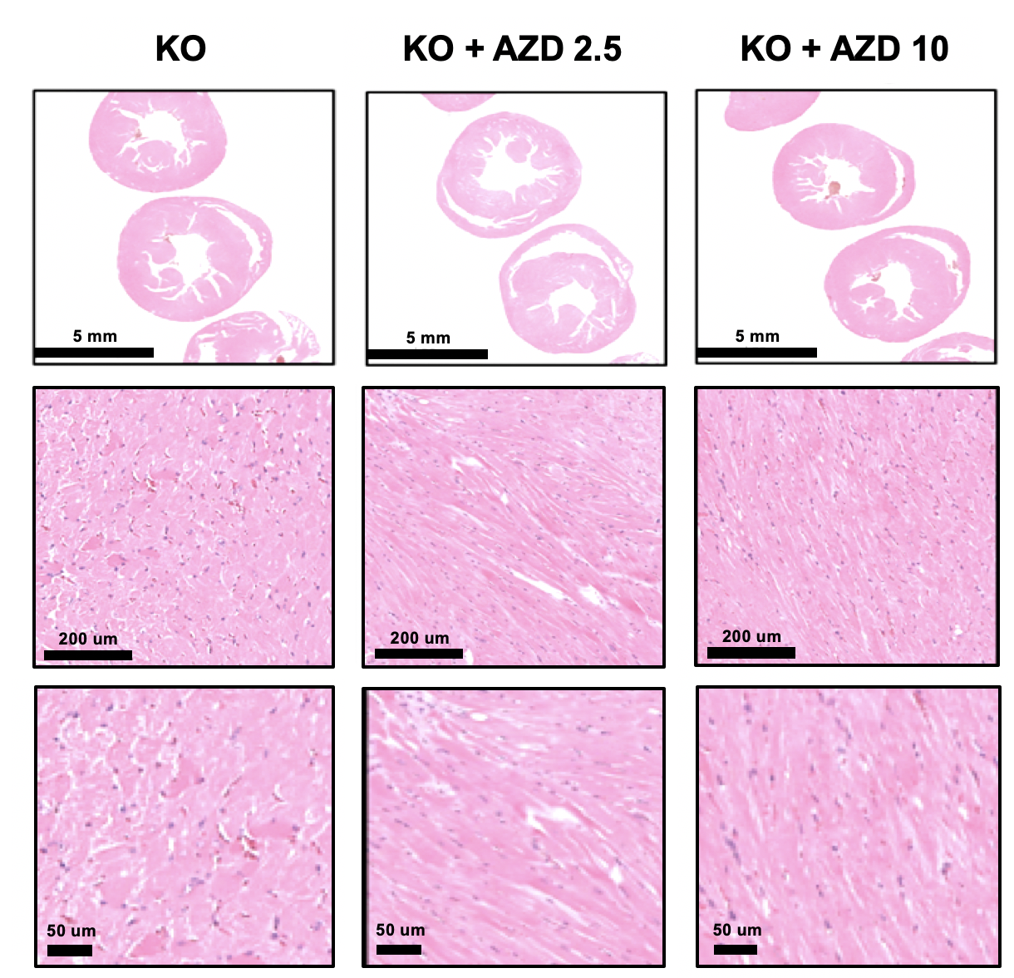

Fig. S2. Representative micrographs of H&E from Mybpc3-KO mouse model via i.p. administration of 2.5 mg and 10 mg AZD2014 (Red indicates cytoplasm; Blue indicates nucleus).

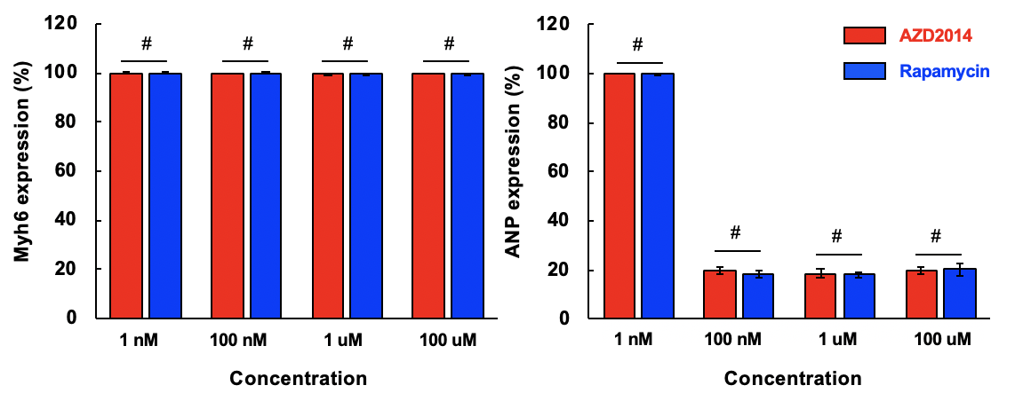
Fig. S3. The protein expression of Myh6 and ANP on phenylephrine (PE)-induced cardiomyocyte by treatment of AZD2014 and rapamycin. Cardiomyocytes were treated with or without PE (100 μM) and cultured with AZD2014 and rapamycin in a dose-dependent manner for 5 days. The protein expression of Myh6 and ANP of AZD2014 or rapamycin-treated cardiomyocytes on post-PE-induced hypertrophy were determined by FACS. #, p > 0.05. n = 3.

