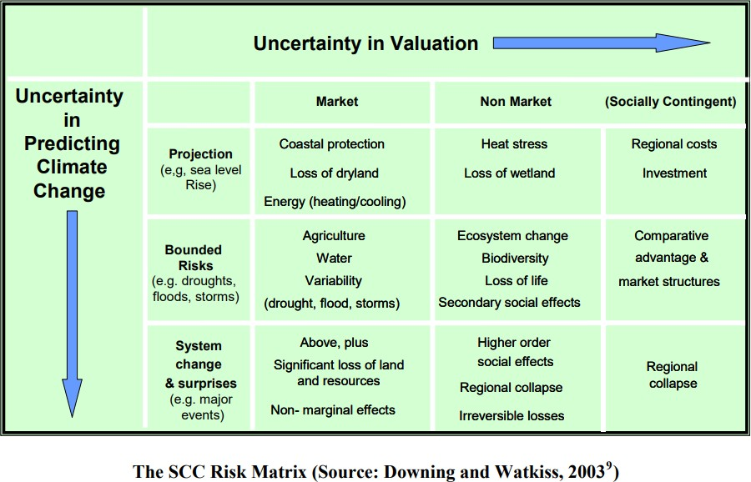

Figure 1: The Social Cost of Carbon Risk Matrix (Downing & Watkiss, 2003;
Downing et al., 2005; Watkiss et al., 2006)

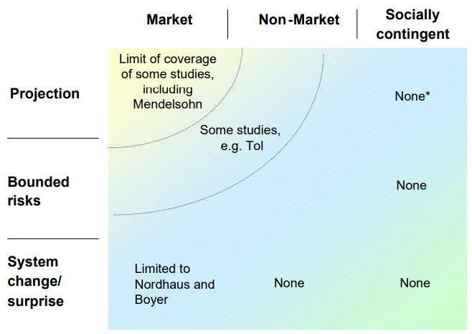

Figure 2: The coverage of SCC studies against the Risk Matrix (Watkiss et al., 2006)

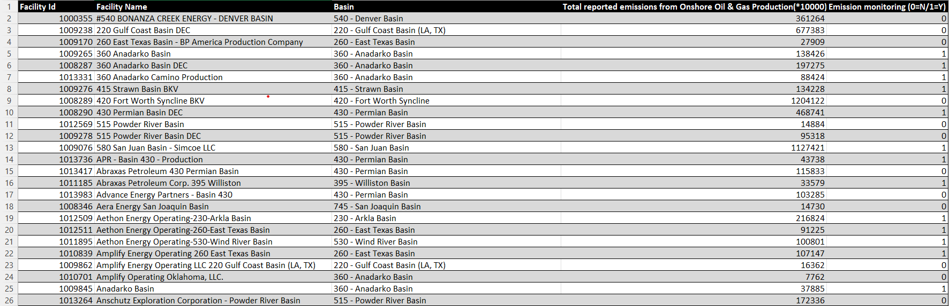
Figure 3: Summary of Onshore Oil & Gas Production Emissions Data

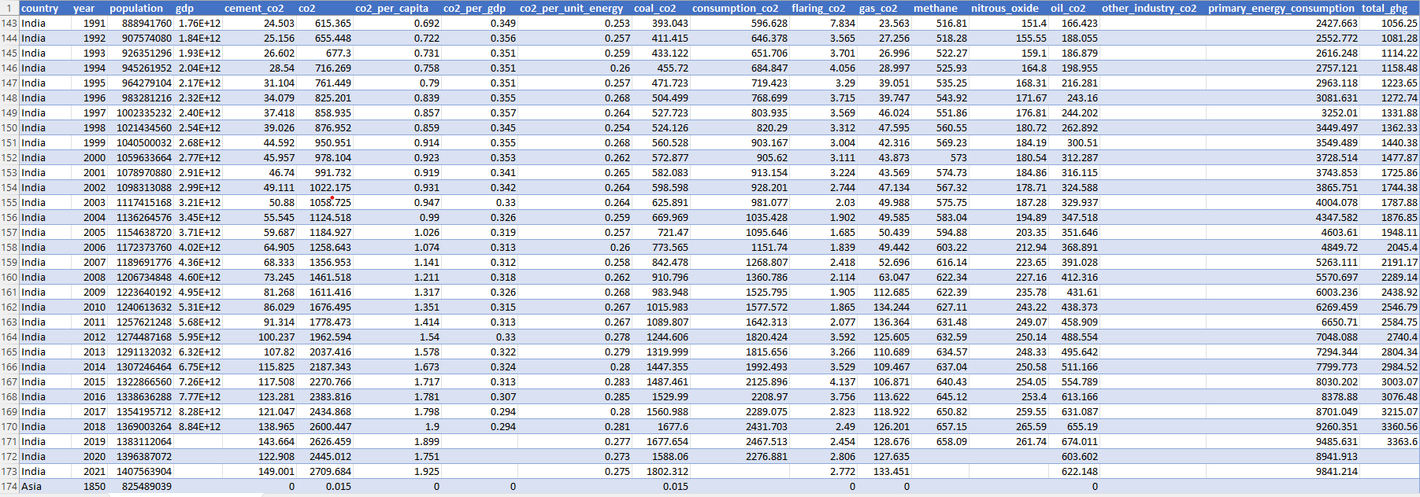
Figure 4: Summary of Emissions and Energy Data Across India, China, and Asia

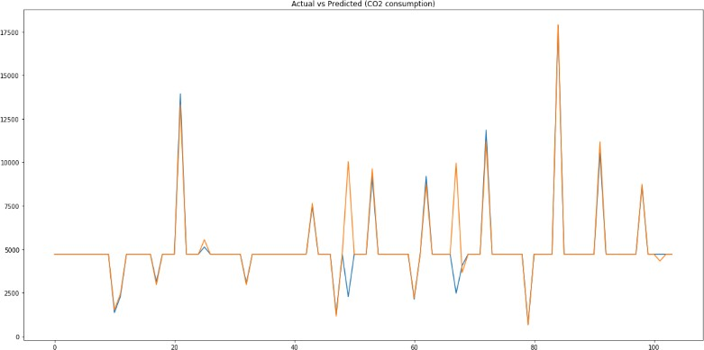
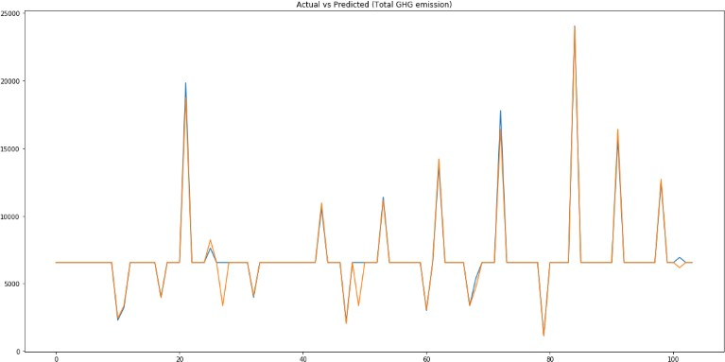

Figure 5: Actual VS Predicted (Total GHG emissions) Figure 6: Actual VS Predicted (CO₂ consumption)

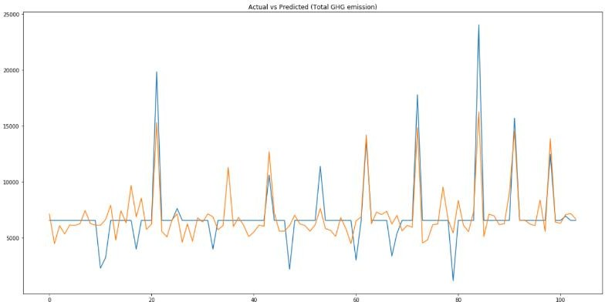
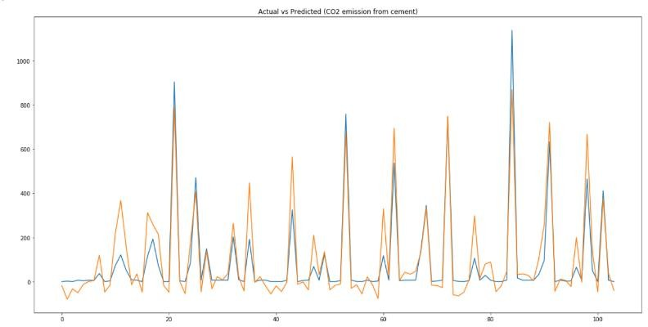
Figure 7: Actual VS Predicted (CO₂ emissions from cement) Figure 8: Actual VS Predicted (Total GHG emissions)

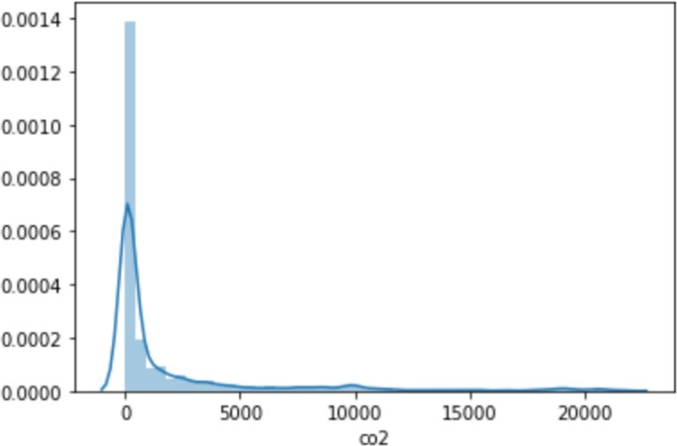
Total CO2 emissions distribution (using Kernel-Destiny estimation plot)

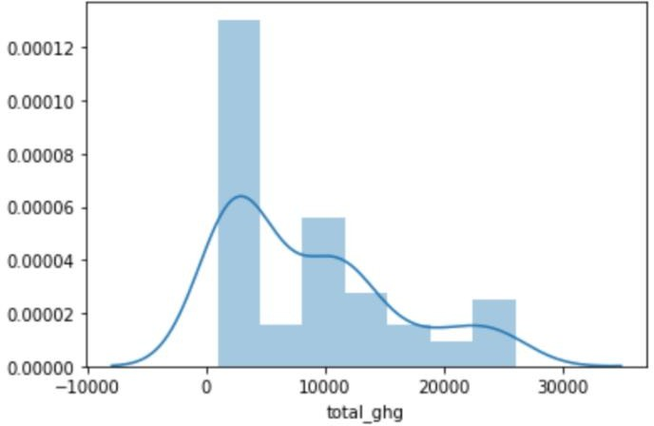
Figure 9: Total GHG emissions distribution Figure 10: Total CO2 emissions distribution
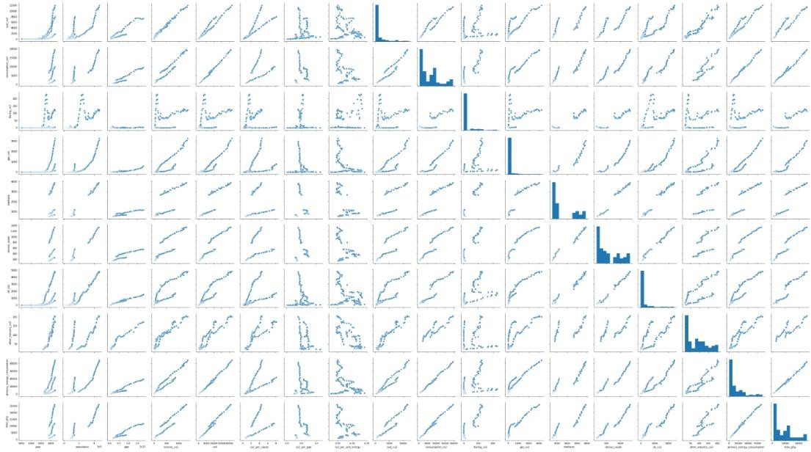
Figure 11: Trend Graphs plotted for visualizing dependencies of all attributes on each other.

