Supplementary Material

Search Strategy
‘home delivery’ OR ‘home management’ OR ‘home-based management’ OR ‘presumptive home treatment’ OR ‘home treatment’ OR ‘treated at home’ OR ‘followed up at home’

AND

‘malaria’ OR malarial infection* OR malaria parasite* OR febrile illness* OR ‘Plasmodium’ OR ‘uncomplicated malaria’ OR ‘uncomplicated Plasmodium falciparum malaria’ OR ‘uncomplicated P falciparum malaria’ OR ‘uncomplicated P. falciparum malaria’

AND

‘artemisinin derivatives’ OR ‘artemisinin antimalarials’ OR ‘artemisinin compounds’ OR ‘artemisinin class’ OR ‘artemisinin’ OR ‘artemisinins’ OR ‘artemisinin-based treatment’ OR ‘artemisinin-based treatments’ OR ‘artemether-lumefantrine’ OR artemisinin combination* OR ‘artemisinin-based combination therapy’ OR ‘artemisinin-based combination therapies’ OR ‘artemether-lumefantrine plus amodiaquine’ OR ‘triple artemisinin-based combination therapy’ OR ‘triple artemisinin-based combination therapies’ OR ‘triple antimalarial combination therapies’ OR ‘dihydroartemisinin-piperaquine’ OR ‘chloroquine’ OR ‘quinine’ OR ‘quinine-based regimen’ OR ‘quinine-based regimens’ OR ‘quinine-based treatment’ OR ‘quinine-based treatments’ OR ‘primaquine’ OR ‘atovaquone-proguanil’ OR ‘artesunate-amodiaquine’ OR ‘artesunate-mefloquine’ OR ‘artesunate-clindamycin’ OR ‘artenimol-piperaquine’ OR ‘artesunate-atovaquone-proguanil’ OR ‘artesunate-sulfadoxine-pyrimethamine’ OR ‘artesunate’ OR ‘mefloquine’ OR ‘atovaquone’ OR ‘proguanil’
Supplementary Figure 1: Pooled effect estimates of home management of malaria with artesunate-amodiaquine compared to home management of malaria with other antimalarial drug combinations on risk of experiencing adverse drug events.

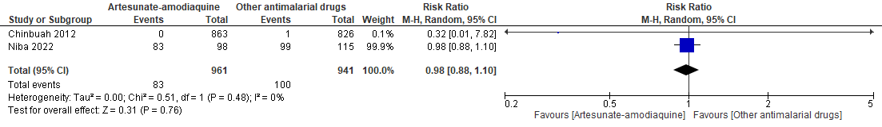

Supplementary Figure 2: Pooled effect estimates of home-based intermittent preventive treatment compared with home-based management of malaria on risk of developing severe malaria.

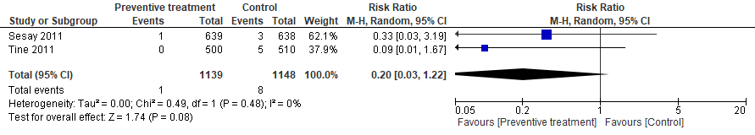

Supplementary Figure 3: Pooled effect estimates of home management of malaria with Argemone mexicana decoction compared to home management of malaria with artesunate-amodiaquine on clinical outcomes.

- Severe malaria in children aged ≤5 years
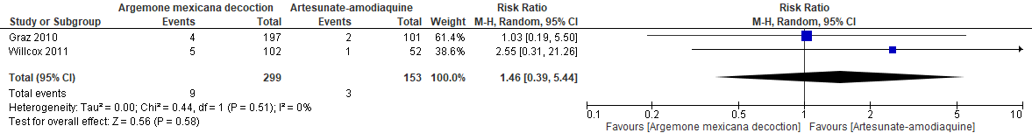

- Parasitaemia
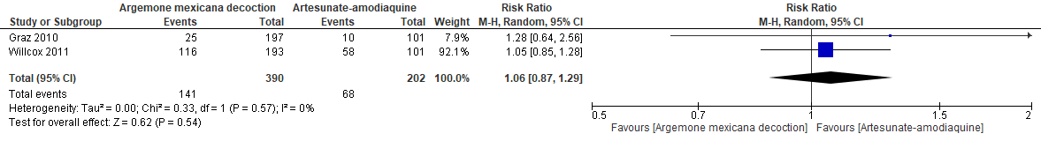

- Need for second-line antimalarial treatment
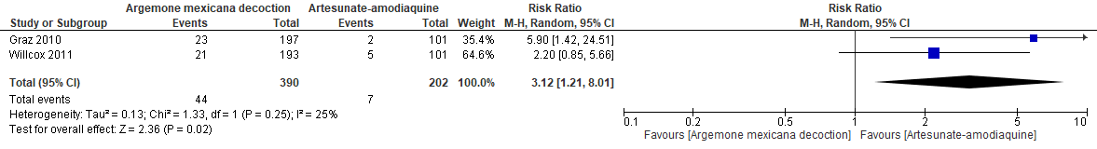

- Serious adverse events
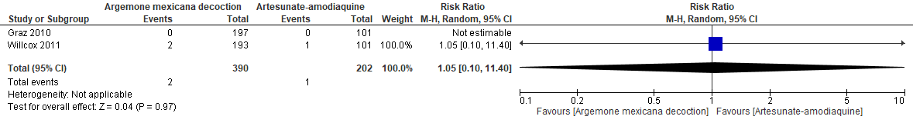

Supplementary Figure 4: Assessment of risk of bias in observational studies based on ROBINS-I tool.
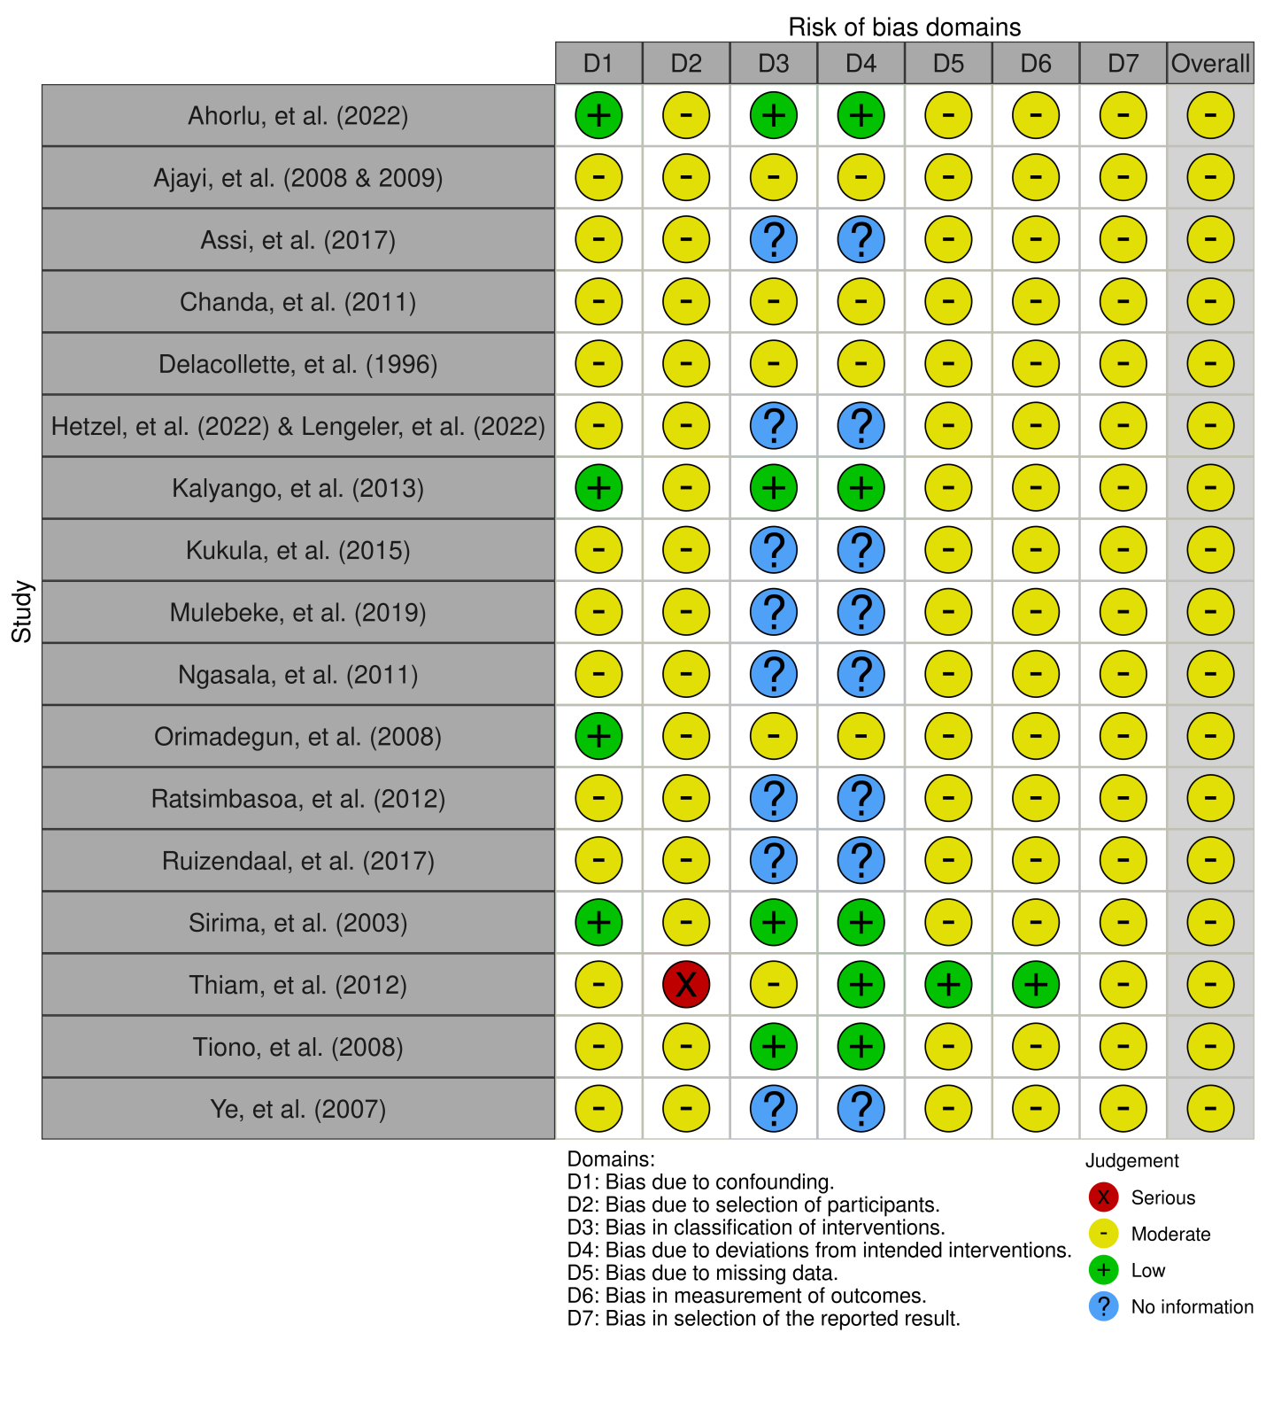

Supplementary Figure 5: Assessment of risk of bias in individually-randomised controlled trials based on RoB 2.0 tool.
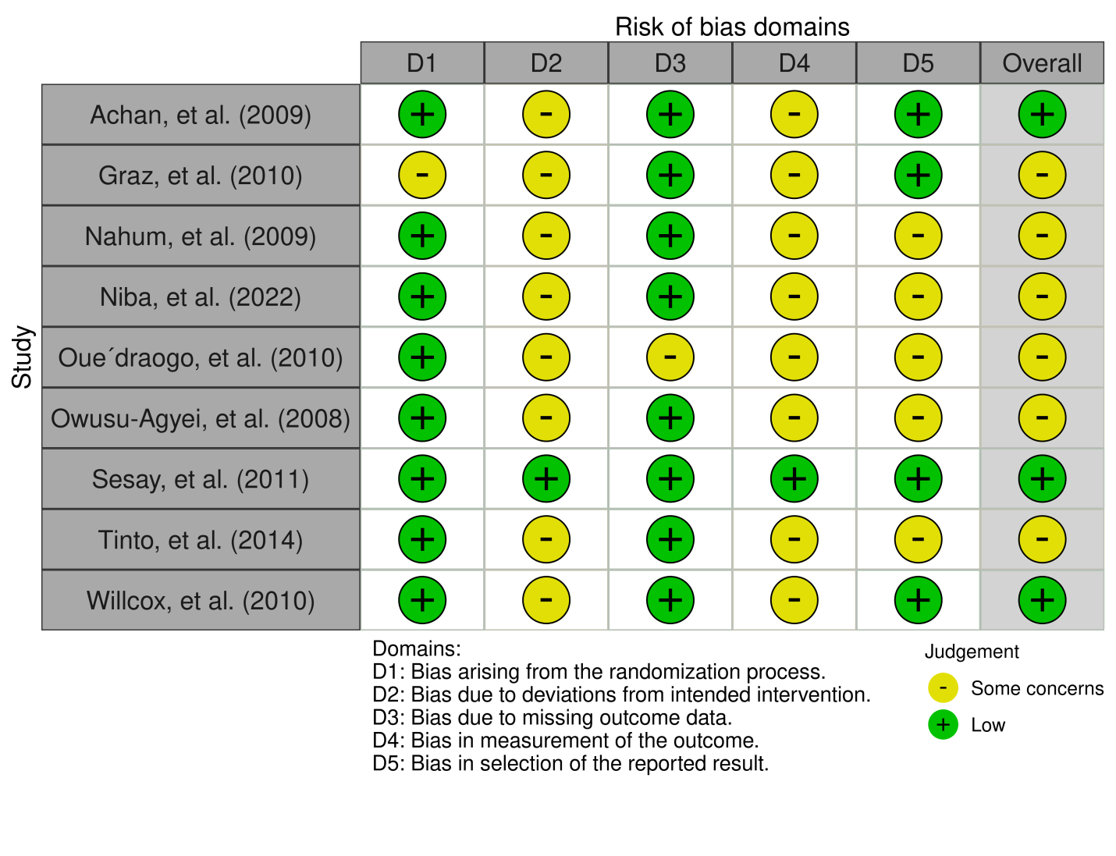

Supplementary Figure 6: Assessment of risk of bias in cluster-randomised controlled trials based on RoB 2.0 CRT tool.
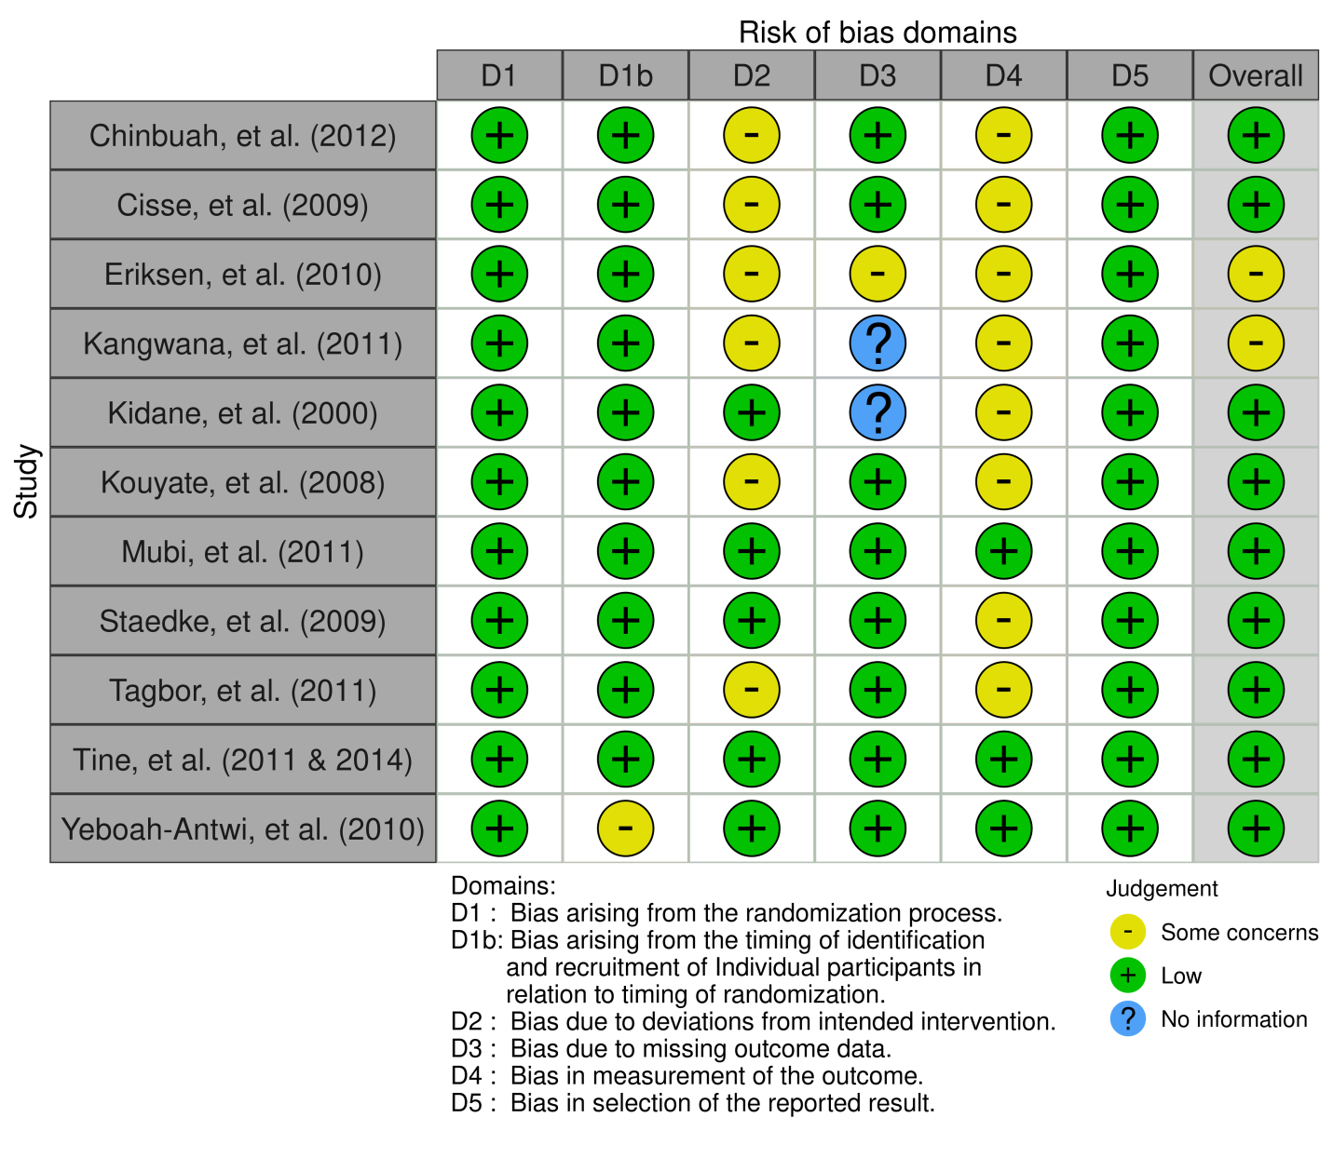

Supplementary Table 1: Summary of included studies.
Study (year), country | Study population | Implementation period | Antimalarial drugs | Home-based care delivery | Main findings
Before-after (pre-post) studies
Adeoti, et al. (2020), Nigeria [71]  [Rural] | Children under 5 years of age with febrile illness (N=1,646) | December 2013 to October 2015 | Artemether-lumefantrine (uncomplicated malaria) or rectal artesunate (severe malaria) | Community health workers recognised early signs and symptoms of malaria, performed rapid diagnostic testing, administered treatment, and counselled caregivers following treatment initiation. | Of the 1,646 children treated, 98.5% received the correct treatment based on their rapid diagnostic test results.
Ahorlu, et al. (2009 & 2011), Ghana [33, 73]  [Rural] | Children aged 6 to 60 months with suspected febrile malaria (N=365) | July 2007 to March 2009 | Artesunate-amodiaquine | Community assistants delivered intermittent preventive treatment of malaria every 4 months with direct observation and follow-up on Day 1, 2, and 3 after treatment. | Overall prevalence of malaria infection decreased from 25.3% at baseline to 1.0% after 2 years. Marked reduction in the parasite prevalence was shown in home delivery of intermittent preventive treatment. A significant reduction was observed in the proportions of febrile children, decreasing form 13.8% at baseline to 2.1% after 2 years. There was no report of serious adverse drug events. No caretaker had lost a child during the 24-month of research implementation.
Ajayi, et al. (2008), Ghana,  Nigeria, and Uganda [34, 72]  [Rural] | Children aged 6 to 59 months with a complaint of fever (N=1,740) | - | Artesunate-amodiaquine (Ghana) or artemether-lumefantrine (Nigeria and Uganda) | In Ghana and Nigeria, caregivers were given antimalarial drugs and administration instructions, following which caregivers treated their children at home without supervision. In Uganda, the first dose of antimalarial drugs was administered to the child in the presence of a community medicine distributor and subsequent doses were administered unsupervised. Home visits were conducted to remind caregivers to administer the medication. | Of 1,740 children enrolled, 68.3% had patent parasitaemia prior to treatment. The cure rate was 97.2% in Uganda, 90.9% in Nigeria, and 91.4% in Ghana. 94.3% of children were reported to comply to correct treatment in terms of dosage and duration. No serious adverse events were reported.
Chinbuah, et al. (2006), Ghana [35]  [Rural] | Children aged 6 to 59 months with uncomplicated malaria or fever (N=764) | August 2004 to May 2005 | Artemether-lumefantrine | Community-based agents examined signs and symptoms, dispensed artemisinin-based combination therapy, and counselled caregivers on case management and referral. | All 204 children aged between 6 and 35 months and 103 of 118 children (87.3%) aged between 36 and 59 months received the correct drug dose from their caregivers. Overall medication adherence was achieved in 92.5% of the children. The intervention improved time of seeking treatment by 1 day. Of 5 adverse reactions reported, only 1 was associated with the study medication. There was no serious adverse drug event.
Elmardi, et al. (2009), Sudan [74]  [Rural] | Individuals of all age groups with malaria (N=23,733) | May 2007 to January 2008 | Artesunate plus sulfadoxine-pyrimethamine (uncomplicated malaria) or rectal artesunate (severe malaria) | Malaria control assistants conducted rapid diagnostic testing, provided treatment, picked up severe malaria and non-malaria cases for referral, and performed stock management. | Home-based management of malaria improved accessibility to artemisinin-based combination therapy from 25.0% to 64.7% (P=0.004) and treatment seeking behaviour of mothers for their febrile child from 83.3% to 100% (P=0.099). Number of deaths was reduced from 61 to 1 (P<0.001), of which 100% and 0% of the deceased were children under 5 years (P=0.016).
Francis, et al. (2017), Tanzania [61]  [Rural] | Individuals of all age groups with febrile illnesses or malaria (N=2,934) | November 2013 to October 2014 | Artemether-lumefantrine | Village health workers deployed a mobile phone-based system to follow up patients through daily home visits to give and supervise intake of artemisinin-based combination therapy, monitor treatment outcomes, and collect blood specimens on Day 7. | Of 860 patients receiving artemether-lumefantrine, 98.2% adhered to treatment. Only 9 patients (1.05%) had malaria parasites detected on Day 7 and were retreated. 1 patient with severe febrile illness was referred to hospital.
Greenwood, et al. (1988) & Menon, et al. (1990), Gambia [75, 76]  [Rural] | Children aged 3 to 59 months with suspected malaria (N=14,000) | April 1982 to 1987 | Chloroquine (presumptive malaria) or pyrimethamine-dapsone (malaria chemoprophylaxis) | Village health workers were trained on how to treat febrile illnesses suggestive of malaria at home. They also provided malaria chemoprophylaxis or placebo to eligible children in the villages every fortnight. They recorded patient medication compliance on registers. | Chloroquine treatment alone had no significant effect on malaria morbidity and mortality. However, combination of treatment with chemoprophylaxis resulted in 49% reduction in mortality and 73% reduction in incidence of clinical malaria.
Nsungwa-Sabiiti, et al. (2007), Uganda [77]  [Rural] | Children aged less than 5 years with fever (N=1,085) | August 2002 to September 2004 | Chloroquine plus sulfadoxine-pyrimethamine | Drug distributors recognized illness symptoms, provided antimalarial drugs, educated mothers about care seeking and treatment of fever during home visits to sick child and through village meetings. | Home-based management was associated with 13.5% higher proportion of febrile children completing all treatment steps, translating to 10.4% improvement in community effectiveness of malaria treatment.
Pagnoni, et al. (1997), Burkina Faso [28]  [Rural] | Children aged less than 5 years with uncomplicated malaria (N=757) | February 1994 to December 1995 | Chloroquine | Mothers and community health workers were presented an algorithm for diagnosis of uncomplicated malaria. Mothers were trained to make decision to treat, whilst community health workers supplied drugs for presumptive treatment, provided the child did not require referral. | In the first year of program implementation, the overall proportion of severe malaria cases was lower than the average of 4 preceding years (3.7% vs. 4.9%). In the second year, the proportion of severe cases was lower in health facilities with a programme coverage of 50% or more in their catchment area compared with health centres with lower coverage (4.2% vs. 6.1%).
Spencer, et al. (1987), Kenya [65, 66]  [Rural] | Children aged 9 years or younger with uncomplicated malaria (N=2,040) | 1981 to 1983 | Chloroquine | Community health workers provided antimalarial treatment. | The intervention had no significant effect on malaria-specific mortality rate in infants and young children, crude birth rate, seropositivity rate to P. falciparum, and malaria prevalence.
Prospective observational studies
Ahorlu, et al. (2022), Ghana [78]  [Rural] | Children under 15 years of age (N=460) | July 2017 to July 2018 | Artesunate-amodiaquine or artemether-lumefantrine | Through biweekly home visits, community-based health volunteers provided timely testing of febrile cases (suspected malaria) using rapid diagnostic tests, promptly treated those with malaria parasite, and referred those who were negative to health facility for further evaluation. | The intervention reduced prevalence of asymptomatic parasitaemia by 33% in 2017 to 44.1% in 2018 after adjusting for age, mean ambient temperature, and insecticide-treated net use (OR=0.67, 95% CI=0.50-0.89, P=0.006) and reduced severe anaemia cases by 67%.
Ajayi, et al. (2008 & 2009), Nigeria [68, 69]  [Rural] | Children aged below 10 years with fever (N=611) | March 2002 and  October 2005 | Chloroquine | Mother trainers were taught to recognise symptoms and signs of malaria, administer treatment for uncomplicated malaria, and refer severe malaria and other illnesses. They formed a core group of mothers to provide education on malaria diagnosis, as well as treatment and prevention to other caregivers or mothers in the communities. | There was a significant increase in correct use of chloroquine in intervention group compared to control (OR=0.02, 95% CI=0.00-0.008, P<0.001). Malaria treatment was commenced significantly earlier in intervention group than those in control (P<0.005). Prevalence of parasitaemia on Day 0 was lower in intervention group compared to control (72.7% vs. 83.8%, P=0.09).
Assi, et al. (2017), Cote d'Ivoire [19]  [Peri-urban] | Individuals of all age groups with suspected uncomplicated malaria (N=12,198) | February 2010 to October 2013 | Artesunate-amodiaquine | Community health workers conducted follow-up visit at home to document signs or symptoms, assess patient compliance, detect adverse events, and refer cases to health centre. | Compliance with treatment was high. Most reported adverse events (93.9%) were of mild or moderate intensity.
Chanda, et al. (2011), Zambia [27, 79]  [Rural] | Individuals of all age groups with uncomplicated malaria (N=34,358) | January 2009 to December 2009 | Artemether-lumefantrine | Community health workers performed rapid diagnostic testing and provided artemisinin-based combination therapy. | Home management of malaria by community health workers was more cost effective than facility-based management of uncomplicated malaria ($4.22 vs. $6.12). No deaths and severe cases attributable to disease progression were documented. Health workers could ensure the availability of antimalarial drugs.
Delacollette, et al. (1996), Democratic Republic of the Congo [63]  [Rural] | Individuals of all age groups with presumptive malaria (N=28,083) | February 1985 to July 1987 | Chloroquine | Community health workers were trained to provide simple treatment algorithm for fever and early recognition and local management of malaria. | Health care behaviour of population in intervention region changed significantly, with over 65% of malaria episodes being treated at community level by the end of study period. Prevalence, incidence, crude parasitological index, and high parasitaemia index for malaria declined dramatically in intervention region compared to control.
Hetzel, et al. (2022) & Lengeler, et al. (2022), Democratic Republic of the Congo, Nigeria  and Uganda [67, 80]  [Rural] | Children under 5  years of age with a positive malaria test and signs of severe malaria (N=6,286) | April 2018 to December 2020 | Rectal artesunate (severe malaria) | Caregivers recognised illness at home. Community health workers diagnosed and administered rectal artesunate. After that, the ill child was immediately referred to hospital or health facility. A follow-up home visit after 28 days was conducted by nurses to determine health status. | In Democratic Republic of the Congo and Nigeria, children who received pre-referral rectal artesunate delivered by community health workers had higher risk of dying by Day 28 compared to those who received neither. However, in Uganda, patients who received rectal artesunate were less likely to die or sick at follow-up.
Kalyango, et al. (2013), Uganda [25]  [Mix of urban and rural] | Children aged 4 to 59 months with fever or respiratory symptoms or both (N=1,276) | October 2011 to November 2011 | Artemether-lumefantrine or artemether-lumefantrine plus amoxicillin | Community health workers gave treatment and medication administration instructions, visited at home on Day 1 and Day 4 after treatment initiation, and referred severe cases to health facilities. | Medication adherence was similar between artemether-lumefantrine group and artemether-lumefantrine plus amoxicillin group (99.2% vs. 98.5%, P=0.19).
Kukula, et al. (2015), Ghana [20]  [Peri-urban] | Individuals of all age groups who were prescribed artemisinin-based combination therapy for suspected or confirmed uncomplicated malaria (N=4,124) | February 2011 to December 2011 | Artesunate-amodiaquine, artemether-lumefantrine, dihydroartemisinin-  piperaquine, artesunate monotherapy,  amodiaquine monotherapy, or sulfadoxine-pyrimethamine | Field workers went to patients’ homes using motorbikes to follow up on adverse events if the patients did not have phone numbers or could not be reached via phone. | 27.4 % of patients reported at least an adverse event. Distance travelled for home visits ranged from 0.65 to 62 kilometres, costing $0.20 to $79.70. Cost of home visits was approximately 2 times higher than cost of telephone call follow-up.
Mulebeke, et al. (2019), Uganda [81]  [Rural] | Individuals of all age groups (N=14,468) | November 2016 to December 2018 | Dihydroartemisinin-piperaquine or artemether-lumefantrine | Community health workers conducted door-to-door mass drug administration delivery, follow-up, and monitored for drug administration and adherence. | Fixed site distribution and door-to-door follow-up resulted in a high population coverage (≥80%) and facilitated community participation and adherence (≥80%) to mass drug administration.
Ngasala, et al. (2011), Tanzania [42]  [Rural] | Children aged 3 to 59 month with uncomplicated fever and a positive rapid malaria diagnostic test (N=244) | March 2007 to August 2007 | Artemether-lumefantrine | Community health workers recognised symptoms, performed rapid diagnostic testing, obtained blood specimens, provided treatment, and referred patients. Home visits were conducted if patients did not attend scheduled follow-ups. | On Day 7, all patients were afebrile. On Day 42, 141 of 241 patients (58.5%) had recurrent parasitaemia. The cure rates on Day 14, 28 and 42 were 97.9%, 95.1%, and 93.0% respectively. Plasma lumefantrine concentration was significantly higher in patients with reinfections (205 ng/ml) or no  parasite reappearance (217 ng/ml) as compared to recrudescence (97 ng/ml, P=0.046). No mortality occurred. There were 2 serious adverse events, but unrelated to antimalarial treatment.
Orimadegun, et al. (2008), Nigeria [82]  [Rural] | Children aged 5 months to 10 years with fever, malaria parasitaemia, and clinical features of severe malarial anaemia and cerebral malaria (N=268) | - | Chloroquine, amodiaquine, sulfadoxine-pyrimethamine, quinine, halofanthrin, or artesunate | Mothers and caregivers were trained to recognize symptoms associated with uncomplicated malaria and provided initial treatment at home before seeking additional care. | Treatment with chloroquine at home was associated with 1.63-fold higher risk of developing celebral malaria compared to no treatment, while 4-fold increased risk of mortality compared to other antimalarial drugs.
Ratsimbasoa, et al. (2012), Madagascar [38]  [Rural] | Children aged 2 to 59 months with suspected malaria (N=1,073) | 2008 to 2009 | Artesunate-amodiaquine | Community health workers assessed signs and symptoms, provided information to parents, managed antimalarial treatment, obtained blood specimens, and conducted scheduled home visits on Day 3, 28, and 42. | Overall, 90.0% of the children were compliant in terms of medication dosage and duration. Treatment failure rates were 1.6% on Day 28 and 2.1% on Day 42. There were 2 reports of death following presumed severe pneumonia.
Ruizendaal, et al. (2017), Burkina Faso [70]  [Rural] | Pregnant women without a known sensitivity to sulphonamides  (N=861) | March 2014 to January 2016 | Artemether-lumefantrine | Community health workers  Were trained to identify malaria symptoms and danger signs and screen for malaria. They paid monthly visits to pregnant women in their second and third trimester until delivery. At each home visit, community health workers performed a rapid diagnostic test, recorded result and treatment, collected blood specimens, and administered antimalarial drugs in positive cases. Referral to health centre was done for serious cases. | 79.1% of participants with malaria received artemether-lumefantrine treatment from community health workers. Adherence to drug regimen was 96.5%.
Sirima, et al. (2003), Burkina Faso [83]  [Rural] | Children aged less than 6 years with fever (N=3,202) | 1998 to 1999 | Chloroquine | Mothers were trained to recognise symptoms of uncomplicated malaria and situations warranting referral to health centre and use pre-packaged antimalarial drugs. Community health workers and village opinion leaders acted as intermediaries between health services and members of the community and offered advice on treatment and referral. | Overall risk of developing severe malaria was 7.7%. The risk varied by age and was lower in children treated with pre-packaged antimalarial drugs compared with untreated children (RR=0.47, 95% CI=0.37-0.60, P<0.0001). Highest risk was observed in the second 6 months of life.
Thiam, et al. (2012), Senegal [29]  [Rural] | Individuals of all ages with suspected malaria (N=12,582) | July 2009 to May 2010 | Artesunate-amodiaquine | Home care providers performed rapid diagnostic testing, gave antimalarial treatment, and referred patients to health facility. | In regions practising home-based management of malaria, total deaths per 100,000 and deaths ascribable to malaria per 100,000 were significantly reduced by 15.4% and 62.5% respectively, whilst no difference was observed in control regions.
Tiono, et al. (2008), Burkina Faso [62]  [Rural] | Children aged less than 5 years with uncomplicated malaria (N=15,226) | May 2006 to October 2006 | Artemether-lumefantrine | Community health workers or key opinion leaders recognised symptoms, provided treatment, and referred severe cases to health facility. | Malaria accounted for 87.4% of all-cause episodes of disease in home-based management group and 34.1% in the control (P<0.0001). 90% of malaria cases in home-based management group had been treated by community health workers or key opinion leaders at the community level.
Ye, et al. (2007), Burkina Faso [84]  [Rural] | Children aged less than 5 years with fever (N=867) | December 2003 to November 2004 | Chloroquine | Trained non-medical staff conducted home visits every week, diagnosed for fever, provided treatment, performed finger prick blood tests, and referred unimproved cases to health facility. | Mortality rates were similar between intervention and control groups. 14 of 15 deaths (93.3%) occurred in children less than 3 years of age, indicating younger children were at increased risk.
Randomised controlled trials
Achan, et al. (2009), Uganda [30]  [Rural] | Children aged 6 to 59 months with  uncomplicated malaria (N=175) | September 2007 to April 2008 | Quinine or artemether-lumefantrine | Nurse supervised administration of first dose. Caregivers were counseled about the necessity of complying with the full treatment course, potential side effects, and how to administer subsequent doses at home. Nurse visited patients’ home the day after treatment was scheduled to be completed. | Cure rates were 96% for artemether-lumefantrine group and 64% for quinine group (Hazard ratio=10.7, 95% CI=3.3- 35.5, P=0.001). In quinine group, 69% of parasitological  failures were due to recrudescence, whilst none in artemether-lumefantrine group. Adverse events did not differ between both groups. Non-adherence to treatment was higher in quinine group than artemether-lumefantrine group (55% vs. 17%, P=0.001).
Graz, et al. (2010), Mali [32]  [Rural] | Individuals with presumed uncomplicated malaria (N=301) | July 2006 to December 2006 | Argemone mexicana decoction, artesunate-amodiaquine, or intramuscular injection of artemether | Village health worker screened patients, provided treatment, followed up patients on Day 3, 7, 14, and 28, took blood films, and advised patients to return to health centre if there was a deterioration or recurrence of symptoms. Home visits were conducted if patients did not return for follow-up. | Medication adherence rate was significantly higher in artesunate-amodiaquine group than Argemone Mexicana group (98.0% vs. 75.1%, P<0.001). On Day 14, 100% of patients receiving artesunate-amodiaquine achieved adequate clinical response compared with 65.7% on  Argemone mexicana decoction (P=0.019). Over 28 days, proportion of patients with parasitaemia was significantly lower in artesunate-amodiaquine group (21-49% vs. 63-76%, P<0.001). Proportion of patients requiring second-line treatment was lower in patients artesunate-amodiaquine group compared to Argemone mexicana decoction group (5.0% vs. 10.7%).
Nahum, et al. (2009), Benin [21]  [Peri-urban] | Children with fever, a P. falciparum mono-infection, and without severe malaria (N=237) | July 2003 and January 2005 | Chloroquine, sulfadoxine-pyrimethamine, or sulfadoxine-pyrimethamine-artesunate | Physicians visited participants at home twice a week, did physical examination, checked their axillary temperature, collected blood samples for microscopic detection and genotyping. | Rate of clinical failure at Day 90 was significantly lower in the  sulfadoxine-pyrimethamine-artesunate group (2.7%) compared to chloroquine (41.4%) or sulfadoxine-pyrimethamine (38.2%) groups (P<0.001).
Niba, et al. (2022), Cameroon [24]  [Urban and peri-urban] | Children aged 6 months to 10 years with uncomplicated malaria (N=242) | May 2019 to April 2020 | Artesunate-amodiaquine or artemether-lumefantrine | Community health workers supervised first dose intake, advised on time and mode of administration, and ensured patients’ compliance with follow-up schedules. | Medication adherence rates were similar between artesunate-amodiaquine and artemether-lumefantrine groups (99.0% vs. 99.1%, P=1.000). Cure rates on Day 28 were similar (96.9% vs. 95.5%, P=0.797). Mild to moderate adverse events were also similar in both groups (84.7% vs. 86.1%, P=0.774).
Oue´draogo, et al. (2010), Burkina Faso [26]  [Rural] | Children aged 6 to 59 months (N=156) | - | Sulfadoxine-pyrimethamine or artemether-lumefantrine | Field workers visited participants twice a week at home to examine body temperature and the presence of malaria symptoms, conduct brief physical examination, take blood smears if there was fever, provided antimalarial treatment, monitored administration of doses, and referred severe episodes to health facility. | Proportion of participants who did not develop clinical malaria was lower in artemether-lumefantrine group (9.6%) compared to sulfadoxine-pyrimethamine (28.8%) and control groups (69.2%, P<0.001). Overall incidence of malaria episodes was higher in groups of artemether-lumefantrine (45.7 per 1,000 child days-at-risk) and sulfadoxine-pyrimethamine (32.6 per 1,000 child days- at-risk) compared to control (10.7 per 1,000 child days-at-risk; P<0.001).
Owusu-Agyei, et al. (2008), Ghana [22]  [Peri-urban] | Children aged 6 months to 10 years with a  history of fever (N=534) | June 2005 to May 2006 | Artemether-lumefantrine, artesunate-amodiaquine, or  artesunate-chlorproguanil-dapsone | Nurse supervised first dose intake and field workers supervised administration of subsequent doses. Field workers conducted home visits on Day 1, 2, 3, 7, 14, and 28 after treatment to solicit adverse events. They also obtained finger prick blood samples for parasitological observations, haematological measurements, and biochemical assessments. | There were no significant differences in rate of treatment failure between the groups. Parasitological and clinical failure on Day 28 for reinfections was significantly lower in the artesunate-amodiaquine group (14.6%) compared to artemether-lumefantrine (27.6%) or artesunate-chlorproguanil-dapsone (28.1%) groups (P=0.005). Incidence of adverse events was comparable between the groups.
Sesay, et al. (2011), Gambia [39]  [Rural] | Children aged 6 to 59 months without clinically significant acute or chronic disease (N=1,277) | May 2008 to January 2009 | Amodiaquine plus sulfadoxine-pyrimethamine or placebo | Village health workers diagnosed malaria cases, scheduled for treatment with artemether-lumefantrine, and referred patients to health centre. | Incidence rates of malaria were similar between treatment and control groups (0.44 attacks per 1,000 vs. 1.32 per 1,000 child months at risk, P=0.35). Mean haemoglobin levels at the end of the malaria season were also similar (10.2 g/dl vs. 10.3 g/dl, P=0.55). A patient in the placebo arm died of pneumonia.
Tinto, et al. (2014), Burkina Faso [85]  [Rural] | Children aged 6 to 59 months weighing 5 kg or more with a P. falciparum infection at a density between 2000 and  200,000/µl and haemoglobin >5 g/dl (N=340) | September 2008 to January 2010 | Artemether-lumefantrine or artesunate-amodiaquine | Nurses educated parents or guardians on how to administer antimalarial drugs at home. If patients did not attend scheduled visits, a standardised history and physical examination would be performed via home visits. | At Day 28, unadjusted adequate clinical and parasitological response was significantly higher in artesunate-amodiaquine group than artemether-lumefantrine group (58.4% vs. 46.1%, P=0.02), but no difference was noted after adjustment with polymerase chain reaction data. Occurrence of recrudescent infection was similar in both arms.
Willcox, et al. (2011), Mali [43]  [Rural] | Individuals of all ages with presumed malaria (N=301) | 2006 to 2007 | Artesunate-amodiaquine decoction, artesunate-amodiaquine, sulfadoxine-pyrimethamine, or artemether-lumefantrine | Village health workers screened signs and symptoms, provided treatment, followed up, obtained blood specimens, and conducted home visits. | From Day 29 to Day 84, number of new episodes of uncomplicated malaria was significantly higher in patients receiving artesunate-amodiaquine decoction for more than 7 days as compared with other therapies (0.435 per patient vs. 0.262 per patient, P=0.011). There were no significant differences between treatment groups in incidence of severe malaria and anaemia. 3 serious adverse events were documented which included 2 deaths in decoction group and 1 miscarriage in artemisinin combination therapy group.
Cluster-randomised controlled trials
Chinbuah, et al. (2012), Ghana [31]  [Rural] | Children aged 2 to 59 months with fever (N=12,333) | January 2006 to December 2009 | Artesunate-amodiaquine or artesunate-amodiaquine plus amoxicillin | Community health workers assessed for symptoms and clinical signs of malaria, provided drugs for caregivers for treating their child, counselled on drug administration, supervised first dose ingestion, and referred patients to health centre. | Mortality rates declined by 30% [Rate ratio (RR)=0.70, 95% confidence interval (CI)=0.53-0.92, P=0.011] in artesunate-amodiaquine group and by 44% [RR=0.56, 95% CI=0.41-0.76, P<0.001) in artesunate-amodiaquine plus amoxicillin group compared with control. Of 7 adverse drug reactions reported, only 1 was found to be associated with the study medication.
Cisse, et al. (2009), Senegal [36]  [Rural] | Children aged 3 to 59 months of age (N=1,893) | July 2007 to December 2008 | Sulfadoxine-pyrimethamine- piperaquine, sulfadoxine-pyrimethamine- amodiaquine, or dihydroartemisinin-  piperaquine | Community health workers visited home to administer first dose of drug treatment, record child’s weights, check child’s health, and referred to clinic if the child was unwell. | 98% of children who received the first dose from a community worker were reported by the mother to have been given the second and third doses at home, most of whom had no difficulty in swallowing the medications. Risks of malaria and parasitaemia were similar in all 3 groups. Piperaquine groups were better tolerated than sulfadoxine-pyrimethamine-amodiaquine group, with a significantly lower risk of adverse events.
Eriksen, et al. (2010), Tanzania [86]  [Rural] | Children aged 6 to 59 months with malaria (N=3,884) | April 2004 to May 2005 | Sulfadoxine-pyrimethamine | Health workers were trained in the principles of malaria case management who then trained women leaders to identify fever, treat, supervise antimalarial drug intake, visit sick child at home on subsequent 2 days, and refer severe cases or other diseases to health centre. | Decrease in prevalence of anaemia was significantly greater in intervention group (43.9% to 0.8%) compared to control group (30.8% to 0.17%) (P=0.038). There were no differences in fever prevalence, reported fever episodes, and mean body weight between intervention and control groups.
Kangwana, et al. (2011), Kenya [87]  [Rural] | Children aged 3 to 59 months with fever (N=2,749) | March 2009 to May 2010 | Artemether-lumefantrine | Retail outlet staff clinically diagnosed and treated malaria, recognised adverse drug reactions, and referred patients to health facility. | Proportion of children receiving antimalarial treatment was significantly greater in intervention arm compared to control. Proportion of children receiving antimalarial therapy on the same day or the next day after developing fever was also significantly greater in intervention group than control group.
Kidane, et al. (2000), Ethiopia [88]  [Rural] | Children aged less than 5 years with malaria (N=14,001) | 1996 to 1998 | Chloroquine | Mother coordinators were trained to teach neighbor-group mothers to identify malaria symptoms, provide appropriate course of antimalarial treatment, share cloroquine properly, and recognise drug-related adverse reactions. | Home treatment intervention resulted in 40.6% reduction in overall under-5 mortality (95% CI=29.2%-50.6%, P<0.003). Of 190 necropsies, only 13 of 70 (18.6%) in intervention group were consistent with possible malaria compared with 68 of 120 (56.7%) in control.
Kouyaté, et al. (2008), Burkina Faso [89]  [Rural] | Children aged 6 to 59 months with fever episodes (N=1,083) | September 2002 to October 2004 | Chloroquine | Women group leaders were trained on malaria knowledge and management. They supervised administration of antimalarial drugs, conducted home visits on second and third day, and referred severe cases to health centre. | At baseline, more children in control villages received chloroquine treatment at home compared to intervention villages (64% vs. 35%), but an opposite was noted at follow-up (60% vs. 72%). The intervention had no effect on prevalence of anaemia, fever, splenomegaly, clinical malaria, and parasitaemia.
Mubi, et al. (2011), Tanzania [37]  [Rural] | Individuals above 3 months of age with fever (N=2,930) | March 2006 to August 2006 | Artemether-lumefantrine | Community health workers diagnosed malaria using rapid diagnostic tests, provided treatment, supervised first dose intake, advised patients or guardians on how to administer remaining doses of antimalarial drugs, and referred patients with danger signs. | Use of rapid diagnostic tests by community health workers significantly reduced prescription of artemether-lumefantrine by 45% compared to group of clinical diagnosis by community health workers.
Staedke, et al. (2009), Uganda [23]  [Urban] | Children aged 1 to 6 years without serious chronic disease (N=700) | September 2005 to February 2007 | Artemether-lumefantrine | Personnel educated households about malaria management based on materials, distributed antimalarial drugs, conducted monthly home visits to deliver the medication. | Children in the home management group received nearly twice as many antimalarial treatments than control group (4.66 per person-year vs. 2.53 per person-year, P<0.0001), and nearly 5 times more treatments than a comparable clinic-based cohort of children (1.03 per person-year, P<0.0001). Proportion of participants with parasitaemia at final clinical assessment was lower in home management group than in controls (2% vs. 10%, P=0.006). 1 child died in each group due to severe pneumonia and presumed respiratory failure.
Tagbor, et al. (2011), Ghana [41]  [Rural] | Children aged 3 to 59 months with presumptive malaria (N=1,490) | April 2007 to November 2008 | Artesunate-amodiaquine | Community-based drug distributors provided treatment for febrile episodes and were trained to utilise a checklist of signs and symptoms of uncomplicated and complicated malaria to make judgments as to treat or refer, measure and interpret axillary temperatures using digital thermometers, and keep clinical records of children and administer antimalarial drugs based on age. | Incidence of presumptive malaria was significantly lower in communities given home management of malaria and intermittent preventive therapy (Protective efficacy: 61.5%, P=0.018). Geometric mean parasite density was similar in both home management of malaria and combined home management and chemoprevention group. Children in the home management only group reported more adverse events and lower medication compliance compared with children in the combined home management.
Tine, et al. (2011 & 2014), Senegal [40, 64]  [Rural] | Children aged 1 to 10 years (N=1,000) | 2010 to 2011 | Artemether-lumefantrine (uncomplicated malaria), rectal artesunate (severe malaria), or amodiaquine plus sulfadoxine-pyrimethamine | Community health workers performed rapid diagnostic testing, provided prompt treatment with artemether-lumefantrine, followed up treatment, referred severe cases to health centre, supervised intermittent preventive treatment administration at health hut, and conducted weekly home visits. | Incidence of clinical malaria was significantly higher in home-based malaria management group compared to children who received combination of intermittent preventive treatment and home-based malaria management (35.6 per 100 vs. 7.2 per 100 children-month at risk, P=0.04). Number of malaria episodes, malaria parasitaemia prevalence, and anaemia prevalence were also significantly lower in children receiving combination intervention. 96.4% of patients with uncomplicated malaria had access to artemisinin combination therapy provided by community health workers.  There was no adverse event noted after using artemisinin combination therapy. Minor to moderate adverse events were reported in 30.0% of children receiving intermittent preventive treatment.
Yeboah-Antwi, et al. (2010), Zambia [90]  [Rural] | Children aged 6 months to 5 years with fever (N=3,125) | December 2007 to November 2008 | Artemether-lumefantrine | Community health workers managed febrile illness, including testing for malaria using rapid diagnostic tests and provided treatment for malaria. | Proportion of children presenting with a history of fever who received antimalarial drugs in intervention arm was 27.5% compared to 99.1% in control arm, suggesting a significant decrease in inappropriate use of antimalarials in the intervention group.

Supplementary Table 2: Sensitivity and specificity of malaria diagnosis.
 | Home management of malaria | No intervention
Ajayi, et al. (2008 & 2009), Nigeria [68, 69] | Sensitivity: 78.1%  Specificity: 29.2% | 82.3%  8.3%
Ruizendaal, et al. (2017), Burkina Faso [70] | Sensitivity: 81.5%  Specificity: 92.1% | -
Tine, et al. (2014), Senegal [40] | Sensitivity: 89.2%  Specificity: 86.2% | -

Supplementary Table 3: Antimalarial treatment following implementation of home-based interventions in communities.
 | Effective treatment for malaria | Patient adherence to medication
Adeoti, et al. (2020), Nigeria [71] | 1,621/1,646 = 98.5% | 1,646/1,646 = 100%
Ajayi, et al. (2008), Ghana,  Nigeria, and Uganda [34] | Prompt treatment: 14,124/20,563 = 68.7%  Correctly treated: 20,063/20,563 = 97.6% | 1,096/1,289 = 85.0%
Ajayi, et al. (2008), Ghana,  Nigeria, and Uganda [72] | - | 230/387 = 59.4%
Chinbuah, et al. (2006), Ghana [35] | 335/363 = 92.3% | 308/334 = 92.2%
Francis, et al. (2017), Tanzania [61] | - | 843/860 = 98.0%
Kalyango, et al. (2013), Uganda [25] | - | 582/589 = 98.8%
Niba, et al. (2022), Cameroon [24] | 215/217 = 99.1% | -
Ratsimbasoa, et al. (2012), Madagascar [38] | 489/543 =90.1% | 497/543 = 91.5%
Staedke, et al. (2009), Uganda [23] | Prompt treatment: 477/862 = 55.3%  Correctly treated: 744/862 = 86.3% | -
Thiam, et al. (2012), Senegal [29] | 4,126/4,270 = 96.6%
Willcox, et al. (2011), Mali [43] | - | 98/101 = 97.0%
Assi, et al. (2017), Cote d'Ivoire [19] | 98.6% | 14,736/15,161 = 97.2%
Achan, et al. (2009), Uganda [30] | - | 89.95%

Supplementary Table 4: Cost-effectiveness findings from relevant individual studies.
 | Cost | Scale-up expenditure
Kukula, et al. (2015), Ghana [20] | $14.74 per home visit | -
Staedke, et al. (2009), Uganda [23] | $33.83 per person | -
Chanda, et al. (2011), Zambia [27] | $4.22 per case | $11,783,910.70 per year
Pagnoni, et al. (1997), Burkina Faso [28] | $0.06 per person | $36,198 per year
Thiam, et al. (2012), Senegal [29] | $0.80 per person | $163,424.61 per year

Supplementary Table 5: Safety findings from individual studies.
 | Adverse events | Serious adverse events
Assi, et al. (2017), Cote d'Ivoire [19] | 2,545 cases  Asthaenia, vomiting, somnolence, and malaria. | 105 cases  Malaria, anaemia, gastroenteritis, asthenia, vomiting, pyrexia, and death.
Owusu-Agyei, et al. (2008), Ghana [22] | 533 cases  Unable to suck/drink, fever, runny nose, cough, difficulty in breathing, diarrhoea, vomiting, itching/pruritus, loss of appetite, nausea, abdominal pain, body pain, difficulty in sleeping, joint pain, palpitation, rash, ulcers in mouth/tongue, and yellow eyes. | -
Niba, et al. (2022), Cameroon [24] | 44 cases  Leucocytosis, lymphocytosis, granulocytopenia, lymphocytosis, thrombocytosis, and fever. | -
Achan, et al. (2009), Uganda [30] | 71 cases  Fever, anorexia, cough, diarrhoea, recurrent seizures, repeated vomiting, and rash. | 3 cases
Chinbuah, et al. (2012), Ghana [31] | 1 case  Itching. | -
Graz, et al. (2010), Mali [32] | Cough, diarrhoea, vomiting, and dizziness. | 0 case
Ahorlu, et al. (2009), Ghana [33] | Feeling weak. | 0 case
Ajayi, et al. (2008), Ghana,  Nigeria, and Uganda [34] | 371 cases | 0 case
Chinbuah, et al. (2006), Ghana [35] | 5 cases  Itching on the neck, dizziness for short spells, fever startling, greenish stool, crying, restlessness, and drowsy. | 0 case
Cisse, et al. (2009), Senegal [36] | 977 cases  Vomiting, fever, rash, itching, and headache. | 6 cases  Death.
Mubi, et al. (2011), Tanzania [37] | 24 cases  Nausea, weakness, headache, and diarrhoea. | 0 case
Ratsimbasoa, et al. (2012), Madagascar [38] | Diarrhoea and sleepiness. | 0 case
Sesay, et al. (2011), Gambia [39] | - | 0 case
Tine, et al. (2014), Senegal [40] | 195 cases  Nausea, vomiting, sleepiness, abdominal pain, diarrhoea, loss of appetite, headache, pruritus, cough, and dizziness. | 0 case
Tagbor, et al. (2011), Ghana [41] | 157 cases  Dark urine, dizziness, headache, itching, jaundice, nausea, skin rash, sought medical attention, sleeplessness, vomiting, and weakness. | 0 case
Ngasala, et al. (2011), Tanzania [42] | 162 cases  Fever, cough, and diarrhoea. | 2 cases  Severe malaria.
Willcox, et al. (2011), Mali [43] | Otitis media, urinary infections, sexually transmitted infections, and malnutrition. | 3 cases  Death and miscarriage.

