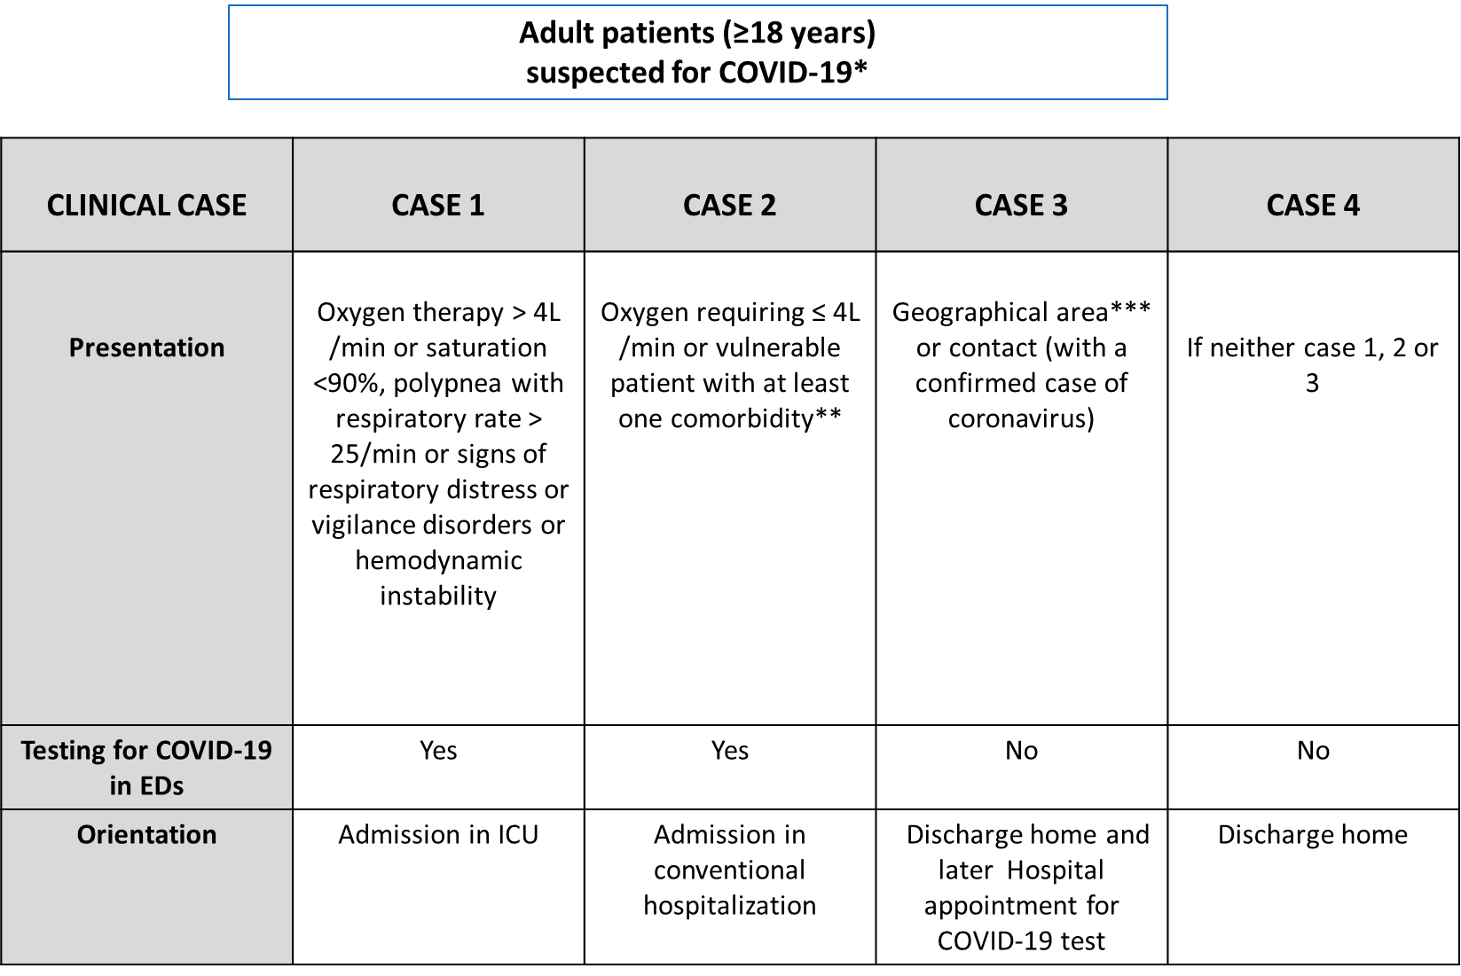
* As the knowledge about the disease grew, we included all patients with at least one of the following symptoms:
- Fever or
- Respiratory symptoms (dyspnea, cough, rhinorrhea/congestion, sore throat..) or
- Other clinical symptoms: nausea or vomiting, anosmia, weakness, diarrhea, myalgia, headache, confusion, abdominal pain, and joint pain.
** At least one of the comorbidities among : chronic respiratory disease insufficiency under oxygen therapy, or asthma, or cystic fibrosis, or any chronic pathology that can decompensate during a viral infection, chronic renal failure on dialysis, heart failure stage NYHA III or IV, cirrhosis ≥ stage B, Insulin-dependent or complicated diabetes, immunosuppression (drug, uncontrolled HIV infection, or CD4 <200/mm3 ), organ transplant, hematological malignancy, metastasized cancer, pregnant woman third trimester.
*** Geographical area at risk: China, Singapore, South Korea, Iran, Italy (Lombardy region, Veneto, Emilia Romagna, Piedmont), Haute-Savoie, Oise at the beginning of the study. Later, these data were re-evaluated according to the evolution of the epidemic.
Supplemental Figure 1 (S1): Orientation from EDs according to the clinical cases.

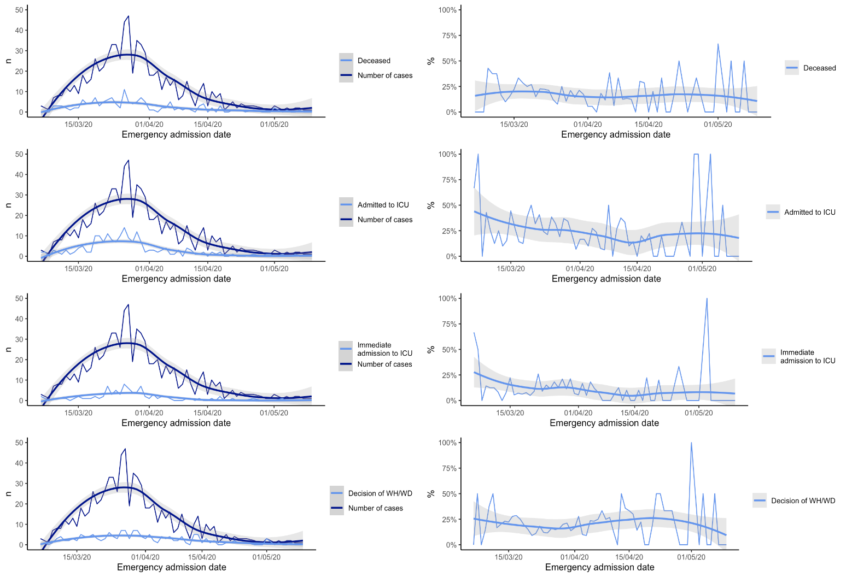
Supplemental figure 2 (S2): Number of deaths, admissions to intensive care units (ICU), transfers from EDs to ICU (immediate admission to ICU), and decisions of withholding and withdrawing life-sustaining treatments (Decision of WH/WD), depending on the day of admission to the EDs among COVID-19 positive patients (the numbers or percentages are reported for each day, with a smoothed curve by local LOESS regression method and its confidence interval).

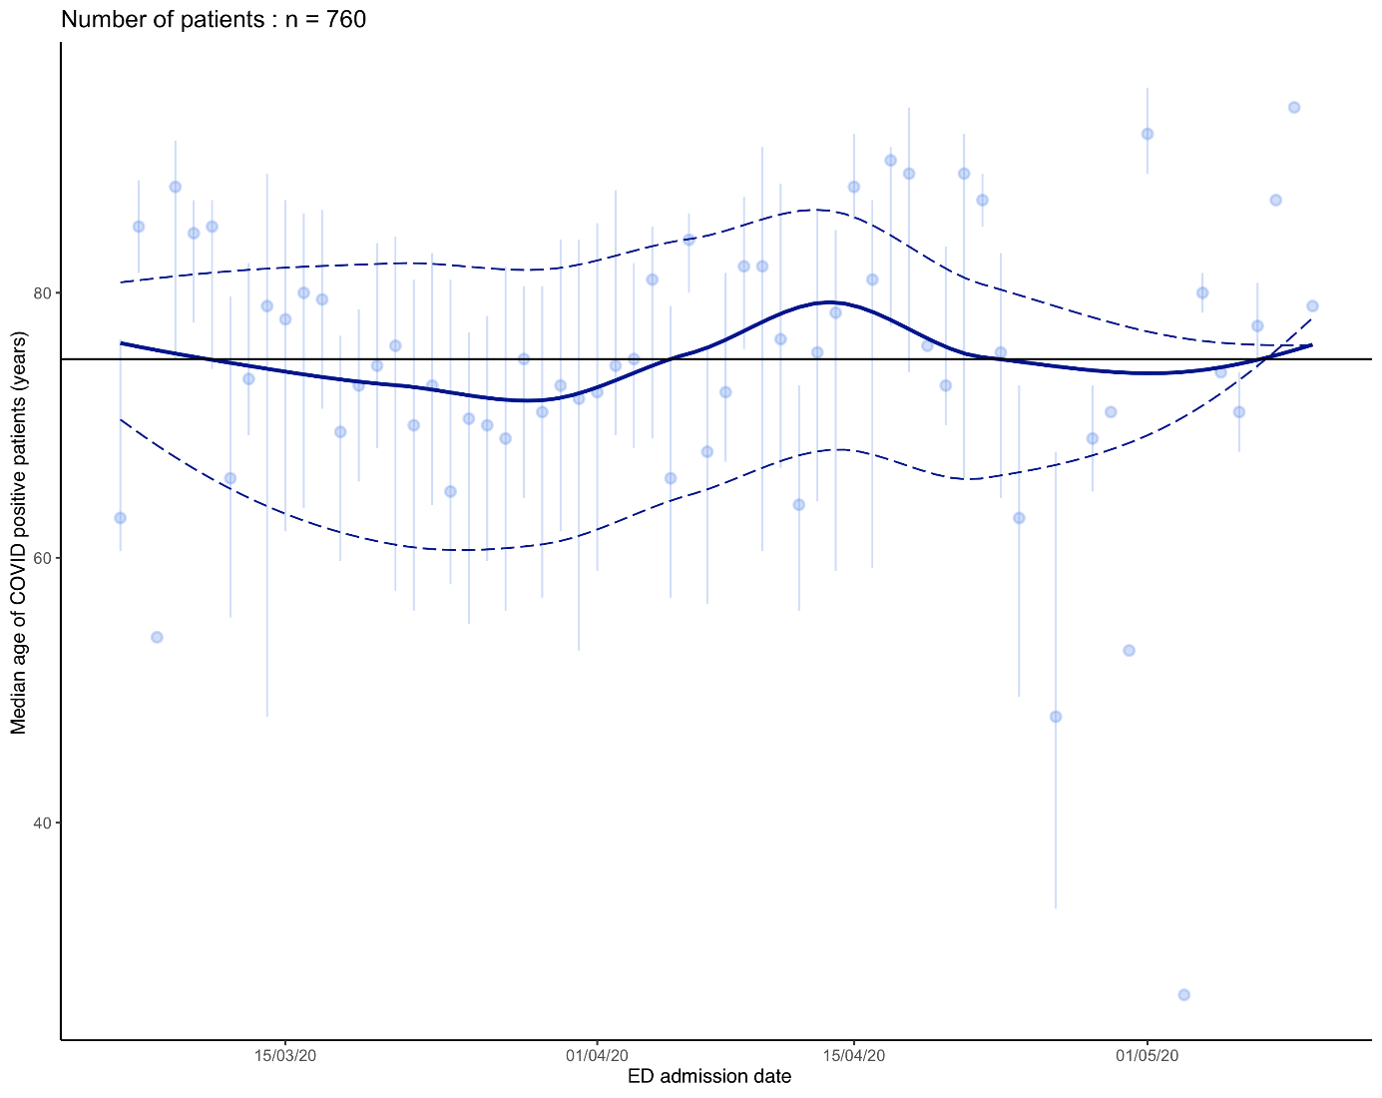

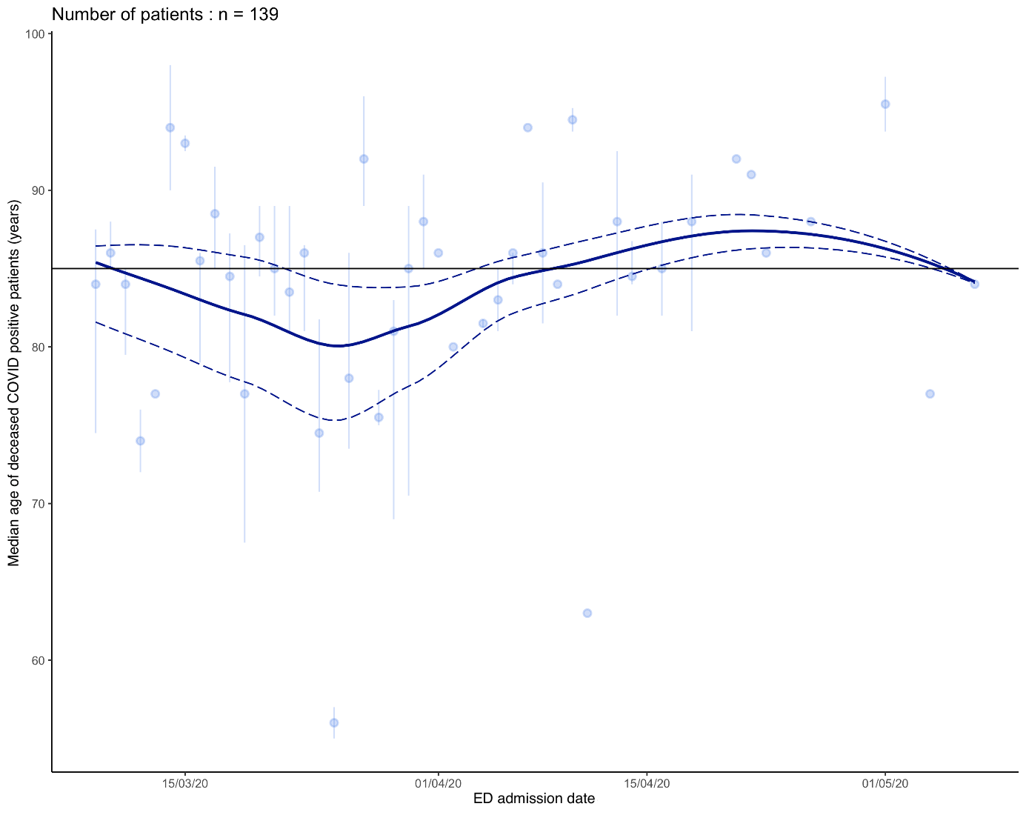

Supplemental figure 3 (S3) : Median age of COVID-19 positive patients and deceased COVID-19 positive patients by date of admission (Median age (dot) and 1st and 3rd quartile (vertical line) with LOESS age regression curves median (solid line) and 1st and 3rd quartile (dotted line) of COVID-19 positive deceased patients according by date of admission).

