Supplementary Information

Fully-Biodegradable and Self-Deployable Electronic Tent for Brain Cortex

Jae-Young Bae^{1,14}, Gyeong-Seok Hwang^{2,14}, Young-Seo Kim^{1,14}, Jooik Jeon³, Min-Seong Chae^{1,4}, Joon-Woo Kim⁵, Seongchan Kim^{6,7}, Sung-Geun Choi¹, Ju-Yong Lee¹, Jae-Hwan Lee¹, Kyung-Sub Kim¹, Woo-Jin Lee¹, Sian Lee^{6,8}, Hyojin Lee^{6,9}, Yu-Chan Kim^{6,9}, Kang-Sik Lee⁴, Jeonghyun Kim⁵, Jung Keun Hyun^{3,10,11*}, Ju-Young Kim^{2*} & Seung-Kyun Kang^{1,12,13*}

¹Department of Materials Science and Engineering, Seoul National University, Seoul, 08826, Republic of Korea.
²Department of Materials Science and Engineering, UNIST (Ulsan National Institute of Science and Technology), Ulsan, 44919, Republic of Korea
³Department of Nanobiomedical Science and BK21 NBM Global Research Center for Regenerative Medicine, Dankook University, Cheonan, 31116, Republic of Korea
⁴Biomedical Engineering Research Center, Asan Medical Center, Seoul, 05505, Republic of Korea
⁵Department of Electronic Convergence Engineering, Kwangwoon University, Seoul, 01897, Republic of Korea
⁶Biomaterials Research Center, Biomedical Research Institute, Korea Institute of Science and Technology (KIST), Seoul, 02792, Republic of Korea
⁷Department of Radiology, Feinberg School of Medicine, Northwestern University, Chicago, IL, 60611, USA
⁸School of Biomedical Engineering, Korea University, Seoul, 02841, Republic of Korea
⁹Division of Bio-Medical Science & Technology, KIST School – Korea University of Science and Technology (UST), Seoul, 02792, Republic of Korea
¹⁰Department of Rehabilitation Medicine, College of Medicine, Dankook University, Cheonan, 31116, Republic of Korea
¹¹Institute of Tissue Regeneration Engineering (ITREN), Dankook University, Cheonan, 31116, Republic of Korea
¹²Research Institute of Advanced Materials (RIAM), Seoul National University, Seoul, 08826, Republic of Korea
¹³Nano Systems Institute SOFT Foundry, Seoul National University, Seoul, 08826, Republic of Korea
¹⁴These authors contributed equally: Jae-Young Bae, Gyeong-Seok Hwang, Young-Seo Kim.
e-mail: rhhyun@dankook.ac.kr; juyoung@unist.ac.kr; kskg7227@snu.ac.kr

Table of contents

1. Shape fixation and deployment using temperature-dependent shape memory polymer (PLCL-PLGA) substrates
2. Performance of electronic devices integrated into the self-deployable electronic tent
3. Optimization of an X-ray marker for device visualization under the skull
4. In vitro phantom brain and skull models
5. Demonstration of a functional lifetime of electronic tent with wireless heater operation
6. FEA simulations for the packaging and deployment process
7. Strain analysis for the packaging process
8. Shape recovery analysis for the deployment process
9. Surgical process
10. Effect of lubricants during in vivo self-deployment and device performance
11. Manufacturing of transparent skull replica
12. Synthesis of a UV fluorescence layer for device visualization
13. Input/output(I/O) interfaces for the electronic tent
14. Operation and data recording of active electrode arrays
15. Characterization of the NFC based wireless sensors
16. Supplementary Reference
Supplementary figures 1–53
Supplementary table 1
Supplementary videos 1-6

1. Shape fixation and deployment using temperature-dependent shape memory polymer (PLCL-PLGA) substrates
Characterization of shape memory behavior - The relaxation modulus of the PLCL-PLGA (thickness ~100 μm) is analyzed using dynamic mechanical analysis (DMA, Supplementary Fig. 1a) at a fixed strain of 10 %. The relaxation modulus decreases as temperature increases with a rapid decrement observed from 35 ℃ to 45 ℃. This indicates the phase transition of PLCL-PLGA into a rubbery phase near the glass transition temperature (T_{g}), suggesting the shape memory effect in this temperature range. Supplementary Figure 1b shows the shape memory process of the blended PLCL-PLGA sample under the same condition as those used in the stress relaxation test. Initially, the blended sample is stretched to approximately 25 % strain (step 1) and cooled down to -10 ℃ (step 2). Subsequently, the stretching force is removed (step 3) and the strain recovery is measured as the temperature increased to 40 ℃ (step 4). The shape fixability (R_{f}) is the ratio of the deformed strains measured with and without the stretching force during step 3 and it is measured as 99.96 %. Additionally, the shape recovery (R_{r}) is 92.04 % as the sample rapidly recovers more than 25 % strain in a few minutes at 40 ℃ when exposed to warm water, such as when it comes out from the syringe and encounters warm water. The shape memory effect starts instantaneously and the deformed part is immediately recovered. Therefore, the recovery process is akin to the reverse packaging process and resembles elastic recovery as the shape recovery is fast and efficient.

Procedure of fixation and automatic shape recovery for deployment - Compared to elastomers, shape memory polymers can hold the programmed shape until an external stimulus is applied (Supplementary Figs. 1c and 2). The fixation process is similar to the previously reported SMP (PLCL-PLGA) actuation methods¹. The electronic tent is packed into a tube with axis conversion and frozen at −20 ℃ for 1 min to fix its temporary deformed. An insignificant amount of water (~40 ℃) is retained in the ends of the tube by capillary force (Supplementary Fig. 10) to provide uniform heat stimulus for the shape recovery of the chassis/supporter structure ends during the device deployment through the tube. Consequently, the deploying motion of the SMP is successfully activated from the fixed shape as the device passes through the warm water meniscus at the end of the tube.

Comparison of fixation and shape recovery behavior between shape memory polymer and elastomer - For comparison of deployment behavior between biodegradable polymer of PLCL-PLGA (SMP) and PBAT (elastomer), a sample made of PBAT with identical geometry (total diameter ~70 mm; 8-chassis with 1 mm width; 3-supporter with 300 μm width) and thickness (100 μm) is prepared using the same fabrication method for comparison. During deployment from the syringe located 5 mm above the target surface, the PBAT sample is deformed and entangled inside the syringe, resulting in the failure of the deployment process (Case 1 in Supplementary Fig. 3). Additionally, the non-controllable and unexpected recovery behavior of the elastomer caused the ends of sample to be randomly deployed, leading to jamming on the target substrate and making it harder to recover its original shape at shallow gap (Case 2 in Supplementary Fig. 3).

2. Performance of electronic devices integrated into the self-deployable electronic tent
Temperature sensor – The Mg resistor (line width, ~120 μm; thickness, ~500 nm) with a temperature coefficient of resistance is used as a temperature sensor to measure the temperature based on resistance variation and the resistance is recorded with a digital multimeter (NI USB-4065, National Instruments). The temperature variation is calculated by the following equation:
T $= \frac{R-R_{0}}{α×R_{0}}+T_{0}$
where R and R₀ are the measured resistance and initial resistance of the sensor, T and T₀ are the measured temperature and initial temperature, and α is the temperature coefficient of resistance (~2.05$×$10⁻³/℃).

Strain sensor – The boron-doped Si NM resistor (line width, ~120 μm; thickness, ~400 nm) with high piezoresistivity is applied as a strain sensor for monitoring the strain. Additionally, the strain sensor resistance is measured similarly with a digital multimeter. The strain is calculated using the following equation, based on the resistance and gauge factor:
G $= \frac{R-R_{0}}{ε×R_{0}}$
where R and R₀ are the measured resistance and initial resistance of the sensor, and G is the gauge factor of the Si strain sensor (gauge factor in Supplementary Fig 5c ~ 20).

pH sensor – The phosphorus-doped Si NM conductor (width, ~700 μm; height, ~90 μm; thickness, ~400 nm) with surface functionalization is used as a pH sensor for monitoring of the pH variation. The conductance of the pH sensor is similarly measured with a digital multimeter. The conductance change came from the surface protonation/deprotonation of Si NM, which functionalized with 3-aminopropyltriethoxysilane (APTES, Sigma-Aldrich)². The functionalized surfaces of Si NM (–NH₂ and –SiOH groups) protonated to NH₃⁺ at low pH and deprotonated to SiO⁻ at high pH, inducing conductance change at different pH conditions^{3,4}.

Passive/active electrode – The Mo electrode (Area, ~300×300 μm²; thickness, ~500 nm) is used as a passive electrode for monitoring bio-potential. The electrical impedance is analyzed using electrochemical impedance spectroscopy (EIS, ZIVE MP2A, WonATech). N-channel MOSFET is used as an active electrode to multiplex the recording signal. To measure the general electrical performances (IV and transfer curve) of n-channel MOSFET, a semiconductor analyzer (4200A-SCS, Keithley) is used. The switching behavior (signal amplitude >10 mV_{pp}) is characterized by a function generator (AFG 31052, Tektronix) for applying gate/drain voltage and an oscilloscope (TBS1052B, Tektronix) for measuring output signals from the source electrode. When the 0 V of gate voltage is applied to the active electrode, it shows an off-state; however, the input signal gradually goes to an on-state during the application of voltage to the gate electrode.

Inductive coupled type wireless system – The spiral shaped Mg trace (line width, ~120 μm; thickness, ~1.5 μm) is used as receiver coil for power harvesting from inductive coupled resonance with external coil. The Mg resistor or electrical pad is connected to the coil for functional actuation (light or heat). A vector network analyzer (TTR503A, Tektronix) is used to measure the resonance behavior of Mg receiver coil.

3. Optimization of an X-ray marker for device visualization under the skull
In vivo verification of X-ray marker – X-ray marker (PBAT-iodixanol) is captured by imaging from the C-arm with a condition of 80 kV, 4 mA, 90 s exposures, and 2.50 mGy, respectively. Under the same thickness conditions (total thickness ~150 μm), a sample with X-ray marker (PLCL-PLGA, ~50 μm / X-ray marker, ~50 μm / PLCL-PLGA, ~50 μm) is detected on microcomputed tomography, compared to the sample without X-ray marker (PLCL-PLGA, ~150 μm; Supplementary Fig. 8).

In vivo verification of X-ray marker - The sample (PLCL-PLGA, ~50 μm / X-ray marker, ~50 μm / PLCL-PLGA, ~50 μm) is implanted in the rat brain after drilling a 10 mm hole in the skull and the drilled hole is sealed with bone adhesive. Microcomputed tomography images are captured using the condition of 50 kV source voltage, 50 μA source current, 0.5 mm filter Al, and 12.64 μm camera pixel size. The images are then reconstructed into a three-dimensional geometry (Supplementary Fig. 9).

4. In vitro phantom brain and skull models
The 3D model of the phantom skull and brain are brought from the open-source community (CGTrader). To better visualize the space between the skull and brain, a 2 cm part from the top of the skull is sliced toward the transverse plane, followed by another cut toward the frontal plane from 1 cm below the top of the skull to open the side view of skull and brain. The sliced skull structure (polylactic acid, PLA) is fabricated by fused deposition modeling (FDM) 3D-printer (DP 200, Sindoh) and the sliced brain structure (1 % agar gel) is made from a customized mold.

5. Demonstration of a functional lifetime of the electronic tent with wireless heater operation
The functional degradation of electronic devices is also investigated during the operation period of the wireless heater (top, PLCL-PLGA, ~50 μm; device, Mg, ~1.5 μm; bottom, PLCL-PLGA, ~50 μm) during immersion in the PBS solution at pH 7.4 and 70 ℃ for accelerated hydrolysis (Supplementary Figs. 15 and 16). Between the PBS solution refreshing period, the external AC power (20 V_{pp} at 10.5 MHz) is applied to the external transmitter coil for inductively coupled power transfer to the wireless heater. Furthermore, infrared images are taken from an IR monitoring system (A655SC, FLIR Systems) after 30 s of device heating. After the measurement, the PBS solution (70 ℃, pH 7.4) is refilled in the container to keep the dissolution process of the device. The electrical performance of the device gradually decreases over several days (~day 5) and completely loses its performance within a week. The functional degradation not only depends on a physical dissolution of the encapsulation layer but critically relies on the permeation of water through the encapsulation film^{5,6}.

6. FEA simulations for the packaging and deployment processes
Supplementary Figure 17 shows the 3D FEA simulation process of folding by suction and shape recovery by injection for a simple mesh-structured device. The inner diameter of the injection tube is 3.9 mm and the balance center diameter is 3.75 mm. The balance center is pushed into the injection tube, which is a rigid body with constant velocity (1 mm/s), and the strain is analyzed at the functional layer between the encapsulation and substrate layers as shown in the inset image at the right end. The explicit mode is used for the simulations to describe the dynamic deformation behavior. To enhance the accuracy in this mode, 0.25 s of small step time, up to 160 of large step number, and under 0.15 mm of refined mesh size are used. The element type is the 8-node linear brick with reduced integration and hourglass control, and the maximum principal strain is used as the strain value. The recovery process is regarded as the reverse suction process as the shape recovery process is fast enough as elastic recovery owing to the shape recovery performance. This is supported by the shape memory effect test with dynamic mechanical analysis, which demonstrate that the PLCL-PLGA can recover strain through the reverse suction process during shape recovery.

7. Strain analysis for the packaging process
Thickness
With increased thickness, the space inside the injection tube becomes insufficient, leading to the behavior similar to an increase in the filling ratio. Supplementary Figure 19b shows the results, where the thickness increases, leading to a rapid increase in the maximum local strain. Furthermore, the thickness of both the substrate and encapsulation layer must be determined considering the shape recoverability, fabrication process, and strain distribution. In this study, the thickness of the substrate and the encapsulation layer is 50 μm, respectively, and the location of the electronic functional layer is between the substrate and the encapsulation layers. Placing the functional layers near the neutral stress plane can effectively reduce the strain at the electronic functional layer compared with that at the outer surfaces of the device^{7,8}. The maximum strain on the outer surface of the device exceeded 20 %, but the maximum local strain on the functional layer is approximately 7 %, owing to the neutral stress plane concept.

Mesh structure
The device is fabricated using a mesh structure, which facilitates conformal contact⁹ between the device and the target surface and also induces less strain during compaction inside the injection tube. During the compaction process, a narrow space is required as the chassis and support parts fold and come closer together. This space is created by the empty areas in the mesh structure. Supplementary Figure 18 shows the strain distribution with and without the mesh structure. When a plane structure is used and filled completely, a highly non-uniform folding occurs during compaction. However, using a mesh structure results in a more even folding of the chassis and buckling of the support, with an 18.7 times difference in maximum strain. In addition, the maximum strain decreases by 28.7 % compared to the circular shape when the support is fabricated in a serpentine shape. This is in accordance with the principle¹⁰ that will be described in the following section, where the buckling radius increases due to the 16.4 % longer length of the support in the serpentine structure, which reduces the maximum deformation rate.

Design factors of electronic tent
In a recoverable way, the circular mesh-shaped device is folded and goes inside of the injection tube by compacting the mesh structure through mixed deformation modes such as local bending, twisting, folding, and stretching. The folding process begins by the bending of the chassis near the central head interacting with the wall of the injection tube. The strain decreases when the marginal gap between the injection tube and the central head increases due to the bending curvature. The chassis follow and bend into the injection tube, and the gap between the chassis decreases by shrinking empty space in the mesh structure. This induces a decrease in the distance between the junctions of the chassis and supports, and elastic buckling occurs on the supports. The folded support parts closely packed in the tube can be jammed at the entrance of the tube, inducing stretching of the already-inserted chassis. To reduce the maximum local strain during the folding process, this must be avoided. Compaction of the device in the tube during the packaging process is carried out by severe folding and twisting of supports connecting the chassis, leading to severe strain concentrations at the chassis-support junctions and middle of the supports. The maximum local strain on the support is 1.83 times (± 0.45) and 2.63 times (± 0.77) higher than the maximum strain on the chassis and the connecting part with the centrum node, respectively. The distribution of local strain analysis enables the mechanically reliable design of the devices. The maximum local strain must be within the elastic deformation limits of constituent materials. Functional parts, such as sensing and wireless communication that can be more rigid are located on the center or junctions of the chassis and supports, and metallic interconnects with better flexibility are located on the chassis and supports where strain concentrates more to connect functional parts (the last column images in Supplementary Fig. 17).
We suggest a filling ratio in the mesh-structured device as a primary factor determining maximum local strain as described in the manuscript with Figs. 2b and 2c. The filling ratio (F) can be defined as the ratio of the filling area by chassis and supports (A_{F}) to the coverage area by unit design (A_{C}) of the device. The filling area, coverage area by unit design, and the filling ratio can be calculated respectively with five structural dimensions based on Supplementary Fig. 19a as
$A_{F}=πR_{CN}^{2}+π\left\{{(R_{S}+\frac{W_{S}}{2})}^{2}-{(R_{S}-\frac{W_{S}}{2})}^{2}\right\}+W_{C}N_{C}(R_{S}-R_{CN}-\frac{W_{S}}{2})$, (S1)
$A_{C}=π({R_{S}+\frac{W_{S}}{2})}^{2}$, (S2)
$F=\frac{A_{F}}{A_{C}}=\frac{\left(W_{C}N_{C}+2πW_{S}\right)R_{S}+πR_{CN}^{2}-W_{C}N_{C}(\frac{W_{S}}{2}-R_{CN})}{π({R_{S}+\frac{W_{S}}{2})}^{2}}$, (S3)
where W_{C} and W_{S} are the widths of the chassis and support, respectively, R_{CN} and R_{S} are the radius of the center node and support, respectively, and N_{C} is the number of chassis. The support gets the maximum local strain due to the severe buckling and folding during suction. If this buckling is assumed as an elastic buckling, the curvature radius (R) can be calculated as the radius of a circle with the buckled support as its circumference. Mathematically, this can be described as:
$R=\frac{\frac{2πR_{S}}{8}}{2π}=\frac{R_{S}}{8}$, (S4)
where R_{S} is the radius of support. The strain ($ε$) due to the buckling can be described as:
$ε=\frac{t}{2R}$, (S5)
where t is the thickness of the film and R is the radius of curvature. The bending strain ($ε$) on the film is inversely proportional to the curvature radius (R) and the curvature radius is proportional to the support radius (R_{S}) according to the simple equations. As a result, the bending strain ($ε$) can substitute the support radius (R_{S}) with equation S6, and the filling ratio can be described with the strain on the film as equation S7:
$R_{S}=kε^{-1}$, (S6)
$F=\frac{\left(W_{C}N_{C}+2πW_{S}\right)kε^{-1}+πR_{CN}^{2}-W_{C}N_{C}(\frac{W_{S}}{2}-R_{CN})}{π({kε^{-1}+\frac{W_{S}}{2})}^{2}}$, (S7)
where k is the coefficient between the support radius and the strain. Figure S19c shows the fitted curve with the calculated relationship between the filling ratio and the maximum local strain, which is well matched with FEA simulation data when W_{C}, W_{S}, R_{CN}, and N_{C} are 1 mm, 0.5 mm, 1.75 mm, and 8, respectively, with 19.01 of k value. Furthermore, factors such as thickness, buckling behavior assumption, size of injection tube, mechanical properties of substrate and encapsulation layers may affect the k value. Further studies will address the detailed relationships among them. Therefore, the support radius can mediate the filling ratio and the maximum local strain because the buckling causes the maximum strain on the support, and the strain and filling ratio can be calculated with equation S7 depending on the condition and design.
Supplementary Figures 20a and 20c show strain analysis results depending on the chassis or support width. The maximum local strain increases as the width of the chassis or support increases, resulting in a higher filling ratio. Supplementary Figure 20b shows the change in strain as the support radius changes. As the support radius decreases, the coverage area by unit design (A_{C}) decreases, therefore despite a decrease in the filling area (A_{F}), the filling ratio (F) increases. Hence, extra chassis out of the outermost support has insignificant effect on the maximum local strain and folding behavior. Supplementary Figure 21a shows the maximum local strain depending on the width ratio between the support and chassis. When the ratio of support width to chassis width is greater than one, asymmetric folding by unstable deformation of chassis and supports is generally observed. Point B of Supplementary Fig. 21a shows unstable deformation, and the entangled bottom support acts as an obstacle to folding by and recovery by injection.

Shrinkage into the injection tube
Shrinkage ratio is defined as the ratio of the coverage area (A_{C}) to the syringe area (A_{S}), and Supplementary Fig. 21b shows that the maximum local strain increases with an increase in the ratio of the filling ratio to the shrinkage ratio, and as shrinkage ratio increases at a fixed ratio. Regarding high shrinkage ratio, a large area-covering device is contained in a narrow tube. Maximum local strain in a symmetric mesh-structured device during suction must be analyzed with primary factors of filling ratio, shrinkage ratio, and support radius.

Experimental results of strain distribution on the electronic tent
Supplementary Figure 22 shows the resistance change of the 1.5 μm thick magnesium electrode between the designed 50 μm thick substrates and 50 μm thick encapsulations during the packaging and deployment processes. Supplementary Figure 22a shows the design factors for three different designs with three filling ratios from 0.17 to 0.38. Supplementary Figure 22b shows negligible resistance change for the mesh structure with a 0.17 of filling ratio where the maximum local strain is analyzed as 2.5 % on the FEA result, contrary to those showing small and sharp increase in resistance for the mesh structure with 0.27 and 0.38 of a filling ratio where the maximum local strain is analyzed as 3.3 % and 6.1 % respectively.

8. Shape recovery analysis for the deployment process
Threshold depth for chassis angle of 60° (D_{threshold})
In this study, we introduce the D_{threshold} for intact recovery for the deployment of the devices in a shallow gap between the brain and skull. Additionally, the depth of the recovery process must be defined and optimized to ensure a highly successful recovery. The radial spread of the support is important before it contacts the bottom surface, and the interaction behavior between the device and the bottom surface becomes important after it contacts the bottom surface. Several forces, including friction, recovery, injection, and reaction forces resulting from the contact between the device and the bottom surface, can influence sliding behavior during the deployment process. When the chassis comes into contact with the bottom surface, the recovery force acting in the forward direction interacts with the remaining three forces (friction, reaction, and injection forces) generated by the contact. The sliding motions of the chassis can be classified as forward sliding or backward sliding, depending on the mechanical interaction. The elastic modulus of the material composing the component and length of the chassis can cause buckling in the chassis by the interaction of the forces, which can ultimately affect the sliding behavior. If the point of first contact with the bottom surface during the injection process does not propagate in the forward direction, there is a high probability of entanglement with subsequently inserted parts, resulting in failure in recovery. In this study, the variables are the friction and the recovery forces as the other parameters like injection speed, material, and shape of the device are kept identical. The recovery force is a factor determined by the design of the device, and changes in behavior owing to friction can be predicted through FEA simulation analysis, as shown in Supplementary Figs. 23a and 23b. To describe the sliding behavior of the chassis, we define the chassis behavior (C), which takes on values of 1 for forward sliding, -1 for backward sliding, and 0 for mixed sliding. Supplementary Figure 23a shows that the mixed sliding behavior occurs between forward and backward sliding from near 65˚. However, the mixed sliding behavior changes to backward sliding behavior at 65˚ with the finite friction coefficient (μ) and the 60˚ of angle shows forward sliding behavior constantly (Supplementary Fig. 23b). The buckling and sliding behavior is determined by the chassis angle when it contacts the bottom surface; however, the chassis behavior becomes -1 when the chassis slides in a backward direction and entangles. In this study this behavior is described with the error function as equation 2. The friction between the bottom surface, the elastic modulus of the substrate material, and the length of the substrate, etc., may affect the A* and w. Supplementary Fig. 23a shows A* and w values decreasing to 63.87, and 0.19 increasing the friction coefficient (μ) from 0 to 0.1. The relationship between many variables for transition behavior will be analyzed in future work.

Design factors for D_{threshold}
Supplementary Figures 24a and 24b show that the D_{threshold} does not change depending on the chassis number and support width. The rapid spreading effect before the chassis contacts the bottom surface hardly occurs even if the number and width of the chassis and support are changed. The D_{threshold} strongly depends on the location of the support as shown in Fig. 2f. As the support radius increases, the spreading of the device by the unfolding of supports at the initial stage of deployment is more pronounced, resulting in lower D_{threshold}.

9. Surgical process
In all surgical processes, canine models are anaesthetized with Zoletil (5 mg/kg, I.M) and xylazine (2 mg/Kg, I.M) and anaesthesia is maintained with isoflurane (< 3 %). After the anaesthetization process, each surgery follows the process below:

Hole drilling for minimally invasive device deployment – The surgery starts with making a small incision of the scalp (~10 mm). Nest, a hole is drilled on the exposed skull using a surgical drill (diameter of drill bit ~5 mm) to reveal the brain surface.

Replacement to the transparent skull replacement for visualization – The operation begins by making a large incision of the scalp (~100 mm) for craniotomy. Next, the skull is removed to match the prepared skull replica. The skull replica is then fixed with the unremoved skull part to prevent shaking during the deployment process.

Electrodes implantation on the sciatic nerve – Both sides of the sciatic nerve are exposed by skin incision and splitting the beneath muscles in both thighs. Hook-shaped electrodes are carefully placed on the sciatic nerve to prevent any mechanical damage to the nerve.

10. Effect of lubricants during in vivo automatic recovery and device performance
The electronic tent for in vivo deployment is dip-coated with a lubricant layer (>98 % concentrated glycerin, medical grade) to reduce the friction from tacky biological tissue. Supplementary Figures 26 and 27 show the effect of lubricant coating during deployment on the biological surface compared to a non-coated sample. Lubricant coated sample easily slides through forward direction as the lubricant reduces surface friction. However, the unlubricated sample without lubricant is prone to jamming rather than sliding through the desired direction due to surface friction. The coated glycerin layer disturbs the signal recording at the early stage of the deployment, but it gradually recovers its original performance as glycerin is dissolved away by water (Supplementary Fig. 26b).

11. Manufacturing of transparent skull replica
The manufacturing of a skull replica begins with X-ray scanning (Ziehm Vision RFD, Ziehm Imaging) of the canine skull a week before the surgery to minimize the size difference caused by skull growth. Furthermore, a replica is printed by an SLA 3D printer (outsourced from Fusion Technologies) with transparent resin (T5550, Qubea) based on the 3D reconstructed image of the skull. The as-printed skull replica is thoroughly dried in an ambient condition over a week to prevent deformation of the structure.

12. Synthesis of a UV fluorescence layer for visualization
Native electronic tent (colorless to natural white) is hard to distinguish due to bleeding during the surgical process. The fluorescence PLCL-PLGA layer is used to visualize the electronic tents through 365-nm light irradiation during the in vivo deployment process (Supplementary Figure 28). Equal weight amounts of PLCL and PLGA pellets are thoroughly mixed with a chloroform solvent (20 wt%) to create a homogeneous solution. Subsequently, 50 mg of rhodamine B powder (Sigma-Aldrich, USA) is added to the PLCL-PLGA solution and the solution is casted onto the SAM-treated substrate for film formation. The PLCL-PLGA sheet with rhodamine B is thermally bonded (~100 ℃) to the bare PLCL-PLGA sheet to prevent leakage of rhodamine B.

13. Input/output(I/O) interfaces for electronic tent
The single chassis devices (electrode, temperature, strain, pH sensor, fabrication method in Method section) are fabricated with a length twice longer than the chassis of the bottom substrate to vertically fix it on the PCL node in the center. Before integrating the single chassis devices (with I/O pad) on the bottom substrate, the shape of the single chassis device is pre-programmed to the vertically bent shape. The pre-programmed single chassis device is then attached along the chassis end of the bottom substrate to the center, and the bent site of the device is attached to the center PCL structure. The attachment is fixed vertically by heat sealing at 110 ℃ (Supplementary Fig. 31). The performance of the vertically fixed I/O interface is measured by oscilloscope after automatic deployment, compared to the as-fabricated single chassis electrode (Supplementary Figs. 32 and 33).

14. Operation and data recording of active electrode arrays
Supplementary Figure 40 shows the circuit of 32-channel active electrode arrays. Each recording node consists of 2$×$2 transistor arrays per chassis, equivalent to the 16$×$2 transistor arrays with a total number of 18 wires. On a single unit of the active electrode, the source electrodes of the transistor serve as recording site and the drain electrodes act as the output pad during the application of gate voltage (1 V) (Supplementary Fig. 43). For interfacing with the 32 active electrodes (16$×$2 arrays), 16 channels of drain electrode are connected with the external recording system, and two channels of gate electrode are linked with the power source. A 1 V gate voltage is applied to activate a particular column, while 0 V is applied when the column is not selected. Signals are acquired from the selected band (0.5-2000 Hz), which is similar to the process of the passive electrode recording (see Method section for more details).

15. Characterization of NFC based wireless sensor
Supplementary Figure 45 shows the circuit diagram of the wireless sensor (temperature, thermal conductivity, and strain) integrated on the electronic tent. The NFC operation circuit includes microcontrollers (2 kB of FRAM, 4 kB of SRAM, and 8 kB of ROM) and capacitors (68 pF, 10 nF, 100 nF, 1 μF, and 2.2 μF). A wireless temperature sensor communicates with the corresponding NFC reader by inductive coupling at 13.56 MHz (Supplementary Fig. 46). Phase and impedance characteristics of a wireless temperature sensor are evaluated by an impedance analyzer (4294A, Agilent).

Temperature – The wireless temperature sensor is composed of a temperature sensor (Mg, ~500 nm), an inductive coupling coil (Mg, ~1.5 μm) above a supporter, and an NFC operation circuit on the center node, which is electrically connected with a coil. The measured data is converted to a temperature value using the following equation¹¹:
$V_{sensor}$ $= \frac{Measured data}{2^{14}-1}×0.9$
Temperature (℃) $=\frac{1}{\{\frac{\log\left(\frac{V_{thermistor}}{100000}\right)}{\log\left(2.718\right)}×\frac{1}{4330}+\left(\frac{1}{298.15}\right)\}}-273.15$
The converted temperature values are calibrated by comparing them with the data obtained from thermographic measurements. The wireless temperature sensor collects data on a hot plate (MSH-20D, DAIHAN Scientific), and this data is then matched with the temperature calibration parameter obtained from IR camera measurement (Supplementary Fig. 47).

Thermal conductivity – The wireless thermal conductivity sensor is composed of a temperature sensor (Mg, ~500 nm), a thermal actuator and an inductive coupling coil (Mg, ~1.5 μm) above a supporter. The sensor is integrated with an NFC operation circuit on the center node and it is electrically connected to a coil. The thermal actuator, which is composed of a non-spiral type inductor and resistor, operates by inductive coupled joule heating at a frequency of approximately 13 MHz. The thermal conductivity of fluids is measured using the transient hot-wire method. The measurement involves inducing a temperature variation in the fluids by heating them with a thermal actuator. The thermal conductivity is then calculated using the following equation¹²:
. $λ= \frac{q}{4π}∙\frac{dΔT}{dΔ\ln{t}}$
Where, λ is thermal conductivity (W/m$∙$K), and q is heating power (W/m). The power is applied of ~1 mW for joule heating when the sensor is immersed in various reference fluids (DI water ~0.6 W/m$∙$K, glycerol ~0.29 W/m$∙$K, ethanol ~0.17 W/m$∙$K) for calibration and the measured values are compared with those obtained from a wired temperature sensor (Supplementary Fig. 47).

Strain – The wireless strain sensor consists of a strain sensor (boron-doped Si NM, ~400 nm), an inductive coupling coil (Mg, ~1.5 μm) above a supporter, and NFC operation circuit on the center node, which is electrically connected to a coil. The measured data is converted to a temperature value with the following equation¹¹:
$V_{sensor}$ $= \frac{Measured data}{2^{14}-1}×0.9$
$R_{sensor}$ = $\frac{V_{sensor}}{2.4 × {10}^{-6}}$
The bending is applied at the sensor for calibration, which is calculated from the bending strain equation and compared with the wired strain sensor (Supplementary Fig. 47).

16. Supplementary Reference
1. Cha, K. J. et al. Shape-memory effect by specific biodegradable polymer blending for biomedical applications. Macromol. Biosci. 14, 667-678 (2014).
2. Hwang, S. -W. et al. Biodegradable elastomers and silicon nanomembranes/nanoribbons for stretchable, transient electronics, and biosensors. Nano Letters 15, 2801-2808 (2015).
3. Vezenov, D. V., Noy, A., Rozsnyai, L. F. & Lieber, C. M. Force titrations and ionization state sensitive imaging of functional groups in aqueous solutions by chemical force microscopy. J. Am. Chem. Soc. 119, 2006-2015 (1997).
4. Cui, Y., Wei, Q., Park, H. & Lieber. C. M. Nanowire nanosensors for highly sensitive and selective detection of biological and chemical species. Science 293, 1289-1292 (2001).
5. Kang, S. -K. et al. Bioresorbable silicon electronic sensors for the brain. Nature 530, 71-76 (2016).
6. Shim, J. -S., Rogers, J. A. & Kang, S. -K. Physically transient electronic materials and devices. Mater. Sci. Eng. R Rep. 145, 100624 (2021).
7. Kaltenbrunner, M. et al. An ultra-lightweight design for imperceptible plastic electronics. Nature 499, 458-463 (2013).
8. Kim, D. -H. et al. Stretchable and foldable silicon integrated circuits. Science 320, 507-511 (2008).
9. Kim. D. -H. et al. Dissolvable films of silk fibroin for ultrathin conformal bio-integrated electronics. Nat. Mater. 9, 511-517 (2010).
10. Lacour, S. P., Jones, J., Wagner, S., Li, T. & Suo, Z. Stretchable interconnects for elastic electronic surfaces. Proc. IEEE 93, 1459-1467 (2005).
11. RF430FRL15xH Firmware User's Guide (Rev. B). Texas Instruments. https://www.ti.com/lit/ug/slau603b/slau603b.pdf.
12. Healy, J. J., de Groot, J. J. & Kestin, J. The theory of the transient hot-wire method for measuring thermal conductivity. Physica B+C 82, 392-408 (1976).

Supplementary figure 1. Characterization of PLCL-PLGA shape memory polymer.
(a) Stress relaxation behavior. (b) Shape memory effect with one cycle, respectively. (c) Shape recovery process of PLCL-PLGA at different temperature.

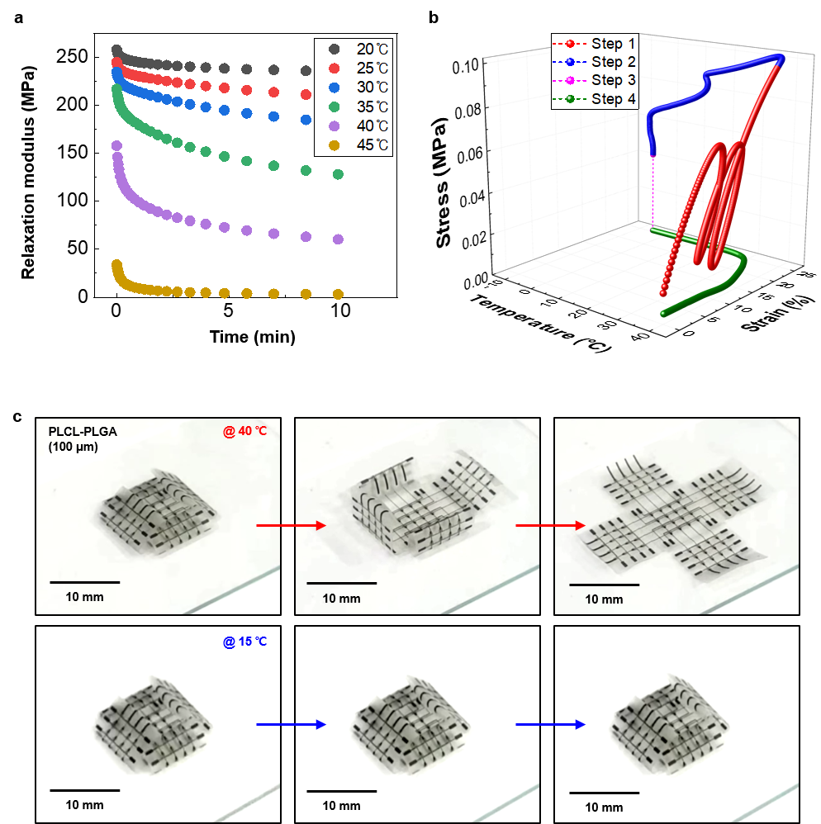

Supplementary figure 2. Shape recovery process of PLCL-PLGA with electronic tent design. Sequential images of electronic tent (~100 μm) injected on free space at temperature of (a) 40 ℃ and (b) 15 ℃.

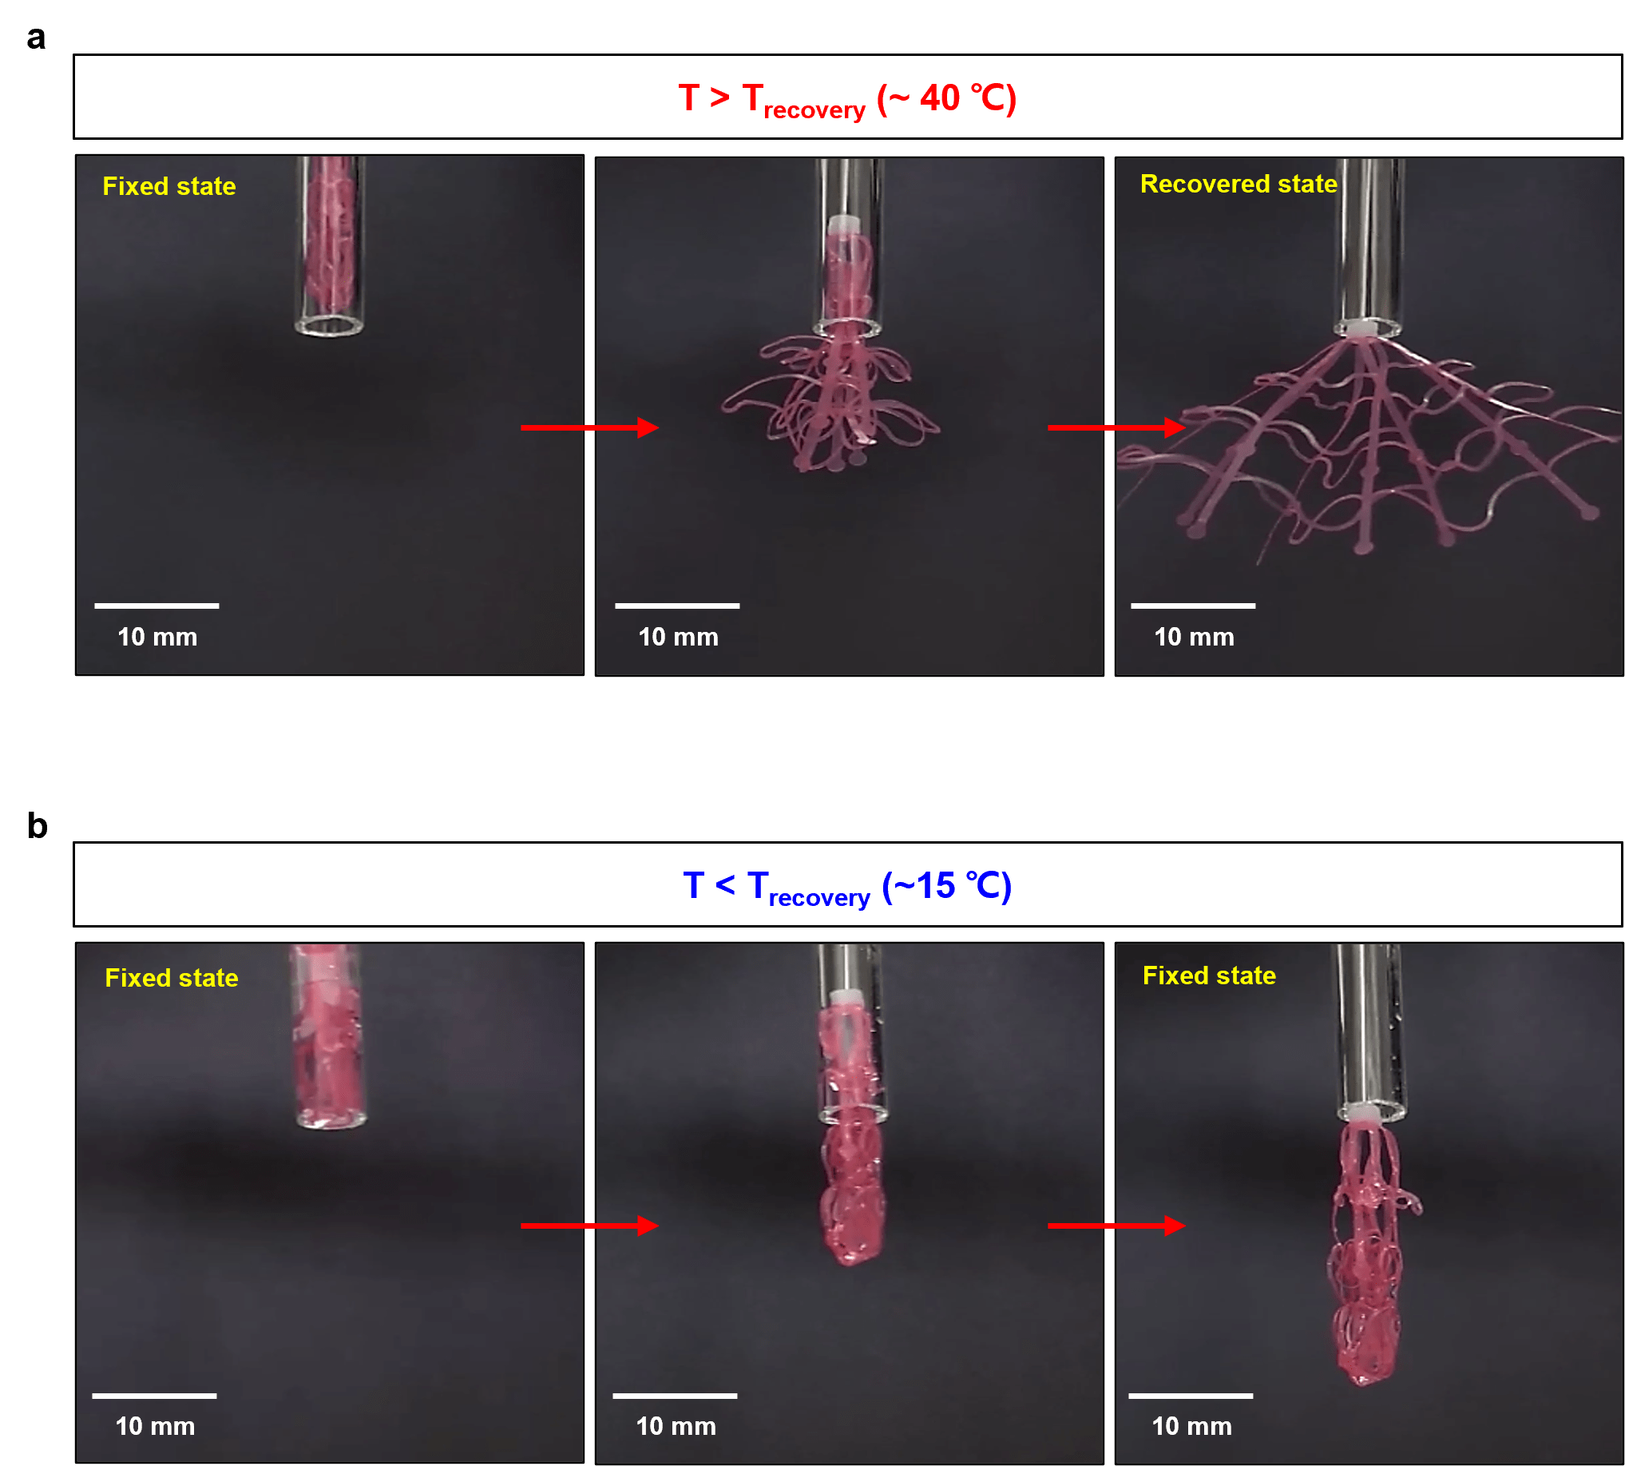

Supplementary figure 3. Possible cases during deploying process using biodegradable elastomer PBAT (~100 μm) with electronic tent design.

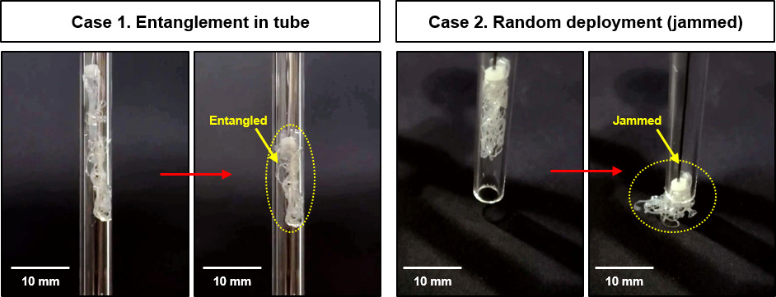

Supplementary figure 4. Fabrication procedures of biodegradable and self-deployable electronic tent.

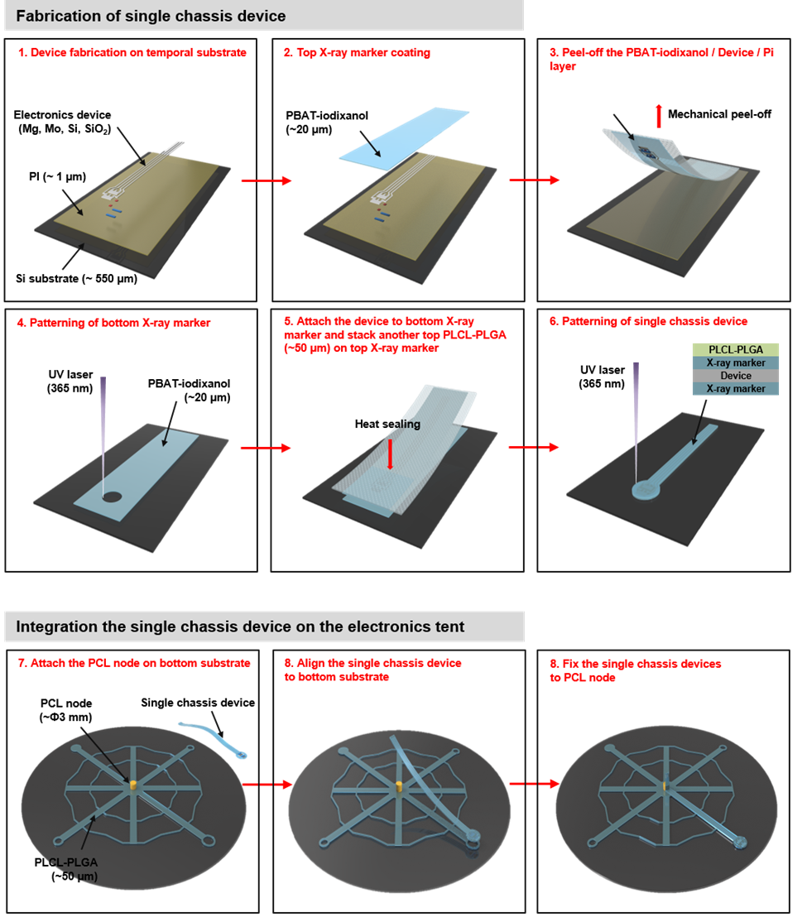

Supplementary figure 5. Electrical performance of various sensor devices.
Image and performance of various sensor devices integrated on electronic tent. (a) Passive electrode, (b) temperature sensor, (c) strain sensor, and (d) pH sensor.

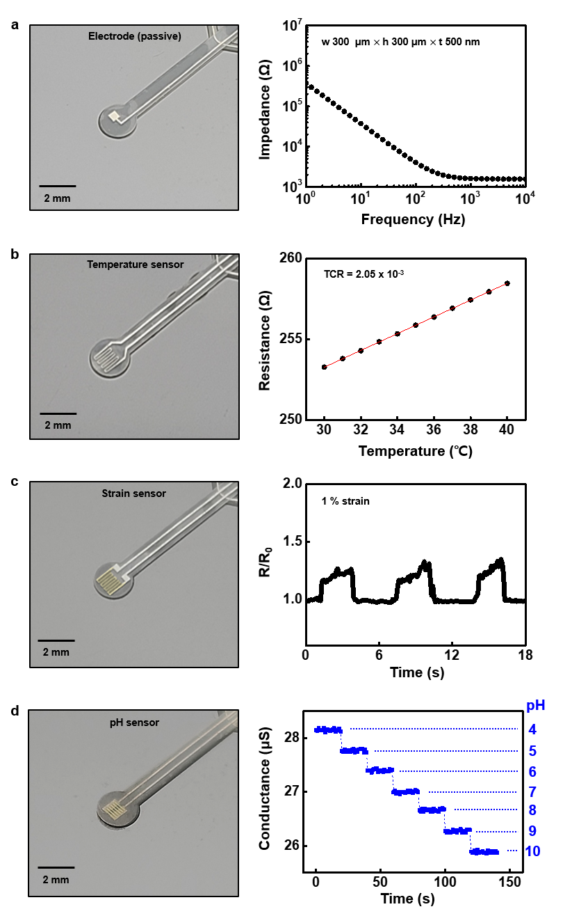
Supplementary figure 6. Electrical characteristics of the wireless power transfer device.
Image (right, inset; magnified view of center node with LED) and performance (left, scattering parameter; red and phase; blue) of wireless coil.

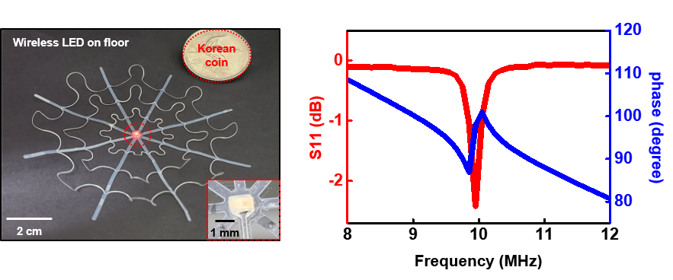

Supplementary figure 7. X-ray marker.
(a) Chemical structure (iodixanol and PBAT) of components in X-ray marker. (b) Images of X-ray marker (left), compared to PBAT only substrate (right).

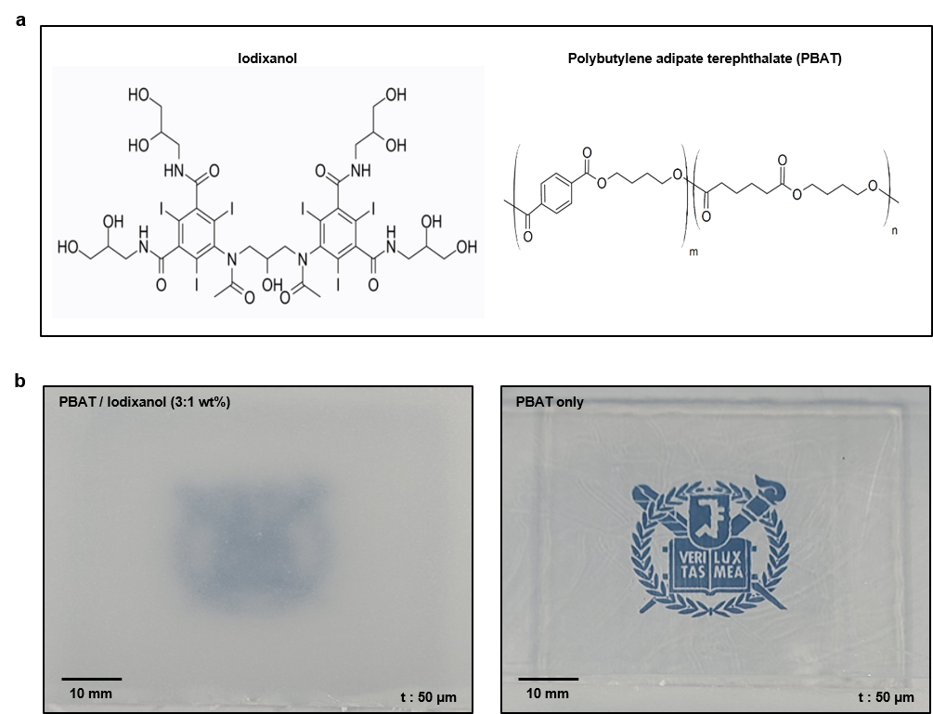

Supplementary figure 8. In vitro verification of X-ray marker.
(a) Optical image of electronic tent without (left) and with X-ray marker (right). (b) X-ray image of electronic tent without (left) and with X-ray marker (right).

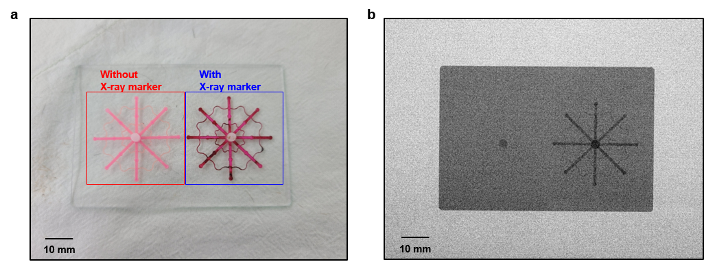

Supplementary figure 9. In vivo verification of X-ray marker.
Sequential process for implanting the electronic tent (total diameter, ~12 mm; PLCL-PLGA, ~50 μm / X-ray marker, ~50 μm / PLCL-PLGA, ~50 μm) under rat brain and imaged by micro CT.

.
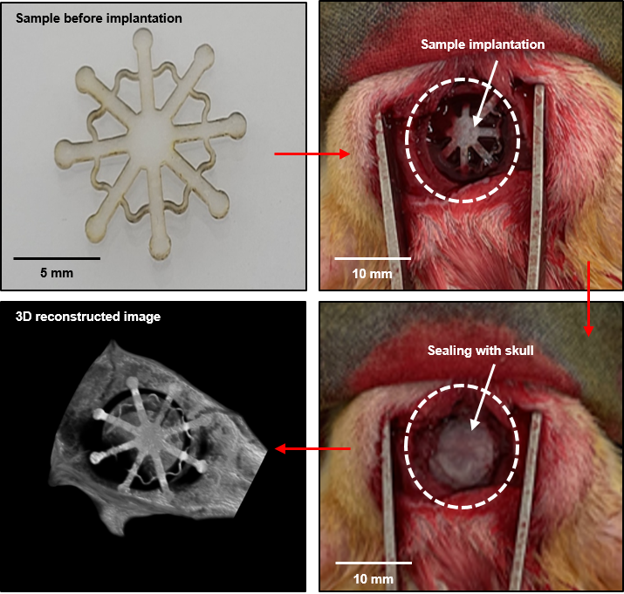

Supplementary figure 10. Injection module.
Images of total injection module (left) and magnified view of injection site (right, inset: the tip of injection tube with water meniscus).

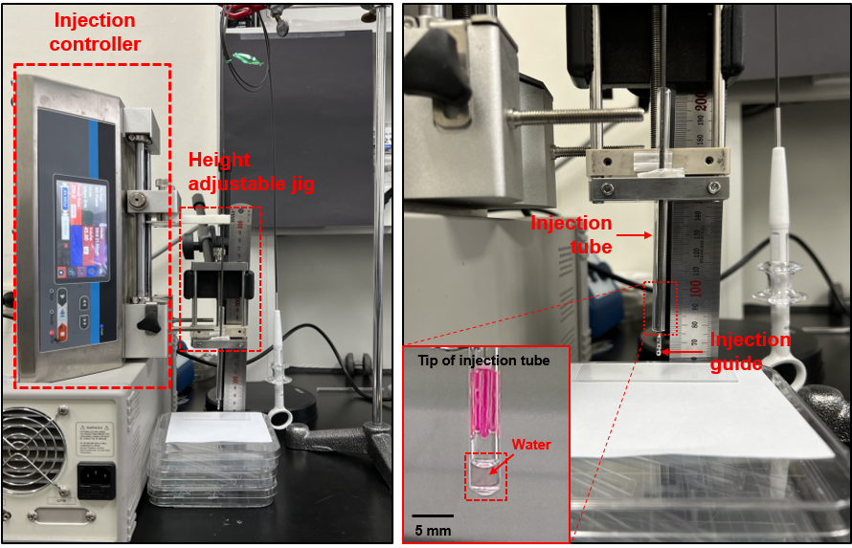

Supplementary figure 11. Device packaging process.
Photographs of sequential suction process of electronic tent (total diameter, ~70 mm) into syringe (inner diameter, ~5 mm).

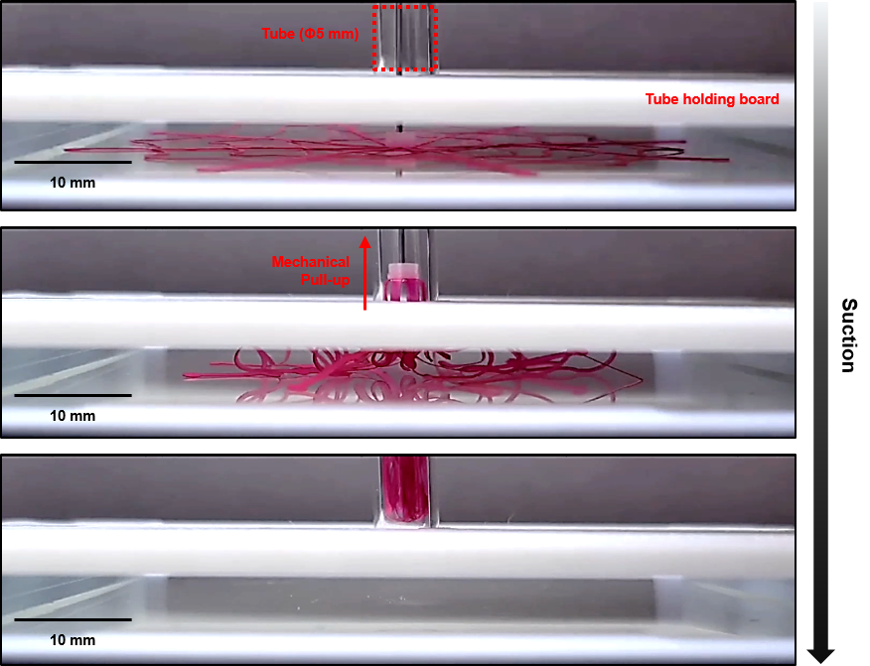

Supplementary figure 12. Simulation of deployment process.
Mechanical analysis (FEA) of representative electronic tent in Fig.1 during deployment at simulated skull structure.

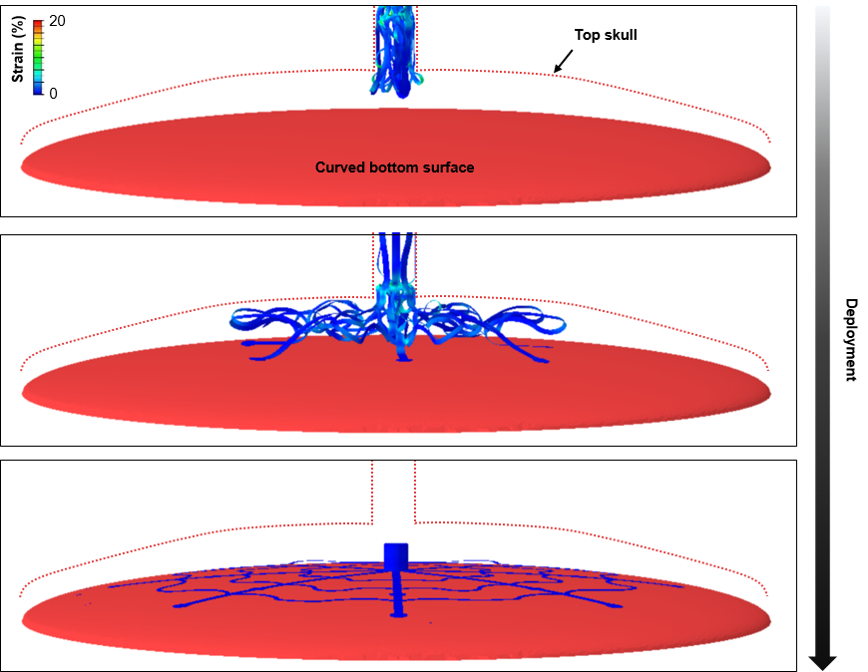

Supplementary figure 13. Functional operation of wireless LED after deployment process.
(a) Experimental set-up for wirelessly power transmission. Transmitter coil was located under 10 mm from deployment zone. (b) Sequential images of deploying process of electronic tent. After device deployment, power (10 V_{pp} @ 10 MHz) was applied to bottom transmitter coil for power transfer.
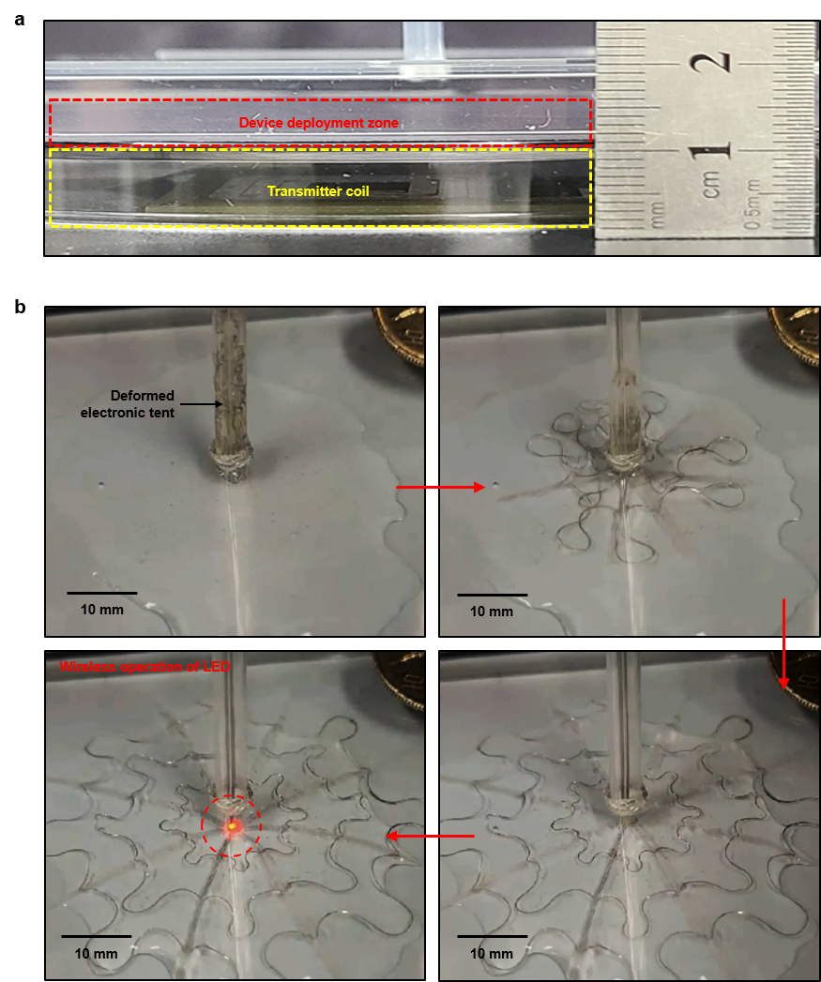

Supplementary figure 14. Dissolution of electronic tent.
Sequential dissolution process of electronic tent integrated with various electronic devices for 45 days in PBS (70 ℃, pH 7.4).

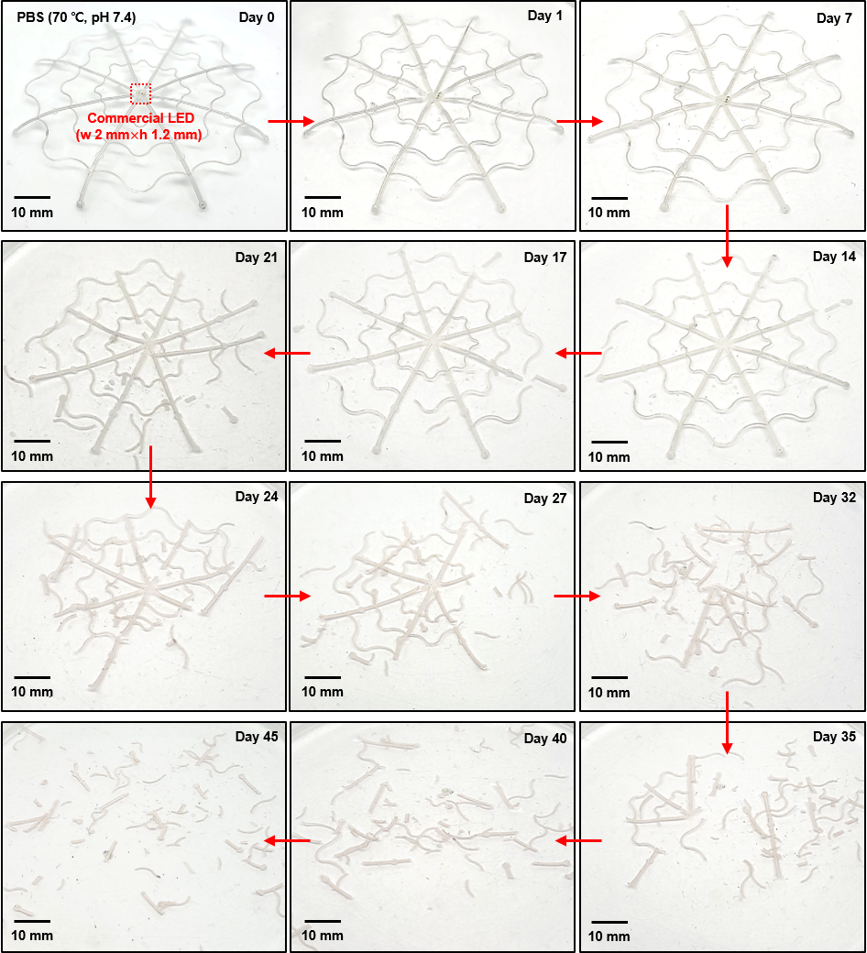

Supplementary figure 15. Functional life-time during dissolution.
Operation life-time of wireless heater immersed in 70 ℃, pH 7.4 PBS. A) Image (left) and performance (right) of wireless heater before PBS immersion. B) Infrared images of wireless heater after 30 s of power transmission for 7 days. Wireless heater was operated at outside of chamber (at room temperature) before solution refreshing.

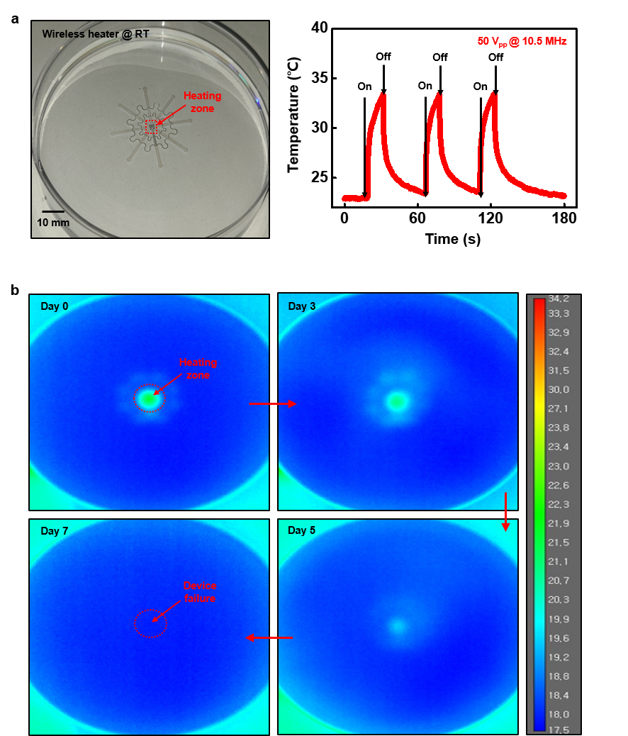
Supplementary figure 16. Circuit degradation process during dissolution
Sequential dissolution images of wireless heater immersed in PBS at 70 ℃, pH 7.4.

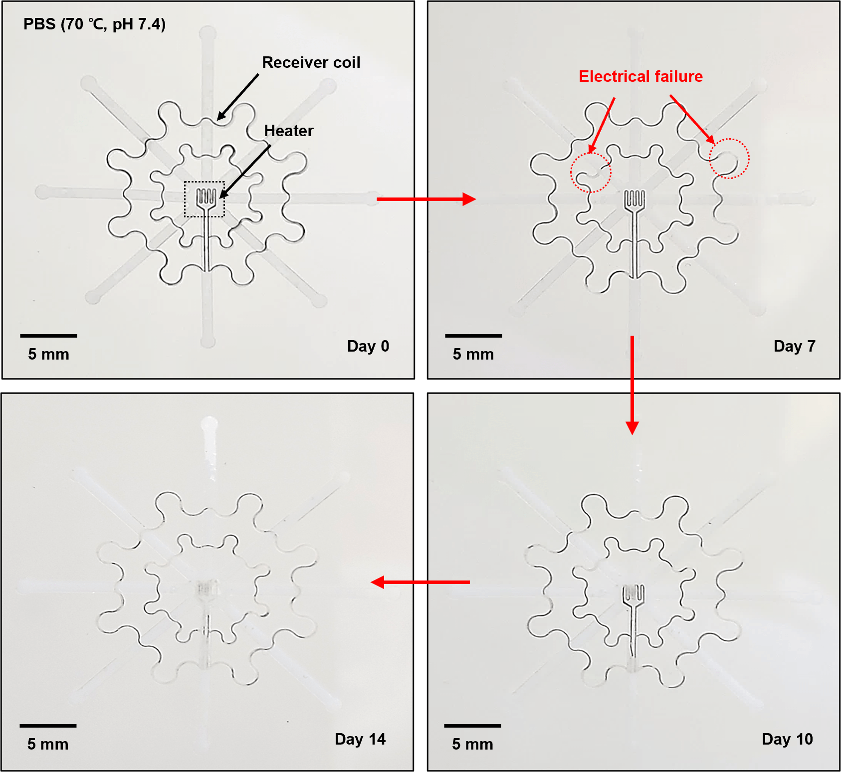

Supplementary figure 17. Simulation of the electronic tent during packaging (upper row, 3D view; bottom row, 2D projection view).

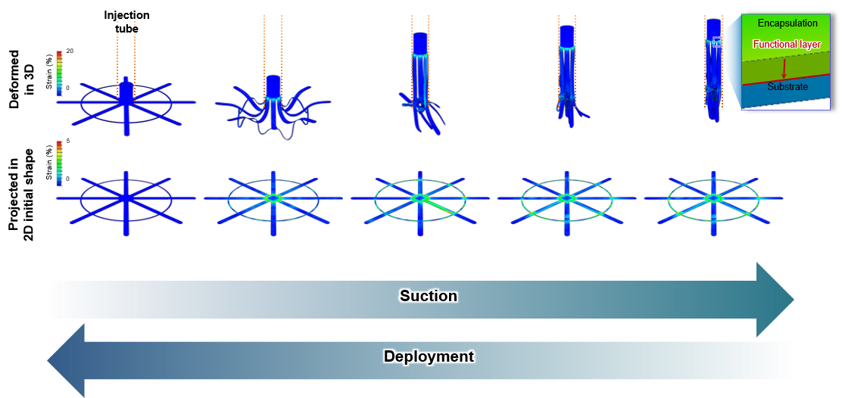

Supplementary figure 18. FEA simulation results of representative shape of electronic tent with mesh and plane structure.
(a) Illustration image shows the representative shape of electronic tent, and the orange circle means the highest strain region due to the maximum filling ratio. (b) Deformed and projected images of FEA result for high strain region with mesh and plane structure. The maximum strain on the mesh structure is 2.78% in the center of support, and the maximum strain in the plane structure is 51.97% on the functional layer.

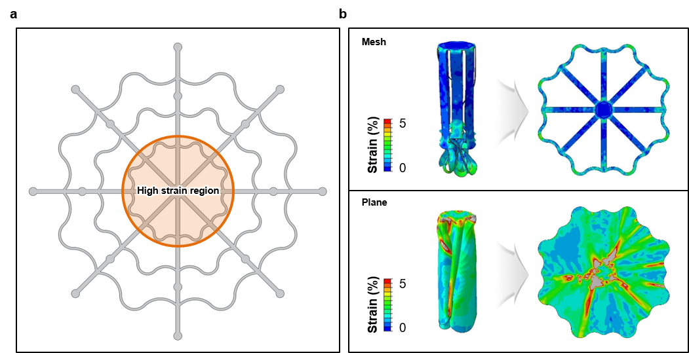

Supplementary figure 19. Strain analysis depending on thickness and filling ratio.
(a) The unit design of the electronic tent shape with various design factors such as support width (W_{S}), chassis width (W_{C}), radius of centrum node (R_{CN}), and support radius (R_{S}). It shows the basic structural design with 1.75 mm of R_{CN}, 1 mm of W_{C}, 10 mm of R_{S}, and 0.5 mm of W_{S}. (b) Plot of the FEA result with the maximum strain depending on the thickness of the substrate and encapsulation layer from the basic structural design factors which is same with (a). (c) Plot of the maximum strain with the filling ratio depending on the different R_{S} for the basic structural design with 1.75 mm of R_{CN}, 1 mm of W_{C}, and 0.5 mm of W_{S} (blue dot, FEA results; blue dotted line, fitted result with the equation 1 and S7 in the manuscript).

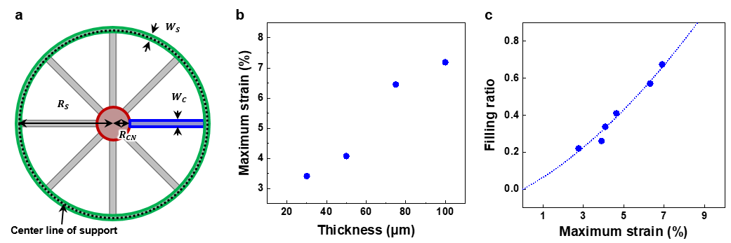

Supplementary figure 20. Strain analysis depending on the geometry.
(a) Plot of the maximum strain depending on the different W_{C} for the basic structural design with 1.75 mm of R_{CN}, 10 mm of R_{S}, and 0.5 mm of W_{S}. (b) Plot of the maximum strain depending on the different R_{S} for the basic structural design with 1.75 mm of R_{CN}, 1 mm of W_{C}, and 0.5 mm of W_{S}. (C) Plot of the maximum strain depending on the different W_{S} for the basic structural design with 1.75 mm of R_{CN}, 1 mm of W_{C}, and 10 mm of R_{S}.

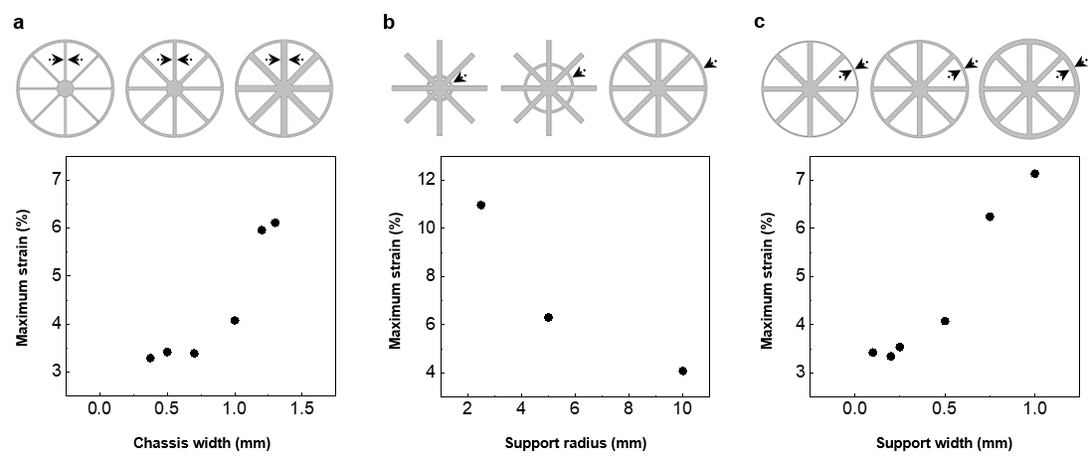

Supplementary figure 21. Strain analysis depending on the combined design factors.
(a) Plot of the maximum strain depending on the ratio between support width and the chassis width. The maximum strain can be different depending on the ratio between the support width and the chassis width with same filling ratio due to unstable deformation. (b) Different aspect of change of the maximum strain depending on the shrinkage ratio which is the ratio between the coverage area by unit area (A_{C}) and the syringe area (A_{S}).

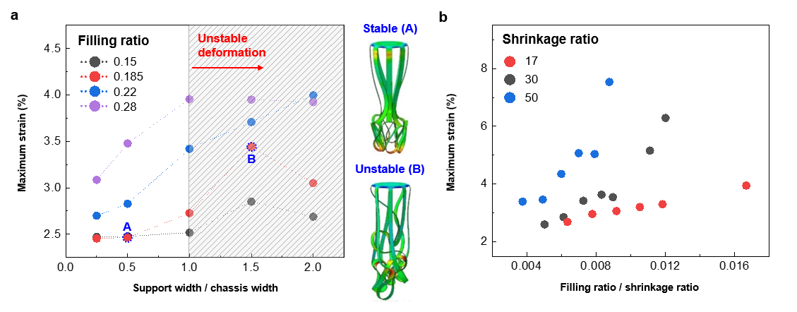

Supplementary figure 22. Experimental results of the relation between filling ratio and electrical resistance.
(a) Tables of sample geometry at filling ratio of 0.17, 0.27 and 0.38. (b) Images (left) and change of electrical resistance (right, blue; filling ratio of 0.38, red; filling ratio of 0.27, black; filling ratio of 0.17) during suction process.

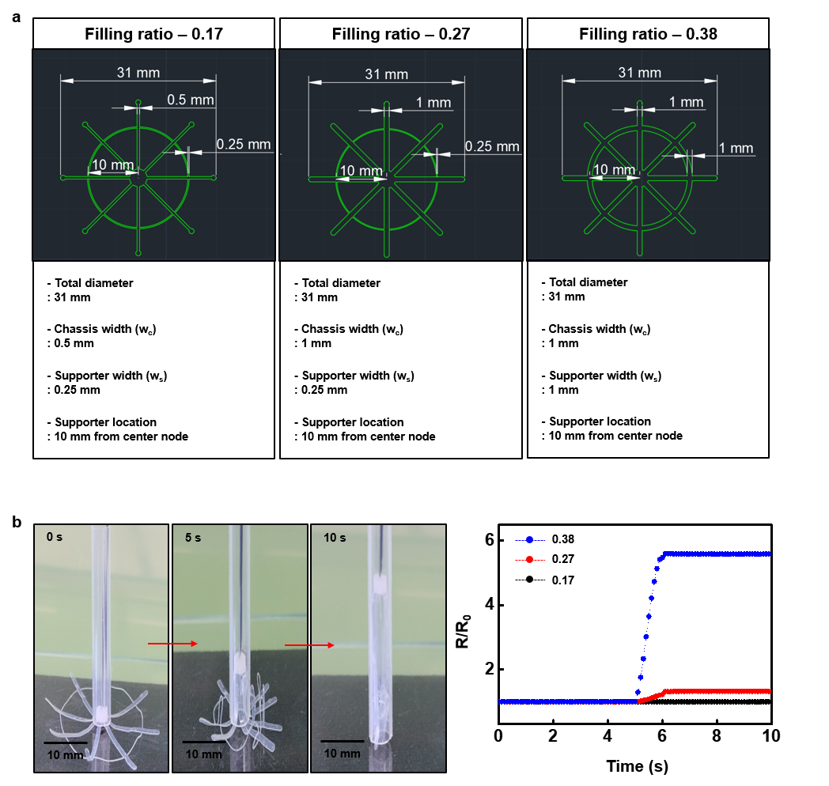

Supplementary figure 23. Chassis behavior at initial stage of the deployment process.
(a) Plot of the chassis behavior from the FEA results with or without the friction (red dot, the chassis behavior without the friction; gray dot, the chassis behavior with 0.1 of friction coefficient; dotted lines, fitted lines with equation 2). (b) Plot of the chassis behavior from the FEA results depending on the friction coefficient with two different chassis angles (red dot, 60˚ of chassis angle; gray dot, 65˚ of chassis angle).

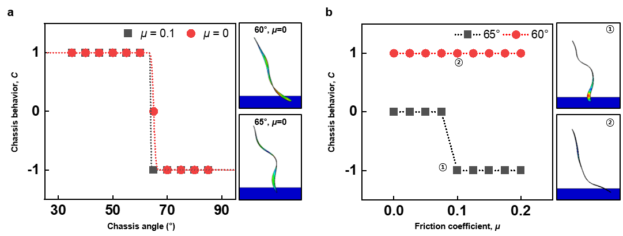

Supplementary figure 24. D_{threshold} depending on the design factors.
D_{threshold} with various (a) Chassis number and (b) support width (red dot, FEA results; gray dot, experimental results).

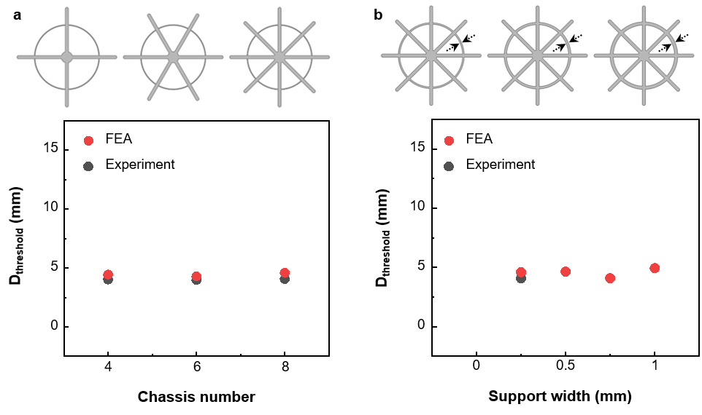

Supplementary figure 25. In vivo experimental set-up for deployment of electronic tent in canine model.

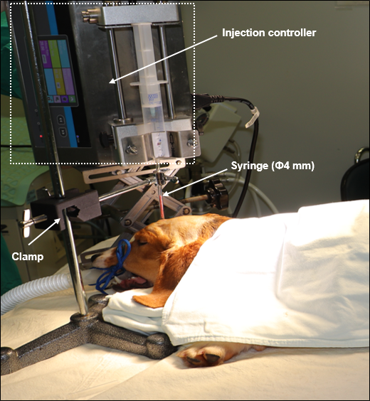

Supplementary figure 26. Water soluble lubricant.
(a) Chemical structure of glycerin (left), and lubricant effect during deploying on pig skin (right). (b) Output response from electrode coated with (red) and without (black) glycerin in PBS at 37 ℃, pH 7.4. Output response of electrode with lubricant gradually recovered original SNR with time.

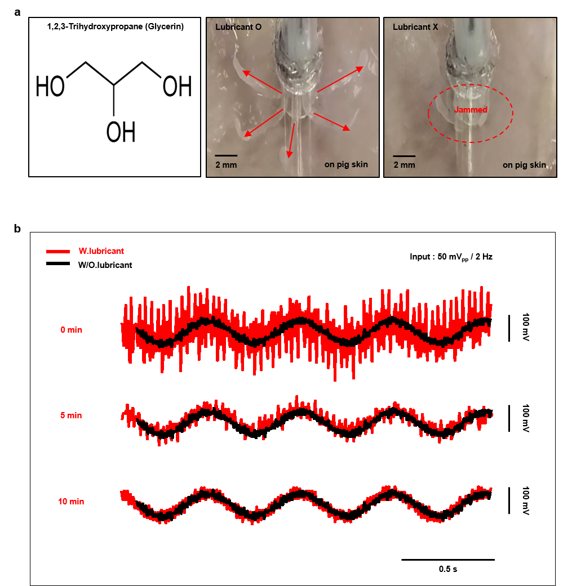
Supplementary figure 27. Ex vivo deployment process of electronic tent coated with glycerin. (a) Experimental set-up and (b) sequential deploying process on pig brain.

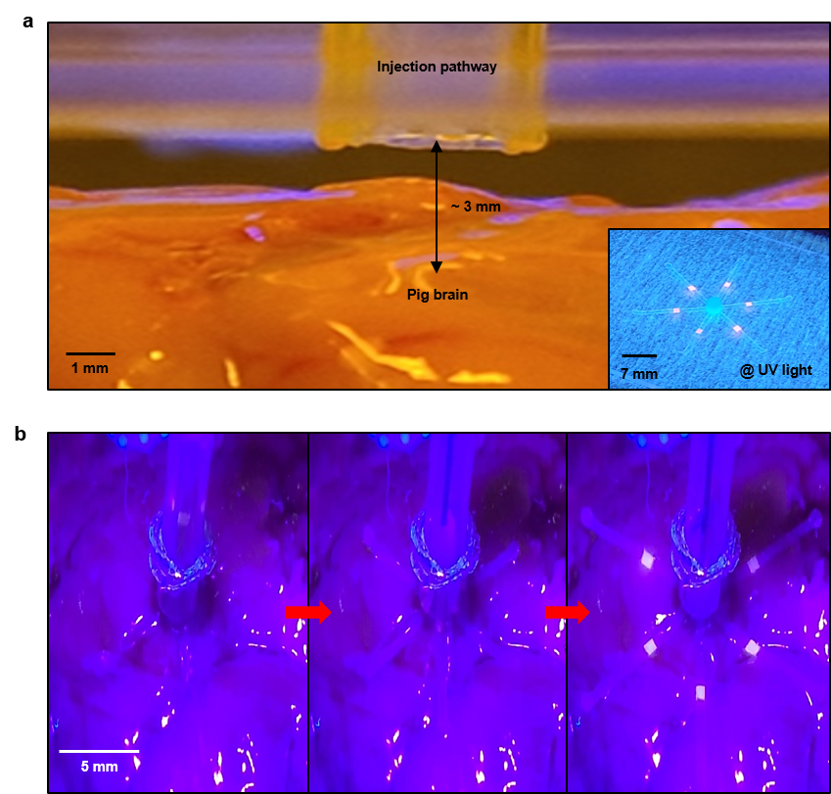

Supplementary figure 28. Fluorescent method.
(a) Chemical structure of rhodamine B for fluorescence under UV light and (b) Image of electronic tent dyed with rhodamine B. Image was obtained under UV light irradiation (365 nm wavelength).

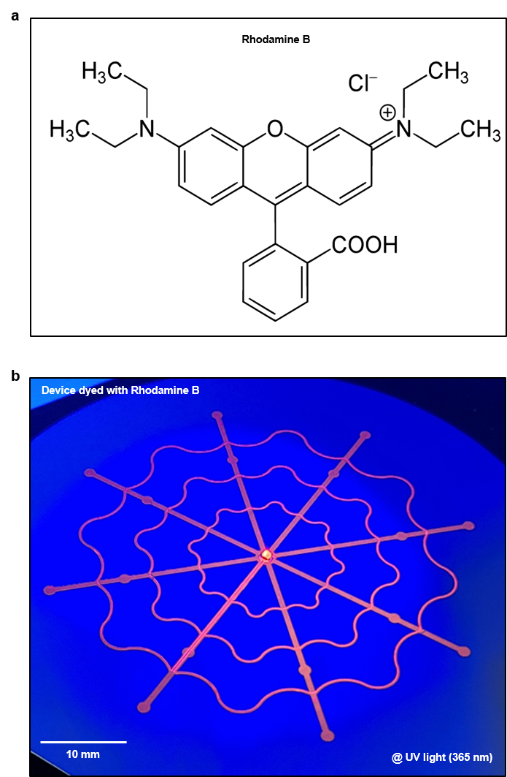
Supplementary figure 29. 3D printed transparent skull replica.
(a) 3D reconstructed image of the canine skull. Image were obtained by C-arm system. The skull replica was obtained from orange area. (b) Photographs of skull replica (left; side view, right; top view)

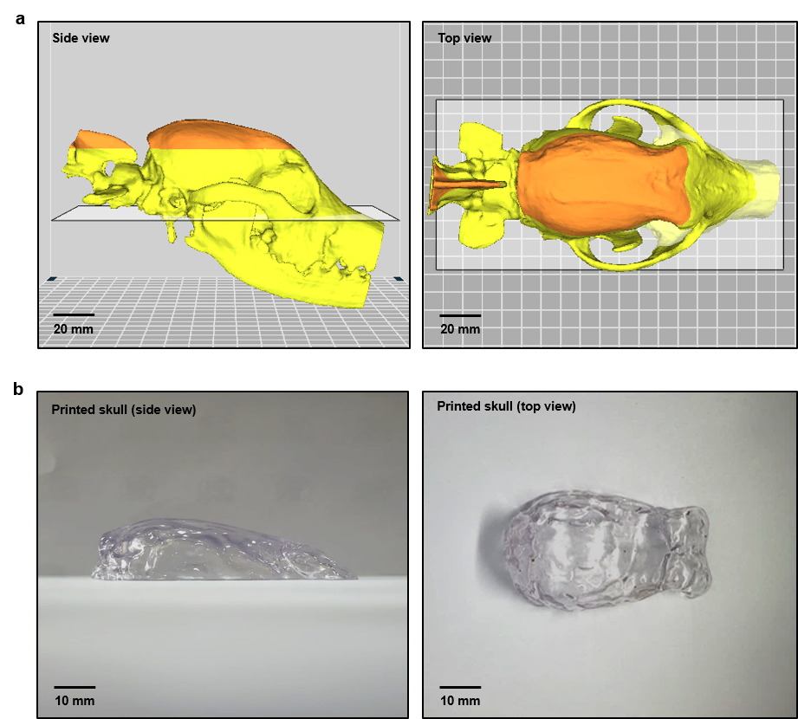

Supplementary figure 30. Image of replaced skull replica for visualizing the shape deployment process.

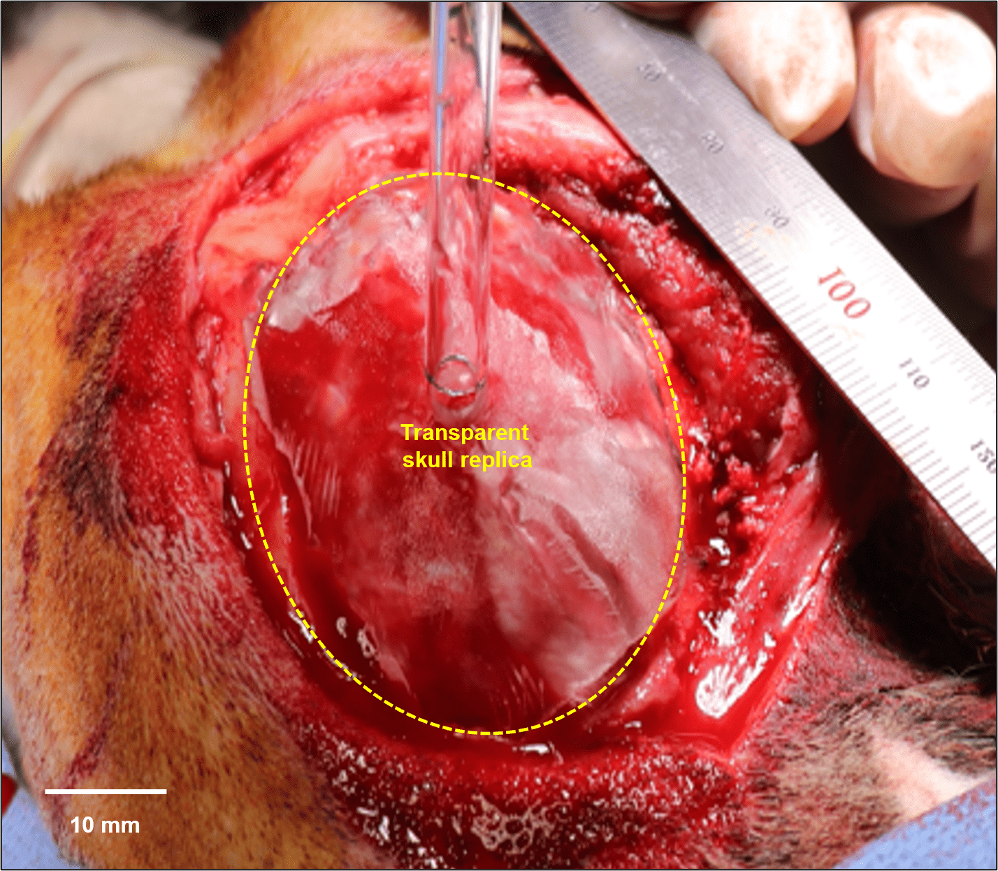

Supplementary figure 31. I/O interface.
(a) CAD images of bottom substrate (left) and 2-channel electrode on single chassis substrate (right). (b) Photograph of 16-channel electrode with I/O interfaces integrated on electronic tent (right). Schematic illustration on left side shows the magnified view of folded chassis device fixed on the PCL solid support.

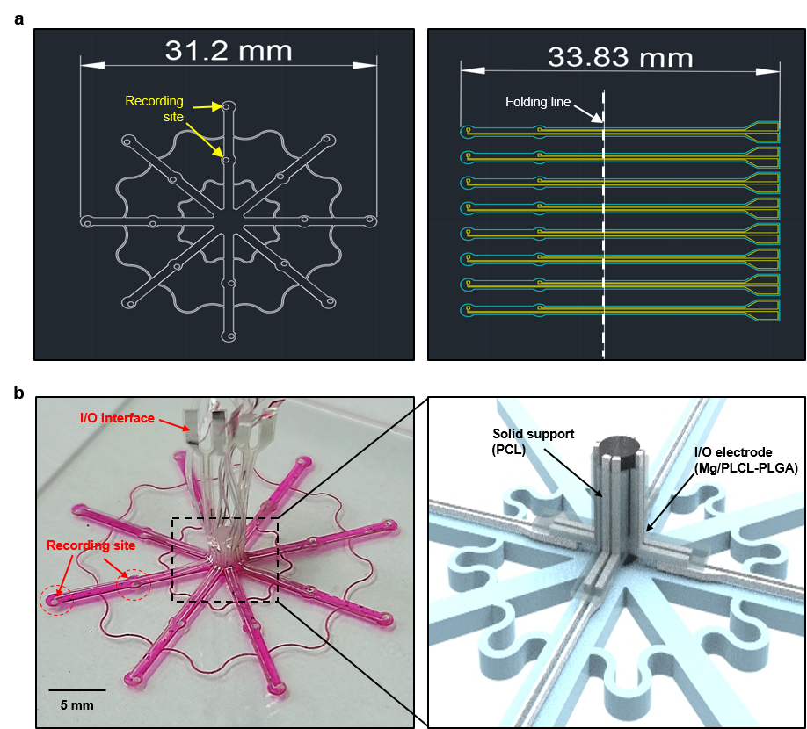

Supplementary figure 32. In vitro deployment and cable connection process of 16 channel electrodes with I/O interfaces integrated on electronic tent on 1% agar gel.

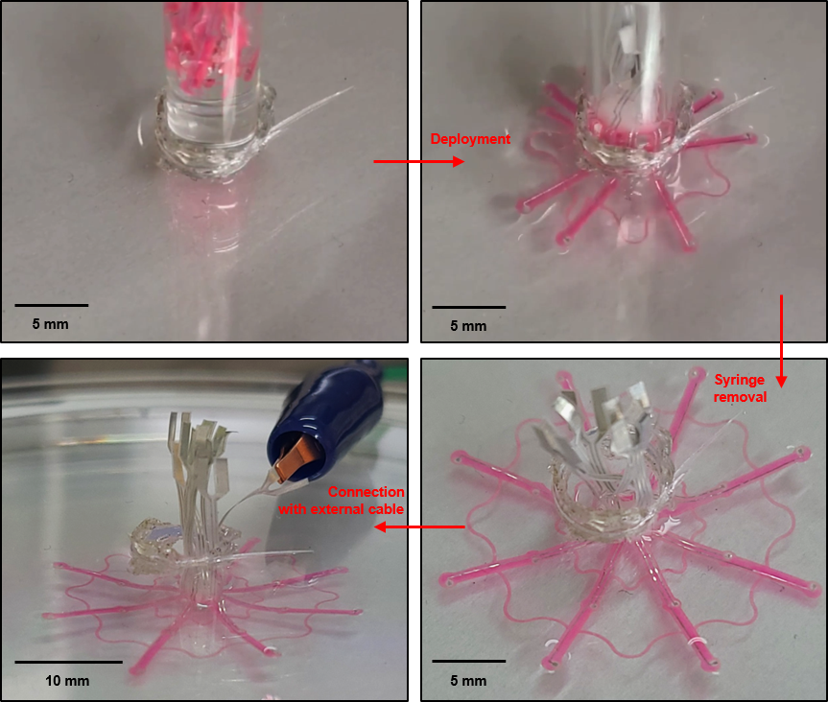

Supplementary figure 33. Validation of I/O interface.
(a) Experiment set-up for verification of I/O interfaces integrated on electronic tent. (b) Output response of I/O interface measured from oscilloscope. Input signal (50 mV_{pp} / 2 Hz) was generated from function generator connected with 1% agar-gel substrate.

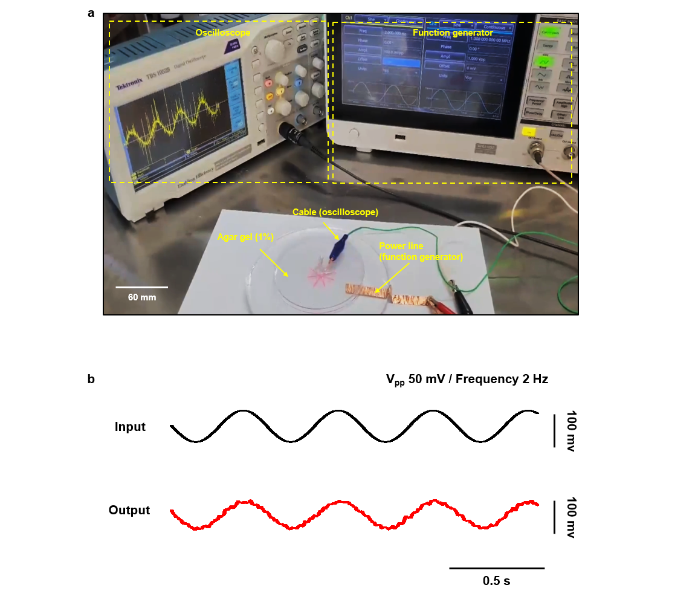

Supplementary figure 34. In vivo ECoG recording process with sciatic nerve stimulation for evoking the somatosensory evoked potential on the motor cortex.

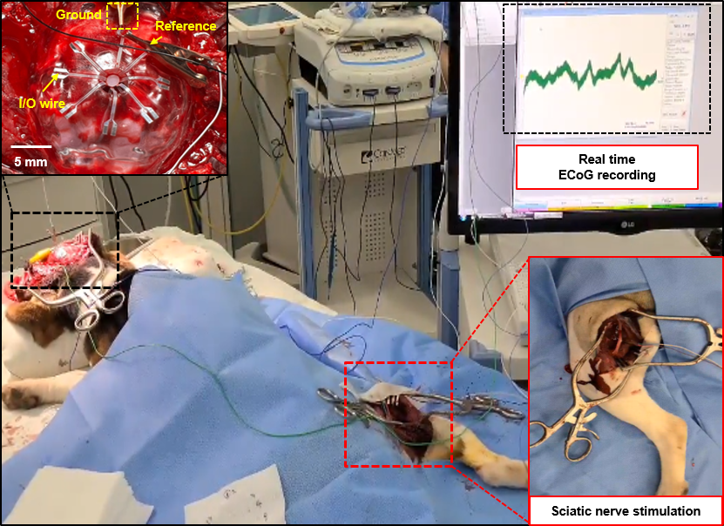

Supplementary figure 35. ECoG data recorded by 16-channel Mo electrode arrays during right sciatic nerve stimulation.

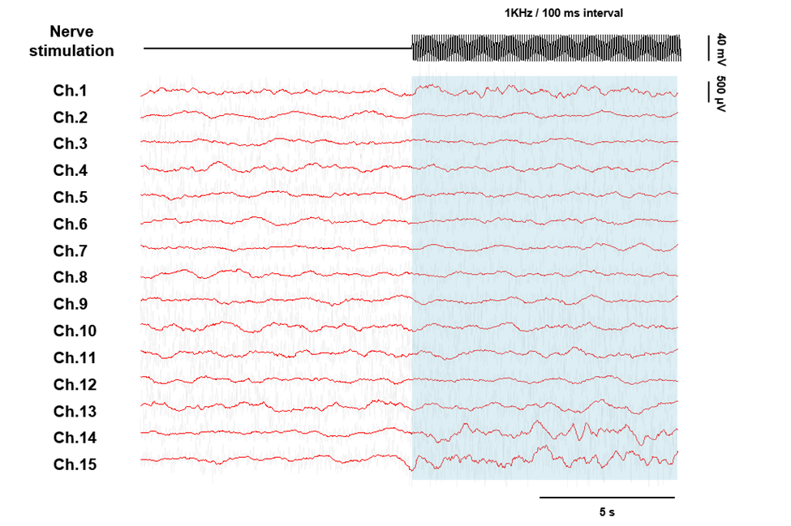

Supplementary figure 36. Frequency analysis of ECoG during left and right sciatic nerve stimulation. (a) Recorded ECoG. (b) Time-frequency power spectrum. (c) Power density spectrum.

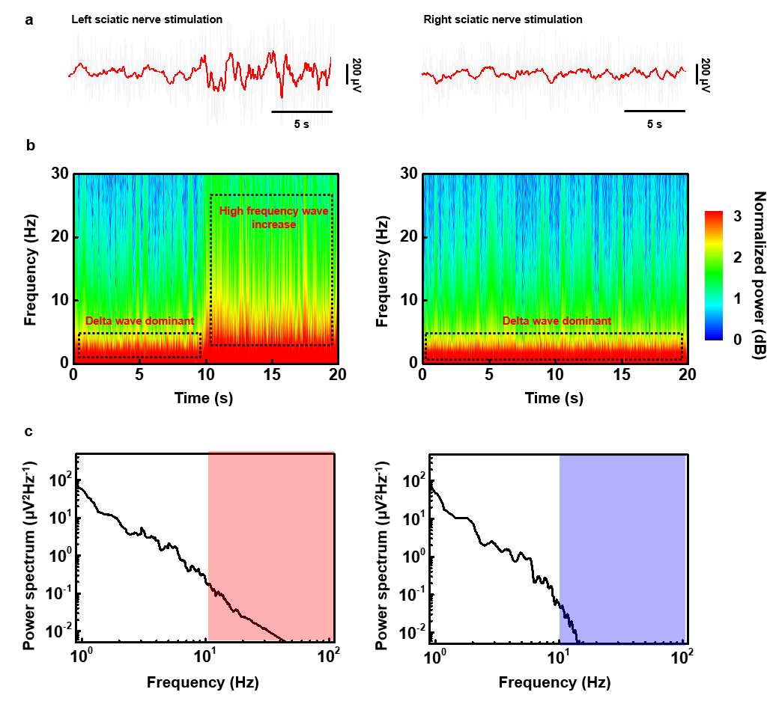

Supplementary figure 37. C-arm images (bottom to top view) of deployed electronic tent for 7 days in canine model.

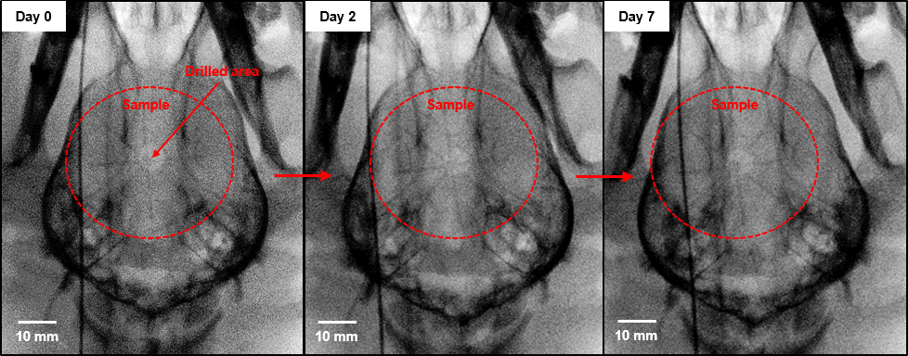

Supplementary figure 38. Animal status after device deployment.
(a) Images of surgical site of animal right after suturing and protector layer. (b) A photograph of freely moving beagle with head cone after a day.

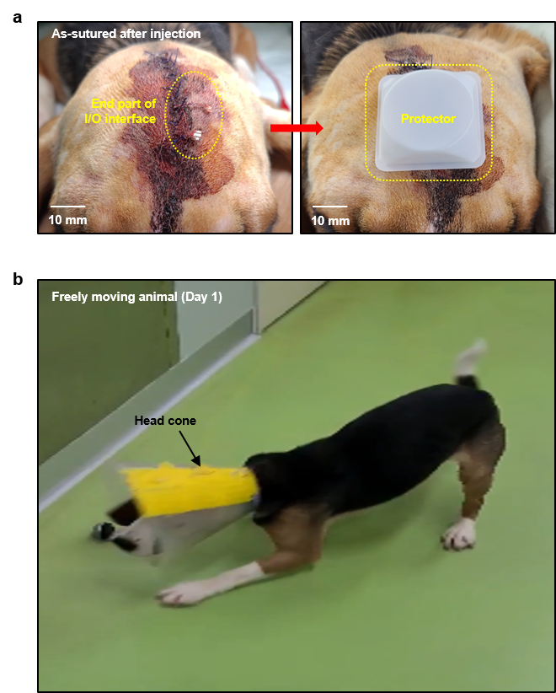

Supplementary figure 39. Impedance change of molybdenum electrode at 1 kHz with (black) and without (red) encapsulation layer immersed in 37 ℃, pH 7.4 PBS.

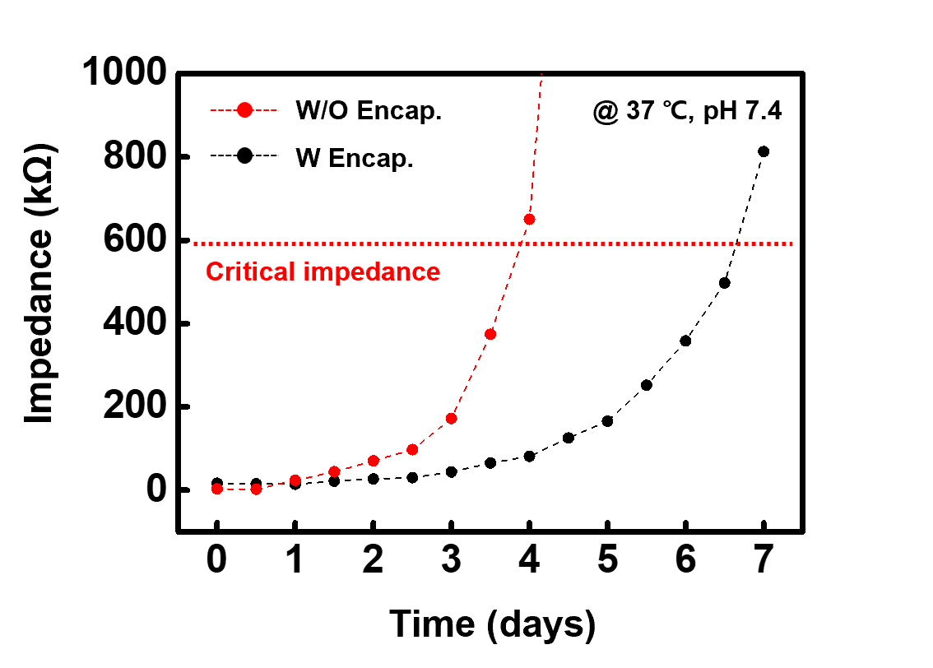

Supplementary figure 40. Design of active electrode arrays.
(a) A photograph and (b) CAD image of 32 channel active electrode arrays on electronic tent. (c) 2$×$2 unit cell on single chassis substrate.

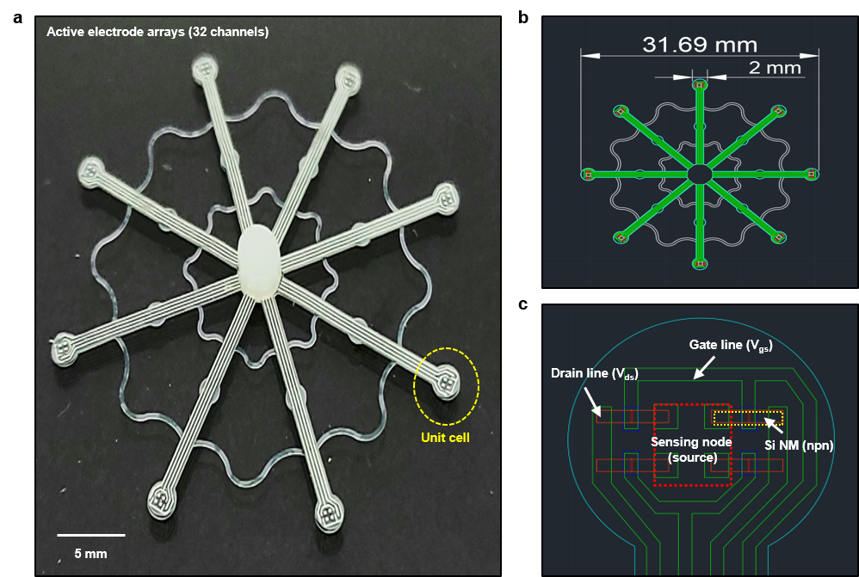

Supplementary figure 41. Electrical properties of MOSFET based active electrode.
(a) IV curve and (b) transfer curve of n-channel MOSFET.

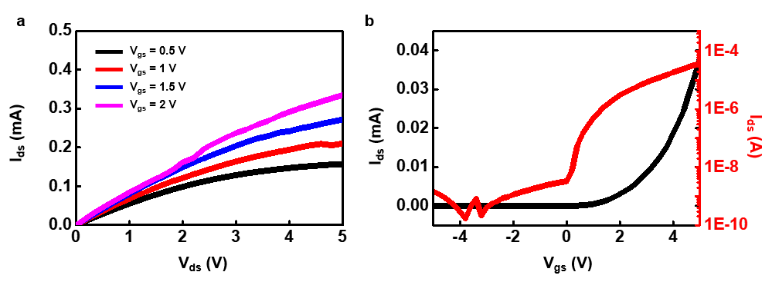

Supplementary figure 42. Experimental set-up for active electrode operation and data acquisition. Gate voltage and input signal were given by function generator, and input signal and output signal were recorded by oscilloscope and multichannel recorder, respectively.

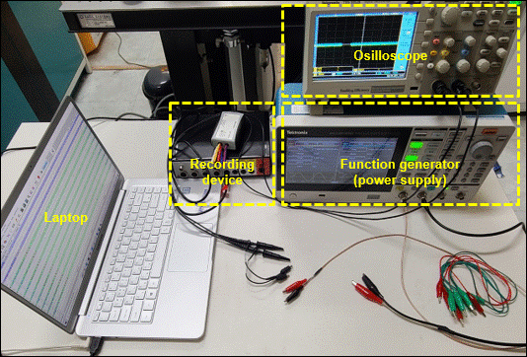

Supplementary figure 43. On/off characteristics of active electrode.
(A) Circuit diagram of active electrode (single unit). (B) On/off characteristics of active electrode with various gate voltage (V_{gs}).

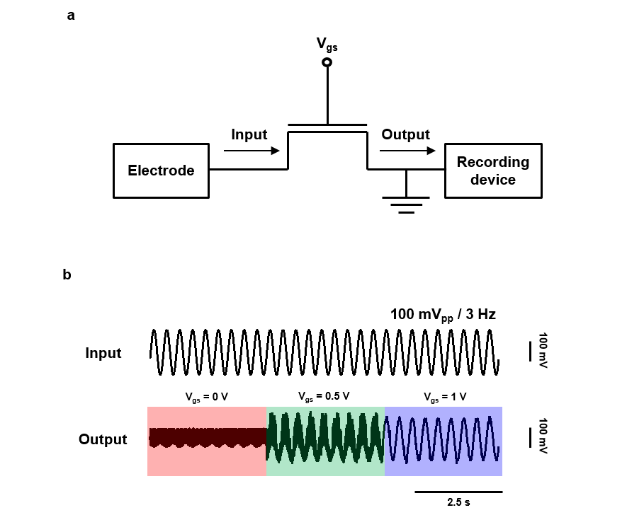

Supplementary figure 44. Switching characteristics of active electrode arrays.
(a) Circuit diagram of active electrode (2$×$2 unit cell). (b) Switching behavior of each channel with change of V_{gs}.

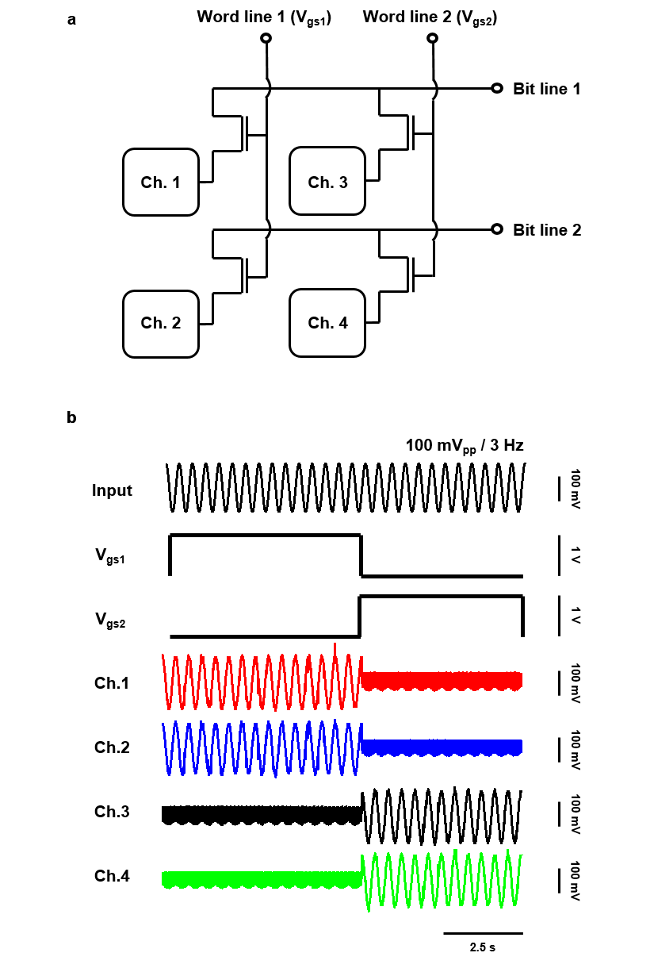

Supplementary figure 45. Design of total device with inductive coupled coil and NFC operation circuit for in vivo experiment.
(a) A photograph (inset; magnified view of via with dyed layer) and (b) CAD image of various sensor (strain and temperature) and actuator (heater) on electronic tent. (c) NFC operation circuit located on center node of electronic tent.

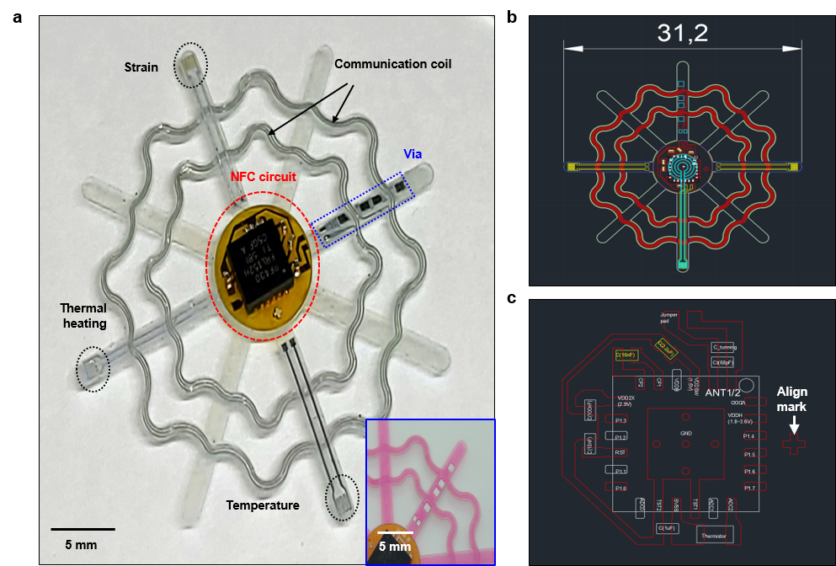

Supplementary figure 46. Frequency dependent impedance (red) and phase (blue) behavior of NFC based wireless system.

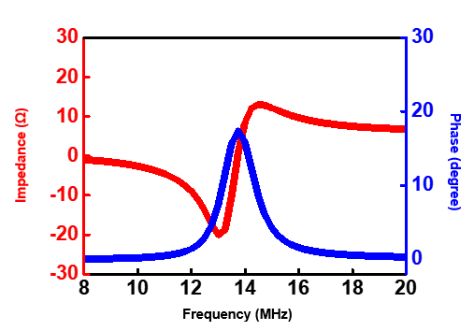

Supplementary figure 47. Verification of NFC based wireless sensors.
(a) Temperature measurement on hot plate from 25 ℃ to 40 ℃, compared to IR imaging. (b) Thermal conductivity measurement of sensor immersed in various liquid, compared to same temperature sensor (Mg, ~500 nm) with wiring. calibration data. (c) Strain measurement during bending deformation, compared to same strain sensor (boron-doped Si NM, ~400 nm) with wiring.

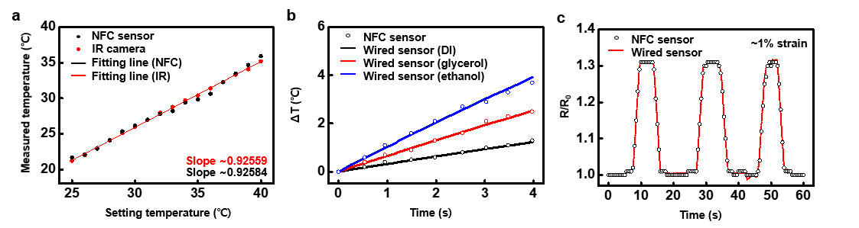

Supplementary figure 48. In vivo wireless monitoring process with NFC operation program. Images show the example of wireless temperature monitoring. The heating process was carried out through IR irradiation, while the cooling process conducted naturally.

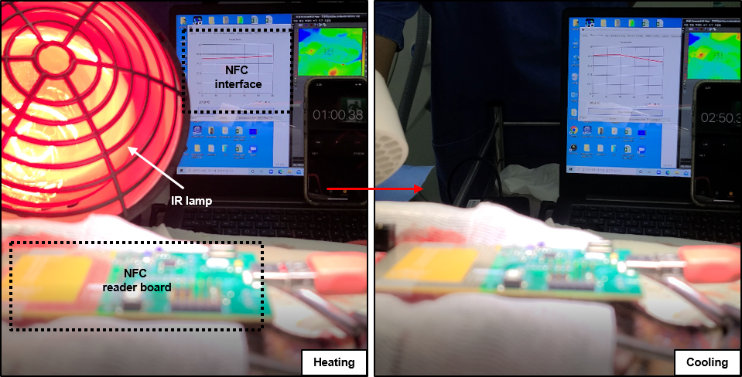

Supplementary figure 49. Images of extracted electronic tent from rat brain at various time stage (day 14, 42, and 70).

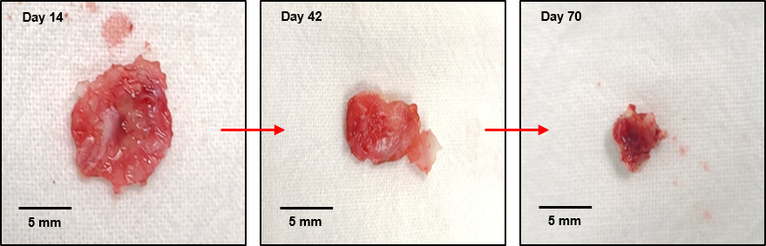

Supplementary figure 50. Histological evaluation of the excised brain tissue.
(a) H&E staining and (b) TUNEL assay (scale bar, 500 μm). No notable toxicity was observed from the tissue at 2, 4, and 6 weeks after implantation.

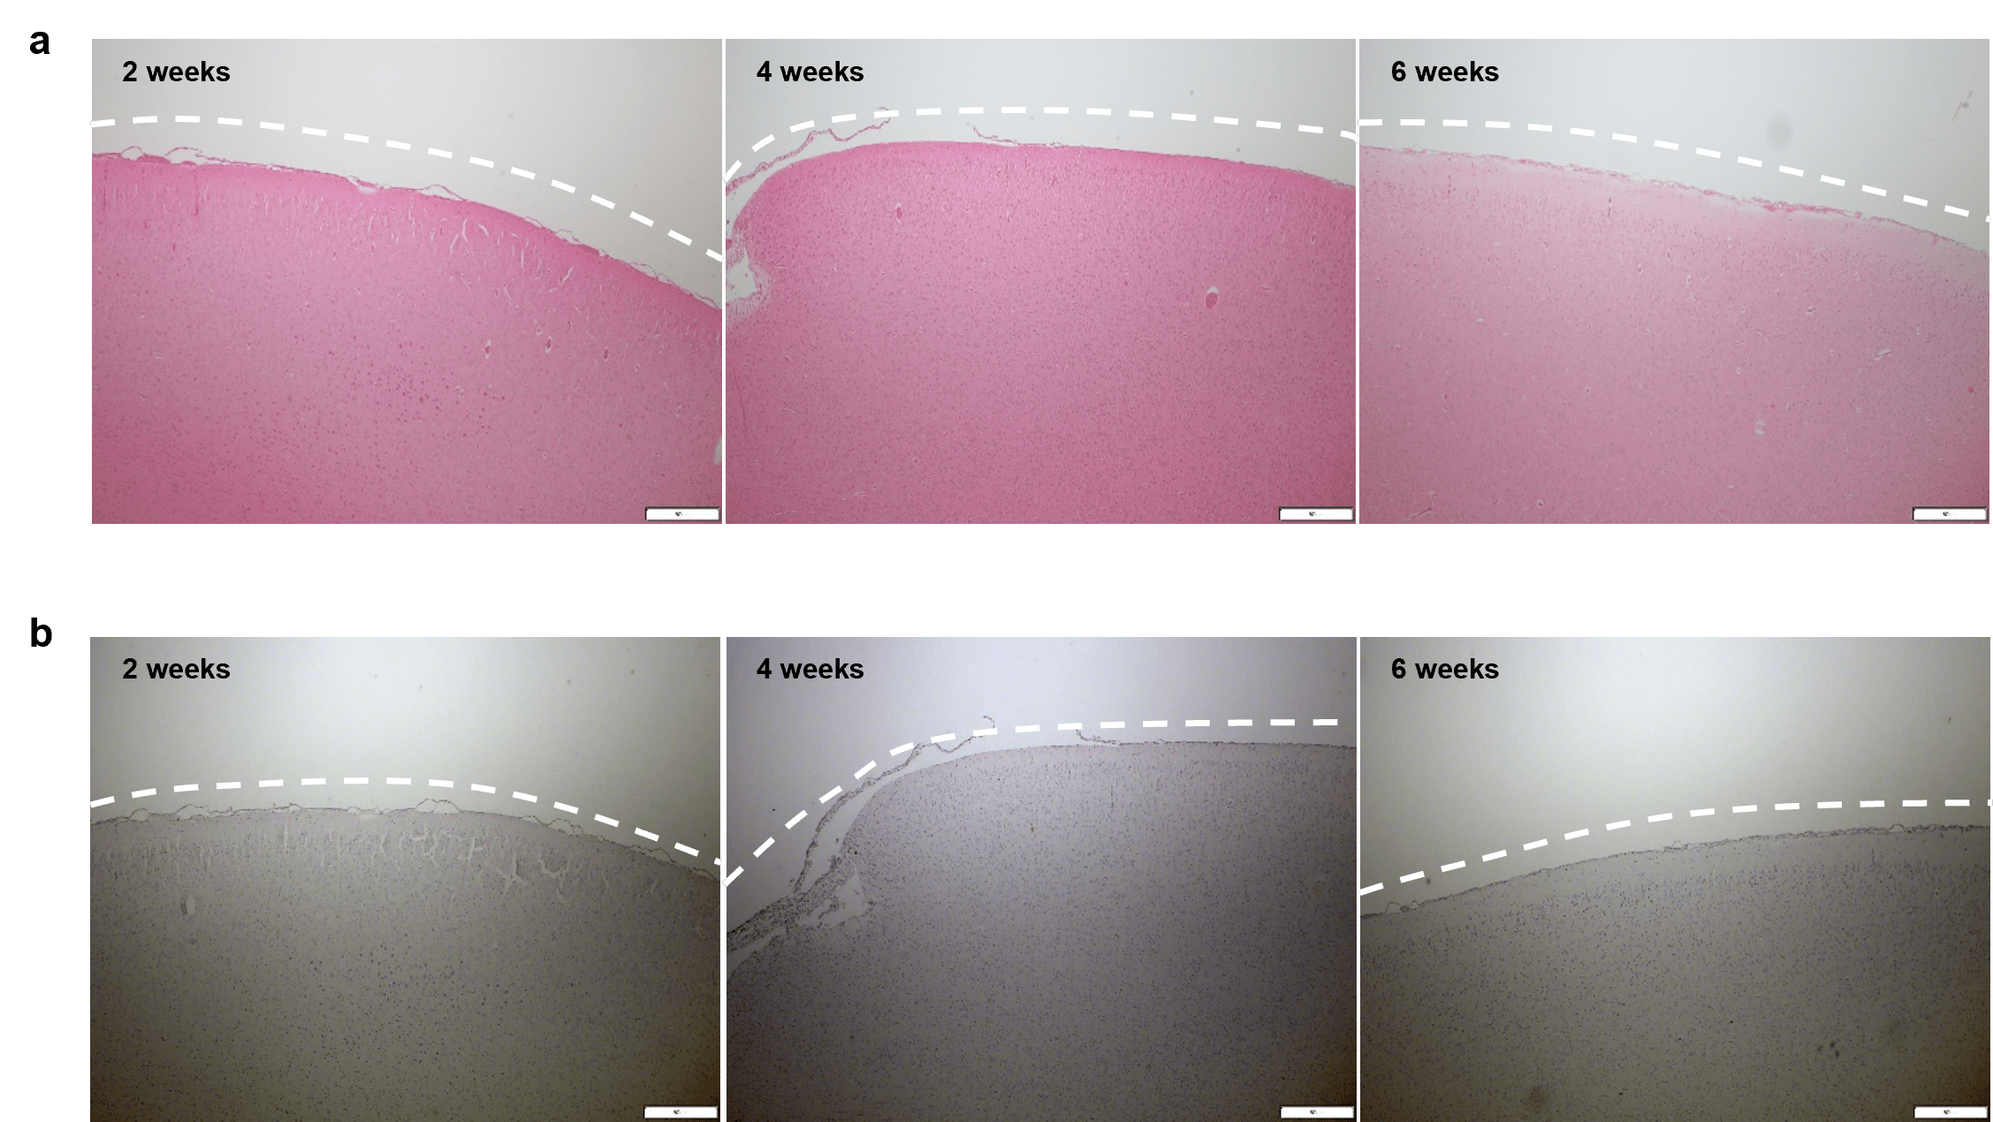

Supplementary figure 51. Magnetic resonance images (coronal view) after 1 weeks implantation.

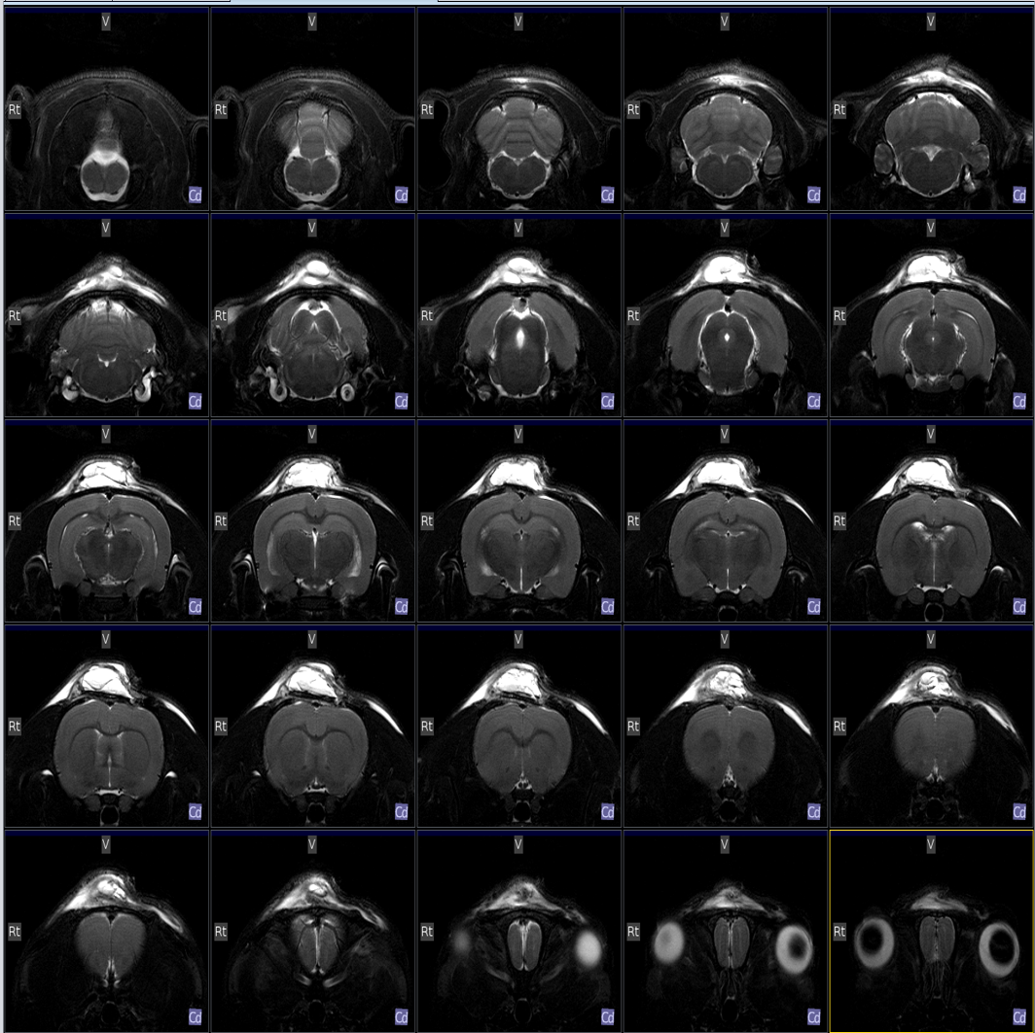

Supplementary figure 52. Magnetic resonance images (coronal view) after 6 weeks implantation.

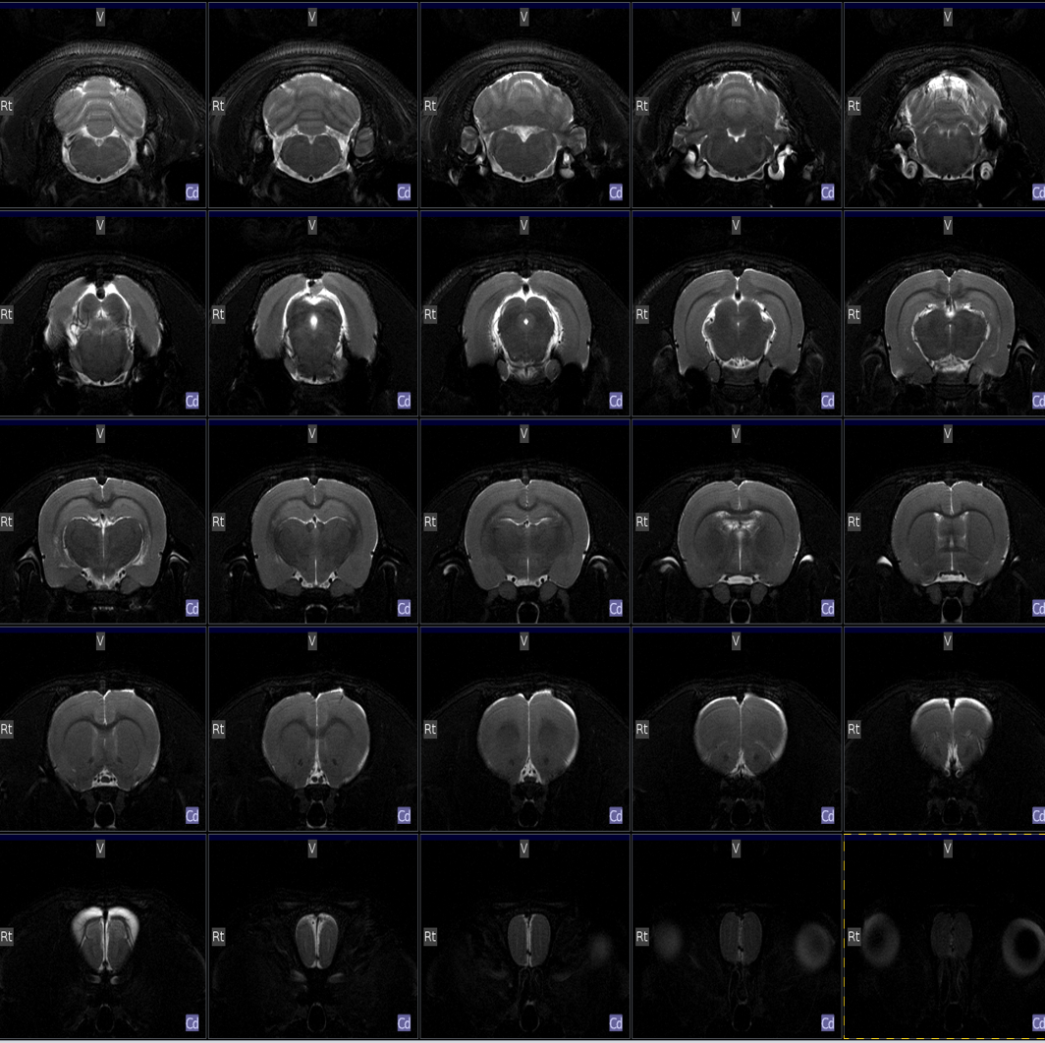

Supplementary figure 53. Weight change of rat (black, implanted rat; red, native rat) with implantation of electronic tent for 6 weeks.

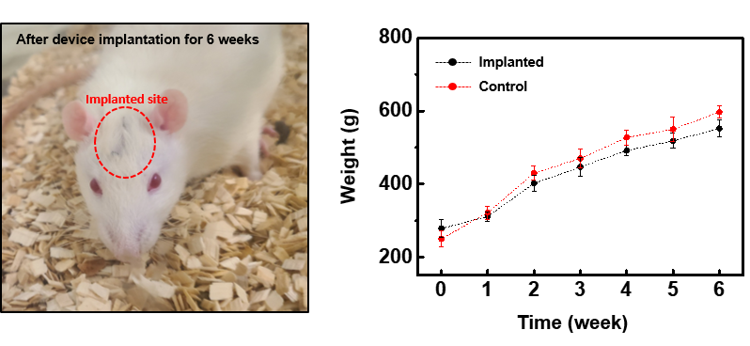

Supplementary table 1. Hydrolysis characteristics of the component materials.

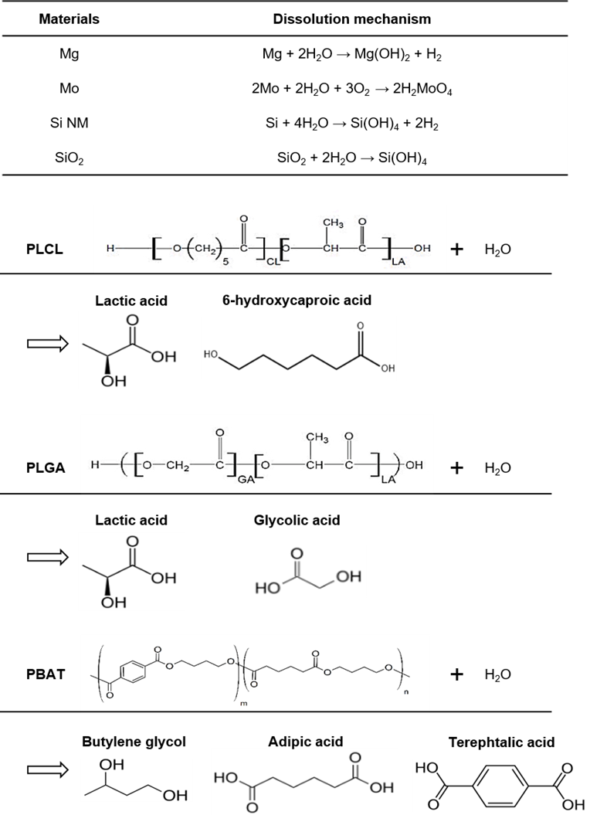

Supplementary video 1. Programmable-packaging and self-deployment (in vitro).
Supplementary video 2. Wireless LED operation after deployment (in vitro).
Supplementary video 3. FEM analysis during programmable-packaging.
Supplementary video 4. Real-time deployment in canine model.
Supplementary video 5. Wireless monitoring (temperature).
Supplementary video 6. Animal’s quick recovery (after 1 day movement).

