Efficacy and safety of Fezolinetant in moderate to severe vasomotor symptoms associated with menopause: A systematic review and meta-analysis.
Hamdy Khaled Sabra^{1,2,#}, Aya M Fayoud^{2,3,#}, Mai Alaaeldin Temraz Elsebaie^{2,4}, Mohammad Hamad^{2,5}, Abdelmonem Siddiq^{2,6}, Ibraheem M. Kereet^{2,7}, Iman Abdelhady Elshnoudy^{1,2}, Noran Magdy Shalma^{1,2}, Mariam Mahmoud Mohamed Elewidi^{1,2}

Table S1. PRISMA checklist for Abstract
Section and Topic | Item # | Checklist item | Reported (Yes/No)
TITLE
Title | 1 | Identify the report as a systematic review. | yes
BACKGROUND
Objectives | 2 | Provide an explicit statement of the main objective(s) or question(s) the review addresses. | yes
METHODS
Eligibility criteria | 3 | Specify the inclusion and exclusion criteria for the review. | yes
Information sources | 4 | Specify the information sources (e.g. databases, registers) used to identify studies and the date when each was last searched. | yes
Risk of bias | 5 | Specify the methods used to assess risk of bias in the included studies. | no
Synthesis of results | 6 | Specify the methods used to present and synthesise results. | yes
RESULTS
Included studies | 7 | Give the total number of included studies and participants and summarise relevant characteristics of studies. | yes
Synthesis of results | 8 | Present results for main outcomes, preferably indicating the number of included studies and participants for each. If meta-analysis was done, report the summary estimate and confidence/credible interval. If comparing groups, indicate the direction of the effect (i.e. which group is favoured). | yes
DISCUSSION
Limitations of evidence | 9 | Provide a brief summary of the limitations of the evidence included in the review (e.g. study risk of bias, inconsistency and imprecision). | no
Interpretation | 10 | Provide a general interpretation of the results and important implications. | yes
OTHER
Funding | 11 | Specify the primary source of funding for the review. | no
Registration | 12 | Provide the register name and registration number. | no

Table S2. PRISMA Checklist for manuscript
Section/Topic | Item # | Checklist Item | Reported on Page #
TITLE
Title | 1 | Identify the report as a systematic review incorporating a network meta-analysis (or related form of meta-analysis). | 1
ABSTRACT
Structured summary | 2 | Provide a structured summary including, as applicable:  Background: main objectives  Methods: data sources; study eligibility criteria, participants, and interventions; study appraisal; and synthesis methods, such as network meta-analysis.  Results: number of studies and participants identified; summary estimates with corresponding confidence/credible intervals; treatment rankings may also be discussed. Authors may choose to summarize pairwise comparisons against a chosen treatment included in their analyses for brevity.  Discussion/Conclusions: limitations; conclusions and implications of findings.  Other: primary source of funding; systematic review registration number with registry name. | NA
INTRODUCTION
Rationale | 3 | Describe the rationale for the review in the context of what is already known, including mention of why a network meta-analysis has been conducted. | 3
Objectives | 4 | Provide an explicit statement of questions being addressed, with reference to participants, interventions, comparisons, outcomes, and study design (PICOS). | 3
METHODS
Protocol and registration | 5 | Indicate whether a review protocol exists and if and where it can be accessed (e.g., Web address); and, if available, provide registration information, including registration number. | NA
Eligibility criteria | 6 | Specify study characteristics (e.g., PICOS, length of follow-up) and report characteristics (e.g., years considered, language, publication status) used as criteria for eligibility, giving rationale. Clearly describe eligible treatments included in the treatment network and note whether any have been clustered or merged into the same node (with justification). | 3
Information sources | 7 | Describe all information sources (e.g., databases with dates of coverage, contact with study authors to identify additional studies) in the search and date last searched. | 3
Search | 8 | Present full electronic search strategy for at least one database, including any limits used, such that it could be repeated. | 3
Study selection | 9 | State the process for selecting studies (i.e., screening, eligibility, included in systematic review, and, if applicable, included in the meta-analysis). | 3,4
Data collection process | 10 | Describe method of data extraction from reports (e.g., piloted forms, independently, in duplicate) and any processes for obtaining and confirming data from investigators. | 4
Data items | 11 | List and define all variables for which data were sought (e.g., PICOS, funding sources) and any assumptions and simplifications made. | 10, 11
Geometry of the network | S1 | Describe methods used to explore the geometry of the treatment network under study and potential biases related to it. This should include how the evidence base has been graphically summarized for presentation, and what characteristics were compiled and used to describe the evidence base to readers. | NA
Risk of bias within individual studies | 12 | Describe methods used for assessing risk of bias of individual studies (including specification of whether this was done at the study or outcome level), and how this information is to be used in any data synthesis. | 4
Summary measures | 13 | State the principal summary measures (e.g., risk ratio, difference in means). Also describe the use of additional summary measures assessed, such as treatment rankings and surface under the cumulative ranking curve (SUCRA) values, as well as modified approaches used to present summary findings from meta-analyses. | 5
Planned methods of analysis | 14 | Describe the methods of handling data and combining results of studies for each network meta-analysis. This should include, but not be limited to:  - Handling of multi-arm trials;  - Selection of variance structure;  - Selection of prior distributions in Bayesian analyses; and  - Assessment of model fit. | 5
Assessment of Inconsistency | S2 | Describe the statistical methods used to evaluate the agreement of direct and indirect evidence in the treatment network(s) studied. Describe efforts taken to address its presence when found. | NA
Risk of bias across studies | 15 | Specify any assessment of risk of bias that may affect the cumulative evidence (e.g., publication bias, selective reporting within studies). | NA
Additional analyses | 16 | Describe methods of additional analyses if done, indicating which were pre-specified. This may include, but not be limited to, the following:  - Sensitivity or subgroup analyses;  - Meta-regression analyses;  - Alternative formulations of the treatment network; and  - Use of alternative prior distributions for Bayesian analyses (if applicable). | 5
RESULTS†
Study selection | 17 | Give numbers of studies screened, assessed for eligibility, and included in the review, with reasons for exclusions at each stage, ideally with a flow diagram. | 5
Presentation of network structure | S3 | Provide a network graph of the included studies to enable visualization of the geometry of the treatment network. | NA
Summary of network geometry | S4 | Provide a brief overview of characteristics of the treatment network. This may include commentary on the abundance of trials and randomized patients for the different interventions and pairwise comparisons in the network, gaps of evidence in the treatment network, and potential biases reflected by the network structure. | NA
Study characteristics | 18 | For each study, present characteristics for which data were extracted (e.g., study size, PICOS, follow-up period) and provide the citations. | 5
Risk of bias within studies | 19 | Present data on risk of bias of each study and, if available, any outcome level assessment. | 6
Results of individual studies | 20 | For all outcomes considered (benefits or harms), present, for each study: 1) simple summary data for each intervention group, and 2) effect estimates and confidence intervals. Modified approaches may be needed to deal with information from larger networks. | 6, 7, 8, 9
Synthesis of results | 21 | Present results of each meta-analysis done, including confidence/credible intervals. In larger networks, authors may focus on comparisons versus a particular comparator (e.g. placebo or standard care), with full findings presented in an appendix. League tables and forest plots may be considered to summarize pairwise comparisons. If additional summary measures were explored (such as treatment rankings), these should also be presented. | 6, 7, 8, 9
Exploration for inconsistency | S5 | Describe results from investigations of inconsistency. This may include such information as measures of model fit to compare consistency and inconsistency models, P values from statistical tests, or a summary of inconsistency estimates from different parts of the treatment network. | 6, 7, 8, 9
Risk of bias across studies | 22 | Present results of any assessment of risk of bias across studies for the evidence base being studied. | NA
Results of additional analyses | 23 | Give results of additional analyses, if done (e.g., sensitivity or subgroup analyses, meta-regression analyses, alternative network geometries studied, alternative choice of prior distributions for Bayesian analyses, and so forth). | 6, 7, 8, 9
DISCUSSION
Summary of evidence | 24 | Summarize the main findings, including the strength of evidence for each main outcome; consider their relevance to key groups (e.g., healthcare providers, users, and policy-makers). | 9
Limitations | 25 | Discuss limitations at study and outcome level (e.g., risk of bias), and at review level (e.g., incomplete retrieval of identified research, reporting bias). Comment on the validity of the assumptions, such as transitivity and consistency. Comment on any concerns regarding network geometry (e.g., avoidance of certain comparisons). | 10
Conclusions | 26 | Provide a general interpretation of the results in the context of other evidence, and implications for future research. | 10
FUNDING
Funding | 27 | Describe sources of funding for the systematic review and other support (e.g., supply of data); role of funders for the systematic review. This should also include information regarding whether funding has been received from manufacturers of treatments in the network and/or whether some of the authors are content experts with professional conflicts of interest that could affect use of treatments in the network. | 10, 11

Table S3. Database search results
Database | Search Term | Number of Results
PubMed | (((menopaus* OR Perimenopaus* OR Postmenopaus* OR Climacteric) AND (vasomotor OR "Hot Flashes" OR "vaginal dryness" OR "vaginal atrophy")) AND (Fezolinetant OR veozah OR ESN$364 OR Neurokinin*)) | 61
Scopus |  | 65
Web of Science (WOS) |  | 18
Cochrane |  | 57

Table S4. Summary of included studies.
Study ID | Protocol registration | Study Desing | Setting (country) | Participants (inclusion criteria) | Exclusion criteria | Intervention | Comparison | Outcomes
Johnson et al. 2023 | (NCT04003142) | Phase 3 RCT | United States, Canada, Czechia, Latvia, Poland, Spain, United Kingdom | Females, aged≥40 years and≤ 65 years, with BMI≥18 kg/m2 and≤ 38 kg/m2, in menopause, had a minimum average of 7–8 moderate to severe VMSs/day, or 50–60/week, normal/negative or no clinically significant findings on mammogram within the previous 12 months or at screening, and normal or not clinically significant Pap test results within the previous 12 months or at screening. | Had any medical condition or use of any medications that confound the interpretation of the study results. | Fezolinetant 30-mg, or 45-mg | Placebo | Both fezolinetant doses are effective in reducing VMSs frequency/severity at week 4 and week 12. Serious treatment-emergent adverse events were infrequently reported by both fezolinetant dose groups
Depypere et al. 2019 | EudraCT (2015-002578-20). | Phase 2a RCT | Belgium | Females aged 40 to 65 years in good general health who had reached menopause and were experiencing moderate or severe VMSs. Only subjects who recorded 7 episodes of moderate/severe VMSs (hot flashes or night sweats) per day over a period of 7 consecutive days (i.e., 49 moderate/severe VMSs episodes) during the screening period were included in the study. | Had any medical condition or use of any medications that confound the interpretation of the study results. | Fezolinetant (90-mg) | Placebo | At week 12, fezolinetant was effective in reducing total VMSs as well as frequency of moderate/severe VMSs compared to placebo. Improvements were achieved in all quality-of-life measures. Fezolinetant was well tolerated.
Fraser et al. 2020 | (NCT03192176) | phase 2b RCT | United States | Postmenopausal women aged >40 and ≤ 65 years, with ≥50 moderate/severe VMSs episodes per week based on seven consecutive days of VMSs recordings from any point during the 35-day screening period, generally in good health, with documentation of a recent mammogram (obtained at screening or ≤9 months before enrollment) showing normal/negative or no clinically significant findings, and BMI of 18-38 kg/m2. | Had any medical condition or use of any medications that confound the interpretation of the study results. | Fezolinetant 15, 30, 60, 90-mg BID or 30, 60, 120-mg QD | Placebo | Fezolinetant is effective in reducing moderate/severe VMSs frequency for all dose groups compared to placebo. Treatment-emergent adverse events were largely mild/moderate; no serious treatment-related treatment-emergent adverse events occurred.
Santoro et al. 2020 | (NCT03192176) | Secondary analysis of phase 2b trial | United States | Same as (Fraser et al. 2020) | Had any medical condition or use of any medications that confound the interpretation of the study results. | Fezolinetant 15, 30, 60, or 90-mg BID or 30, 60, or 120-mg QD | Placebo | Oral fezolinetant helps in improvements of QoL and other PRO measures (MENQoL, HFRDIS, GCS), including a reduction in VMSs-related interference with daily life.
Lederman et al. 2023 | (NCT04003155) | phase 3 RCT | United States, Canada, Czech Republic, Hungary, Poland, Spain, and the United Kingdom | Same as (Johnson et al. 2023) | Had any medical condition or use of any medications that confound the interpretation of the study results. | Fezolinetant 30-mg or 45-mg | Placebo | Both doses of fezolinetant are effective in reducing the frequency and severity of vasomotor symptoms compared to placebo. During the first 12 weeks, TEAEs occurred in (37%), (43%), and (45%) in the fezolinetant 30 mg, 45mg, and placebo groups, respectively.
Neal-Perry et al. 2023 | NCT04003389 | phase 3 RCT | United States, Canada, Czechia, Latvia, Poland, Spain, Ukraine, and United Kingdom | Participants were aged 40–65 years, seeking treatment for vasomotor symptoms associated with menopause, had BMI between 18 and 38, and were confirmed to be postmenopausal. | Had any medical condition or use of any medications that confound the interpretation of the study results. | Fezolinetant 30-mg or 45-mg | Placebo | TEAEs occurred in 64.1%, 67.9%, and 63.9% of the placebo, fezolinetant 30-mg, and 45-mg dose groups, respectively.
BID, twice a day; BMI, body mass index; GCS, Greene climacteric scale; HFRDIS, Hot flash-related daily interference scale; MENQoL, Menopause-specific quality of life; QD, once a day; QoL, quality of life; RCT, randomized controlled trial; TEAEs, treatment-emergent adverse events; VMS, vasomotor symptoms.

Table S5. Baseline characteristics of the participants.
Study ID | Study Arm | Number | Age, mean (SD), y | Weight, mean (SD), kg | BMI, mean (SD), kg/m2 | Ethnicity, No. (%) |  | Race, No. (%) |  | Oophor-ectomy, yes, No. (%) | Hyster-ectomy, yes, No. (%) | Time since onset of VMS, mean (SD), months | Current smoker, No. (%)
 |  |  |  |  |  | Hispanic/ Latino | Not Hispanic nor Latino | White | Other
Johnson et al. 2023 | Fezolinetant 30-mg | 166 | 53.9 (4.9) | 75.33 (11.3) | 27.94 (3.6) | 34 (20.5) | 132 (79.5) | 131 (78.9) | 35 (21.1) | 34 (20.5) | 53 (31.9) | 76.2 (68.7) | 34 (20.5)
Johnson et al. 2023 | Fezolinetant 45-mg | 167 | 54.3 (5.4) | 74.62 (11.7) | 27.91 (3.6) | 41 (24.6) | 126 (75.4) | 132 (79.0) | 35 (21) | 38 (22.8) | 56 (33.5) | 81.7 (73.7) | 34 (20.4)
Johnson et al. 2023 | Placebo | 167 | 54.7 (4.6) | 74.57 (14.7) | 28.16 (3.6) | 32 (19.3) | 134 (80.7) | 134 (80.2) | 33 (19.8) | 37 (22.2) | 51 (30.5) | 81.9 (67.4) | 35 (21.0)
Depypere et al. 2019 | Fezolinetant 90-mg | 43 | 53.3 (4.03) | 69.0 (13.19) | 25.1 (1.17) | NA | NA | 42 (97.7) | 1 (2.3) | NA | NA | NA | NA
Depypere et al. 2019 | Placebo | 44 | 53.7 (4.25) | 70.8 (16.27) | 26.5 (1.5) | NA | NA | 44 (100) | 0 | NA | NA | NA | NA
Fraser et al. 2020 | Fezolinetant 15-mg BID | 45 | 53.7 (5.0) | NA | 29.3 (4.3) | 16 (35.6) | 29 (64.4) | 37 (82.2) | 8 (17.8) | NA | NA | NA | 10 (22.2)
Fraser et al. 2020 | Fezolinetant 30-mg BID | 43 | 53.9 (3.8) | NA | 28.3 (4.0) | 9 (20.9) | 34 (79.1) | 31 (72.1) | 12 (27.9) | NA | NA | NA | 5 (11.6)
Fraser et al. 2020 | Fezolinetant 60-mg BID | 45 | 54.6 (5.0) | NA | 29.1 (5.2) | 13 (28.9) | 32 (71.1) | 28 (62.2) | 17 (37.8) | NA | NA | NA | 8 (17.8)
Fraser et al. 2020 | Fezolinetant 90-mg BID | 44 | 54.9 (4.0) | NA | 27.3 (4.6) | 10 (22.7) | 34 (77.3) | 36 (81.8) | 8 (18.2) | NA | NA | NA | 4 (9.1)
Fraser et al. 2020 | Fezolinetant 30-mg QD | 43 | 52.7 (3.8) | NA | 28.8 (4.0) | 17 (39.5) | 26 (60.5) | 31 (72.1) | 12 (27.9) | NA | NA | NA | 3 (7.0)
Fraser et al. 2020 | Fezolinetant 60-mg QD | 45 | 55.0 (4.9) | NA | 28.3 (4.4) | 12 (26.7) | 33 (73.3) | 34 (75.6) | 11 (24.4) | NA | NA | NA | 11 (24.4)
Fraser et al. 2020 | Fezolinetant 120-mg QD | 44 | 56.8 (4.4) | NA | 28.8 (4.9) | 9 (20.5) | 35 (79.5) | 30 (68.2) | 14 (31.8) | NA | NA | NA | 3 (6.8)
Fraser et al. 2020 | Placebo | 43 | 54.8 (5.5) | NA | 27.3 (4.8) | 15 (34.9) | 28 (65.1) | 30 (69.8) | 13 (30.2) | NA | NA | NA | 3 (7.0)
Santoro et al. 2020 | The same population of Fraser et al. 2020
Lederman et al. 2023 | Fezolinetant 30-mg | 174 | 54.2 (4.9) | 75.24 (14.07) | 28.14 (4.83) | 43 (25) | 131 (75) | 148 (86) | 25 (14) | 37 (21) | 61 (35) | 77·4 (66·3) | 22 (13)
Lederman et al. 2023 | Fezolinetant 45-mg | 173 | 54.2 (5.1) | 75.50 (12.66) | 28.28 (4.35) | 47 (27) | 126 (73) | 141 (82) | 32 (18) | 37 (21) | 56 (32) | 71·9 (59·3) | 22 (13)
Lederman et al. 2023 | Placebo | 175 | 54.7 (4.8) | 74.41 (12.14) | 28.19 (4.28) | 46 (26) | 128 (74) | 142 (81) | 33 (19) | 38 (22) | 51 (29) | 81.9 (73.6) | 22 (13)
Neal-Perry et al. 2023 | Fezolinetant 30-mg | 611 | 54.7 (4.7) | NA | 28.4 (4.5) | 118 (19.3) | 493 (80.7) | 479 (78.5) | 132 (21.5) | 75 (12.3) | 100 (16.4) | NA | 116 (19.0)
Neal-Perry et al. 2023 | Fezolinetant 45-mg | 609 | 54.7 (4.8) | NA | 28.4 (4.7) | 116 (19.1) | 491 (80.9) | 479 (78.8) | 130 (21.2) | 86 (14.1) | 114 (18.7) | NA | 116 (19.0)
Neal-Perry et al. 2023 | Placebo | 610 | 54.9 (4.8) | NA | 28.2 (4.6) | 133 (21.8) | 477 (78.2) | 502 (82.3) | 108 (17.7) | 86 (14.1) | 127 (20.8) | NA | 117 (19.2)

Table S6. Quality assessment for randomized-controlled trials (RCT) using Cochrane ROB II.
Domains | Risk of bias | Judgment of the authors
Johnson et al. 2023
Randomization Process | Low | The randomization number was based on Interactive Response Technology, which was used to stratify participants by smoking status.
Deviation from the intended intervention | Low | No deviation from intended intervention. The investigators, project team members, clinical staff, and participants were blinded.
Missing outcome data | Low | Statistical analysis methods were done to resolve the missing data.
Bias in the measurement of outcome | Low | The method of measuring the outcomes was appropriate.
Selection of reported results | Low | The protocol was available, and all pre-specified outcomes were reported appropriately.
Overall bias | Low | The risk of bias was supposed to be low for all domains.
Depypere et al. 2019
Randomization Process | Low | Randomization was based on a computer-generated schedule, balanced using randomly permuted blocks across treatment groups without stratification.
Deviation from the intended intervention | Low | No deviation from intended intervention. The investigators, project team members, clinical staff, and participants were blinded.
Missing outcome data | Low | Intend-to-treat analysis was used.
Bias in the measurement of outcome | Low | The method of measuring the outcomes was appropriate.
Selection of reported results | Low | The protocol was available, and all pre-specified outcomes were reported appropriately.
Overall bias | Low | The risk of bias was supposed to be low for all domains.
Fraser et al. 2020
Randomization Process | Low | Randomization was based on a computer-generated schedule, balanced using randomly permuted blocks across treatment groups.
Deviation from the intended intervention | Low | No deviation from the intended intervention. The blinding was maintained.
Missing outcome data | Low | Participants who received at least one dose of the study drugs were included in the full set analysis.
Bias in the measurement of outcome | Low | The method of measuring the outcomes was appropriate.
Selection of reported results | Low | The protocol was available, and all pre-specified outcomes were reported appropriately.
Overall bias | Low | The risk of bias was supposed to be low for all domains.
Santoro et al. 2020
Randomization Process | Low | Randomization was based on a computer-generated schedule, balanced using randomly permuted blocks across treatment groups.
Deviation from the intended intervention | Low | No deviation from the intended intervention. The blinding was maintained.
Missing outcome data | Low | Participants who received at least one dose of the study drugs included in the full set analysis.
Bias in the measurement of outcome | Low | The method of measuring the outcomes was appropriate.
Selection of reported results | Low | The protocol was available, and all pre-specified outcomes were reported appropriately.
Overall bias | Low | The risk of bias was supposed to be low for all domains.
Lederman et al. 2023
Randomization Process | Low | The randomization number was based on Interactive Response Technology, which was used to stratify participants by smoking status.
Deviation from the intended intervention | Low | No deviation from intended intervention. The investigators, project team members, clinical staff, and participants were blinded.
Missing outcome data | Low | Participants who received at least one dose of the study drugs included in the full set analysis.
Bias in the measurement of outcome | Low | The method of measuring the outcomes was appropriate.
Selection of reported results | Low | The protocol was available, and all pre-specified outcomes were reported appropriately.
Overall bias | Low | The risk of bias was supposed to be low for all domains.
Neal-Perry et al. 2023
Randomization Process | Low | The randomization number was based on Interactive Response Technology, which was used to stratify participants by smoking status.
Deviation from the intended intervention | Low | No deviation from intended intervention. The investigators, project team members, clinical staff, and participants were blinded.
Missing outcome data | Low | Participants who received at least one dose of the study drugs included in the full set analysis.
Bias in the measurement of outcome | Low | The method of measuring the outcomes was appropriate.
Selection of reported results | Low | The protocol was available, and all pre-specified outcomes were reported appropriately.
Overall bias | Low | The risk of bias was supposed to be low for all domains.
Studies included in review.
(n = 6)
Reports of included studies
(n = 6)
Included
Fig. S1. Risk of bias assessment of the included studies.
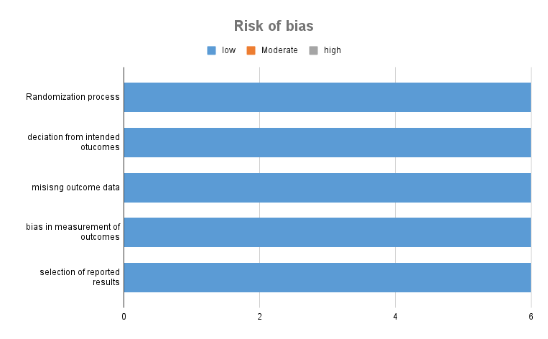

Fig. S2. Change from baseline in GCS vasomotor symptom score at week 4.
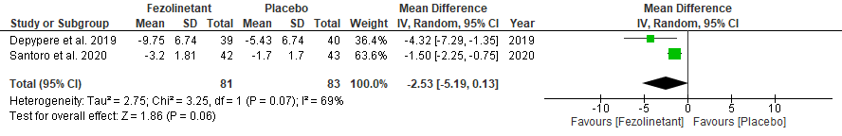
Fig. S3. Change from baseline in GCS vasomotor symptom score at week 12.
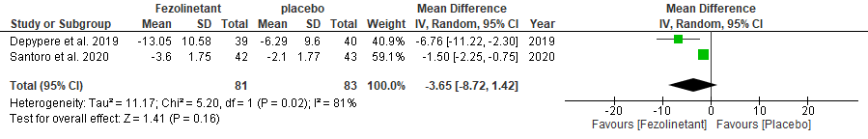
Fig. S4. Change from baseline in HFRDIS score at week 4.
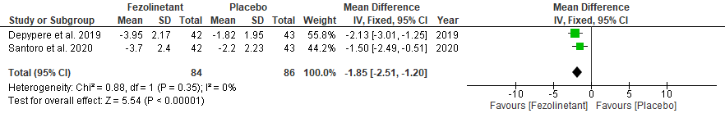
Fig. S5. Change from baseline in HFRDIS score at week 12.
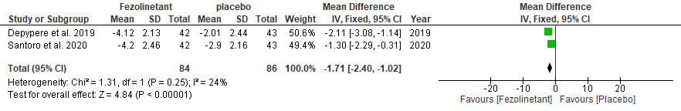
Fig. S6. Change from baseline in PROMIS SD SF 8b total score at week 4.
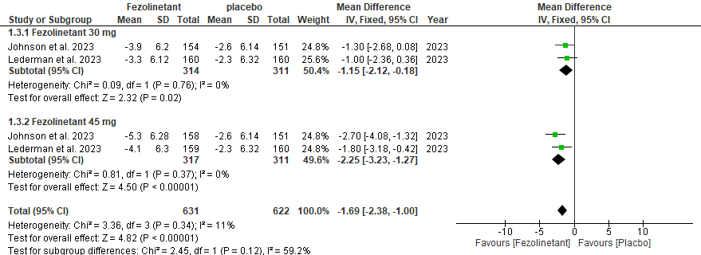

Fig. S7. Change from baseline in PROMIS SD SF 8b total score at week 12.
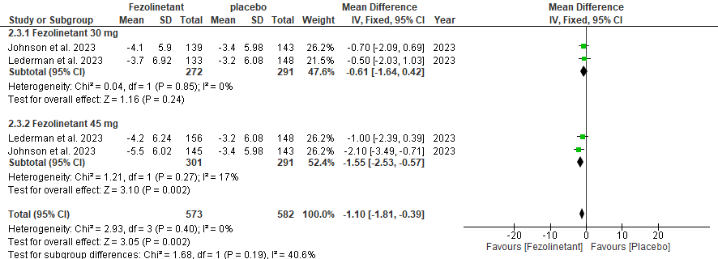

Fig. S8. Change from baseline in MENQoL total score at week 4.
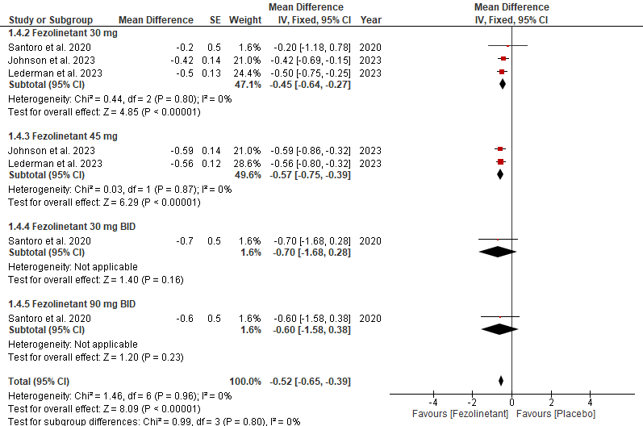
Fig. S9. Change from baseline in MENQoL total score at week 12.
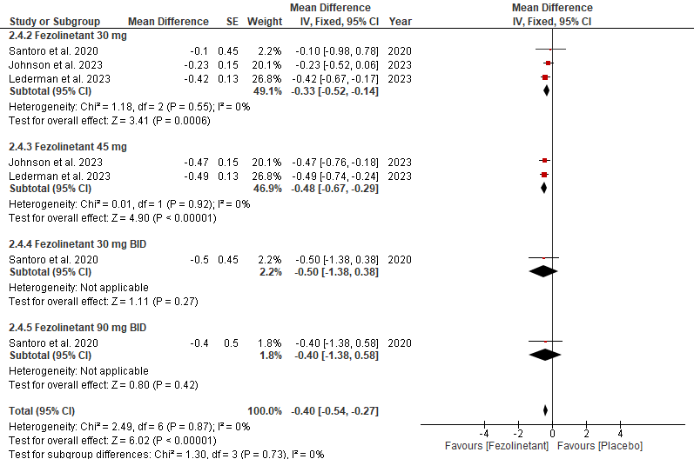
Fig. S10. Forest plot for serious treatment-emergent adverse events (Fezolinetant 30-mg vs placebo).
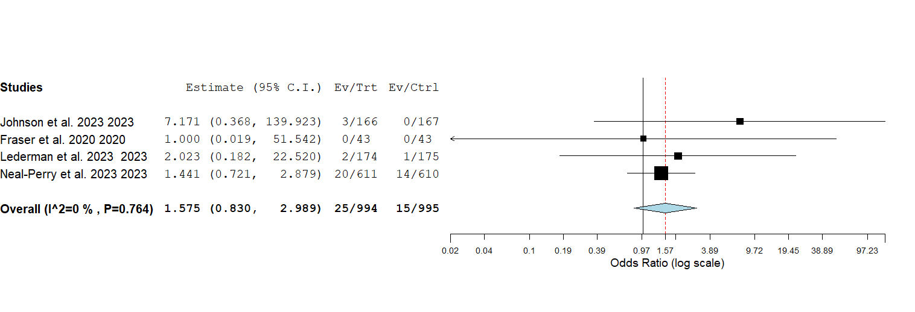 Fig. S11. Forest plot for serious treatment-emergent adverse events (Fezolinetant 45-mg vs placebo).
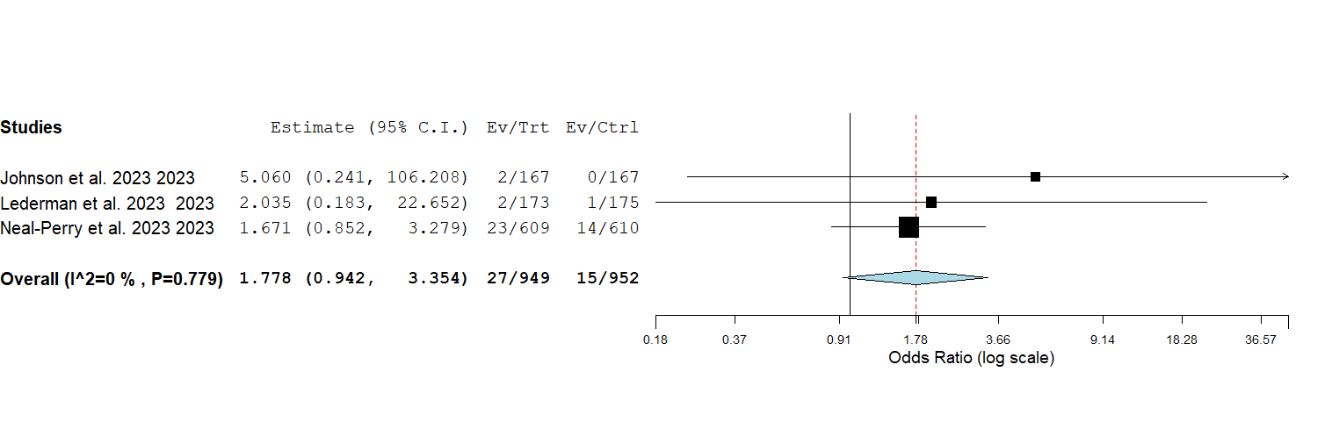

Fig. S12. Forest plot for drug-related serious adverse events (Fezolinetant 30-mg vs placebo).
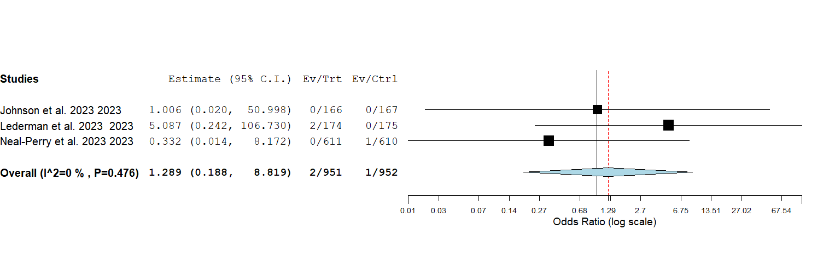
Fig. S13. Forest plot for drug-related serious adverse events (Fezolinetant 45-mg vs placebo).
