Supporting Information
Octupole Moment Driven Free Charge Generation in Partially Chlorinated Subphthalocyanine for Planar Heterojunction Organic Photodetectors

Aniket Rana^{1,†}, Song Yi Park^{2,†}, Chiara Labanti^{2,†}, Feifei Fang^{4,†}, Sungyoung Yun⁴, Yifan Dong^{1,5}, Emily Yang², Davide Nodari,¹ Nicola Gasparini,¹ Jeong-Il Park⁴, Jisoo Shin⁴, Daiki Minami⁴ Kyung-Bae Park^{4*}, Ji-Seon Kim^{2,*}, James R Durrant^{1,3*}

¹Department of Chemistry and Centre for Processable Electronics, Imperial College London, London W12 0BZ, UK.
²Department of Physics and Centre for Processable Electronics, Imperial College London, London SW7 2AZ, UK.
³SPECIFIC, Faculty of Science and Engineering, Swansea University, Swansea, SA1 8EN, UK
⁴Organic Materials Lab, Samsung Advanced Institute of Technology, Samsung Electronics Co. Ltd., Samsung-ro, Yeongtong-gu, Suwon-si, Gyeonggi-do, 16678, Korea
⁵Present address: National Renewable Energy Laboratory, 15013 Denver W Pkwy, Golden, CO 80401, United States

*Corresponding Author:
Kyung-Bae Park (myshkin.park@samsung.com), Ji-Seon Kim (ji-seon.kim@imperial.ac.uk), James R. Durrant (j.durrant@imperial.ac.uk).

†These authors contributed equally to this work

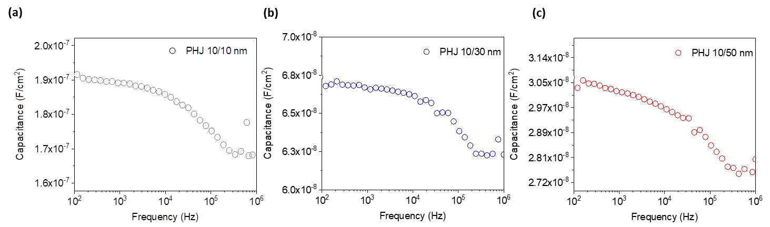

Figure S1 Capacitance response with respect to frequency for (a) PHJ 10/10 nm (b) PHJ 10/30 nm (c) PHJ 10/50 nm devices.

The calculation of trap density (tDoS) utilizes capacitance frequency measurement which corresponds to the fraction of thermally excited trapped charges responding to the applied AC field. Figure S1 shows the capacitance response for all PHJ devices. The applied AC field alternately traps and release carriers which are present near to the Fermi energy. The trap energy related to the measurement frequency by the following equation (1)¹
$E_{t}=kTln\left(\frac{ω_{0}}{ω}\right)$ (1)
Where k is Boltzmann’s constant, T is the temperature, and $ω_{0}$ is rate perfector for thermal excitation of carriers from trap and typically for organic photodiode it is 10¹² Hz and $ω$is AC perturbation frequency^{2,3}. The technique for detecting traps states from the capacitive response was originally proposed by Walter et. al⁴ and given by equation (2)
$tDoS\left(E_{t}\right)=-\frac{V_{bi}}{qW}\frac{dC}{dω}\frac{ω}{kT}$ (2)
where q is electric charge, C is measured capacitance with respect to frequency, V_{bi} is built in potential, W is thickness of PHJ layer. The change in slope dC/d$ω$ reflects the increase of trap density with respect to the trap energy. To estimate the $σ$ (disorder parameter) and mean trap energy ${(E}_{0}$) trap density is fitted with Gaussian distribution function as given in equation (3)
$tDoS\left(E_{t}\right)=\frac{tDoS}{\sqrt{2πσ}}exp\left[\frac{{-{(E}_{0}-E_{t})}^{2}}{{2σ}^{2}}\right]$ (3)
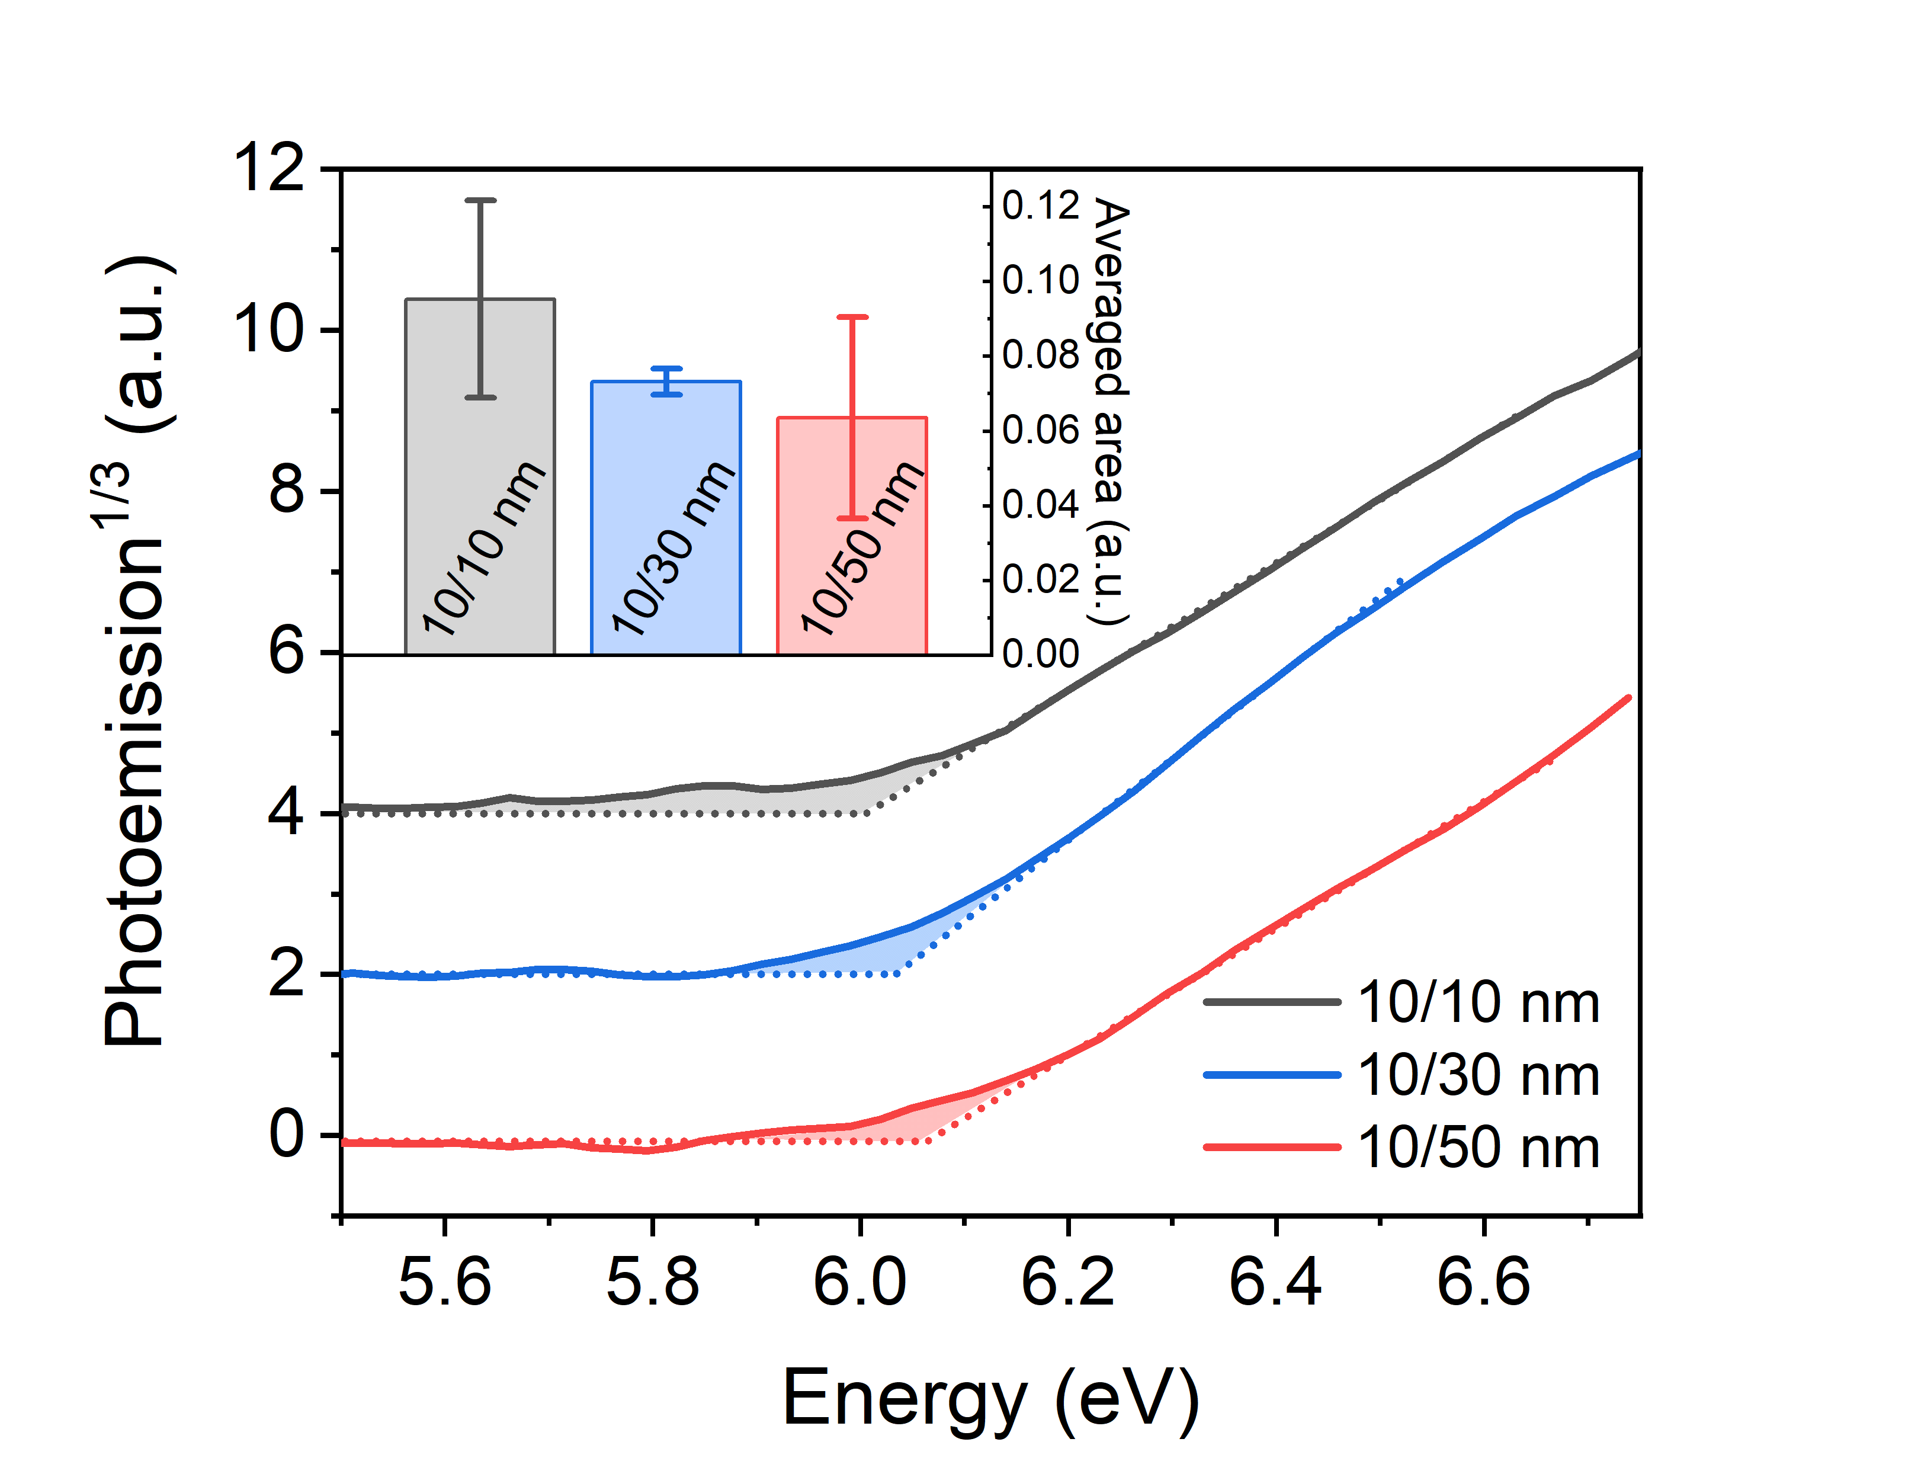
Figure S2 The photoemission spectra for PHJ 10/10 nm, PHJ 10/30 nm and PHJ 10/50 nm devices. Shaded area illustrates additional overall trap states in devices. Inset shows integrated area of these trap states which also qualitatively indicates that PHJ 10/50 nm has least trap states.

Figure S3 Trap density per distribution per unit area determined from capacitance frequency measurements to estimate interfacial traps.

Figure S4 (a) PL quenching efficiency of PHJ devices as a function of the effective electric field within overall wavelengths. (b) Summary of EQE increase as a function effective electric field.

Figure S5 Charge carrier generation. Transient absorption spectra after global analysis at excitation fluences (a) 4 μJ/cm⁻² (b) 8 μJ/cm⁻² and corresponding kinetics for excitons and charges at (c) 4 μJ/cm⁻² (d) 8 μJ/cm⁻² excitation fluences for neat Cl₆-SubPc films.
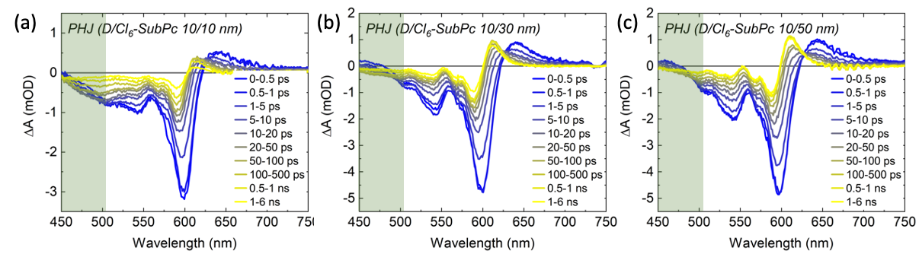
Figure S6. Transient absorption spectra for planar heterojunction MPTA/Cl₆-SubPc films with varying acceptor thicknesses. For (a)PHJ 10/10nm (b) PHJ 10/30nm (c) PHJ 10/50nm. Samples were excited at 610 nm, selectively exciting Cl₆-SubPc, with a fluence of 6 µJ cm⁻². Data for 10/30 and 10/50 nm bilayers are almost indistinguishable from neat Cl₆-SubPc. The thinnest 10/10nm bilayer is also very similar, with only a small additional bleach signal around 500 nm, most likely resulting from minor MPTA photoexcitation.
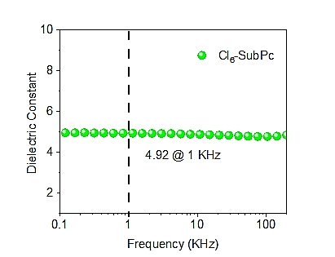
Figure S7 Impedance analysis. Dielectric constant with respect to frequency ranging from 0.1 KHz to 200 KHz for single layer Cl₆-SubPc (50nm) without MPTA. At frequency of 1 KHz, the recorded dielectric constant is 4.9⁵.

Figure S8 Photo current linearity. Derivative of ln(J_{sc}) as function of light intensity under (a) 0 V (no bias) (b) -1 V
Figure S9 Device photocurrent transient. Measured by charge extraction (CE) at 0 V and under 10⁻² W/cm² white light. PHJ 10/10 nm shows high current due to the highest trap density as compared to the thick devices.
Figure S10 Single molecule DFT calculations for quadruple moment in SubPc derivatives.

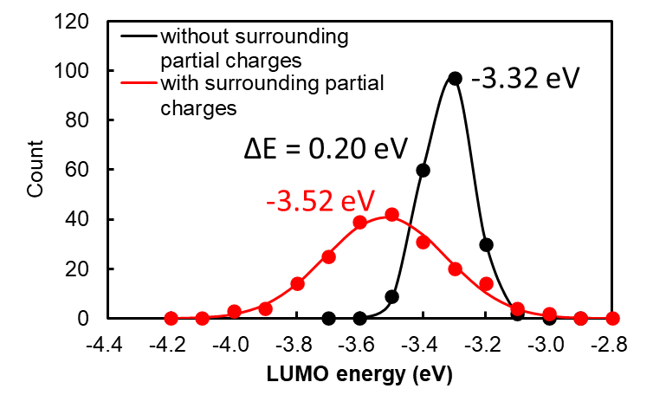
Figure S11 Energy level distributions. LUMO of Cl₆-SubPc’s in each cluster calculated without/with inclusion of the partial charges associated with Cl₆-SubPc’s high octupole moment.

Figure S12 DFT simulations of film structures and energetics. (a) The crystal structure of 1000 molecules of Cl₆-SubPc generated from molecular dynamics simulations. (b) The grain boundary morphology obtained by such molecular dynamic simulations (c) HOMO energy level distributions of randomly selected clusters of Cl₆- SubPc molecules in the bulk or at grain boundaries without inclusion of the partial charges associated with Cl₆-SubPc’s high octupole moment. (d) HOMO energy distributions as for (c) but with inclusion of the patrial chargers associated with Cl₆-SubPc’s high octupole moment.

Figure S13. Thickness dependent photodetector performance. Spectral responsivity versus wavelength under different bias calculated from EQE at (a) 0V and (b) -1V for all PHJ OPDs.

Figure S14 Thickness dependent photodetector performance parameter under different bias. (a) Spectral responsivity versus wavelength and (b) specific detectivity (D*_{noise}) versus wavelength calculated from EQE at -2V for all PHJ OPDs by considering noise spectral density (Figure S15).
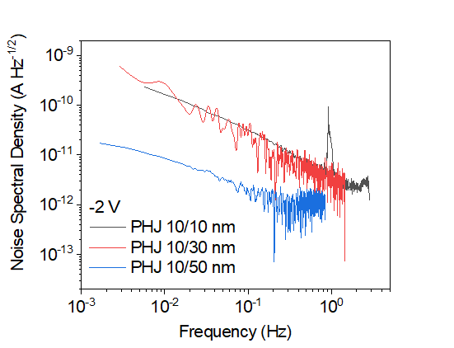

Figure S15 Noise measurements. Spectral noise density at -2 V for all PHJ 10/10nm, PHJ 10/30 nm and PHJ 10/50 nm photodiode

The noise referenced specific detectivity (D*_{noise}) spectra at a reverse bias of -2 V were calculated using D*_{noise}=R√AΔf/i_{n}, where R is the responsivity, A is the active area, Δf is the detection bandwidth and i_{n} is the noise current measured as described in the methods section anddepicted in figure S14. i_{n} can also be modelled by the following equation (1).
${\left(i_{n}\right)}^{2}=\left(2qi_{d}+\frac{4kT}{R_{sh}}+i_{1/f}^{2}\right)∆f$ (1)
where q is the elementary charge, i_{d} is the dark current, k is the Boltzmann constant, T is the temperature, R_{sh} is the shunt resistance and [i_{1/f}]² is the flicker noise spectral density^{6,7}. The detectivity data reported in the main text are calculated just considering 2qi_{d} (shot noise) as main contribution to the overall noise of the devices.

References
1. Rana, A., Kumar, A., Chand, S. & Singh, R. K. Exploring deep defect state impact on open circuit voltage of conventional and inverted organic solar cells. J Appl Phys 124, 103101 (2018).
2. Yao, W. et al. Organic Bulk Heterojunction Infrared Photodiodes for Imaging Out to 1300 nm. ACS Appl Electron Mater 1, 660–666 (2019).
3. Kublitski, J. et al. Reverse dark current in organic photodetectors and the major role of traps as source of noise. Nat Commun 12, (2021).
4. Walter, T., Herberholz, R., Müller, C. & Schock, H. W. Determination of defect distributions from admittance measurements and application to Cu(In,Ga)Se 2 based heterojunctions. J Appl Phys 80, 4411–4420 (1996).
5. Hughes, M. P. et al. Determining the Dielectric Constants of Organic Photovoltaic Materials Using Impedance Spectroscopy. Adv Funct Mater 28, 1801542 (2018).
6. Fang, Y., Armin, A., Meredith, P. & Huang, J. Accurate characterization of next-generation thin-film photodetectors. Nature Photonics 2018 13:1 13, 1–4 (2018).
7. Ho Lee, T. et al. Organic Planar Heterojunction Solar Cells and Photodetectors Tailored to the Exciton Diffusion Length Scale of a Non-Fullerene Acceptor. Adv Funct Mater 32, 2208001 (2022).

