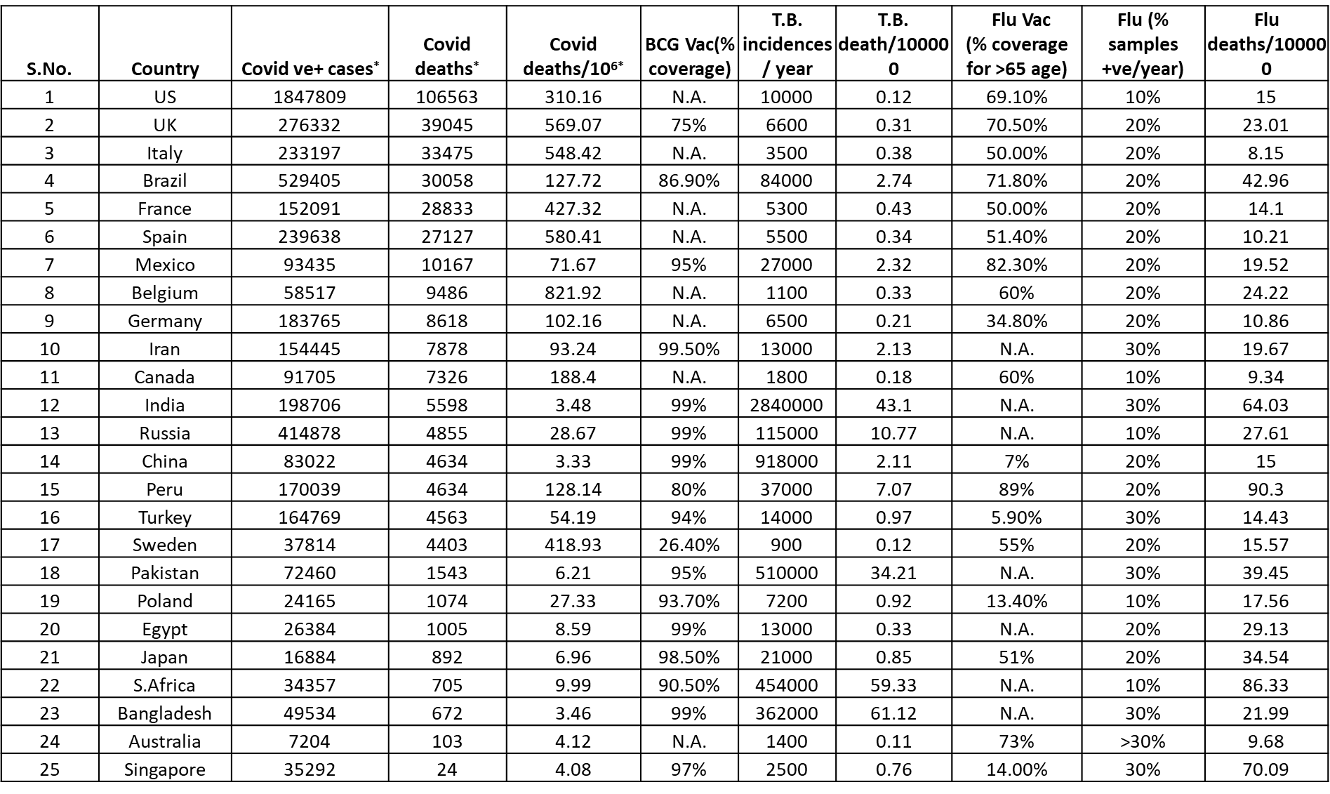
Table1: Countries were arranged based on highest to lowest deaths due to Covid-19 infections and compared with respect to BCG vaccination coverage, TB incidences, TB deaths/100,000, Flu vaccination coverage, Flu incidences and Flu deaths/100,000. * Data for Covid-19 incidences and deaths is as of 1st June 2020.

