Supplementary Material

Table 1: Information on the used datasets
 | Dataset 1 | Dataset 2 | Dataset 3 | Dataset 4
Recruitment site | Synthetically produced (Thiebaut de Schotten, Foulon, and Nachev (2020)) | University College London Hospitals, London (UK) | School of Medicine of the Washington University, St. Louis (USA) | School of Medicine of the Washington University, St. Louis (USA)
Conducted analyses | 3D U-Net training | 3D U-Net testing, deep-disconnectome production, and UMAP space creation | UMAP training, 86 neuropsychological scores | out-of-sample testing of predictions, 86 neuropsychological scores
Demographics
N | 1333 synthetic lesions | 1333 real lesions | 119 | 20
Males/females, n | NA | 748/585 | 65/54 | 12/8
Age, years | NA | 64 ± 16 (18–97) | 54 ± 11 (19–83) | 58 ± 12 (34–95)
Education, years | NA | NA | 13.2 ± 2.5 (5–20) | 13.7 ± 2.6 (9–19)
Right-handed/left-handed, n | NA | NA | 109/10 | 17/3
MRI
Chronology | NA | 1–2 weeks after stroke | 14 ± 8 days after stroke | 13 ± 4 days after stroke
Dominant lesion site | 44% right hemisphere  56% left hemisphere | 44% right hemisphere  56% left hemisphere | 46% right hemisphere  54% left hemisphere | 40% right hemisphere  60% left hemisphere
Neuropsychological assessment
Delay after stroke onset, days | NA | NA | 393 ± 56 | 385 ± 22
Delay after MRI scan, days | NA | NA | 379 ± 57 | 373 ± 22

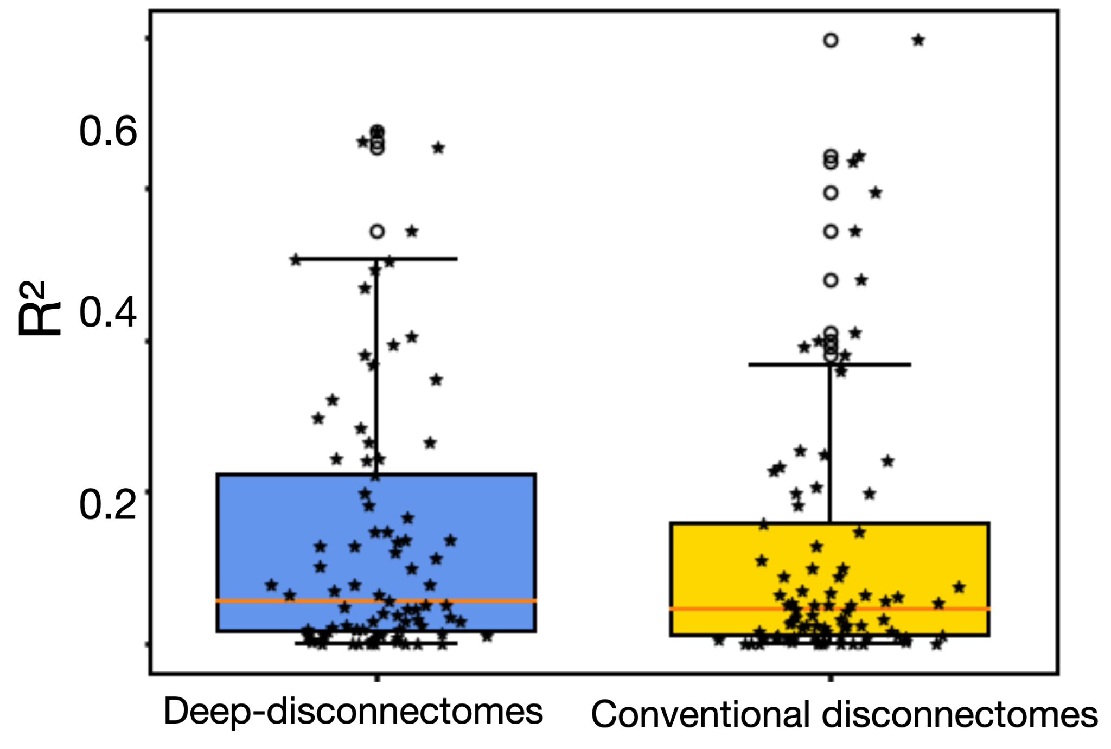
Figure 1: The boxplot shows all the R² for the predictions of the validation set (N=20) across N=86 neuropsychological scores for the framework using deep-disconnectomes compared to the framework using disconnectomes obtained by BCBToolkit. The boxes represent the quartiles, the whiskers indicate the distribution, and the outliers are marked as white dots. Inside the boxes, the median is visualized by the red line. The P-value obtained from a paired t-test (2-tails): P=0.241 shows no significant difference in the prediction power for this out-of-sample cohort.
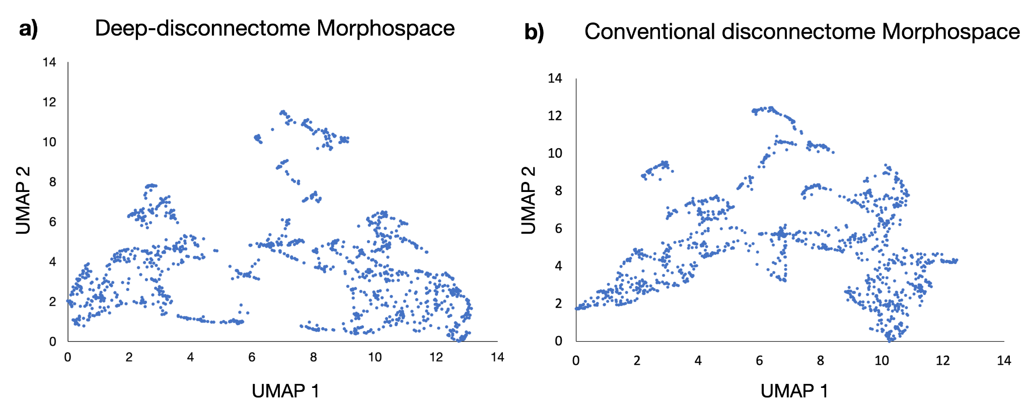
Figure 2: Comparison of the morphospaces obtained using different disconnectomes. (a) Deep-disconnectome morphospace. (b) Conventional disconnectome morphospace

