Supplementary Material

- Supplementary Figures

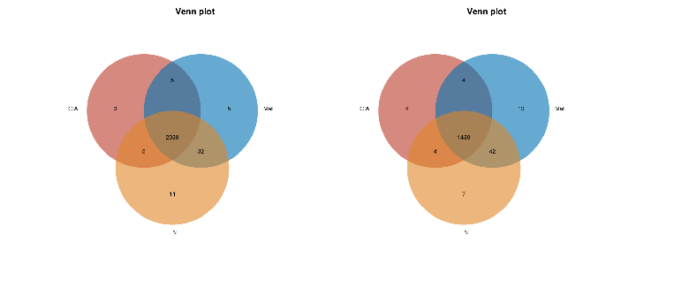
Supplementary Figure 1. The detected metabolites in each group.

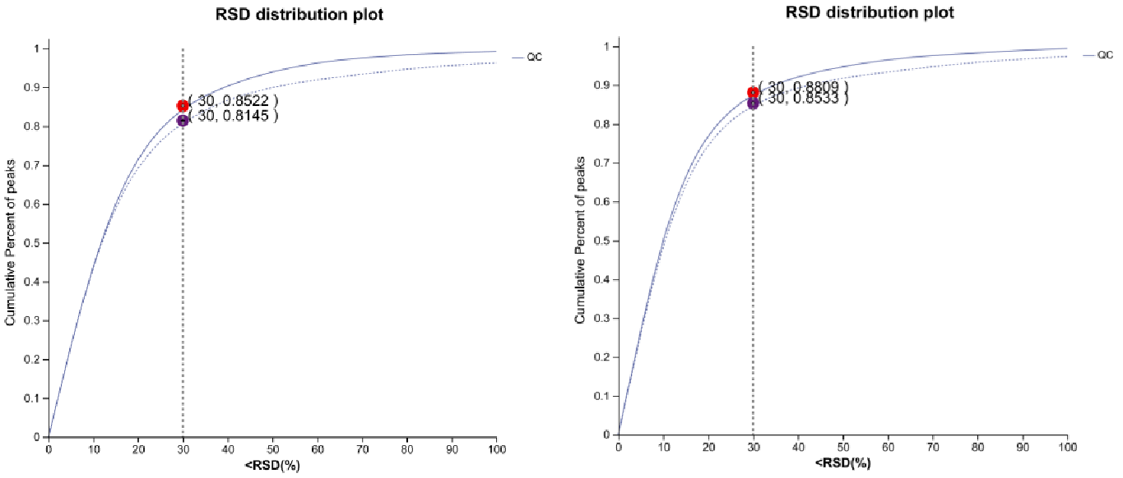
Supplementary Figure 2. QC sample evaluation chart under positive and negative ion modes.

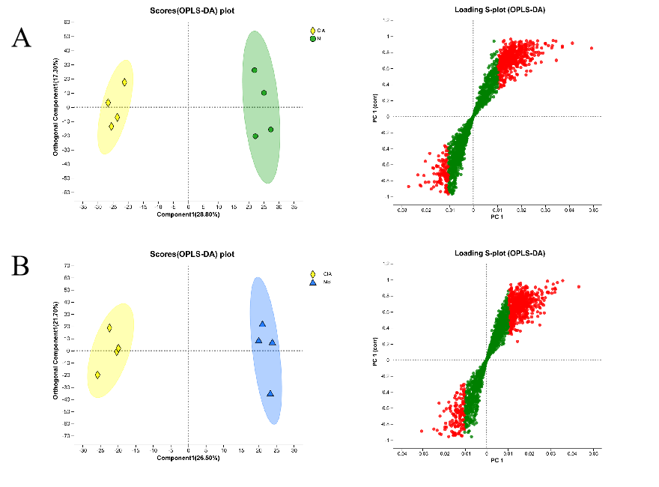
Supplementary Figure 3. (A) OPLS-DA,and S-plot under positive ion mode obtained by comparing the CIA group with the N group.
- OPLS-DA,and S-plot under positive ion mode obtained by comparing the CIA group with the Mel group.

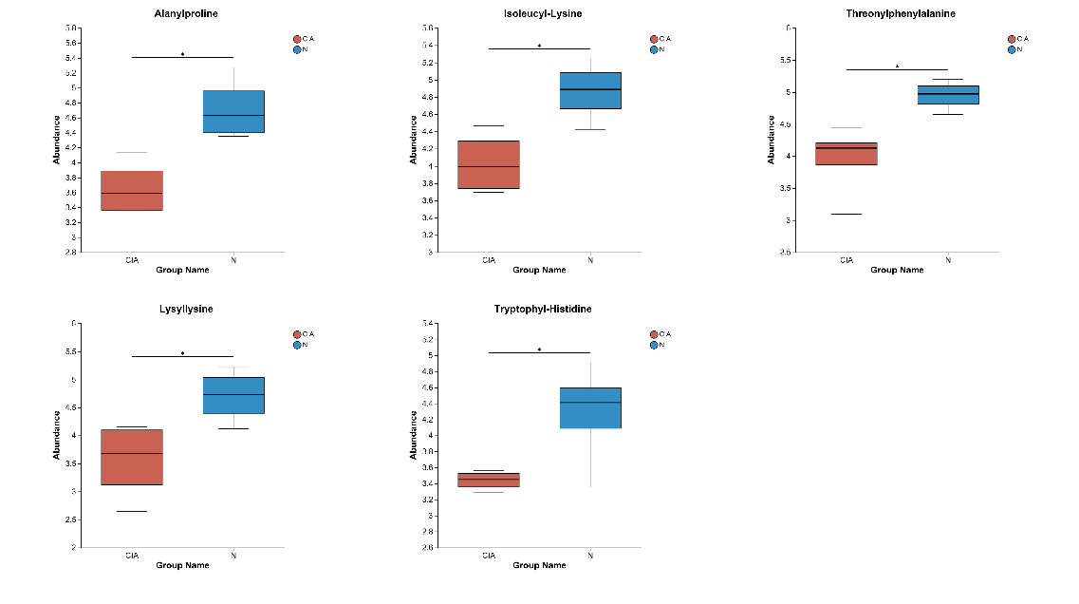
Supplementary Figure 4. Differential metabolites by comparing the CIA group with the N group.

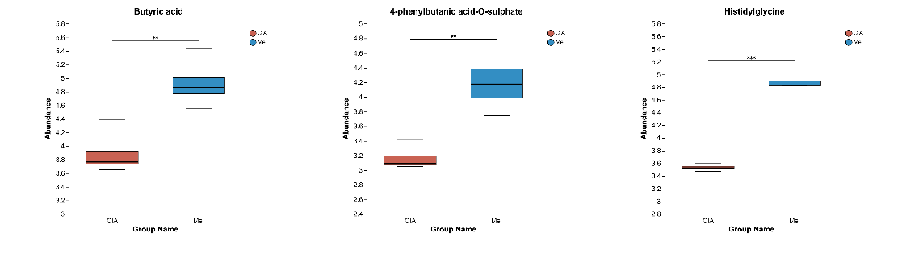
Supplementary Figure 5. Differential metabolites by comparing the CIA group with the Mel group.

2.Supplementary Tables

Supplementary Table1. The 9 metabolites identified that can discriminate CIA from N group.
Metabolite/pathway | Ion mode | VIP | p-value | FDR | m/z | rt(s)
Butyl (S)-3-hydroxybutyrate [arabinosyl-(1->6)-glucoside] | neg | 2.6412 | 0.005747 | 0.1806 | 435.1886 | 3.9882
Glutamylproline | neg | 2.5724 | 0.005889 | 0.1806 | 487.2047 | 4.2437
Alanylproline | neg | 2.4509 | 0.01022 | 0.1864 | 557.2944 | 4.4596
Isoleucyl-Lysine | neg | 2.0979 | 0.01871 | 0.2017 | 258.1823 | 1.0288
Threonylphenylalanine | neg | 2.2569 | 0.01927 | 0.2032 | 265.1196 | 2.4814
Phenylalanylaspartic acid | neg | 2.2153 | 0.03042 | 0.2156 | 279.0989 | 2.4974
Lysyllysine | pos | 2.6093 | 0.03713 | 0.2068 | 138.1073 | 0.5001
Serylglutamine | pos | 2.0924 | 0.04228 | 0.2196 | 508.2398 | 3.7153
Tryptophyl-Histidine | pos | 2.0014 | 0.0467 | 0.2286 | 306.1337 | 2.3167

Supplementary Table2. The 7 metabolites identified that can discriminate CIA from N group.
Metabolite/pathway | Ion mode | VIP | p-value | FDR | m/z | rt(s)
Histidylglycine | pos | 3.4399 | 1.26E-06 | 0.005837 | 230.1243 | 1.2977
Butyl (S)-3-hydroxybutyrate [arabinosyl-(1->6)-glucoside] | neg | 2.752 | 0.0004792 | 0.1596 | 435.1886 | 3.9882
4-phenylbutanic acid-O-sulphate | neg | 2.5479 | 0.002842 | 0.2079 | 289.0389 | 4.1569
Butyric acid | neg | 2.5547 | 0.005925 | 0.2079 | 263.1501 | 5.1188
Glutamylproline | neg | 2.2778 | 0.007933 | 0.2079 | 487.2047 | 4.2437
Serylglutamine | pos | 2.5202 | 0.02688 | 0.2864 | 508.2398 | 3.7153
Phenylalanylaspartic acid | neg | 2.2215 | 0.03944 | 0.2464 | 279.0989 | 2.4974

