Appendix: Dynamic Predictors of vaccination uptake over two years of the COVID-19 vaccination campaign: lessons from Hong Kong

Appendix Table 1. An overview of study survey rounds
Timeframe | Sample size, cooperation rate ª (N, %)
Period 1 (2021): Covering the fourth pandemic wave and representing an initial period of vaccine roll-out before the introduction of various incentive strategies
Feb 22 – 23 | 509 (71.8)
Mar 29 - 31 | 1001 (64.6)
Apr 27 - 30 | 1010 (66.6)
May 24 - 28 | 1003 (62.3)
Period 2 (2021): Covering the post-fourth pandemic wave and representing a scaled-up phase when various incentives were introduced to boost primary doses vaccination uptake
Jun 21 - 25 | 1004 (71.2)
Jul 19 – 24 | 1005 (68.1)
Aug 16 - 20 | 1006 (68.0)
Sept 13 - 25 | 1000 (67.2)
Oct 11 - 22 | 1004 (70.0)
Nov 9 - 18 | 1011 (72.4)
Dec 6 - 16 | 1026 (70.0)
Period 3 (2022): Covering the fifth pandemic wave (Omicron wave) and representing a period when the vaccine pass policy was announced and implemented to promote uptake of the booster dose
Jan 3 - 13 | 1013 (74.4)
Feb 7 - 10 | 539 (75.9)
Feb 14 - 17 | 516 (71.5)
Mar 7 -10 | 512 (70.3)
Period 4 (2022): Covering the post-fifth pandemic wave and representing a scale-up phase for promoting the completion of the booster dose
Jun 6 - 15 | 1003 (59.7)
Nov 7 -17 | 1017 (61.1)
ª Survey cooperation rate is defined as the proportions of participants who completed the interviews against subjects who were contacted and identified to be eligible.

Appendix Table 2. Subthemes and descriptions of corresponding indicators of SVI
SVI subthemes | Descriptions of the indicators ª
Socioeconomic status ^{b}
Poverty | Proportion of persons below poverty line ^{c}
Unemployment | Proportion of persons aged 15 or above being unemployed
Income | Median income per capita
Educational level | Proportion persons aged 15 or above having education level below high school
Household composition ^{d}
Persons aged 65 and older | Proportion of persons aged 65 and older
Persons aged 14 or below | Proportion of individuals aged 14 or below
Single-parent households | Proportion of single-parent households among all households
Elderly living alone | Proportion of elderly (aged 65 or above) living alone
Housing condition ^{b}
Household density | Mean number of persons per household
Area of accommodation | Median floor area of accommodation per household
Healthcare system ^{e}
Hospital beds | Proportion of hospital beds per 100,000 persons
Intensive care unit (ICU) beds | Proportion of ICU beds per 100,000 persons
Hospital manpower | Proportion of hospital manpower (full-time staff employed by Hong Kong Hospital Authority) per 100,000 persons
ª All statistics were calculated at the residential district level of Hong Kong.
^{b} Data from the 2021 Hong Kong population by-census data. Available from https://www.census2021.gov.hk/en/index.html
^{c} Monthly household income that below 50% of the median monthly household income in Hong Kong before any government interventions was categorized as below poverty line.
^{d} Data from the 2016 Hong Kong population by-census data due to unavailable access to 2021 by-census reports. Available from https://www.censtatd.gov.hk/hkstat/sub/so459.jsp
^{e} Data from the 2020-2021 Hospital Authority Annual Report, Hong Kong. Available from https://www3.ha.org.hk/data/HAStatistics/StatisticalReport/2020-2021

Appendix Table 3. Details of measures and coding strategy in the MGM networks
Construct level | Node name | Item questions | Network coding
Outcome variable | VA | How many doses of COVID-19 vaccine have you already received? | 1 = Taken the first dose  2 = Taken the second dose  3 = Taken the third dose  We used the first dose and the third dose vaccine uptake as our main outcomes, non-uptake were coded as 0.
Risk perceptions | RP1 | How likely do you think it is that you will contract novel coronavirus pneumonia over the next one month? | 1 = Never  2= Very unlikely  3= Unlikely  4 = Evens  5 = Likely  6 = Very likely  7 = Certain
Risk perceptions | RP2 | How serious or mild do you think novel coronavirus pneumonia would be for you if you were infected? | 1 = Very mild  2 = Mild  3 = Moderate  4 = Serious  5 = Very serious
Risk perceptions | RP3 | How much do you worry that you would be infected with novel coronavirus pneumonia in the next one month? | 1 = Not at all worried  2 = Slightly worried  3 = Moderately worried  4 = Very much worried  5 = Extremely worried
Efficacy | Self_eff | I’m confident that I can take measures to protect myself against novel coronavirus pneumonia. | 1 = Strongly disagree  2 = Disagree  3 = Half-half/ neutral  4 = Agree  5 = Strongly agree
Efficacy | Tru_gov | I believe that the Hong Kong government can take effective measures to control novel coronavirus pneumonia spread in Hong Kong | Same as above
Health status | PH | Over the past one week, would you say your health is: | 1 = Poor  2 = Fair  3 = Good  4 = Very good  5 = Excellent
 | Stress1 | Not being able to stop or control worrying | 0 = Not at all  1 = Several days  2 = More than half the days  3 = Nearly every day
 | Stress2 | Feeling down, depressed, or hopeless | Same as above
 | Stress3 | Little interest or pleasure in doing things | Same as above
 | Stress4 | Perceived negativity of vaccine-related news | Same as above
 | Chronic | Has a doctor ever told you that you have any chronic medical conditions? | 0 = No  1 = Yes
Vaccine confidence attitudes | VC1 | (Overall) I think COVID-19 vaccines will be safe | 1 = Strongly disagree  2 = Disagree  3 = Half-half/ neutral  4 = Agree  5 = Strongly agree
Vaccine confidence attitudes | VC2 | (Overall) I think COVID-19 vaccines will be important to have | Same as above
Vaccine confidence attitudes | VC3 | (Overall) I think COVID-19 vaccines will be effective | Same as above
Vaccine confidence attitudes | VC4 | Receiving COVID-19 vaccines are compatible with my personal value | Same as above
Avoidance behaviors | Avoid1 | Avoid going to crowded places | 0 = No  1 = Yes
Avoidance behaviors | Avoid2 | Avoid going out as much as possible | Same as above
Avoidance behaviors | Avoid3 | Avoid going to health care facilities | Same as above
Avoidance behaviors | Avoid4 | Keep appropriate social distancing with people outside of your family in public places | Same as above
Avoidance behaviors | Avoid5 | Avoid using public transportation when not necessary (e.g. going out on holidays) | Same as above
Avoidance behaviors | Avoid6 | Avoid social gathering (such as having lunch/dinner) | Same as above
Hygienic behavior | hygiene | We asked participants how frequent they adopted the below preventive measures:  a. Wear face masks when going outside  b. Wash hands immediately after going outside  c. Avoid touching common objects (e.g. door knobs, lift buttons) or use protective measures when touching these common objects (e.g. cover the object by tissue)  d. Wash hands or use hand sanitizer immediately after touching common objects  e. Use liquid soap when washing hands  f. Rub your hands (surfaces and fingers) with the liquid soap for at least 20 seconds when washing hands | 1 = Never  2 = Sometimes (less than half of the times)  3 = Often (half of the time or more)  4 = Always (all of the time)  Mean score were calculated across all the items. Higher score indicates greater frequency for taking hygienic behavior.
Cohabit-related variables | Marriage | What is your marital status? | 1 = Single  2 = Married/ cohabiting  3 = Divorced/ separated/ widowed  For easy interpretation, we combined 1 & 3 and coded as 0 (non-marital status); and coded 2 as 1 (married).
Cohabit-related variables | Live_chi | How many children do you have that is under 12 years old in your family? | 0 = None  1 = Yes, ____ (provide number)  For easy interpretation, we treated this variable as binary, participants reported to have at least one child were coded as 1.
Demographic characteristics | Sex | Given that we conducted our survey over telephone, interviewee directly recorded participants’ gender | 1 = Male  2 = Female
Demographic characteristics | Age | Can you provide your age group? | 1 = 18-24  2 = 25-34 →  3 = 35-44 →  4 = 45-54 →  5 = 55-64  6 = 65 or above →
Demographic characteristics | Education | What is your education level? | 1 = Primary or below  2 = Secondary school  3 = Tertiary or above  For easy interpretation, we combined 1 & 2 and coded as 0 (Secondary or below), we coded 3 as 1 (Tertiary or above).
Demographic characteristics | Employ | What is your occupation? | 1. Executive and professional  2. Clerical and service worker  3. Production worker  4. Student  5. Homemaker / housewife  6. Retired person  7. Unemployed or not working for other reason  For easy interpretation, we coded 7 as 0 (unemployed); and combined 1-6 and coded as 1 (employed or others). This is because we want to strictly distinguish the most vulnerable group from other groups. We defined unemployed as people who self-reported that they have no work or unemployed for a while, rather than people who have no need to seek a job currently (i.e., students, housewife or retired person)¹.
Contextual factors | case_14d | Data obtained from the Hong Kong Centre for Health Protection² | In MGM, this variable was treated as a count variable. We averaged the proportion of official-reported confirmed cases prior 14-days of participant’s survey date.
Contextual factors | death_14d ª | Data obtained from the Hong Kong Centre for Health Protection² | In MGM, this variable was treated as a count variable. We averaged the proportion of official-reported confirmed cases prior 14-days of participant’s survey date.
Contextual factors | SVI5 | Where do you live? (provide living district) | We used the percentile ranking method to calculate an overall SVI score for each of the 18 districts in Hong Kong. The SVI score was further categorized into fiver levels:  1 = Very low vulnerability  2 = Low vulnerability  3 = Medium vulnerability  4 = High vulnerability  5 = Very high vulnerability  Then we assigned the SVI level (1-5) based on participant’s self-reported living district^{1,3}.
ª Variable only used in P3 and P4 given the small number of death cases in previous two periods.

Measurement accuracy of self-reported vaccine uptake

We compared the actual vaccine uptake rates in Hong Kong reported by the government with the self-reported vaccine uptake rates collected from our repeated telephone surveys to assess the measurement accuracy. Self-reported vaccination uptake rates were generally lower compared to the actual uptake rates during the survey periods (see Appendix Table 4). However, the independent-samples t-test found that there was no significant difference for actual uptake rates (M=0.61, SD=0.33) and self-reported uptake rates (M=0.60, SD=0.31); t(32)=-0.08, p=0.936. Besides, the actual uptake rates were significantly and highly correlated with self-reported uptake rates (r(15)=0.995, p<0.01). Overall, the two assessment indicate that self-reported uptake rates can be used as a proxy for actual vaccination uptake.

Appendix Table 4. Differences between actual vaccination uptake rates reported by the government and self-reported vaccination uptake rates collected in telephone survey by survey waves
Survey waves | Survey date | Actual vaccination uptake rates reported by the government ª (%) | Self-reported vaccination uptake rates collected in surveys ^{b} (%)
1 | Feb 22 – 23, 2020 | 0 | 0
2 | Mar 29 – 31, 2020 | 461055 (0.08) | 106 (0.11)
3 | Apr 27 – 30, 2020 | 916317 (0.15) | 170 (0.17)
4 | May 24 – 28, 2020 | 1319759 (0.22) | 234 (0.23)
5 | Jun 21 – 25, 2021 | 2092314 (0.34) | 381 (0.38)
6 | Jul 19 – 24, 2021 | 3006599 (0.49) | 516 (0.52)
7 | Aug 16 - 20, 2021 | 3884763 (0.63) | 631 (0.63)
8 | Sept 13 - 25, 2021 | 4451390 (0.73) | 701 (0.70)
9 | Oct 11 - 22, 2021 | 4583113 (0.75) | 673 (0.67)
10 | Nov 9 - 18, 2021 | 4688635 (0.77) | 747 (0.74)
11 | Dec 6 - 16, 2021 | 4823337 (0.79) | 744 (0.73)
12 | Jan 3 – 13, 2022 | 5086843 (0.83) | 781 (0.77)
13 | Feb 7 - 10, 2022 | 5533139 (0.81) | 448 (0.83)
14 | Feb 14 - 17, 2022 | 5782245 (0.83) | 445 (0.86)
15 | Mar 7 -10, 2022 | 6376696 (0.92) | 466 (0.91)
16 | Jun 6 - 15, 2022 | 6726456 (0.97) | 947 (0.94)
17 | Nov 7 -17, 2022 | 6895602 (0.98) | 969 (0.95)
Total: M (SD) (%) |  | 61 (33) | 60 (31)
ª Calculated as the actual COVID-19 first dose uptake rates among adults aged 18 or above on the end dates of each survey wave. The total number of eligible populations was adapted based on the government policies that gradually lowered eligible age for COVID-19 vaccine uptake.
^{b} Calculated as the proportion of participants who reported they had already received at least one dose of COVID-10 vaccines in each survey wave.
Appendix Table 5. Percentile rank of SVI and its subthemes
District | Socioeconomic status ª |  | Household composition ª | Housing condition ª | Healthcare system ª | SVI ^{b} | SVI level ^{c}
Central & Western | 0.00 | 0.12 |  | 0.12 | 0.00 | 0.00 | 1
Wan Chai | 0.06 | 0.06 |  | 0.00 | 0.65 | 0.06 | 1
Eastern | 0.24 | 0.47 |  | 0.41 | 0.65 | 0.41 | 3
Southern | 0.35 | 0.35 |  | 1.00 | 0.00 | 0.35 | 2
Yau Tsim Mong | 0.18 | 0.18 |  | 0.35 | 0.12 | 0.12 | 1
Sham Shui Po | 0.76 | 0.88 |  | 0.59 | 0.47 | 0.88 | 5
Kowloon City | 0.41 | 0.41 |  | 0.41 | 0.12 | 0.24 | 2
Wong Tai Sin | 0.88 | 0.76 |  | 0.76 | 0.12 | 0.76 | 4
Kwun Tong | 1.00 | 1.00 |  | 0.88 | 0.94 | 1.00 | 5
Kwai Tsing | 0.94 | 0.82 |  | 0.82 | 0.47 | 0.94 | 5
Tsuen Wan | 0.24 | 0.00 |  | 0.41 | 0.47 | 0.18 | 1
Tuen Mun | 0.71 | 0.53 |  | 0.24 | 0.82 | 0.71 | 4
Yuen Long | 0.65 | 0.88 |  | 0.29 | 0.82 | 0.82 | 5
North | 0.82 | 0.71 |  | 0.18 | 0.12 | 0.47 | 3
Tai Po | 0.47 | 0.29 |  | 0.59 | 0.12 | 0.29 | 2
Sha Tin | 0.53 | 0.59 |  | 0.88 | 0.12 | 0.65 | 4
Sai Kung | 0.12 | 0.18 |  | 0.59 | 0.94 | 0.47 | 3
Islands | 0.59 | 0.65 |  | 0.06 | 0.65 | 0.59 | 3
ª Percentile rank of the subtheme was generated by the percentile rank of their respective indicators. A higher score (i.e., approaching 1) denoted greater relative vulnerability.
^{b} Percentile rank of the SVI was generated by the percentile rank of the sum scores aggregated by the four subthemes. A higher score (i.e., approaching 1) denoted greater relative community vulnerability.
^{c} Based on the percentile rank of SVI scores, we further categorized SVI into five levels from 1 to 5: very low vulnerability (0% ~ 20%), low vulnerability (20% ~ 40%), moderate vulnerability (40% ~

Self-reported reasons for non-vaccinations by age groups

In nine survey rounds conducted between 6th December 2021 and 14th July 2022, participants who had not received any / received only one dose / received only two doses of COVID-19 vaccines but indicated that they would be never/very unlikely/unlikely/unsure to take one dose / the second dose / the booster dose of COVID-19 vaccine in the future were asked about the major reasons for being hesitant or resistant about taking COVID-19 vaccination. The open-ended responses for why to be hesitant or resistant about taking a COVID-19 vaccine or a vaccine booster from these nine survey rounds were coded as reasons for vaccination resistance. Participants were asked to provide reasons that first came to mind, then the interviewer jot down notes of participants’ statements and asked follow-up questions of “any other reasons” to encourage participants to give more than one reason for their vaccination decision. Amongst the 1043 participants who were eligible to answer the open-ended questions (i.e., they did not take the first dose or the third dose of COVID-19 vaccine), 983 provided at least one reason. Their provided reasons are summarized in the Appendix Table 6.

Appendix Table 6. Reasons for non-vaccination among participants who did not receive the primary doses and booster dose of COVID-19 vaccine
 | Primary vaccine doses uptake  (N = 225) |  |  |  |  |  | Booster dose vaccine uptake  (N = 709)
Reasons for non-vaccination (%) | 18-24 | 25-34 | 35-44 | 45-54 | 55-64 | >65 | 18-24 | 25-34 | 35-44 | 45-54 | 55-64 | >65
Concerned about vaccine safety | 22.20 | 40.70 | 56.00 | 53.30 | 44.40 | 33.70 | 34.20 | 34.10 | 26.30 | 29.60 | 29.10 | 31.40
Concerned about vaccine effectiveness | 0 | 14.80 | 40.00 | 26.70 | 11.10 | 11.90 | 15.40 | 23.70 | 18.60 | 27.60 | 22.80 | 6.90
No urgency or low need to take the vaccine | 11.10 | 22.20 | 4.00 | 6.70 | 5.60 | 11.90 | 41.00 | 30.60 | 26.30 | 21.40 | 27.80 | 24.50
Concern about chronic condition | 11.10 | 14.70 | 12.00 | 40.00 | 41.70 | 43.60 | 1.70 | 3.50 | 3.40 | 5.10 | 1.30 | 9.80
Concern about old age | 0 | 0 | 0 | 0 | 2.80 | 9.90 | 0 | 0 | 0 | 0 | 0 | 5.90
Already got antibodies ª | 33.30 | 7.40 | 12.00 | 6.70 | 8.30 | 2.00 | 12.00 | 13.30 | 12.70 | 8.20 | 11.40 | 10.80
Low trust in government | 22.20 | 3.70 | 8.00 | 6.70 | 13.90 | 0 | 3.40 | 1.70 | 1.70 | 1.00 | 7.60 | 1.00
Lack of social norm or support ^{b} | 11.10 | 7.40 | 0 | 0 | 11.10 | 11.90 | 3.40 | 1.70 | 2.50 | 3.10 | 1.30 | 7.80
Perceived low disease risk | 11.10 | 3.70 | 4.00 | 6.70 | 0 | 5.90 | 6.80 | 4.60 | 5.90 | 4.10 | 5.10 | 5.90
Wait for better vaccine | 11.10 | 0 | 4.00 | 0 | 2.80 | 1.00 | 1.70 | 1.20 | 3.40 | 5.10 | 2.50 | 2.00
No mandatory / Dislike mandatory | 0 | 0 | 4.00 | 0 | 0 | 0 | 7.70 | 7.50 | 11.90 | 5.10 | 8.90 | 4.90
Others (i.e., pregnant) ^{c} | 0 | 3.70 | 4.00 | 0 | 0 | 0 | 0.90 | 2.30 | 2.50 | 3.10 | 2.50 | 3.90
No incentives to take the vaccine | 0 | 0 | 0 | 0 | 0 | 1.00 | 0 | 0.60 | 0.80 | 2.00 | 2.50 | 0
Not convenient to take the vaccine | 0 | 0 | 0 | 0 | 0 | 0 | 0 | 0 | 0 | 1.00 | 2.50 | 0
Free rider psychology ^{d} | 0 | 3.70 | 0 | 0 | 0 | 0 | 0.90 | 0.60 | 0 | 0 | 1.30 | 0
ª Already got antibodies consisted of the following reasons: already got antibodies because of natural infections; antibodies are sufficient after getting two jabs.
^{b} Lack of social norm or support consisted of the following reasons: have not been encouraged by doctor/family/friends/other people.
^{c} Others consisted of the following reasons: pregnancy; not yet the age to take the third dose; not enough duration after the second jab.
^{d} Free rider psychology consisted of the following reason: others will take the vaccine so no need to take it myself.
The blue shaded cells indicate the top three reasons for not taking the primary vaccine doses by the six age groups, while the orange shaded cells indicate the top three reasons for not taking the booster vaccine dose by the six age groups.
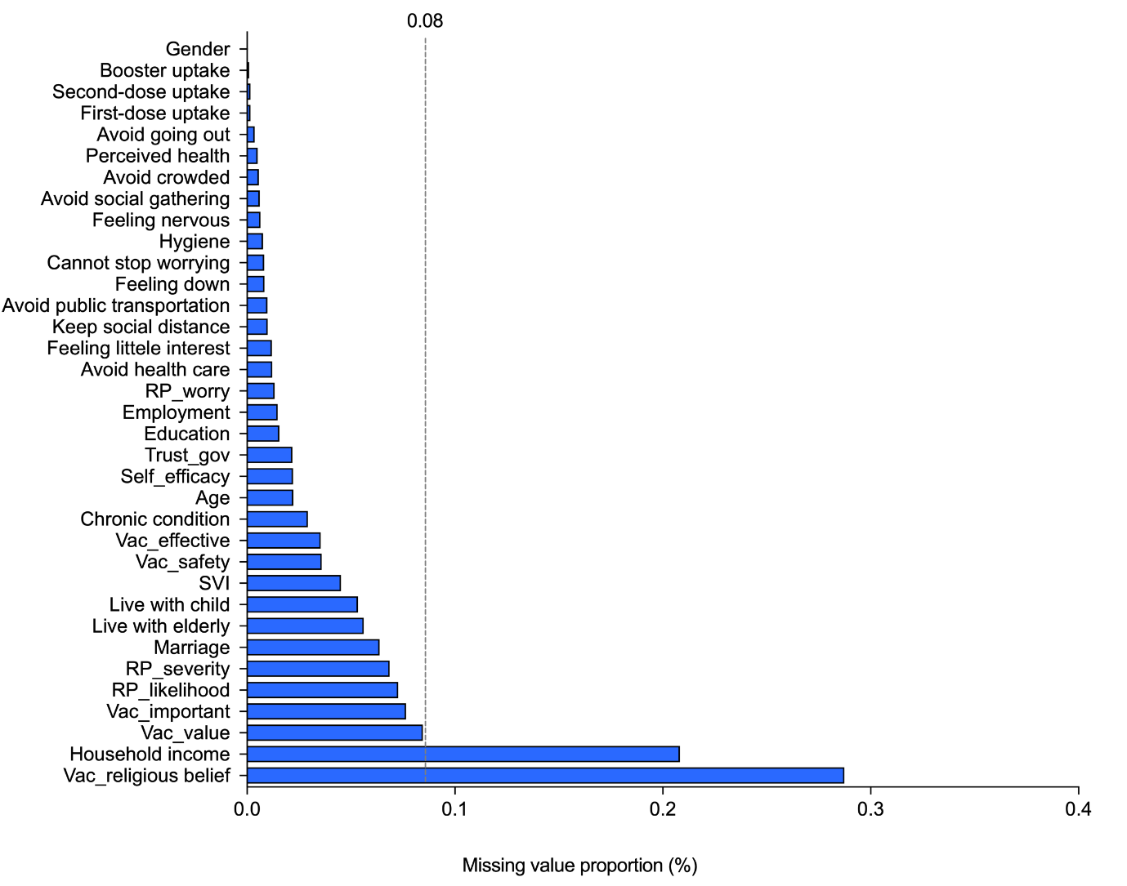
Appendix Figure 1. Proportion of missing values in selected variables
We removed two variables with high proportion of missing values in the network model, one is monthly household income (missing value rate: 20.8%), another is one of the vaccine confidence items (“I believe that vaccine is compatible with my religious belief”; missing value rate: 28.7%). The high proportion of missing values in these two variables could be that the questions were relatively sensitive to answer over telephone, and not many people can accurately report their household income and religious belief (answer “Don’t know” will be categorized as missing in our survey). The remaining variables have no more than 8% of the missing values were all included into the final models.

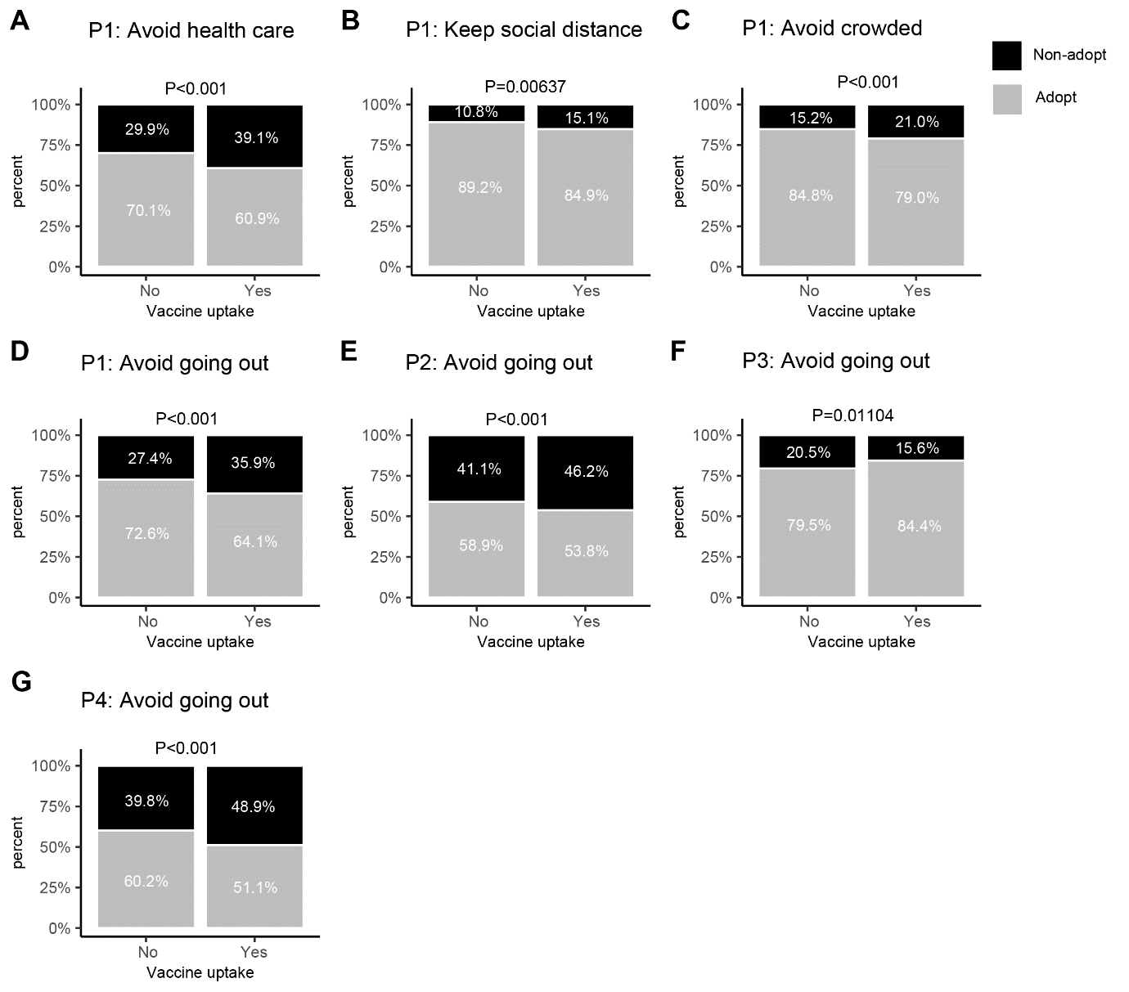
Appendix Figure 2. Proportion of adopting or non-adopting non-pharmaceutical preventive behaviors by vaccination uptake status
P1 indicates Period 1, P2 indicates Period 2, P3 indicates Period 3, P4 indicates Period 4. P-value was determined by Chi-square test. Major non-pharmaceutical preventive behaviors were selected based on their relative importance to vaccine uptake in mgm networks. From this figure we can rule out the possibility that the negative associations between adoption of non-pharmaceutical preventive behaviors and vaccination uptake could be due to vaccinated people may relax their preventive behaviors, because actually vaccinated people were more likely to adopt non-pharmaceutical preventive behaviors. While amongst those non-vaccinated people, a larger proportion chose to take alternative preventive measures for self-protection.

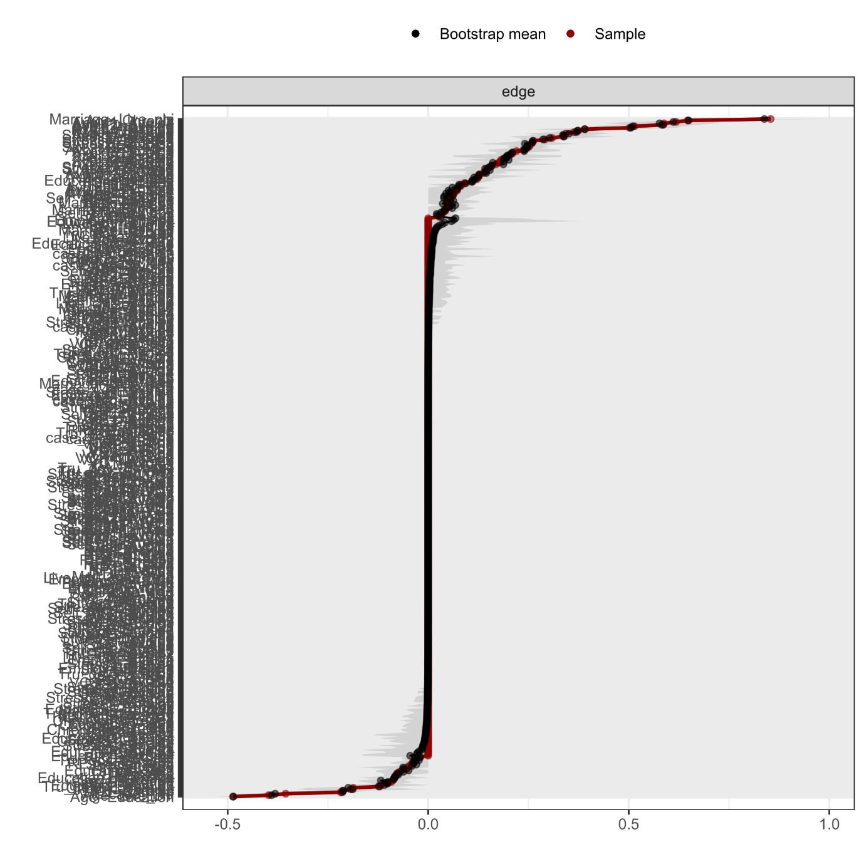
Appendix Figure 3. Accuracy of the edge-weight parameters and associated bootstrapped confidence intervals (CIs) for the mgm model of P1 network
The red line represents the real sample values; the grey area represents the bootstrapped CIs; all the observed edges of the network were presented on the y-axis but excluded the edge names to avoid information overload. The analysis revealed small and accurate confidence intervals for all edge weights (i.e., the red line falls within the grey area), suggesting that our sample well represents the real population.

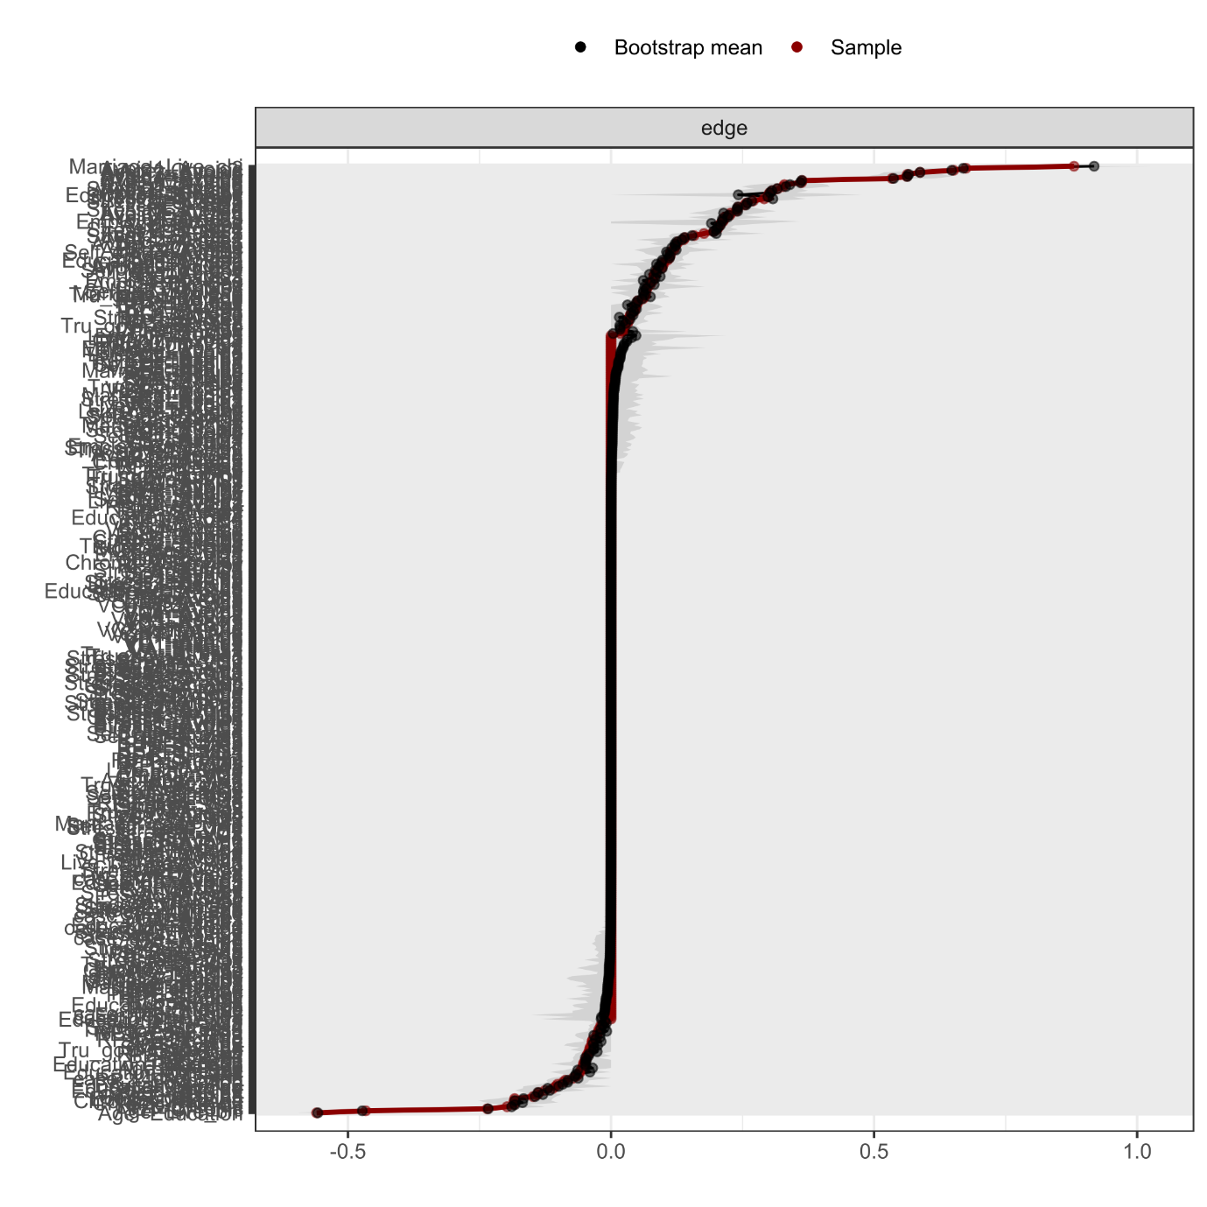
Appendix Figure 4. Accuracy of the edge-weight parameters and associated bootstrapped confidence intervals (CIs) for the mgm model of P2 network
The red line represents the real sample values; the grey area represents the bootstrapped CIs; all the observed edges of the network were presented on the y-axis but excluded the edge names to avoid information overload. The analysis revealed small and accurate confidence intervals for all edge weights (i.e., the red line falls within the grey area), suggesting that our sample well represents the real population.

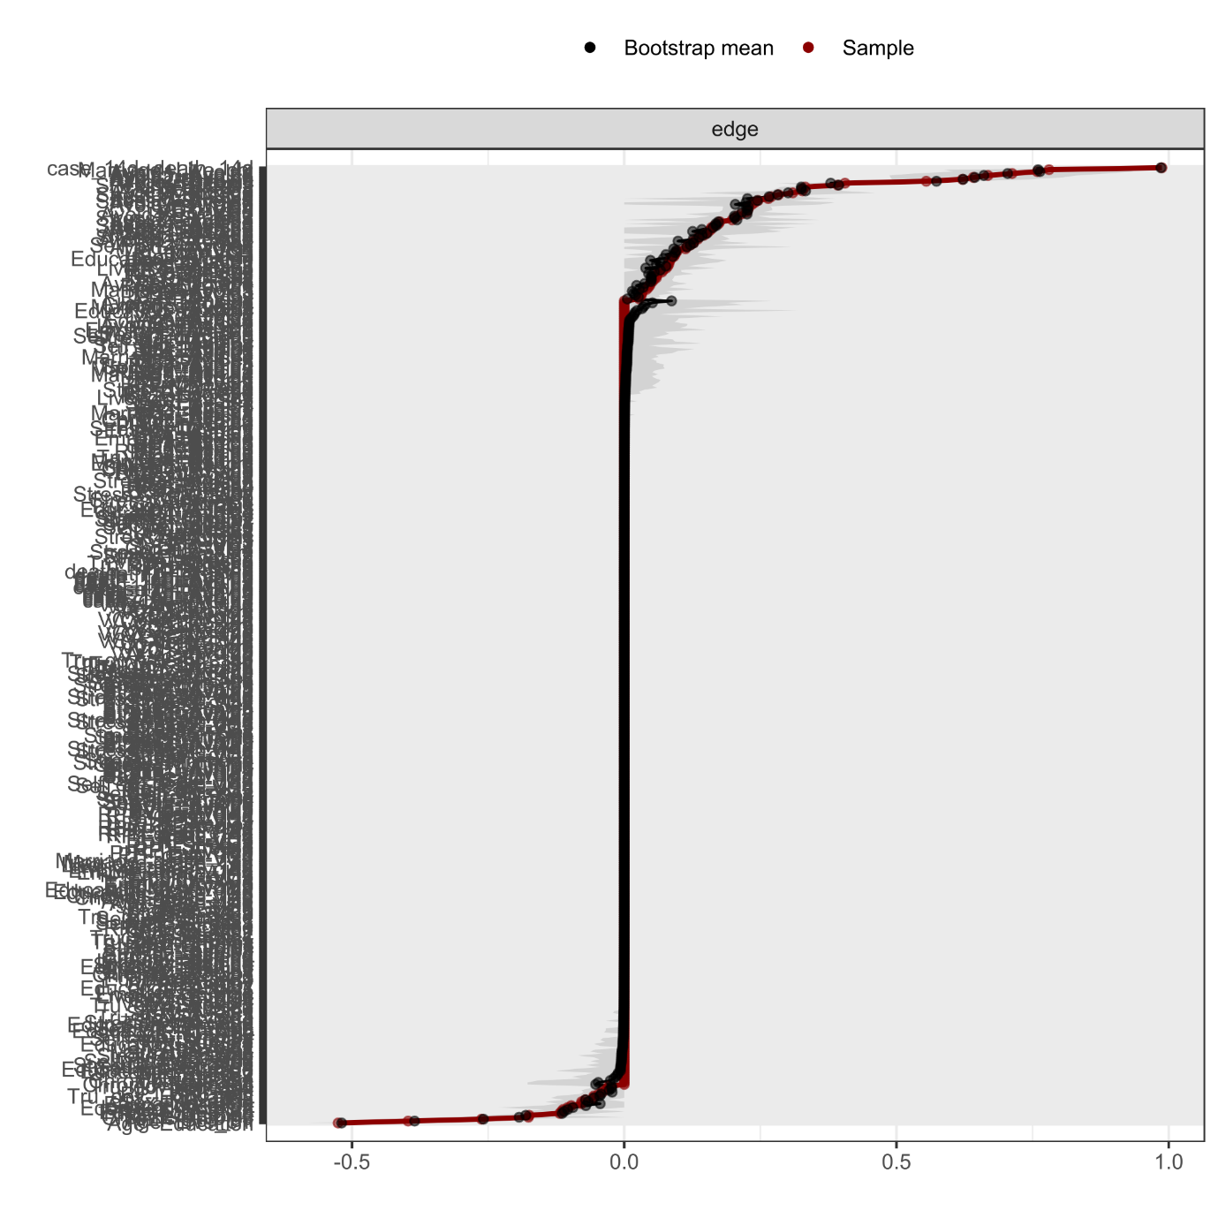
Appendix Figure 5. Accuracy of the edge-weight parameters and associated bootstrapped confidence intervals (CIs) for the mgm model of P3 network
The red line represents the real sample values; the grey area represents the bootstrapped CIs; all the observed edges of the network were presented on the y-axis but excluded the edge names to avoid information overload. The analysis revealed small and accurate confidence intervals for all edge weights (i.e., the red line falls within the grey area), suggesting that our sample well represents the real population.

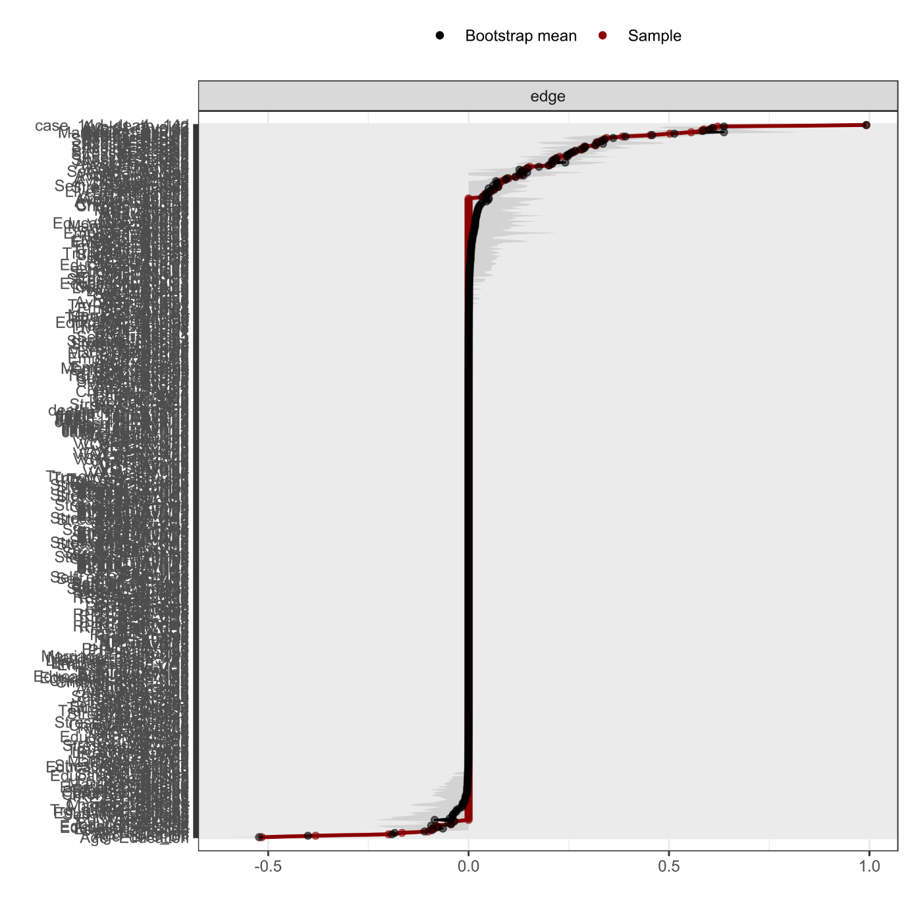
Appendix Figure 6. Accuracy of the edge-weight parameters and associated bootstrapped confidence intervals (CIs) for the mgm model of P4 network
The red line represents the real sample values; the grey area represents the bootstrapped CIs; all the observed edges of the network were presented on the y-axis but excluded the edge names to avoid information overload. The analysis revealed small and accurate confidence intervals for all edge weights (i.e., the red line falls within the grey area), suggesting that our sample well represents the real population.

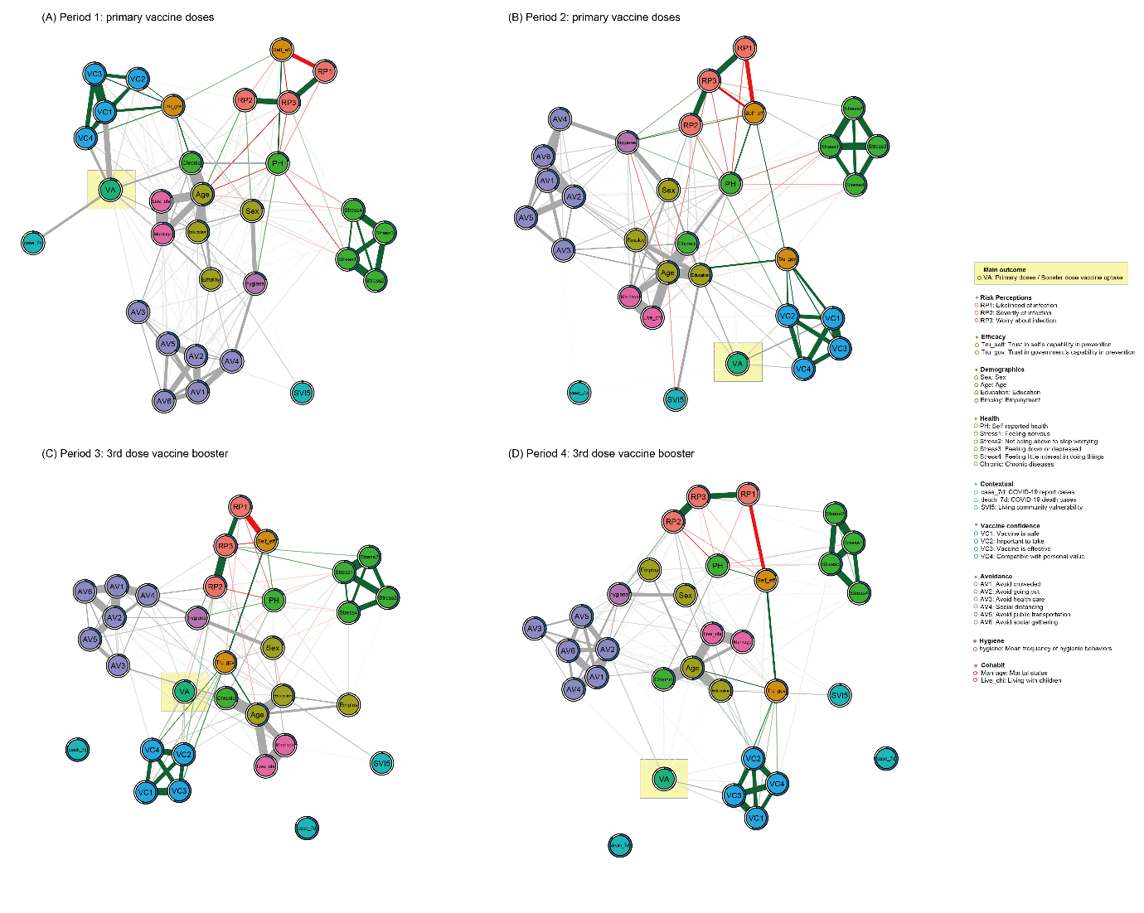
Appendix Figure 7. Networks of determinants associated with vaccine uptake across P1-P4 using 7-day time window for the COVID-19 report cases and death numbers
This figure replicated our main analyses reported in the main manuscript, except that we replaced the contextual determinants with 7-day time window for the COVID-19 report cases and death numbers.

References
1 Yuan, J. et al. Can psychological distress account for the associations between COVID‐19 vaccination acceptance and socio‐economic vulnerability? Applied Psychology: Health and Well‐Being 2023, 1–20 (2023).
2 Department of Health. Data in Coronavirus Disease (COVID-19). https://data.gov.hk/en-data/dataset/hk-dh-chpsebcddr-novel-infectious-agent (2023).
3 Liao, Q. et al. Assessing community vulnerability over 3 waves of COVID-19 pandemic, Hong Kong, China. Emerging Infectious Diseases 2021 27, 1935 (2021).

