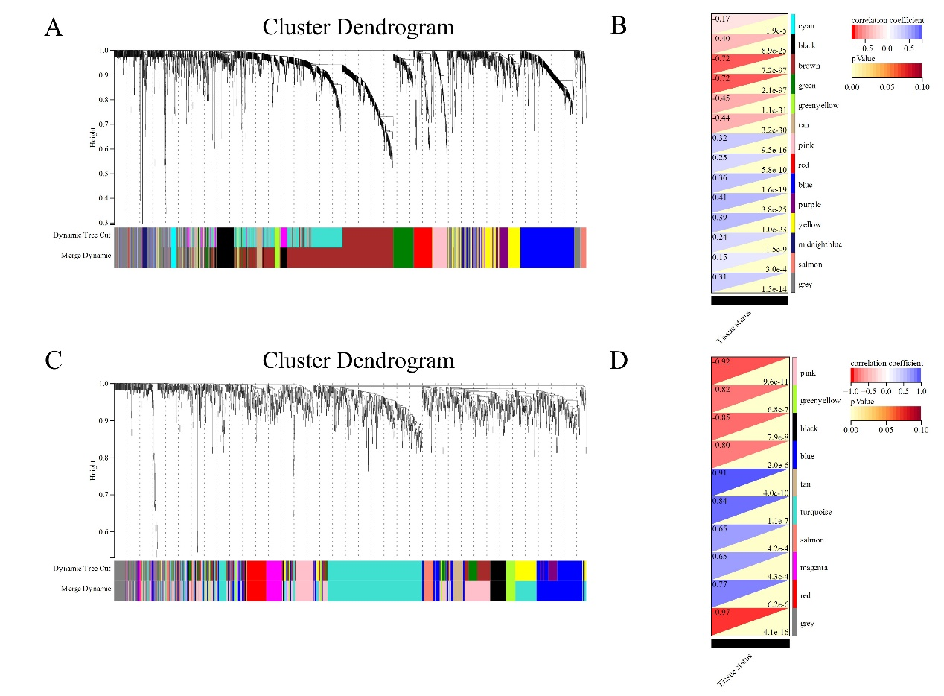
Supplement fig1| Weighted gene co-expression network analysis (WGCNA).
(A)The cluster dendrogram of co-expression genes in BC. (B)Module–trait relationships in BC. Each cell contains the corresponding correlation and p-value. (C)The cluster dendrogram of co-expression genes in NAFLD. (D)Module–trait relationships in NAFLD. Each cell contains the corresponding correlation and p-value. BC, Breast carcinoma; NAFLD, Non-alcoholic fatty liver disease.

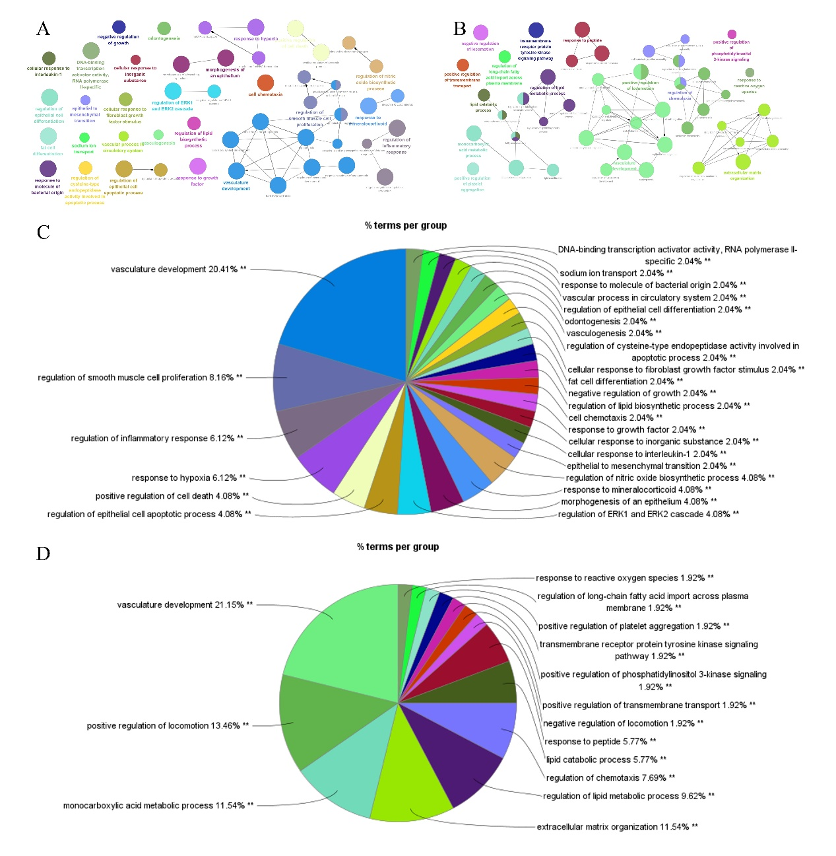
Supplement fig2| Weighted gene co-expression network analysis (WGCNA).
(A)The discovery cohort interaction network of GO terms generated by the Cytoscape plug-in ClueGO. The significant term of each group is highlighted. (B)The validation cohort interaction network of GO terms generated by the Cytoscape plug-in ClueGO. The significant term of each group is highlighted. (C)Discovery cohort proportion of each GO terms group in the total. (D) Validation cohort proportion of each GO terms group in the total. GO, gene ontology. **p < 0.05.

