Supplementary Information

A wetland condition assessment to consider ecological relationships of a Maya cultural keystone species within the Lake Atitlan, Guatemala littoral zone

Jorge Garcia-Polo^{1,2,*}, Stewart A.W. Diemont¹, Tomasz B. Falkowski³, Donald J. Leopold¹

¹ State University of New York, College of Environmental Science and Forestry, Syracuse, New York, USA
² Universidad del Valle de Guatemala, Centro de Estudios Atitlán, Sololá, Guatemala
³ New Mexico Highlands University, Department of Forestry, Las Vegas, New Mexico, USA
*Corresponding Author: jgarci16@syr.edu

Fig. S1. LULC rapid assessment method. On-screen analysis templates, four sites per each managed territory, (A)Santiago, (B)San Juan, (C)San Pablo and San Pedro (D). Aerial images from Google Earth 2021, processing in QGIS and scoring system based on Shappell et al. 2016.

A. Santiago
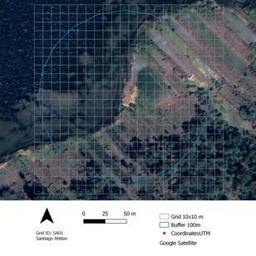 | 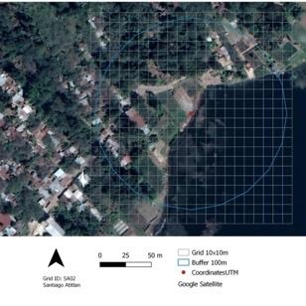 | 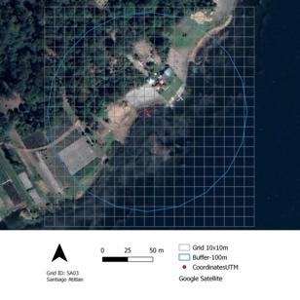 | 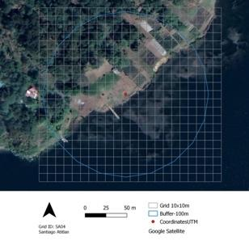
B. San Juan
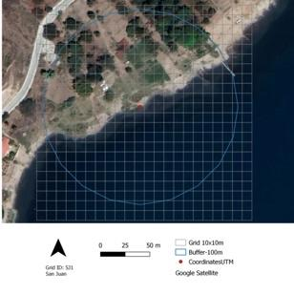 | 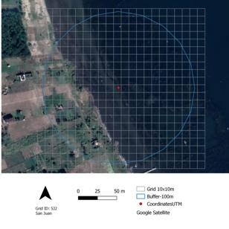 | 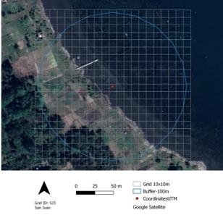 | 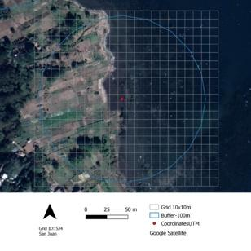
C. San Pablo
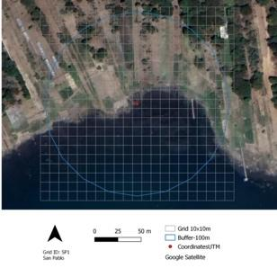 | 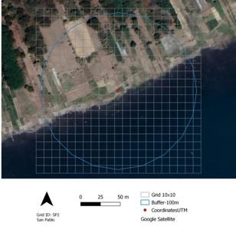 | 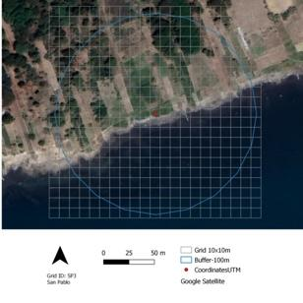 | 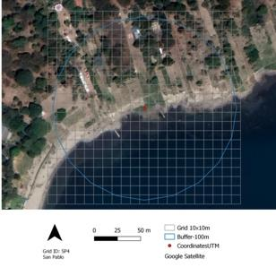
D. San Pedro
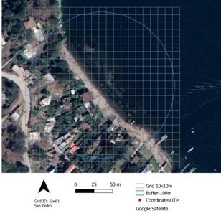 | 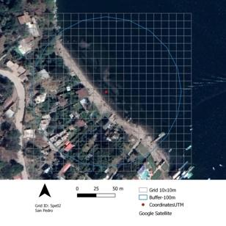 | 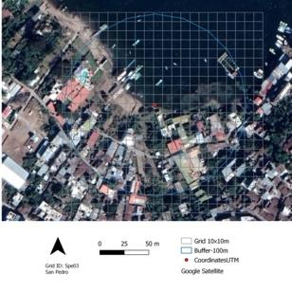 | 