Supporting Information
Redox Dynamics and Surface Structures of an Active Palladium Catalyst during Methane Oxidation
Shengnan Yue,^{1,2,¶} Praveen C. S.,^{3, ¶} Alexander Klyushin,^{4, ¶} Masahiro Hashimoto,⁵ Qian Li,^{1,2} Travis Jones,⁶* Panpan Liu,^{1,2} Wenqian Yu,^{1,2} Marc-Georg Willinger,^{7,8} and Xing Huang^{1,2,7}*
¹ College of Chemistry, Fuzhou University, 350108 Fuzhou, China
² Qingyuan Innovation Laboratory, 362100 Quanzhou, China
³ International School of Photonics, Cochin University of Science and Technology, 682022 Cochin, India
⁴ MAX IV Laboratory, Lund University, Box 118, 22100 Lund, Sweden
⁵ JEOL (EUROPE) SAS, allée de Giverny, 78290 Croissy-sur-Seine, France
⁶ Theoretical Division, Los Alamos National Laboratory, 87545 New Mexico, USA
⁷ Scientific Center for Optical and Electron Microscopy, ETH Zurich, 8093 Zurich, Switzerland
⁸ Department of Chemistry, Technical University of Munich, 85748 Garching, Germany
¶ Equal contribution
Emails: tejones@lanl.gov; xinghuang@fzu.edu.cn
Experimental methods
In situ / operando TEM experiments
The Pd NPs studied in methane combustion were purchased from Sigma-Aldrich and were used as received. These Pd NPs, dispersed in chloroform, were drop-cast onto a MEMS-based heating chip. After drying in air, an oxygen plasma treatment was performed to remove organic residues. The heating chip was loaded into the DENSsolutions in situ gas-flow holder, after which the oxygen plasma treatment was repeated. The in situ holder was then inserted into the TEM chamber of an aberration-corrected JEM GrandARM 300F transmission electron microscope and the inlet connected to the DENSsolutions gas feeding system while the outlet gas manifold was connected to a quadrupole mass spectrometer (JEOL JMS-Q1500GC). After evacuating the gas-feeding system, 20% O₂ in He was flowed into the nanoreactor and the temperature was increased rapidly to 300 °C , where it was held for 10 hours. Then the temperature was increased to 350 °C and CH₄ was added to the flow of O₂ in He to reach p(CH₄)=39.5 mbar, p(O₂)=8.8 mbar at p(total)=180 mbar. When the gas phase compositionstabilized, the temperature was increased from 350 to 800 °C in 10 min and then decreased to 550 °C in 5 min. The imaging was performed using Gatan OneView IS Camera at an acquisition rate of 4 frames per second with 2K x 2K pixels. The structural dynamics were recorded at 350 and 550 °C (at the aforementioned gas phase composition) at different magnifications while the composition of the off-gas flow was monitored by MS. In a separate experiment, CH₄ was added into the flow of O₂ in He at 550 °C (p(CH₄)=39.5 mbar, p(O₂)=8.8 mbar, p(total)=180 mbar) and the structural changes of the Pd NPs was monitored. To study the temperature effect at this gas composition, the temperature was increased from 550 to 800 °C and then decreased to 550 °C (p(CH₄)=38.6 mbar, p(O₂)=12.9 mbar, p(total)=180 mbar). The process was monitored using similar settings as mentioned above. Atomic-scale observations were also carried out in situ to study the active structure of the catalyst at 550 °C (p(CH₄)=36.7 mbar, p(O₂)=16.7 mbar, p(total)=180 mbar).
NAP-XPS experiments
The NAP-XPS experiments were performed at the HIPPIE beamline of MAX IV Laboratory (Lund, Sweden). All measurements were performed in a catalytic cell placed at the solid-gas branch, the details of which are described elsewhere.(1) The powder samples were pressed into a 10 mm diameter pellet. The samples were placed between a stainless-steel sample holder and a lid (with a 6 mm square hole). The samples were heated from the back side using an infrared laser and the temperature was measured by a chromel–alumel thermocouple spot-welded onto the sample plate. Photoelectrons from the sample are collected by a differentially pumped electrostatic lens system that refocuses the emitted electrons into the focal plane of a hemispherical electron energy analyzer. We recorded the Pd 3d (hν = 535 eV) and O 1s (hν = 740 eV) spectra with the same electron kinetic energy in order to obtain the same information depth of 5 Å in all experiments.(2) The overall spectral resolution was 0.1 eV in the O 1s and 0.07 eV in the Pd 3d regions. Binding energies at the core level (BE) were calibrated using the Fermi level. The accuracy of the BE calibration has been estimated to be around 0.1 eV.
All XP spectra were recorded in normal photoemission mode. For quantitative XPS analysis, least squares fit of the spectra was performed using the CasaXPS software (www.casaxps.com). The XPS line shape was assumed to be a Gaussian–Lorentzian function for the oxygen components and palladium oxide(s) and a Doniach–Sunjic function(3) for the Pd 3d metallic component. A Shirley-background was used to obtain the best fit.
DFT calculations
All density functional theory (DFT) calculations were performed using the Quantum ESPRESSO package(4) using the GGA-PBE formalism(5) with projected augmented wave pseudopotentials(6) taken from the PSlibrary(7) with a kinetic energy (charge density) cutoff of 55 Ry (600 Ry). The surfaces were modelled using the PBE optimized bulk palladium lattice parameter of 3.948 Å. A 3x3 supercell was used for all calculations with the periodic images separated by approximately 15 Å vacuum to avoid spurious interactions. The bottom three layers of the slabs (six layers for PdO bulk and compressed surfaces) were fixed to their bulk positions and all other atoms were allowed to relax while performing the geometry optimization. Brillouin zone integrations were performed on a shifted 4x4x1 k-point mesh with Marzari-Vanderbilt cold smearing applied with smearing value of 0.015 Ry.(8)
Image processing
The reconstructed HRTEM images shown in Figure 1c and Figure 3a-c and 3h-j were obtained by overlapping the original HRTEM image with Fourier filtered images of Pd and PdO fractions. The Fourier filtered images of Pd and PdO can be obtained by performing FFT of the original HRTEM image first and then masking the diffraction spots of Pd and PdO in the FFT image followed by an inversed FFT.
To compare images recorded after different time intervals and quantify the differences induced by structural dynamics, we first corrected the image drift using “prealign Stack” plugin of ImageJ, and then performed the “difference” function in the “Image Calculator” plugin of ImageJ. The intensity of each pixel in the newly generated image was calculated by img_{new}=|img₁-img₂|. Therefore, if the difference between two compared images is large, the intensity given in the generated image is correspondingly high.

Figure S1. (A) TEM image, (B) SAED patterns and (C) HRTEM image of the initial metallic Pd NPs recorded at room temperature.

Figure S2. In situ observation of morphological transformation of Pd catalyst during increasing temperature from 350 to 800 °C in reactive atmosphere (p(CH₄)=39.5 mbar, p(O₂)=8.8 mbar and p(He)=131.7 mbar).
Figure S3. In situ (A) TEM image and corresponding (B) SAED patterns of Pd particles at 800 °C (p(CH₄)=39.5 mbar, p(O₂)=8.8 mbar and p(He)=131.7 mbar).

Figure S4. In situ observation of particle fragmentation during temperature decrease from 800 to 550 °C (p(CH₄)=38.6 mbar, p(O₂)=12.9 mbar and p(He)=128.5 mbar) at full scale.
Figure S5. In situ SAED patterns and the derived line profiles at 550 °C in (A,B) O₂/He (p(CH₄)=30 mbar, p(He)=150 mbar) and (C,D) CH₄/O₂/He mixture (p(CH₄)=39.5 mbar, p(O₂)=8.8 mbar and p(He)=131.7 mbar).
Figure S6. In situ TEM image (inset) and particle size distribution at 550 °C (p(CH₄)=39.5 mbar, p(O₂)=8.8 mbar and p(He)=131.7 mbar).

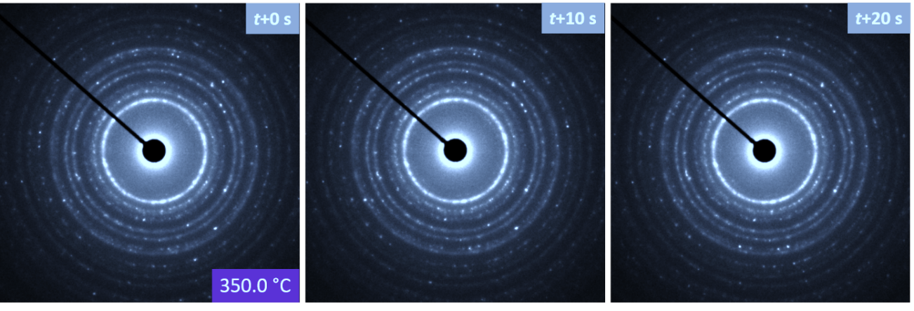
Figure S7. In situ SAED data recorded at 350 °C (p(CH₄)=39.5 mbar, p(O₂)=8.8 mbar and p(He)=131.7 mbar), which barely change with time due to absence of phase oscillations.
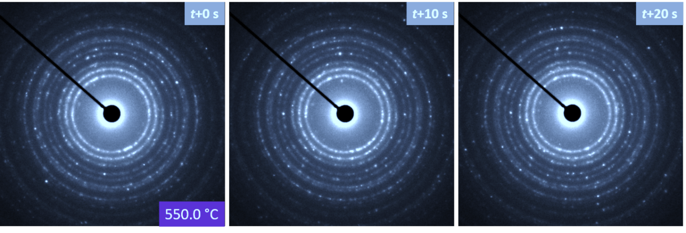
Figure S8. In situ SAED data recorded at 550 °C (p(CH₄)=39.5 mbar, p(O₂)=8.8 mbar and p(He)=131.7 mbar), which change dynamically due to phase oscillations.
Figure S9. In situ SAED patterns and the derived line profiles at 350 (top panel) and 550 °C (bottom panel) (p(CH₄)=39.5 mbar, p(O₂)=8.8 mbar and p(He)=131.7 mbar), showing an increased fraction of metallic Pd at 550 °C.

Figure S10. (A,B) In situ observation at 550 °C without beam irradiation between the two shots (p(CH₄)=39.5 mbar, p(O₂)=8.8 mbar and p(He)=131.7 mbar). (C) Difference between images A and B. (D-F) Enlarged images from the dotted squares indicated in (A-C). Dose rate was 3800 e nm⁻²s⁻¹.

Figure S11. (A) MS data (CO₂ and CO) recorded during in situ experiments (p(CH₄)=39.5 mbar, p(O₂)=8.8 mbar and p(He)=131.7 mbar). (B) Peak ratio of CO₂ and CO. (C) CO₂ mass spectrum from NIST library.(9)

Figure S12. In situ observations recorded at 550 °C in the reaction mixture (p(CH₄)=38.6 mbar, p(O₂)=12.9 mbar and p(He)=128.5 mbar) at low magnifications, showing phase oscillation-induced structural dynamics (reshaping, outgrowth, and etc.), which are similar to these recorded at higher magnifications. Dose rate is 2300 e nm⁻²s⁻¹.

Figure S13. O 1s XPS data of Pd NPs in (a) 1 mbar O₂ at 350 °C, (b) 1 mbar O₂ at 550 °C, (c) 1.3 mbar and CH₄/O₂ = 4.5:1 at 550 °C, (d) 1.3 mbar CH₄/O₂ = 4.5:1 at 350 °C, and (e) 1.3 mbar CH₄/O₂ = 4.5:1 at 550 °C after temperature decrease.

Table S1. The XPS fitting parameters of Pd 3d_{5/2} spectra.

 | Pd⁰ |  |  |  |  | Pd^{δ+} |  |  |  |  | Pd²⁺
 | Shape | BE, eV | FWHM, eV | % | Shape |  | BE, eV | FWHM, eV | % | Shape |  | BE, eV | FWHM, eV | %
O₂, 350 ºC | DS(0.12,400) | 335.0 | 0.7 | 51.3 | GL(80) |  | 335.5 | 0.7 | 3.0 | GL(80) |  | 336.3 | 0.8 | 45.7
O₂, 550 ºC | DS(0.12,400) | - | - | - | - |  | - | - | - | GL(80) |  | 336.4 | 0.8 | 100
CH₄:O₂, 550 ºC | DS(0.12,400) | 334.9 | 0.6 | 79.6 | GL(80) |  | 335.3 | 0.8 | 19.9 | GL(80) |  | 336.1 | 0.8 | 0.5
CH₄:O₂, 350 ºC | DS(0.12,400) | 334.9 | 0.5 | 61.0 | GL(80) |  | 335.3 | 0.7 | 30.9 | GL(80) |  | 336.1 | 0.8 | 8.1
CH₄:O₂, 550 ºC_2 | DS(0.12,400) | 334.8 | 0.6 | 81.4 | GL(80) |  | 335.3 | 0.8 | 18.6 | - |  | - | - | -

Table S2. The XPS fitting parameters of O 1s spectra.
 | Pd 3p3/2 |  |  |  | O contamination |  |  |  | O lattice |  |  |  | O surface
 | Shape | BE, eV | FWHM, eV | % | Shape | BE, eV | FWHM, eV | % | Shape | BE, eV | FWHM, eV | % | Shape | BE, eV | FWHM, eV | %
O₂, 350 ºC | GL(30) | 531.9 | 2.7 | 47.0 | GL(30) | 530.4 | 1.3 | 23.3 | GL(30) | 529.1 | 1.3 | 29.7 | - | - | - | -
O₂, 550 ºC | GL(30) | 533.0 | 2.7 | 28.7 | GL(30) | 530.9 | 1.4 | 19.3 | GL(30) | 529.6 | 1.3 | 39.3 | GL(30) | 528.7 | 1.4 | 12.7
CH₄:O₂, 550 ºC | GL(30) | 531.9 | 2.7 | 79.7 | GL(30) | 530.5 | 1.4 | 17.0 | GL(30) | 529.2 | 1.3 | 3.3 | - | - | - | -
CH₄:O₂, 350 ºC | GL(30) | 531.8 | 2.7 | 79.3 | GL(30) | 530.4 | 1.4 | 4.0 | GL(30) | 529.1 | 1.3 | 16.7 | - | - | - | -
CH₄:O₂, 550 ºC_2 | GL(30) | 531.8 | 2.7 | 81.6 | GL(30) | 530.3 | 1.3 | 16.0 | GL(30) | 529.0 | 1.3 | 2.4 | - | - | - | -

Additional discussion on XPS data:
We employed DFT to compute the Pd 3d_{5/2} and O 1s core level binding energies using the ΔSCF method. Oxygen in bulk PdO was used for the O1s reference state assuming a binding energy of 529.1 eV. For the O1s calculations we have used the O.star1s-pbe-van_gipaw pseudopotential and for Pd, we generated a Pd pseudo with a core hole starting from the PSLibrary PAW input file using the ld1.x code of the QE package. The oxygen pseudopotential is available at http://pseudopotentials.quantum-espresso.org/upf_files/O.star1s-pbe-van_gipaw.UPF. Tables S3 and S4 show the results for the Pd 3d_{5/2} and O 1s calculations.
As we can see in Table S3 (and Figure 4), the Pd 3d_{5/2} energy of Pd is 334.9 and PdO is 335.7 eV, where the 0.8 eV shift indicates the presence of Pd(II). Screening different structures within DFT offers insight into the mechanism, where we have focused on Pd atoms in the (i) bulk, (ii) subsurface and (iii) surface of the structures considered in this work. We begin with the pristine Pd(100) surface. In this case, Pd bulk and subsurface have a BE of 334.9 eV, with the surface palladium atom showing a surface core level shift of -0.4 eV due to the unsaturated bonds at the surface. On the PdO(001) surface the bulk and subsurface Pd atoms have a 335.7 eV BE. The BE of the surface Pd atom on PdO(001) is shifted +0.4 eV relative to the bulk oxide, showing the surface atoms are oxidized to Pd(II+δ) due to the surface oxygen. From our mechanistic calculations we find this highly oxidized species is extremely reactive, which agrees with its near absence from the measured spectrum.
We also considered the role of strain on the XP BEs. First we consider a PdO(001) surface strained to match the Pd(100) surface. In this case, the Pd3d_{5/2} BE are slightly higher than that of the bulk PdO reference, showing the influence of lattice strain on the BEs. Now, if we look at the BEs of Pd in the PdO(001)/Pd(100) structure, the bulk Pd atom shows the same binding energy (334.9) as the bulk Pd atom within the pristine Pd(100), corresponding to a Pd⁰ metallic state, as expected. The surface Pd atom that are bound oxygen, however, show much higher BEs (336.6 eV), matching those computed for the strained PdO surface. The subsurface Pd atoms shows an intermediate BE of 335.5 eV. This can be ascribed to a partially oxidized, or Pd(I). This corroborates the experimental XPS, suggesting the presence of partially oxidized Pd at the metal oxide interface. To further test this assignment, we removed the terminating oxygen layer from the PdO(001)/Pd(100) surface and calculated the BEs. In this case, the surface and subsurface Pd atoms show BEs between that of a neutral Pd atom and Pd(II). Finally, we estimated the binding energy of Pd atoms close to an oxygen vacancy in the surface of the PdO(001)/Pd(100) SMSI structure and observed that the Pd atom close the vacancy, which is now partially reduced, shows a BE of 335.5 eV, like that of Pd(I) (335.4 eV). Therefore, we find that Pd(I), may appear neat oxygen defect sites in the oxide or at the metal oxide interface.
Table S3. Pd 3d_{5/2} BE calculated using the ΔSCF method using DFT. For all the surfaces considered, we have computed the BE of the bulk Pd atom, a subsurface Pd atom and a surface Pd (top most Pd layer) atom. Bulk Pd metal was taken as the reference state with a Pd 3d_{5/2} of 334.9 eV
System | Pd-atom-Studied | Core-level BE (eV)
Pd(Bulk) |  | 334.9
PdO(Bulk) | Pd(Bulk) | 335.7
Pd(100)Surface | Pd(Bulk) | 334.9
 | Pd(Sub-surface) | 334.9
 | Pd(Surface) | 334.5
PdO(001)Surface-Bulk-Geometry | Pd(Bulk) | 335.7
 | Pd(Sub-surface) | 335.7
 | Pd(Surface) | 336.1
PdO(001)Surface-Strained | Pd(Bulk) | 336.8
 | Pd(Sub-surface) | 336.0
 | Pd(Surface) | 336.6
PdO(001)/Pd(100) | Pd(Bulk) | 334.9
 | Pd(Sub-surface) | 335.5
 | Pd(Surface) | 336.6
PdO(001)/Pd(100)-Sub-Surface | Pd(Bulk) | 334.9
 | Pd(Sub-surface) | 335.4
 | Pd(Surface) | 335.0
PdO(001)/Pd(100)-with-O_{v} | Pd(Bulk) | 334.9
 | Pd(Sub-surface) | 335.4
 | Pd(Surface) | 336.4
 | Pd(Surface-O_{v}) | 335.5

Now we move on to the O BEs. The collected O 1s at 350 °C in 1 mbar O₂ shows a peak at BE of 529.1 eV due to the lattice oxygen (Figure S13a).(10, 11) An additional peak is present at BE of 530.4 eV previously attributed to the supersaturated adsorbed oxygen layer (O_{ads}).(12) However, the DFT results in Table S4 suggest this assignment might be incorrect and the oxygen species at BEs above 529.4 eV are more likely related to contaminants. While Table S4 shows such species could also be associated with short lived species such as CO, CO₂ or OCH₃, these are however likely be below the detection limit. Also note that the measured XP peaks of the Pd 3p_{3/2} region (cyan trace) overlap with the O 1s XPS peak. The signal from the gaseous O₂ is identified by two peaks at BE of 537.1 eV and 538.2 eV (Figure S13a).(13, 14) Increasing the temperature to 550 °C in 1 mbar O₂ leads to the presence of an additional component that is 1 eV lower than O_{lattice} (orange line in Figure S13b), in addition to O_{lattice} and O_{ads}/O_{contam} peaks discussed above. This component has been assigned previously to surface oxides of Pd,(13, 14) as confirmed using DFT (Table S3). The co-feeding of CH₄ to the O₂ flow (CH₄:O₂=4.5:1) at 550 °C leads to the absence of the O_{ads}/O_{contam} species at a BE of 530.9 eV and almost a complete disappearance of O_{lattice} species after introducing CH₄ in the O₂ flow (Figure S13c), in agreement with results in the Pd 3d region (Figure 4c). Yet a new peak at BE = 530.5 eV appears (wine-red line). DFT indicates that the O species at 530.5 eV could be related to bound intermediates (O-bound intermediates) such as CO and CH₂O (Table S4), but again their lifetimes are expected to be short, suggesting the species at 530.5 eV could be a contaminant. The small peaks with BE higher than Pd 3p_{3/2} indicates the presence of H₂O (BE of 536.4 eV) and CO₂ (BE of 535.0 eV) in the gas phase near the sample surface, in agreement with the DFT result that shows when adsorbed, H₂O and CO₂ will appear at lower BEs.(13-15) Consistent with MS data of the operando TEM experiment, the O 1s XPS region reveals the absence of CO near the surface of the Pd catalysts, suggesting the complete oxidation of CH₄. Decreasing the temperature from 550 to 350 °C in the CH₄/O₂ mixture results in the disappearance of the peaks of gas-phase CO₂ and H₂O in the O 1s XPS region (Figure S13d), indicating lower catalytic activity at 350 °C. When the temperature is increased back to 550 °C, the contribution from methane combustion products and the gas-phase returns (Figure S13e).

Table S4. O 1s Core levels calculated using the ΔSCF method using DFT. For all the surfaces considered, we have computed the BE of the bulk O atom, a subsurface O atom and a surface oxygen atom. In addition, for general reference, we have computed the BE of an adsorbed oxygen and oxygens from CO, CO₂, OH and H₂O fragments for the Pd(100) surface and OH, CO₂ and CH₂O fragments for the PdO(001) surface.
System | O-atom-Studied | BE (eV)
PdO-Bulk | Bulk-O-Atom | 529.1
PdO(001)-Surface-PBE-Geometry
i | Bulk-O-Atom | 529.0
ii | Subsurface-O-Atom | 528.7
iii | Surface-O-Atom | 526.8
Pd(100) Surface
i | O@O adsorbed | 528.2
ii | O@CO adsorbed | 530.5
iii | O@CO₂ adsorbed | 533.4
Iv | O@OH adsorbed | 527.6
v | O@H₂O adsorbed | 531.8
PdO(001)-Surface-Strained-Geometry
i | Bulk-O-Atom | 529.4
ii | Subsurface-O-Atom | 528.8
iii | Surface-O-Atom | 527.2
PdO(001)/Pd(100)
i | Subsurface-O-Atom | 528.4
ii | Surface-O-Atom | 527.1
iii | O@OH adsorbed | 528.6
Iv | O@CO₂ adsorbed | 533.4
v | O@CH₂O adsorbed | 530.5

DFT calculations results
Ab initio atomistic thermodynamics:
To study the total combustion of CH₄ on the Pd/PdO catalyst, we started by computing the Pd/O surface phase diagram to gain insight into the phases that may participate in combustion. The stability of various surface structures was determined by way of ab initio atomistic thermodynamics,(16) wherein DFT computed adsorption energies are corrected by the gas-phase chemical potential of O₂, $μ_{O2}\left(T,p_{O2}\right)$. The surface free energy of a Pd_{x}O_{y} overlayer relative to a clean surface can then be written as:
$∆G_{PdxOy}\left(T,p_{O2}\right)≈E_{PdxOy}- x μ_{Pd}-1/2 y μ_{O2}\left(T,p_{O2}\right)-E_{clean}$,
where $E_{PdxOy}$ and $E_{clean}$ are the DFT total energies of the slab with and without the overlayer of interest, respectively. $μ_{Pd}$ is the chemical potential of Pd, which we take to be the total energy of the bulk metal. $μ_{O2}\left(T,p_{O2}\right)$ is the gas-phase chemical potential of O₂ and contains the temperature through tabulated enthalpic and entropic corrections taken from the NIST JANAF tables and an ideal-gas pressure dependence to give:
$μ_{O2}\left(T,p_{O2}\right)=E_{O2}+H\left(T, p^{0}\right)-H\left(0, p^{0}\right)-TS\left(T, p^{0}\right)+k_{B}T ln\left(p_{O2}/p^{0}\right)≡E_{O2}+{\tilde{μ}}_{O2}\left(T,p_{O2}\right)$,
where $E_{O2}$ is the DFT energy of O₂, see below for details of its calculation, and the H and S terms come from the NIST JANAF tables. Note, in this form, all condensed phases are assumed to have no entropic contribution to the free energy. While this is not true, the difference in the entropic contributions to the free energies between different overlayers will be small. Thus, the main impact of ignoring the entropic contributions to the free energy of the solid phases is an underestimation of the stability of all phases containing oxygen. We can estimate the magnitude of this error by considering the experimental decomposition temperature of PdO under varying oxygen pressure. Using the PdO heat of formation of 1.17 eV and the decomposition temperatures recommended in literature,(17, 18) we can estimate the error in temperature. This results in a temperature error of ca. 70 K at ca. 1 bar, that is, the prediction from ab initio atomistic thermodynamics is 70 K below the observed decomposition temperature for bulk PdO. At an oxygen pressure of ca. 0.5 bar the error increases to 76 K, while at ca. 0.1 bar the error increases marginally to 77 K. Thus, we expect a temperature error of ca. 80 K in the pressure range used in this work. These errors are in line with previous estimates on the Ag/O system.(19) The second major source of error in this analysis is the binding energy of the O₂ molecule, which is strongly over bound in DFT at the PBE level.(19) To avoid this over binding, we took the energy of ½ O₂ from the PdO bulk oxide as:
$1/2 E_{O2}=E_{PdO}-E_{Pd}-∆H_{f,PdO}$,
where $E_{PdO}$and $E_{Pd}$ are the DFT total energies of bulk PdO and Pd, respectively, and $∆H_{f,PdO}$ is the experimental heat of formation of PdO, which we took to be 1.17 eV.(17) With these definitions we can compute the surface phase diagram of the Pd/O system, as shown in Figure S14, as a function of oxygen partial pressure and temperature. Only clean Pd metal, Pd with adsorbed oxygen, and PdO appear on the phase diagram. The oxide overlayers seen in TEM are thus present due to kinetic limitations, hence catalyst dynamics. The metastability limits of these overlayers are shown in Figure S14.
Figure S14. Surface phase diagram computed by employing ab inito thermodynamics. Only the bulk oxide PdO, metal with adsorbed oxygen, and oxygen free Pd appear as stable phases, as labeled. Yellow lines indicate the areas where the PdO(001)/Pd and PdO(101)/Pd interfaces are stable.

Kinetics of CH₄ combustion:
To address the kinetics of methane combustion and catalyst dynamics, we considered several structures from the computed phase diagram as possible combustion catalysts. As Pd metal is observed during in situ TEM, we begin our discussion with the metallic phase with a low coverage of oxygen adatoms. To compute the reaction energetics on the clean surface we employed a six layer (3x3) Pd(100) surface and adsorbed CH₄ on the surface together with a 1/9 monolayer (ML) coverage of adsorbed oxygen, see Figure S15. From the figure two hydrogen atoms can be seen to sequentially transfer to adsorbed oxygen to first form a hydroxide and adsorbed CH₃, then an adsorbed water molecule and adsorbed CH₂. Once the water molecule was created, it was assumed to desorb and was replaced by another oxygen atom to allow the reaction to progress in this low oxygen coverage regime. Two hydrogen atoms are then sequentially transferred from the adsorbed CH₂ to the second adsorbed oxygen atom to form a second water molecule and adsorbed carbon. At this point, it should be noted that the remaining carbon atom strongly binds to the four-fold Pd hollow site and hence coke formation is likely in this low oxygen coverage limit, though additional oxygen can oxidize the adsorbed carbon to CO, which would desorb in the low oxygen coverage limit, resulting in incomplete methane oxidation under oxygen lean conditions if Pd metal becomes the only available active phase.
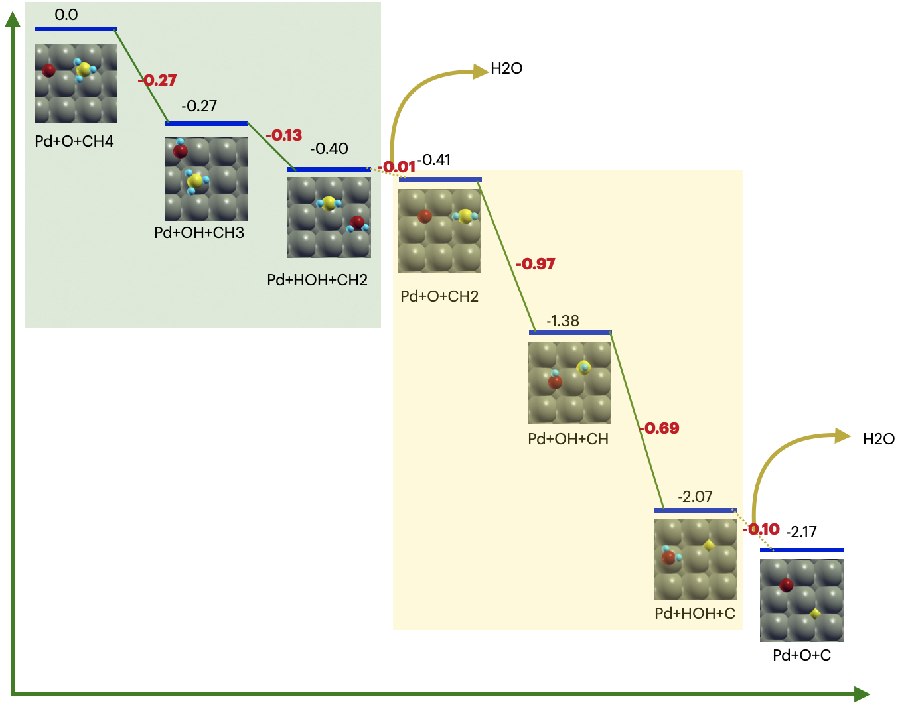
Figure S15. Reaction steps involved in methane combustion on Pd(0). Color coding of the atoms are as follows. Dark green (Pd), Red(O), Yellow (C), and Blue (H). Yellow arrows represent the desorption of H₂O from the metal surface.
Closer inspection of Figure S15 reveals the first and second hydrogen transfer reactions are weakly exothermic. Such behavior is consistent with the high gas-phase dissociation enthalpy of the H-CH₃ bond.(20) The third and fourth hydrogen transfers are, however, more exothermic. Thus, on the metal surface, the oxygen assisted H transfer from methane follows the gas-phase behavior, with the first steps proving to be the least energetically favorable. This exothermicity will influence the rates of the elementary steps. Usually, metal and metal oxide surfaces follow the Bronsted-Evans-Polyani (BEP) principle, that is, there is a linear relationship between the heat of reaction of an elementary steps and the step’s activation energy: $E_{a}\sim α {∆E}_{rxn}+β$. From literature,(21-23) we can assume the BEP slope ($α$) does not vary considerably across the different hydrogen transfer steps and adopt the universal dehydrogenation BEP relationship: $0.86 ∆E_{rxn}+1.14 eV$,(22) which is also close to the universal BEP relationship suggested for C-C, C-O, and O-O coupling and dissociation reactions: $0.84 ∆E_{rxn}+1.92 eV$.(24) This assumption constant BEP slope leads to the conclusion that the steps with highest heats of reaction will have the lowest activation barriers and hence faster reaction kinetics.
On the pristine Pd(100) surface (Figure S15), the early dehydrogenation steps, which are weakly exothermic (-0.27 eV and -0.13 eV, Table S5), will be slower than the final dehydrogenation steps, which are moderately exothermic (-0.97 eV and -0.69 eV). Therefore, the first and second hydrogen transfer will be rate limiting during the initial stages of CH₄ oxidation at low oxygen coverage. With an estimated BEP barrier of 0.9-1.0 eV for the two slow steps, see Table 5. This will make the combustion reaction slow compared to reoxidation, where the adsorption energy of 2/9 ML O (1.42 eV) gives an estimated BEP barrier of 0.7 eV. By way of example, the Boltzmann factors for the estimated barrier to O-O bond breaking and the first hydrogen transfer step from methane to the surface differ by a factor of 29 at 350 °C and 13 at 550 °C. From the Hertz-Knudsen equation, this implies p_{CH4}>29p_{O2} would be required to maintain the reduced surface at 350 °C, assuming equal sticking probabilities, and p_{CH4}>13p_{O2} would be required at 550 °C. Here the pressures differ by only ca. 4.5 and the metallic phase is not maintained.

Table S5. Computed heats of reaction and BEP estimated activation energies for methane combustion on Pd metal. The universal dehydrogenation BEP was employed for the dehydrogenation steps, while the universal BEP C-C, C-O, and O-O coupling/dissociation BEP was used for reoxidation. Note if the later was used for dehydrogenation the dehydrogenation barriers would increase and not alter the conclusions. ¹The reoxidation reaction was consider to be $O_{2}→2O_{ads}$ on the 3x3 Pd(100) surface.
Step | Erxn / eV | Ea / eV
1 | -0.27 | 0.9
2 | -0.13 | 1.0
3 | -0.97 | 0.3
4 | -0.69 | 0.5
Reoxidation¹ | -1.42 | 0.7

Since our thermodynamic analysis predicts an oxidized surface will be present under reaction conditions, we can turn our attention to the bulk PdO oxide. Here we considered the PdO(001) surface, where a pure PdO(001) surface was generated using the PBE optimized lattice parameter for the PdO bulk. We found that CH₄ oxidation on the PdO surface proceeds through the five-step mechanism shown in Figure 5 in the main text. In the first step, the CH₄ molecule physisorbs onto the surface and in the second step a hydrogen is transferred to one of the surface oxygens while the CH₃ fragment adsorbs onto an oxygen molecule by making an O-CH₃ bond (Note, this reaction is qualitatively distinct from that occurring in the low oxygen coverage limit on the Pd(100) surface where O-C bond formation is inhibited until the CH₄ is fully oxidized to adsorbed carbon and water). Once formed, the second hydrogen atom on the O-CH₃ is transferred to a second oxygen on the surface and the remaining O-CH₂ fragment is further oxidized to form the OCH₂O species shown in Figure 5. This OCH₂O fragment transfers a hydrogen atom to a surface oxygen to form a formate-like OCHO species. In the final step, hydrogen is transferred from formate to surface oxygen to yield CO₂. Following the previous example of the metal surface, these reaction energies can be used to assess the kinetic stability of the bulk PdO phase by way of the universal BEP scaling relationships.
As discussed above, the first and second elementary steps involve hydrogen transfer as well as O-C bond formation. Therefore, they are strongly exothermic in comparison with the elementary steps found on the metal surface and also with respect to the pure dehydrogenation steps 3 and 4 on the oxide. Assuming the BEP relationship holds, the third and fourth dehydrogenation step will be rate limiting for methane combustion over the oxide owing to the small heat of reaction. This produces two interesting differences to methane oxidation over the metal that should be mentioned: i) on the oxide, activation of the H-CH₃ bond is no longer expected to rate limiting, making catalysis over the oxide distinct from the gas-phase chemistry of methane or catalytic combustion on the metal, and ii) the formation of C-O bonds in kinetically facile steps will prevent incomplete combustion if oxide is the active phase because H_{x}CO₂ is formed before any kinetically slow steps.
We can now estimate the kinetic stability of the PdO phase by comparing the activation energy estimated from the universal BEP relationships for the slow step of dehydrogenation with reoxidation, where the heat of reaction of reoxidation was computed as the total energy associated with filling di-oxygen vacancies on the oxide surface:
$E_{reoxidation}=E_{Clean}-E_{di-vacancy}-E_{o2}$,
Two divacancy configurations were considered, see Figure S16. The resultant barriers estimated from the universal dehydrogenation BEP and universal BEP for C-C, C-O, and O-O coupling/dissociation are shown in Table S6. Unlike in the case of the metal surface, the estimated activation energies in the case of bulk PdO for the slow combustion step and reoxidation are similar. In fact, the barriers are within the error expected for the BEP fits; the mean absolute error (MAE) of the employed BEP fits are 0.3 eV and 0.35 eV for the dehydrogenation and C-C, C-O, and O-O coupling/dissociation, respectively.(22, 24) From the similarity in methane oxidation (surface reduction) and surface reoxidation barriers, we conclude oxidation and reduction of PdO will be competitive.
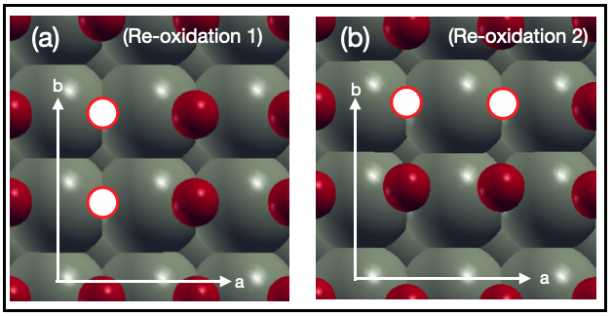
Figure S16. Ball and stick representation of two competing reoxidation mechanisms. In Reoxidation 1, the O₂ molecule splits and adsorb onto two different Pd bridge sites shared by four different Pd atoms. While in Reoxidation 2, the O₂ molecule splits and adsorb onto two different bridge sites shared by the same Pd atom.
Table S6. Computed heats of reaction for the slow step of methane oxidation over PdO and the reoxidation of PdO_{x} together with the barriers estimated using the universal dehydrogenation BEP and universal BEP for C-C, C-O, and O-O coupling/dissociation. The former was used for the dehydrogenation step and the later for the reoxidation step.
Step | Erxn / eV | Ea / eV
Dehydrogenation step 4 | -1.12 | 0.2
Reoxidation 1  (vacancy configuration 1) | -1.52 | 0.6
Reoxidation 2  (vacancy configuration 2) | -2.00 | 0.2

As catalyst reoxidation and reduction through methane combustion are competitive, catalyst dynamics emerge. It is thus important to also consider the Pd/PdO interface. Here two cases can be considered: 1) multilayer PdO and 2) single layer PdO.
When multilayer PdO domains are in contact with Pd metal, the oxide is strained into epitaxy with the metal at the metal/oxide interface, as shown in Figure 3, where the amount of strain depends on the distance to the interface. When a PdO monolayer is present a Pd(200)/PdO(002) interface appears to form and maintain an epitaxial relationship with the metal. (Note this phase was observed at 550 °C. Figure 3k shows a PdO(100) overlayer on Pd(111)). To study the catalytic behavior of these structures we modelled a PdO(001) overlayer on a Pd(100) surface, which we denote Pd/PdO. The Pd/PdO surface is modelled by placing a PdO(001) overlayer on the Pd(100) surface while keeping the lattice constant of Pd(100) fixed. This makes the overlayer PdO surface strained with respect to the bulk PdO lattice parameter. The strained bulk oxide was modeled using the same in-plane lattice parameters as the Pd/PdO but the model included effectively 2 layers of PdO rather than PdO and metal.
We found both the strained PdO and Pd/PdO surfaces oxidize methane through the same five-step mechanism as unstrained PdO. However, the strain increases the exothermicity of the slow dehydrogenation steps at the expense of the exothermicity of the early fast dehydrogenation steps, see Figure 5. Overall, this equating of heats of reaction for each elementary step is expected to increase the rate of methane oxidation. Estimating the barriers of these slow steps using the universal dehydrogenation BEP relationship suggests the reactions even become barrierless while the reaction energies for two reoxidation steps involving different di-oxygen vacancy configurations are shown in Table S7. The estimated activation energies for these steps are 0.8 eV on the Pd/PdO interface and 0.6 eV on the strained PdO. Thus, while theses strained structures appear to be more active in methane oxidation, their re-oxidation may be slow compared to their reduction. Overall, this will drive small PdO domains to metallic Pd. Thermodynamics will, however, push the catalyst back to the PdO, thereby setting up catalyst dynamics, the kinetics of which will show strong size dependence owing to the influence of interfacial Pd/PdO strain.
Table S7. The reaction energies for two competing reoxidation step, see Figure S16.
Step | (Pd/PdO): Erxn / eV; Ea / eV | (Strained PdO): Erxn / Ev; Ea / eV
Reoxidation 1  (vacancy configuration 1) | -1.36 ; 0.8 | -1.57; 0.6
Reoxidation 2  (vacancy configuration 2) | -1.28; 0.8 | -1.61; 0.6

References
1. S. Zhu et al., HIPPIE: a new platform for ambient-pressure X-ray photoelectron spectroscopy at the MAX IV Laboratory. Journal of Synchrotron Radiation 28, 624-636 (2021).
2. H. Shinotsuka, S. Tanuma, C. J. Powell, D. R. Penn, Calculations of electron inelastic mean free paths. X. Data for 41 elemental solids over the 50 eV to 200 keV range with the relativistic full Penn algorithm. Surface and Interface Analysis 47, 871-888 (2015).
3. S. Doniach, M. Sunjic, Many-electron singularity in X-ray photoemission and X-ray line spectra from metals. Journal of Physics C: Solid State Physics 3, 285 (1970).
4. P. Giannozzi et al., QUANTUM ESPRESSO: a modular and open-source software project for quantum simulations of materials. Journal of Physics: Condensed Matter 21, 395502 (2009).
5. J. P. Perdew, K. Burke, M. Ernzerhof, Generalized Gradient Approximation Made Simple. Physical Review Letters 77, 3865-3868 (1996).
6. P. E. Blöchl, Projector augmented-wave method. Physical Review B 50, 17953-17979 (1994).
7. A. Dal Corso, Pseudopotentials periodic table: From H to Pu. Computational Materials Science 95, 337-350 (2014).
8. N. Marzari, D. Vanderbilt, A. De Vita, M. C. Payne, Thermal Contraction and Disordering of the Al(110) Surface. Physical Review Letters 82, 3296-3299 (1999).
9. W. E. W. NIST Mass Spectrometry Data Center, director, "Mass Spectra" in NIST Chemistry WebBook, NIST Standard Reference Database Number 69, Eds. P.J. Linstrom and W.G. Mallard, National Institute of Standards and Technology, Gaithersburg MD, 20899, https://doi.org/10.18434/T4D303, (retrieved August 6, 2022)
10. G. Ketteler et al., In Situ Spectroscopic Study of the Oxidation and Reduction of Pd(111). Journal of the American Chemical Society 127, 18269-18273 (2005).
11. H. Gabasch et al., In situ XPS study of Pd(111) oxidation at elevated pressure, Part 2: Palladium oxidation in the 10⁻¹mbar range. Surface Science 600, 2980-2989 (2006).
12. D. Zemlyanov et al., In situ XPS study of Pd(111) oxidation. Part 1: 2D oxide formation in 10⁻³mbar O2. Surface Science 600, 983-994 (2006).
13. S. Blomberg et al., In Situ X-Ray Photoelectron Spectroscopy of Model Catalysts: At the Edge of the Gap. Physical Review Letters 110, 117601 (2013).
14. V. R. Fernandes et al., Reversed Hysteresis during CO Oxidation over Pd₇₅Ag₂₅(100). ACS Catalysis 6, 4154-4161 (2016).
15. I. P. Prosvirin, A. V. Bukhtiyarov, H. Bluhm, V. I. Bukhtiyarov, Application of near ambient pressure gas-phase X-ray photoelectron spectroscopy to the investigation of catalytic properties of copper in methanol oxidation. Applied Surface Science 363, 303-309 (2016).
16. K. Reuter, M. Scheffler, Composition, structure, and stability of RuO₂(110) as a function of oxygen pressure. Physical Review B 65, 035406 (2001).
17. N. N. Smirnova, T. A. Bykova, N. A. Polotnyanko, N. D. Shikina, I. L. Khodakovskii, Low-temperature heat capacity and standard entropy of PdO(cr.). Russian Journal of Physical Chemistry A 84, 1851-1855 (2010).
18. H. Zhang, J. Gromek, G. W. Fernando, H. L. Marcus, S. Boorse, PdO/Pd system equilibrium phase diagram under a gas mixture of oxygen and nitrogen. Journal of Phase Equilibria 23, 246 (2002).
19. T. E. Jones et al., Thermodynamic and spectroscopic properties of oxygen on silver under an oxygen atmosphere. Physical Chemistry Chemical Physics 17, 9288-9312 (2015).
20. D. Ciuparu, M. R. Lyubovsky, E. Altman, L. D. Pfefferle, A. Datye, Catalytic Combustion of Methane over Palladium-Based Catalysts. Catalysis Reviews 44, 593-649 (2002).
21. J. Cheng et al., Brønsted−Evans−Polanyi Relation of Multistep Reactions and Volcano Curve in Heterogeneous Catalysis. The Journal of Physical Chemistry C 112, 1308-1311 (2008).
22. S. Wang et al., Universal transition state scaling relations for (de)hydrogenation over transition metals. Physical Chemistry Chemical Physics 13, 20760-20765 (2011).
23. J. E. Sutton, D. G. Vlachos, A Theoretical and Computational Analysis of Linear Free Energy Relations for the Estimation of Activation Energies. ACS Catalysis 2, 1624-1634 (2012).
24. S. Wang et al., Universal Brønsted-Evans-Polanyi Relations for C–C, C–O, C–N, N–O, N–N, and O–O Dissociation Reactions. Catalysis Letters 141, 370-373 (2011).

