Figure 1A
Rich2
Rich2 Marker
β-actin
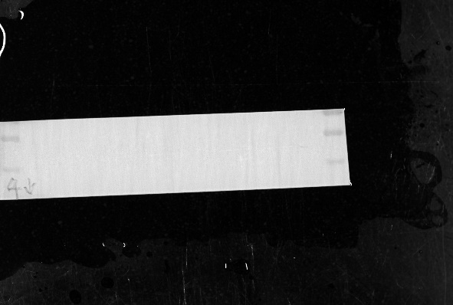 β-actin Marker
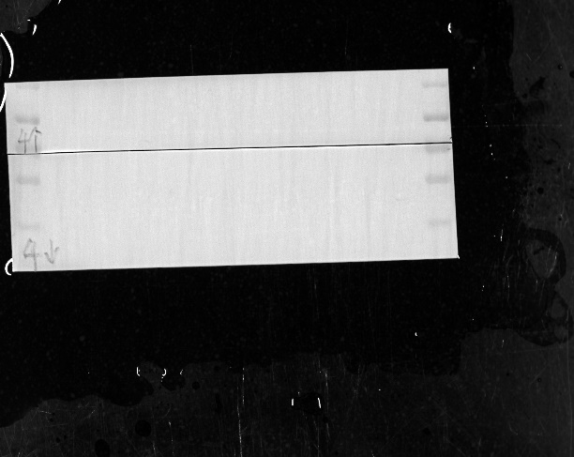 Full gel Marker

Figure 5A
NLRP3
NLRP3 Marker
β-actin
β-actin Marker
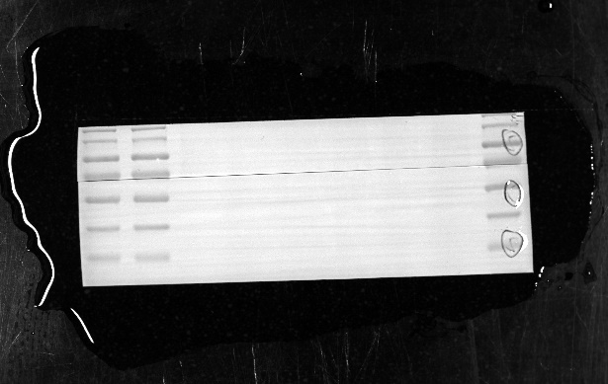 Full gel Marker

Figure 5B
NLRP3
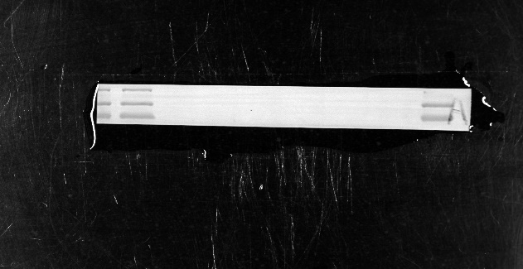 NLRP3 Marker
β-actin
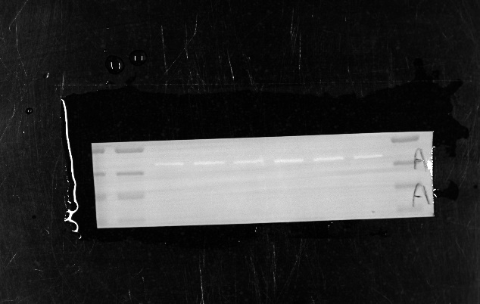 β-actin Marker
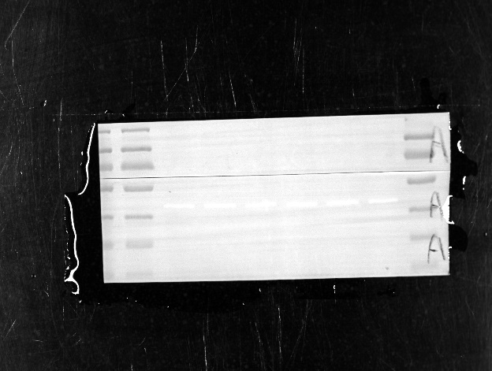 Full gel Marker

Figure 5C
ASC
ASC Marker
β-actin
β-actin Marker
Full gel Marker

Figure 5E
Pro-caspase-1
Pro-caspase-1 Marker
Caspase-1
Caspase-1 Marker
GAPDH
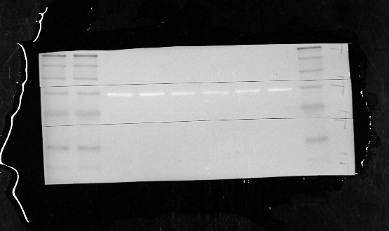 Full gel Marker

Figure 5F
Pro-caspase-1
Pro-caspase-1 Marker
Caspase-1
Caspase-1 Marker
GAPDH
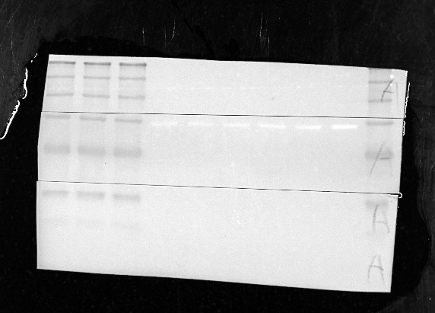 Full gel Marker

Figure 5G
IL-1β
IL-1β Marker
β-actin
β-actin Marker
Full gel Marker

Figure 5H
IL-1β
IL-1β Marker
β-actin
β-actin Marker
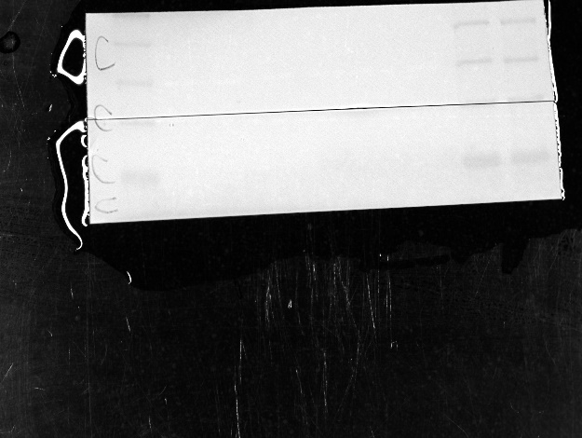 Full gel Marker

Figure 5I
IL-18
IL-18 Marker
β-actin
β-actin Marker
Full gel Marker

Figure 5j
IL-18
IL-18 Marker
β-actin
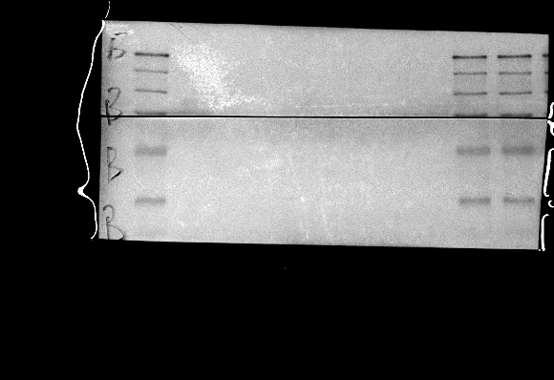 β-actin Marker

Figure 6B
NLRP3
NLRP3 Marker
β-actin
β-actin Marker
Full gel Marker
NLRP3
NLRP3 Marker
β-actin
β-actin Marker
Full gel Marker

Figure 6C
NLRP3
NLRP3 Marker
β-actin
β-actin Marker
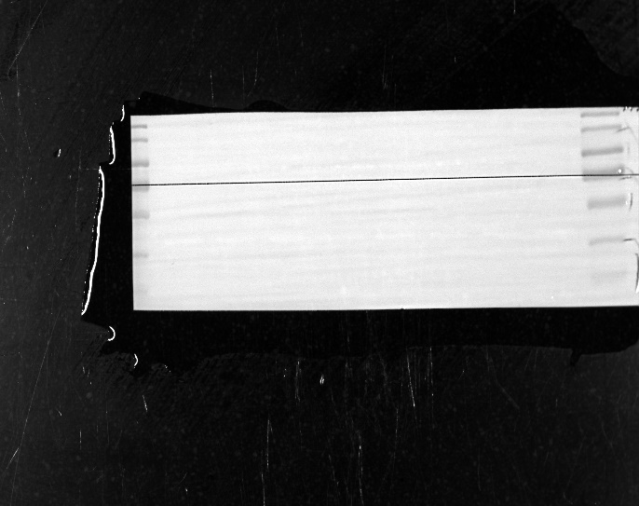 Full gel Marker

Figure 6D
Beclin 1
Beclin 1 Marker
β-actin
β-actin Marker
Full gel Marker

Figure 6E
Beclin 1
Beclin 1 Marker
β-actin
β-actin Marker
Full gel Marker

Figure 6F
LC3
β-actin
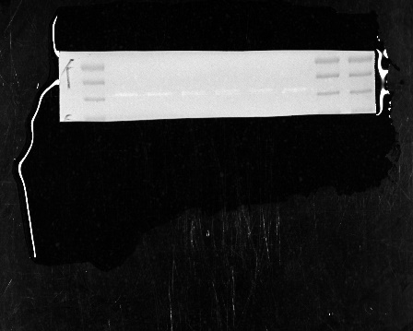 β-actin Marker
Full gel Marker

Figure 6G
LC3
LC3 Marker
β-actin
β-actin Marker
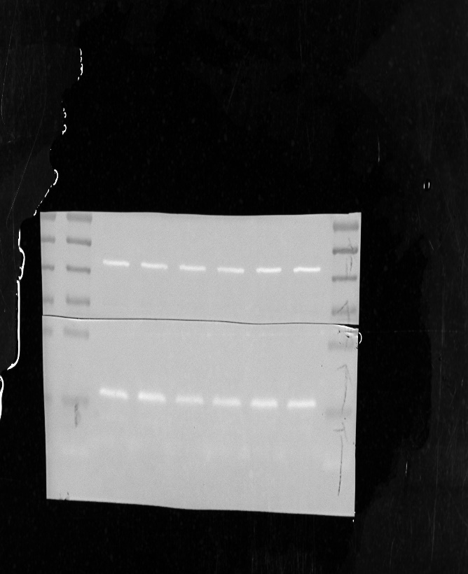 Full gel Marker

Figure 6I
NLRP3
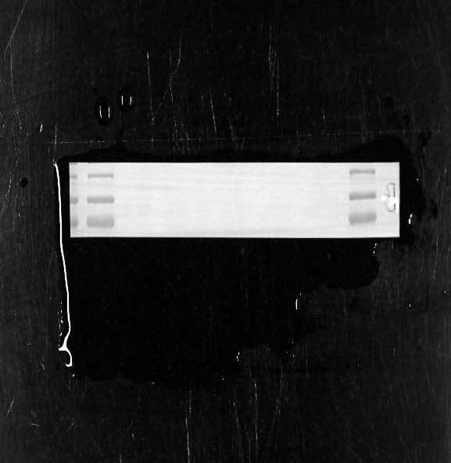 NLRP3 Marker
β-actin
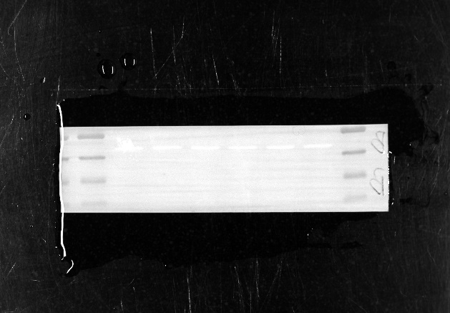 β-actin Marker
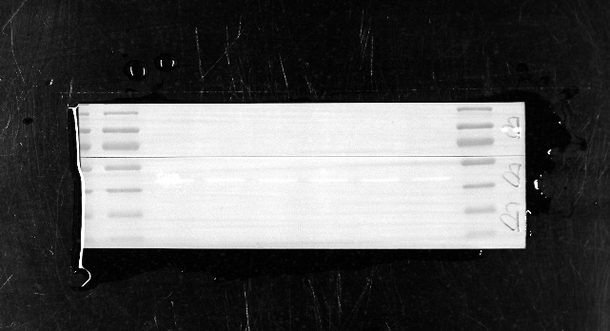 Full gel Marker

Figure 6J
IL-1β
IL-1β Marker
β-actin
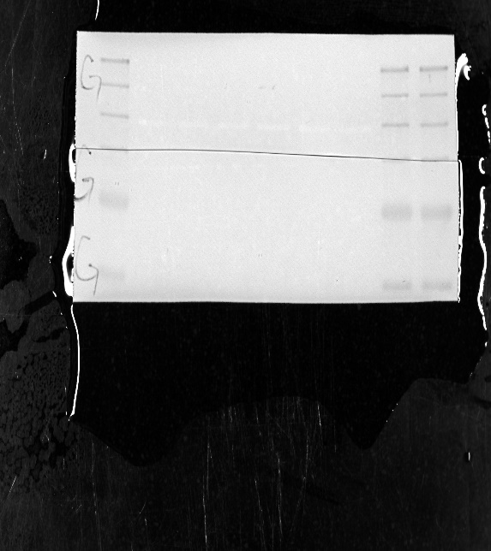 Full gel Marker

Figure 6K
IL-18
IL-18 Marker
β-actin
β-actin Marker
Full gel Marker

Figure 7D
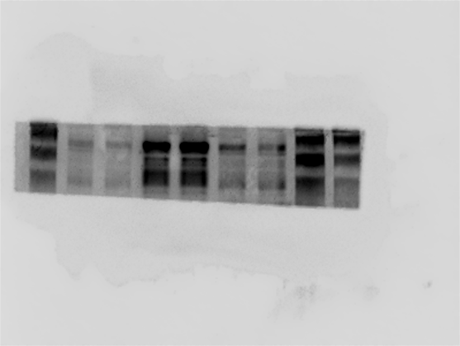 IL-1β
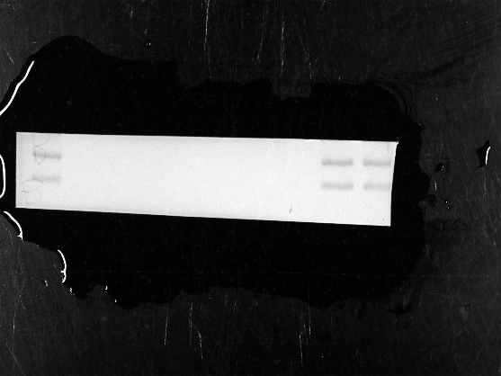 IL-1β Marker
β-actin
β-actin Marker
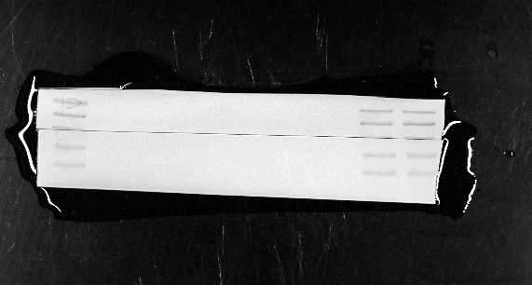 Full gel Marker

Figure 7E
IL-18
IL-18 Marker
β-actin
β-actin Marker
Full gel Marker

Figure S2A
Rich2
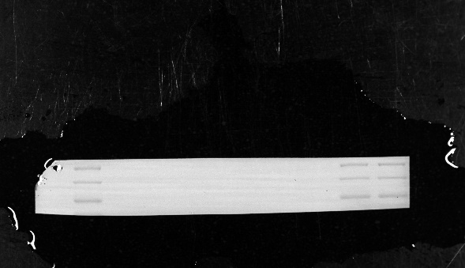 Rich2 Marker
β-actin
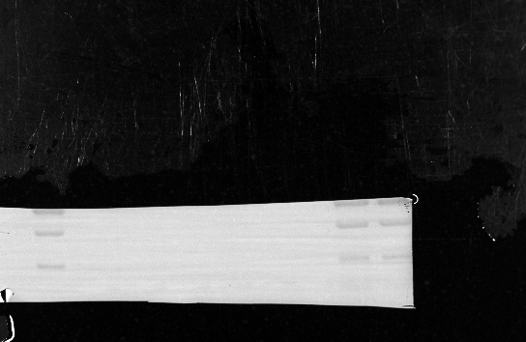 β-actin Marker
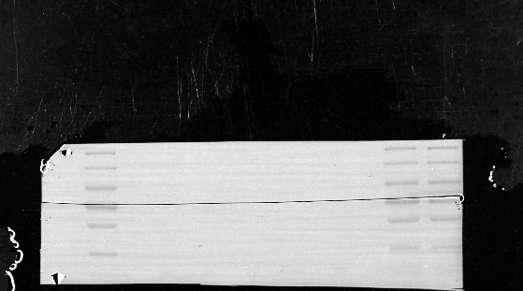 Full gel Marker

Figure S2B
Rich2
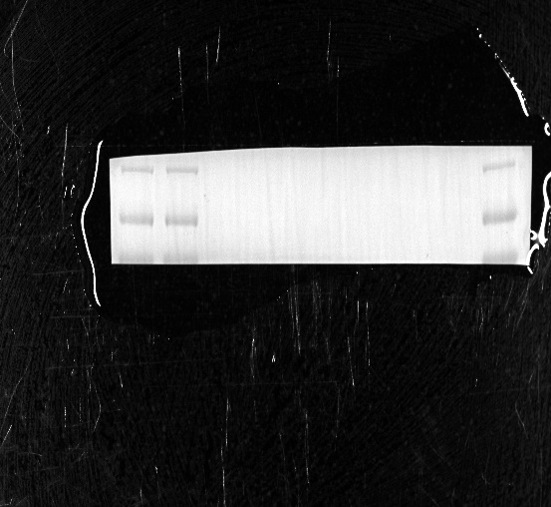 Rich2 Marker
β-actin
β-actin Marker
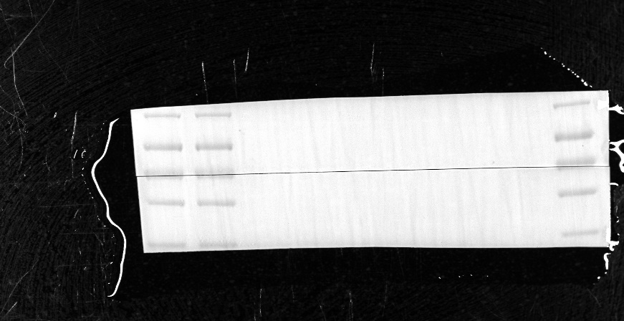 Full gel Marker

