Supporting Information of:
Advancing SSP-aligned Scenarios of
Shipping Toward 2050

Diogo Kramel*¹, Sebastian Marco Franz², Jan Klenner¹, Helene Muri¹, Marie Munster², and Anders H. Stromman¹

¹Industrial Ecology Programme (IndEcol), Norwegian University of Science and Technology (NTNU), Trondheim, Norway
²Department of Technology, Management and Economics, Technical University of Denmark (DTU), Copenhagen, Denmark

* Corresponding author: diogo.kramel@ntnu.no

SI.1 – Trade elasticity
Trade-GDP elasticity logarithmic regressions for ship types and their respective R2.

$$y=a\log\left(year\right)+b$$

Ship type | a | b | R2
Bulk carriers | -3.93 | 100.58 | 0.61
Chemical tankers | -10.72 | 102.29 | 0.85
Container ships | -2.71 | 103.79 | 0.39
Oil tankers | -16.89 | 103.17 | 0.95
Liquefied gas carriers | -21.80 | 105.09 | 0.79
Ro-ro | -15.78 | 106.91 | 0.63

SI.2 – Energy intensity and demand for highest 50 O&Ds
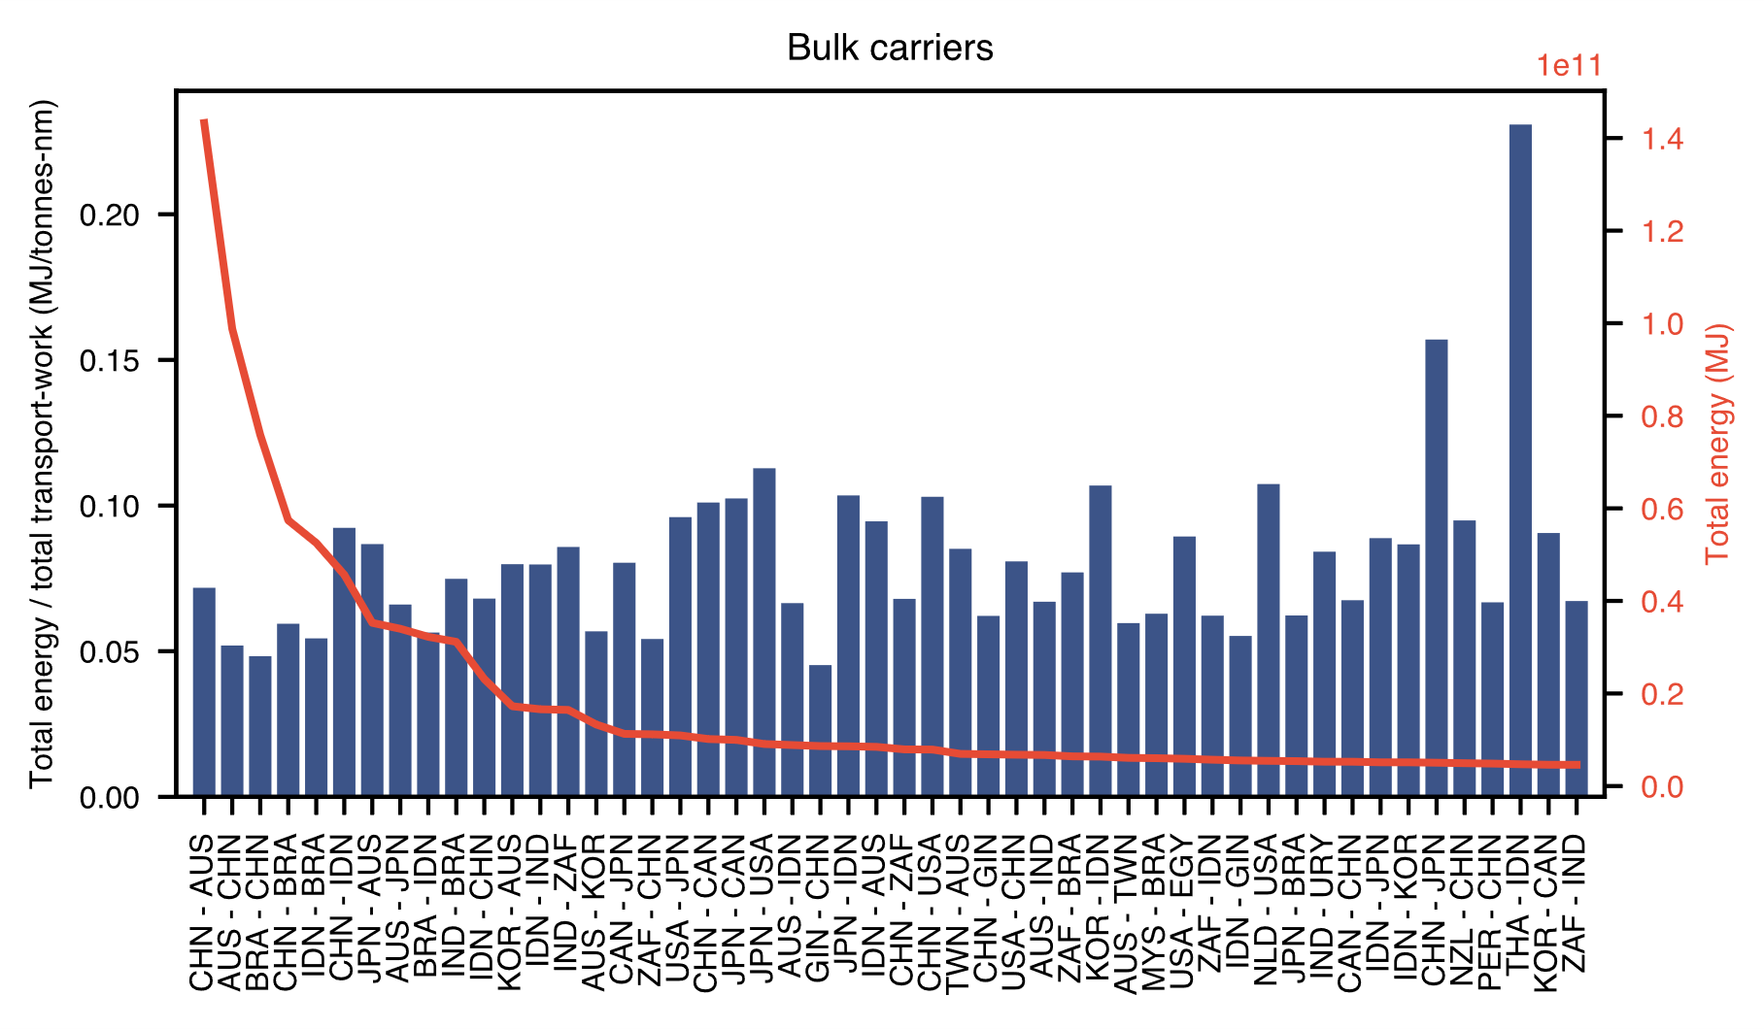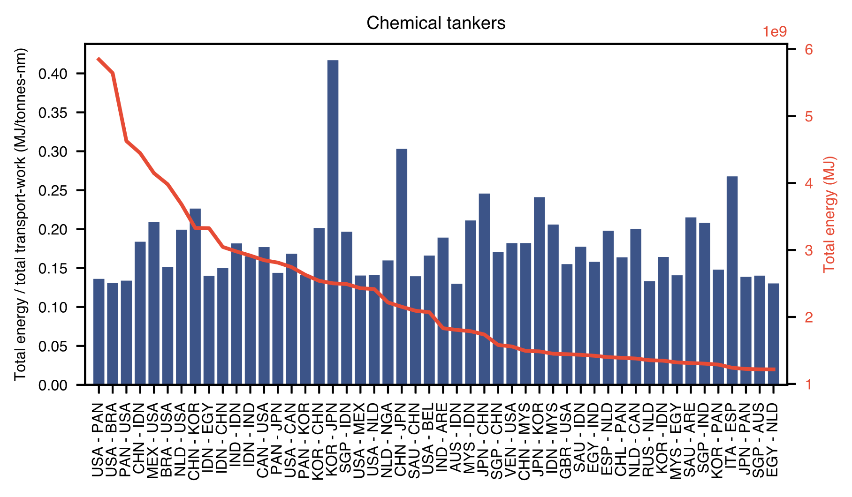
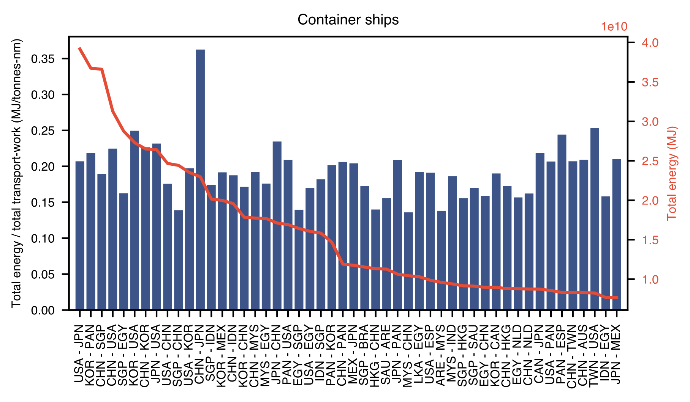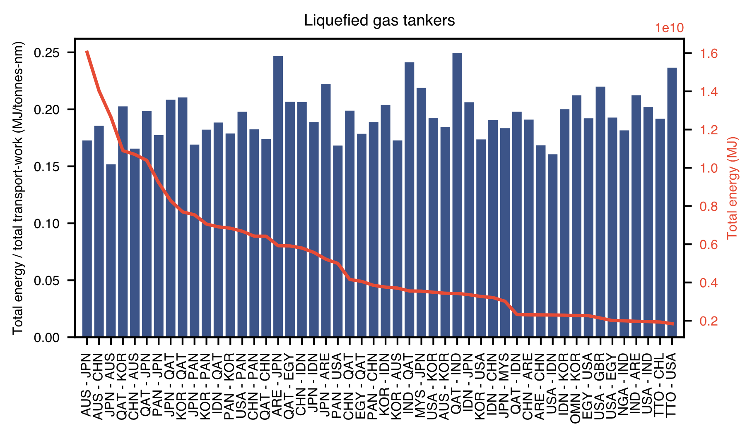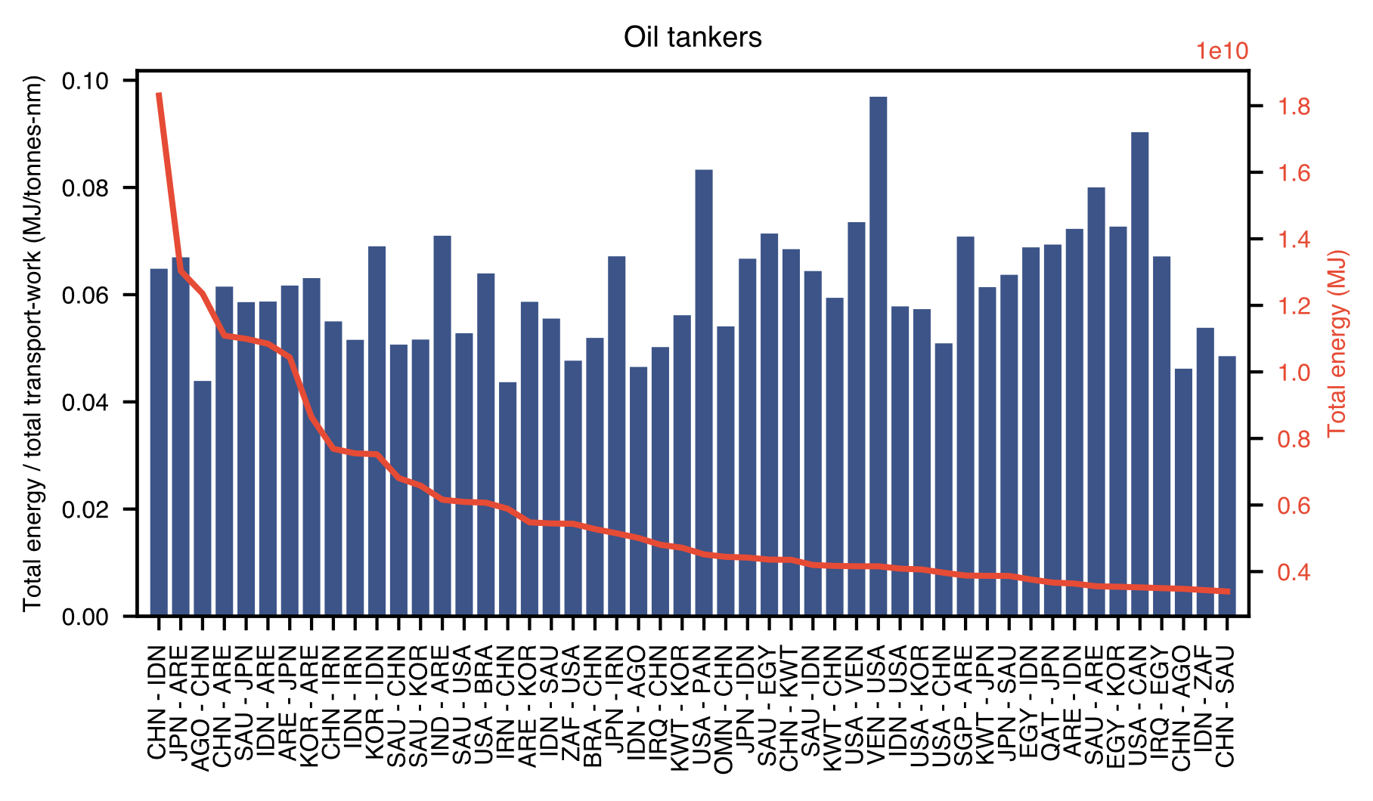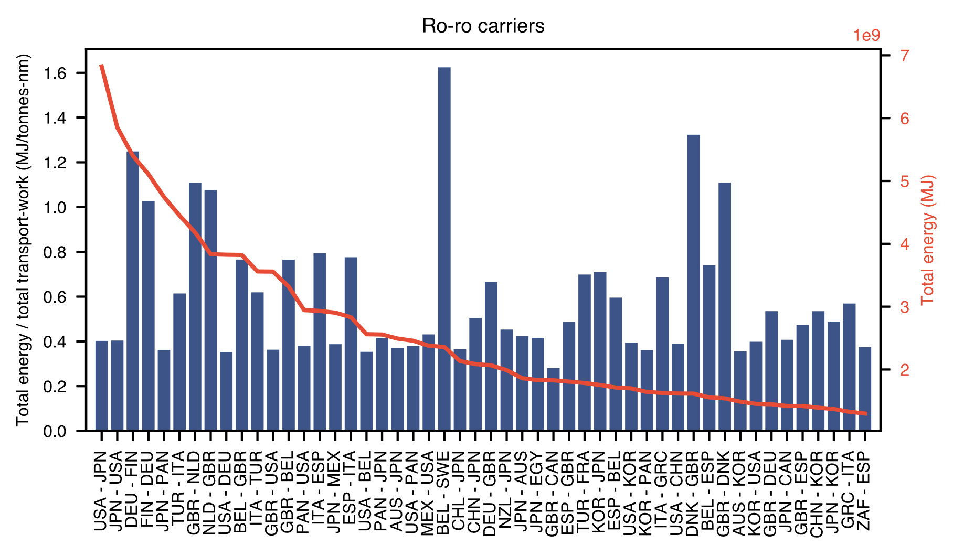

SI.3 – Hindcast analysis and projections for R11 regions

