Supplementary Information:

Stapler Strategies for Upcycling Mixed Plastics

Chen Zou¹, Jiawei Chen¹, Guifu Si¹*, Changle Chen¹*

1. Preparation of pre-graft copolymers S2
2. Preparation of graft copolymers S9
3. HDPE/PCL/PLA ternary blends S12
4. NMR and ESI analysis of small molecule simulation reactions S12
5. 3D printed sample image of HDPE/PCL blends S18
6. Synthesis of stapler molecules MIMIS and MTHD S18
7. Supplementary Figures of NMR of graft copolymers S19
8. Supplementary Figures of DSC of graft copolymers. S26
9. Supplementary Figures of GPC of graft copolymers. S31
10. Original tensile curve of the blends. S36

1. Preparation of pre-graft copolymers
1.1 Preparation of pre-graft copolymers using transition metal catalysts. In a typical experiment, a 350 mL glass thick walled pressure vessel was charged with solvent, a desired amount of comonomer (Undecylenic acid, methyl 10-undecenoate, 10-undecylenol) and a magnetic stir bar in the glovebox. The pressure vessel was connected to a high pressure line and the solution was degassed. The vessel was warmed to the desire temperature using an oil bath and allowed to equilibrate for 5 min. The metal complex (Pd or Ti) in 2 mL CH₂Cl₂ was injected into the polymerization system via syringe. With rapid stirring, the reactor was pressurized, maintained at a desired pressure of ethylene, and stirred continuously for the desired time. The pressure vessel was vented, the polymerization was quenched via the addition of MeOH and the copolymer was precipitated using excess MeOH. After filtration, the copolymer (P-OH1.0, P-OH2.0, P-OH5.0, P-COOH2.0, P-COOCH₃2.0) was obtained and dried at 45 °C for 36 h under vacuum. The polar monomer incorporation (mol %) was calculated from ¹H NMR analysis.
Supplementary Table1. Synthesis of pre-graft copolymers. ª
Ent. | pre-graft copolymer | Cat | Comonomer (mol/L) | Yield (g) | X mol% ^{b} | M_{n} ^{c}(10⁴) | M_{w}/M_{n} ^{c}
1 | P-OH1.0 | Pd | 10-undecylenol (1.0) | 5.31 | 1.0% | 10.86 | 1.94
2 | P-OH2.0 | Ti ^{d} | 10-undecylenol (0.5) | 4.42 | 2.0% | 5.10 | 2.41
3 | P-OH2.0 | Pd | 10-undecylenol (1.5) | 4.61 | 2.1% | 8.80 | 2.77
4 | P-OH5.0 | Pd | 10-undecylenol (2.0) | 4.11 | 5.0% | 3.60 | 2.54
5 | P-COOH2.0 | Pd | Undecylenic acid (1.5) | 6.21 | 1.9% | 13.7 | 2.36
6 | P-COOCH₃2.0 | Pd | methyl 10-undecenoate (1.5) | 5.80 | 2.1% | 7.95 | 2.72
ªConditions: catalyst 20 μmol, ethylene 8 atm, toluene+ comonomer 30 mL, t = 60 min. ^{b} Determined by ¹H NMR (C₂D₂Cl₄, 120 ºC). ^{c} M_{n}: 10⁴ g mol⁻¹, M_{n} and M_{w}/M_{n} were determined by gel permeation chromatography (GPC) in 1, 2, 4-trichlorobenzene at 160 °C. ^{d} [PhNH(CH₃)₂][B(C₆F₅)₄] (1.2 equiv.), iBu₃Al (1000 equiv.).

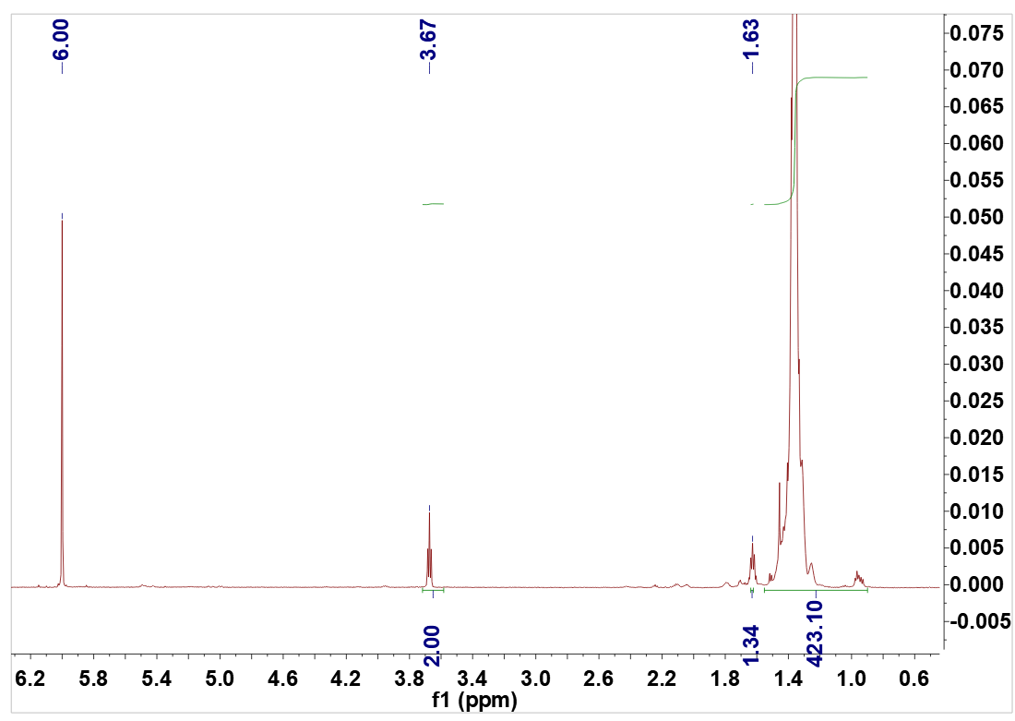
CH₂OH
Supplementary Figure 1. ¹H NMR spectrum of the pre-graft copolymer P-OH1.0. (Supplementary Table1. entry 1, C₂D₂Cl₄, 120 ºC).
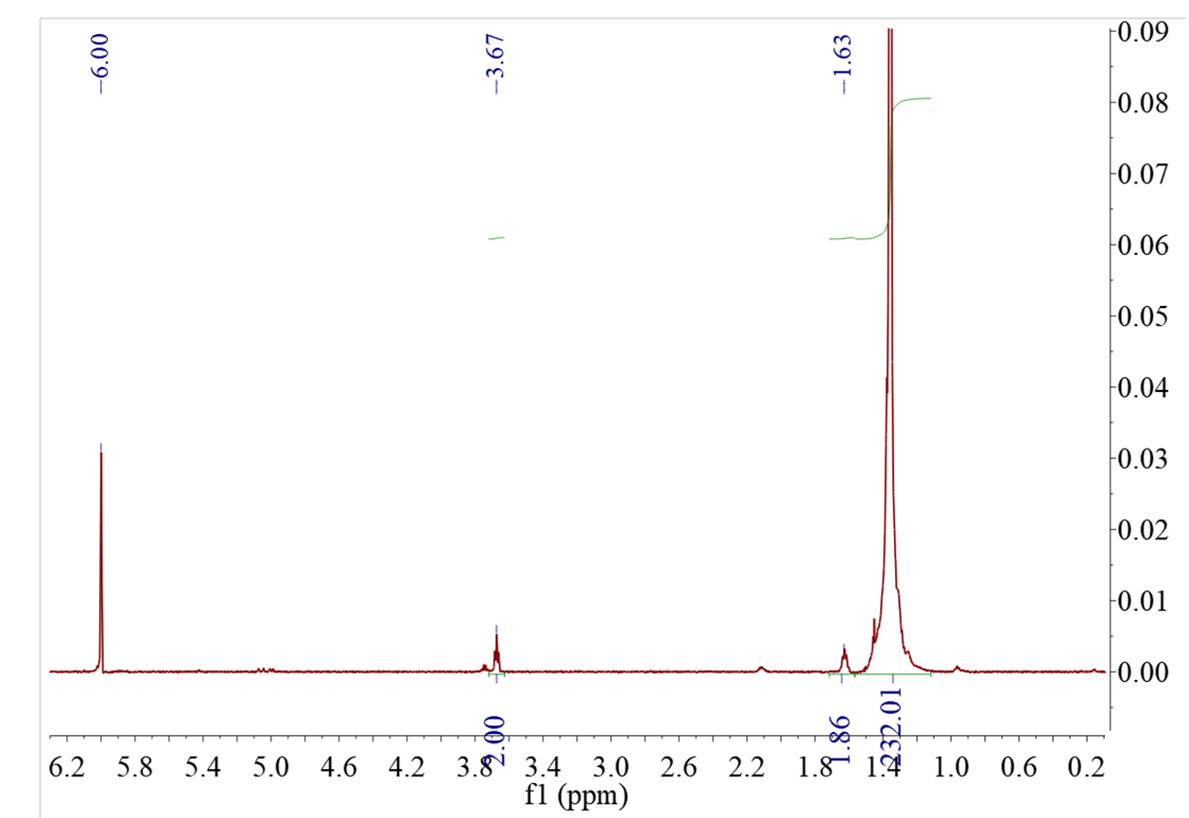
CH₂OH
Supplementary Figure 2. ¹H NMR spectrum of the pre-graft copolymer P-OH2.0. (Supplementary Table1. entry 2, C₂D₂Cl₄, 120 ºC).
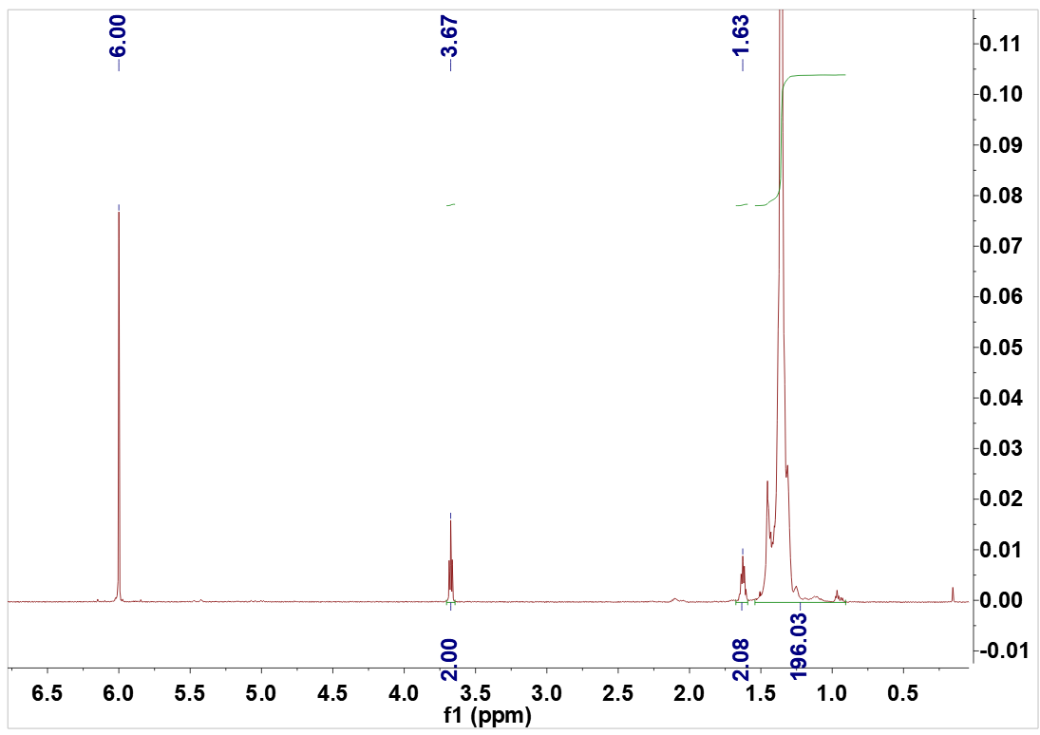
CH₂OH
Supplementary Figure 3. ¹H NMR spectrum of the pre-graft copolymer P-OH2.0. (Supplementary Table1. entry 3, C₂D₂Cl₄, 120 ºC).
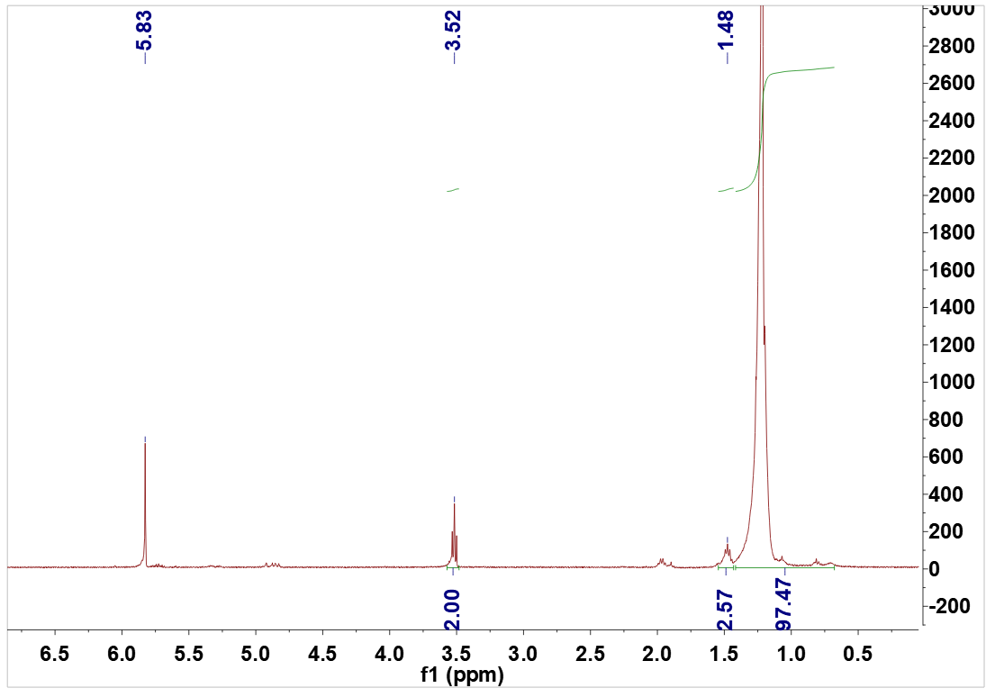
CH₂OH
Supplementary Figure 4. ¹H NMR spectrum of the pre-graft copolymer P-OH5.0. (Supplementary Table1. entry 4, C₂D₂Cl₄, 120 ºC).
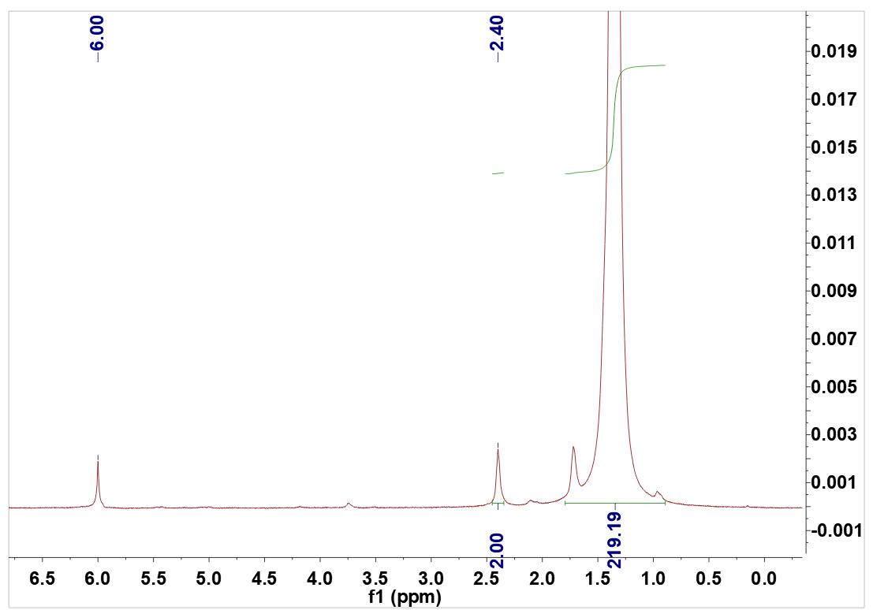
CH₂COOH
Supplementary Figure 5. ¹H NMR spectrum of the pre-graft copolymer P-COOH2.0. (Supplementary Table1. entry 5, C₂D₂Cl₄, 120 ºC).
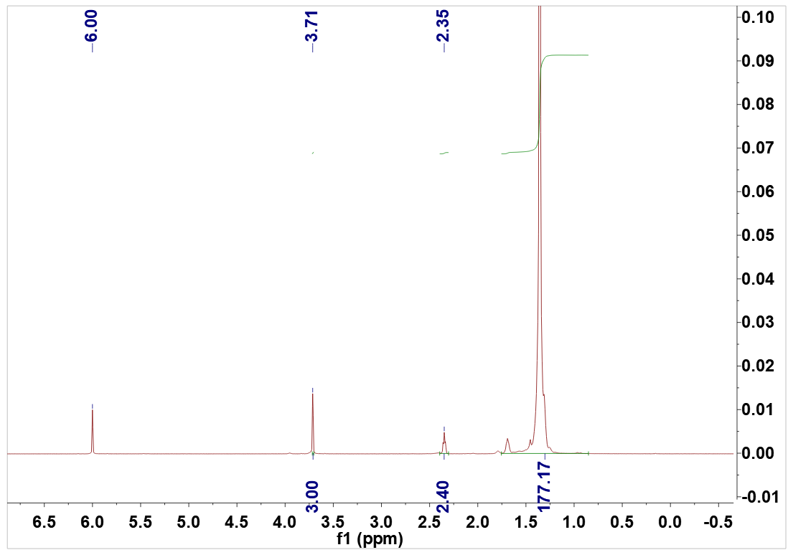
COOCH₃
CH₂COOCH₃
Supplementary Figure 6. ¹H NMR spectrum of the pre-graft copolymer P-COOCH₃2.0. (Supplementary Table1. entry 6, C₂D₂Cl₄, 120 ºC).

1.2 Preparation of pre-graft copolymer by twin screw extruder. Add 10 g of commercialized PP, 0.5 g of 1- (2-hydroxyethyl) -1H pyrrole-2,5-dione, and 0.5 g of DCP to a twin screw extruder (180 °C, 80 r/min), circulate for 8 minutes, extrude the mixture, dissolve it in toluene, and add ethanol precipitation to obtain a pure product.
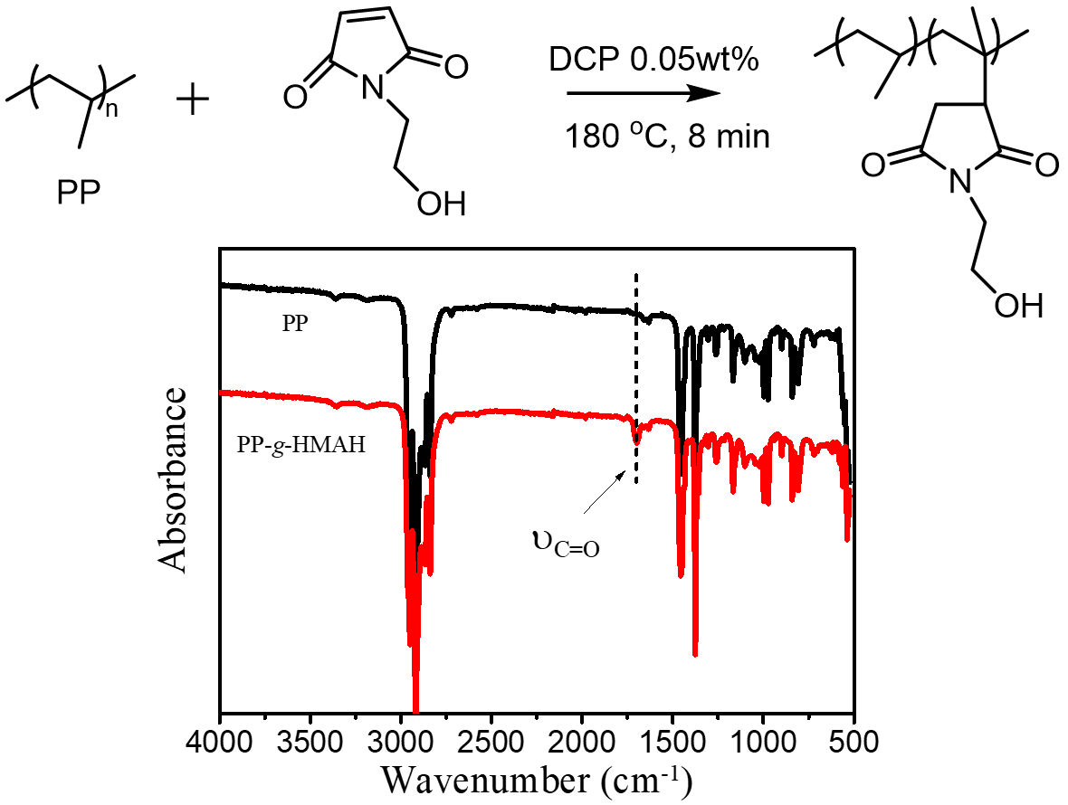
Supplementary Figure 7. IR spectrum of the pre-graft copolymer PP-OH preparated by twin screw extruder.
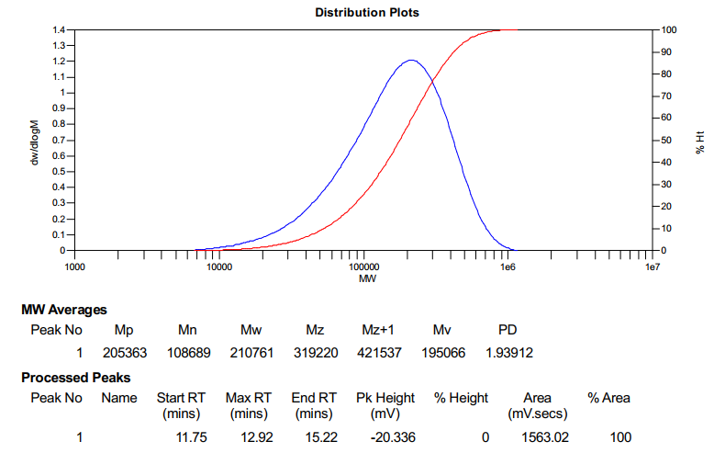
Supplementary Figure 8. GPC of the P-OH1.0 synthesized from Supplementary Table1. entry 1.
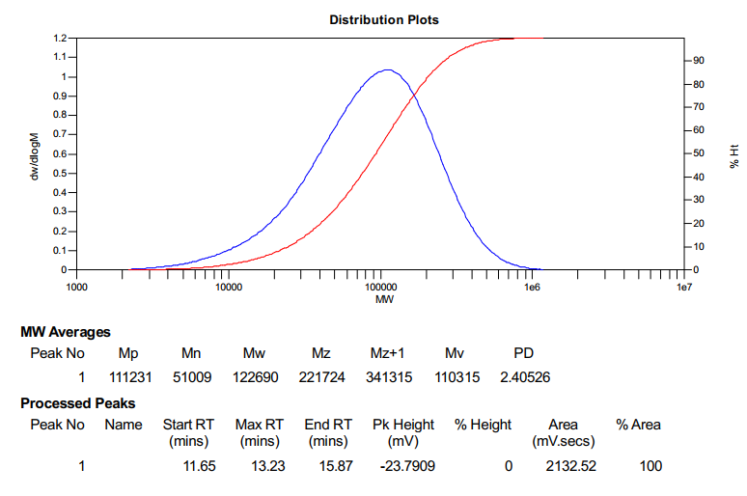
Supplementary Figure 9. GPC of the P-OH2.0 synthesized from Supplementary Table1. Entry 2.

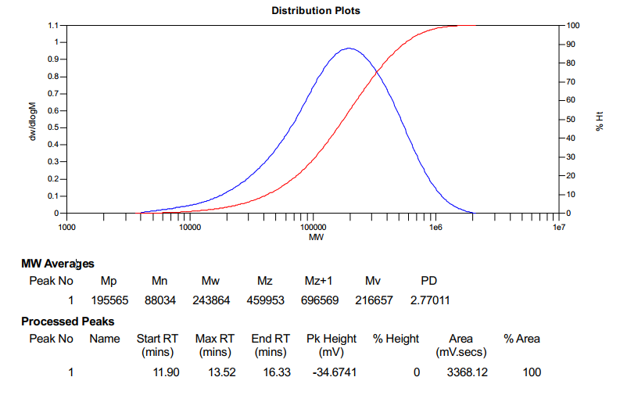
Supplementary Figure 10. GPC of the P-OH2.0 synthesized from Supplementary Table1. entry 3.

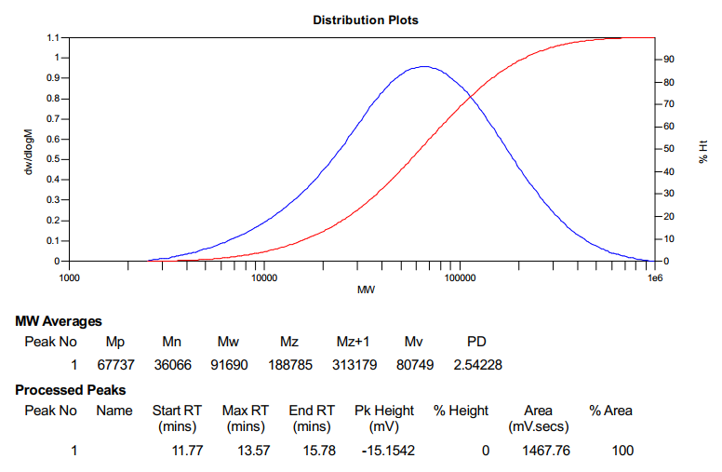
Supplementary Figure 11. GPC of the P-OH5.0 synthesized from Supplementary Table1. entry 4.
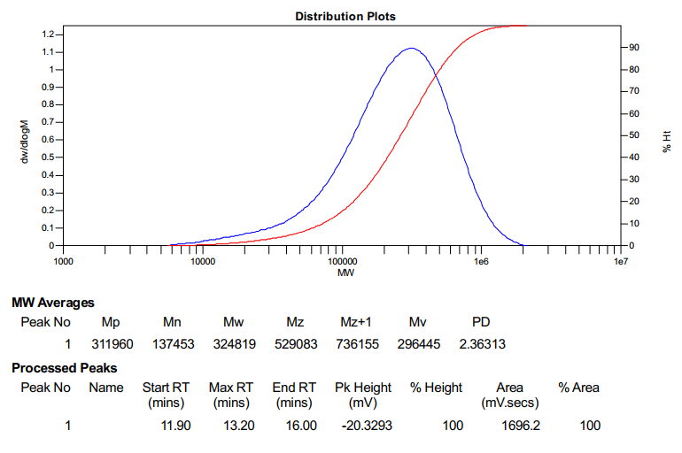
Supplementary Figure 12. GPC of the P-COOCH₃2.0 synthesized from Supplementary Table1. entry 5.
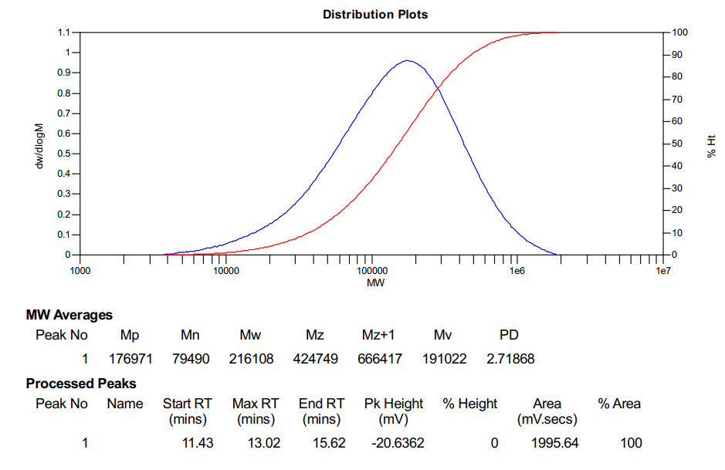
Supplementary Figure 13. GPC of the P-COOH2.0 synthesized from Supplementary Table1. entry 6.

2. Preparation of graft copolymer (P-OH-g-PCL, P-OH-g-PLA, P-OH-g-PCL/PLA, P-OH5.0, P-COOH2.0, P- COOCH₃2.0)

Supplementary Table1. Synthesis of graft copolymers.ª
Ent. | Graft copolymersª | Pre-graft copolymer (g) ^{b} | X/  (mmol)^{c} | (X)/Monm.^{d} | Graft length ^{e} | Productivity(%)^{f} | M_{n}^{g} | PDI ^{g}
1 | P-OH1.0-g-PCL20 | P-OH1.0 (0.3) | 0.052 | 1/50 CL | 20 | 87 | 14.9 | 2.11
2 | P-OH2.0-g-PCL10 | P-OH2.0 (0.5) | 0.33 | 1/80 CL | 11 | 95 | 15.2 | 2.51
3 | P-OH2.0-g-PCL20 | P-OH2.0 (0.5) | 0.33 | 1/100 CL | 22 | 89 | 26.3 | 2.42
4 | P-OH2.0-g-PCL30 | P-OH2.0 (0.2) | 0.13 | 1/200 CL | 30 | 64 | 30.3 | 2.29
5 | P-OH5.0-g-PCL20 | P-OH5.0 (0.15) | 0.21 | 1/180 CL | 20 | 69 | 18.9 | 1.96
6 | P-OH1.0-g-PLA5 | P-OH1.0 (0.75) | 0.13 | 1/80 LA | 5 | 55 | 11.3 | 1.93
7 | P-OH2.0-g-PCL20/PLA4 | P-OH2.0 (0.5) | 0.32 | 1/100/100 CL/LA | 21/4 | 52 | 27.2 | 2.10
8 | P-OH2.0-g- PDMS12 | P-OH2.0 (0.5) | 0.32 | 1/50 D₃ | 12 | 67 | 16.1 | 2.18
9 | P-COOH2.0-g-PA3 | P-COOH2.0 (0.5) | 0.32 | 1/50 CPL | 3 | 88 | 10.2 | 2.52
10 | P-OH2.0-g-PBT4 | P-OH2.0 (0.5) | 0.32 | PBT ^{h} | 4 | 62 | 14.5 | 2.13
11 | P-COOCH₃2.0-g-PEG | P-COOCH₃2.0 (0.5) | 0.32 | PEG-750 ^{i} | 1 | 78 | 20.9 | 1.80
ª Entries 1, 3, 4, 5, and 7: synthesized in a ball mill. Entries 2 and 6: synthesized using a twin-screw extruder. Entries 8–11: synthesized in solution. Entries 1–7 and 11: reaction rate of hydroxyl groups in the pre-graft copolymer was 100%. In Entries 8, 9, and 10, only a portion of hydroxyl groups reacted during the grafting reaction, and the reaction rate was 44 mol%, 21 mol%, and 14 mol%, respectively. ^{b} Pre-graft copolymers: P-OH1.0, P-OH2.0, P-OH5.0, P-COOH2.0, and P-COOCH₃2.0, where the number represents the molar insertion percentage of the polar comonomer of the corresponding ethylene copolymer. ^{c} The molar amount of reactive functional groups contained in the pre-graft copolymer used in the reaction. ^{d} The molar ratio of reactive groups (X, -OH, -COOH, and -COOCH₃) in the pre-graft copolymers to the added monomers. ^{e} The number of monomer units graft onto each functional group, determined by ¹H NMR. ^{f} The yield of synthetic graft copolymers. ^{g} M_{n} = 10⁴ g mol⁻¹, M_{n} and PDI were determined by gel permeation chromatography (GPC) in 1, 2, 4-trichlorobenzene at 160 °C. ^{h} Entry 10, graft copolymer P-OH2.0-g-PBT4 was prepared by reacting the pre-graft copolymer P-OH2.0 with PBT. ^{i} Entry 11, graft copolymer P-COOCH₃2.0-g-PEG was prepared by reacting the pre-graft copolymer P-COOCH₃2.0 with PEG750.

2.1 P-OH-g-PCL,
Ball milling method. Taking P-OH2.0-g-PCL10 as an example, 0.3 g of pre-graft copolymer P-OH2.0, 1.5 g of caprolactone, and 0.5 mmol of AlEt₃ were taken and placed in a ball milling tank. The mixture was kept in a nitrogen atmosphere and subjected to shaking reaction (20Hz) for 2 hours. The resulting graft copolymer P-OH2.0-g-PCL10 was obtained after washing with ethanol. The same method was used for other P-OH-g-PCL graft copolymers, and the dosage of various raw materials was shown in Table 1.
Twin screw method. Adding 0.5 mmol of catalyst triethylaluminum to 10 g of caprolactone in the glove box. Quickly add 1g of pre-graft copolymer P-OH2.0 and monomer with added catalyst to the twin screw in a nitrogen atmosphere, and react at 150 ° C at 80 rpm for 3 minutes. The resulting graft copolymer P-OH2.0-g-PCL10 was obtained after washing with ethanol.

2.2 P-OH-g-PLA,
Twin screw method. Mix 8 g of D, L-Lactide, 1.5 g of pre-graft copolymer P-OH, and 2 mmol of stannous octanoate catalyst evenly, and add them to the twin screw under nitrogen atmosphere. React at 150 ° C and 80 rpm for 10 minutes. The resulting graft copolymer P-OH1.0-g-PLA5 was obtained after washing with ethanol.

2.3 P-OH2.0-g-PCL20/PLA4. Taking 0.5 g of graft copolymer P-OH2.0-g-PCL20, 0.95 g of D, L-Lactide, and 0.1 mmol of DBU in a ball milling tank, The mixture was kept in a nitrogen atmosphere and subjected to shaking reaction (20Hz) for 2 hours. The obtained mixture was washed with ethanol to obtain graft copolymer P-OH2.0-g-PCL20/PLA4.

2.4 P-COOCH₃2.0-g-PEG, taking 1.5 g of pre-graft copolymer P-COOCH₃2.0 (incorporation rate of 2 mol%), 10 mmol PEG-750, and 0.83 mmol TBD, dissolved them in 30 mL of toluene and reacted at 120 ℃ in nitrogen atmosphere for 12 hours. Add 100 mL of ethanol to precipitate the polymer and wash to obtain the graft copolymer P-COOCH32.0-g-PEG.

2.5 P-OH2.0-g-PDMS12, taking 0.5 g of pre-graft copolymer P-OH2.0 (with a hydroxyl incorporation rate of 2 mol%) and 1 g of Hexamethylcyclosiloxane, dissolved them in 30 mL of toluene and added 0.97 mmol of nBuLi under argon atmosphere. After heating at 100 ℃ for 24 hours, added 100 mL of ethanol to precipitate the polymer and wash to obtain the graft copolymer P-OH2.0-g-SiO12.

2.6 P-COOH2.0-g-PA3, under nitrogen atmosphere, 1g of pre graft copolymer P-COOH2.0 was dissolved in 20 mL of toluene and refluxed at 130 ℃. 0.2 g of SOCl₂ was added to obtain solution A. At the same time, take another Shrek bottle, take 1g of Caprolactam and melt it in N₂ atmosphere at 140 ℃, add 0.05 g of sodium hydroxide, pump it under 140 ℃ for 1h with vacuum pump, cool it to 110 ℃, smash the solid, pour it into solution A and react for 6h, add ethanol to precipitate and wash it to obtain the graft copolymer P-COOH2.0-g-PA3.

2.7 P-OH2.0-g-PBT4, under nitrogen atmosphere, 1g of pre graft copolymer P-OH2.0, 1 g of dried PBT, and 0.05 g of tetraisopropyl titanate were added to a Shrek flask, stirred at 120 ℃ for 30 minutes, then heated to 260 ℃ for 2 hours of reaction, and vacuum pumped for 1 hour. Dissolve the mixture in 30 mL of toluene, add ethanol precipitation, and wash to obtain graft copolymer P-OH2.0-g-PBT5.

3. HDPE/PCL/PLA ternary blends.
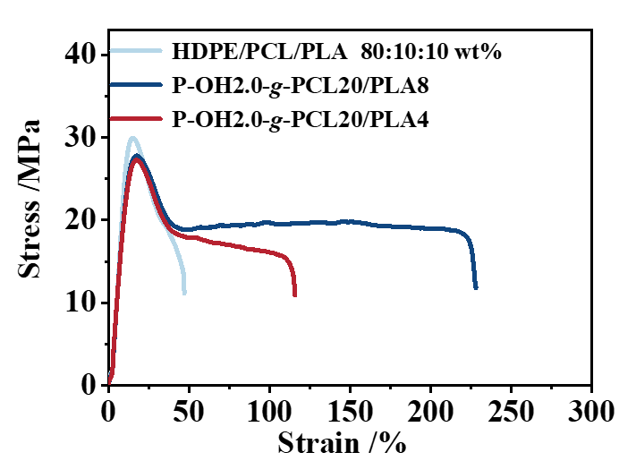
Supplementary Figure 14. The stress-strain curve of graft copolymer used for toughening ternary blends. The blend was mixed in a twin screw for 10 minutes, at 200 ℃ and then transferred to an injection molding machine for insulation and injection molding to prepare the sample (gauge length, 50 mm; width, 4 mm; thickness, approximately 2 mm), followed by tensile testing (10 mm min⁻¹, 25 °C).

4. NMR and ESI analysis of small molecule simulation reactions.
In order to study the reaction mechanism of stapler strategy plastic recycling, we used small molecules to simulate the reaction of polymer chain. Taking HDPE/PCL system as an example, cyclohexane was used to simulate the polyethylene molecular chain, and small molecules b was used to simulate the graft copolymer and part of Polycaprolactone chain segments.
Reaction A involves dissolving 0.1 g of cyclohexane, 0.5 g of ICEMA, and 0.001 g of DCP in 2 mL benzene. After heating at 140 ℃ for 0.5 hours, the reaction was monitored by in situ ¹H-MNR and HSQC. From Supplementary Figures 16 and 17, it can be seen that ICEMA was grafted onto C-H of cyclohexane, and the presence of the graft product can be detected by ESI (Supplementary Figures 18).
Reaction B involves dissolving 0.1 g b and 0.2 g ICEMA in 2 mL of benzene, heating at 140 ° C for 0.5 hours, and monitoring the reaction with in situ ¹H-MNR. From Supplementary Figure 19, it can be seen that the NCO group of ICEMA reacted with the hydroxyl group of b, and the presence of the graft can be detected by ESI (Supplementary Figures 20).
Reaction C involves dissolving 0.1 g b, 0.2 g ICEMA and 0.001 g of DCP in 2 mL of benzene, heating at 140 ° C for 0.5 hours, the reaction was monitored by in situ ¹H-MNR and HSQC. It can be seen that the NCO group of ICEMA reacted with the hydroxyl group of b, and it can be seen that ICEMA was grafted onto C-H of b (Supplementary Figures 21 and 22), and the presence of the graft product can be detected by ESI (Supplementary Figures 23).

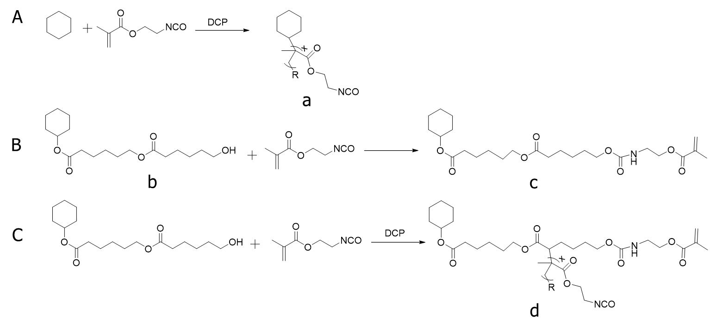
Supplementary Figure 15. Small molecule simulation reaction.

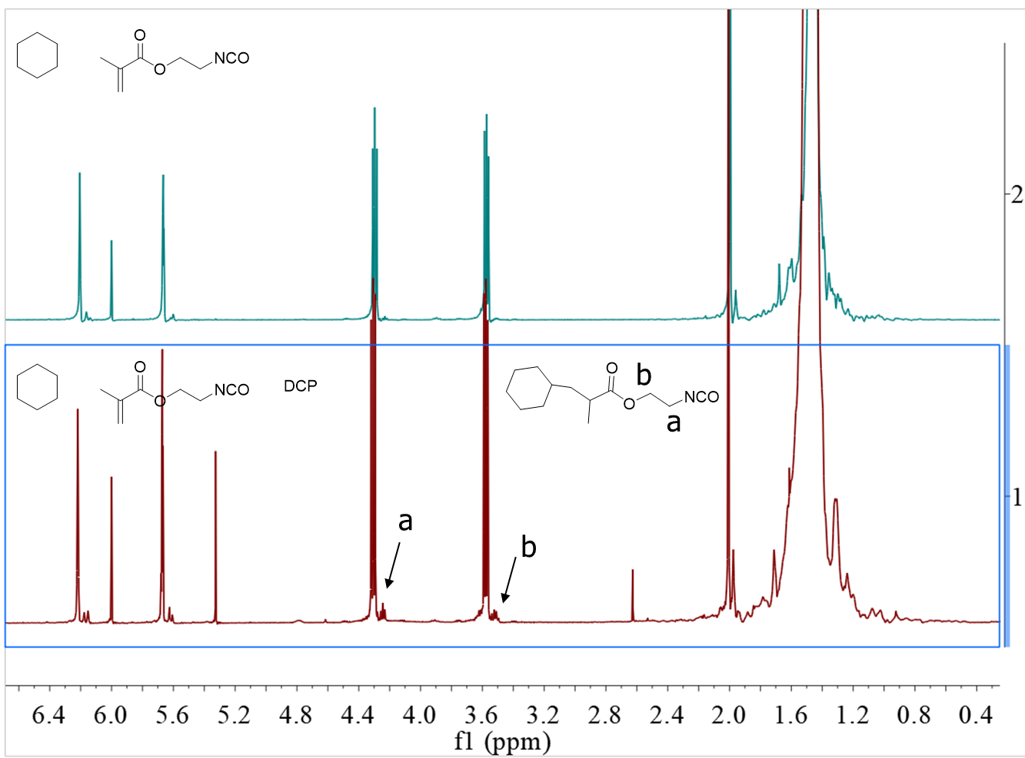
Supplementary Figure 16. ¹H NMR comparison diagram of small molecule simulation reaction A (400 Hz, C₆D₆).
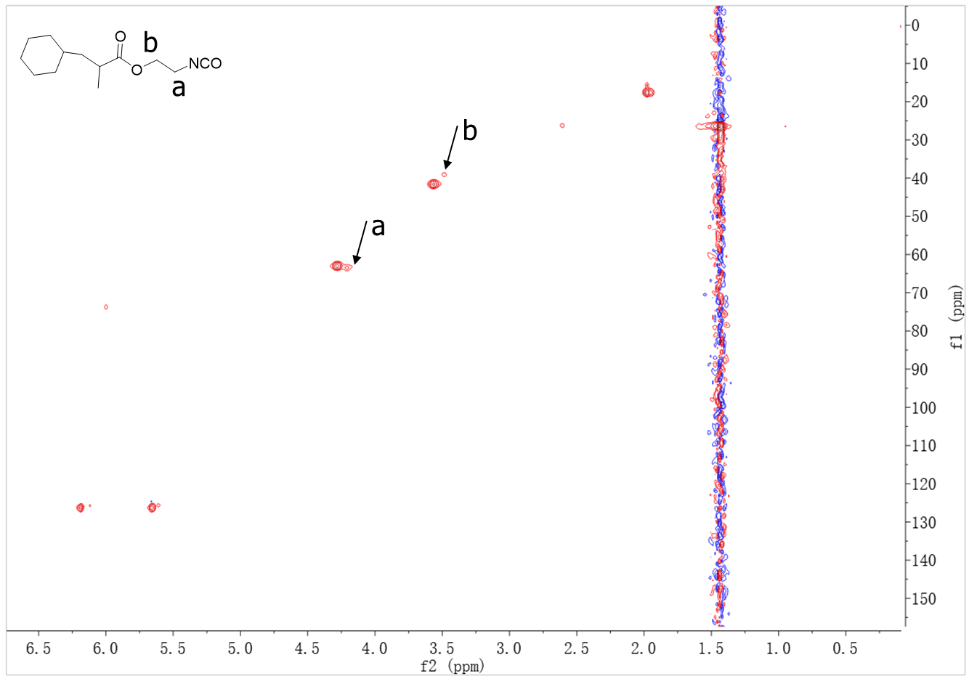
Supplementary Figure 17. HSQC of small molecule simulation reaction A (400 Hz, C₆D₆).
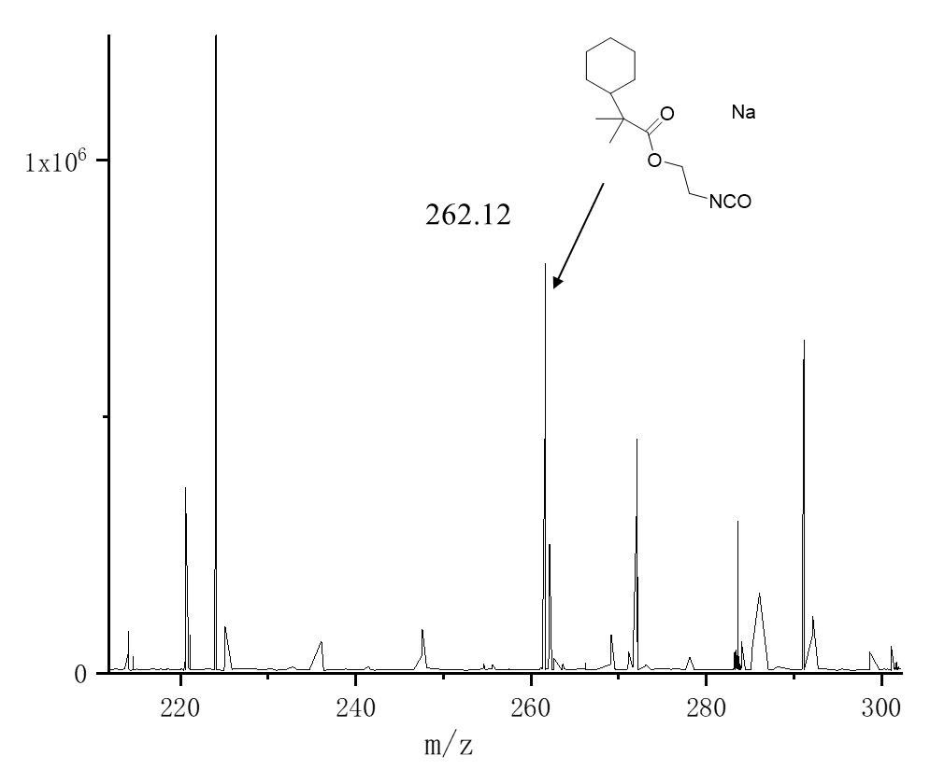
Supplementary Figure18. ESI of small molecule simulation reaction A.
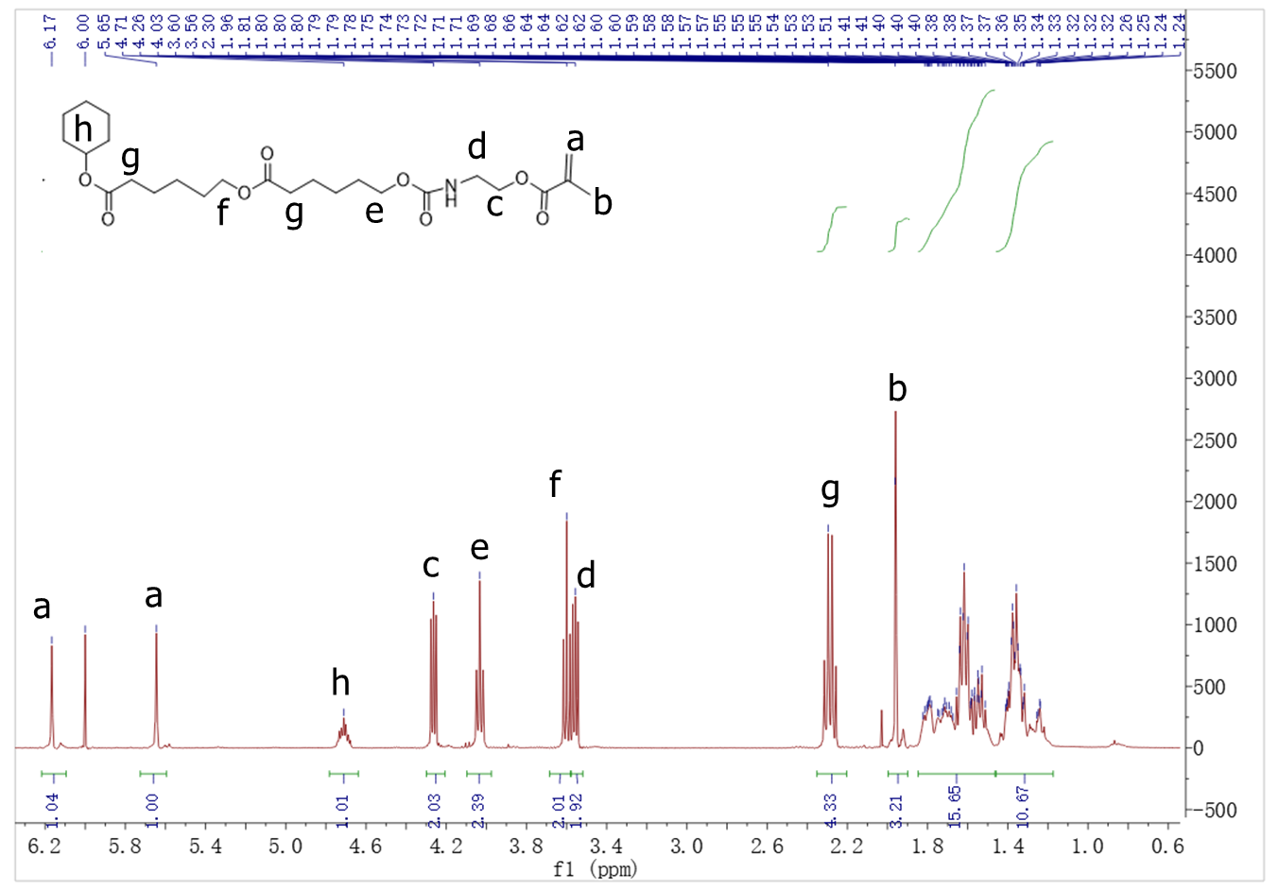
Supplementary Figure 19. ¹H NMR of small molecule simulation reaction B (400 Hz, C₆D₆).

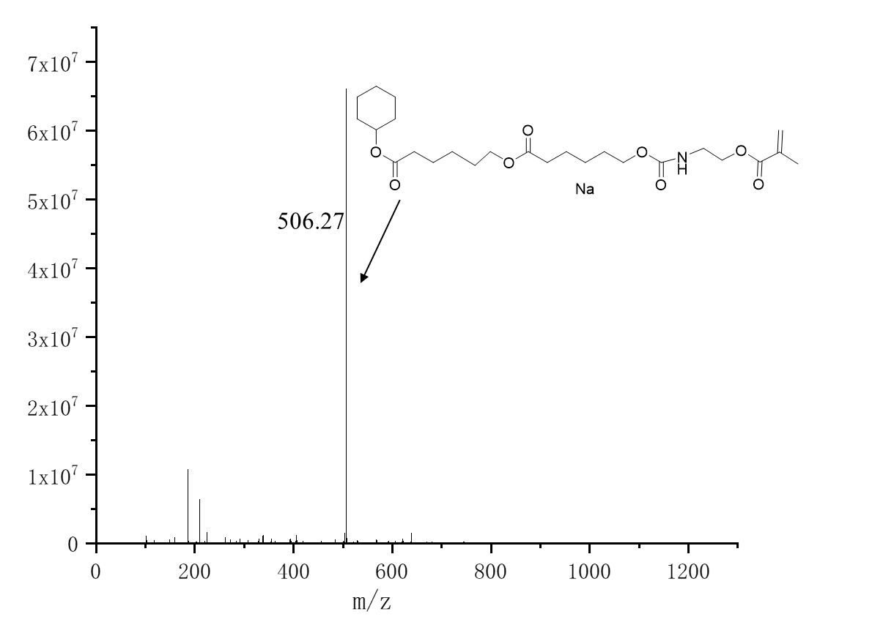
Supplementary Figure 20. ESI of small molecule simulation reaction B.

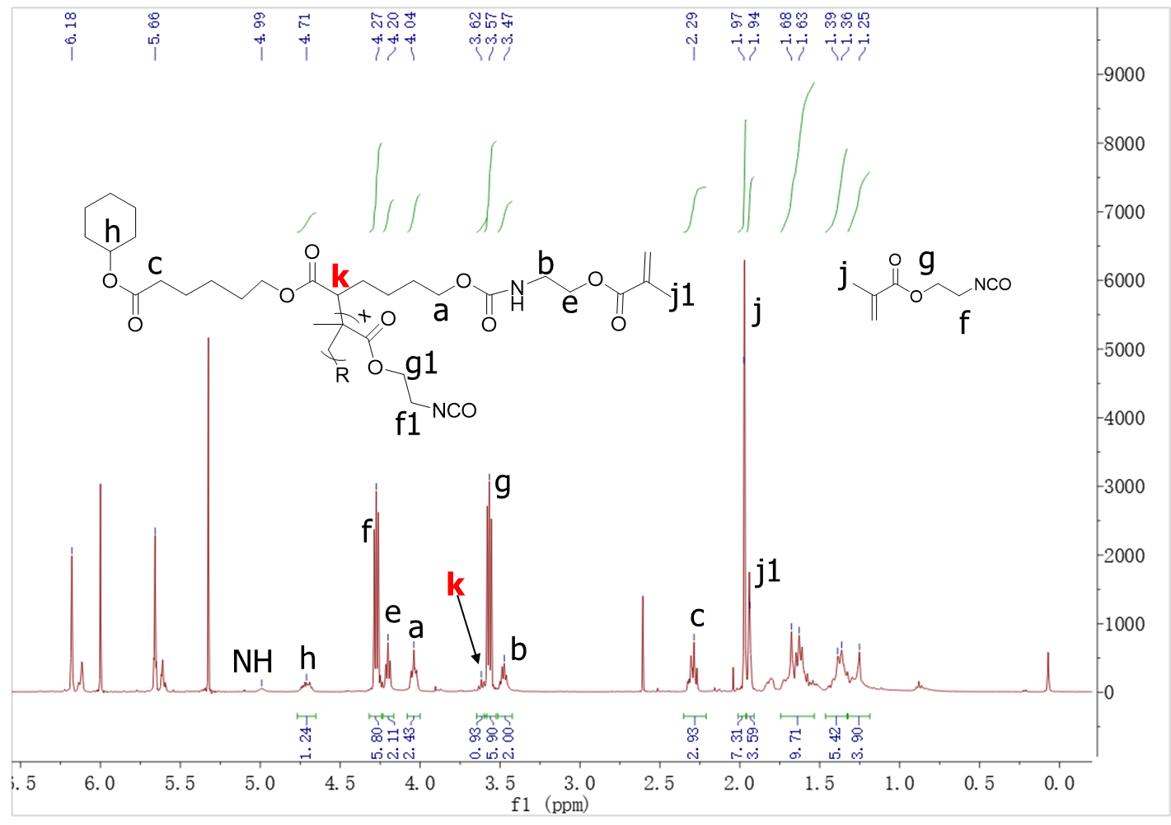
Supplementary Figure 21. ¹H NMR of small molecule simulation reaction C (400 Hz, C₆D₆).

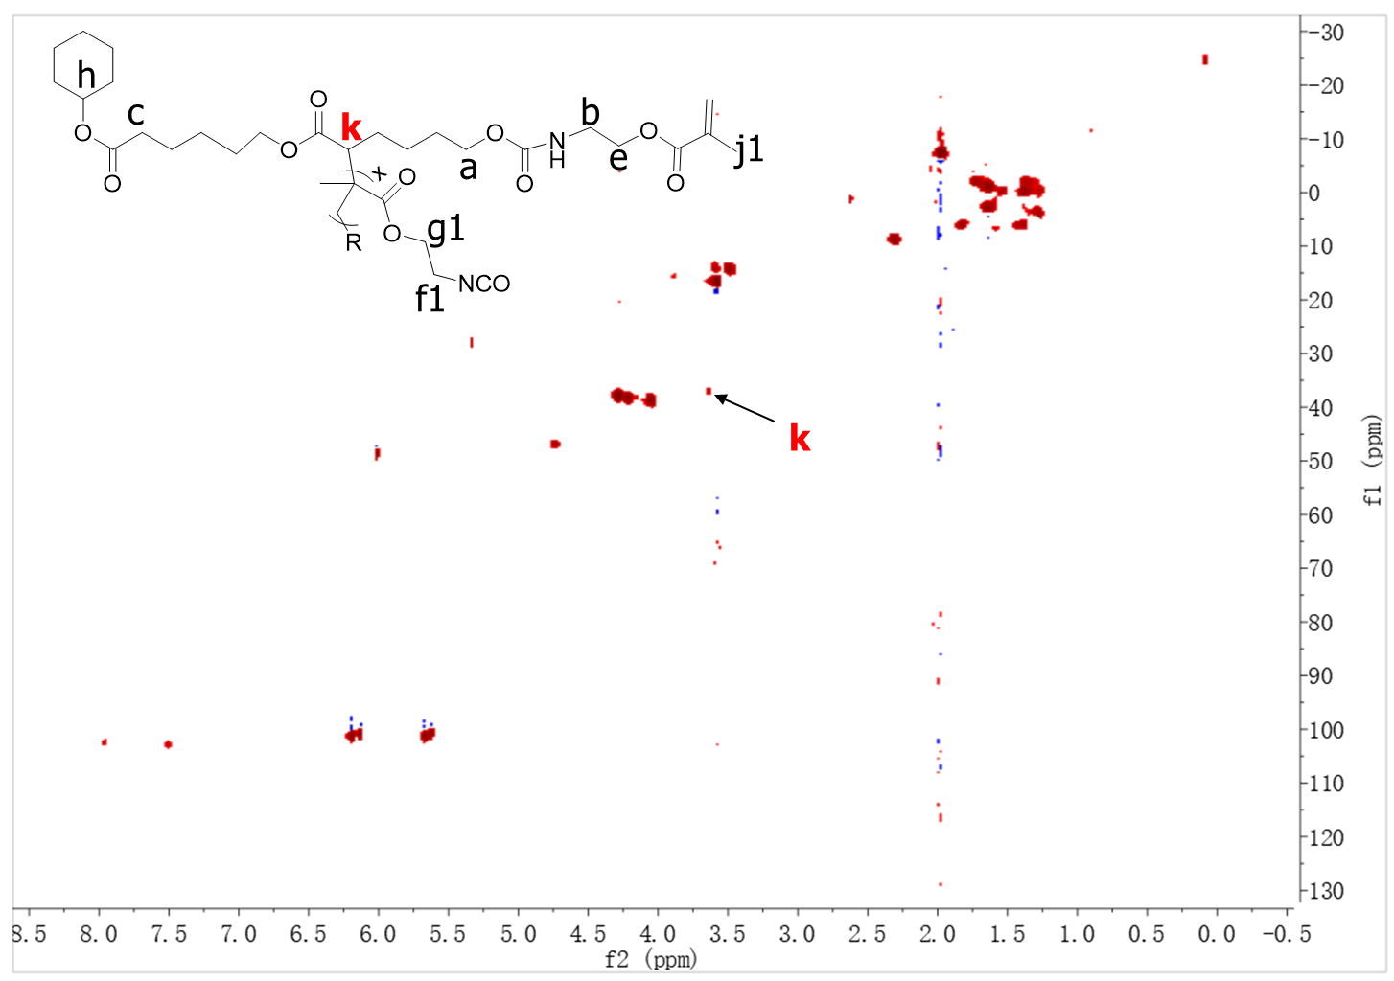
Supplementary Figure 22. HSQC of small molecule simulation reaction C (400 Hz, C₆D₆).

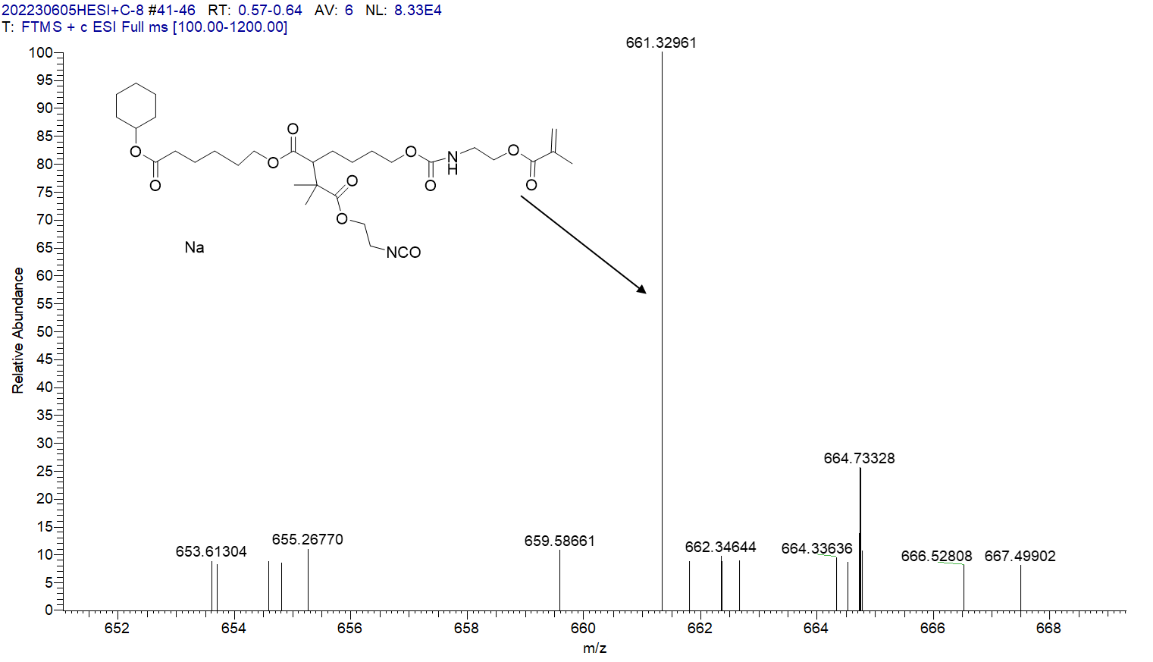
Supplementary Figure 23. ESI of small molecule simulation reaction C.

5. 3D printed sample image of HDPE/PCL blends.
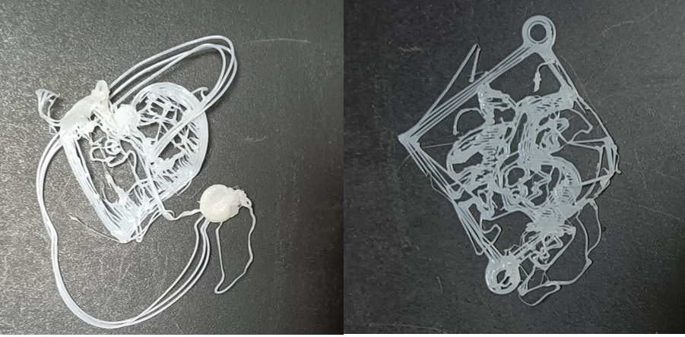
Supplementary Figure 24. 3D printed sample image of HDPE/PCL blends.

6. Synthesis of stapler molecules MIMIS and MTHD.
6.1 Synthesis of stapler molecules MIMIS 3g of 2-amino-4,6-dimethylpyrimidine and 30g of hexamethylene diisocyanate were taken and placed in a nitrogen atmosphere. The reaction was carried out at 80 ºC for 10 hours, and the reaction solution was cooled to room temperature. 100 mL of n-hexane was added to precipitate the reaction product. Vacuum filtration was performed, and the filtered solid was washed three times with n-hexane. After drying, MIMIS was obtained with a yield of 79%.
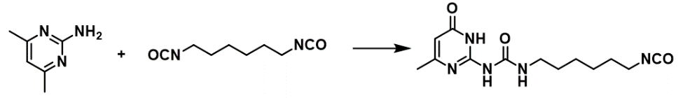
Supplementary Figure 25. ¹H NMR of stapler molecules MIMIS (400 Hz, CDCl₃).

6.2 Synthesis of stapler molecules MTHD 1.3 g of 2,2-bis (hydroxymethyl) propionic acid and 2.1 g of methacryloyl chloride were dissolved in 50 mL THF, placed in a nitrogen atmosphere, added 1 mL of triethylamine, and reacted at 50 ° C for 3 hours. The solvent was drained to obtain the solid. Then, 10g of hexamethylene diisocyanate was added and reacted at 80 ° C for 10 hours. The reaction solution was cooled to room temperature, and 100mL of n-hexane was added to precipitate the reaction product. Vacuum filtration was performed, the filtered solid was washed 3 times with n-hexane and dried to obtain MTHD with a yield of 68%.
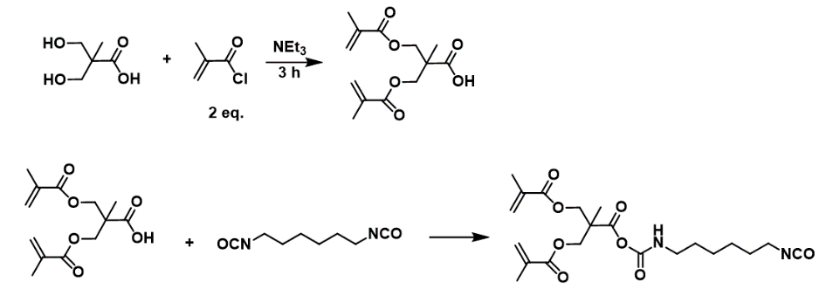
Supplementary Figure 26. ¹H NMR of stapler molecules MTHD (400 Hz, CDCl₃).

7. Supplementary Figures of NMR of graft copolymers.

-CH₂OH
-CH₂-O-CO-
Supplementary Figure 27. ¹H NMR spectrum of the P-OH1.0-PCL20 from Table 1, entry 1. (C₂D₂Cl₄, 120 ºC).

-CH₂OH
-CH₂-O-CO-
Supplementary Figure 28. ¹H NMR spectrum of the P-OH2.0-PCL10 from Table 1, entry 2. (C₂D₂Cl₄, 120 ºC).
-CH₂-O-CO-

-CH₂OH
Supplementary Figure 29. ¹H NMR spectrum of the P-OH2.0-PCL20 from Table 1, entry 3. (C₂D₂Cl₄, 120 ºC).

-CH₂-O-CO-

-CH₂OH
Supplementary Figure 30. ¹H NMR spectrum of the P-OH2.0-PCL30 from Table 1, entry 4. (C₂D₂Cl₄, 120 ºC).

-CH₂OH
-CH₂-O-CO-
Supplementary Figure 31. ¹H NMR spectrum of the P-OH5.0-PCL20 from Table 1, entry 5. (C₂D₂Cl₄, 120 ºC).
a
c, b

b Chain end
-CH₂OH
Supplementary Figure 32. ¹H NMR spectrum of the P-OH1.0-PLA5 from Table 1, entry 6. (C₂D₂Cl₄, 120 ºC).
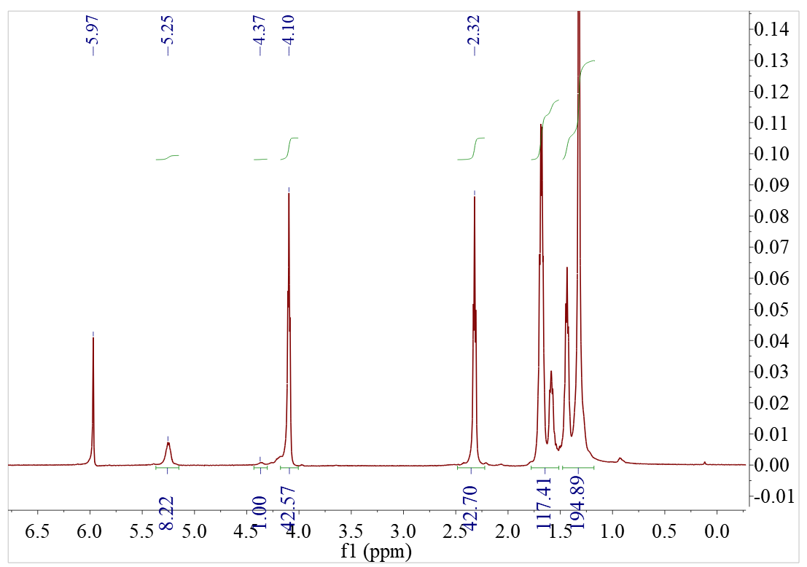
Supplementary Figure 33. ¹H NMR spectrum of the P-OH1.0-PCL21/PLA4 from Table 1, entry 7. (C₂D₂Cl₄, 120 ºC).

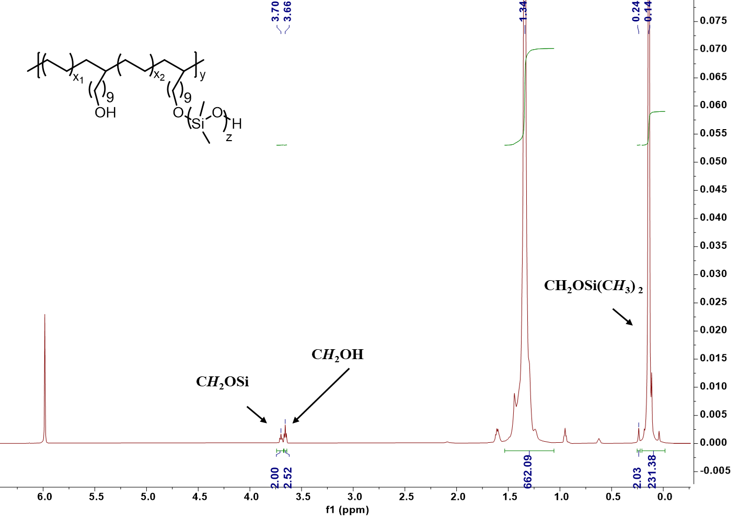
Supplementary Figure 34. ¹H NMR spectrum of the P-OH2.0-SiO12 from Table 1, entry 8. (C₂D₂Cl₄, 120 ºC).

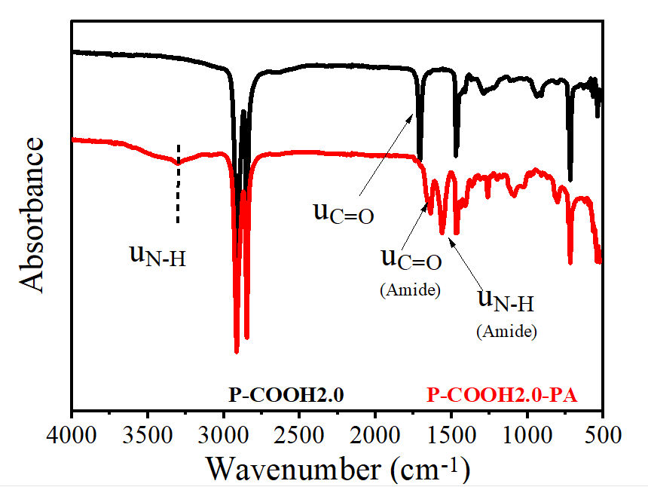
Supplementary Figure 35. IR spectrum of the pre-graft copolymer P-COOH2.0-PA3 from Table 1, entry 9.
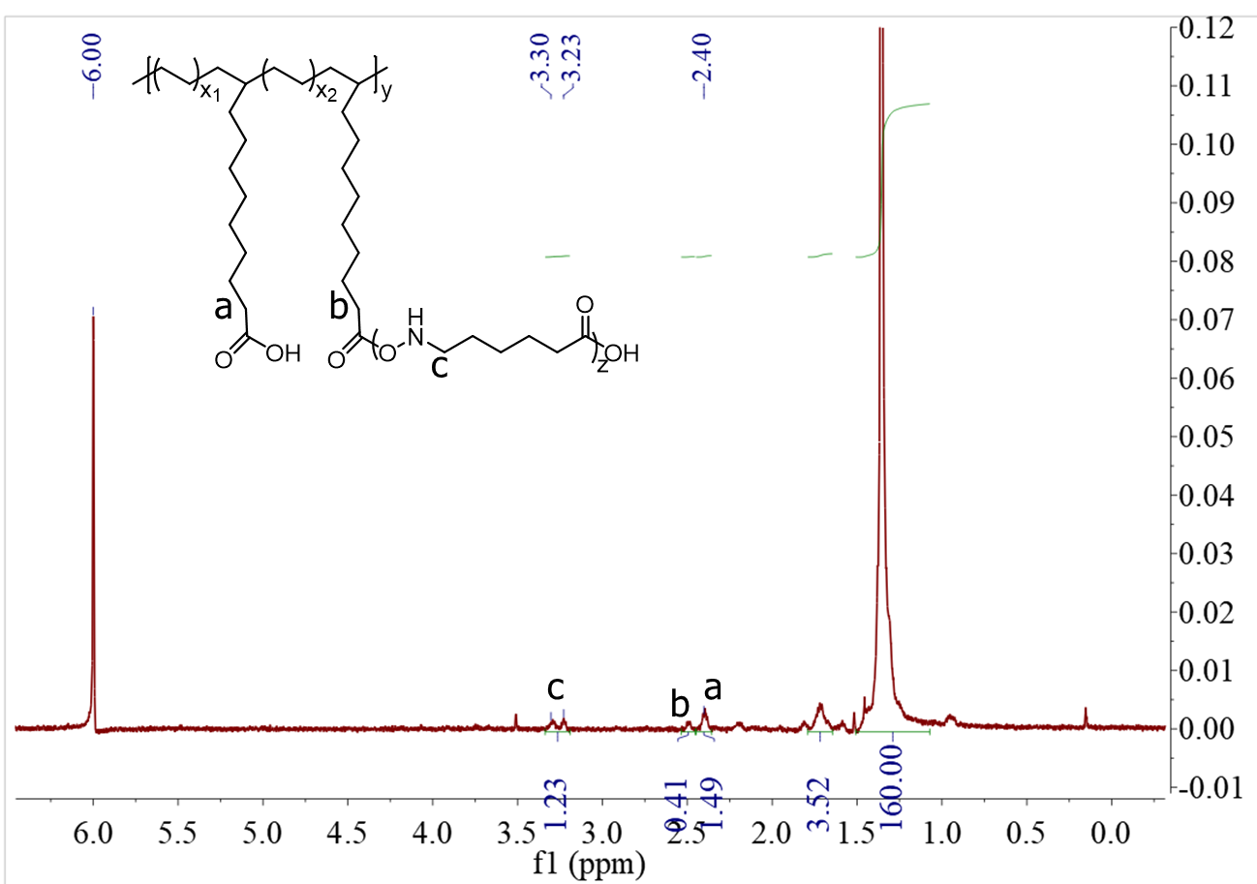
*

*

Supplementary Figure 36. ¹H NMR spectrum of the P-COOH2.0-PA from Table 1, entry 9. (C₂D₂Cl₄, 120 ºC).
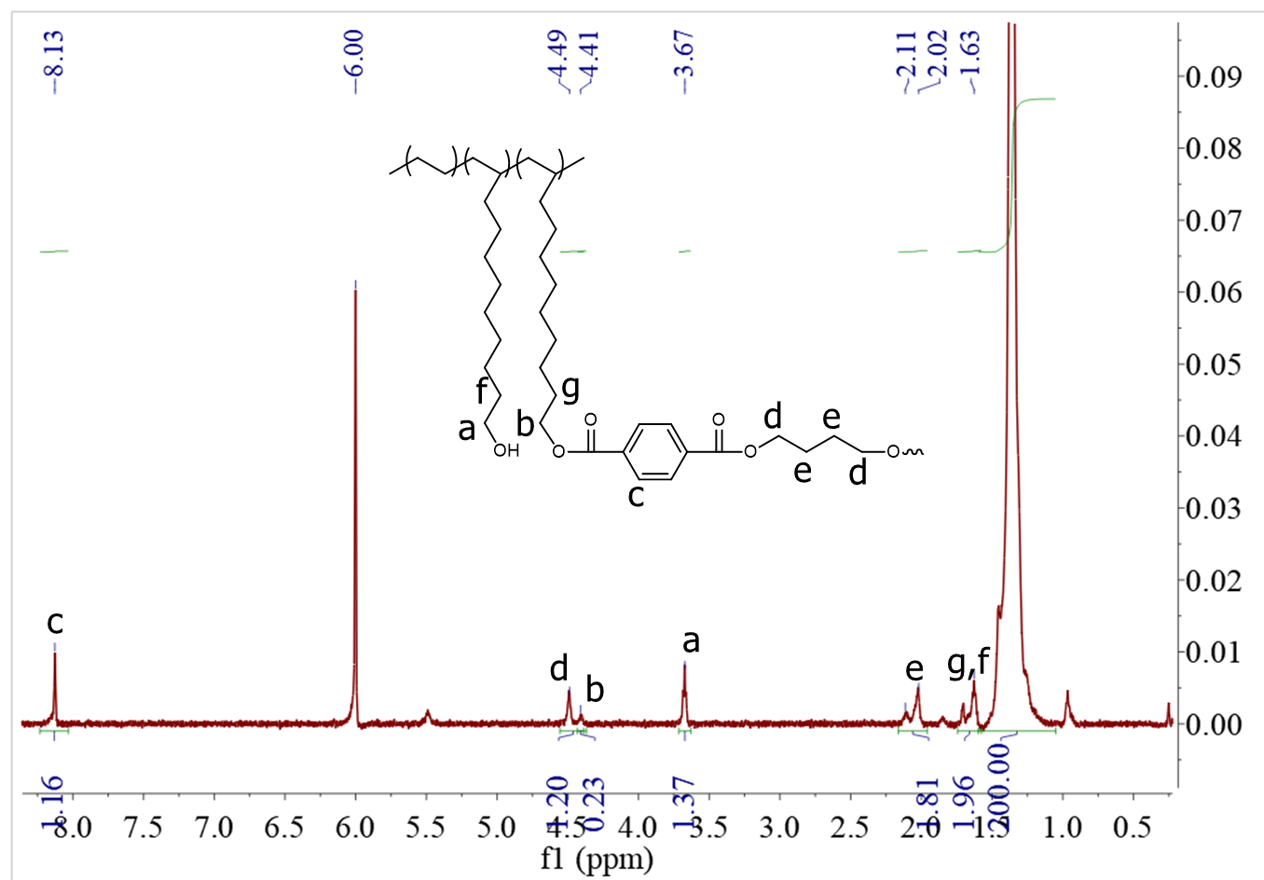
Supplementary Figure 37. ¹H NMR spectrum of the P-OH2.0-PBT4 from Table 1, entry 10. (C₂D₂Cl₄, 120 ºC).

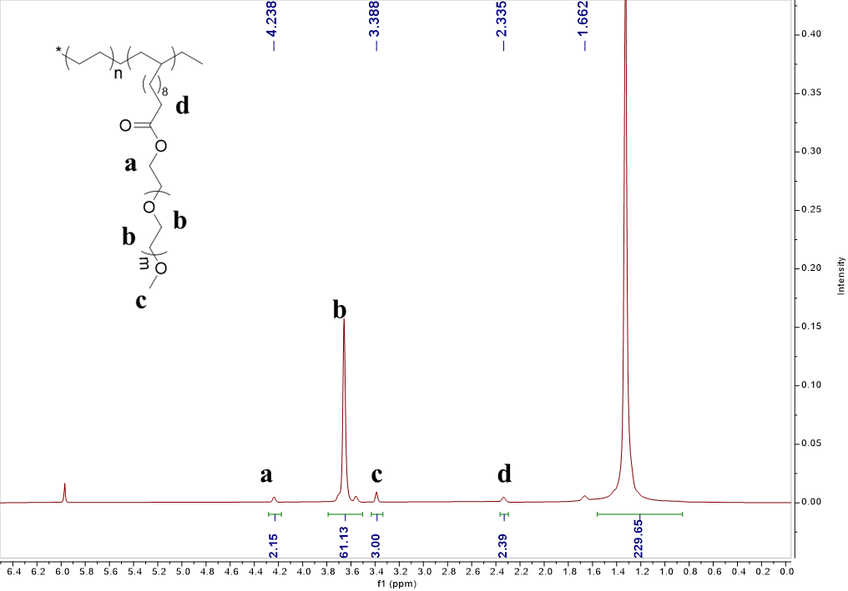
Supplementary Figure 38.¹H NMR spectrum of the P-OH2.0-PEG from Table 1, entry 11. (C₂D₂Cl₄, 120 ºC).

8. Supplementary Figures of DSC of graft copolymers.
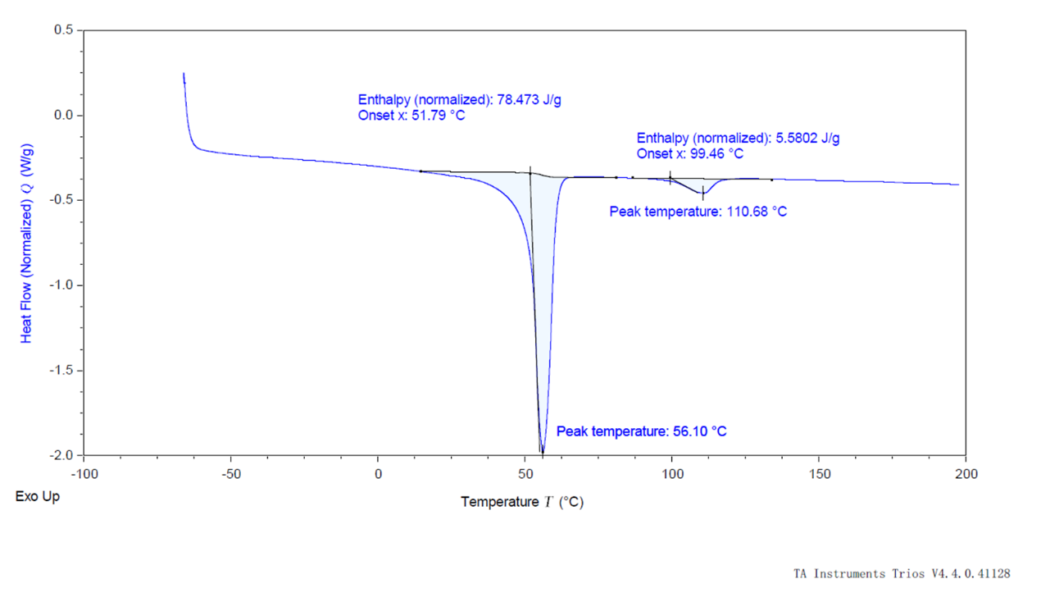
Supplementary Figure 39. DSC of the P-OH1.0-PCL20 from Table 1, entry 1.

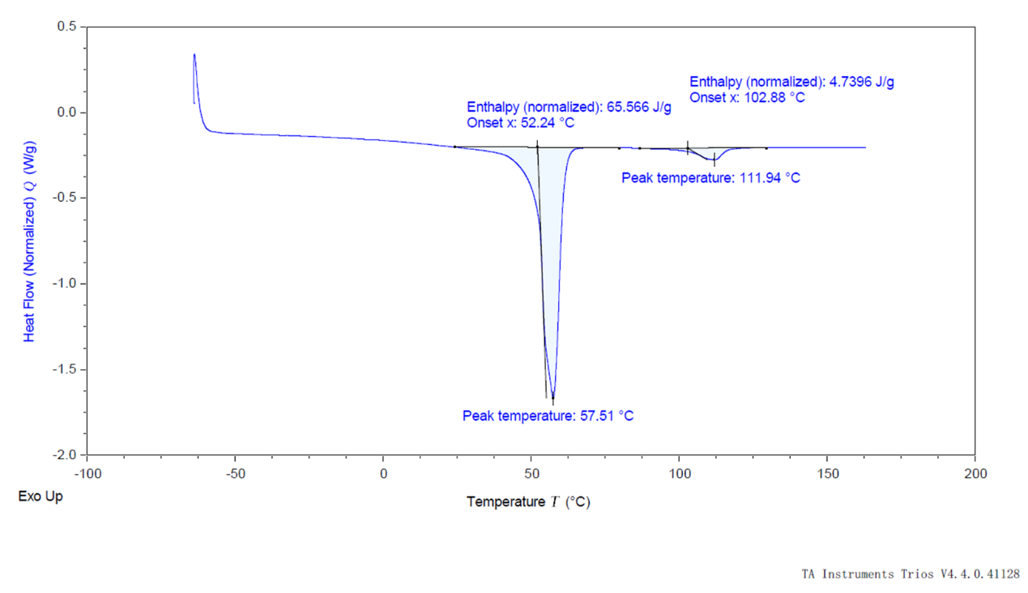
Supplementary Figure 40. DSC of the P-OH2.0-PCL10 from Table 1, entry 2.

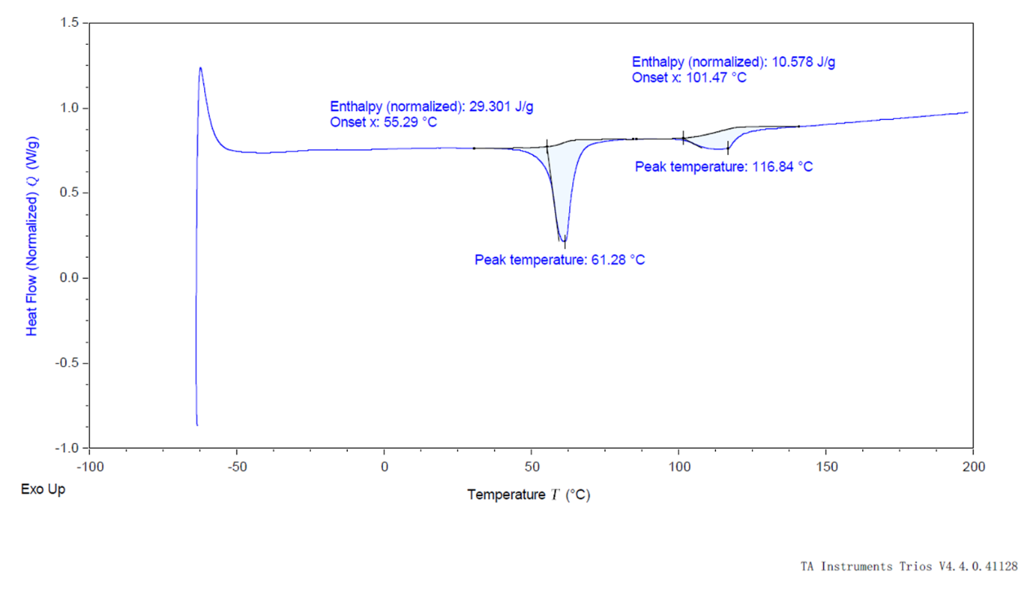
Supplementary Figure 41. DSC of the P-OH2.0-PCL20 from Table 1, entry 3.
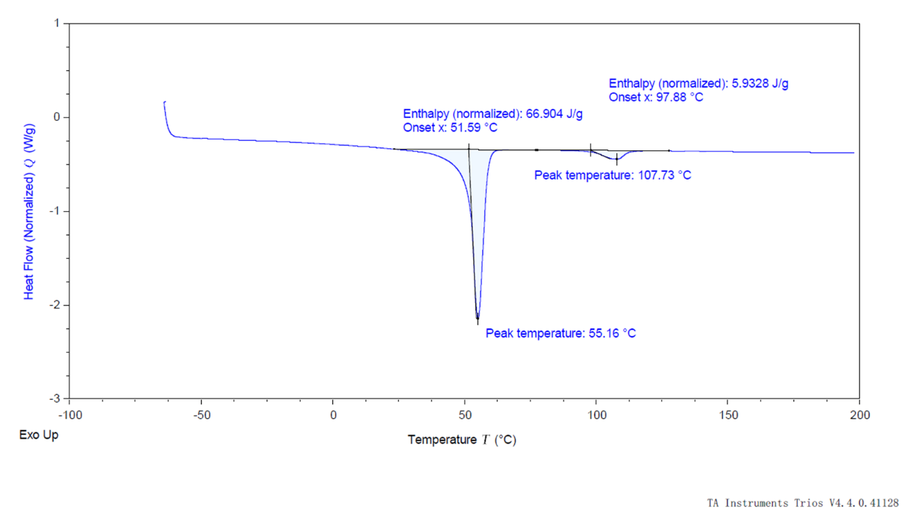
Supplementary Figure 42. DSC of the P-OH2.0-PCL30 from Table 1, entry 4.

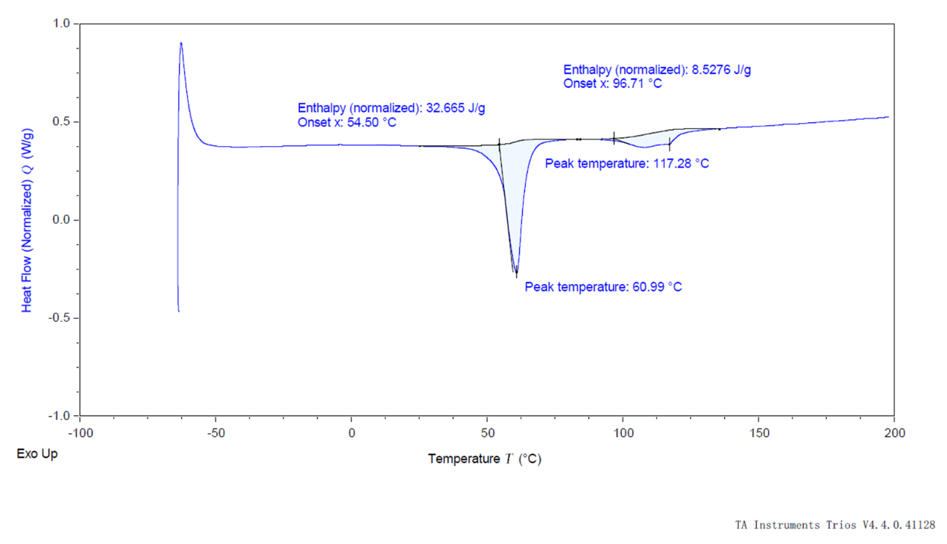
Supplementary Figure 43. DSC of the P-OH5.0-PCL20 from Table 1, entry 5.
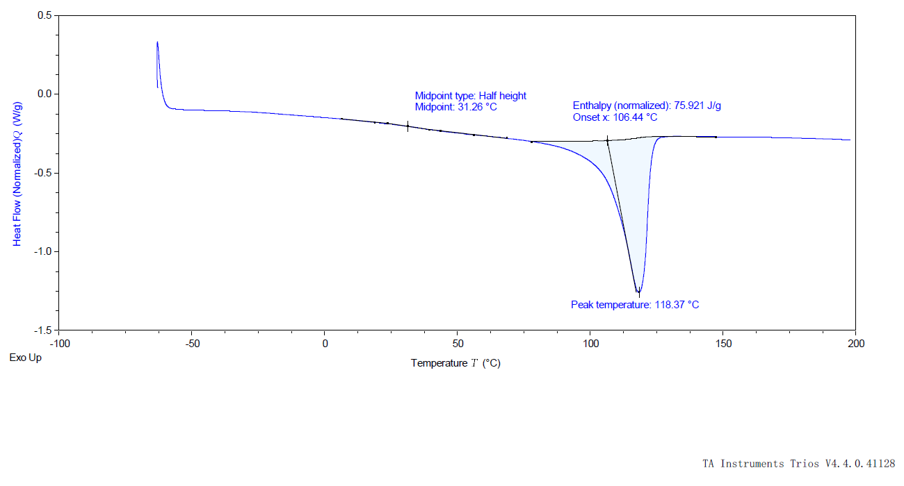
Supplementary Figure 44. DSC of the P-OH1.0-PLA5 from Table 1, entry 6.
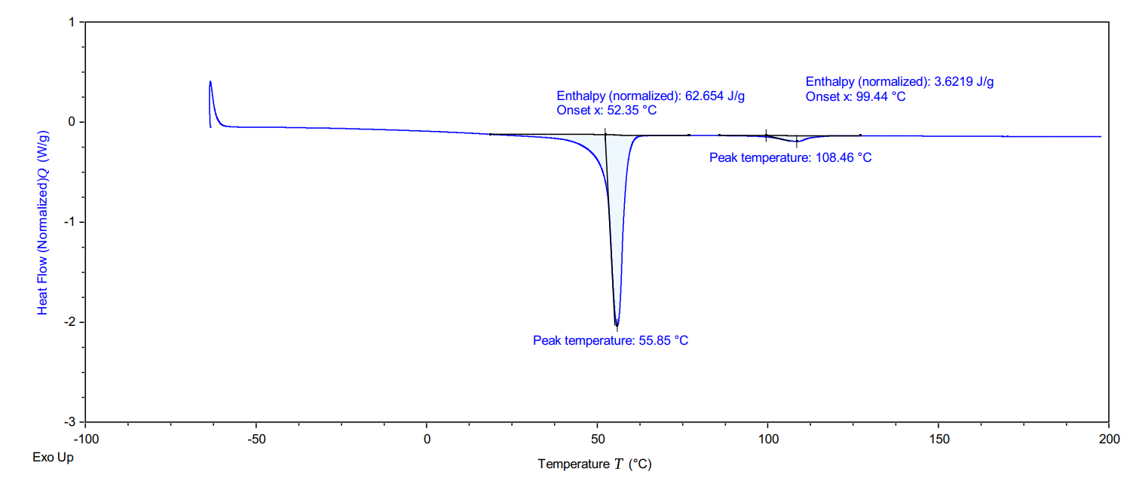
Supplementary Figure 45. DSC of the P-OH2.0-PCL21/PLA4 from Table 1, entry 7.

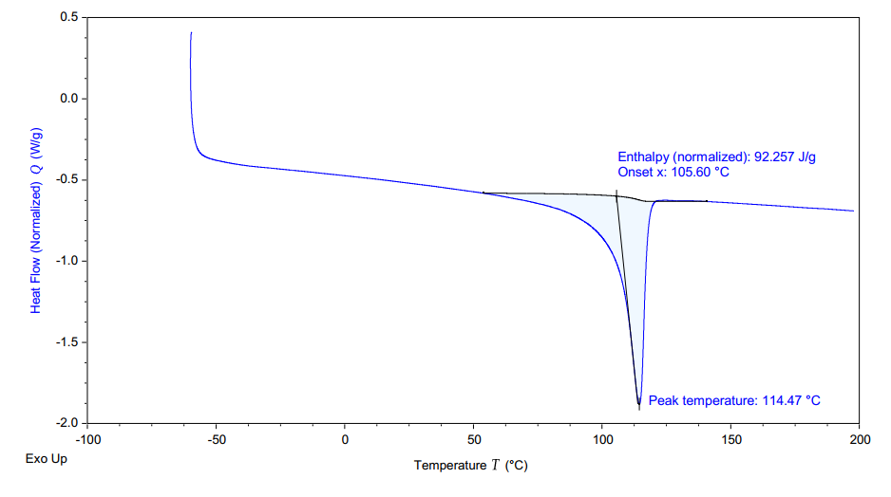
Supplementary Figure 46. DSC of the P-OH2.0- SiO9 from Table 1, entry 8.
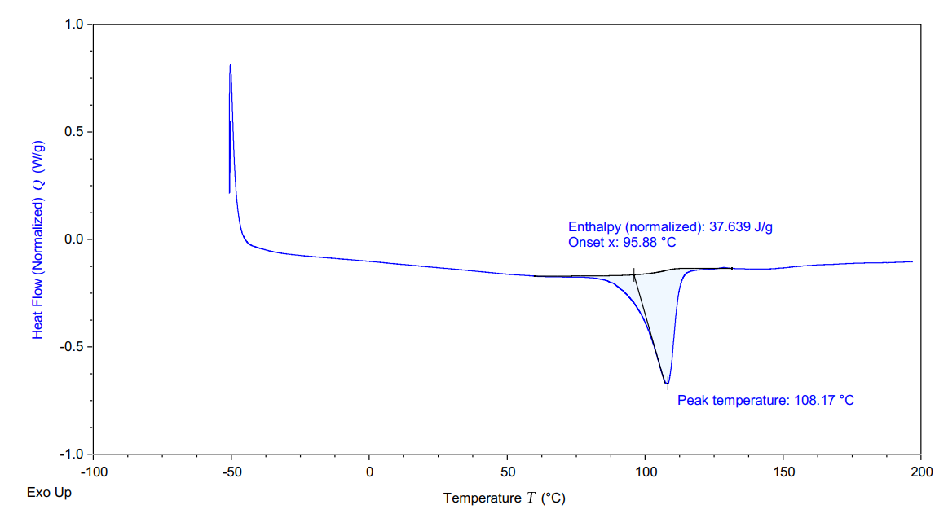
Supplementary Figure 47. DSC of the P-OH2.0- PA from Table 1, entry 9.

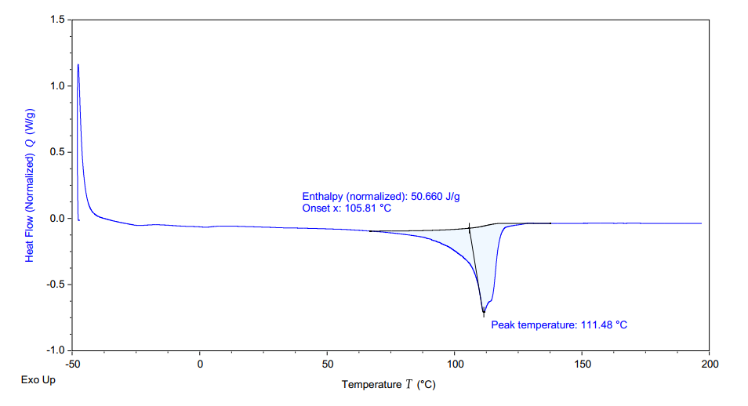
Supplementary Figure 48. DSC of the P-OH2.0- PBT from Table 1, entry 10.
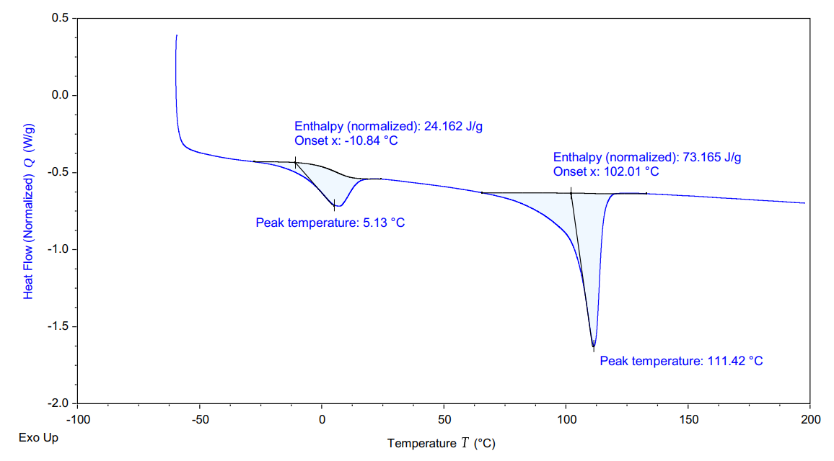
Supplementary Figure 49. DSC of the P-OH2.0-PEG from Table 1, entry 11.

9. Supplementary Figures of GPC of graft copolymers.
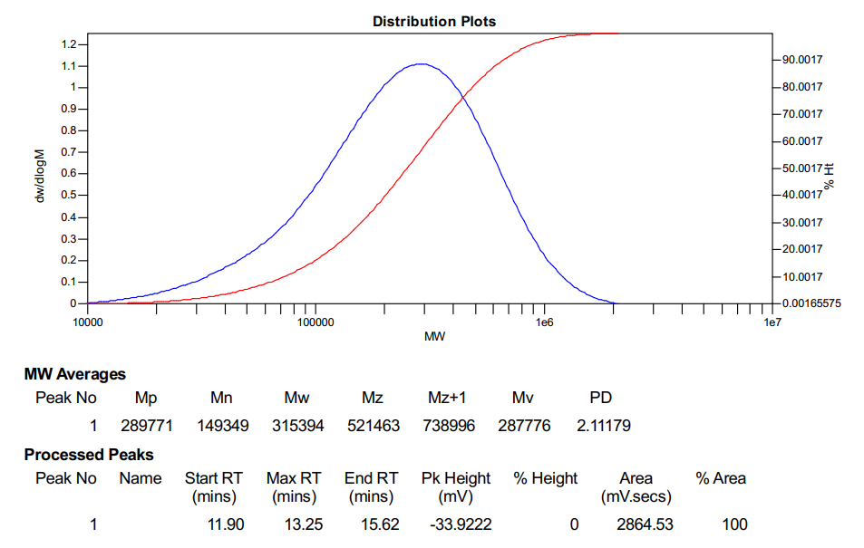
Supplementary Figure 50. GPC of the P-OH1.0-g-PCL10 from table 1, entry 1.

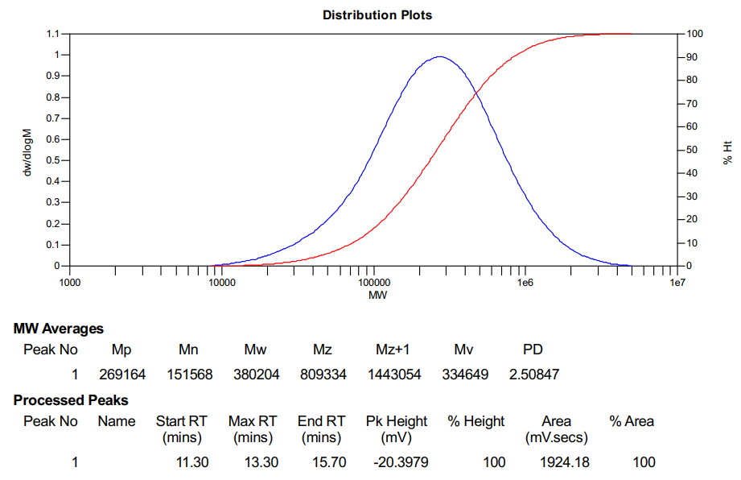
Supplementary Figure 51. GPC of the P-OH2.0-g-PCL10 from table 1, entry 2.

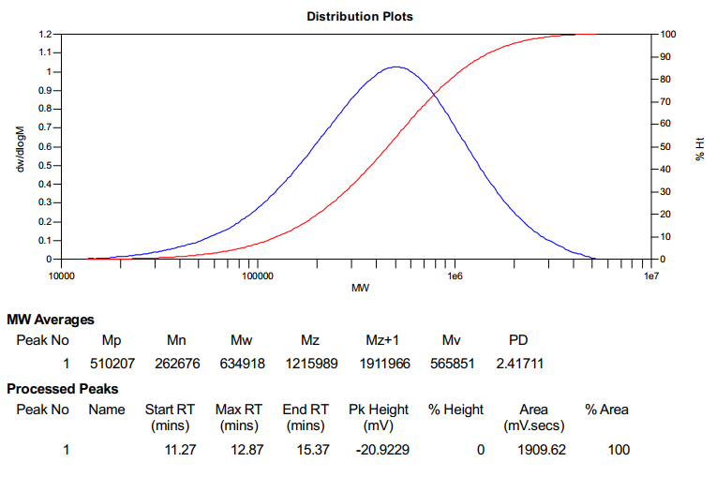
Supplementary Figure 52. GPC of the P-OH2.0-g-PCL20 from table 1, entry 3.

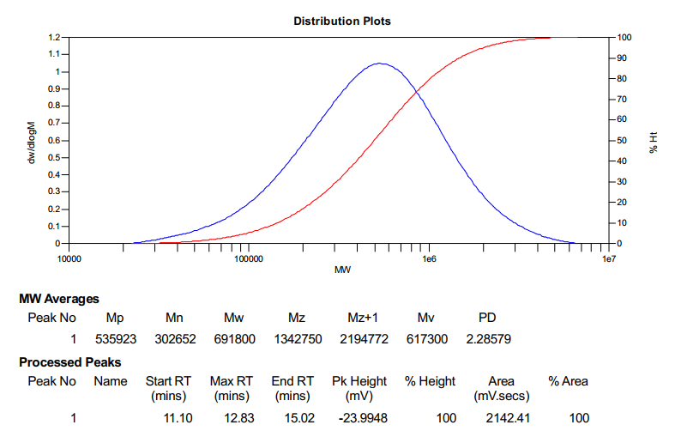
Supplementary Figure 53. GPC of the P-OH2.0-g-PCL30 from table 1, entry 4.
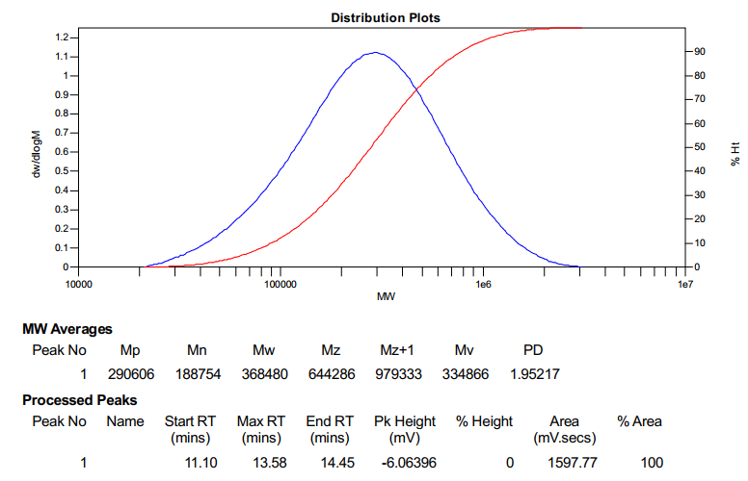
Supplementary Figure 54. GPC of the P-OH5.0-g-PCL20 from table 1, entry 5.

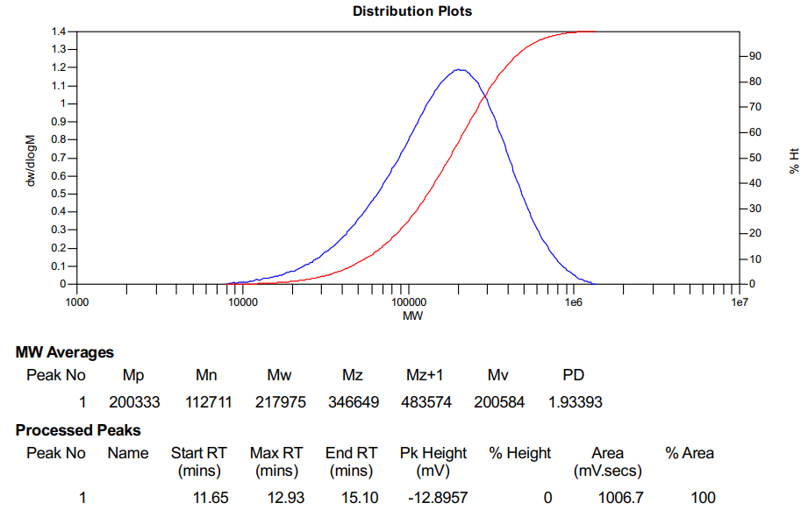
Supplementary Figure 55. GPC of the P-OH1.0-g-PCL10 from table 1, entry 6.
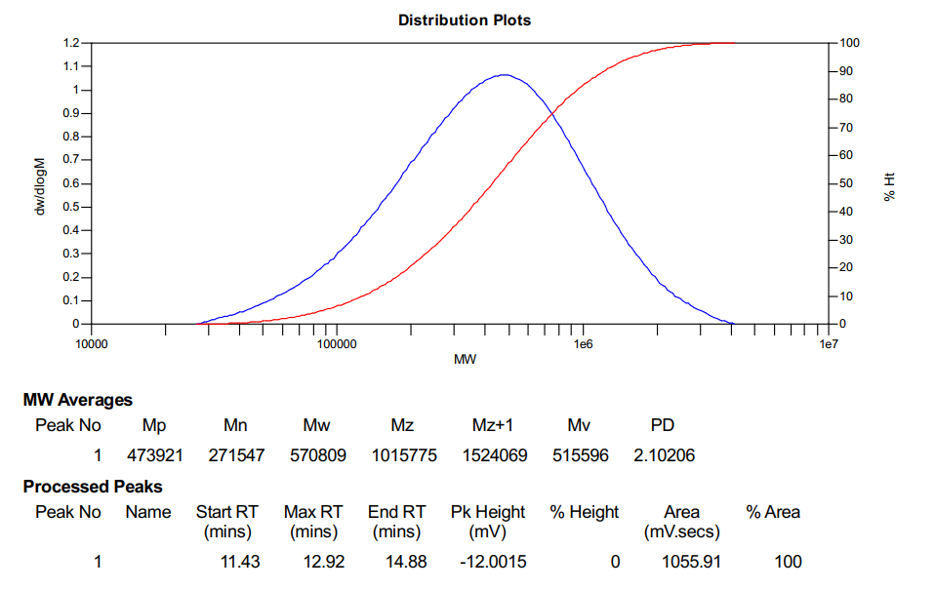
Supplementary Figure 56. GPC of the P-OH1.0-g-PCL10 from table 1, entry 7.
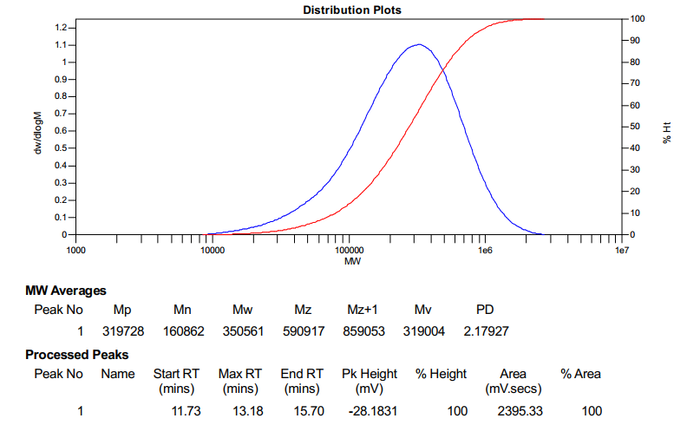
Supplementary Figure 57. GPC of the P-OH2.0-g-SiO9 from table 1, entry 8.
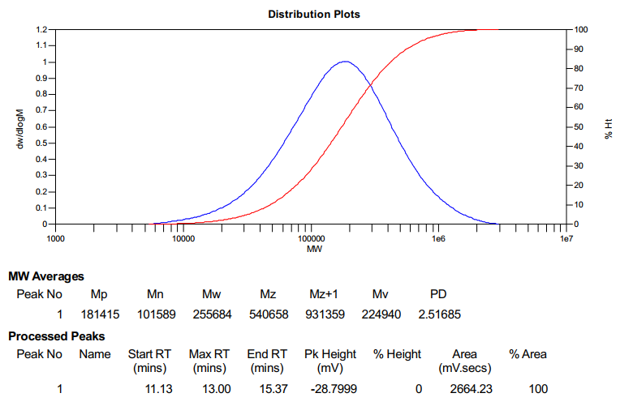
Supplementary Figure 58. GPC of the P-COOH2.0-g-PA from table 1, entry 9.
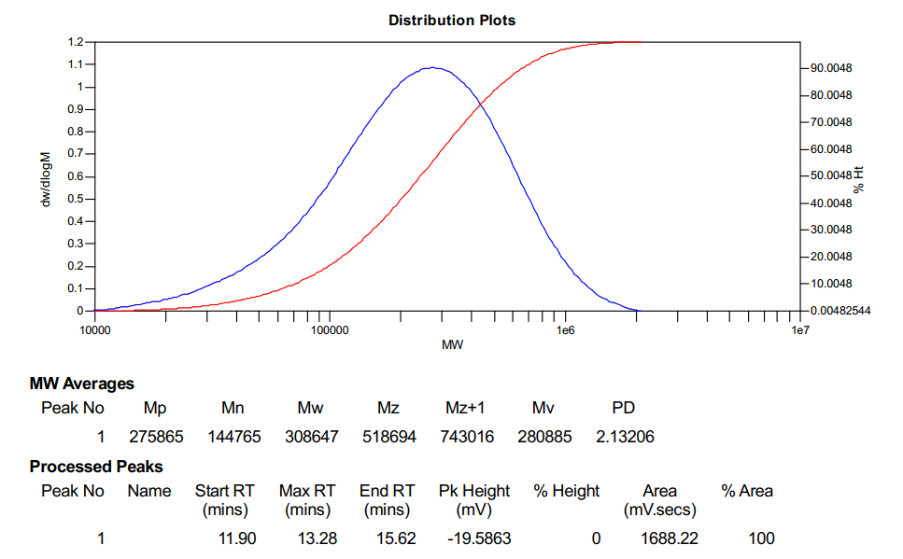
Supplementary Figure 59. GPC of the P-COOCH₃2.0-g-PBT from table 1, entry 10.

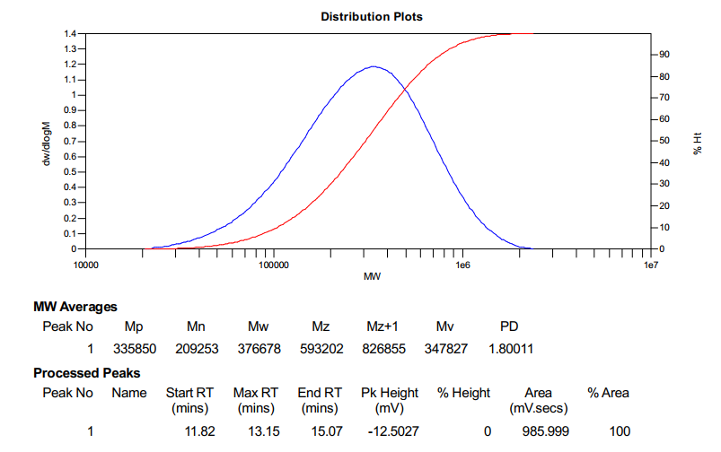
Supplementary Figure 60. GPC of the P-COOCH₃2.0-g-PEG from table 1, entry 11.

10. Original tensile curve of the blends.
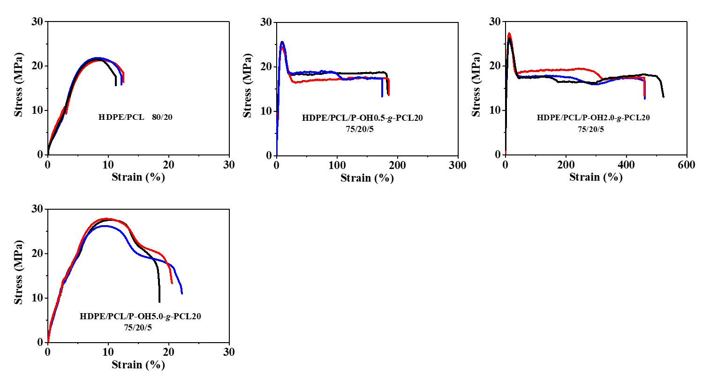
Supplementary Figure 61. The original tensile curves of the blend in Figure 3A. The components and mass ratio of the blend are indicated in the figure.
Supplementary Figure 62. The original tensile curves of the blend in Figure 3B. The components and mass ratio of the blend are indicated in the figure.
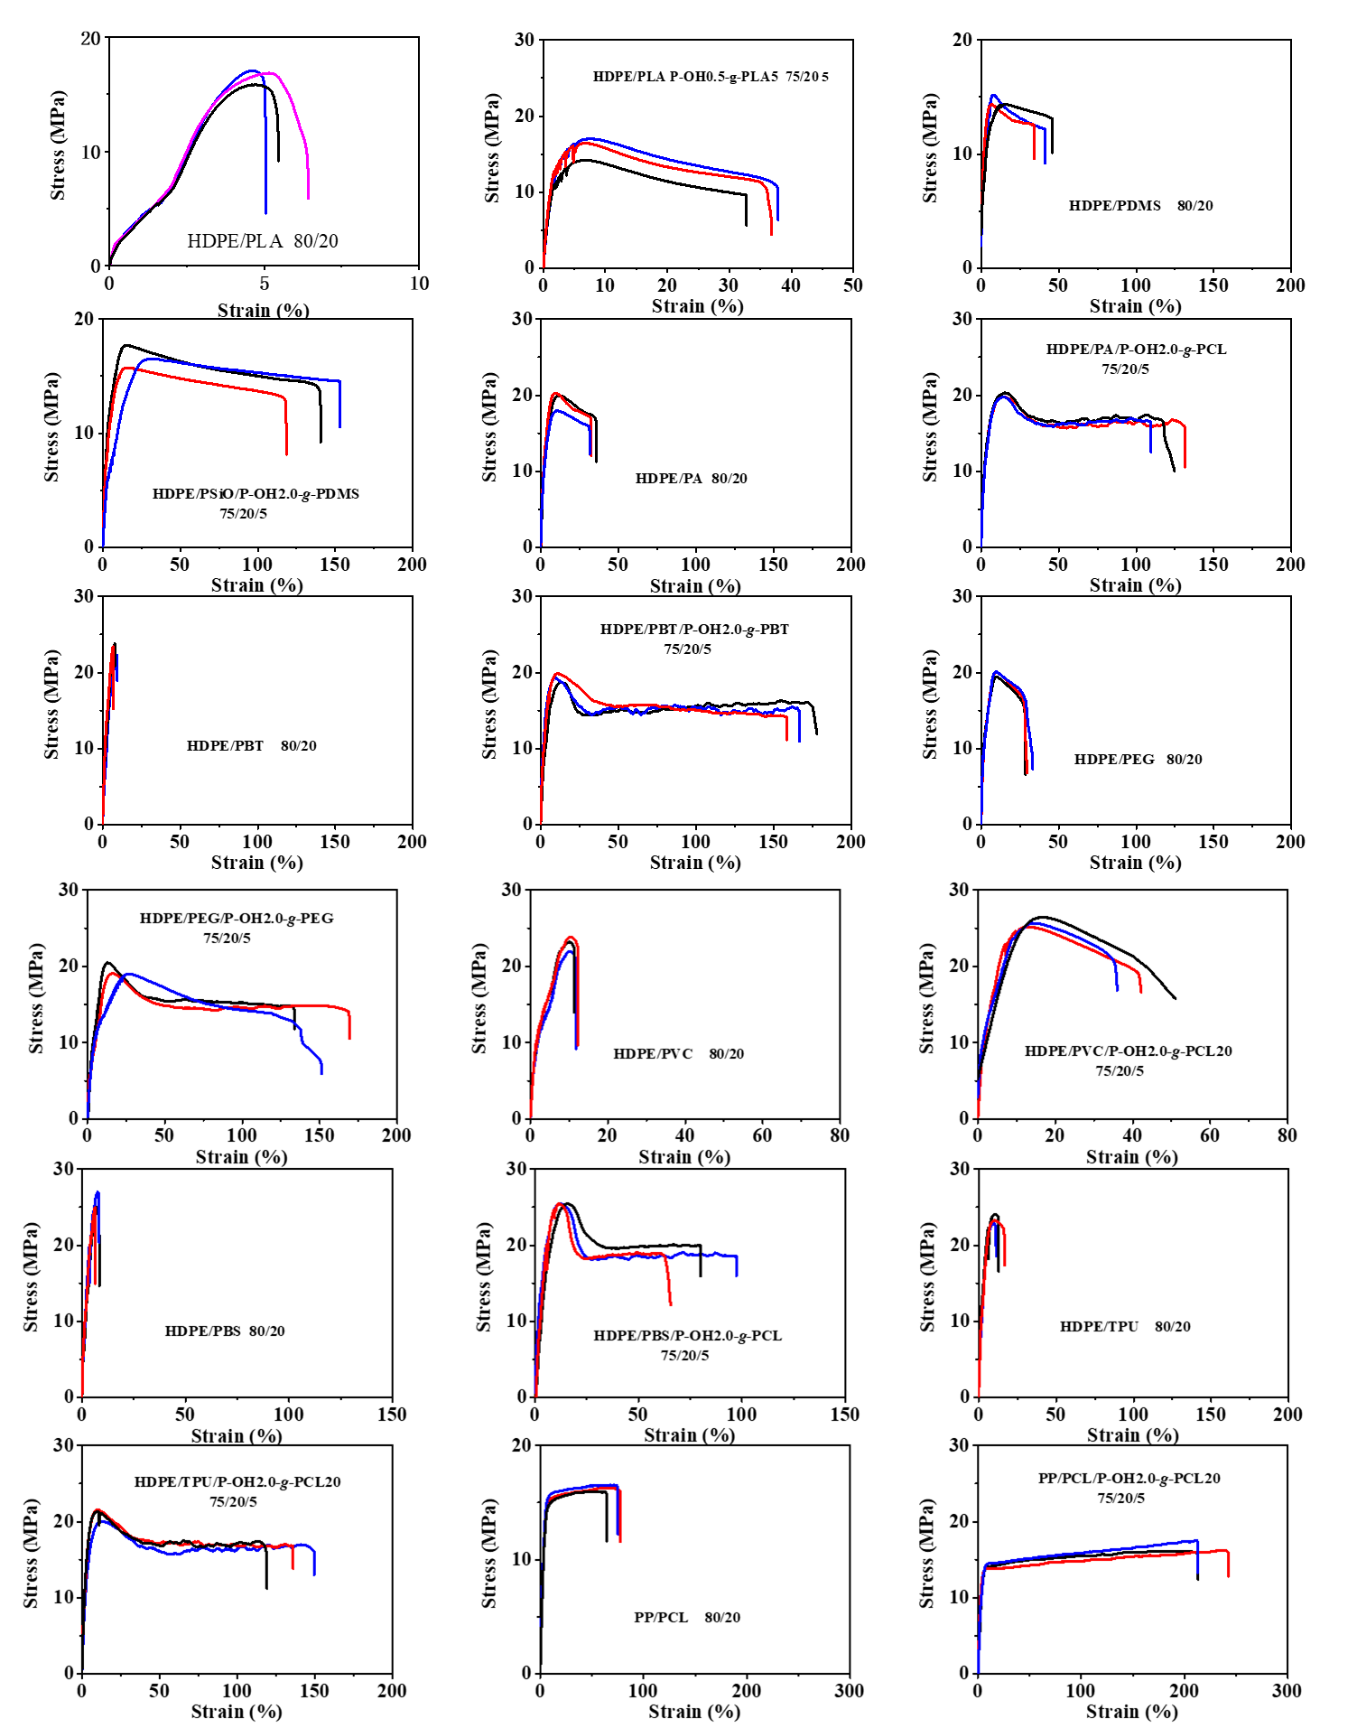
Supplementary Figure 63. The original tensile curves of the blend in Figure 3G. The components and mass ratio of the blend are indicated in the figure.

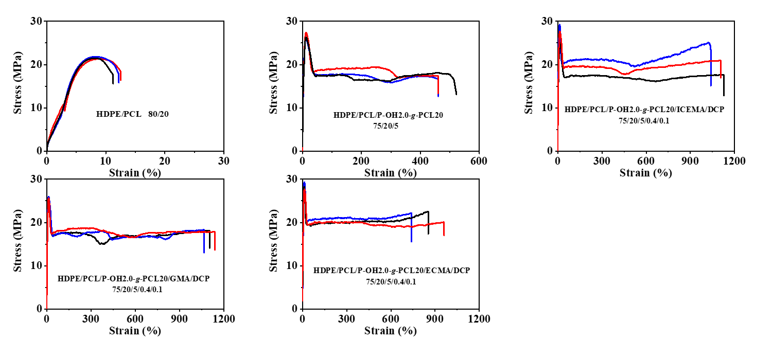
Supplementary Figure 64. The original tensile curves of the blend in Figure 5A. The components and mass ratio of the blend are indicated in the figure.
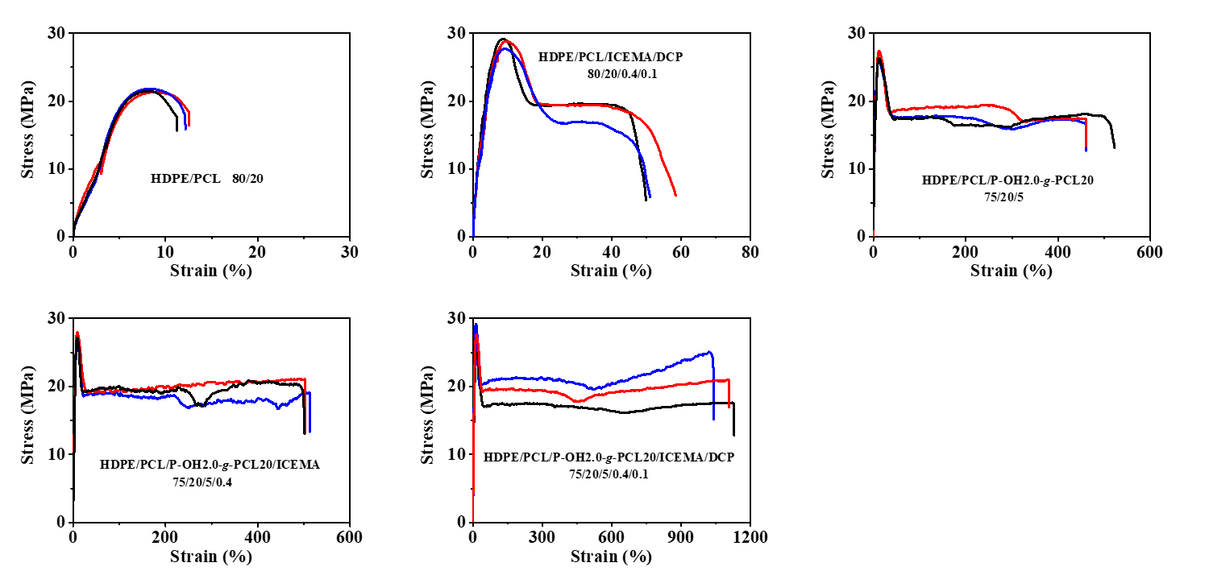
Supplementary Figure 65. The original tensile curves of the blend in Figure 5B. The components and mass ratio of the blend are indicated in the figure.
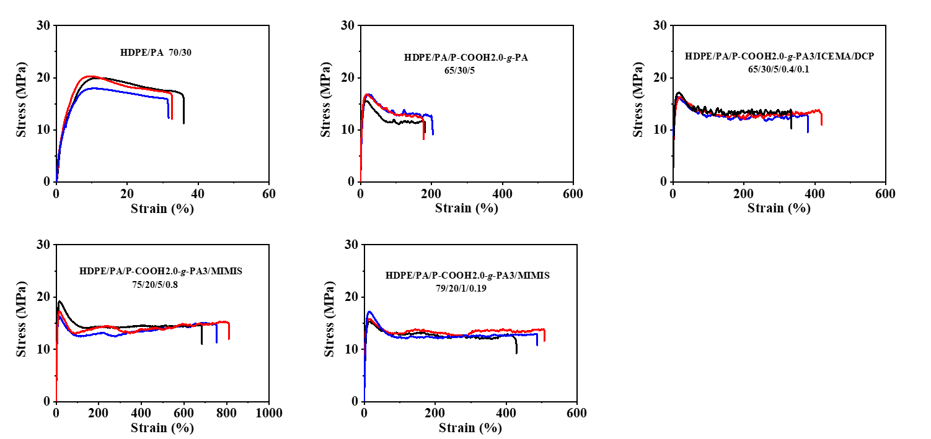
Supplementary Figure 66. The original tensile curves of the blend in Figure 5C. The components and mass ratio of the blend are indicated in the figure.
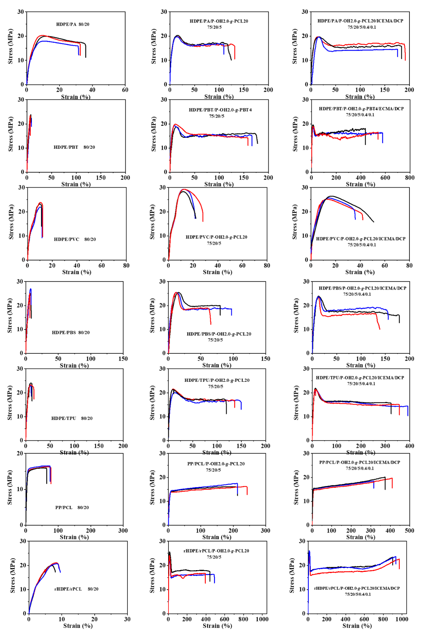
Supplementary Figure 67. The original tensile curves of the blend in Figure 5D. The components and mass ratio of the blend are indicated in the figure.
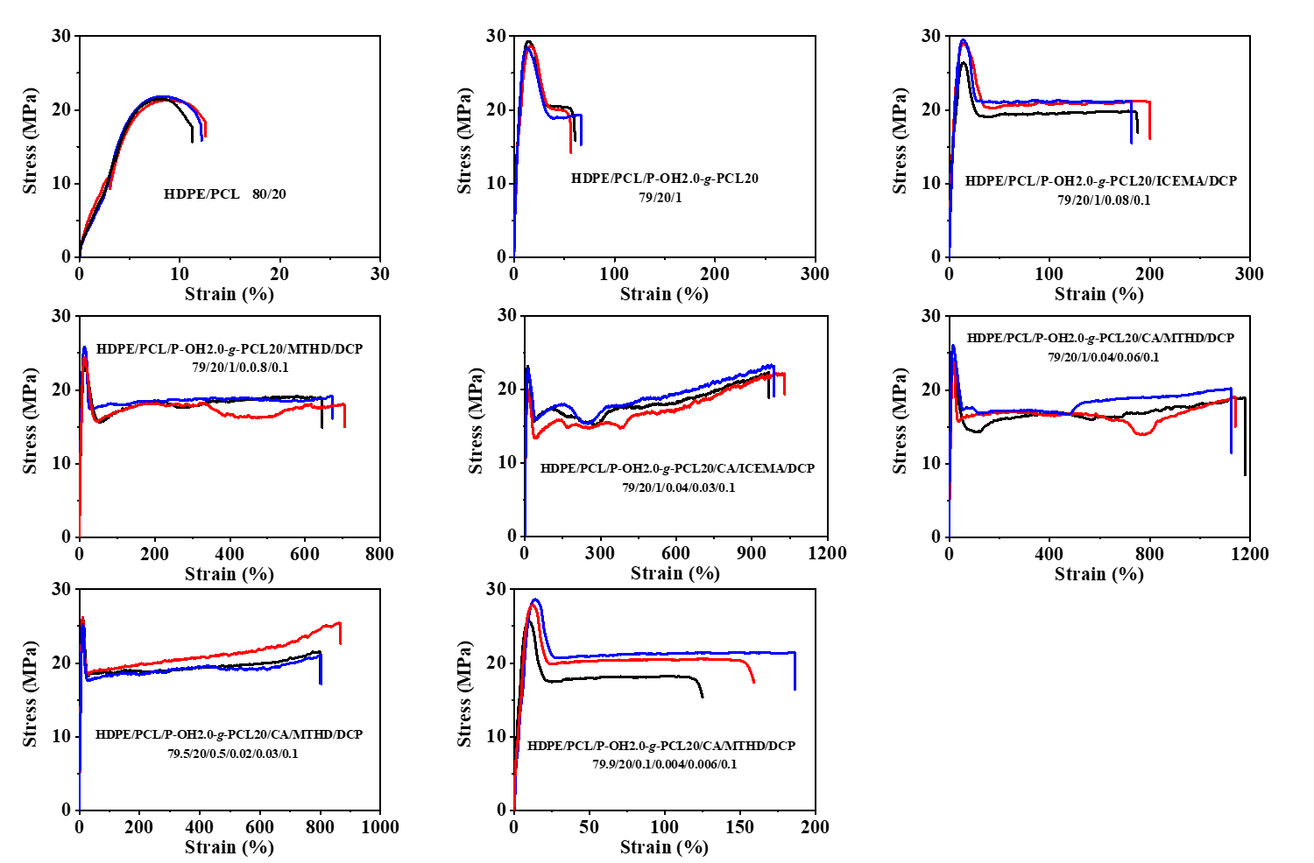
Supplementary Figure 68. The original tensile curves of the blend in Figure 6A. The components and mass ratio of the blend are indicated in the figure.
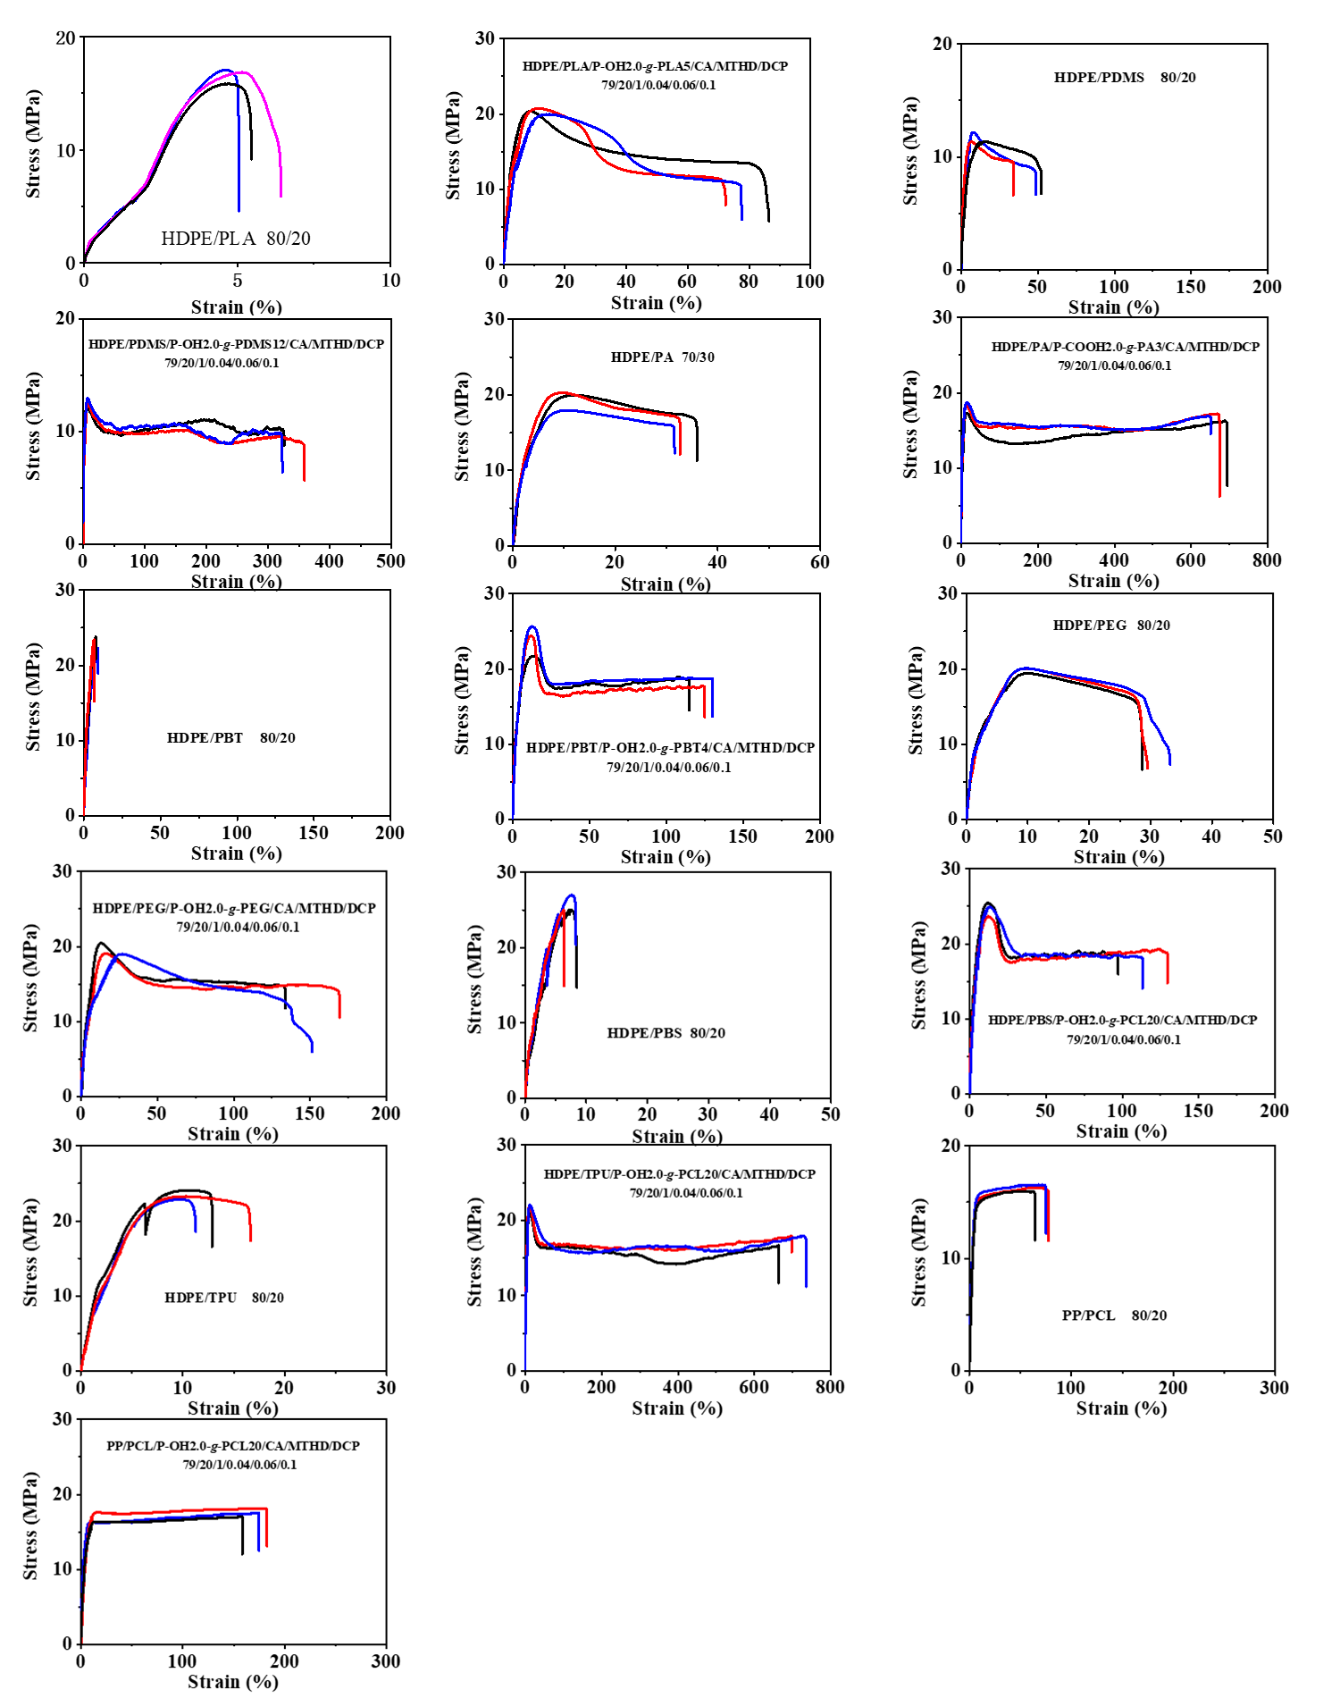
Supplementary Figure 69. The original tensile curves of the blend in Figure 6B. The components and mass ratio of the blend are indicated in the figure.

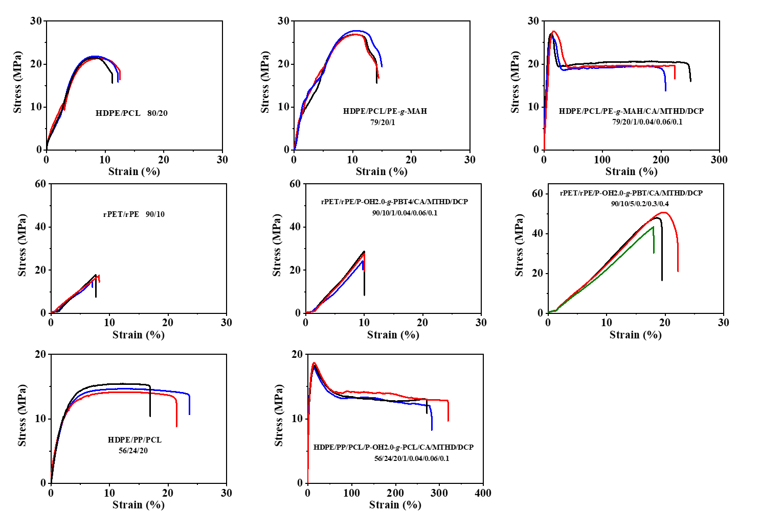
Supplementary Figure 70. The original tensile curves of the blend in Figure 7. The components and mass ratio of the blend are indicated in the figure.
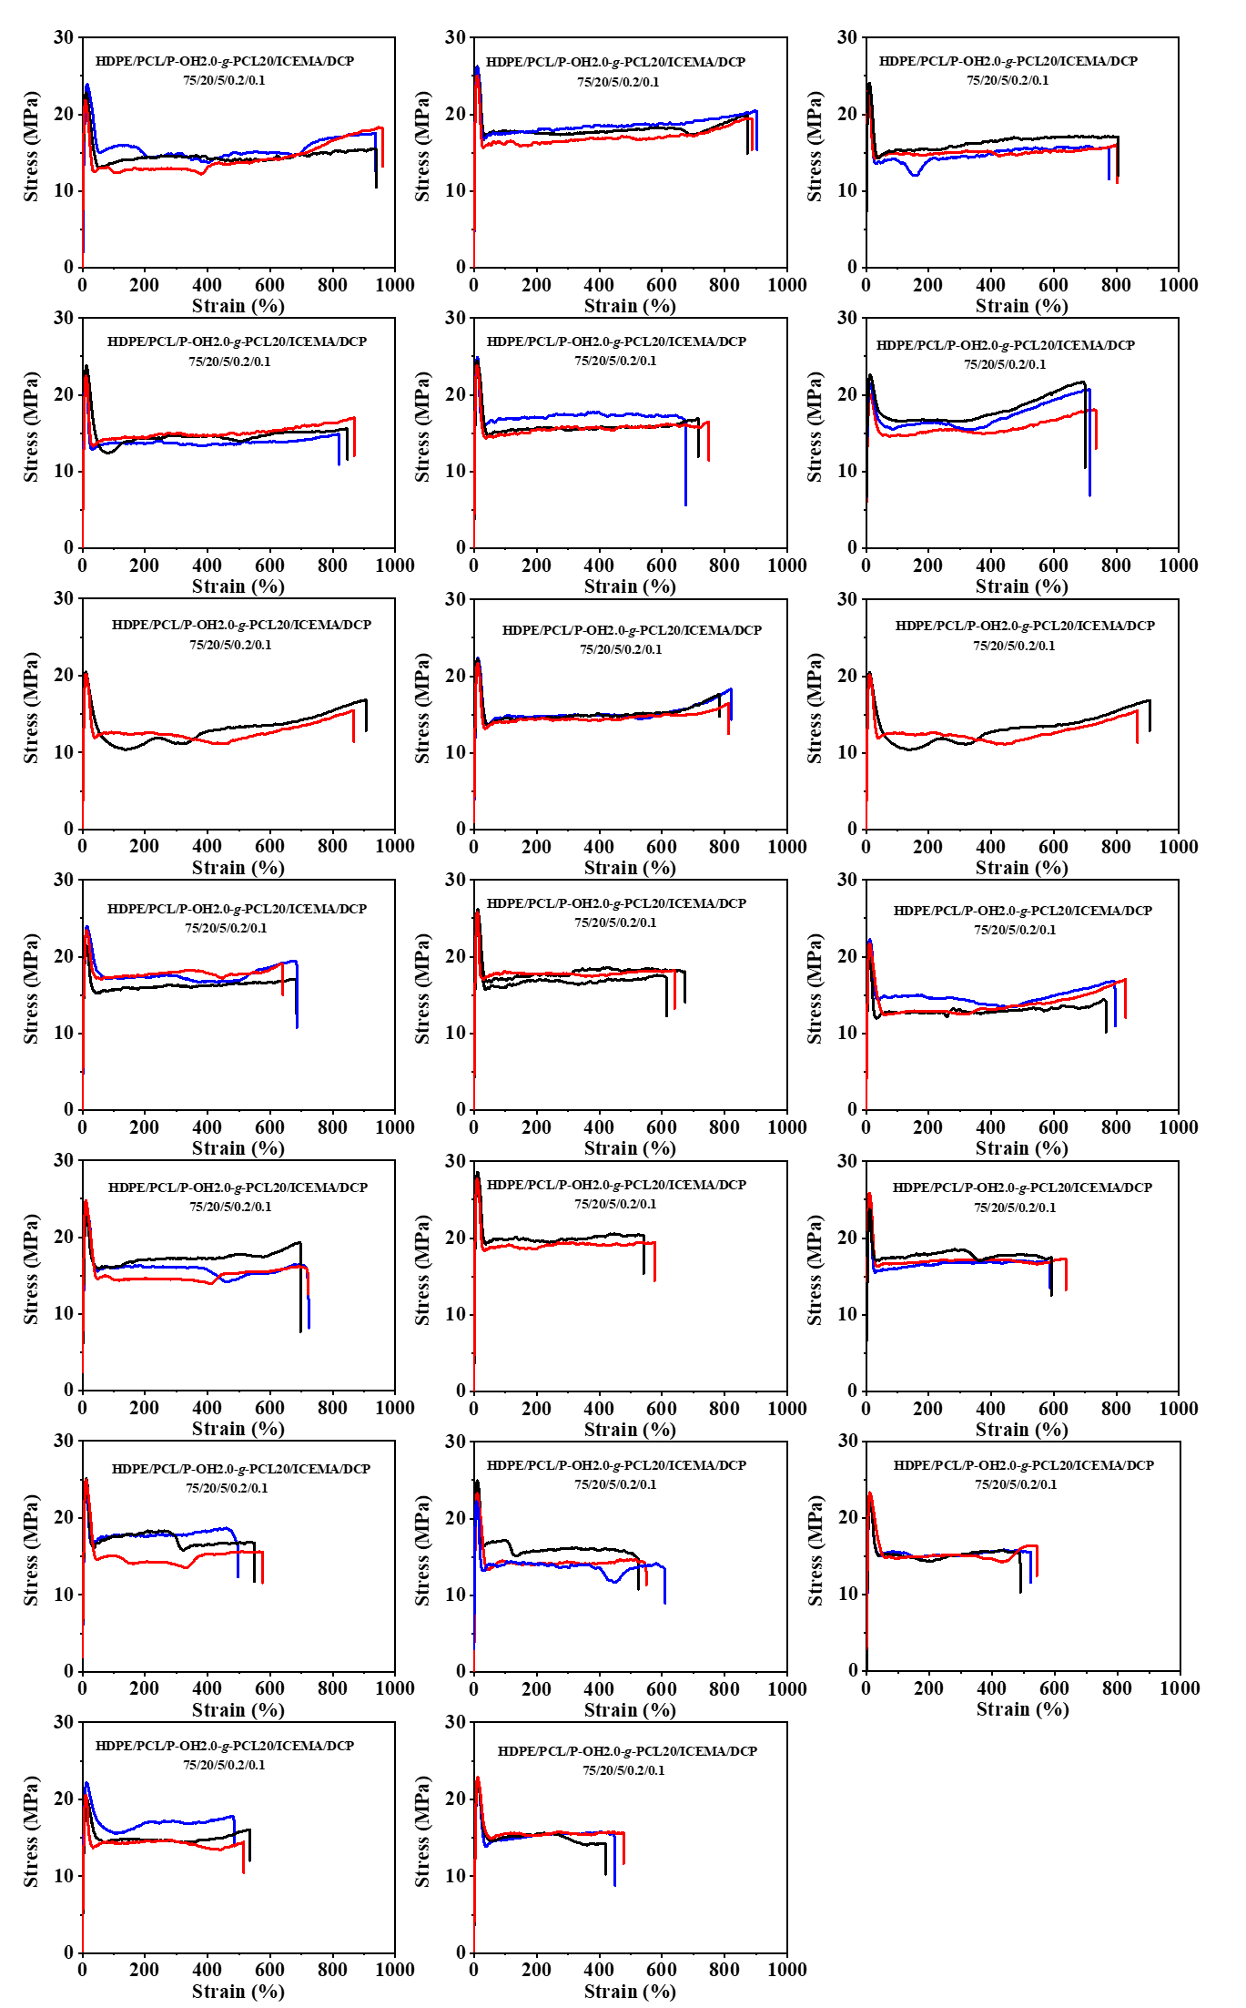
Supplementary Figure 71. The original tensile curves of the blend in Figure 8B. The components and mass ratio of the blend are indicated in the figure.
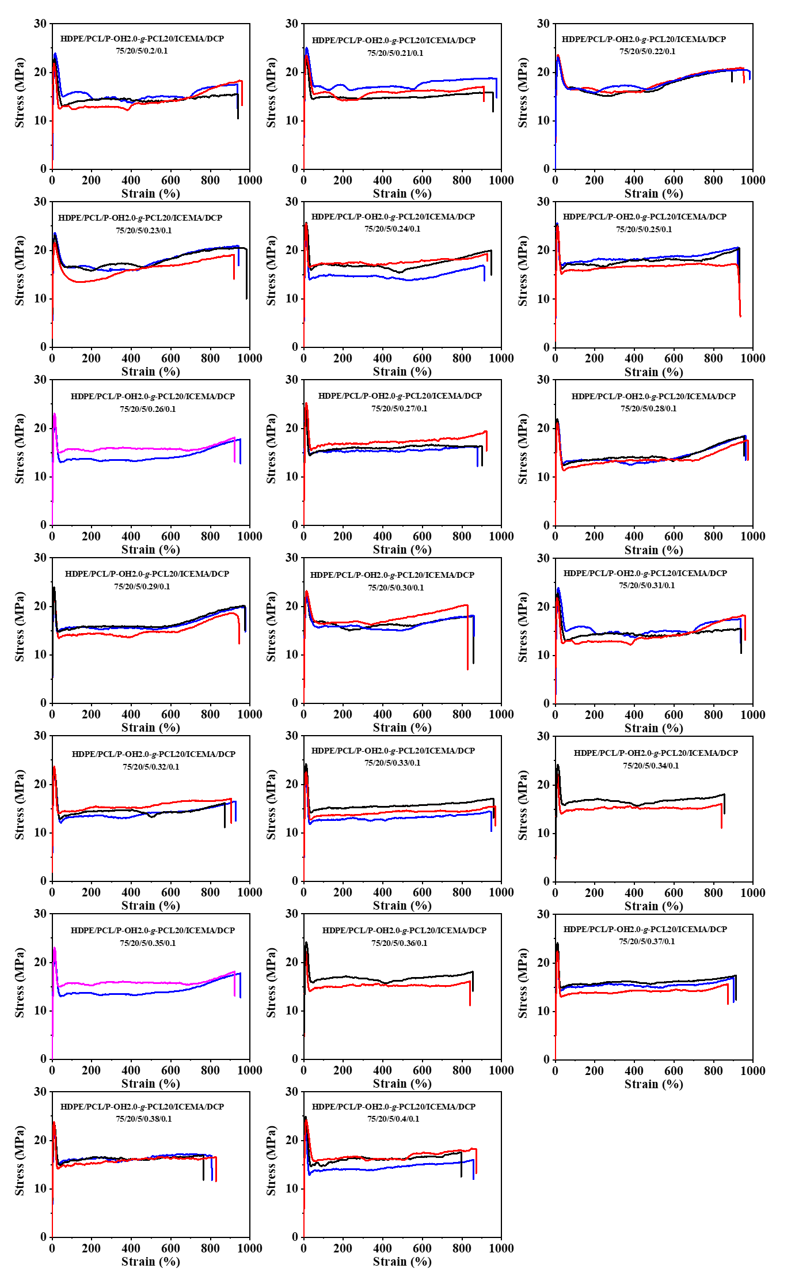
Supplementary Figure 72. The original tensile curves of the blend in Figure 8C. The components and mass ratio of the blend are indicated in the figure.

