Supplementary Information: Fully flexible implantable neural probes for electrophysiology recording and controlled neurochemical modulation

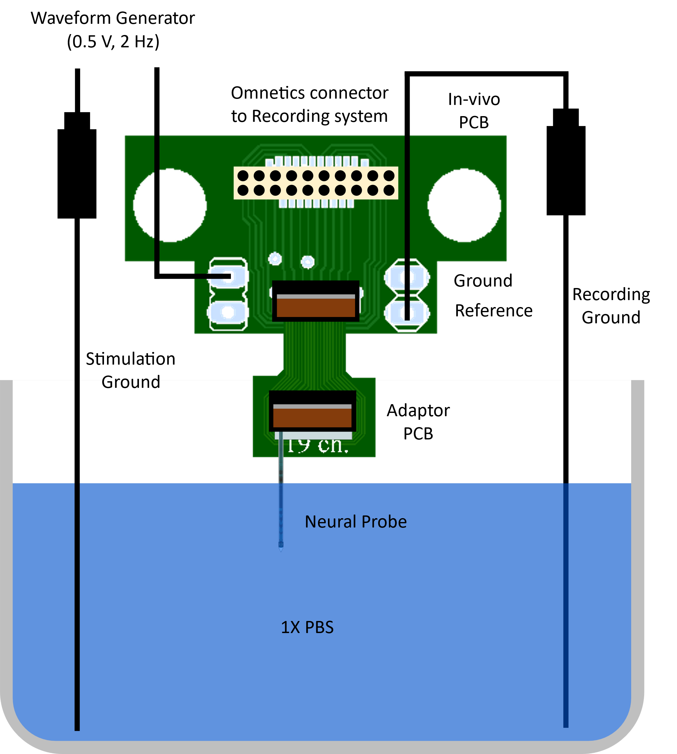
Fig. S1: To measure the potential interference of the stimulation voltage on recording microelectrodes, a synthetic experiment was designed, in which the stimulation sinusoidal voltage was applied to one of the chemical sites in PBS and the resulting signal was recorded through recording microelectrodes using the recording system. This figure shows the schematic of the synthetic experiment setup.

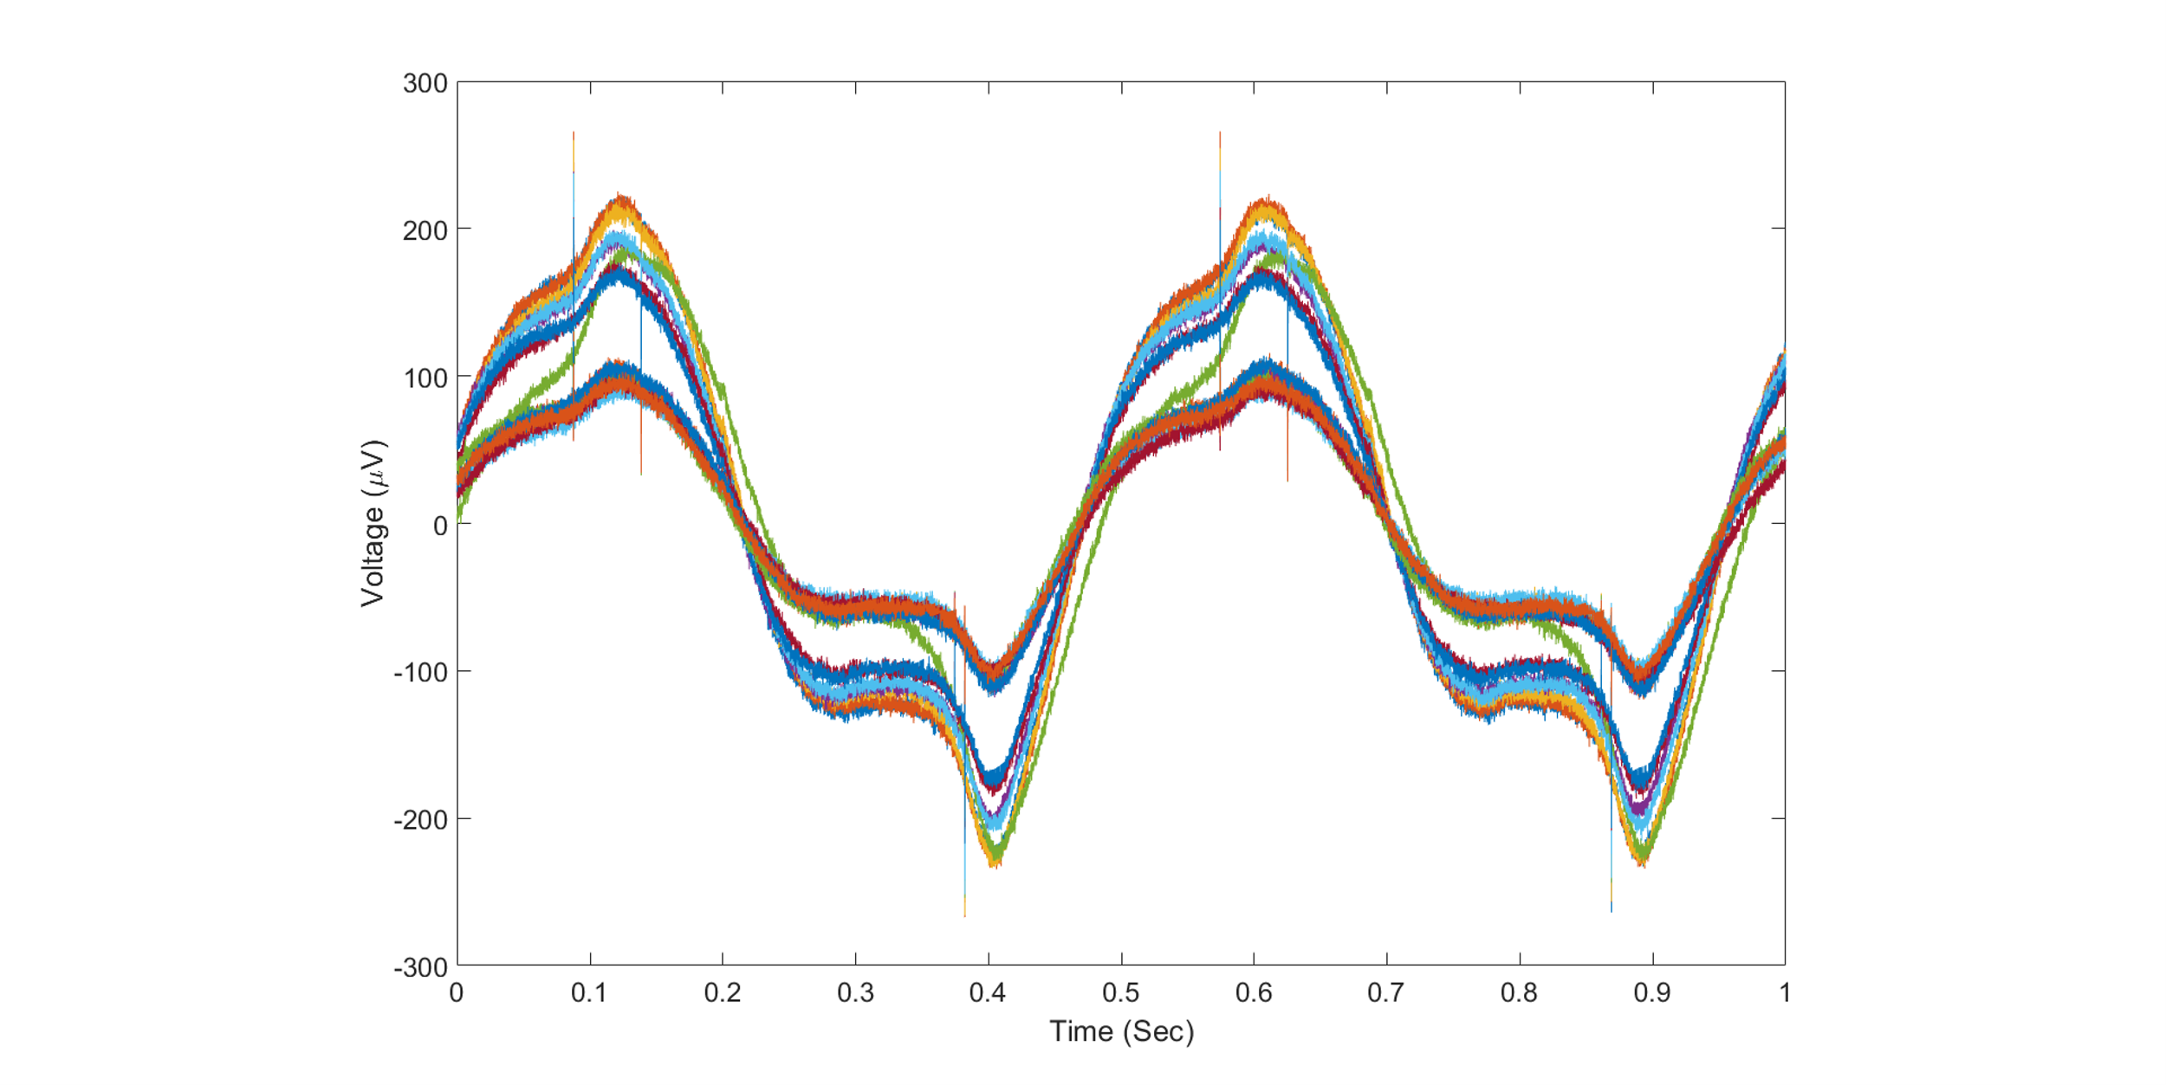
Fig. S2: The recorded stimulation signal by all recording microelectrodes in the synthetic experiment.

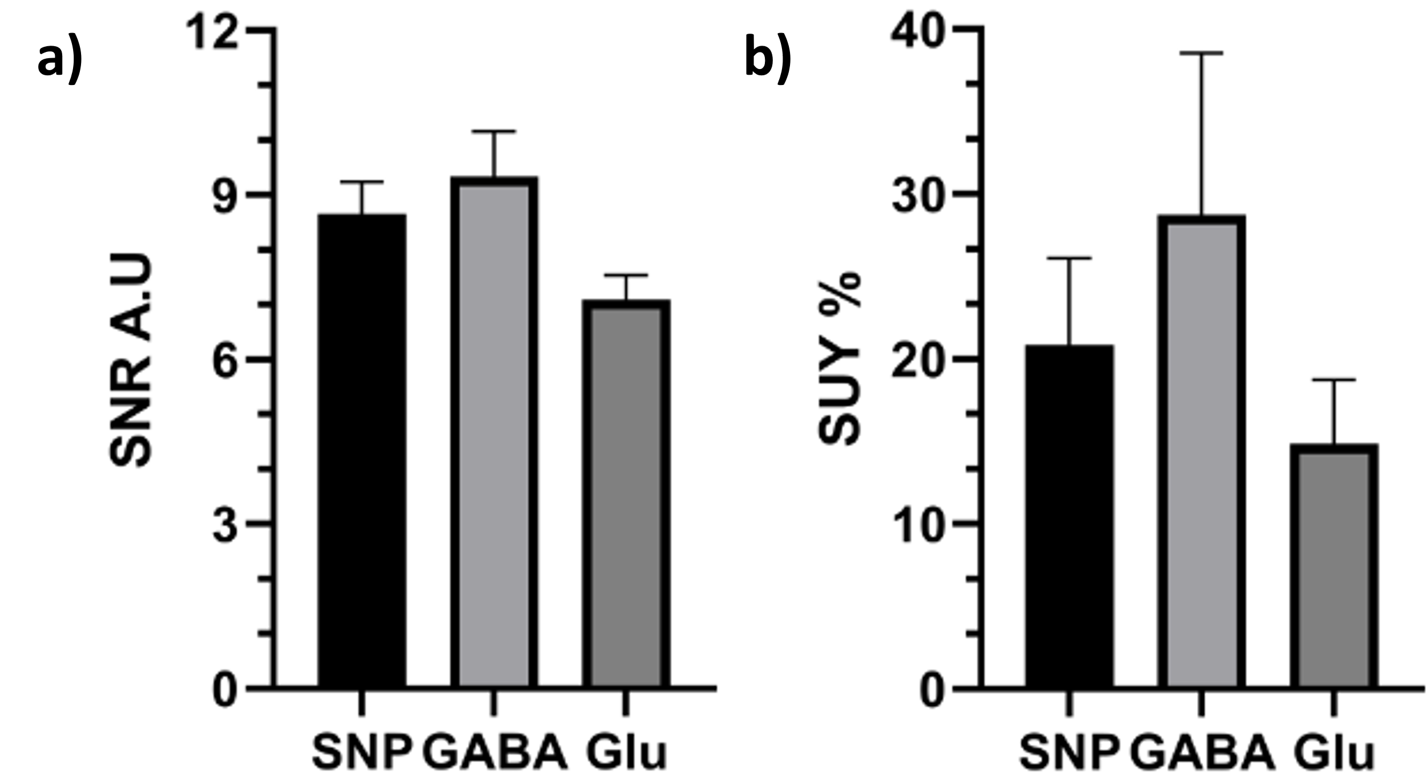
Fig. S3: a, Average SNR of all single units in each group used in in vivo analysis. b, Average SUY of all implanted neural probes in each animal group.

