Prognostic implications of a four-gene signature in non-muscle invasive bladder cancer
Huangqi Duan^{1*}, Shenggen Yu^{1*}, Weimin Xia¹, Chen Wang¹, Shun Zhang¹, Yu Shen¹, Qifeng Cao¹, Ding Xu¹, Hailong Liu^{1#}, Haibo Shen^{1#}

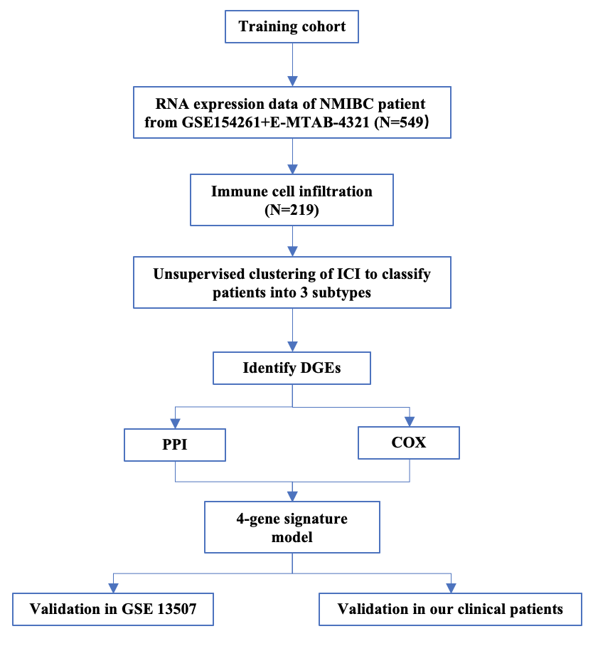
Supplementary Figure 1. Flow chart of data collection and analysis.

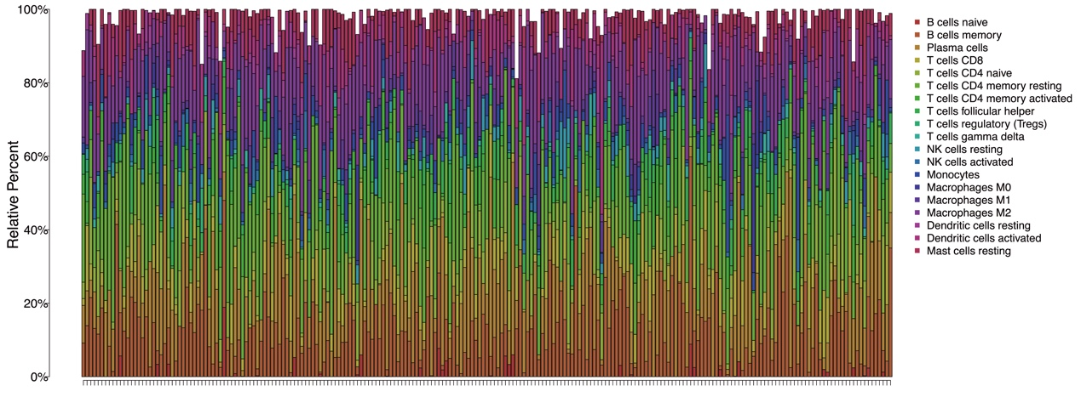

Supplementary Figure 2. The proportion of 22 kinds of ICI in NMIBC tumor samples.

Supplementary Figure 3. Consensus matrixes of the cohort for each k (k = 2–5).

Supplementary Figure 4. Interaction network constructed with the nodes with interaction confidence value >0.90.

