Supporting Information

Sequential recovery of protein and ammonium from waste sludge and functional metabolism in a combined process of nutrient recovery electro-fermentation (NREF)

Jiayu Gu, Huihui Zhou, Jing Wang, Kun Feng, Guojun Xie, Bingfeng Liu, Defeng Xing*
ª State Key Lab of Urban Water Resource and Environment, School of Environment, Harbin Institute of Technology, Harbin 150090, China
*Corresponding author. School of Environment, P.O. Box 2614, 73 Huanghe Road, Nangang District, Harbin, Heilongjiang Province 150090, China
E-mail address: dxing@hit.edu.cn; Tel: +0086-451-86283123

Metals Analysis.
To measure the concentrations of heavy metals, the DS and the recovered freeze-dried pellet samples were transferred to a mortar and grinded to fine powders. To determine the overall content of heavy metals, the samples were placed into a 100 mL beaker and 15 mL of HCl and 5 mL of HNO₃were added and covered with a watch-glass. The sample was then digested on an electric hot plate until the solution became almost transparent, then leave to cool slightly before adding 5 mL of HClO₄. The sample was heated further until 2-3 mL of acid remained. 50 mL deionized water was added and boiled to dissolve all salts, before being transferred to a 100 mL volumetric flask for constant volume for further analyses of the heavy metals with ICP-AES (Optima8300, PerkinElmer, USA).
Pseudomonas aeruginosa PAO1 cultivation test with recovered protein.
The Luria–Bertani (LB) medium used for P. aeruginosa PAO1 growth contained 10 g/L NaCl, 5 g/L yeast extract, and 10 g/L peptone. Then adjusted the medium pH to 7 ± 0.1. The strain PAO1 was cultured at 37 °C and 150 r/min for 24 h prior to use.
Recovered protein was used as a substitute for yeast extract and/or peptone to test its bio-availability. RP-1000 medium (NaCl 10 g/L and recovered protein 5g/L; protein concentration of medium was 1000 mg/L), RP-1500 medium (NaCl 10 g/L and recovered protein 10g/L; protein concentration was 1500 mg/L), RPY-2700 medium (NaCl 10 g/L, yeast extract 5 g/L, and recovered protein 5g/L; protein concentration was 2700 mg/L), RPY-3700 medium (NaCl 10 g/L, yeast extract 5 g/L, and recovered protein 10g/L; protein concentration was 3700 mg/L), RPP-1800 medium (NaCl 10 g/L, peptone 10 g/L, and recovered protein 5g/L; protein concentration was 1800 mg/L), and RPP-3000 medium (NaCl 10 g/L, peptone 10 g/L, and recovered protein 10g/L; protein concentration was 3000 mg/L) were prepared. The LB medium served as control were diluted to the same protein concentration as above mediums (LB-1000, LB-1500, LB-2700, LB-3700, LB-1800, and LB-3000). P. aeruginosa PA01 was transferred at a concentration of 10% in 300 μL different mediums in 96-well plates respectively. And the OD₆₀₀ was automatically monitored at 37 °C with a Bioscreen C (Oy Growth Curves AB Ltd., Finland) over 24 h.
Start-up procedures of EFS reactors
To start up EFS reactors, anodes were enriched in MFC mode using WAS as the anodic inoculum and 1 g/L sodium acetate as anolyte, while 50 mM K3Fe(CN)6 mixed with 100 mM PBS was used as catholyte ¹. The cell voltage across an external resistor of 1000 Ω was recorded by a data acquisition system (model 2700 with a 7702 module, Keithley Instruments Inc., USA) as previously reported ². A half of anolyte was replaced with fresh anolyte when the current was below 0.5 mA. The electroactive biofilm on anode was enriched after 30 days of cultivation. Then the anodes with pre-acclimated biofilm were then retained in EFS reactors for the following experiment.
High-throughput sequencing data analysis
Each sample data was separated from the sequencing data according to barcode sequence and PCR primer sequence. After the amputation of barcode and primer sequences, FLASH software (V1.2.11, http://ccb.jhu.edu/software/FLASH/) was applied to assemble reads of samples and get the raw tags³. Then use fastP software for quality control and get high quality of clean tags. Subsequently, Usearch software was used to compare clean tags with a database to detect and remove chimeras ⁴, resulting in the final effective data, namely effective tags. QIIME2 software was performed for noise reduction and filtering out effective tags with a richness less than 5 to obtain the final Amplicon Sequence Variants (ASVs) and feature list. The obtained ASVs were clustered using the silva138.1 database by the classify-sklearn module in QIIME2 software to obtain the species information for each ASV. To study phylogenetic relationship of each ASV and the differences of the dominant species among different samples, multiple sequence alignment was performed using QIIME2 software. Alpha diversity was calculated from seven indices in QIIME2, including Observed ASV, Chao1, Shannon, Simpson, Dominance, Good’s coverage and Pielou e. Beta diversity was calculated based on weighted and unweighted unifrac distances in QIIME2. Cluster analysis was performed with principal component analysis (PCA) using the ade4 package and ggplot2 package in R software (Version 3.5.3). Principal Coordinate Analysis (PCoA) was performed to obtain principal coordinates and visualize differences of samples in complex multi-dimensional data using ade4 package and ggplot2 package in R software (Version 2.15.3).
Metagenomic analysis.
DNA extraction, sequencing and read processing. Total genomic DNA extraction was conducted from electrode biofilm and suspension samples using CTAB method for high-throughput sequencing. The quality of the extracted DNA was examined by 1 % agarose gel, the concentration was determined by Qubit® dsDNA Assay Kit in a Qubit® 2.0 Flurometer (Life Technologies, CA, USA). The DNA sample was fragmented by sonication to a size of 350 bp, then DNA fragments were end-polished, A-tailed, and ligated with the full-length adaptor for Illumina sequencing with further PCR amplification. PCR products were purified (AMPure XP system) and libraries were analyzed for size distribution by Agilent 2100 Bioanalyzer and quantified using real-time PCR. Libraries and sequencing were constructed on Illumina PE150 platform (Illumina Inc., San Diego, CA, USA). The Raw data was preprocessed using Readfq (V8, https://github.com/cjfields/readfq) to acquire the clean data for subsequent analysis. Clean data was then blasted to the host database using Bowtie2.2.4 software (http://bowtiebio. sourceforge.net/bowtie2/index.shtml) to filter out reads that were of host origin ⁵.
Metagenome Assembly. MEGAHIT software (v1.0.4-beta) was used to assemble the clean data. subsequently, the assembled Scaftigs were interrupted from N connection and leave the Scaftigs without N⁶ . Clean data were compared to each Scaffolds, respectively by Bowtie2.2.4 software to acquire the PE reads were not used. Scaffolds with a length of more than 500 bp were retained for statistical tests. Finally, Scaftigs with a length of more than 500 bp were extracted and broken into contigs without gaps.
Gene prediction and abundance analysis: The assembled Scaftigs (> 500 bp) were used to predict open reading frames (ORF) using the MetaGeneMark (V2.10, http://topaz.gatech.edu/GeneMark/) software. CD-HIT software (V4.5.8, http://www.bioinformatics.org/cd-hit) was used to reduce redundancy and obtain a unique initial gene catalogue. The clean data of each sample was then mapped to initial gene catalogue using Bowtie2.2.4, and the number of reads that mapped to each in each sample was recorded. The genes with fewer than two reads were filtered out, and the gene catalogue (Unigenes) was obtained for subsequently analysis. The abundance information of each gene in each sample was calculated based on the number of mapped reads and the length of gene.
Taxonomy prediction: DIAMOND software (V0.9.9, https://github.com/bbuchfink/diamond/) was used to blast the Unigenes to the sequences of Bacteria, Fungi, Archaea, and Viruses which are all extracted from the NR database (Version: 2018-01-02, https://www.ncbi.nlm.nih.gov/) of NCBI with e-value cutoff of 1e⁻⁵. The table containing the number of genes and the abundance information of each sample in each taxonomy hierarchy are obtained based on the LCA annotation result and the gene abundance table.
Functional database annotations: DIAMOND software (V0.9.9) was used to perform a BLASTp search against functional databases (e-value <= 1e-5) adopted to blast Unigenes to functional database (blastp, e-value <= 1e-5) ^{7, 8}, including KEGG database (Version 2018-01-01, http://www.kegg.jp/kegg/), eggnog database (Version 4.5, http://eggnogdb.embl.de/#/app/home), and CAZy database (Version 201801, http://www.cazy.org/). The gene number table of each sample in each taxonomy hierarchy was obtained based on the function annotation result and gene abundance table, where the gene number of a function in a sample was equal to the number of genes annotated to that function with nonzero abundance. Subsequently, the abundance table of each taxonomy hierarchy was used to generate a count of annotated gene numbers, an overview of the general relative abundance situation, an abundance cluster heat map, and a dimensionality reduction analysis using PCA and NMDS.

Table S1. Characteristics of buffered raw sludge and treated sludge
Sample | Conductivity  (mS/cm) | VSS  (g/L)
RS + PBS | 6.65 ± 0.01 | 10.56 ± 0.02
TS + PBS | 9.10 ± 0.03 | 5.61 ± 0.03

Table S2. α diversity index of samples.
Sample Name | Qualified reads | Mean length | Observed OTUs | Chao1 | Dominance | Pielou e | Shannon | Simpson | Goods coverage
AD-RS | 97,996 | 417 | 989 | 989.789 | 0.019 | 0.757 | 7.528 | 0.981 | 1.000
AD-TS | 94,538 | 418 | 896 | 896.526 | 0.073 | 0.669 | 6.559 | 0.927 | 1.000
EFS-RS-bio | 100,404 | 424 | 729 | 732.138 | 0.127 | 0.546 | 5.196 | 0.873 | 1.000
EFS-RS-ss | 96,615 | 419 | 914 | 914.000 | 0.041 | 0.696 | 6.841 | 0.959 | 1.000
EFS-TS-bio | 99,549 | 423 | 687 | 687.778 | 0.051 | 0.661 | 6.232 | 0.949 | 1.000
EFS-TS-ss | 96,718 | 419 | 862 | 862.429 | 0.045 | 0.678 | 6.616 | 0.955 | 1.000

Table S3. Summary of metagenomic sequencing data.
Sample Name | Raw data (M) | Clean data (M) | Percent of raw reads (%) | Contigs | N50 (bp) | N90  (bp)
AD-RS | 10,274.45 | 10,259.06 | 99.85 | 503,194 | 1,091 | 562
AD-TS | 11,033.01 | 11,025.16 | 99.929 | 451,925 | 1,292 | 576
EFS-RS-bio | 10,731.14 | 10,713.02 | 99.831 | 481,462 | 1,086 | 561
EFS-RS-ss | 10,528.89 | 10,509.85 | 99.819 | 267,457 | 1,146 | 564
EFS-TS-ss | 10,627.82 | 10,615.10 | 99.88 | 411,847 | 1,331 | 579
EFS-TS-bio | 10,084.52 | 10,061.36 | 99.77 | 185,966 | 1,307 | 581

Table S4. Concentrations of heavy metals in dewatered sludge and recovered protein
Element | Dewatered Sludge  mg/kg | Recovered protein  mg/kg | Legal standard ª
Al | 7636.19 ± 89.06 | 2766.83 ± 8.27 | -^{b}
Ca | 7140.95 ± 82.23 | 2872.50 ± 18.58 | -
Fe | 106.67 ± 4.11 | 91.33 ± 2.49 | -
Cu | 15322.86 ± 195.75 | 1513.33 ± 13.20 | -
Ni | 448.10 ± 6.09 | 46.67 ± 0.94 | -
Zn | 198.38 ± 1.79 | 199.50 ± 3.08 | -
Cr | 834.00 ± 9.09 | 94.66 ± 4.78 | 10
Pb | 10.95 ± 1.05 | 4.33 ± 1.25 | 10
As | ND | ND | 2
Ag | ND | ND | -
Cd | ND | ND | 0.5
Hg | ND | ND | 0.1
Se | ND | ND | 2
a: The lowest in the hygienic standard for feeds in the people’s Republic of China (GB 13078-2001).
b: Not prescribed in the regulation.
ND: Not detected.

Table S5. Economic Evaluation of NREF process
Parameters | NREF-TS
NaOH addition (g/g DS) | 0.005
Cost of NaOH ($/g DS) | -1.650 × 10⁻⁶
H₂SO₄ addition (g/g DS) | 0.012
Cost of H₂SO₄ ($/g DS) | -6.944 × 10⁻⁷
Cost of phosphate buffer solution ($/g DS) | -1.3129 × 10⁻⁵
Cost of NaCl ($/g DS) | -1.084 × 10⁻⁶
Energy consumption of heating (kWh/g DS) | 0.0187
Cost of energy consumption of heating ($/g DS) | -0.0002
Energy consumption of EFS (kWh/g DS) | 1.218 × 10⁻³
Cost of energy consumption ($/g DS) | -1.3035 × 10⁻⁴
Protein concentration (mg/ g DS) | 6.796
Benefit from protein recovery ($/g DS) | 5.988 × 10⁻⁴
Ammonium concentration (mg-N/ g DS) | 0.72
Benefit from ammonium recovery ($/g DS) | 1.1896 × 10⁻⁶
Methane yield (mL/g DS) | 0.238
Benefit from electric energy by methane ($/g DS) | 8.544× 10⁻⁷
Net profit ($/g DS) | 2.539 × 10⁻⁴
The average price of NaOH is 330 $/t, H₂SO₄ is 56 $/t, Na₂HPO₄ is 428 $/t, NaH₂PO₄ is 428 $/t, and NaCl is 85 $/t taken from http://www.alibaba.com/.
Energy consumption of heating: The power of heat collecting magnetic stirrer is 300 W, W=P × t = 535 W × 4.5 h= 1.575 kWh, the maximum heating volume is 3 L.
Energy consumption of EFS: According to the power consumption data recorded by potentiostat, as1 w is equivalent to 1 J/s, the total energy consumption of EFS-TS (the average of three replicates) is 241.43 kJ= 241.43 /3 600 kWh=0.067 kWh, the DS treated per reactor is 330 / 6 = 55 g. Therefore, the energy consumption of EFS for treatment of one g VSS is 0.067 / 55 = 0.001218 kWh/ g VSS.
The electric charge is $ 0.107/kWh in Harbin, China. Thus, the operating cost of Cost of energy consumption = Energy consumption × electric charge.
Benefit from protein recovery: refer to Xiao et al.⁹, the price of recovered protein is 40 $/lb = 88.11 $/kg. The DS mass of one liter mixture is 330 g.
The benefit from ammonia recovery: The total cost of (NH₄)₂SO₄ recovery from ammonium under 300 mg-N/L and pH of 12 is estimated by 0.072 $/ kg (NH₄)₂SO₄ with 90% recovery efficiency, refer to ¹⁰. The average price of (NH₄)₂SO₄ is 461 $/t. Benefit from ammonia recovery = market price of (NH₄)₂SO₄ − cost of (NH₄)₂SO₄ recovery.
Benefit from electric energy produced from methane: Methane yield × 3.59.

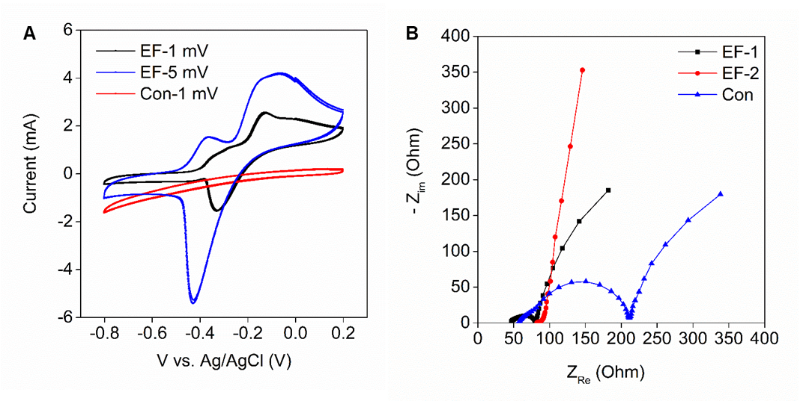
Figure S1. CV scans (A) and EIS analysis (B) of enriched EF reactors and unenriched control reactors.

Figure S2. Effects of alkaline-thermal (AT) pretreatment and enzyme lysis (EL) of dewatered sludge on protein concentration.
Figure S3. The growth curve of Pseudomonas aeruginosa PAO1 in medium of recovered protein used as a substitute for yeast and peptone (A), a substitute for peptone (B), and a substitute for yeast (C). The cell wet weight after 24 hours (D).

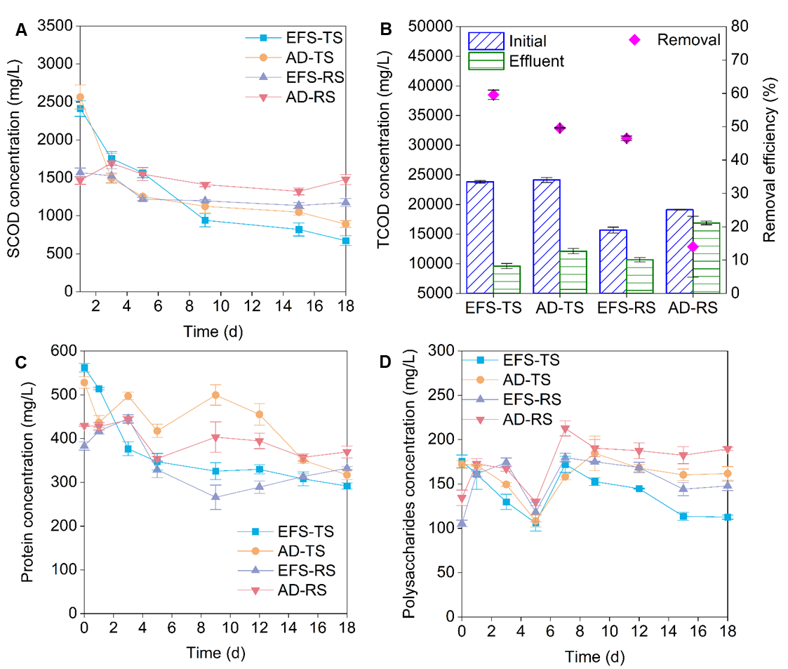
Figure S4. The variation of SCOD concentration (A), removal of TCOD (B), variation of protein concentration (C), and polysaccharides concentration (D) using raw (RS) and treated dewatered sludge (TS) for the second period of operation.

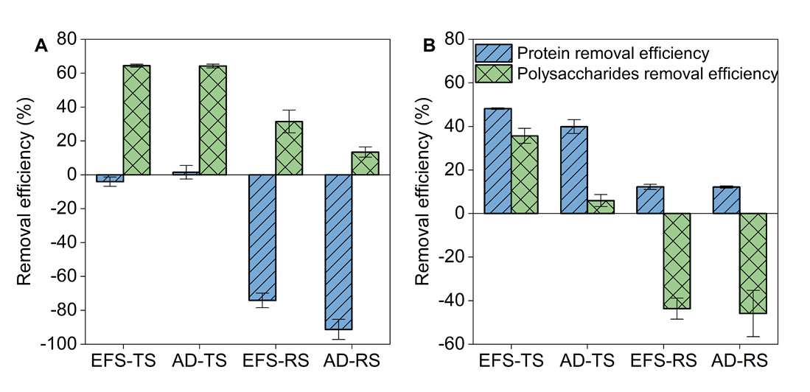
Figure S5. The removal efficiency of protein concentration and polysaccharides concentration for the first (A) and second (B) period of operation.
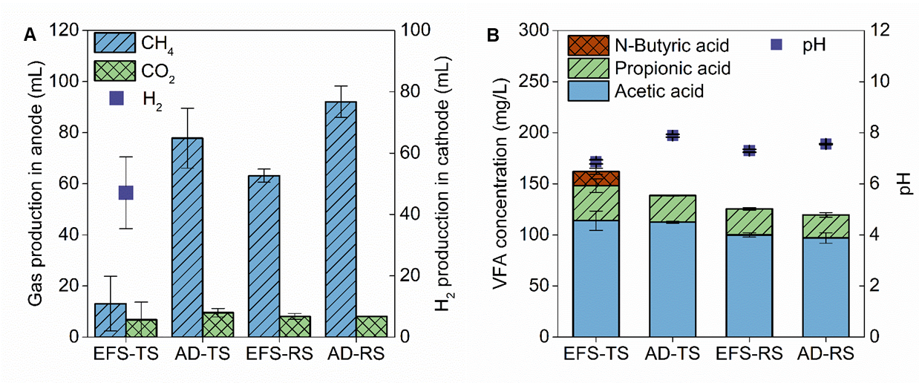
Figure S6. The gas production in anode and cathode chambers (A) and the VFAs concentration (B) at the end of fermentation.

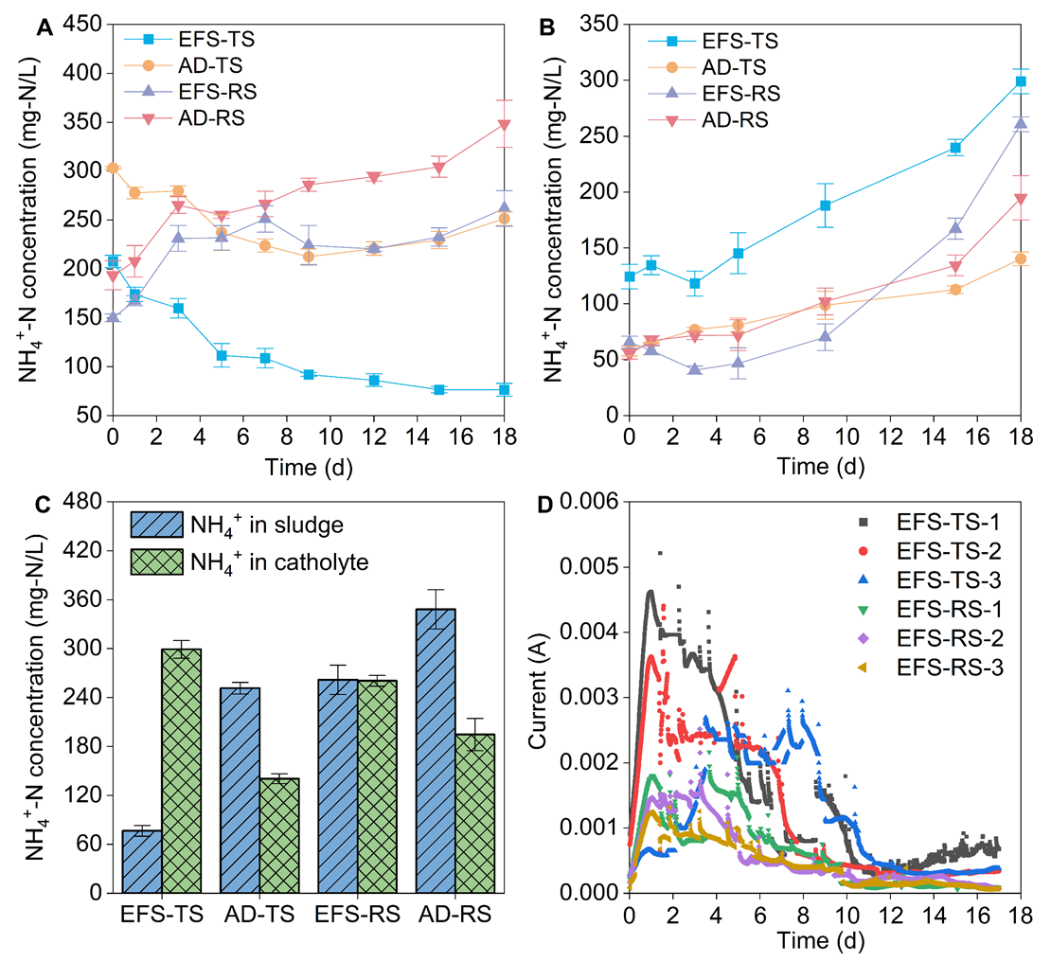
Figure S7. NH₄⁺ variation of anode (A) and cathode (B) for the second period, NH₄⁺ concentration at the end of fermentation (C), and the current variation in the six closed-circuit EFS during a batch fermentation (D).
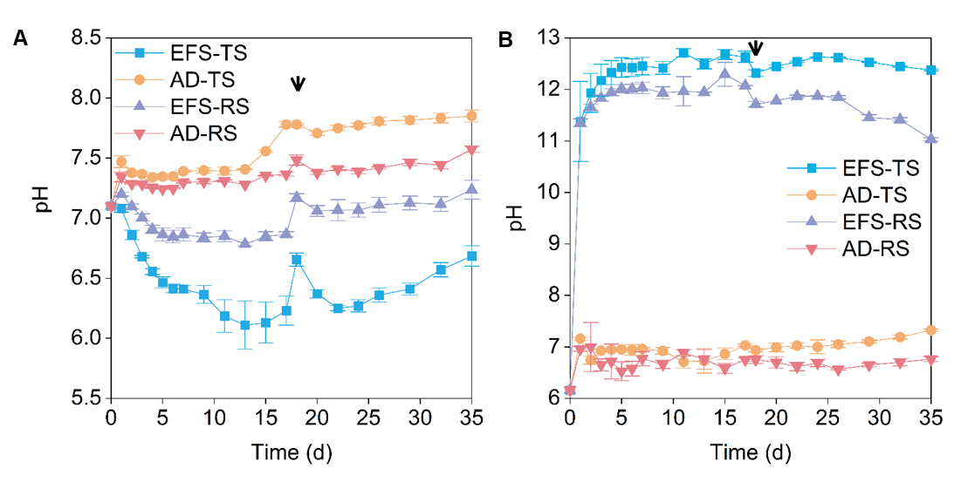
Figure S8. The pH variation of anode (A) and cathode (B) chamber during two successive period. The arrows indicate solution replacement.
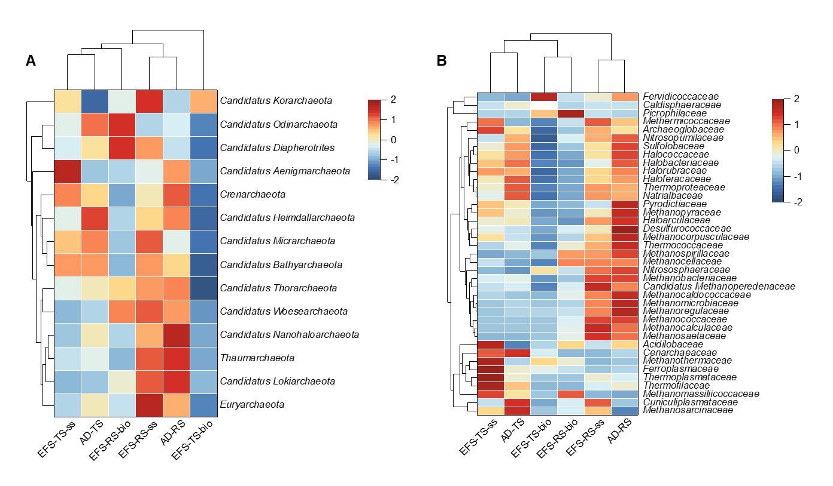
Figure S9. A heatmap of archaeal community composition at the phylum (A) and family (B) level.

Figure S10. The relative abundances of the dominant genera based on metagenomic analysis.
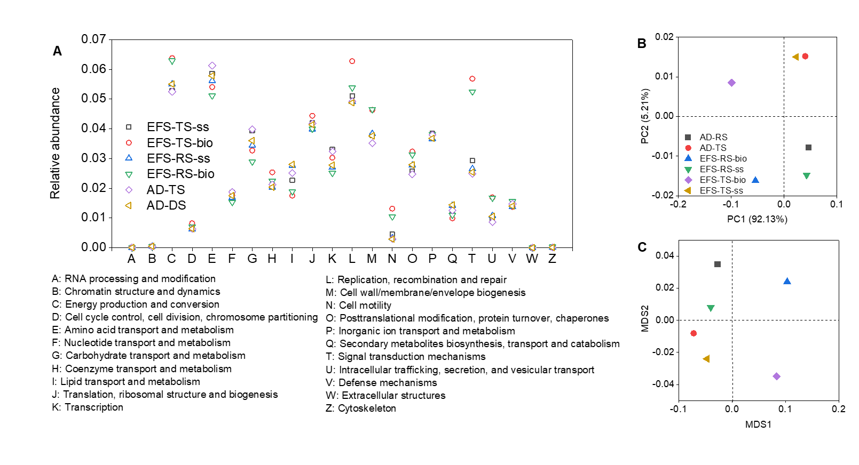
Figure S11. The relative abundance of eggNOG-annotated genes (A), principal coordinates analysis (B), and non-metric multidimensional scaling analysis (C).

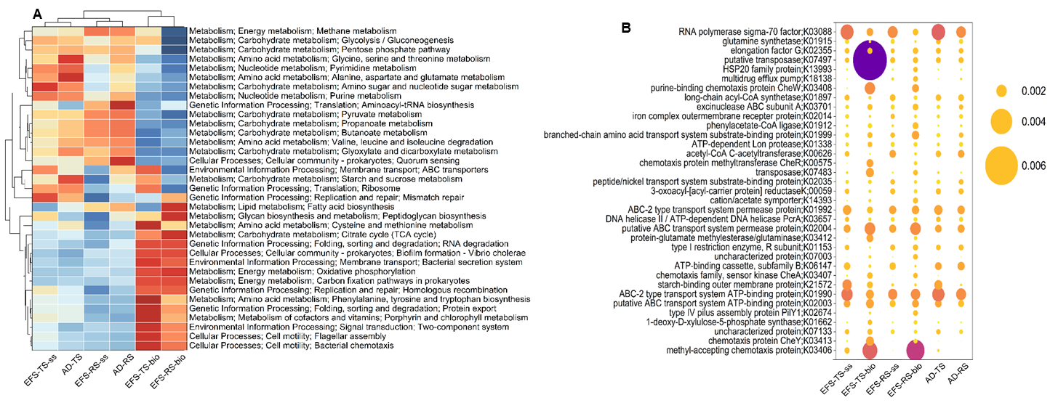
Figure S12. Clustering heatmap of KEGG at level 3 (A) and annotated genes (B) (top 35).

Figure S13. Proportion of Geobacter in pta, ackA, macA, and ccdA unigenes in different groups.

References:
1. Lu, L.; Xing, D.; Liu, B.; Ren, N., Enhanced hydrogen production from waste activated sludge by cascade utilization of organic matter in microbial electrolysis cells. Water Res. 2012, 46, (4), 1015-26.
2. Gu, J.; Li, Z.; Xie, G.; Yang, Y.; Liu, B.; Ren, Z. J.; Xing, D., Electro-fermentation enhances H₂ and ethanol co-production by regulating electron transfer and substrate transmembrane transport. Chem. Eng. J. 2022, 429.
3. Magoc, T.; Salzberg, S. L., FLASH: fast length adjustment of short reads to improve genome assemblies. Bioinformatics 2011, 27, (21), 2957-2963.
4. Haas, B. J.; Gevers, D.; Earl, A. M.; Feldgarden, M.; Ward, D. V.; Giannoukos, G.; Ciulla, D.; Tabbaa, D.; Highlander, S. K.; Sodergren, E.; Methe, B.; DeSantis, T. Z.; Petrosino, J. F.; Knight, R.; Birren, B. W.; Human Microbiome, C., Chimeric 16S rRNA sequence formation and detection in Sanger and 454-pyrosequenced PCR amplicons. Genome Res. 2011, 21, (3), 494-504.
5. Karlsson, F. H.; Fak, F.; Nookaew, I.; Tremaroli, V.; Fagerberg, B.; Petranovic, D.; Backhed, F.; Nielsen, J., Symptomatic atherosclerosis is associated with an altered gut metagenome. Nat. Commun. 2012, 3.
6. Karlsson, F. H.; Tremaroli, V.; Nookaew, I.; Bergstrom, G.; Behre, C. J.; Fagerberg, B.; Nielsen, J.; Backhed, F., Gut metagenome in European women with normal, impaired and diabetic glucose control. Nature 2013, 498, (7452), 99-+.
7. Scher, J. U.; Sczesnak, A.; Longman, R. S.; Segata, N.; Ubeda, C.; Bielski, C.; Rostron, T.; Cerundolo, V.; Pamer, E. G.; Abramson, S. B.; Huttenhower, C.; Littman, D. R., Expansion of intestinal Prevotella copri correlates with enhanced susceptibility to arthritis. Elife 2013, 2.
8. Oh, J.; Byrd, A. L.; Deming, C.; Conlan, S.; Program, N. C. S.; Kong, H. H.; Segre, J. A., Biogeography and individuality shape function in the human skin metagenome. Nature 2014, 514, (7520), 59-64.
9. Xiao, K.; Chen, Y.; Jiang, X.; Seow, W. Y.; He, C.; Yin, Y.; Zhou, Y., Comparison of different treatment methods for protein solubilisation from waste activated sludge. Water Res. 2017, 122, 492-502.
10. Rongwong, W.; Bae, T.-H.; Jiraratananon, R., Economic optimization of hollow fiber membrane contactors for ammonia nitrogen recovery from anaerobic digestion effluents. Journal of Environmental Chemical Engineering 2022, 10, (6), 108631.

